**Business Justification**

**for the development of new ISO 20022 financial repository items**

*Note: the purpose of this document is to give guidelines to organisations that want to develop new candidate ISO 20022 message definitions. Such requests are subject to the approval of a business justification by the ISO 20022 Registration Management Group (RMG). Please consult the iso20022.org website for additional details on* [*the registration process*](http://www.iso20022.org/development.page)*. The business justification must include the following captions, as described. Business justifications are to be sent via e-mail to* [*iso20022ra@iso20022.org*](mailto:iso20022ra@iso20022.org)

1. **Name of the request:**

The (short) name, proposed by the submitting organisation, to refer to the registration request, eg, name to be given to the new message set. Change to this name may be proposed by the ISO 20022 Registration Authority (RA), Registration Management Group (RMG) or Standards Evaluation Groups (SEG), for example when necessary to avoid confusion with another request or to better highlight the scope of the request.

Buyer Protection

1. **Submitting organisation(s):**

Identity of the organisation, group, initiative or community that submits the request. If the submitting organisation acts on behalf of other groups, initiatives or communities, they should also be identified.

SWIFT and Securities Market Practice Group (SMPG)

1. **Scope of the new development:**

This Business Justification aims at requesting a suit of ISO 20022 messages to support automated or bilateral buyer protection whereby the buyer (or its asset servicer) who has yet to receive the underlying securities of an elective corporate action can automatically instruct the seller (or its asset servicer) to protect its corporate actions entitlement and receive the outturn of its choice.

The scope of the ISO 20022 Buyer Protection messages is to instruct a buyer protection, obtain a status of such buyer protection instruction, request the cancellation of a previously sent buyer protection instruction, obtain a status of the cancellation of the buyer protection instruction and be notified of any alleged buyer protection instruction.

Based on the European standards and the existing processed in place in Euroclear UK & International CSD, the SMPG Corporate Actions (CA) Working Group (WG) has identified the below business needs:

1. to instruct a buyer protection;
2. to report a status change of the buyer protection instruction or, in case of bilateral buyer protection, to accept/reject a buyer protection instruction;
3. to request the cancellation of a buyer protection instruction ;
4. to report the status of the cancellation request of a buyer protection instruction;
5. to provide the details of an alleged individual buyer protection instruction ;
6. to cancel/remove an allegement of a buyer protection instruction;
7. to request the list of all outstanding buyer protection instructions (report) – the intention is to have a generic request for CA related reports;
8. to provide the list of all outstanding buyer protection instructions (report).

We believe these needs can be addressed by creating a series of eight new messages.

**Actors and Roles – automated buyer protection:**

1. Executing/Servicing Party

The party reporting the status of the buyer protection instruction and any alleged buyer protection instruction. In an automated buyer protection environment, the CSD automatically transmit the buyer protection instructions from the buyer (or its agent) to the seller (or its agent)

1. Instructing Party

The party instructing the buyer protection.

|  |  |
| --- | --- |
| Instructing Party | Executing/Servicing Party |
| Central Securities Depository (CSD) participants and their underlying clients | Central Securities Depository, any CSD participant (custodian) |

* 1. Buyer protection instruction, status and allegement

This scenario illustrates the communication flow between the instructing party and the executing/servicing party to:

* instruct a buyer protection[1]
* provide the status of such buyer protection instruction
* provide the details of an alleged buyer protection instruction once the executing party has alleged it to the other party
* remove an alleged buyer protection instruction once the other party has sent its instruction or to cancel an alleged buyer protection instruction once the instructing party has subsequently cancelled its instruction
* OPTIONAL – request a list of all outstanding buyer protection instructions
* OPTIONAL (based on subscription) – to provide the list of all outstanding buyer protection instructions (report).

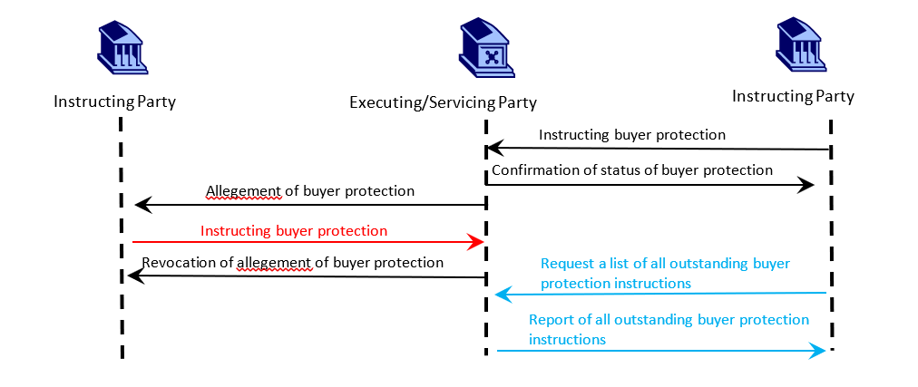

* 1. Buyer protection instruction cancellation and status

This scenario illustrates the communication flow between the instructing party and the executing/servicing party to:

* instruct a buyer protection
* provide the status of such buyer protection instruction
* instruct a cancellation of a buyer protection instruction
* provide the status of a cancellation request of a buyer protection instruction

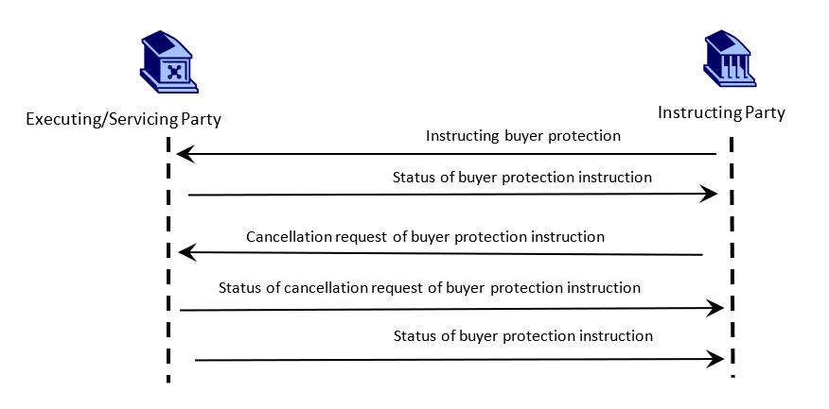

**Actors and Roles – bilateral buyer protection:**

1. Instructing Party/buyer

The party instructing the buyer protection.

1. Receiving Party/seller

The party receiving the buyer protection instructions from the buyer.

|  |  |
| --- | --- |
| Instructing Party | Receiving Party |
| Buyer | Seller |

1. Buyer protection instruction, status and allegement

This scenario illustrates the communication flow between the instructing parties to:

* instruct a buyer protection
* provide the status of such buyer protection instruction
* instruct a cancellation of a buyer protection instruction
* provide the status of a cancellation request of a buyer protection instruction

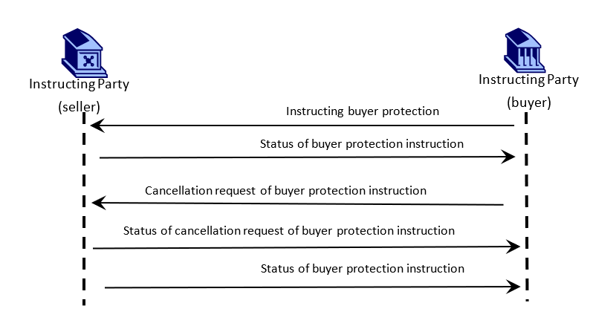

In view of the scope, we propose that the new message definitions be part of the ‘seev’ Business Area and be evaluated by the Securities SEG, via the existing Corporate Actions Evaluation team.

1. **Purpose of the new development:**

According to the European standards for transaction management as per the Corporate Events Joint Working Group (CEJWG), a buyer protection instruction should be created by the buyer, referencing the corporate action, the chosen option(s), the quantity of securities and the underlying transaction.

In case of automated buyer protection, the buyer protection instruction should be communicated from the buyer to the seller without undue delay via the chain of intermediaries and the (I)CSDs in formatted electronic form using standards defined and used by the securities industry such as the ISO standards, irrespective of the communication channel used.

In case of manual buyer protection, the buyer protection instruction should be communicated from the buyer to the seller electronically using the agreed template or an ISO message (once available).

There are no ISO messages to meet the requirements for automated or manual buyer protection. As such, it’s only handled via (I)CSDs via proprietary messages and manually or semi-manually along the chain of intermediaries. Manual buyer protection is managed via email or fax.

1. **Community of users and benefits:**

*This section is critical. It will be used by the RMG to determine the business case and priority of the proposed development. Even if the benefits of the project may have already been described to some extent in the previous sections, submitting organisations are invited to repeat them here and to spend the time necessary to collect requested information for each of the captions below. If a caption cannot be completed, the submitting organisation is requested to explain why.*

The categories of parties/actors that would use/benefit from the new messages are:

|  |  |
| --- | --- |
| Instructing Party | Executing/Servicing Party |
| CSD participants and their underlying clients | CSD, any CSD participant (custodian) |

1. Benefits/savings: There is currently no ISO message support for buyer protection instruction processing. Such process is either managed manually via email/fax or where CSD support it (see Euroclear UK&International) via proprietary messages. These new messages would enhance STP.
2. Adoption scenario: the new messages would be introduced on SWIFTNet FINplus as of SWIFT Standards Release 2026 (SR 2026) if possible.
3. Volumes: The exact number in Europe cannot be determined. However, in Euroclear UK & International, during the period 2020-2023, there were approximately 5,000 buyer protection instructions being processed each year, on average.
4. Sponsors and adopters: SMPG CA WG member countries in the EEA, Switzerland and the UK sponsor the request. The adoption will be left to each CSD in the relevant country.
5. **Timing and development:**

The intention is to submit the models to the RA as soon as the business justification is approved.

The development will be based on the requirements collected by the SMPG CA WG and will involve the CA experts of the joint ISO 15022/ISO 20022 maintenance working group.

1. **Commitments of the submitting organisation:**

SWIFT and the SMPG confirm that they can and will:

* undertake the development of the candidate ISO 20022 business and message models that it will submit to the RA for compliance review and evaluation. The submission will be compliant with the [ISO 20022 Master Rules](http://www.iso20022.org/documents/general/ISO20022_MasterRules.ZIP) and include a draft Part 1 of the Message Definition Report (MDR) compliant with the [template for MDR part 1](http://www.iso20022.org/documents/general/ISO20022_MasterRules.ZIP) provided by the RA, the [ISO 20022 Message Transport Mode](http://www.iso20022.org/documents/general/MessageTransportModes.xls) (MTM) that the submitting organisations recommend to consider with the submitted message set, and examples of valid instances of each candidate message;
* address any queries related to the description of the models and messages as published by the RA on the ISO 20022 website.

The submitting organisations confirms that they will promptly inform the RA about any changes or more accurate information about the number of candidate messages and the timing of their submission to the RA. If the submitting organisations do not submit the candidate messages within the timing announced in section F and do not inform the RA beforehand, the business justification may lapse and require re-submission of a new business justification for approval by the RMG.

The submitting organisations do not intend to organise any testing of the candidate messages once they have been reviewed and qualified by the RA and before their submission to the SEG for approval.

The submitting organisations confirm that they are committed to undertake the future message maintenance.

The submitting organisations confirm their knowledge and acceptance of the ISO 20022 Intellectual Property Rights policy for contributing organisations, as follows.

*“Organizations that contribute information to be incorporated into the ISO 20022 Repository shall keep any Intellectual Property Rights (IPR) they have on this information. A contributing organization warrants that it has sufficient rights on the contributed information to have it published in the ISO 20022 Repository through the ISO 20022 Registration Authority in accordance with the rules set in ISO 20022. To ascertain a widespread, public and uniform use of the ISO 20022 Repository information, the contributing organization grants third parties a non-exclusive, royalty-free licence to use the published information”.*

1. **Contact persons:**

Mariangela Fumagalli, co-chair SMPG CA-WG

Email Address: mariangela.fumagalli@bnpparibas.com

Christine Strandberg, co-chair SMPG CA-WG

Email Address: [christine.strandberg@seb.se](mailto:christine.strandberg@seb.se)

Miriam Ortseifen, SWIFT

Email Address: Miriam.ortseifen@swift.com

Jacques Littré, SWIFT

Email Address: jacques.littre@swift.com

1. **Comments from the RMG members and relevant SEG(s) or SubSEG(s) and disposition of comments by the submitting organisation:**

This section will include the comments received from RMG members and the SEG(s) or SubSEG(s), if any, and the response given to each of these comments by the submitting organisation.

1. Depending on the type of event (voluntary versus mandatory with options) and the rules of the CSD, both parties may be required to instruct the buyer protection. We have indicated the optionality of such instruction by having one of the two instructions in red.