**Business Justification**

**for the development of new ISO 20022 financial repository items**

*Note: the purpose of this document is to give guidelines to organisations that want to develop new candidate ISO 20022 message definitions. Such requests are subject to the approval of a business justification by the ISO 20022 Registration Management Group (RMG). Please consult the iso20022.org website for additional details on* [*the registration process*](http://www.iso20022.org/development.page)*. The business justification must include the following captions, as described.*

*Business justifications* are to be submitted through the ISO 20022 website through following [*e-request*](https://www.iso20022.org/development-new-iso-20022-message-definitions-request), in which this template must be attached.

1. **Name of the request:**

**“ESAP Metadata Reporting”**

1. **Submitting organisation(s):**

European Securities and Markets Authority (ESMA)  
201-203 rue de Bercy  
75012 Paris  
France

1. **Scope of the new development:**

**Background**

Regulation (EU) 2023/2859 of the European Parliament and of the Council of 13 December 2023 establishing a European Single Access Point ([ESAP](https://eur-lex.europa.eu/legal-content/EN/TXT/?uri=CELEX:32023R2859)) providing centralised access to publicly available information of relevance to financial services, capital markets and sustainability, requires the Joint Committee of the European Supervisory Authorities (ESAs) to develop draft Implementing Technical Standards (ITS) specifying the characteristics of the metadata accompanying the information and necessary for the functioning of ESAP.

**Scope:**

This new development is based on Regulation (EU) 2023/2859 of the European Parliament and of the Council of 13 December 2023 establishing ESAP[1] and

* Implementing Technical Standards (ITS) specifying the characteristics of the metadata accompanying the information and necessary for the functioning of ESAP.

*Art.5(1)(e): [Collection Bodies shall] provide ESAP […] with the information, the metadata for that information and, where required, the qualified electronic seal;*

*Art.5(10): The ESAs, through the Joint Committee, shall develop draft implementing technical standards specifying […]*

*(e) the characteristics of the metadata necessary for the ESAP search function referred to in Article 7(3), metadata referred to in paragraph 6 of this Article and any other metadata necessary for the functioning of ESAP;*

The submitting organisation expects to develop one set of one message for ESAP metadata reporting.

The submitting organisation wants to deploy the future message in the default ISO 20022 XML syntax.

The proposed business area for the set of messages is “auth”.

Based on the scope, the submitting organisation proposes to assign the Securities Derivatives Standards Evaluation Subgroup (SubSEG) under the leadership of the Securities Standards Evaluation Group (SEG) for the evaluation of the candidate ISO 20022 messages, once developed.

1. **Purpose of the new development:**

The ESAs have conducted an open public consultation on the draft implementing technical standards on which this request is based, analysed the potential related costs and benefits and requested the opinion of the Securities and Markets Stakeholder Group established by Article 37 of Regulation (EU) No 1095/2010 of the European Parliament and of the Council. For ESAP, the new development is related to:

* ITS with respect to tasks of the collection bodies.

The ITS on tasks of the collection bodies clarifies the characteristics of the metadata necessary for ESAP, as well as characteristics of the data collection interface.

The draft ITS annexed to the consultation paper specifies that the metadata should be provided by collection bodies to ESAP in a common format in accordance with the ISO 20022 methodology. When the submitted information is in a machine-readable format, entities may in alternative submit the metadata in the same format of the information.

ESAP constitutes a new data collection and ESMA proposes to develop a new ISO 20022 message:

* “Regulatory metadata report”

1. **Community of users and benefits:**

The community of users for these new messages is represented by the entities, that are subject to reporting and disclosure requirements; the collection bodies, among which the National Competent Authorities, as well as ESMA, in charge of the establishment and operation of ESAP.

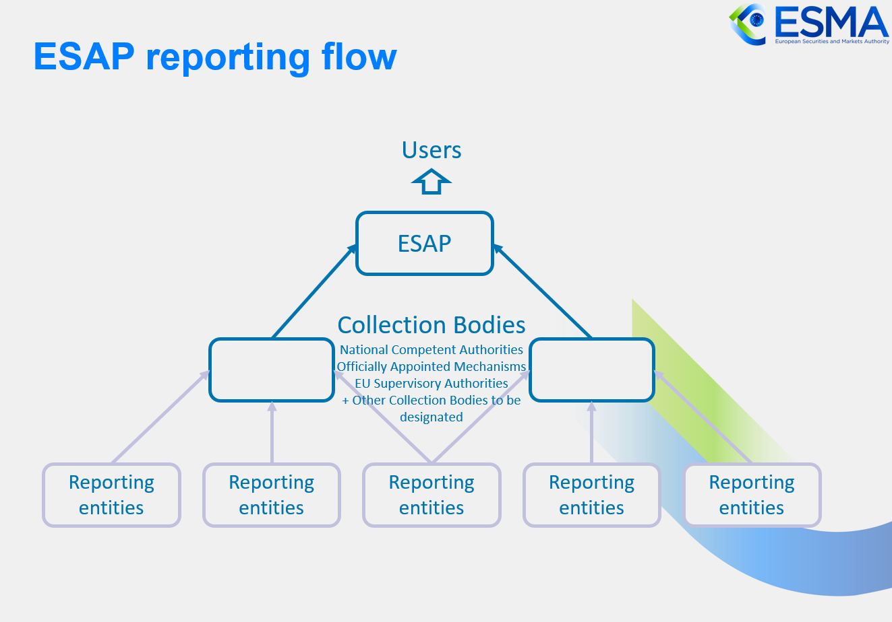

1. **Benefits/savings:**

The proposed messages will enable efficient data exchange between entities, collection bodies, and authorities as it will make use of existing ISO 20022 business concepts. At the same time ESMA will benefit from the adoption of these messages as the usage of business concepts from the ISO 20022 standard will allow to apply consistent definitions for the data.

Additionally, the usage of standards is likely to improve data quality and ensure global semantic interoperability with all other ISO 20022 based systems.

1. **Adoption scenario:**

The new messages will be adopted as soon as the Implementing Technical Standards (ITS) are endorsed by the European Commission and the European Parliament and the Regulations enter into force.

1. **Volumes:**

It is estimated that between 30 and 200 collection bodies will use the ISO 20022 message under ESAP.

More precise information on the expected volume is not known yet and will be available at later stage.

1. **Sponsors and adopters:**

Once endorsed by the European Commission, the new Implementing Technical Standard (ITS) for ESAP will entail the adoption of the new messages by all reporting entities for the obligations which are expected to start in July 2026. Furthermore, ESMA and the ESAP collection bodies will implement the processing of the new messages before the start of the reporting.

1. **Timing and development:**

The new ESAP message will be included in the Securities Market Regulatory Reporting message set. ESMA expects to have the new candidate ISO 20022 message developed and ready for submission to the RA by November 2024.

1. **Commitments of the submitting organisation:**

The submitting organisation confirms that it can and will:

* undertake the development of the candidate ISO 20022 business and message models that it will submit to the RA for compliance review and evaluation. The submission must be compliant with the [ISO 20022 Master Rules](https://www.iso20022.org/sites/default/files/documents/D7/ISO20022_MasterRules.zip) and include a draft Part 1 of the Message Definition Report (MDR) compliant with the [template for MDR part 1](https://www.iso20022.org/sites/default/files/documents/D7/ISO20022_MasterRules.zip) provided by the RA, the [ISO 20022 Message Transport Mode](http://www.iso20022.org/documents/general/MessageTransportModes.xls) (MTM) that the submitting organization recommends to consider with the submitted message set, and, optionally, examples of valid and invalid instances of each candidate message. The submission may also include a Message User Guide (MUG) to complement the MDR and describe in further details how to use the different possibilities/options of the proposed candidate messages;
* address any queries related to the description of the models and messages as published by the RA on the ISO 20022 website.

The submitting organisation confirms that:

* it will inform and consult the market on the metadata message but it does not intend to organize any testing of the candidate messages once they have been reviewed and qualified by the RA and before their submission to the SEG(s) for approval.
* It is committed to undertake the future message maintenance.

The submitting organisation confirms the knowledge and acceptance of the ISO 20022 Intellectual Property Rights policy for contributing organisations, as follows:

*“Organizations that contribute information to be incorporated into the ISO 20022 Repository shall keep any Intellectual Property Rights (IPR) they have on this information. A contributing organization warrants that it has sufficient rights on the contributed information to have it published in the ISO 20022 Repository through the ISO 20022 Registration Authority in accordance with the rules set in ISO 20022. To ascertain a widespread, public and uniform use of the ISO 20022 Repository information, the contributing organization grants third parties a non-exclusive, royalty-free licence to use the published information”.*

1. **Contact persons:**

* Minoux Cyril

[cyril.minoux@esma.europa.eu](mailto:cyril.minoux@esma.europa.eu)

* Gosso Stephanie

[stephanie.gosso@esma.europa.eu](mailto:stephanie.gosso@esma.europa.eu)

1. **Comments from the RMG members and relevant SEG(s) or SubSEG(s) and disposition of comments by the submitting organisation.**

1. [Regulation - EU - 2023/2859 - EN - EUR-Lex (europa.eu)](https://eur-lex.europa.eu/legal-content/EN/TXT/?uri=CELEX:32023R2859)