**Business Justification**

**for the development of new ISO 20022 financial repository items**

*Note: the purpose of this document is to give guidelines to organisations that want to develop new candidate ISO 20022 message definitions. Such requests are subject to the approval of a business justification by the ISO 20022 Registration Management Group (RMG). Please consult the iso20022.org website for additional details on* [*the registration process*](http://www.iso20022.org/development.page)*. The business justification must include the following captions, as described.*

*Business justifications* are to be submitted through the ISO 20022 website through following [*e-request*](https://www.iso20022.org/development-new-iso-20022-message-definitions-request), in which this template must be attached.

1. **Name of the request:**

**“Crypto-Asset data and Metadata Exchange”**

1. **Submitting organisation(s):**

European Securities and Markets Authority (ESMA)  
201-203 rue de Bercy  
75012 Paris  
France

1. **Scope of the new development:**

**Background**

Regulation (EU) 2023/1114 of the European Parliament and of the Council of 31 May 2023 on markets in crypto-assets, and amending Regulations (EU) No 1093/2010 and (EU) No 1095/2010 and Directives 2013/36/EU and (EU) 2019/1937 ([MiCA](https://eur-lex.europa.eu/legal-content/EN/TXT/PDF/?uri=CELEX:32023R1114)) require ESMA to develop Regulatory Technical Standards (RTS) detailing data reporting and disclosure requirements for issuers and service providers of crypto-assets.

Regulation (EU) 2023/2859 of the European Parliament and of the Council of 13 December 2023 establishing a European single access point ([ESAP](https://eur-lex.europa.eu/legal-content/EN/TXT/?uri=CELEX:32023R2859)) providing centralised access to publicly available information of relevance to financial services, capital markets and sustainability, requires the Joint Committee of the ESAs to develop draft Implementing Technical Standards (ITS) specifying the characteristics of the metadata accompanying the information and necessary for the functioning of ESAP.

**Scope:**

For MiCA, this new development is based on Regulation (EU) 2023/1114 of the European Parliament and of the Council of 31 May 2023 on markets in crypto-assets[1] and

* the regulatory technical standards specifying records to be kept of all crypto-asset services, activities, orders and transactions undertaken (hereafter the **RTS on recordkeeping**) and specifically to Article 68 for the records to be kept of all crypto-asset services, activities, orders and transactions undertaken

*Paragraph 9. Crypto-asset service providers shall arrange for records to be kept of all crypto-asset services, activities, orders, and transactions undertaken by them. Those records shall be sufficient to enable competent authorities to fulfil their supervisory tasks and to take enforcement measures, and in particular to ascertain whether crypto-asset service providers have complied with all obligations including those with respect to clients or prospective clients and to the integrity of the market.*

*The records kept pursuant to the first subparagraph shall be provided to clients upon request and shall be kept for a period of five years and, where requested by the competent authority before five years have elapsed, for a period of up to seven years.*

*Paragraph 10. ESMA shall develop draft regulatory technical standards to further specify the records to be kept of all crypto-asset services, activities, orders and transactions undertaken referred to in paragraph 9.*

* the regulatory technical standards specifying the content and format of order book records for crypto-asset service providers operating a trading platform for crypto-assets (hereafter the **RTS on order book**) and specifically to Article 76 for the records to be kept of all crypto-asset services, activities, orders and transactions undertaken

*Paragraph 15. Crypto-asset service providers operating a trading platform shall keep at the disposal of the competent authority, for at least five years, the relevant data relating to all orders in crypto-assets that are advertised through their systems, or give the competent authority access to the order book so that the competent authority is able to monitor the trading activity. That relevant data shall contain the characteristics of the order, including those that link an order with the executed transactions that stem from that order.*

*Paragraph 16. ESMA shall develop draft regulatory technical standards to further specify the content and format of order book records to be maintained as specified in paragraph 15.*

For ESAP, this new development is based on Regulation (EU) 2023/2859 of the European Parliament and of the Council of 13 December 2023 establishing ESAP[2] and

* Implementing Technical Standards (ITS) specifying the characteristics of the metadata accompanying the information and necessary for the functioning of ESAP.

*Art.5(1)(e): [Collection Bodies shall] provide ESAP […] with the information, the metadata for that information and, where required, the qualified electronic seal;*

*Art.5(10): The ESAs, through the Joint Committee, shall develop draft implementing technical standards specifying […]*

*(e) the characteristics of the metadata necessary for the ESAP search function referred to in Article 7(3), metadata referred to in paragraph 6 of this Article and any other metadata necessary for the functioning of ESAP;*

The new MICA messages will use the ISO 20022 Business Application Header (BAH) without repeating header elements within the message.

These messages could be complemented with additional messages in the future based on potential needs.

For MiCA, the submitting organisation wants to deploy the future messages in the ISO 20022 JSON syntax only and therefore would welcome the prompt finalization of the JSON syntax whitepaper.

The submitting organisation expects to develop two sets of messages:

* One set composed of 3 messages for MiCA regulatory information
* One set composed of 1 message for ESAP metadata regulatory reporting

The proposed business area for the two sets of messages is “auth”.

Based on the scope, the submitting organisation proposes to assign the Securities Derivatives Standards Evaluation Subgroup (SubSEG) under the leadership of the Securities Standards Evaluation Group (SEG) for the evaluation of the candidate ISO 20022 messages, once developed.

1. **Purpose of the new development:**

ESMA has conducted open public consultations on the draft regulatory and implementing technical standards on which this request is based, analysed the potential related costs and benefits, and requested the opinion of the Securities and Markets Stakeholder Group established by Article 37 of Regulation (EU) No 1095/2010 of the European Parliament and of the Council.

For MiCA, the new development is related to:

* RTS on order book
* RTS on recordkeeping

The RTS on order book clarifies the templates to be used by crypto-asset services providers operating a trading platform for crypto-assets to keep at the disposal of the NCA, including the details of orders to be kept covering among others the identification of the relevant parties, of the order, prices and events affecting the order.

The RTS on recordkeeping clarifies the templates to be used by crypto-asset services providers to keep at the disposal of the NCA.

* every initial order received from a client and in relation to every initial decision to deal taken, to the extent they are applicable to the order or decision to deal in question
* the details to be kept for all transactions that are undertaken

The RTS specifies the information that must be kept by entities in their record and made available upon request to authorities and also the standards/formats in which these details should be represented (even though it was not possible to impose a specific obligation to maintain the details according to ISO 20022 methodology, the standards/formats prescribed in the templates should be compatible with such methodology).

The crypto-asset services providers and crypto-asset services providers operating a trading platform for crypto-assets should maintain data relating to the RTS on recordkeeping and crypto-asset services providers operating a trading platform for crypto-assets should also maintain data on the RTS on order book and make them available to National Competent Authorities (NCAs) when requested, in order for them to exchange them with other NCAs.

MiCA constitutes a new data collection but there are existing ISO 20022 messages containing a comparable set of information that may be reused partially:

* Auth.016
* Auth.113

The proposed new messages will reuse as much as possible these existing ISO 20022 messages and will register additional business concepts related to the digital tokens whenever required to address the specific MiCA regulatory reporting requirements.

For ESAP, the ESAs have conducted an open public consultation on the draft implementing technical standards on which this request is based, analysed the potential related costs and benefits and requested the opinion of the Securities and Markets Stakeholder Group established by Article 37 of Regulation (EU) No 1095/2010 of the European Parliament and of the Council. For ESAP, the new development is related to:

* ITS with respect to tasks of the collection bodies.

The ITS on tasks of the collection bodies clarifies the characteristics of the metadata necessary for ESAP, as well as characteristics of the data collection interface.

The draft ITS annexed to the consultation paper specifies that the metadata should be provided by collection bodies to ESAP in a common format in accordance with the ISO 20022 methodology. When the submitted information is in a machine-readable format, entities may in alternative submit the metadata in the same format of the information.

ESAP constitutes a new data collection and ESMA proposes to develop a new ISO 20022 message:

* “Regulatory metadata report”

1. **Community of users and benefits:**

The community of users for these new messages is represented by the entities, that are subject to reporting and disclosure requirements; the NCAs and ESMA; and in the case of ESAP, the collection bodies.

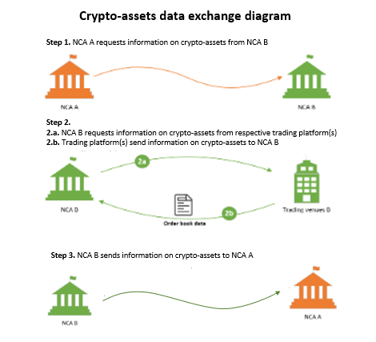

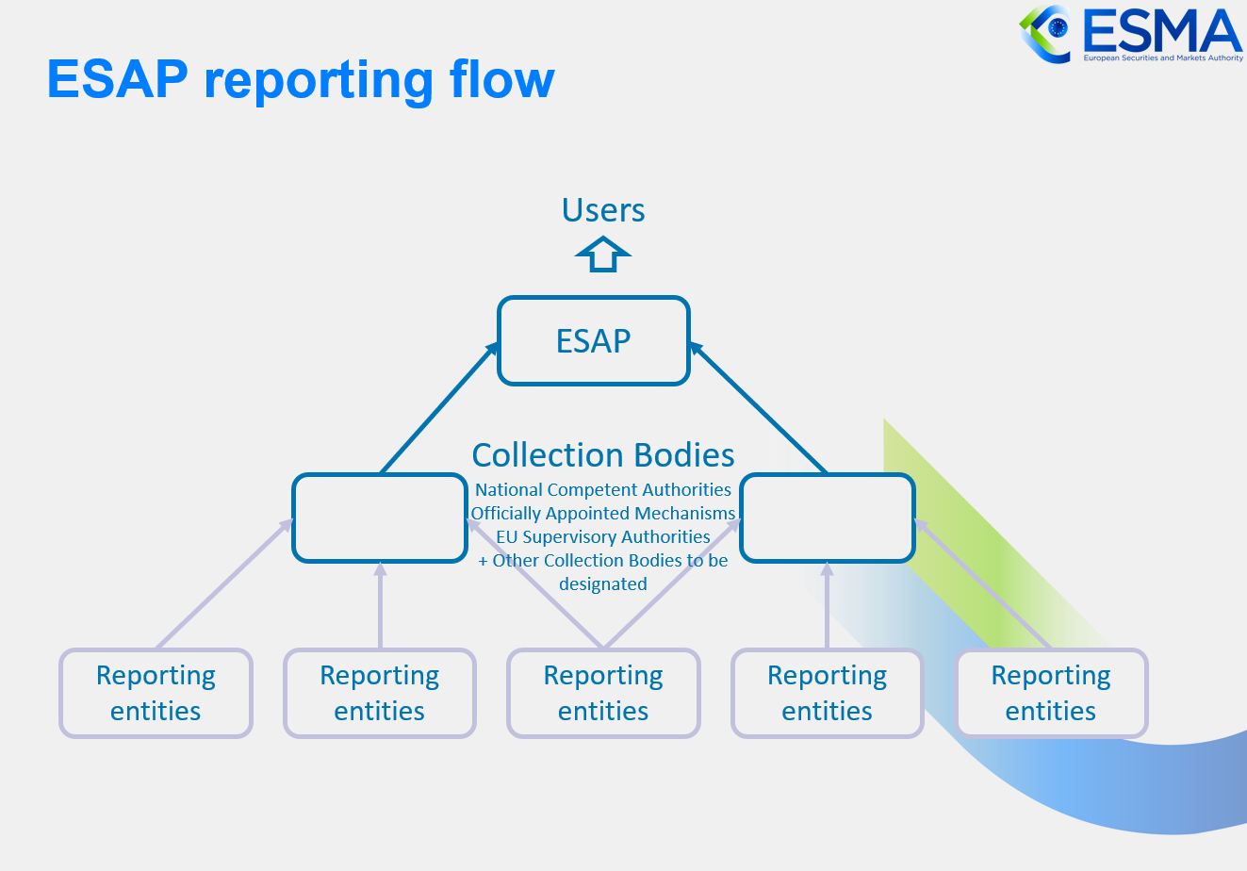

1. **Benefits/savings:**

The proposed messages will enable efficient data exchange between entities, collection bodies, and authorities as it will make use of existing ISO 20022 business concepts. At the same time ESMA will benefit from the adoption of these messages as the usage of business concepts from the ISO 20022 standard will allow to apply consistent definitions for the data.

Additionally, the usage of standards is likely to improve data quality and ensure global semantic interoperability with all other ISO 20022 based systems.

1. **Adoption scenario:**

The new messages will be adopted as soon as the Regulatory and Implementing Technical Standards (RTS and ITS) are endorsed by the European Commission and the European Parliament and the Regulations enter into force.

1. **Volumes:**

The expected volume of crypto-assets is not yet known and will be available at a later stage.

It is estimated that between 30 and 200 collection bodies will use the ISO 20022 message under ESAP.

More precise information on the expected volume is not known yet and will be available at later stage.

1. **Sponsors and adopters:**

Once endorsed by the European Commission, the new Implementing Technical Standard (ITS) for MiCA will entail the adoption of the new messages by all reporting entities for the obligations which are expected to start in January 2026. Furthermore, ESMA and the national competent authorities will implement the processing of the new messages before the start of the reporting.

Once endorsed by the European Commission, the new Implementing Technical Standard (ITS) for ESAP will entail the adoption of the new messages by all reporting entities for the obligations which are expected to start in July 2026. Furthermore, ESMA and the ESAP collection bodies will implement the processing of the new messages before the start of the reporting.

1. **Timing and development:**

The new MiCA messages will be included in the Securities Market Regulatory Reporting message set. ESMA expects to have the new candidate ISO 20022 message developed and ready for submission to the RA by September 2024.

The new ESAP message will be included in the Securities Market Regulatory Reporting message set. ESMA expects to have the new candidate ISO 20022 message developed and ready for submission to the RA by September 2024.

1. **Commitments of the submitting organisation:**

The submitting organisation confirms that it can and will:

* undertake the development of the candidate ISO 20022 business and message models that it will submit to the RA for compliance review and evaluation. The submission must be compliant with the [ISO 20022 Master Rules](http://www.iso20022.org/documents/general/ISO20022_MasterRules.ZIP) and include a draft Part 1 of the Message Definition Report (MDR) compliant with the [template for MDR part 1](http://www.iso20022.org/documents/general/ISO20022_MasterRules.ZIP) provided by the RA, the [ISO 20022 Message Transport Mode](http://www.iso20022.org/documents/general/MessageTransportModes.xls) (MTM) that the submitting organization recommends to consider with the submitted message set, and, optionally, examples of valid and invalid instances of each candidate message. The submission may also include a Message User Guide (MUG) to complement the MDR and describe in further details how to use the different possibilities/options of the proposed candidate messages;
* address any queries related to the description of the models and messages as published by the RA on the ISO 20022 website.

The submitting organisation confirms that:

* it will inform and consult the market on the transaction reporting messages but it does not intend to organize any testing of the candidate messages once they have been reviewed and qualified by the RA and before their submission to the SEG(s) for approval.
* It is committed to undertake the future message maintenance.

The submitting organisation confirms the knowledge and acceptance of the ISO 20022 Intellectual Property Rights policy for contributing organisations, as follows:

*“Organizations that contribute information to be incorporated into the ISO 20022 Repository shall keep any Intellectual Property Rights (IPR) they have on this information. A contributing organization warrants that it has sufficient rights on the contributed information to have it published in the ISO 20022 Repository through the ISO 20022 Registration Authority in accordance with the rules set in ISO 20022. To ascertain a widespread, public and uniform use of the ISO 20022 Repository information, the contributing organization grants third parties a non-exclusive, royalty-free licence to use the published information”.*

1. **Contact persons:**

* For MICA: Gosso Stephanie

[stephanie.gosso@esma.europa.eu](mailto:stephanie.gosso@esma.europa.eu)

* For ESAP: Minoux Cyril

[cyril.minoux@esma.europa.eu](mailto:cyril.minoux@esma.europa.eu)

1. **Comments from the RMG members and relevant SEG(s) or SubSEG(s) and disposition of comments by the submitting organisation:**

**Comment1 from Switzerland (Rainer Vogelgesang):**

As a general comment, we were wondering whether this BJ should have been rejected by the RA, as the ISO 20022 standard and the pertinent registration procedures do not currently support JSON.

We understand that only the proposed ESAP message is planned to be developed in the default XML syntax.

However, as regards the 3 MiCA messages, the submitting organization indicates that it intends to deploy those in the JSON syntax only. Due to the fact that the current edition of the ISO 20022 standard does not support JSON as a syntax, the submitting organization should indicate whether it intends, as part of its submission, to develop, maintain and take ownership for JSON transformation rules as domain-specific syntax.

If a domain-specific syntax submission is not intended, the submitting organization should indicate whether the BJ is conditional upon a future version of ISO 20022, currently under revision, which is foreseen to encompass a new part 9 (Syntax Generation Requirements and Rules) as well as the availability of future registration procedures for such syntaxes which will be outside of the ISO 20022 standard itself. In the latter case, does the submitting organization intend to develop, maintain and take ownership for such JSON transformation rules and request as submitting organisation their approval as new ISO 20022 syntax?

The submitting organisation should indicated whether it has any fall-back options in case the availability of the next edition of ISO 20022 and the related registration procedures for additional syntaxes in line with the future ISO 20022 part 9 were not to become, fully or partially, available on time for the expected start of using the messages for MiCa and ESAP reporting as of January 2026 and July 2026, respectively.

1. <https://eur-lex.europa.eu/legal-content/EN/TXT/PDF/?uri=CELEX:32023R1114>
2. [Regulation - EU - 2023/2859 - EN - EUR-Lex (europa.eu)](https://eur-lex.europa.eu/legal-content/EN/TXT/?uri=CELEX:32023R2859)