Business Justification
for the development of new ISO 20022 API resources as ISO 20022 financial repository items)
Note: the purpose of this document is to give guidelines to organisations that want to develop new candidate ISO 20022 API resource definitions. Such requests are subject to the approval of a business justification by the ISO 20022 Registration Management Group (RMG). Please consult the iso20022.org website for additional details on the registration process. The business justification must include the following captions, as described.

- Name of the request:
Account Validation API resources
- Submitting organisation(s):
- Swift
- European Payments Council (EPC)
- Nordic Payments Council (NPC)
Referred to as ‘submitting organisations’ in this document.
- Scope of the new development:
The proposed API resources allows users to validate an account’s existence (identity and status), ownership and type. The validation is completely independent from any payment scheme or payment initiation. The validation of the data can be done directly by a financial institution or by a third party.
The requesting entity is the data consumer which can be a Debtor Agent, a Creditor agent, a financial institution or a Creditor, a Debtor (e.g. a corporate validating the account number of a new supplier). The responding entity is the data provider which can be a Creditor Agent, a Debtor Agent, or a third party account/name check provider.
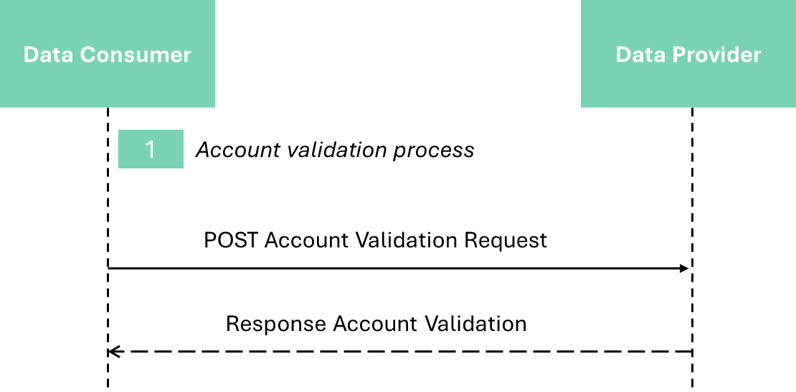

The API request and response are composed of existing ISO 20022 components (e.g., account number element). However, some data structures and codes lists are required to be created as this currently does not exist in ISO 20022.
The submitting organisations propose to re-use ISO 20022 definitions where they exist and submit new definitions (expected to be data structures and code lists) where no suitable existing ISO 20022 message component is available.
The proposed data structures and code lists could be re-used in any other business domains where an account needs to be validated.
- Purpose of the new development:
The process of validating the matching between an account and a name is an emerging requirement in many domestic markets, and for cross-border payments.
There is a risk that each scheme will develop its own proprietary API/model, leading to fragmentation that inhibits the emergence of common solutions and creates excess complexity for institutions that participate in multiple schemes.
The EPC, with the Verification Of Payee (VOP) scheme, aims to standardise a set of rules and practices to support payment service providers (PSPs) in the Single Euro Payments Area (SEPA) that will be required to comply with legal obligations on the verification of a payee in the case of credit transfers as outlined in the EU Instant Payments Regulation (IPR) amending the SEPA Regulation (8 April 2024).
This new development proposes a baseline standard model for any such scheme with the aim of reducing industry fragmentation, ensuring interoperability and encouraging the development of high quality, standard implementations benefiting the whole financial community. It will also further facilitate fraud prevention.
The submitting organizations acknowledge the existence of a Business Justification in a similar domain submitted by NACHA/Afinis (link) for account pre-validation for US ACH payments. The international and cross-border scope of the present BJ, and the support for direct debit as well as credit transfer scenarios, necessitates elements not found in the NACHA/Afinis proposal, and NACHA has expressed a preference to continue with their existing scope. So, the submitting organizations propose that both initiatives are progressed in parallel, with the possibility of convergence at a later date.
- Community of users and benefits:
This section is critical. It will be used by the RMG to determine the business case and priority of the proposed development, independently of whether the Business Justification relates to a new Business Area, or not. Even if the benefits of the project may have already been described to some extent in the previous sections, submitting organisations are invited to repeat them here and to spend the time necessary to collect requested information for each of the captions below. If a caption cannot be completed, the submitting organisation is requested to explain why.
The justification will identify the categories of parties/actors that would use/benefit from the new message(s), and for each category of users:
- Benefits/savings:
As set out above, the benefit of standardisation of a resource for APIs in the account validation domain is to avoid the frictions and inefficiencies of the fragmentation that would otherwise result as APIs proliferate, and would facilitate the development of cross border account validations. In addition, this standardisation is expected to yield a higher payments success rate and, at the same time, a reduction of the level of exceptions and investigations processing and effort related to failed payments. These improvements should translate into a reduction in associated costs.
These benefits extend to the data consumer, which can be a Debtor Agent, a Creditor Agent, a financial institution or a Creditor, a Debtor (e.g. a corporate), as well as the data provider, which can be a Creditor Agent, a Debtor Agent or a third party account/name check provider.

Adoption scenario:
A Swift API resource based on ISO 20022 is live and being used by financial institutions around the world for account verification.
The submitting organisations propose that this model forms the basis of the new standard, subject to the ISO 20022 API resource definition development and approval process.
New default standard API specifications for the VOP scheme, implementing payment account validation services, will be introduced by the EPC in the SEPA geographic area to secure compliance with the EU Instant Payments Regulation (IPR). The deadline for eurozone Payment Service Providers (PSPs) to offer verification of payee services ison the 9th of October 2025.
- Volumes:
The cross-border Swift API is currently being used by members of the Swift community. Call volumes are of the order of millions per month. The proposed API resource could be used by any financial institution using API technology to offer added value services to their customers.
In the SEPA area, the expected volume of VOP scheme-based messages is in the range of several billions per year (the volumes of SEPA (Instant) Credits Transfer and Direct Debits in the EU-27 area reached 64 Bn transactions per year in 2022, ECB data).
- Sponsors and adopters:
The Swift community of 12,000+ FIs are candidates to adopt account validation APIs.
The EPC is developing a standardized scheme for Verification Of Payee that will apply across the SEPA area , with implementation by financial institutions expected to begin in 2025.
The EPC develops and manages pan-European payment and payment-related schemes for the SEPA geographic area. The number of EPC payment scheme participants encompasses ar. 3.900 PSPs across the 36 SEPA countries, 62% of which already support the SEPA Instant Credit Transfer (SCT Inst) scheme. As an effect of the IPR regulation introduced at EEA (European Economic Area) level, the majority of the 3.900 PSPs currently participating to the EPC payment schemes are expected to offer a payment account verification service by October 2025.
The NPC has a similar remit for a verification of payee scheme in the Nordics.
- Timing and development:
The submitting organisations would undertake to work with the ISO 20022 community to define an industry standard based on the proven cross-border model already in use. They believe it will be possible to complete the development process and submit the ISO 20022 model for review and registration by end Q2 2024.
- Commitments of the submitting organisation:
The submitting organisations confirm that it can and will:
- undertake the development of the candidate ISO 20022 API resource models that it will submit to the RA for compliance review and evaluation. The submission must be compliant with the ISO 20022 Master Rules and include a draft Part 1 of the ISO 20022 Resource Definition Report (RDR) compliant with the template for RDR part 1 provided by the RA and, optionally, examples of valid and invalid instances of each candidate ISO 20022 API resource.
- address any queries related to the description of the models and ISO 20022 API resources as published by the RA on the ISO 20022 website.
The submitting organisations confirm that it will promptly inform the RA about any changes or more accurate information about the number of candidate ISO 20022 API resources and the timing of their submission to the RA. If the submitting organisations do not submit the candidate ISO 20022 API resources within the timing announced in section F and does not inform the RA beforehand, the business justification may lapse and require re-submission of a new business justification for approval by the RMG.
The submitting organisations confirm they are committed to undertake the future maintenance of the ISO 20022 API resources.
The submitting organisations confirm their acknowledgement and acceptance of the ISO 20022 Intellectual Property Rights policy for contributing organisations, as follows.
“Organizations that contribute information to be incorporated into the ISO 20022 Repository shall keep any Intellectual Property Rights (IPR) they have on this information. A contributing organization warrants that it has sufficient rights on the contributed information to have it published in the ISO 20022 Repository through the ISO 20022 Registration Authority in accordance with the rules set in ISO 20022. To ascertain a widespread, public and uniform use of the ISO 20022 Repository information, the contributing organization grants third parties a non-exclusive, royalty-free licence to use the published information”.
- Contact persons:
The submitting organisations will provide the contact details (name, e-mail address, telephone) of the person(s) at the submitting organisation that can be contacted by the RA, RMG, SEG, SubSEG, API SEG, BMST and/or TSG to get additional information on the project and/or its business justification.
EPC Primary Contact Person: Marc Lemaire - marc.lemaire@epc-cep.eu
EPC Backup Contact Person: Dominique Allebroeck - Dominique.Allebroeck@epc-cep.eu - +32 2 737 74 96

- Comments from the RMG members and relevant SEG(s) or SubSEG(s) and disposition of comments by the submitting organisation:

Comments from the Austrian community:
Can you pls provide information on the planned data set to be used with this new API POST and GET (response) call (optional and mandatory data).
Reply from submitting organisation:
After the approval of the Business Justification, the resource submission, which will be evaluated by the API SEG, will define the data set proposed for this domain.

Comments from EBA CLEARING:
EBA CLEARING and its community welcome the development of an open industry standard to support the verification of payee services. Currently EBA CLEARING offers its community an API based Account Assessment functionality including elements like IBAN Name matching, which is live and available to all participants and used with several millions of calls per month.
We note that the business justification refers to existing Swift account pre-validation APIs as the basis for the development of a future VoP API standard.
We would welcome to cooperate in the development of an API standard for Verification of Payee as proposed, contributing our knowledge and experience with similar APIs in the same geographical and product scope as mentioned in the BJ by the EPC, with an aim to come to a open standard for the industry, neutral to technology and solutions.
Upfront we would like to provide the following points for consideration during development of the VoP API specifications:
• The VoP API standard should be network agnostic and its specifications should ensure high security without any proprietary components.
• Purpose of the Verification of Payee is to reduce the risks of fraudulent transactions. We suggest that the VoP API standard includes an optional field that will allow to carry additional risk information beyond the VoP results, this could contribute further to the combatting of fraud in SEPA payments.
• The VoP API should be designed as a synchronous API. Verification of Payee services are required by the EC IPR Regulation on Instant Payments and can be used by PSPs (and other relevant requestors) for potentially all payments. PSPs will need to use this service in conjunction with further fraud combatting solutions and processes, time available to complete such processes is usually a few hundreds of milliseconds in the process of initiating instant payments.
Additional information: Fraud Pattern and Anomaly Detection (FPAD) (ebaclearing.eu)
Reply from submitting organisation:
A number of the comments focus on the implementation which is not the scope of this Business Justification. The submitters agree that the points provided up front are relevant to the implementation.
It is proposed to keep the initial scope contained to Verification of Payee given the pressing matter of the IPR and related timelines.
Of course, the submitters would be happy to discuss extending the specification to other functionality in due course.

Comments from the Norwegian community:
We understand that Berlin Group is working on something similar, se their 2024 workplan, chapter 2.9: https://www.berlin-group.org/_files/ugd/c2914b_2be6e01b9e2b437090d64e3f…
Has there been any contact with them in relation to this BJ?
Reply from submitting organisation:
The Berlin Group is a participant in the API SEG for which this Business Justification was circulated to API SEG members.
The Berlin Group is already collaborating with the EPC to the design of the VOP API specification (a representative of the Berlin Group is a member of the EPC VOP API Work Block).

Comments from the Swiss community:
The Swiss Association for SWIFT and Financial Standards (SASFS) is the representative organisation for financial standardisation in the financial centre of Switzerland and Liechtenstein. We have reviewed the latest version 4 of BJ 245 ‘Account Validation API resources’ and are supportive of its general direction and the proposed development of API resources.
We have noticed what seems to be an inconsistency in the definition of the scope and related benefits.
In chapter C ‘Scope of the new development’, it is explicitly stated that, amongst others, corporates are in scope, for instance, in order to validate the account number of a new supplier.
In contrast, in chapter E ‘Community of users and benefits’, there is no mention that the user community does indeed encompass corporates as well. To avoid any misunderstandings we would appreciate if this could be clarified and if possible extended to include this community.
In respect of the benefits, we believe that those are wider than the mere efficiency gains. The improved processes, when employing the proposed API resources, are expected to yield a higher payments success rate and, at the same time, a reduction of the level of exceptions and investigations processing and effort related to failed payments. All participants in the end-to-end payment life cycle, both corporates and financial institutions, are expected to benefit from the cost reduction achieved through these improvements.
Reply from submitting organisation:
The submitters agree to clarify Chapter E and indicate that the benefit extends to the data consumer and data provider as mentioned in Chapter C to avoid confusion.
The submitters agree that the benefit extends beyond mere efficiency gains and to clarify Chapter E.

The EU-27 is a subset of the SEPA geographic area, which encompasses 36 countries, see https://www.europeanpaymentscouncil.eu/about-us/epc-and-sepa-process.
See https://data.ecb.europa.eu/data/datasets/PAY/dashboard. ECB data for Credit Transfer and Direct Debit include limited volumes of domestic non-SEPA schemes.

