Business Justification
for the development of new ISO 20022 API resources as ISO 20022 financial repository items)
Note: the purpose of this document is to give guidelines to organisations that want to develop new candidate ISO 20022 API resource definitions. Such requests are subject to the approval of a business justification by the ISO 20022 Registration Management Group (RMG). Please consult the iso20022.org website for additional details on the registration process. The business justification must include the following captions, as described.

- Name of the request:
Securities Corporate Actions API resources
- Submitting organisation(s):
TCS – Tata Consultancy Services
SWIFT SCRL
- Scope of the new development:
The proposed API resources will support the exchange between Financial Institutions (FIs) – typically playing an Account Owner and Account Servicer role in the asset servicing chain of intermediaries - of information related to corporate actions services. The resources can also be used to support business processes inside Financial Institutions (FIs).

The ISO 20022 business area is “securities events” (“seev" prefix in the Message Identifier). These APIs can handle all financial instruments covered by the Classification of Financial Instrument [CFI] standard (ISO 10962).
Thirteen resources have been identified initially:

- Corporate actions event dashboard: API used to populate a dashboard (for elective events)
- Corporate actions event search: API used to list all events according to input provided by the user
- Corporate actions event details: API is used to retrieve all the details of the corporate action event and all the available option details for the selected event
- Corporate actions eligibility details: API is used to retrieve all the eligibility and trade details of the selected corporate action event.
- Corporate actions entitlement details: API is used to retrieve all the cash and securities entitlement details of the selected corporate action event.
- Corporate actions response details: API is used to retrieve all the submitted responses for the corporate action event.
- Corporate actions booking details: API is used to retrieve all the cash and securities transaction details of the selected corporate action event.
- Corporate actions term details: API is used to retrieve all the Narrative details (equivalent to MT 564)
- Corporate action initiate response: API is used to retrieve all the corporate action events for which input is required from the user.
- Corporate actions event uninstructed account list: API is used to retrieve eligibility details per account.
- Corporate actions event response options: API is used to retrieve all options on which a user can respond of the selected corporate action event.
- Corporate actions response cancellation initiation
- Submit response (13a)/cancel (13b): API is used to submit a new response or to cancel a response.
Here is the technical flow illustrating the different steps:

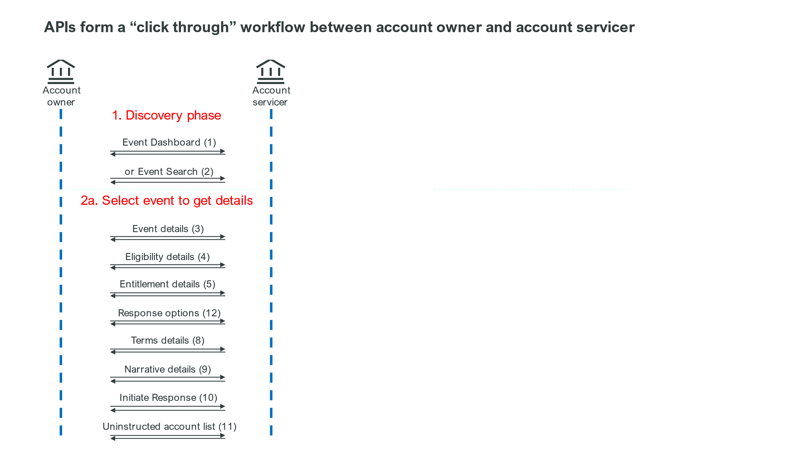
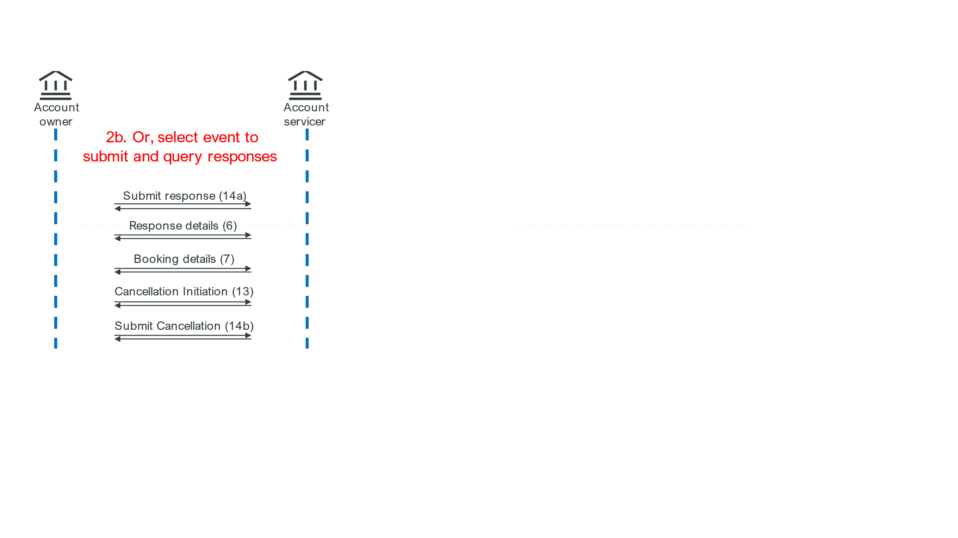
These resources will handle all types of corporate action events (mandatory, voluntary and voluntary with options). Additional resources could be developed in addition to the above listed APIs for adjacent processes such as such as general meetings, market claims, shareholder identification etc. These additional processes are excluded in the first phase of the project, but can be considered for a future version of this API resources set.
The resources and information are based on the current understanding and may both evolve while developing. It is assumed that most ISO 20022 repository items already exist and will be reused for the creation of these API resources. The ISO 20022 repository items are all those already used in the ISO 20022 corporate action (and general meetings) messages.
In terms of existing ISO 20022 business areas, the scope encompasses the following ISO 20022 messages:

MessageDefinition | Abbreviated Name | Message Identifier
CorporateActionNotification | CANO | seev.031
CorporateActionCancellationAdvice | CACN | seev.039
CorporateActionNarrative | CANA | seev.038
CorporateActionInstruction | CAIN | seev.033
CorporateActionInstructionStatusAdvice | CAIS | seev.034
CorporateActionInstructionCancellationRequest | CAIC | seev.040
CorporateActionInstructionCancellationRequestStatusAdvice | CACS | seev.041
CorporateActionInstructionStatementReport | CAST | seev.042
CorporateActionMovementPreliminaryAdvice | CAFE | seev.035
CorporateActionMovementPreliminaryAdviceCancellationAdvice | CAPC | seev.044
CorporateActionMovementConfirmation | CACO | seev.036
CorporateActionEventProcessingStatusAdvice | CAPS | seev.032
CorporateActionInstructionStatusAdvice | CARE | seev.037

The search functionalities in the proposed API set have no message equivalent, however these can be created as part of a different submission (by another submitter) while substantially reusing the related API resources.
The relevant ISO 20022 Standards Evaluation Group(s) are the Securities Standards Evaluation group (SEG), the Corporate Actions Evaluation Team (CA ET) and API SEG.

- Purpose of the new development:
There is an appetite for users who are not yet using ISO 20022 messages for corporate actions to start using standardised APIs for corporate actions. At the same time these APIs can support business processes that are not covered by ISO 20022 corporate action messages, eg, query a database based on selected event terms. In addition, we know that internal processes in financial institutions, and in vendor software, are already using APIs for corporate action processes.
TCS and Swift aim at starting the development of the described resources in the course of Q2 2024. Making these resources public will allow other organizations to comment the proposal, make any adjustments to it both in terms of generalization of the specifications as well as of refinement to cater for additional asset servicing requirements.

- Community of users and benefits:
The community of users will be:
- (International) Central Securities Depositories
- (Global) Custodians
- Investment Managers
- Brokers
- Data and software vendors
Benefits/savings: According to a recent ISSA survey the average cost of a corporate action unit at a custodian is 5 million USD and is expected to still grow. The costs for brokers and investment managers are slightly less but still very high.
The corporate actions processes are still very manual, error prone and high risk, so all initiatives that can bring more efficiency and straight through processing are welcome, especially since the volume of corporate actions is still growing and more complex events are issued.
Many financial institutions whether custodians, brokers or investment managers also used software and data vendors to have better processes and better data. APIs are more and more requested to complement existing ISO 20022 messages, especially for timely query and response style interactions.

- Timing and development:
As mentioned in the previous point, all initiatives to improve the efficiency of corporate action processing will yield savings. In addition, a number of the proposed APIs have functionality that is not covered by the current set of ISO 20022 messages.
The submitters envision to submit the resources for evaluation in Q4 2024.
Relevant specialist and groups will be involved in reviewing the draft resources before ISO submission. Suggestions for extra, related resources will be noted, and will be evaluated for development after the finalisation of the already planned API functionalities as listed above.

- Commitments of the submitting organisation:
TCS and Swift confirm that it can and will:
- undertake the development of the candidate ISO 20022 API resource models that it will submit to the RA for compliance review and evaluation. The submission must be compliant with the ISO 20022 Master Rules and include a draft Part 1 of the ISO 20022 Resource Definition Report (RDR) compliant with the template for RDR part 1 provided by the RA and, optionally, examples of valid and invalid instances of each candidate ISO 20022 API resource.
- address any queries related to the description of the models and ISO 20022 API resources as published by the RA on the ISO 20022 website.
TCS and Swift confirm that they will promptly inform the RA about any changes or more accurate information about the number of candidate ISO 20022 API resources and the timing of their submission to the RA. If the submitting organisation does not submit the candidate ISO 20022 API resources within the timing announced in section F and does not inform the RA beforehand, the business justification may lapse and require re-submission of a new business justification for approval by the RMG.
TCS and Swift confirm they intend to organize testing of the candidate ISO 20022 API resources once they have been reviewed and qualified by the RA and before their submission to the SEG(s), API SEG, BMST and/or TSG for approval. In such a case, the submitting organisation must indicate when the testing is expected to complete and the candidate ISO 20022 API resources be re-submitted to the RA for SEG(s) approval. The submitting organisation must confirm that it will promptly inform the RA about any changes or more accurate information about the timing of this re-submission to the RA. If the submitting organisation does not re-submit the candidate ISO 20022 API Resources as announced and does not inform the RA beforehand, the business justification may lapse and require re-submission of a new business justification for approval by the RMG.
The submitting organisations confirm they are committed to undertake the future maintenance of the ISO 20022 API resources.
The submitting organisation must confirm its knowledge and acceptance of the ISO 20022 Intellectual Property Rights policy for contributing organisations, as follows.
“Organizations that contribute information to be incorporated into the ISO 20022 Repository shall keep any Intellectual Property Rights (IPR) they have on this information. A contributing organization warrants that it has sufficient rights on the contributed information to have it published in the ISO 20022 Repository through the ISO 20022 Registration Authority in accordance with the rules set in ISO 20022. To ascertain a widespread, public and uniform use of the ISO 20022 Repository information, the contributing organization grants third parties a non-exclusive, royalty-free licence to use the published information”.
- Contact persons:
Giles Elliott, giles.elliott@tcs.com
Uthappa Subramani, c.uthappa@tcs.com
Tom Alaerts, Tom.ALAERTS@swift.com
Karin De Ridder, Karin.deridder@swift.com
Miriam Ortseifen, miriam.ortseifen@swift.com

- Comments from the RMG members and relevant SEG(s) or SubSEG(s) and disposition of comments by the submitting organisation:
This section will include the comments received from RMG members and the SEG(s), SubSEG(s), API SEG, BMST and/or TSG, if any, and the response given to each of these comments by the submitting organisation.

