Business Justification
for the development of new ISO 20022 financial repository items
Note: the purpose of this document is to give guidelines to organisations that want to develop new candidate ISO 20022 message definitions. Such requests are subject to the approval of a business justification by the ISO 20022 Registration Management Group (RMG). Please consult the iso20022.org website for additional details on the registration process. The business justification must include the following captions, as described. Business justifications are to be sent via e-mail to iso20022ra@iso20022.org

- Name of the request:
Portfolio Transfer Completion.
- Submitting organisation(s):
Securities Market Practice Group – Investment Funds (SMPG IF).
- Scope of the new development:
Currently in the investment funds business domain, the portfolio transfer process comprises the following steps:
- Portfolio discovery phase (optional)
  - The Transferee (optionally) requests details of the customer’s account from the Transferor
- Portfolio transfer phase
  - The Transferee instructs the Transferor to transfer the customer’s account
  - The Transferor validates the instruction and the account details and confirms back to the Transferee that the assets on the account will be transferred
- Asset transfer phase (described in more details in separate SMPG IF market practices)
  - The Transferor issues re-registration instructions to the asset manager for the relevant assets in the customer’s account (out of scope for this document)
  - The Transferor issues redemption instructions to the asset manager for the relevant assets in the customer’s account (out of scope for this market practice)
  - The Transferor makes a cash payment to the Transferee using its preferred payment method (out of scope for this market practice)
  - The Transferor sends a payment advice to the Transferee
- Completion phase
  - The Transferor advises the Transferee that the transfer(s) is(are) complete => this is the scope of the new development.

High Level Process Overview
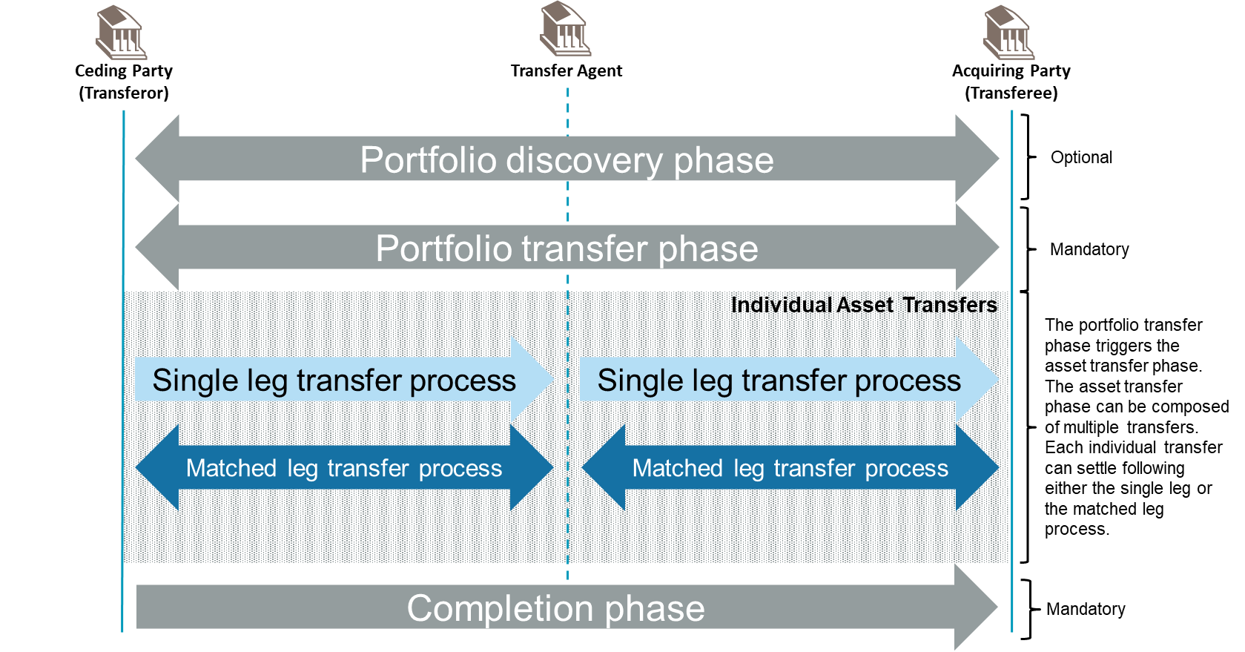

Message Sequence
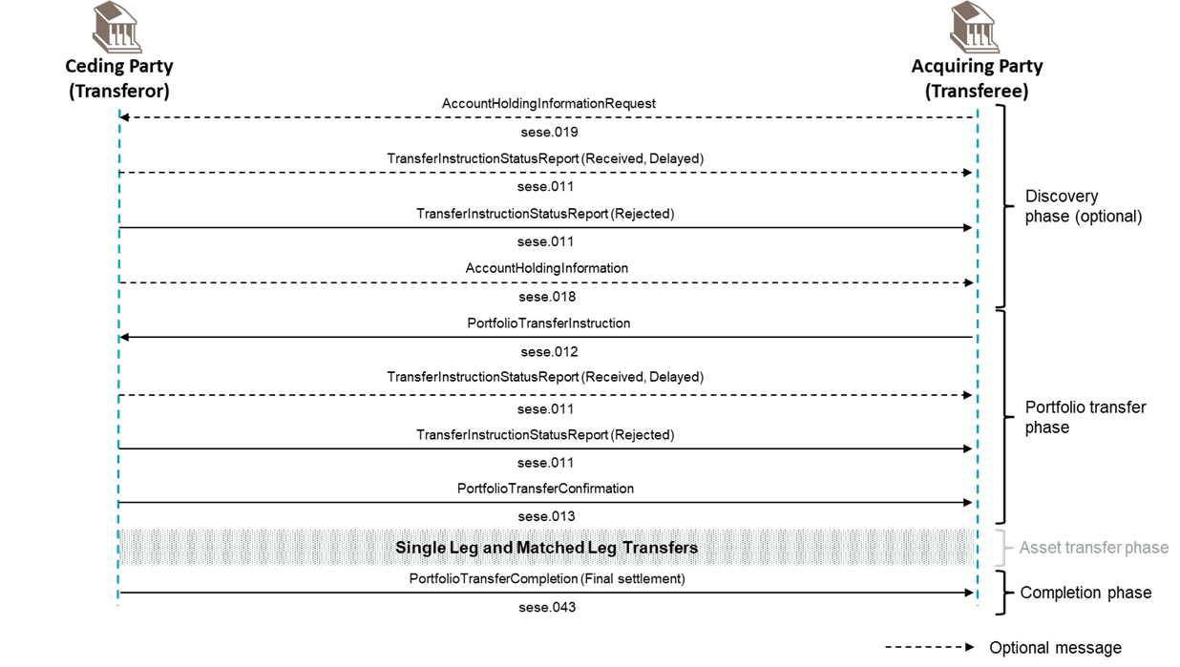

The new message will be deployed in the ISO 20022 XML syntax.
The new message will not use the ISO 20022 Business Application Header (BAH).
The proposed business area for the message is “sese”.
Based on the scope, the submitting organisation proposes to assign the Funds Evaluation Team of Securities Standards Evaluation Group(s) (SEG) for the evaluation of the candidate ISO 20022 messages, once developed.

- Purpose of the new development:
While working on the market practice for portfolio transfers, the SMPG IF realised that in the above process, the sese.011 does not have all the relevant elements needed to convey the necessary data for the useful reporting of the completion of the portfolio transfer process, and the sese.013 while adapted to the use case is already used as a portfolio transfer initiation confirmation. There are 3 potential solutions to resolve that issue:
• The misuse of the Portfolio Transfer Confirmation (sese.013);
• A change request to enlarge the definition and scope of the Transfer Instruction Status Report (sese.011) and the addition of new elements to it, which would also be a misuse of the messages;
• The creation of a new portfolio transfer completion ISO 20022 message, based on the sese.013, that allows the users to derive the message’s function from its request type.
The SEG has confirmed that the creation of a new message is the way to go for the coverage of a new use case within this message workflow.

- Community of users and benefits:
- Benefits/savings:
  - Ability to convey critical post-settlement information that is not available to day in the sese.011, e.g.,:
    - Execution date;
    - Debited account details;
    - Credited account details;
    - ISIN identification of the assets that have been transferred;
    - Quantity or percentage of the assets that have been transferred;
    - Value or currency of the assets that have been transferred.
  - Ability to derive the function of transfer completion from the message request type rather than from a code within the message payload. This can help save development time for users to integrate the message within their operational process.
- Adoption scenario: the expected impact of adopting the new messages and the expected time frame: the new message should go live by Nov. 2025
  - The UK market could migrate from the sese.011 to the new message during the Standard Release of 2025 or 2026.
  - That will allow the completion of the Portfolio Market practice which will be campaigned to the markets.
- Volumes: 105k messages/year in the UK.
- Sponsors and adopters:
- Sponsor: SMPG IF
- The following types of institutions will use the investment funds messages:
 | Estimated number of users
Fund managers | 250
Distributors / intermediaries / funds supermarkets | 14+
Transfer agents
Fund accountants
Banks | 7000
Broker dealers | 350
Insurance companies | 350
ICSDs | 2
CSDs | 90+
Custodians
Order routing platforms
Investment managers
Trustees
- The full benefits of this initiative to the financial industry will be the potential for the automation of paper based processes, straight-through processing, reduced costs, greater efficiency and an improved service to the investors.

- Timing and development:
The submitting organisation expects to have the message for the Standards Release 2025.
- Not having this message developed will prevent the finalization of the Investment Fund Portfolio Transfer market practice and perpetuate the use of the inadequate sese.011 with poor data by the UK market;
- The date when the submitting organisation is planning to have the new candidate ISO 20022 business and message models developed and ready for submission to the RA: August 2024;
- Who will the submitting organisation involve in the development: SMPG IF;
- Any other known standards initiative(s) involved in an effort to address the same requirements: No.
- Commitments of the submitting organisation:
The submitting organisation confirms that it can and will:
- undertake the development of the candidate ISO 20022 business and message models that it will submit to the RA for compliance review and evaluation. The submission must be compliant with the ISO 20022 Master Rules and include a draft Part 1 of the Message Definition Report (MDR) compliant with the template for MDR part 1 provided by the RA, the ISO 20022 Message Transport Mode (MTM) that the submitting organization recommends to consider with the submitted message set, and, optionally, examples of valid and invalid instances of each candidate message. The submission may also include a Message User Guide (MUG) to complement the MDR and describe in further details how to use the different possibilities/options of the proposed candidate messages;
- address any queries related to the description of the models and messages as published by the RA on the ISO 20022 website.
The submitting organisation confirms that:
- it will inform and consult the market on the Portfolio Transfer Pre-advice message but it does not intend to organize any testing of the candidate message once they have been reviewed and qualified by the RA and before their submission to the SEG(s) for approval.
- It is committed to undertake the future message maintenance.
The submitting organisation confirms the knowledge and acceptance of the ISO 20022 Intellectual Property Rights policy for contributing organisations, as follows:
“Organizations that contribute information to be incorporated into the ISO 20022 Repository shall keep any Intellectual Property Rights (IPR) they have on this information. A contributing organization warrants that it has sufficient rights on the contributed information to have it published in the ISO 20022 Repository through the ISO 20022 Registration Authority in accordance with the rules set in ISO 20022. To ascertain a widespread, public and uniform use of the ISO 20022 Repository information, the contributing organization grants third parties a non-exclusive, royalty-free licence to use the published information”.
- Contact persons:
- Gregory Mestdag – SWIFT Standards, mail to: gregory.mestdag@swift.com

- Comments from the RMG members and relevant SEG(s) or SubSEG(s) and disposition of comments by the submitting organisation:
This section will include the comments received from RMG members and the SEG(s) or SubSEG(s), if any, and the response given to each of these comments by the submitting organisation.

