Business Justification
for the development of new ISO 20022 API resources as ISO 20022 financial repository items)
Note: the purpose of this document is to give guidelines to organisations that want to develop new candidate ISO 20022 API resource definitions. Such requests are subject to the approval of a business justification by the ISO 20022 Registration Management Group (RMG). Please consult the iso20022.org website for additional details on the registration process. The business justification must include the following captions, as described. Business justifications are to be sent via e-mail to iso20022ra@iso20022.org

- Name of the request:
“Customer and Financial Institution Credit Transfers API Resources”

- Submitting organisation(s):
Swift (on behalf of Swift Community)
Avenue Adèle, 1
1310 La Hulpe
Belgium

- Scope of the new development:
The scope encompasses the full life-cycle of credit transfer payments transactions, from initiation though to clearing and settlement and reporting:
- Domestic and international / cross-border (including currency conversion)
- Customer and Financial Institution credit transfers
- Serial and cover methods (for cross-border)
- Batch and real-time processes
- Rejects and returns
In terms of existing ISO 20022 business areas, the scope encompasses:
- pain (payment initiation)
- pacs (payments clearing and settlement)
- …and parts of camt (cash management) relating to exception handling and payment status reporting
Actors interacting via APIs with the generic payment resource would include:
- Financial Institutions (FIs)
- Payments Market Infrastructures (PMIs)
- Payments Service Providers (PSPs)
- Businesses (from multinational corporations to SMEs and sole traders), including corporate payments factories
- Consumers – expected to be via eBanking products (apps, portals) provided by FIs or PSPs
- Value-added network service providers

Some (non-exhaustive) business examples to illustrate the scope:
[Note that in practice more than one instance of the generic credit transfer payments resource, maintained by different actors in the chain, would likely be required in the end-to-end process.]
- Corporate cross-border payment using correspondent banking:
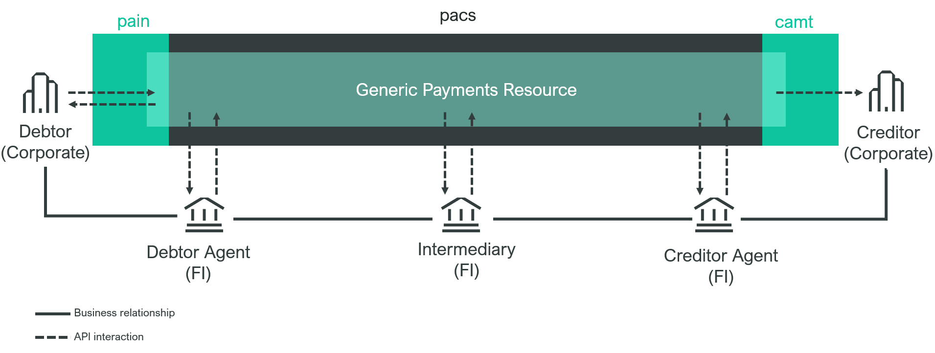

- Consumer-to-Business cross-border payment settled via correspondent banking:
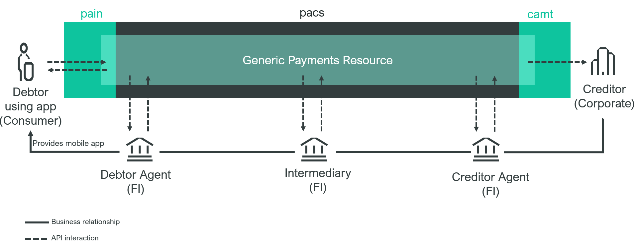
- Corporate cross-border payment settled in domestic PMI:
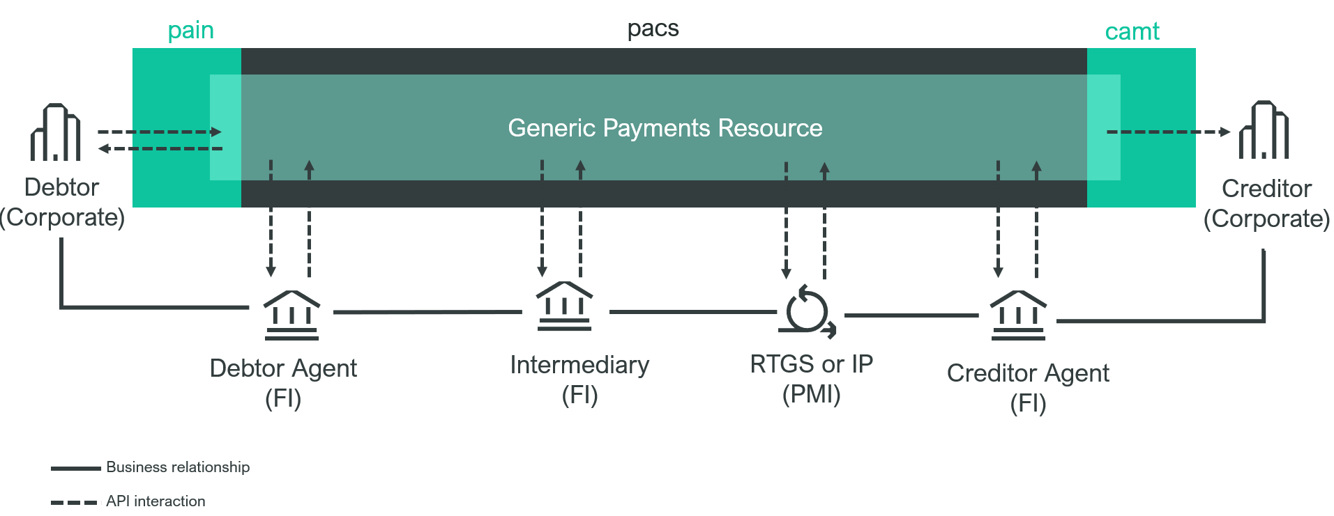

In outline, the generic payments resource would conform to a scheme similar to that shown below:

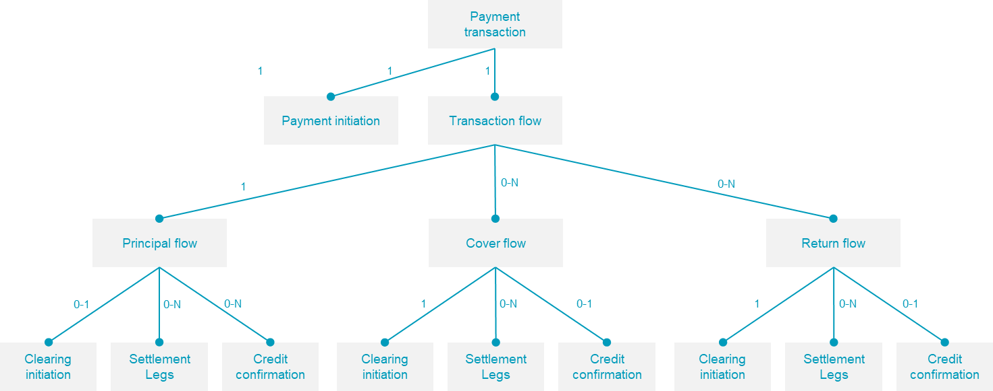

The basic transaction details (currency, principal amount, debtor, creditor, etc).are captured in Payment Initiation. Details of the principal financial institution processing are captured by Principal Flow. For cross-border payments using the ‘cover’ method, this optional process is captured in Cover flow. In case a payment has to be returned, processing details are provided in Return flow.
Each …flow element contains sub-elements for Clearing and Settlement legs, and an optional Credit confirmation element:
- The clearing element provides the details on the routing of the credit transfer through the payment chain
- The Settlement leg elements provides the details on how actual movement of the funds through the payment chain is performed
- Credit confirmation provides the details of the actual booking of the payment on the creditor’s account.

Following actors might be involved in the process:
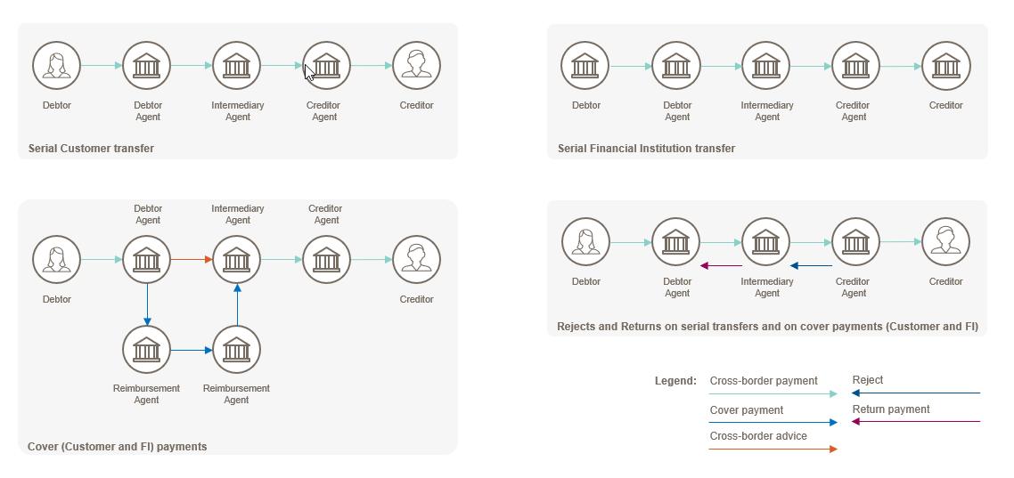
Below diagram provides an illustration of the business data evolving along the transaction lifecycle depending on the role of the agent in a serial customer credit transfer scenario:
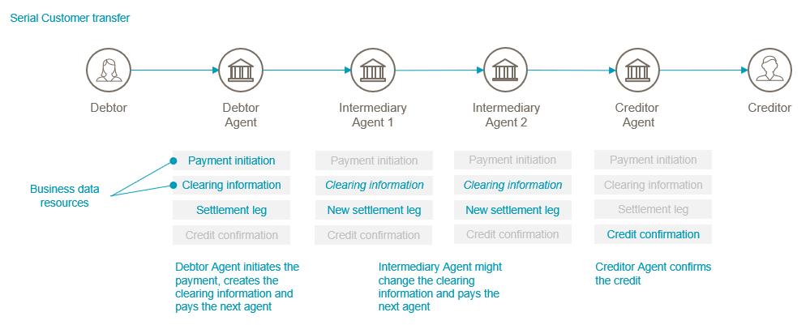

The submitting organisation sees no reason why these ISO 20022 API resources could not be used by other business domains, entities, and/or processes where a credit transfer needs to be initiated.
The submitting organisation will ensure that the repository items will be full aligned with the existing ISO 20022 message definitions (Swift is the submitting organisation of the equivalent ISO 20022 message definitions as illustrated above).
It is understood that it is not possible yet to describe all of the above mentioned items in complete detail, but the API resources will at minimum support the flows as described in the ISO 20022 message definitions documentation for the Payment Initiation and Payment Clearing and Settlement business areas and processes which have been developed previously.
The scope of the business justification is as mentioned inline with functionality of the existing ISO 20022 interbank Payments Clearing And Settlement message definitions, and hence also includes the possibility to extend the credit transfer payments to direct debit payments in the future, since the resources although different in terms of content, are very close to the resources required for credit transfer payments.
Functionalities such as, for example, support for CBDC or cryptocoins in general is out of scope for this BJ. A possible expansion to include specific APIs with such functionality would require its own business justification. Or the functionality can be added with the change request process after publication ov v1 (which would also be applied to the relevant ISO 20022 messages) – with the aim of having a consistent, universal solution. In the same vein, sanctions and monitoring related functions are also out of scope and have their own BJ as appropriate. This set of APIs aims to offer not more and not less than the equivalent functionality of (and alignment with) the comparable pain, pacs and camt messages as currently widely used for payments.

- Purpose of the new development:

Use of APIs is emerging in many steps in the payments value chain, from payment initiation to settlement and reporting. In many end-to-end payments business processes, APIs and financial messages – increasingly ISO 20022 messages – will be used together. The industry has spent many years and billions of dollars already in the effort to converge on a common messaging standard from a starting point of extreme fragmentation (and we’re not done yet).
We face creating a similar fragmentation problem in the use of APIs. Fragmentation introduces risk, cost and friction into end-to-end payments processes, without counterbalancing benefits. Use of APIs is evolving, as service providers compete to offer new products, so the industry needs a balanced approach to combat fragmentation without constraining innovation. Standardisation of a common generic API resource for payments, based on ISO 20022, promotes interoperability at the data level between the APIs and messages implemented by the multiple actors that together realize payments business processes. Benefits include ease of composing new business processes from existing services; preservation of structured data from end to end without truncation or loss of semantic precision; ease of integration with existing business processes, applications and infrastructure.

- Community of users and benefits:

- Benefits and savings:
As set out above, the benefit of standardisation of a resource for APIs in the payments domain is to avoid the frictions and inefficiencies of the fragmentation that would otherwise result as APIs proliferate.
- Adoption scenario:
As submitter, Swift undertakes to adopt the standard for payments APIs developed for its community. Although many APIs already exist in the payments space, many were developed with ISO 20022 underpinnings (e.g. UK OBIE, Berlin Group, many banks proprietary developments). Given that 1) implementations are likely to join up in new or existing business processes (e.g. domestic PMIs interlinking with one another, per CPMI recommendations, or with cross-border); 2) the adoption of ISO 20022 messaging for cross-border and the great majority of domestic payment schemes, we would anticipate gradual convergence of existing API specification with a formally registered generic payment resource model, and that new API developments would also draw on a standard resource model as the best way to achieve interoperability and as a facilitator of adoption in their target markets.
- Volumes:
As noted elsewhere, there are many payments related API initiatives in progress today, and the trend is set to accelerate. Volumes are difficult to estimate accurately, but in scope would be any payment initiated or processed using API technology.
- Sponsors and adopters:
The Swift community of 12,000+ FIs and Corporates would be candidates to adopt APIs based on the generic payment model. Swift’s Standards team also works with domestic PMIs (high-value, ACH and instant) through it’s ISO 20022 harmonization programme, and also with CPMI on its cross-border ‘building blocks’, which include ISO 20022 and API standardisation.

- Timing and development:
Swift believes that the risk of fragmentation in API specifications for payments business has already materialised, and that it is therefore urgent that the industry addresses this problem through standardisation. Swift would conduct a campaign with other interested organisations and seek input on the design during 2023, and aim to present a draft specification to the API and Payments SEGs, Q4/2023.
As part of its outreach, Swift would build on existing relationships with central banks and payment scheme operators, commercial banks, application vendors and PSPs.

- Commitments of the submitting organisation:
Swift as submitting organisation confirms that it can and will:
- undertake the development of the candidate ISO 20022 API resource models that it will submit to the RA for compliance review and evaluation. The submission must be compliant with the ISO 20022 Master Rules and include a draft Part 1 of the ISO 20022 Resource Definition Report (RDR) compliant with the template for RDR part 1 provided by the RA and, optionally, examples of valid and invalid instances of each candidate ISO 20022 API resource.
- address any queries related to the description of the models and ISO 20022 API resources as published by the RA on the ISO 20022 website.
The submitting organisation confirms that it will promptly inform the RA about any changes or more accurate information about the number of candidate ISO 20022 API resources and the timing of their submission to the RA. If the submitting organisation does not submit the candidate ISO 20022 API resources within the timing announced in section F and does not inform the RA beforehand, the business justification may lapse and require re-submission of a new business justification for approval by the RMG.
The submitting organisation confirms it does not intend to organize any testing of the candidate ISO 20022 API resources once they have been reviewed and qualified by the RA and before their submission to the SEG(s), API SEG, BMST and/or TSG for approval.
The submitting organisation confirms it is committed to undertake the future maintenance of the ISO 20022 API resources.
The submitting organisation confirms its knowledge and acceptance of the ISO 20022 Intellectual Property Rights policy for contributing organisations, as follows.
“Organizations that contribute information to be incorporated into the ISO 20022 Repository shall keep any Intellectual Property Rights (IPR) they have on this information. A contributing organization warrants that it has sufficient rights on the contributed information to have it published in the ISO 20022 Repository through the ISO 20022 Registration Authority in accordance with the rules set in ISO 20022. To ascertain a widespread, public and uniform use of the ISO 20022 Repository information, the contributing organization grants third parties a non-exclusive, royalty-free licence to use the published information”.

- Contact persons:
The submitting organisation will provide the contact details (name, e-mail address, telephone) of the person(s) at the submitting organisation that can be contacted by the RA, RMG, SEG, SubSEG, API SEG, BMST and/or TSG to get additional information on the project and/or its business justification.
Primary Contact Person:
Tom Alaerts
tom.alaerts@swift.com
Office telephone (Hong Kong time zone) +852 2107 8715
Backup Contact Person:
Neil Buchan
neil.buchan@swift.com
Office telephone (London time zone) +44 20 7762 2135

- Comments from the RMG members and relevant SEG(s) or SubSEG(s) and disposition of comments by the submitting organisation:
This section will include the comments received from RMG members and the SEG(s), SubSEG(s), API SEG, BMST and/or TSG, if any, and the response given to each of these comments by the submitting organisation.

Payments SEG comments (P. Hoogervorst):
General comment: in general standardising payment API (hence the API SEG) will be a good thing but I note that this API Business Justification is extremely broad in scope. I don’t believe it is appropriate to submit an API business justification for all payment types including future currency instruments which have not yet fully been defined, such as CBDC. Submitter should clarify the scope / be more specific, cross border examples would be better / more specific to start.
Swift Response: Although we understand that the scope might be broad and cover all payment types, we have aligned the API business justification with the scope of the BJ006 Credit Transfers business justification (covering all Payment Clearing and Settlement - pacs - credit transfer messages), to ensure that we have a consistent implementation across all payment types in the future.
Swift has already developed several APIs in the scope of the Transaction Manager, which is currently concentrating on the interbank space through a central platform to interact with the different participants.
Below you will find a list of the current defined end-points which are implementing the baseline proposed API resources as defined in this Business Justification:

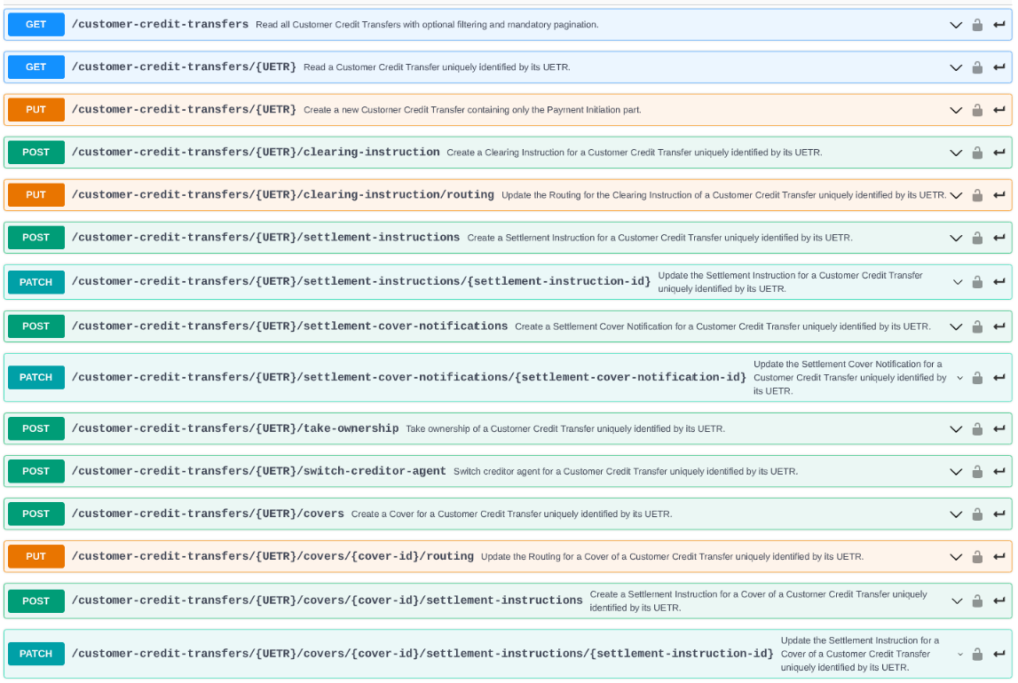
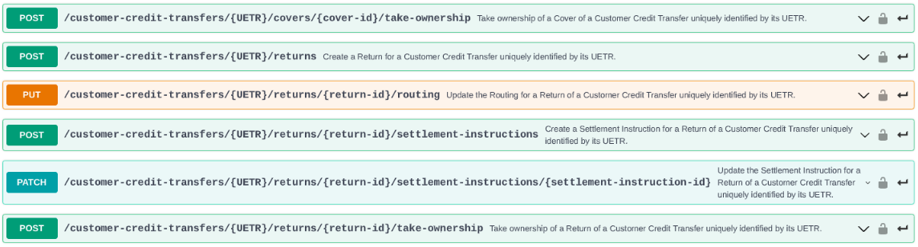
Based on the resources defined in the scope of Transaction Manager, which are closely linked to the structure of the equivalent pacs XML messages and related message components, we are confident that the current API resources will provide for a strong basis to extend the scope in the future to cover correspondent banking APIs without the Transaction Manager. The same approach was taken originally for the pacs messages, which were initially built to support the SEPA requirements, but through the input from the Payments SEG members, the layout and design of the pacs XML messages was reviewed and extended during the harmonization workshop to support all interbank messaging requirements.
Swiss comments (R. Vogelgesang):
The Swiss Association for SWIFT and Financial Standards (SASFS) is the representative organisation for financial standardisation in the financial centre of Switzerland and Liechtenstein.
The Swiss RMG delegation jointly with the SASFS payments experts have evaluated BJ 220 and the proposed development of generic Customer and Financial Institution Credit Transfers API Resources.
The SASFS fully appreciates the initiative of SWIFT to move forward the standardisation in the payments space and understands the stated motivation, first, to ensure as much as possible an alignment between ISO 20022 messages and ISO 20022 API resources and, second, to avoid further fragmentation in the API space and related unwelcome consequences.
We note that the aspiration of BJ 220 consists in developing generic API resources that cover a broad and all-encompassing spectrum of use cases that can cater for, amongst others, both domestic and international specificities, both batch and real-time contexts, all types of currency instruments including currency innovations still at an early stage of their evolutionary cycle such as CBDCs as well as the possibility to extend the foreseen credit transfer use cases to additional use cases like direct debits in the future.
We are however not convinced that this approach is sufficiently promising in order to achieve the stated objects.
Instead, we are conscious of the magnitude of this challenge. API resources to fulfil this broad range of purposes and use cases are likely to be subject to a constant stream of change requests and thus in a state of constant change. For implementers, these API resources will appear as a moving target that rarely reaches a degree of stability that one would expect in order to invest in their implementation. In proportion to the use cases targeted, the number of stakeholders to be involved will increase as well.
It should be noted that in certain business areas, especially in the customer-to-bank interface space, there are already numerous existing API implementation and market practices. These markets would have to be included in such development. Not doing so would risk that API resources are defined that may not be used for a long time or may be inadequately defined vis-à-vis the broad range of requirements of all stakeholder groups targeted.
Ensuring inclusivity for all stakeholders and existing implementers will likely constitute a challenge, in particular, in areas where SWIFT currently does not enjoy a strong presence.
For such topics, in particular CBDCs, it may make sense first to await for more clarity to become available as regards the implementation of CBDCs and related standards. For these use cases, it may be more promising an approach for SWIFT to try and enlist the support and leadership of the main stakeholders in this space in order for them to take ownership for the submission of a distinct BJ in their own name, possibly with the involvement or support of SWIFT. Such stakeholders could be amongst the ranks of central banks and/or supranational organisations such as the Bank for International Settlements (BIS).
On a formal note we acknowledge that SWIFT proposes the developments of this BJ in the name of the SWIFT community.

The SASFS also representing the Swiss SWIFT national member and user group, we are convinced that, in submitting BJ 220, SWIFT intends to act in the best interest of its community. Unless a prior well-defined process for the opinion building as regards the submission of the BJ has been organised within the SWIFT community, we would however recommend that SWIFT submits the BJ in its own name.

In the view of the inherent complexities of this very comprehensive BJ, we wonder whether SWIFT could consider as an alternative approach to submit an adjusted BJ with a focus on those business areas in which SWIFT is actively involved and for which it is known for its competency. In these areas the proposed API resources could be promptly implemented and thus immediately demonstrate their usefulness and purpose. Such areas could include cross-border interbank payments as well as interfaces to multinational corporate customers.

Considering the alternative approach of an adjusted BJ based on selected parts of the current BJ which promises more likely to attain the stated objectives of BJ 220, we feel it is not appropriate to support the comprehensive extent of BJ 220 in its current form and, therefore, reject its approval in order to afford SWIFT sufficient time and the opportunity to carefully consider the alternatives.

We look forward to the responses of SWIFT, as the submitting organisation of this BJ, to the points raised above and remain available for further considerations.

Swift Response: We are conscious that the initial set of API resources will not cover the full spectrum of all areas of the credit transfers, but our intention is to build a foundation of API resources which can be used directly in the scope of the correspondent banking space, which may be extended later to cover new domains or payments instruments. As already indicated in response to the Payments SEG comments, such API resources are ready and have already been tested in the scope of the Swift Transaction Manager.
Swift agrees also that for evolutionary items, such as the CDBCs, we need to put any developments on hold until there is clarity from a regulatory aspect, but as you mentioned, those new developments will probably not be revolutionary, and will still have to fit into the current payments landscape – therefore we believe it is important that those new developments should be considered already as part of the current submission to ensure the related API resources are evolved smoothly and not submitted as separate disruptive API resources implementing the CBDCs.
Regarding the fact that there are already numerous existing API implementation and market practices in the customer-to-bank interface space, we are fully aware of those developments and Swift is ready to accept the organisations which have developed those API implementations as co-submitting organisations. An example is the PSD2 Payment Initiation API resources, where Swift has worked closely with Berlin Group, STET and OBIE to define a common unified set of API resources for the Payment Initiation area. The API resource defined in the scope of TM for the Payment Initiation is derived as a subset from this common unified resource.
Swift believes that the whole customer credit transfer API resources ecosystem should remain within the scope of a single Business Justification to ensure that the development in those domains lead to a standardised set of API resources, which cannot be achieved with multiple and separate business justifications.
Reply from Swiss delegation (R.Vogelgesang):
We appreciate the clarifications provided by the submitting organisation including its willingness to accept, as co-submitting organisations, any organisations in the customer-to-bank interface space which have developed existing API implementations.
Due to the comprehensive scope of this BJ, it will be important to gather a competent evaluation team of subject-matter experts.
We are supportive of the direction in which this BJ is proposed to evolve.

