Business Justification
for the development of new ISO 20022 API resources as ISO 20022 financial repository items)
Note: the purpose of this document is to give guidelines to organisations that want to develop new candidate ISO 20022 API resource definitions. Such requests are subject to the approval of a business justification by the ISO 20022 Registration Management Group (RMG). Please consult the iso20022.org website for additional details on the registration process. The business justification must include the following captions, as described.

- Name of the request:
Account Validation API resources
- Submitting organisation(s):
- Swift
- European Payments Council (EPC)
- Nordic Payments Council (NPC)
Referred to as ‘submitting organisations’ in this document.
- Scope of the new development:
The proposed API resources allows users to validate an account’s existence (identity and status), ownership and type. The validation is completely independent from any payment scheme or payment initiation. The validation of the data can be done directly by a financial institution or by a third party.
The requesting entity is the data consumer which can be a Debtor Agent, a financial institution or a Debtor (e.g. a corporate validating the account number of a new supplier. The responding entity is the data provider which can be a Creditor Agent or a third party account/name check provider.
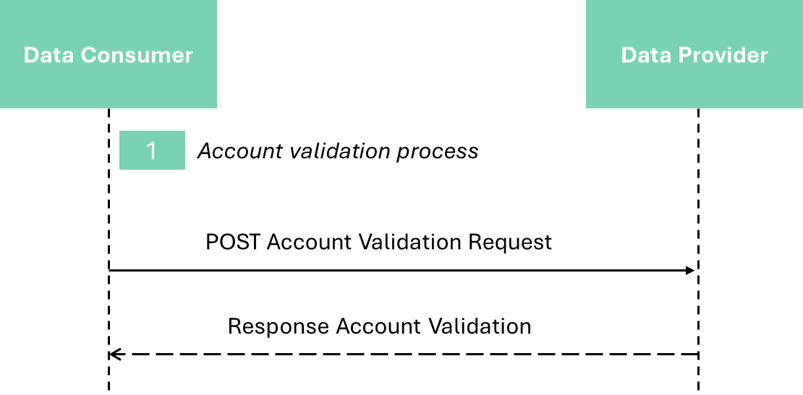

The API request and response are composed of existing ISO 20022 components (e.g., account number element). However, some data structures and codes lists are required to be created as this currently does not exist in ISO 20022.
The submitting organisations propose to re-use ISO 20022 definitions where they exist and submit new definitions (expected to be data structures and code lists) where no suitable existing ISO 20022 message component is available.
The proposed data structures and code lists could be re-used in any other business domains where an account needs to be validated.
- Purpose of the new development:
The process of validating the matching between an account and a name is an emerging requirement in many domestic markets, and for cross-border payments.
There is a risk that each scheme will develop its own proprietary API/model, leading to fragmentation that inhibits the emergence of common solutions and creates excess complexity for institutions that participate in multiple schemes.
The EPC, with the Verification Of Payee (VOP) scheme, aims to standardise a set of rules and practices to support payment service providers (PSPs) in the Single Euro Payments Area (SEPA) that will be required to comply with legal obligations on the verification of a payee in the case of credit transfers as outlined in the proposed EU Instant Payments Regulation (IPR) amending the SEPA Regulation.
This new development proposes a baseline standard model for any such scheme with the aim of reducing industry fragmentation, ensuring interoperability and encouraging the development of high quality, standard implementations benefiting the whole financial community. It will also further facilitate fraud prevention.
The submitting organizations acknowledge the existence of a Business Justification in a similar domain submitted by NACHA/Afinis (link) for account pre-validation for US ACH payments. The international and cross-border scope of the present BJ, and the support for direct debit as well as credit transfer scenarios, necessitates elements not found in the NACHA/Afinis proposal, and NACHA has expressed a preference to continue with their exiting scope. So, the submitting organizations propose that both initiatives are progressed in parallel, with the possibility of convergence at a later date.
- Community of users and benefits:
This section is critical. It will be used by the RMG to determine the business case and priority of the proposed development, independently of whether the Business Justification relates to a new Business Area, or not. Even if the benefits of the project may have already been described to some extent in the previous sections, submitting organisations are invited to repeat them here and to spend the time necessary to collect requested information for each of the captions below. If a caption cannot be completed, the submitting organisation is requested to explain why.
The justification will identify the categories of parties/actors that would use/benefit from the new message(s), and for each category of users:
- Benefits/savings:
As set out above, the benefit of standardisation of a resource for APIs in the account validation domain is to avoid the frictions and inefficiencies of the fragmentation that would otherwise result as APIs proliferate, and would facilitate the development of cross border account validations.
Adoption scenario:
A Swift API resource based on ISO 20022 is live and being used by financial institutions around the world for account verification.
The submitting organisations propose that this model forms the basis of the new standard, subject to the ISO 20022 API resource definition development and approval process.
New default standard API specifications for the VOP scheme, implementing payment account validation services, will be introduced by the EPC in the SEPA geographic area to secure compliance with the EU Instant Payments Regulation (IPR). The deadline for eurozone Payment Service Providers (PSPs) to offer verification of payee services is 18 months after the IPR entry-in-force date (mid-April 2024), thus expected to be October 2025.
- Volumes:
The cross-border Swift API is currently being used by members of the Swift community. Call volumes are of the order of millions per month. The proposed API resource could be used by any financial institution using API technology to offer added value services to their customers.
In the SEPA area, the expected volume of VOP scheme-based messages is in the range of several billions per year (the volumes of SEPA (Instant) Credits Transfer and Direct Debits in the EU-27 area reached 64 Bn transactions per year in 2022, ECB data).
- Sponsors and adopters:
The Swift community of 12,000+ FIs are candidates to adopt account validation APIs.
The EPC is developing a standardized scheme for Verification Of Payee that will apply across the SEPA area , with implementation by financial institutions expected to begin in 2025.
The EPC develops and manages pan-European payment and payment-related schemes for the SEPA geographic area. The number of EPC payment scheme participants encompasses ar. 3.900 PSPs across the 36 SEPA countries, 62% of which already support the SEPA Instant Credit Transfer (SCT Inst) scheme. As an effect of the IPR regulation introduced at EEA (European Economic Area) level, the majority of the 3.900 PSPs currently participating to the EPC payment schemes are expected to offer a payment account verification service by October 2025.
The NPC has a similar remit for a verification of payee scheme in the Nordics.
- Timing and development:
The submitting organisations would undertake to work with the ISO 20022 community to define an industry standard based on the proven cross-border model already in use. They believe it will be possible to complete the development process and submit the ISO 20022 model for review and registration by end Q2 2024.
- Commitments of the submitting organisation:
The submitting organisations confirm that it can and will:
- undertake the development of the candidate ISO 20022 API resource models that it will submit to the RA for compliance review and evaluation. The submission must be compliant with the ISO 20022 Master Rules and include a draft Part 1 of the ISO 20022 Resource Definition Report (RDR) compliant with the template for RDR part 1 provided by the RA and, optionally, examples of valid and invalid instances of each candidate ISO 20022 API resource.
- address any queries related to the description of the models and ISO 20022 API resources as published by the RA on the ISO 20022 website.
The submitting organisations confirm that it will promptly inform the RA about any changes or more accurate information about the number of candidate ISO 20022 API resources and the timing of their submission to the RA. If the submitting organisations do not submit the candidate ISO 20022 API resources within the timing announced in section F and does not inform the RA beforehand, the business justification may lapse and require re-submission of a new business justification for approval by the RMG.
The submitting organisations confirm they are committed to undertake the future maintenance of the ISO 20022 API resources.
The submitting organisations confirm their acknowledgement and acceptance of the ISO 20022 Intellectual Property Rights policy for contributing organisations, as follows.
“Organizations that contribute information to be incorporated into the ISO 20022 Repository shall keep any Intellectual Property Rights (IPR) they have on this information. A contributing organization warrants that it has sufficient rights on the contributed information to have it published in the ISO 20022 Repository through the ISO 20022 Registration Authority in accordance with the rules set in ISO 20022. To ascertain a widespread, public and uniform use of the ISO 20022 Repository information, the contributing organization grants third parties a non-exclusive, royalty-free licence to use the published information”.
- Contact persons:
The submitting organisations will provide the contact details (name, e-mail address, telephone) of the person(s) at the submitting organisation that can be contacted by the RA, RMG, SEG, SubSEG, API SEG, BMST and/or TSG to get additional information on the project and/or its business justification.
EPC Primary Contact Person: Marc Lemaire - marc.lemaire@epc-cep.eu
EPC Backup Contact Person: Dominique Allebroeck - Dominique.Allebroeck@epc-cep.eu - +32 2 737 74 96

- Comments from the RMG members and relevant SEG(s) or SubSEG(s) and disposition of comments by the submitting organisation:
This section will include the comments received from RMG members and the SEG(s), SubSEG(s), API SEG, BMST and/or TSG, if any, and the response given to each of these comments by the submitting organisation.

The EU-27 is a subset of the SEPA geographic area, which encompasses 36 countries, see https://www.europeanpaymentscouncil.eu/about-us/epc-and-sepa-process.
See https://data.ecb.europa.eu/data/datasets/PAY/dashboard. ECB data for Credit Transfer and Direct Debit include limited volumes of domestic non-SEPA schemes.

