Business Justification
for the development of new ISO 20022 financial repository items

- Name of the request:
Documentary Credit Payment Messages
- Submitting organisation(s):
Cross-Border Interbank Payment System (CIPS Co., Ltd.)
The Bund Square, 100 South Zhongshan Road,
Shanghai 200010,
China
- Scope of the new development:
This submission is related to messages on documentary credit review.
The following table outlines the financial instruments, business area and business process of this request.
Financial Instruments | Administration
Business Area | Trade Services(ts)
Business Process | Trade Services Initiation (tsin)
Business Roles
Description | Definition
Applicant | The party at whose request a transaction or service (of the documentary credit) is to be undertaken.
Issuer | Party that issues and revises the documentary credit.
Presenting Bank | The bank that presents documentary credit to the issuer for  payment.
Beneficiary | Party in whose favour the documentary credit is issued.

In order to support documentary credit review, we will submit the messages below:
- AuthorizationToPay
- The AuthorizationToPay message is sent by the applicant to the issuer to authorize the issuer to send DocumentaryCreditSettlementAdvice message.
- DocumentaryCreditSettlementAdvice
- The DocumentaryCreditSettlementAdvice message is sent by the issuer to the applicant to inform the applicant that the documentary credit has been settled.
- The DocumentaryCreditSettlementAdvice message is also sent by the presenting bank to the beneficiary to inform the beneficiary that payments have been received.
- DocumentaryCreditReimbursementOrPayment
- The DocumentaryCreditReimbursementOrPayment message is sent by the issuer to the presenting bank .

The following diagram depicts the Documentary Credit Payment message flow:

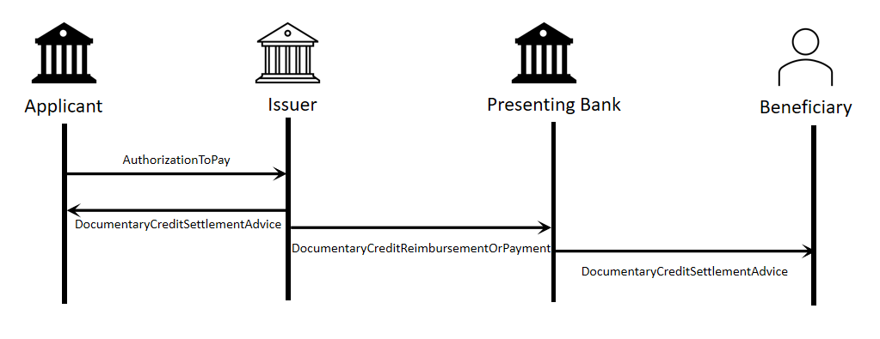 INCLUDEPICTURE "C:\\Users\\xiejc\\AppData\\Local\\Temp\\企业微信截图_16239798851980.png" \* MERGEFORMATINET INCLUDEPICTURE "C:\\Users\\xiejc\\Desktop\\AppData\\Local\\Temp\\企业微信截图_16239798851980.png" \* MERGEFORMATINET INCLUDEPICTURE "C:\\Users\\xiejc\\Desktop\\AppData\\Local\\Temp\\企业微信截图_16239798851980.png" \* MERGEFORMATINET INCLUDEPICTURE "C:\\Users\\xiejc\\Desktop\\AppData\\Local\\Temp\\企业微信截图_16239798851980.png" \* MERGEFORMATINET INCLUDEPICTURE "C:\\Users\\xiejc\\Desktop\\AppData\\Local\\Temp\\企业微信截图_16239798851980.png" \* MERGEFORMATINET INCLUDEPICTURE "C:\\Users\\xiejc\\Desktop\\AppData\\Local\\Temp\\企业微信截图_16239798851980.png" \* MERGEFORMATINET INCLUDEPICTURE "https://www.iso20022.org/sites/AppData/Local/Temp/企业微信截图_16239798851980.png" \* MERGEFORMATINET INCLUDEPICTURE "https://www.iso20022.org/sites/AppData/Local/Temp/企业微信截图_16239798851980.png" \* MERGEFORMATINET INCLUDEPICTURE "https://www.iso20022.org/sites/AppData/Local/Temp/企业微信截图_16239798851980.png" \* MERGEFORMATINET INCLUDEPICTURE "https://www.iso20022.org/sites/AppData/Local/Temp/企业微信截图_16239798851980.png" \* MERGEFORMATINET INCLUDEPICTURE "https://www.iso20022.org/sites/AppData/Local/Temp/企业微信截图_16239798851980.png" \* MERGEFORMATINET INCLUDEPICTURE "https://www.iso20022.org/sites/AppData/Local/Temp/企业微信截图_16239798851980.png" \* MERGEFORMATINET INCLUDEPICTURE "https://www.iso20022.org/sites/AppData/Local/Temp/企业微信截图_16239798851980.png" \* MERGEFORMATINET INCLUDEPICTURE "https://www.iso20022.org/sites/AppData/Local/Temp/企业微信截图_16239798851980.png" \* MERGEFORMATINET INCLUDEPICTURE "https://www.iso20022.org/sites/AppData/Local/Temp/企业微信截图_16239798851980.png" \* MERGEFORMATINET INCLUDEPICTURE "https://www.iso20022.org/sites/AppData/Local/Temp/企业微信截图_16239798851980.png" \* MERGEFORMATINET INCLUDEPICTURE "https://www.iso20022.org/sites/AppData/Local/Temp/企业微信截图_16239798851980.png" \* MERGEFORMATINET INCLUDEPICTURE "https://www.iso20022.org/sites/AppData/Local/Temp/企业微信截图_16239798851980.png" \* MERGEFORMATINET
CIPS proposes that Trade Services SEG should be assigned the evaluation of the candidate ISO 20022 messages.
CIPS supports optional use of BAH with all of the proposed messages.
CIPS intends to deploy the future messages in the ISO 20022 XML syntax.
- Purpose of the new development:
Currently, there are no relevant ISO 20022 messages that could perform the task of documentary credit payment. Developing the new messages helps to fill the existing gap and enhances the implementation of ISO 20022 in the payment of documentary credit regarding trade services. Thus, CIPS decides to pursue standardized and transparent messages to better manage the system.
Generic benefits to the industry are highlighted as follows:
- Standardize business process of documentary credit payment
- Develop ISO 20022 messages which can be implemented by market participants more easily and at a lower cost
- Ensure efficiency, accuracy and consistency of documentary credit payment
- Community of users and benefits:
These messages are designed to address market needs regarding documentary credit payment.
Benefits and savings:
- Applicants and beneficiaries: use of common nomenclature and terminology among participants by adopting a single standard will enhance the efficiency and transparency of documentary credit payment in the field of trade services.
- Issuer and presenting bank: Standardized format and business information will improve the efficiency and security of documentary credit payment.
Adoption scenario:
Documentary Credit Payment Messages were designed and successfully put into operation by CIPS in 2022. They are currently being used by CIPS participants and enterprises. After the ISO 20022 submission is approved, participants will continue to use these messages and the adoption will be further improved.
Volumes:
As of December 2022, CIPS has more than a thousand participants using CIPS system for payment and settlement. The year 2022 saw more than 4,000,000 trades processed through CIPS and the transaction value exceeded 90 trillion yuan. The growth is expected to continue with the expanding cross-border business and growing demand for cross-border transactions.
Sponsors and adopters:
The adoption is advocated and designated as mandatory by CIPS and it is already deployed to participants.
- Timing and development:
CIPS plans to complete the message development and registration process in Q3 2024.
Candidate ISO 20022 message models and Message Definition Report will be developed and submitted to the RA in Q4 2023.
- We know that there is no other standard initiative involved in an effort to submit a Business Justification relating to documentary credit payment.
After the whole process is completed, this message can better serve participants and can be used in a more unified way.
- Commitments of the submitting organisation:
CIPS confirms that it can and will:
- undertake the development of the candidate ISO 20022 business and message models that it will submit to the RA for compliance review and evaluation. The submission must be compliant with the ISO 20022 Master Rules and include a draft Part 1 of the Message Definition Report (MDR) compliant with the template for MDR part 1 provided by the RA, the ISO 20022 Message Transport Mode (MTM) that CIPS recommends to consider with the submitted message set, and examples of valid instances of each candidate message;
- address any queries related to the description of the models and messages as published by the RA on the ISO 20022 website.
CIPS confirms that it will promptly inform the RA about any changes or more accurate information about the number of candidate messages and the timing of its submission to the RA. If CIPS does not submit the candidate messages within the timing announced in section F and does not inform the RA beforehand, the business justification may lapse and require re-submission of a new business justification for approval by the RMG.
CIPS confirms that it intends to organize any testing of the candidate messages once they have been reviewed and qualified by the RA and before its submission to the SEG(s) for approval. The testing is expected to complete in September 2023 and the candidate message will be re-submitted to the RA for SEG(s) approval. CIPS confirms that it will promptly inform the RA about any changes or more accurate information about the timing of this re-submission to the RA. If CIPS does not re-submit the candidate messages as announced and does not inform the RA beforehand, the business justification may lapse and require re-submission of a new business justification for approval by the RMG.
CIPS confirms that it is committed to undertake the future message maintenance.
CIPS confirms its knowledge and acceptance of the ISO 20022 Intellectual Property Rights policy for contributing organizations, as follows.
“Organizations that contribute information to be incorporated into the ISO 20022 Repository shall keep any Intellectual Property Rights (IPR) they have on this information. A contributing organization warrants that it has sufficient rights on the contributed information to have it published in the ISO 20022 Repository through the ISO 20022 Registration Authority in accordance with the rules set in ISO 20022. To ascertain a widespread, public and uniform use of the ISO 20022 Repository information, the contributing organization grants third parties a non-exclusive, royalty-free license to use the published information”.
- Contact persons:
- JI Chenjue jicj@cips.com.cn
Staff- Standardization Department, CIPS
- Weiwei Shen sww@cips.com.cn +86 21 63120212
Assistant General Manager - Standardization Department, CIPS

