Business Justification
for the development of new ISO 20022 API resources as ISO 20022 financial repository items)
Note: the purpose of this document is to give guidelines to organisations that want to develop new candidate ISO 20022 API resource definitions. Such requests are subject to the approval of a business justification by the ISO 20022 Registration Management Group (RMG). Please consult the iso20022.org website for additional details on the registration process. The business justification must include the following captions, as described. Business justifications are to be sent via e-mail to iso20022ra@iso20022.org

- Name of the request:
"Mortgage API Resources"
- Submitting organisation(s):
Swiss Fintech Innovations
- Scope of the new development:
This registration request covers the API resources needed for the application for new mortgages and for the prolongation of existing mortgages, respectively. Possible actors are end customers requesting a mortgage, mortgage brokers which offer the service of collecting offers from different financial institutions on behalf of the end customer and financing institutions which provide the mortgage. Currently, the scope is limited to retail customers. In the future, corporate customers may be included as well.
The application for new mortgages is currently a process that comes with an excessive exchange of documents and data. The latter comprises real estate information as well as the financial status of the applicant. Standardization of the data objects containing this information is an important prerequisite for automating the mortgage process.
This also applies to the availability of suitable containers for structured documents, such as land register extracts, tax valuations, etc.
Although the specific requirements for these documents and data may vary from country to country, the possible classes of documents and data are of finite complexity.
Please note that a dedicated ISO 20022 Standards Evaluation Group (SEG) for Mortgages does not (yet) exist. Therefore, and based on the scope, SFTI as the submitting organisation proposes the API SEG and Payment SEG to evaluate the candidate ISO 20022 API resources, once SFTI has developed the candidate API resources.
The business area 'bank loan/deposit' is proposed as the corresponding business area according to the list of available business areas published here:
https://www.iso20022.org/sites/default/files/documents/D7/ISO20022_BusinessAreas.pdf
Use Case Diagrams
The following diagrams describe the basic use cases relevant in this BJ
- New Mortgage
The first use case describes how customers choose between available mortgages and order a new one. To walk through this process the customer requests a list of available mortgages, provides information about the property and the applicant, requests financing and order, and at the end decides whether and which order the customer would like to fulfill. All these steps are guided by the TPP, which asks the customer to provide the required information and transmit provided data to the mortgage administrator (e.g., bank).
The corresponding diagram provides a more detailed description of the workflow, including all API endpoints needed to provide the functionality (use case) of applying for a new mortgage. This diagram can be used to determine which endpoints need to be implemented by the TPP to provide this workflow.
- Show Mortgage and Extend
The second use case describes how to extend an existing mortgage. In this case, the customer has to select an existing mortgage, update its information, and request a prolonging offer. The TTP coordinates all requests between the customer and the mortgage administrator (e.g., bank) as follows.
The corresponding diagram provides a more detailed description of the workflow to extend the mortgage. The following diagram can be used to determine which endpoints need to be implemented by the TPP to provide this workflow.

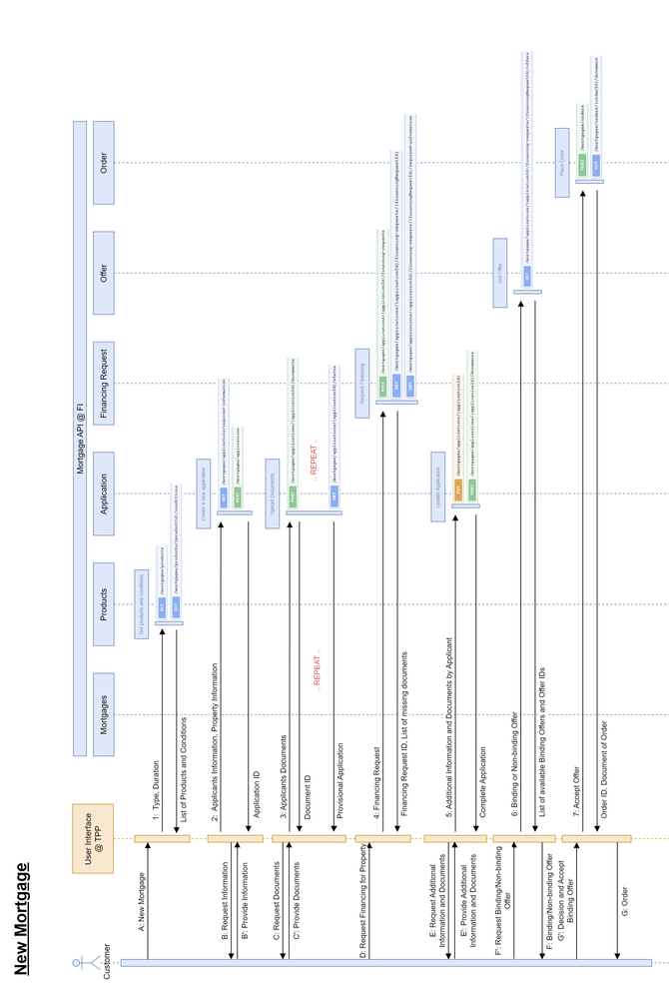
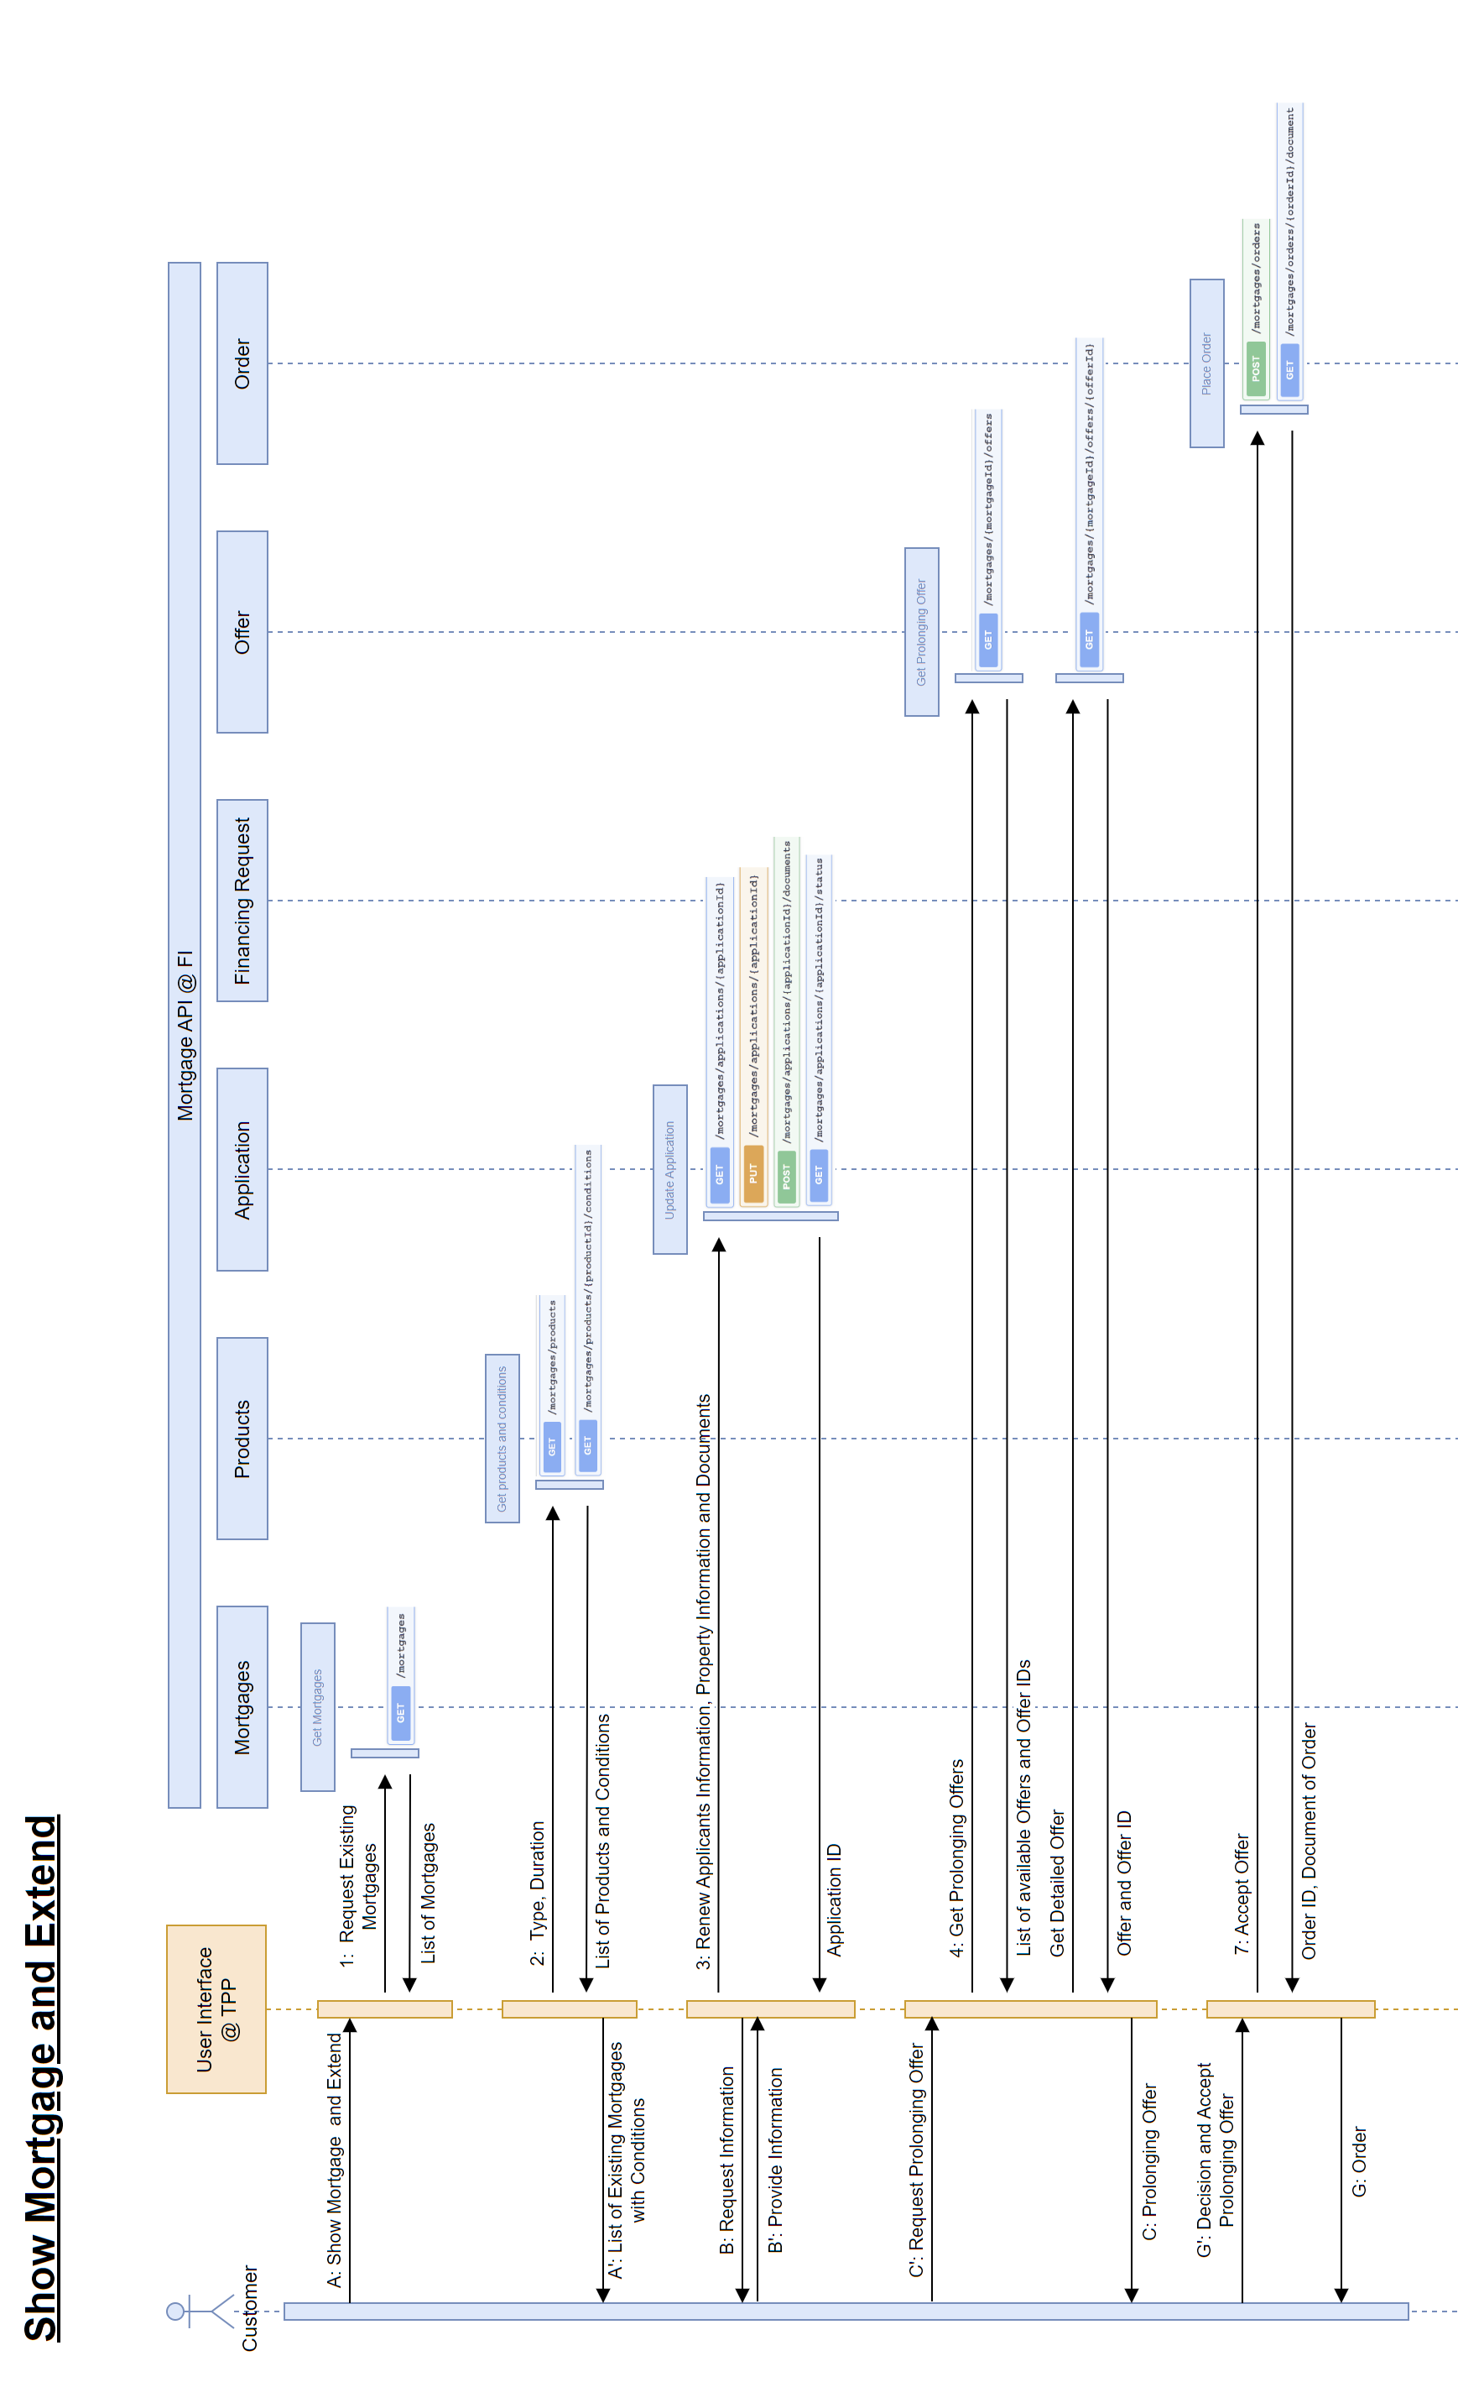
The API resources required to cover the above use cases are:

API Resource | Context description
Applicant | Applicant information needed by the FI for creating a binding offer.
Document | Document containing information for given document type for given order, e.g., value appraisal on the property for the increase of a mortgage loan.
FinancingRequest | Based on the application, several financing requests can be sent to the FI
Mortgage | All relevant information regarding a specific mortgage
MortgageCase | A complete mortgage case including the application details
Offer | All relevant details describing the FI's offer for a mortgage product
Order | All information needed to choose a specific offer and place a binding order
Party | The applicant party which may consist of one or multiple persons

- Purpose of the new development:
The management of mortgage applications from end customers (b2c) or mortgage brokers (b2b2c) is still characterized by a significant lack of digitalization: Neither the process itself nor the information to be exchanged is based on structured, machine-readable data objects.
Consequently, standardized digital interfaces for the business ues cases Application for new mortgage or Prolongation of existing mortgage do not yet exist at financial institutions. This fact leads to considerably increased processing efforts and a long processing time.
By introducing API resources that cover all relevant data in a well-defined way, significant efficiency gains can be achieved. The FI itself as well as authorized TPPs can make use of the resulting APIs to streamline their processes.

- Community of users and benefits:
- Benefits/savings
  - Mortgage providers
Banks, insurances, and other businesses offering mortgages will be enabled to process Mortgage applications with a significant higher rate of automation. Also, the data quality may be assured with much lesser efforts than nowadays. As a result, Mortgage provider may offer their services to a higher number of applicants without having to extend the existing internal resources. By also being faster, the customer’s expectation of speedy processing can be met.
  - Mortgage brokers
The services of Mortgage brokers will also experience a significant acceleration. From an end customer perspective, this makes it more attractive to work with mortgage brokers who implement said API resources. This also improves the match of customer profiles with the FI's risk profile.
  - other TPPs
Software vendors offering white-label solutions for FIs to manage the mortgage process can offer their products at a more attractive cost, as their internal development effort for the interface to the FI is significantly reduced. The operational effort for their solutions is also reduced.
- Furthermore, the use of standards is always associated with a gain in quality for the whole process.
- Adoption scenario
  - Mortgage providers
Adopting the new ISO 20022 API resources at the Mortgage provider side will result in a streamlined IT architecture.
The implementation process can be done sequentially and should be on the order of a few man-months, depending on which of the existing artifacts can be adopted.
  - Mortgage brokers
Making use of the new ISO 20022 API resources at the Mortgage broker side will make it obsolete to deal with a plethora of proprietary interfaces at the Mortgage provider side.
  - other TPPs
Similar to Mortgage broker.
The first end-to-end implementations are already available, with one of the largest banks in Switzerland among the early adopters on the banking side. On the TPP side, MoneyPark as the largest FinTech in this field of business is the first consumer of the Mortgage API. brokermarket.ch. another large start-up has started implementation and other TPPs wave shown interest too.
TheAPI spec is available at:
https://github.com/swissfintechinnovations/ca-mortgage
The Use Case documentation is available at:
https://c-a-p-s.atlassian.net/wiki/spaces/PUB/pages/1443790849/3.+Mortgages+API
- Volumes
  - Mortgage providers
The potential number of implementers of the proposed ISO 20022 API resources is determined by the number of FIs offering Mortgages.
As the benefits of those APIs for API consumers already arise when a small number of participants implement them, the targeted ‘critical mass’ is in the mid-single digits.
  - Mortgage brokers
Same as Mortgage provider.
  - other TPPs
Same as Mortgage provider.
- Sponsors and adopters
  - Swiss Fintech Innovations (SFTI)
SFTI is the leading branch organisation for the Swiss financial sector with dedicated focus on innovation and Open Finance. Our member companies cover around 75% of the balance sheet volume of Swiss banks and a significant proportion of insurers. Our members include, for example, UBS, Credit Suisse, Raiffeisen, Postfinance, AXA, SwissLife and Zurich.
The Mortgage API was jointly developed by FIs and TPPs, which not necessarily had to be SFTI members. Currently, the API is implemented at the second largest bank and at a large regional bank, with others to follow at the FI side. Regarding TPPs, the largest Mortgage broker already makes use of this API, another important FinTech has started implementation and the largest price comparison provider has also signalized interest to join.
More than 100,000 mortgage loans are concluded in Switzerland every year. In addition, the state pension scheme promotes home ownership (2nd pillar of Swiss retirement pension system). The processes involved are therefore particularly important for the Swiss market.

  - Mortgage providers
On the mortgage provider side, first implementations started shortly after SFTI published the API recommendation. So, it may be expected that the same will happen on other markets as well.
  - Mortgage brokers
Same as Mortgage provider.
  - other TPPs
No empirical values are available here yet. However, it can be assumed that the TPPs will also adapt existing interfaces to the proposed standard sooner or later.

- Timing and development:
The API that implements the resources described above is already developed and in use by first Swiss banks and TPPs. A change management process is in place. The API specification is available on GitHub for the general public: https://github.com/swissfintechinnovations/ca-mortgage. Adjustments or additions that become necessary during the registration process can be made on this platform.

- Commitments of the submitting organisation:
SFTI as submitting organisation confirms that it can and will:
- undertake the development of the candidate ISO 20022 API resource models that it will submit to the RA for compliance review and evaluation. The submission must be compliant with the ISO 20022 Master Rules and include a draft Part 1 of the ISO 20022 Resource Definition Report (RDR) compliant with the template for RDR part 1 provided by the RA and, optionally, examples of valid and invalid instances of each candidate ISO 20022 API resource.
- address any queries related to the description of the models and ISO 20022 API resources as published by the RA on the ISO 20022 website.
SFTI as submitting organisation confirms that it will promptly inform the RA about any changes or more accurate information about the number of candidate ISO 20022 API resources and the timing of their submission to the RA. If the submitting organisation does not submit the candidate ISO 20022 API resources within the timing announced in section F and does not inform the RA beforehand, the business justification may lapse and require re-submission of a new business justification for approval by the RMG.
SFTI as submitting organisation confirms to best possibly intend to organize any testing of the candidate ISO 20022 API resources once they have been reviewed and qualified by the RA and before their submission to the SEG(s), API SEG, BMST and/or TSG for approval. These tests are performed with the same means used for internal pre-testing during development, i.e., no additional procedures are introduced. SFTI as the submitting organisation will indicate when the testing is expected to complete, and the candidate ISO 20022 API resources be re-submitted to the RA for SEG(s) approval in a timely manner.
SFTI as submitting organisation confirms that it will promptly inform the RA about any changes or more accurate information about the timing of this re-submission to the RA. If SFTI does not re-submit the candidate ISO 20022 API Resources as announced and does not inform the RA beforehand, the business justification may lapse and require re-submission of a new business justification for approval by the RMG.
SFTI as submitting organisation confirms that it is committed to undertake the future maintenance of the ISO 20022 API resources.
SFTI as submitting organisation confirms its knowledge and acceptance of the ISO 20022 Intellectual Property Rights policy for contributing organisations, as follows.
“Organizations that contribute information to be incorporated into the ISO 20022 Repository shall keep any Intellectual Property Rights (IPR) they have on this information. A contributing organization warrants that it has sufficient rights on the contributed information to have it published in the ISO 20022 Repository through the ISO 20022 Registration Authority in accordance with the rules set in ISO 20022. To ascertain a widespread, public and uniform use of the ISO 20022 Repository information, the contributing organization grants third parties a non-exclusive, royalty-free licence to use the published information”.

- Contact persons:
Jürgen Petry, juergen.petry@swissfintechinnovations.ch, +41 76 575 21 21
- Comments from the RMG members and relevant SEG(s) or SubSEG(s) and disposition of comments by the submitting organisation:
Comments from the Swiss delegation:
Submitter of comments: Rainer Vogelgesang (rainer.vogelgesang@six-group.com)
Date: 27 June 2023
Commentary:
The Swiss Association for SWIFT and Financial Standards (SASFS) is the representative organisation for financial standardisation in the financial centre of Switzerland and Liechtenstein.
The SASFS has reviewed BJ 223 with the support of the SASFS subject-matter experts in the ‘mortgage business’ domain.
As a result, Switzerland supports BJ 223 ‘Mortgage API Resources’ and agrees to the development and definition of the proposed ISO 20022 API resources. As the APIs, that will be able to make use of the proposed ISO 20022 API resources, are already implemented amongst various Swiss banks, our community can demonstrate a confirmed proof-of-concept for the proposed standardisation initiative.
We look forward to the next stages of development and evaluation of the proposed API resources and remain available for further considerations.

Here it is about the transmission of files as a whole (e.g., real estate exposé, wage statement, ...), and for this purpose suitable container formats are needed.
The 2nd pillar is the occupational pension plan in Switzerland.

