Business Justification
for the development of new ISO 20022 financial repository items
Note: the purpose of this document is to give guidelines to organisations that want to develop new candidate ISO 20022 message definitions. Such requests are subject to the approval of a business justification by the ISO 20022 Registration Management Group (RMG). Please consult the iso20022.org website for additional details on the registration process. The business justification must include the following captions, as described. Business justifications are to be sent via e-mail to iso20022ra@iso20022.org

- Name of the request:
E-invoice Presentment and Payment (EIPP) Services
- Submitting organisation(s):
The submitting organisation is European Payments Council (EPC), Cours Saint-Michel 30A, B-1040 Brussels, Belgium
The EPC submits this document on behalf of the EPC Multi-stakeholder Group on E-invoice Presentment and Payments (EIPP MSG). The organisations represented in the EIPP MSG as members are:
- EPC (European Payments Council)
- EESPA (European E-invoicing Service Providers Association)
- EACT (European Association of Corporate Treasurers)
- EuroCommerce (association representing the retail, wholesale and international trade sector in Europe)
- EcommerceEurope (association representing companies selling goods and/or services online to consumers in Europe)
The following organisations are represented as observers in the EIPP MSG: Eurosystem (Banque de France, Eesti Pank, Bundesbank and the ECB’s Euro Retail Payments Board – ERPB) and SWIFT.
Contact person: Valentin Vlad (secretariat@epc-cep.eu), secretary of the EIPP MSG.

- Scope of the new development:
- Background
In 2018 the EPC Multi-stakeholder Group on E-invoice Presentment and Payment (EIPP MSG), mandated by the ERPB, worked on the development of the technical elements required to build a pan-European and interoperable eco-system for E-invoice Presentment and Payment (EIPP). The outcome of this work has been presented in the report released by the ERPB in November 2018:
(2018 Report from the EIPP Multi-Stakeholder Group). The first deliverable of the Group was the update of the existing ISO 20022 pain.013 and pain.014 to respond to the EIPP requirements for Request-To-Pay (RTP). The corresponding CRs have been approved and were published in February 2019.

- Scope
The current request for new development covers the second part of the EIPP functional design delivered by the EIPP MSG, i.e. the “servicing messages”. These messages enable:
- Payees to register in EIPP eco-system (enrolment messages)
- Payers to send requests to Payees to activate EIPP service (activation messages).
- Complementary unenrolment, amendment, deactivation and responses to the abovementioned messages should also be created.
- The Creditor/Payee enrolment messages
The purpose of these messages is to inform the EIPP Solution Providers in the eco-system that a new Payee has been registered. The Enrolment request message is sent by the Payee EIPP Providers to the EIPP Directory Providers.
The information flows of enrolment request messages and related /amendment/cancellation messages and their response status messages can be depicted as follows:
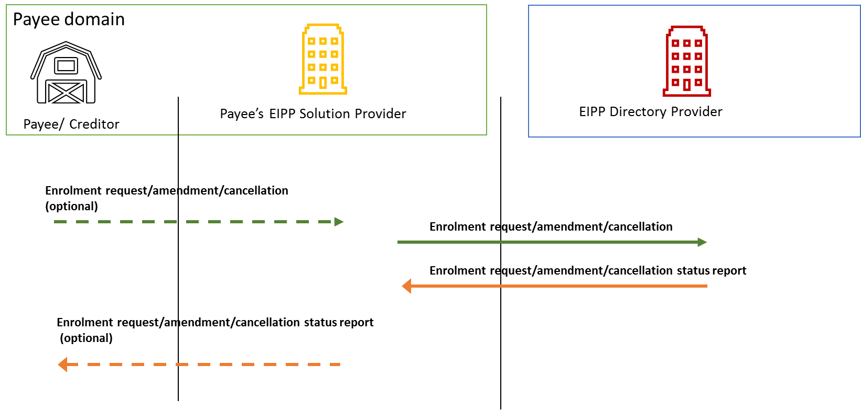
- The Debtor/Payer service activation messages
The purpose of this message is to establish a link between a Payer and a Payee so that the Payer, at its initiative, can request to the Payee the activation of the EIPP service via the electronic channels provided by its EIPP Provider, expressing in this way its consent to receive E-invoices and Requests-to-pay from this Payee.
The information flows of Activation request messages and amendment/cancellation messages and their response status messages can be depicted as follows:
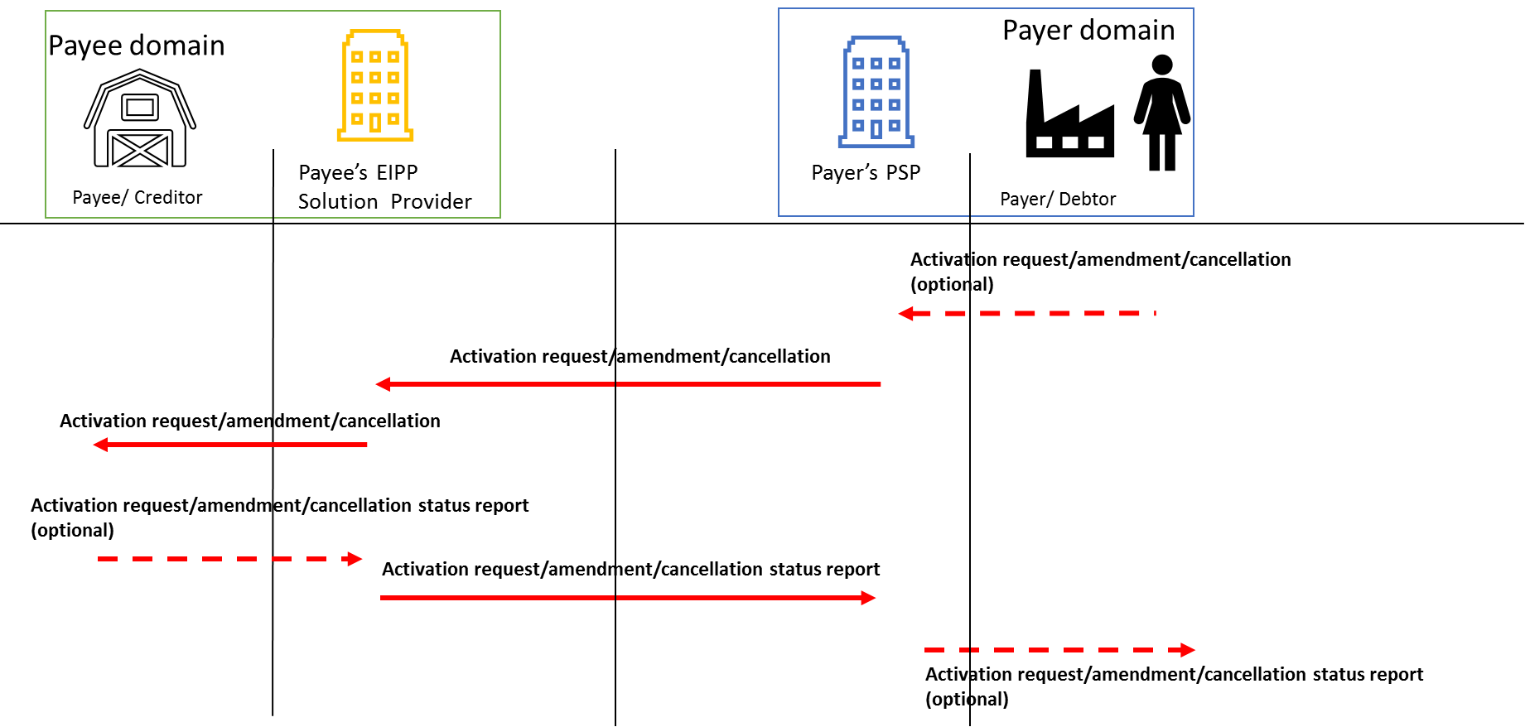

Based on this scope the EPC proposes that the candidate ISO 20022 messages should be assigned to Payments SEG for evaluation.
The use of ISO 20022 Business Application Header (BAH) could be considered for the requested messages in the further design stages, provided that it doesn’t hinder the proper implementation of the required functions.
The future messages should be deployed in the ISO 20022 XML syntax.
- Purpose of the new development:
The ERPB and the EPC strategy has been since 2016 to promote the development of a pan-European eco-system enabling the smooth transmission and payment of e-invoices (EIPP services). The submission of Change Requests to ISO 20022 for adapting the pain.013 and pain.014 for EIPP is included in this strategy. Therefore, these messages were enriched to support the inclusion of e-invoices as attachments and to provide support for other payment conditions.
Nevertheless, currently there are no interoperable solutions for the Payees/Creditors to inform their customers that the EIPP service is available so that the Payers/Debtors can request, receive Requests-to-pay (RTP) and pay related e-invoices. Also, there are no interoperable solutions for the Payers/Debtors to submit requests to their suppliers for receiving RTPs and invoices electronically for payment by customer Credit Transfer. Where similar solutions exist, they have only domestic coverage and are not interoperable.
Without a complete set of messages, as described in the section C, the use of the RTP functionality in an interoperable context would be very limited, and the Payees and Payers would need to undertake not standardised and automated actions such as:
- The Payees would need to inform through other channels their participation to the EIPP eco-system
- The Payers should communicate their identity and give their consent through other channels than the EIPP eco-system
By making use of the proposed set of “servicing messages” the EIPP Solution Providers would overcome these obstacles. Along with the RTP set of messages (pain.013 and pain.014) the development of the Enrolment and Activation servicing messages would allow:
- The Payees to inform in a standardised way all the EIPP eco-system that they support the EIPP service.
- The Payees to manage changes of their identity and other relevant information for EIPP services within the EIPP eco-system.
- The Payers to identify a Payee and its capability to propose the EIPP service, regardless of the Payee’s localisation, in the same country or cross-border. By making use of the Activation message the Payers will also have a secure tool to express their consent to receive RTPs and related e-invoices and to pay them by customer Credit Transfer from a particular Payee.
- The Payees to have a harmonised Straight Through Processing (STP) functionality for checking Payers data and register the activations in their own systems and databases.
- Community of users and benefits:
Benefits and savings for the parties:
The “servicing messages” would bring the following benefits to the parties in the EIPP eco-systems:
- If the Enrolment messages are implemented, the individual B2C customers (Payers) can look up into EIPP Directories for a Payee’s identity and its capability to propose the EIPP service. This lookup service can be included in the Payer’s EIPP Provider (e.g. PSPs) electronic interface (e-banking GUIs). The B2B customers can also check their provider data into EIPP Directory providers through GUIs or using APIs that could be published by these Directory providers.
- The Payees can benefit from the implementation of the Enrolment messages to inform their customer base about their details including their identity and that they support the RTP functionality.
- The Payees can use other methods to submit this information to EIPP Providers but these providers, after validation, must use the Enrolment message to update the records in the EIPP Directory Providers.
- The implementation of the Activation messages would provide the Payers with a secure tool for sending their consent to receive e-invoices from the Payees and to pay them by customer Credit Transfer. This function can be included in the Payer’s EIPP Provider (e.g. PSP) electronic interface (e-banking). The B2B customers may find useful to use file-based Activation messages sent directly through remote banking or EIPP provider interfaces.
- On the Payer side EIPP Provider (e.g. PSPs) can benefit from the Activation messages to enrich their EIPP solution with an easy way to initiate or stop these services by the end-users.
- On the Payee side the PSPs and E-invoicing solution providers can benefit from the Enrolment messages to enrich their EIPP solution with one single message to publish/enrol the Payees in EIPP directories. By standardised automatic processing of Activation messages, the Payees can control and quickly respond to the requests from their customers to start sending RTPs and e-invoices.
Adoption scenario:
The availability of the ISO messages will be the first step for implementing a pan-European EIPP eco-system. Once the messages will be available, activity will proceed on defining a common EIPP framework consisting of harmonised processes and service agreements at pan-European level, and implement the servicing messages by the EIPP participants.
The expected adoption time-frame consists in the following milestones on the roadmap for a pan-European EIPP service:
- ERPB assessment whether to start working on the creation of an EIPP framework, following the conclusions of the EIPP MSG report of November 2019
- In parallel, as of 2020 interested providers will start the implementation of EIPP requirements related to EIPP messages infrastructure and EIPP Directories while waiting for the registration of the new ISO 20022 servicing messages

Expected volumes:
Based on Eurostat figures, there are 27 million companies in EU. Considering that a pan-European EIPP eco-system would be of the interest of a large majority of companies, the EIPP MSG estimates a potential volume of 22 million companies that could use the Enrolment function and associate servicing message.
On the Payer side, out of the whole EU population, the EIPP MSG considers that potentially 50%, or about 200 million could use EIPP services. It is very likely that a household or person have contracts with more than one supplier. Therefore, estimating an average of 3 suppliers per Payer the EIPP MSG considers that up to 600 million activations and associate servicing message could be expected.
Millions of activations and corresponding responses would also come from the B2B usage of this service where multilateral relations with suppliers is more relevant than in B2C. Additional enrolments and corresponding responses are expected from the B2B segment as companies usually have several bank accounts.
These volumes represent a service “startup” that could be spread over few years. Even though once these initial enrolments and activations are done, fewer messages are expected, the number of amendments is expected to grow to reach a regular number after few years. Similar with volumes of bank account switching, and to the number of creations, termination and merging of companies, the volumes of amendment messages are expected to reach a magnitude of millions per year.
Sponsors and adopters
Based on the work performed by the EIPP MSG over the last 2 years and on the consultations performed among the existing EIPP Solution Providers and the public consultation conducted by the EPC in June-July 2019, the following communities have been identified as potential adopters and sponsors:
- Payment Service Providers (PSPs) – represented by the EPC
- E-invoicing Solution Providers – represented by the EESPA
- Retailers – represented by Eurocommerce
- Online merchants – represented by Ecommerce Europe
- National treasury and finance professional associations in Europe – represented by EACT
- Timing and development:
The EIPP MSG considers that the new set of candidate ISO 20022 messages for EIPP servicing messages should be submitted to the RA by Q4 2019.

- Commitments of the submitting organisation:
The EPC confirms that it will undertake the development of the candidate ISO 20022 business and message models and will submit them to the RA for compliance review and evaluation.
The EPC will address any queries related to the description of the models and messages as published by the RA on the ISO 20022 website.
The EPC confirms that it will promptly inform the RA about any changes or more accurate information about the number of candidate messages and the timing of their submission to the RA.
The EPC doesn’t intend to organize any testing of the candidate messages once they have been reviewed and qualified by the RA and before their submission to the SEG(s) for approval.
The EPC confirms that it is committed to undertake the future message maintenance.
For the all above mentioned tasks the EPC may involve in this development the resources (human resources, tools, documentation) from organisations members of the EPC or other organisations upon decision of the EPC Board.
The EPC confirms its knowledge and acceptance of the ISO 20022 Intellectual Property Rights policy for contributing organisations, as follows.
“Organizations that contribute information to be incorporated into the ISO 20022 Repository shall keep any Intellectual Property Rights (IPR) they have on this information. A contributing organization warrants that it has sufficient rights on the contributed information to have it published in the ISO 20022 Repository through the ISO 20022 Registration Authority in accordance with the rules set in ISO 20022. To ascertain a widespread, public and uniform use of the ISO 20022 Repository information, the contributing organization grants third parties a non-exclusive, royalty-free license to use the published information”.

- Contact persons:
Valentin Vlad
Email:
secretariat@epc-cep.eu
Phone: +32 (0) 2 733 35 33
- Comments from the RMG members and relevant SEG(s) or SubSEG(s) and disposition of comments by the submitting organisation:
Note from the RA (20.08.2020)
The Payments SEG – during their review of the messages – requested to
make the definition more generic by removing the term EIPP from the definition. The SEG believed the term is specific to the EPC scheme. This will enhance future re-usability by other market infrastructures
It was decided to keep the RTP – Request to Pay concept instead (EIPP will be a subset of this scheme). The SEG accepted this proposal.

1The Euro Retail Payments Board (ERPB) is a high-level strategic body set up by the European Central Bank (ECB) tasked with fostering the integration, innovation and competitiveness of euro retail payments in the European Union. It is chaired by a high-level representative of the ECB and comprises members from the supply side of the market such as PSPs, from the demand side (representatives of retailers, consumers, corporates, public administrations), from national central banks, and European Commission as an observer.
2018 Report from the EIPP Multi-Stakeholder Group

