ISO 20022

[<Name of resource set (as per Business Justification>]

Resource Definition Report Part 1

[<For evaluation by the <name of the SEG> SEG >]

<This document provides information about the use of the candidate resources for <Name of resource set> and includes, for example, business transactions and examples.>

<Publication date>

Table of Contents

Table of Contents 2

1 Introduction 5

1.1 Terms and Definitions 5

1.2 Abbreviations and Acronyms 5

1.3 Document Scope and Objectives 6

1.4 References 7

2 Scope and Functionality 8

2.1 Background 8

2.2 Scope 8

2.3 Groups of ResourceDefinitions and Functionality 8

3 BusinessRoles and Participants 9

3.1 Participants and BusinessRoles Definitions 9

3.2 BusinessRoles and Participants Table 9

4 BusinessProcess Description 10

5 Description of BusinessActivities 12

5.1 Business Activity 1 12

6 BusinessTransactions 14

6.1 Business Transaction 1 15

7 Business Examples 16

7.1 Account Management 16

8 Revision Record 17

Preliminary Note

The Resource Definition Report (RDR) is made out of three parts:

RDR Part 1

This describes the contextual background required to understand the functionality of the proposed resource set. Part 1 is produced by the submitting organization that developed or maintained the resource set in line with an RDR Part 1 template provided by the ISO 20022 Registration Authority (RA) on [www.iso20022.org](http://www.iso20022.org).

RDR Part 2

This is the detailed description of each resource definition of the resource set. Part 2 is produced by the RA using the model developed by the submitting organization.

RDR Part 3

This is an extract if the ISO 20022 Business Model describing the business concepts used in the resource set. Part 2 is an Excel document produced by the RA.

# Introduction

## Terms and Definitions

The following terms are reserved words defined in ISO 20022 Edition 2013 – Part1. When used in this document, the UpperCamelCase notation is followed.

| Term | Definition |
| --- | --- |
| BusinessRole | Functional role played by a business actor in a particular BusinessProcess or BusinessTransaction. |
| Participant | Involvement of a BusinessRole in a BusinessTransaction. |
| BusinessProcess | Definition of the business activities undertaken by BusinessRoles within a BusinessArea whereby each BusinessProcess fulfils one type of business activity and whereby a BusinessProcess may include and extend other BusinessProcesses. |
| BusinessTransaction | Particular solution that meets the communication requirements and the interaction requirements of a particular BusinessProcess and BusinessArea. |
| ResourceDefinition | Formal description of the structure of a resource instance. |

1. When a ResourceDefinition or resource identifier is specified, it should include the variant and version number. However, in this document (except in the business examples section, if present), variant and version numbers are not included. In order to know the correct variant and version number for a ResourceDefinition, the related Resource Definition Report Part 2 document should be consulted.

## Design principles

Modelling Push notifications

Service providers may use so-called **push notifications** to notify customers when something has changed (e.g. an update, a new transaction, etc…). This is to avoid that the customer must continuously request or poll the service provider for news. Instead, the service provider pushes this information as soon as there is a change, not waiting for the customer to request it (which is called a pull).

In a BusinessTransaction, this can be modelled as a single request (GET) from the customer with a (deferred) response, or pragmatically as a POST from the service provider each time there is an update.

## Abbreviations and Acronyms

The following is a list of abbreviations and acronyms used in the document.

Make sure all abbreviations in this document are listed here.

| Abbreviation/Acronyms | Definition |
| --- | --- |
| ACK | Acknowledgement |
| ACH | Automated Clearing House |
| AML | Anti-Money Laundering |
| BIC | Business Identifier Code |
| B/D | Broker/Dealer |
| XML | eXtensible Mark-up Language |
|  |  |

## Document Scope and Objectives

This document is the first part of the <Name of resource set> Resource Definition Report (RDR) that describes the Scope, the BusinessProcesses, the BusinessActivities, the BusinessTransactions for the underlying resource set. For the sake of completeness, the document may also describe BusinessActivities that are not in the scope of the business processes covered in this document.

This chapter describes the following:

* the BusinessProcess scope
* the BusinessRoles involved in these BusinessProcesses

The main objectives of this document are as follows:

* to provide information about the resources that support the business processes
* to explain the BusinessProcesses and BusinessActivities these resources have addressed
* to give a high level description of BusinessProcesses and the associated BusinessRoles
* to document the BusinessTransactions
* to provide business examples

The resources definitions are specified in Resource Definition Report Part 2.

## References

Insert here references to relevant documents such as the Business Justification

| Document | Version | Date | Author |
| --- | --- | --- | --- |
|  |  |  |  |
|  |  |  |  |

# Scope and Functionality

## Background

This Resource Definition Report covers a set of <Number of resource definitions> candidate ResourceDefinitions developed by <Name of the submitting organization> in close collaboration with <xxxxxx> and submitted for the approval of the <Name of the SEG> Standards Evaluation Group (SEG) on <Date of approval>. These candidate resources are specifically designed to support <xxxx>.

## Scope

As described in the ISO 20022 Business Justification, the scope covers the following communication flows:

Diagram, if you have one

## Groups of ResourceDefinitions and Functionality

Insert here the name of the ResourceComponent

Example: TradeLegNotification5

Some introductory text (style is ‘normal’)

### Groups

#### Account Management

Some introductory text if appropriate (style is ‘normal’)

| ResourceDefinition | Resource Identifier |
| --- | --- |
| TradeLegNotification |  |

### Functionality

See Resource Definition Report Part 2 for the resource and formats.

### Related Resources

Other ISO resources are also used in the context of <xxxx xxxx> and may be referred to in this document.

| ResourceDefinition | Resource Identifier |
| --- | --- |
|  |  |

Any resources from other submissions that may be relevant

# BusinessRoles and Participants

A BusinessRole represents an entity (or a class of entities) of the real world, physical or legal, a person, a group of persons, a corporation. Examples of BusinessRoles: “Financial Institution”, “Automated Clearing House”, “Central Securities Depository”.

A Participant is a functional role performed by a BusinessRole in a particular BusinessProcess or BusinessTransaction. Examples of Participants: the “user” of a system, “debtor”, “creditor”, “investor”.

The relationship between BusinessRoles and Participants is many-to-many. One BusinessRole can be involved as different Participants at different moments in time or at the same time. Examples of BusinessRoles: "user", "debtor”, "creditor", "investor". Different BusinessRoles can be involved as the same Participant.

In the context of <xxxxxx> the high-level BusinessRoles and typical Participants can be represented as follows:

* DIAGRAM (style) is ‘graphic’ – this is simply to centre the diagram and add space top and bottom

## Participants and BusinessRoles Definitions

Participants

Retrieve the BusinessRoles and Participants from the related Business Justification

| Description | Definition |
| --- | --- |
| Account Servicer | Party that manages the account |
| Account Owner | Party that owns the account |
|  |  |

Business Roles

| Description | Definition |
| --- | --- |
| Custodian | Party that safekeeps |
| CSD | Infrastructure that holds |

## BusinessRoles and Participants Table

| BusinessRole | Participant  Account Servicer | Participant  Account Owner |
| --- | --- | --- |
| Custodian | X | X |
| CSD | X | X |
| Market Data Provider | X |  |
| Institutional Investor |  | X |

# BusinessProcess Description

The BusinessRoles are modelled as actors in PlantUML and must be defined in the repository

This diagram represents the high level BusinessProcesses.

* DIAGRAM –

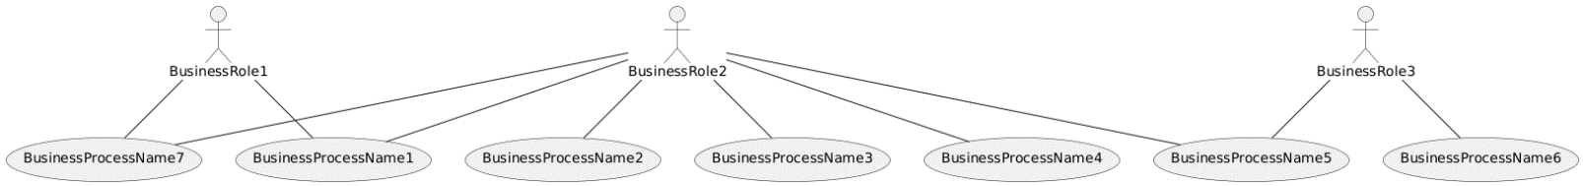



Use the PlantUML use case diagram template to model the BusinessProcesses

paste the PlantUML script of the above diagram into this embedded document

BusinessProcess1

Make sure the name is identical to the name defined in the Business Justification

| Item | Description |
| --- | --- |
| Definition | Definition of the business process |
| Trigger | Events or items that will trigger the business process to initiate |
| Pre-conditions | Conditions that need to be met before the business process can initiate. |
| Post-conditions | Conditions that need to be met when the business process is finished. |
| Role | BusinessRole name |

# Description of BusinessActivities

This section presents the different BusinessActivities within each BusinessProcess. The BusinessActivities of a process are described with activity diagrams, using plantUML, based on below script.

BusinessRole names must be identical throughout the various diagrams.

Legend

| Symbol | Name | Definition |
| --- | --- | --- |
|  | Start Point | Shows where the lifecycle of the business process commences. |
|  | End Point | Shows where the lifecycle of the business process may ends. |
|  | Lozenge (or diamond) | Indicates that a choice between several actions can be made. |
|  | Bar | Indicates that several actions are initiated in parallel. |

## Business Activity 1

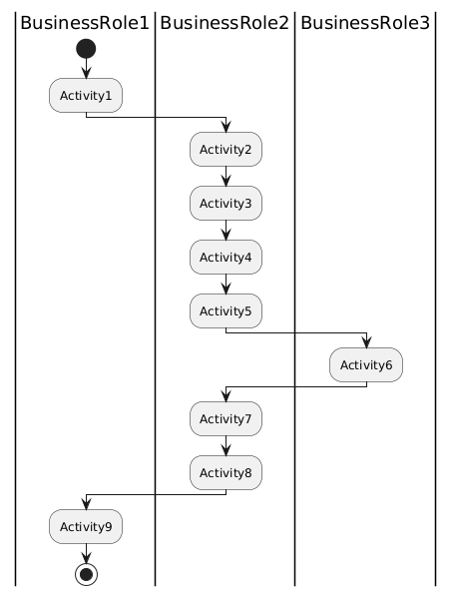

DIAGRAM -



paste the PlantUML script of the above diagram into this embedded document

| Step | Description | Initiator |
| --- | --- | --- |
| Activity1 | Description of Activity1 | BusinessRole1 |
| Activity2 | … | … |

Make sure the activity names here are identical to the names in the script

# BusinessTransactions

This section describes the flows based on the activity diagrams documented above. It shows the typical exchanges of information in the context of a BusinessTransaction.

Business Transactions are interactions. They are modelled in PlantUML,

Following guidelines must be followed in PlantUML:

* The names of the participants in quotes must have been defined in chapter 3.
* Keyword participant is used to model a rectangle.
* Keyword actor is used to model a stickman.
* Keyword Activate / Deactivate is used to link the Participant’s lifeline to the Resource (must be on the Participant that services the Resource).
* Resource names must be actual resources that exist in the repository.
* Operation requests may contain parameters in between the brackets, separated by comma’s)

Ensure the swimlane names correspond to the names of the Participants

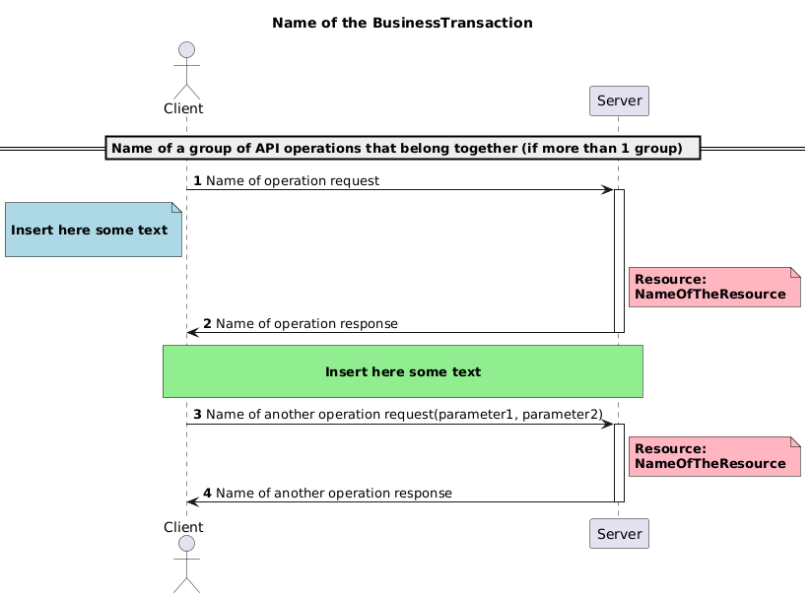

Optional text boxes that help clarify the scenario

Use the activation bar to highlight the participant that is servicing the resource

paste the PlantUML script of the above diagram into this embedded document



## Business Transaction 1

<Insert here your depiction and PlantUML script>

# Business Examples

This section describes business examples of the use of the various candidate ResourceDefinitions.

## Account Management

### Account32

Description

An Account resource contains the data model for an API that manages accounts.

Resource Instance

:

:

# Revision Record

|  |  |  |  |  |
| --- | --- | --- | --- | --- |
| Revision | Date | Author | Description | Sections affected |
|  |  |  |  |  |
|  |  |  |  |  |
|  |  |  |  |  |
|  |  |  |  |  |
|  |  |  |  |  |
|  |  |  |  |  |

Disclaimer:

Although the Registration Authority has used all reasonable efforts to ensure accuracy of the contents of the iso20022.org website and the information published thereon, the Registration Authority assumes no liability whatsoever for any inadvertent errors or omissions that may appear thereon. Moreover, the information is provided on an "as is" basis. The Registration Authority disclaims all warranties and conditions, either express or implied, including but not limited to implied warranties of merchantability, title, non-infringement and fitness for a particular purpose.

The Registration Authority shall not be liable for any direct, indirect, special or consequential damages arising out of the use of the information published on the iso20022.org website, even if the Registration Authority has been advised of the possibility of such damages.

Intellectual Property Rights:

The candidate ISO 20022 ResourceDefinitions described in this document were contributed by <Submitting Organization>. The ISO 20022 IPR policy is available at www.ISO20022.org > About ISO 20022 > Intellectual Property Rights.