Change Request
for the update of an External Code Set
Note: this document is to be completed by parties that request to either add new codes or clarify the definition of existing codes or replace existing codes by new one(s) or expire existing codes in one of the External Code Sets used in ISO 20022 messages. All change requests conforming to this template that are received prior to the end of a quarter (31 March, 30 June, 30 September, 31 December) will be evaluated by the SEG and, if approved, incorporated in the following quarterly publication cycle of the External Code Sets (respectively, by end of May, August, November and February), unless otherwise specified by the SEG.

Origin of the request:

A.1 Submitter:

Name of the company, organization, group, initiative or community that submits the change request. | Swift

A.2 Contact person:
Person that can be contacted for additional information on the request

A.2.1. First name, Last name | Dominique Forceville
A.2.2. Email address | dominique.forceville@swift.com
A.2.3. Telephone | 0032 2 655 4948

A.3 Sponsors:
If the submitter acts on behalf of or has gained support from other organisations, groups, initiatives or communities, these should be listed as sponsors.

Case Management Pilot Group

Description of the change request:
Specify the request type: creation of new code set, update of existing code set, deletion of existing code set.
For the creation of a new code set or for updating an existing code set, also complete the table in section H below. For the addition of new codes, all the details must be specified, including a proposed code, a proposed code name, a clear definition, and any other indications, such as an example or format to be published with the code set.

Request type: creation, update, deletion | Update

Related External Code Set:
For updating or deleting an existing code set, indicate the exact name of the code set as indicated in the External Code Sets documents on iso20022.org. For creating a new code set, indicate a proposed name for the new code set.
A specific change request form must be completed for each code set to be updated.

ExternalInvestigationStatusReason1Code

Purpose of the change:
Background, business context, community of users interested by the change and expected benefits/savings.
This section must explain why the existing code set needs to be changed. The reason for the update may be a business reason (e.g., evolution of market practice, or creation of new financial instruments), a technical reason (e.g., automation of the business process, or switch from a batch to a real time process), a regulatory reason (introduction, generally mandatory, of new rule/law) or the extension of the user community (newly identified business requirements).

Background of the request is related to the Case Manager initiative:

About the Case Manager initiative
The Case Manager initiative is originated and is driven by the payments industry and supported by Swift. This initiative started through discussions at industry level when creating the camt.110 & camt.111 messages, where a set of active institutions in this process identified potential for enhanced investigations processing while capitalizing on various assets available today. This would ultimately result in a reduced number of investigations, and more efficient handling of the remaining investigations through the implementation of orchestration for investigations.

About the Case Manager service
The Case Manager is a central investigation orchestration tool provided by Swift enabling all Swift institutions to raise investigations of any type, on any underlying (payment, account, statement entry or other). This tool applies orchestration of investigations based on agreed industry business rules to streamline overall investigation processing.

Explanation of the request:
Using Tracker information, Case Manager is able to check the status of the payment at the time when an investigation request is initiated (via camt.110 investigation request). Based on Case Manager orchestration features, in some scenarios, Case Manager is able to auto-close/auto-reject an investigation, or to generate pending statuses to the requestor of the investigation providing additional information as to why the investigation is kept pending.
When a CCNR (Creditor Claim Non Receipt) investigation is initiated by an agent (usually debtor agent of a CCT transaction), and the payment has an associated cover which is pending (f.ex. with the cover creditor agent), Case Manager auto-generates a camt.111 investigation response towards the debtor agent with investigation status PDNG (pending) and investigation status reason G004 (waiting for cover). By doing this, the debtor agent is immediately informed that that the investigation is kept pending as the advice receiver is waiting to receive for the credit of the cover.
G004 is a status reason code word used in the context of gpi tracking (since 2017).
In the current pilot implementation of this use case, G004 is populated in the proprietary status reason element of the camt.111.
The request is to add G004 (waiting of cover) to the code set ExternalInvestigationStatusReason1Code for usage in the camt.111 (associated with status PDNG -pending) so that usage of proprietary element can be avoided going forward.
Please check section F for full illustration of the use case.

Urgency of the request:
By default, valid change requests, subsequently approved by the SEG will be included in the following quarterly publication of External Code Sets, unless decided otherwise by the SEG.
If there is a need to have the new version of the related code set published earlier, the reason for the urgency and the expected consequences of a delay should be described here. Acceptance of such an unscheduled publication is subject to approval by the SEG.

As soon as possible.

Business examples:
Provide examples illustrating usage of the code set and indicate messages where the code set may be used.

Code G004 to be used in code set ExternalInvestigationStatusReason1Code for usage in the camt.111 (for status PDNG).
Here is a full use case for illustration.

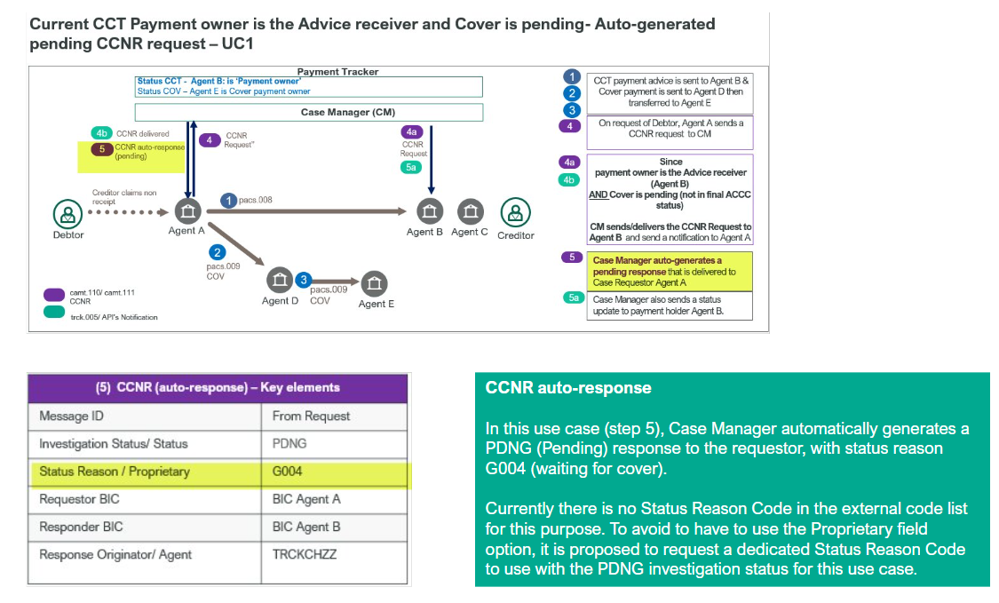

SEG recommendation:
This section will be completed by the SEG in charge of the related External Code Set.

Accept |  |  | Timing
 |  |  | Next possible quarterly release
 |  |  | Urgent request

Comments:

Reject

Reason for rejection:

DESCRIPTION OF THE CHANGE REQUEST

Type | Code Value | Code Name | Code Definition | Replaced By | Additional Information
Addition | G004 | Waiting for Cover | Indicates that the credit claim non receipt investigation is pending as the cover creditor is waiting for the credit of the cover. | N/A | Only to be used with status PDNG.

