Standards

Standards MT Release 2025

Discussion paper and Minutes

Corporate Actions

Distribution: Corporate Action Maintenance Working Group

Author: Miriam Ortseifen / Jacques Littré

Date Issued: **31 October 2024**

Version: **FINAL v1.1**

Meeting Date: August 27 & 28, 2024

**Table of Contents**

1 Introduction 4

ISO 15022 – 20022 Maintenance Process 4

Standards Illustrations in this document 4

SR 2025 change requests 4

CR Title Colour notation (**for minutes only**) 4

Contact persons regarding this document 4

CA MWG Members for SR2025 4

2 Overview of MT Submitted Change Requests 6

2.1 CR 002148: Add New Tax Reclassification Event 6

2.2 CR 002190: Amend some Income Distribution Event Codes for Investment Funds 12

2.3 CR 002085: Adding UTC Time to All Periods Qualifiers or Removing Time 19

2.4 CR 002079: Add New Proration Indicator in CA Notification for Instructions below MIEX 27

2.5 CR 002102: Add Fiscal Year Date in CA Event Details 32

2.6 CR 002099: Add Dutch Auction Indicator in CA Notification 36

2.7 CR 002140: Add New Forfeiture of Interest Flag in Notification 40

2.8 CR 002098: Add Price Calculation Method in CA Notification 44

2.9 CR 002159: Add New Acceptance Priority Type and Acceptance Priority Level Code 49

2.10 CR 002100: Amend Definitions of Some Tax Related Amounts and Rates 56

2.11 CR 002178: Add New Documentation Required Flag and Documentation Deadline Date 67

2.12 CR 002094: Remove Reversal Reason Code POCS 76

2.13 CR 002071: Amend NVRs Textual Description on Reversal Reason Presence 79

2.14 CR 002072: Aligning Status Codes in CA Instruction Status Message 81

2.15 CR 002074: Add Status Quantities in CA Instruction Status 85

2.16 CR 002092: Amendment of Reason Codes in CA Event Processing Status Message 96

2.17 CR 002157: Add New Return Status Code on CA Instruction Status Messages 100

2.18 CR 002180: Add New Issuer Sourced Indicator in Notification (CA and GM) 108

3 Overview of ISO 20022 Submitted Change Requests 113

3.1 CR 002196: Align Rate and Price Data Types with ISO 15022 Data Types for Securities Messages Coexistence (ISO 20022 CR 1390) 113

3.2 CR 002198: Add New Transfer of Proceeds Type Indicator and Quantities Related to Market Claims (ISO 20022 CR 1396) 116

3.3 CR 002194: Add Reversal Reason Rule in CA Movement Preadvice Message (ISO 20022 CR 1370) 123

3.4 CR 002193: Amend Bid Interval Data Type in CA Notification Subset and Fix Pagination Rule (ISO 20022 CR 1368) 126

3.5 CR 002192: Amend Spelling of NotSpecifiedReason Element (ISO 20022 CR 1341) 129

3.6 CR 002195: Remove Useless Rule in Market Claim Creation Message (ISO 20022 CR 1371) 132

3.7 CR 002197: Issuer Agent - Agent Notification Advice Amendment and Alignment with CA Notification Message (ISO 20022 CR 1391) 134

# Introduction

ISO 15022 – 20022 Maintenance Process

As from the year 2012, a joint maintenance process has been put in place for ISO 20022 and 15022 and Corporate Action messages with the support of the ISO 20022 RMG and of the SWIFT Board.

This joint maintenance will ensure interoperability between the two standards and a more efficient maintenance process.

Standards Illustrations in this document

Standards illustrations are provided by SWIFT Standards. They are not part of the original request.

Any standard illustrations (rules, codes, qualifiers, wordings) are **only for illustration purposes**. It does not mean SWIFT Standards is in agreement with the maintenance request or that the final standards solutions (for accepted maintenance requests) will be as shown in this document.

The MT Standards Release Guide (+ potential erratum) and the ISO 20022 message definition reports are the ONLY source of reliable information based on which implementation of changes should be made. Any other documentation (including this one) is subject to change.

SR 2025 change requests

This document contains all CA MT/MX CRs for MT category 5 and equivalent MX messages investigated this year for implementation in SR 2025.

The requests originator is indicated as follows:

* + Requesting Country; Country code of requesting NMPG or UG; eg. BE
  + Requesting Group: a SWIFT User Group or a National (Securities) Market Practice Group with the acknowledgement of the UGC or Recognized industry group eg. SMPG (the global Securities Market Practice Group)

CR Title Colour notation (**for minutes[1] only**)

In GREEN are items that are approved or approved with comments or approved with alternative solution.

In RED are items that are rejected, postponed, withdrawn or linked to agreed items

Contact persons regarding this document

Miriam Ortseifen - SWIFT Standards; [miriam.ortseifen@swift.com](mailto:miriam.ortseifen@swift.com)

Jacques Littré – SWIFT Standards; jacques.littre@swift.com

CA MWG Members for SR2025

The following people are part of the CA MWG for SR2025.

|  |  |  |
| --- | --- | --- |
| **Maintenance working group members** | **Representing** | **Attendance Meeting 27 / 28 August** |
| Priscilla Ferri de Barros (ASX) | AU | Absent |
| Hakim Akka (BNY) | BE | Present |
| David Petitville (RBC) | CA | Absent |
| Michael Blumer (CS) | CH | Present |
| Daniel Schäfer (HSBC) | DE | Present |
| Tanja Ronne Kofod (Nykredit) | DK | Absent – Country feedback provided |
| Diego Garcia (DB) | ES | Absent |
| Stephane Peard (SG) | FR | Present |
| James Mullens (Nomura) | HK | Present |
| Shiori Ikeda (Mizuho) | JP | Present |
| Catarina Marques (Clearstream) | LU | Present |
| Paola De Antoni (SG) | IT | Present |
| Huseyin Boler (ABN Amro) | NL | Present |
| Mariangela Fumagalli (BNP) | UK | Present |
| Paul Fullam (FIS) | US / ISITC | Present |
| Jean-Paul Lambotte (Euroclear) | XS | Present |
| Sanjeev Jayram (RMB) | ZA | Present |
| Christine Strandberg (SEB) | ISO 20022 Securities SEG (SE) | Present |
| Steve Sloan (DTCC) | ISO 20022 Securities SEG (US) | Present |
| Jacques Littré (Swift) | CA MWG Chair | Present |
| Miriam Ortseifen (Swift) | CA MWG | Present |

# Overview of MT Submitted Change Requests

## CR 002148: Add New Tax Reclassification Event

|  |  |
| --- | --- |
| **Origin of request** | |
| Requesting Country: | US United States of America |
| Requesting Group: |  |
| **Sponsors** | |
| ISITC | |
| **Message type(s) impacted** | |
| MT 564, MT 566, MT 568, seev.031, seev.035, seev.036, seev.037, seev.039, seev.044, seev.009, seev.011  (SnR) MT 508, MT 536, MT 537, MT 538, MT 575 (for the CA event list only)  (SnR) semt.015, semt.016, semt.017, semt.018 (for the CA event list only) | |
| **Complies with regulation** | |
| None | |
| **Business impact of this request** | |
| MEDIUM | |
| **Commitment to implement the change** | |
| Number of messages sent and received: 25000  Percentage of messages impacted: 100  Commits to implement and when: DTCC in SR 2025 | |
| **Business context** | |
| During the calendar year, distributions by U.S. entities paid to non-U.S. persons are treated as dividends for U.S. tax purposes and subject to U.S. withholding tax. These are announced usually as a DVCA event. Prior to a distribution DTCC will classify a distribution into multiple components for US tax withholding purposes. These distributions can come from various types of securities, (ETFs, mutual funds, partnerships, exchange traded notes, etc.) and can classify the payment in various types of income for US tax withholding purposes such as Dividends, Interest, distributions from a partnership, Other Income, etc.). These events are currently announced as an OTHR event and linked via a Related Events linkage to the DVCA. The withholding that occurs will only occur for foreign clients subject to tax withholding. For US participants, these OTHR events are to be used by the tax department of the participant firms.  DTCC is requesting that a new event type RCLA - Reclassification be created to take the place of OTHR. In the above scenario, the reclassified event announcement which is created is sent to all participants of DTCC and would better indicate for US clients that this is a Reclassification and is for tax information purposes only.  In addition, we believe the use case for the new event type RCLA can be broadened to accommodate the communication of the income reclassification process in the US. Most firms have traditionally waited until after year-end to perform income reclassification. The new event RCLA will be an alternative option for asset servicers to issue announcements on any reclassification they would perform. Attached is a PDF document from BBH detailing their concurrence with the new event type. | |
| **Nature of change** | |
| New CAEV Code - RCLA - Reclassification | |
| **Examples** | |
|  | |

**Workaround**

|  |
| --- |
| Use the CAEV code “OTHR” |

**SWIFT Comment**

|  |
| --- |
| The event should also likely be present in the MT568 when appended to a MT564 and at least in the seev.039 (CACN – Cancellation) MX message to be able to cancel the notification.  Are we sure that the event should not be present in other CA messages?  This change should also be applied in the SnR messages as we have an agreement with the SnR WG to keep the CA event list in sync.  The impact on SnR messages should be as follows:  (SnR) MT 508, MT 536, MT 537, MT 538, MT 575 (for the CA event list only)  (SnR) semt.015, semt.016, semt.017, semt.018 (for the CA event list only) |

**Standards Illustration**

**1. ISO 15022 Illustration**

**In the MT 564, MT 566 and MT 568, in sequence A, add a new code “RCLA” (Reclassification) for Qualifier CAEV in field 22F: Indicator, as defined and illustrated below:**

**MT 564 Field Specifications**

5. Field 22F: Indicator

FORMAT

|  |  |  |
| --- | --- | --- |
| Option F | :4!c/[8c]/4!c | (Qualifier)(Data Source Scheme)(Indicator) |

PRESENCE

Mandatory in mandatory sequence A

QUALIFIER

(Error code(s): T89)

| **Order** | **M/O** | **Qualifier** | **R/N** | **CR** | **Options** | **Qualifier Description** |
| --- | --- | --- | --- | --- | --- | --- |
| 1 | O | CAEP | N |  | F | Corporate Action Event Processing |
| 2 | M | CAEV | N | C4, C6, C10, C11, C23, C26, C30 | F | Corporate Action Event Indicator |
| 3 | M | CAMV | N |  | F | Mandatory/Voluntary Indicator |

DEFINITION

This qualified generic field specifies:

|  |  |  |
| --- | --- | --- |
| CAEP | Corporate Action Event Processing | Type of processing involved by a Corporate Action. |
| CAEV | Corporate Action Event Indicator | Specifies the type of corporate event. |
| CAMV | Mandatory/Voluntary Indicator | Specifies whether the event is mandatory, mandatory with options or voluntary. |

CODES

If Qualifier is CAEP and Data Source Scheme is not present, Indicator must contain one of the following codes (Error code(s): K22):

|  |  |  |
| --- | --- | --- |
| DISN | CA Results in a Distribution | The holder of the relevant security on a certain date, for example, the record date, will receive a benefit without giving up the underlying security. |
| GENL | General | No debit or credit of resources. |
| REOR | CA Results in a Reorganisation | The underlying security will be debited and may be replaced by another resource (or resources). |

CODES

If Qualifier is CAEV and Data Source Scheme is not present, Indicator must contain one of the following codes (Error code(s): K22):

|  |  |  |
| --- | --- | --- |
| ACCU | Accumulation | Funds related event in which the income (for example accumulation units) that accrues during an accounting period is retained within the fund instead of being paid away to investors. The retained income is nonetheless deemed to have been distributed to investors for tax purposes. |
| ACTV | Trading Status: Active | Trading in the security has commenced or security has been re-activated after a suspension in trading. |
| ATTI | Attachment | Combination of different security types to create a unit. Units are usually comprised of warrants and bonds or warrants and equities. Securities may be combined at the request of the security holder or based on market convention. |
| …. | …. | … |
| **RCLA** | **Reclassification** | **Securities related event which reclassifies the distribution in various types of income for US tax withholding purposes.** |
| REDM | Final Maturity | The redemption of an entire issue outstanding of securities, for example, bonds, preferred equity, funds, by the issuer or its agent, for example, asset manager, at final maturity. |
| RHDI | Intermediate Securities Distribution | The distribution of intermediate securities that gives the holder the right to take part in a future event. |
| RHTS | Rights Issue/Subscription Rights/Rights Offer | Offer to holders of a security to subscribe for additional securities via the distribution of an intermediate security. Both processes are included in the same event. |
| XMET | Extraordinary or Special General Meeting | Extraordinary or special general meeting. |

**2. ISO 20022 Illustration**

**In the seev.031 (CANO – CorporateActionNotification)** message, in sequence CorporateActionGeneralInformation/EventType, in the *CorporateActionEventType31Code*,

**and in the** **seev.035 (CAFE/CAPA – CorporateActionMovementPreliminaryAdvice)** message, in sequence CorporateActionGeneralInformation/EventType, in the *CorporateActionEventType32Code*,

**and in the** **seev.036 (CACO – CorporateActionMovementConfirmation)** message, in sequence CorporateActionGeneralInformation/EventType, in the *CorporateActionEventType30Code*,

**and in the** **seev.037 (CARE – CorporateActionMovementReversalAdvice)** message**,** in sequence CorporateActionGeneralInformation/EventType, in the C*orporateActionEventType30Code*,

**and in the seev.039 (CACN – CorporateActionCancellationAdvice)** message, in sequence CorporateActionGeneralInformation/EventType, in the *CorporateActionEventType31Code*,

**and in the seev.044 (CAPC – CorporateActionMovementPreliminaryAdviceCancellationAdvice)** message, in sequence CorporateActionGeneralInformation/EventType, in the *CorporateActionEventType32Code*,

add new code **“RCLA” (Tax Reclassification)** as defined for ISO 15022 above and as illustrated below:

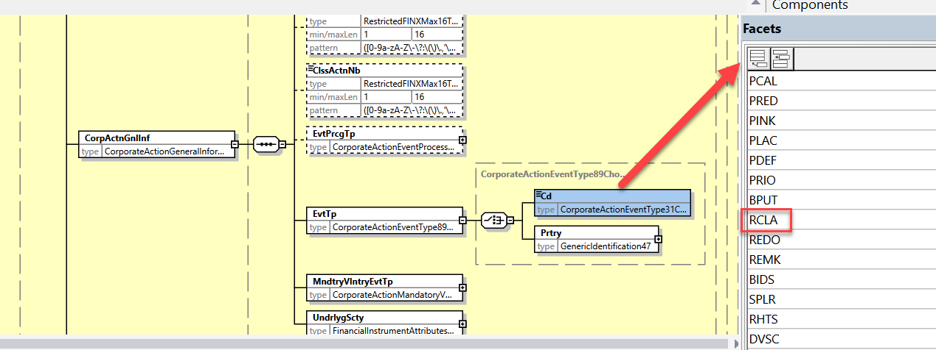

**Working Group Meeting**

|  |
| --- |
| **Discussion** |
| The CA SWG agreed with the business case and solution. However as noted by Swift, the SWG confirms that the implementation solution is to be extended to the confirmation (and narrative message as well) since this event leads to movements.  DE, LU, FR and XS do not support the change request since it would be contradicting the current local market practice, where the underlying tax rate should be corrected through the original distribution event. Therefore, there is no business case for these markets.  Switzerland is in favour of the change request to minimize the use of OTHR event flow, which is currently used for instance for adjustments of tax rates, instead of a dedicated code for the specific purpose.  Both UK and IE are in favour of the change request if a clear market practice is defined for the tax reclassification practice in the US vs. the different scenario for a change in a tax rate for a cash dividend payment.  Finally, the SWG resolved to vote on the CR.  The CR was approved by 10 votes in favour and 4 votes against (DE, FR, LU, XS).  The condition of the UK, IE and IT to vote in favour of the change request is that a market practice be provided by April 2025 by the SMPG restricting the usage of RCLA mainly to the US or having local commitments for its global usage. |
| **Decision** |
| **Approved with comments.** |

## CR 002190: Amend some Income Distribution Event Codes for Investment Funds

|  |  |
| --- | --- |
| **Origin of request** | |
| Requesting Country: |  |
| Requesting Group: | SMPG IF |
| **Sponsors** | |
|  | |
| **Message type(s) impacted** | |
| MT 564, MT565, MT 566, MT 567, MT568, seev.009, seev.011, seev.031, seev.032, seev.033, seev.034, seev.035, seev.036, seev.037, seev.039, seev.040, seev.041, seev.042, seev.044, seev.050, seev.051, seev.052, seev.053  (SnR) MT 508, MT 536, MT 537, MT 538, MT 575 (for the CA event list only)  (SnR) semt.015, semt.016, semt.017, semt.018 (for the CA event list only) | |
| **Complies with regulation** | |
| None | |
| **Business impact of this request** | |
| LOW  This is a change of definition and does not impact the message structure. | |
| **Commitment to implement the change** | |
| Number of messages sent and received: 45000000  Percentage of messages impacted: 15  Commits to implement and when: The investment funds community in SR 2025 | |
| **Business context** | |
| “Distribution of income paid out as cash or securities based upon a holder’s dividend reinvestment option at the transfer agent. No election is required from the holder for the proceeds to be paid out or reinvested. The choice between the two options depends on the set-up of the holder’s account at the CSD or the Transfer Agent (TA).“  Today, as no CA event and market practice caters for the above-mentioned scenario, the market misuse the DVOP. The problem is that this event does not have a definition, codes, and market practices that reflect the business scenario of an Investment Funds Income Distribution (IFID).  For that reason, we would like to formalize the IFID market practices in the ‘SMPG CA Global Market Practice Part 1’ document and submit it to the SMPG CA working group for review and publication, this document is used as a working document to define the differentiating factors between “regular” DVOP and the ones used to notify about IFID.  If need be, based on the formalized market practices we will submit a change request to the SMPG CA to update the definition of the DVOP, as well as the definition of STIN. | |
| **Nature of change** | |
| - For the DVOP code, update the definition to: Distribution of a dividend to shareholders with a choice of benefit to receive. Shareholders may choose to receive shares or cash. To be distinguished from DRIP as the company creates new share capital in exchange for the dividend rather than investing the dividend in the market. For investment funds the option applicability is subject to the account owner established dividend preference. The account owner will receive mandatory cash or shares.  (Impacted messages: 564, 566, Seev.031, Seev.035, Seev.036, Seev.037).  - For the STIN code / Standing Instruction Indicator element, update the definition to: Indicates whether an account owner has placed a standing order to select this corporate action option. For investment funds the option applicability is subject to the account owner’s established dividend preference at the moment of the account opening.  (Impacted messages: 564, seev.031).  - For the IFIX code / Fixing Date element, update the definition to: Date/time at which an index/rate/price/value will be determined.  For investment funds, date/time of the Net Asset Value. (Impacted messages: 564, 566, Seev.031, Seev.035, Seev.036, Seev.037). | |
| **Examples** | |
|  | |

**Workaround**

|  |
| --- |
| Misuse of messages. |

**SWIFT Comment**

|  |
| --- |
| For harmonisation purpose, Swift recommends to amend the definition of the DVOP event to all CA MT and CA MX messages. This change should also be applied in the SnR messages as we have an agreement with the SnR WG to keep the CA event list in sync.  The impact on SnR messages should be as follows:  (SnR) MT 508, MT 536, MT 537, MT 538, MT 575 (for the CA event list only)  (SnR) semt.015, semt.016, semt.017, semt.018 (for the CA event list only) |

**Standards Illustration**

**1. ISO 15022 Illustration**

**For MT 564, MT 565, MT 566, M T567 and MT 568, amend the following definitions as described and illustrated below:**

* **In sequence A of MT 564, MT565, MT 566, MT567 and the MT568, in the field 22F for indicator CAEV, amend the definition for the DVOP code.**
* **In sequence A of MT 564, MT565, MT 566, MT567 and the MT568, in the field 22F for indicator CAEV, amend the definition for the DVCA code.**
* **In sequence D of MT 564 and sequence C of MT 566, in field :22F::RHDI, amend the definitions of the DVOP and DVCA code**
* **In sequence E of MT 564 only, in the field 17B Flag, amend the definition for the STIN code.**

**MT 564 Field Specifications**

5. Field 22F: Indicator

FORMAT

|  |  |  |
| --- | --- | --- |
| Option F | :4!c/[8c]/4!c | (Qualifier)(Data Source Scheme)(Indicator) |

PRESENCE

Mandatory in mandatory sequence A

QUALIFIER

(Error code(s): T89)

| **Order** | **M/O** | **Qualifier** | **R/N** | **CR** | **Options** | **Qualifier Description** |
| --- | --- | --- | --- | --- | --- | --- |
| 1 | O | CAEP | N |  | F | Corporate Action Event Processing |
| 2 | M | CAEV | N | C4, C6, C10, C11, C23, C26, C30 | F | Corporate Action Event Indicator |
| 3 | M | CAMV | N |  | F | Mandatory/Voluntary Indicator |

DEFINITION

This qualified generic field specifies:

|  |  |  |
| --- | --- | --- |
| CAEP | Corporate Action Event Processing | Type of processing involved by a Corporate Action. |
| CAEV | Corporate Action Event Indicator | Specifies the type of corporate event. |
| CAMV | Mandatory/Voluntary Indicator | Specifies whether the event is mandatory, mandatory with options or voluntary. |

CODES

If Qualifier is CAEP and Data Source Scheme is not present, Indicator must contain one of the following codes (Error code(s): K22):

|  |  |  |
| --- | --- | --- |
| DISN | CA Results in a Distribution | The holder of the relevant security on a certain date, for example, the record date, will receive a benefit without giving up the underlying security. |
| GENL | General | No debit or credit of resources. |
| REOR | CA Results in a Reorganisation | The underlying security will be debited and may be replaced by another resource (or resources). |

CODES

If Qualifier is CAEV and Data Source Scheme is not present, Indicator must contain one of the following codes (Error code(s): K22):

|  |  |  |
| --- | --- | --- |
| ACCU | Accumulation | Funds related event in which the income (for example accumulation units) that accrues during an accounting period is retained within the fund instead of being paid away to investors. The retained income is nonetheless deemed to have been distributed to investors for tax purposes. |
| DVCA | Cash Dividend | Distribution of cash to **~~share~~**holders, in proportion to their equity holding. Ordinary dividends are recurring and regular. **~~Shareh~~H**older must take cash and may be offered a choice of currenc**~~y~~**i**es**. |
| DVOP | Dividend Option | Distribution of a dividend to **~~share~~**holders with a choice of benefit to receive**~~. Shareholders may choose to receive~~** **additional securities** **~~shares~~** or cash.  To be distinguished from DRIP as the company creates new share capital in exchange for the dividend rather than investing the dividend in the market. |
| DVSC | Scrip Dividend/Payment | Dividend or interest paid in the form of scrip. |
| WRTH | Worthless | Booking out of valueless securities. |
| WTRC | Withholding Tax Relief Certification | Certification process for withholding tax reduction or exemption based on the tax status of the holder. |
| XMET | Extraordinary or Special General Meeting | Extraordinary or special general meeting. |

**MT 564 Field Specifications**

64. Field 17B: Flag

FORMAT

|  |  |  |
| --- | --- | --- |
| Option B | :4!c//1!a | (Qualifier)(Flag) |

PRESENCE

Mandatory in optional sequence E

QUALIFIER

(Error code(s): T89)

| **Order** | **M/O** | **Qualifier** | **R/N** | **CR** | **Options** | **Qualifier Description** |
| --- | --- | --- | --- | --- | --- | --- |
| 1 | M | DFLT | N |  | B | Default Processing Flag |
|  | or | STIN | N |  | B | Standing Instruction Flag |
| 2 | O | RCHG | N |  | B | Charges Flag |
| … |  |  |  |  |  |  |
| 6 | O | APLI | N |  | B | Applied Option Flag |

DEFINITION

This qualified generic field specifies:

|  |  |  |
| --- | --- | --- |
| APLI | Applied Option Flag | Indicates whether the option, different from the default one, shall be applied by the account owner. |
| CHAN | Change Allowed Flag | Indicates whether change of instruction is allowed. |
| DFLT | Default Processing Flag | Indicates whether the option, for example, currency option, will be selected by default if no instruction is provided by the account owner. |
| RCHG | Charges Flag | Indicates whether charges apply to the holder, for instance redemption charges. |
| STIN | Standing Instruction Flag | Indicates whether an account owner has placed a standing order to select this corporate action option.  **The standing instruction may or may not be overridden, depending on account or event terms.** |

**2. ISO 20022 Illustration**

**1. In the seev.031 (CANO – CorporateActionNotification)** message, in sequence CorporateActionGeneralInformation/EventType,

**And in the seev.032 (CAPS – CorporateActionEventProcessingStatusAdvice)** message, in sequence CorporateActionGeneralInformation/EventType,

**And in the seev.033 (CAIN – CorporateActionInstruction)** message, in sequence CorporateActionGeneralInformation/EventType,

**And in the seev.034 (CAIS – CorporateActionInstructionStatusAdvice)** message, in sequence CorporateActionGeneralInformation/EventType,

**And in the seev.035 (CAPA – CorporateActionMovementPreliminaryAdvice)** message, in sequence CorporateActionGeneralInformation/EventType,

**And in the seev.036 (CACO – CorporateActionMovementConfirmation)** message, in sequence CorporateActionGeneralInformation/EventType,

**And in the seev.037 (CARE – CorporateActionMovementConfirmation)** message, in sequence CorporateActionGeneralInformation/EventType,

**And in the seev.039 (CACN – CorporateActionCancellationAdvice)** message, in sequence CorporateActionGeneralInformation/EventType,

**And in the seev.040 (CANC – CorporateActionInstructionCancellationRequest)** message, in sequence CorporateActionGeneralInformation/EventType,

**And in the seev.041 (CACS – CorporateActionInstructionCancellationRequestStatusAdvice)** message, in sequence CorporateActionGeneralInformation/EventType,

**And in the seev.042 (CAST – CorporateActionInstructionStatementReport)** message, in sequence CorporateActionEventAndBalance/GeneralInformation/EventType,

**And in the seev.044 (CAPC – CorporateActionMovementPreliminaryAdviceCancellationAdvice)** message, in sequence CorporateActionGeneralInformation/EventType,

Amend the definition of the **Event Type Code “DVOP”** and “DVCA” as proposed and illustrated for ISO 15022 above.

2. Apply the same change in DVOP and DVCA on the following messages: seev.009, seev.011, seev.050, seev.051, seev.052, seev.053, semt.015, semt.016, semt.017, semt.018

**3. In the seev.031 (CANO – CorporateActionNotification)** message, in sequence CorporteActionOptionDetails/DefaultProcessingOrStandingInstruction,

**And in the seev.035 (CAPA – CorporateActionMovementPreliminaryAdvice)** message, in sequence CorporteActionOptionDetails/DefaultProcessingOrStandingInstruction,

**And in the seev.042 (CAST – CorporateActionInstructionStatementReport)** message, in sequence CorporateActionEventAndBalance/Balance/TotalInstructedBalanceDetails/OptionDetails

Amend the definition of the **Standing Instruction Indicator** as proposed and illustrated for ISO 15022 above.

**Working Group Meeting**

|  |
| --- |
| **Discussion** |
| The CA SWG had expected that the SMPG IF WG would have submitted this CR to the SMPG CA WG for review beforehand.  Nevertheless, instead of expanding the existing event definition with an IF specific paragraph (which should rather be tackled in a market practice for funds), the SWG agreed to instead amend the definition by making it more generic for all securities instruments for DVOP by removing specific references to shares and apply the same to the DVCA definition.  The SWG has also proposed an alternative solution / definition for the STIN (Standing Instruction) flag qualifier.  For the IFIX (Fixing Date/Time) qualifier, the SWG agreed to reject the change of definition as the current definition is deemed fine for IF.  The SWG will ask the submitter (the SMPG IF WG) to validate the proposed alternative solution illustrated above in the next week. If the IF WG does not agree with the proposed changes, the CR will be rejected. |
| **Decision** |
| **Approved with alternative solution.** |

## CR 002085: Adding UTC Time to All Periods Qualifiers or Removing Time

|  |  |
| --- | --- |
| **Origin of request** | |
| Requesting Country: |  |
| Requesting Group: | SMPG |
| **Sponsors** | |
| SMPG members and global custodians | |
| **Message type(s) impacted** | |
| MT 564, MT 566, seev.031, seev.035, seev.036 | |
| **Complies with regulation** | |
| None | |
| **Business impact of this request** | |
| LOW | |
| **Commitment to implement the change** | |
| Number of messages sent and received: 20000000  Percentage of messages impacted: 1  Commits to implement and when: SMPG in 2025 | |
| **Business context** | |
| We noticed that there is an issue with the periods as they can be expressed as date and time but UTC is not available. | |
| **Nature of change** | |
| We would like to:  a) add UTC to the period and in particular, PWAL or  b) remove the time from all periods. | |
| **Examples** | |
|  | |

**Workaround**

|  |
| --- |
| Narratives are used. |

**SWIFT Comment**

|  |
| --- |
| UTC time is already present by default in the ISODateTime data type in all ISO 20022 messages. Therefore, adding UTC time does not apply to ISO 20022 messages.  The change must be applied on ISO 20022 CA MX only if it is decided to remove the Time component from all periods. |

**Standards Illustration**

**1. ISO 15022 Illustration**

**Solution Option 1 – Add UTC Time component to all periods**

**For MT 564 and MT 566, create 3 new 69a Period format options K, L M similar to the format option B, D, F but with the addition of a UTC Indicator for all DateTime components as defined and illustrated below:**

The change is applicable for the following field 69a period field qualifiers having format options B, D, F) in the MT 564:

* Sequence C: Trading Period, Qualifier TRDP
* Sequence D: Qualifiers BOCL; CLCP; CODS; CSPD; DSBT; DSDA; DSDE; DSPL; DSSE; DSWA; DSWN; DSWS; INPE; PRIC; SPLP
* Sequence E: Qualifiers PRIC; REVO; PWAL; PARL; SUSP; AREV; DSWO (as illustrated below)
* Sequence E1: Qualifier TRDP

The change is applicable for the following field 69a period field qualifiers (for format options B, D and F) in the MT 566:

* Sequence C: Qualifiers PRIC, INPE, CSPD, CLCP, BOCL (as illustrated below)
* Sequence D: Qualifiers PARL, PRIC, PWAL

**MT 564 Field Specifications**

67. Field 69a: Period

FORMAT

|  |  |  |
| --- | --- | --- |
| Option A | :4!c//8!n/8!n | (Qualifier)(Date1)(Date2) |
| Option B | :4!c//8!n6!n/8!n6!n | (Qualifier)(Date1)(Time1)(Date2)(Time2) |
| Option C | :4!c//8!n/4!c | (Qualifier)(Date)(Date Code) |
| Option D | :4!c//8!n6!n/4!c | (Qualifier)(Date)(Time)(Date Code) |
| Option E | :4!c//4!c/8!n | (Qualifier)(Date Code)(Date) |
| Option F | :4!c//4!c/8!n6!n | (Qualifier)(Date Code)(Date)(Time) |
| Option J | :4!c//4!c | (Qualifier)(Date Code) |
| **Option K** | :4!c//8!n6!n**[,3n][/[N]2!n[2!n]]** /8!n6!n**[,3n][/[N]2!n[2!n]]** | (Qualifier)(Date1)(Time1)**(Decimals)(UTC Indicator)** (Date2)(Time2)**(Decimals)(UTC Indicator)** |
| **Option L** | :4!c//8!n6!n**[,3n][/[N]2!n[2!n]]**/4!c | (Qualifier)(Date)(Time)**(Decimals)(UTC Indicator)** (Date Code) |
| **Option M** | :4!c//4!c/8!n6!n**[,3n][/[N]2!n[2!n]]** | (Qualifier)(Date Code)(Date)(Time) **(Decimals)(UTC Indicator)** |

PRESENCE

Optional in optional sequence E

QUALIFIER

(Error code(s): T89)

| **Order** | **M/O** | **Qualifier** | **R/N** | **CR** | **Options** | **Qualifier Description** |
| --- | --- | --- | --- | --- | --- | --- |
| 1 | O | PRIC | N |  | A, B, C, D, E, F, J, **K, L or M** | Price Calculation Period |
| 2 | O | REVO | N |  | A, B, C, D, E, F, J, **K, L or M** | Revocability Period |
| 3 | O | PWAL | N |  | A, B, C, D, E, F, J, **K, L or M** | Period of Action |
| 4 | O | PARL | N |  | A, B, C, D, E, F, J, **K, L or M** | Parallel Trading Period |
| 5 | O | SUSP | N |  | A, B, C, D, E, F, J, **K, L or M** | Suspension of Privilege |
| 6 | O | AREV | N |  | A, B, C, D, E, F, J, **K, L or M** | Account Servicer Revocability Period |
| 7 | O | DSWO | N |  | A, B, C, D, E, F, J, **K, L or M** | Depository Suspension Period for Withdrawal in Street Name on Outturn Security |

DEFINITION

This qualified generic field specifies:

|  |  |  |
| --- | --- | --- |
| AREV | Account Servicer Revocability Period | Period during which the participant of the account servicer can revoke change or withdraw its instructions. |
| DSWO | Depository Suspension Period for Withdrawal in Street Name on Outturn Security | Period defining the last date on which withdrawal in street name requests on the outturn security will be accepted and the date on which the suspension will be released and withdrawal by transfer processing on the outturn security will resume. |
| PARL | Parallel Trading Period | Period during which both old and new equity may be traded simultaneously, for example, consolidation of equity or splitting of equity. |
| PRIC | Price Calculation Period | Period during which the price of a security is determined. |
| PWAL | Period of Action | Period during which the specified option, or all options of the event, remains valid, for example, offer period. |
| REVO | Revocability Period | Period during which the shareholder can revoke, change or withdraw its instruction. |
| SUSP | Suspension of Privilege | Period during which the privilege is not available, for example, this can happen whenever a meeting takes place or whenever a coupon payment is due. |

NETWORK VALIDATED RULES

Date must be a valid date expressed as YYYYMMDD (Error code(s): T50).

Time must be a valid time expressed as HHMMSS (Error code(s): T38).

**Solution Option 2 – Remove UTC Time component from all periods qualifiers**

**For MT 564 and MT 566, remove the time component from all period qualifiers. This resolves to deleting format options B, D and F from the 69a fields as illustrated below on the MT 564:**

**MT 564 Field Specifications**

67. Field 69a: Period

FORMAT

|  |  |  |
| --- | --- | --- |
| Option A | :4!c//8!n/8!n | (Qualifier)(Date1)(Date2) |
| **~~Option B~~** | **~~:4!c//8!n6!n/8!n6!n~~** | **~~(Qualifier)(Date1)(Time1)(Date2)(Time2)~~** |
| Option C | :4!c//8!n/4!c | (Qualifier)(Date)(Date Code) |
| **~~Option D~~** | **~~:4!c//8!n6!n/4!c~~** | **~~(Qualifier)(Date)(Time)(Date Code)~~** |
| Option E | :4!c//4!c/8!n | (Qualifier)(Date Code)(Date) |
| **~~Option F~~** | **~~:4!c//4!c/8!n6!n~~** | **~~(Qualifier)(Date Code)(Date)(Time)~~** |
| Option J | :4!c//4!c | (Qualifier)(Date Code) |

PRESENCE

Optional in optional sequence E

QUALIFIER

(Error code(s): T89)

| **Order** | **M/O** | **Qualifier** | **R/N** | **CR** | **Options** | **Qualifier Description** |
| --- | --- | --- | --- | --- | --- | --- |
| 1 | O | PRIC | N |  | A, **~~B~~**, C, **~~D~~**, E, **~~F,~~** or J | Price Calculation Period |
| 2 | O | REVO | N |  | A, **~~B~~**, C, **~~D~~**, E, **~~F~~**, or J | Revocability Period |
| 3 | O | PWAL | N |  | A, **~~B~~**, C, **~~D~~**, E**~~, F~~**, or J | Period of Action |
| 4 | O | PARL | N |  | A, **~~B~~**, C, **~~D~~**, E**~~, F~~**, or J | Parallel Trading Period |
| 5 | O | SUSP | N |  | A, **~~B~~**, C, **~~D~~**, E, **~~F~~**, or J | Suspension of Privilege |
| 6 | O | AREV | N |  | A, **~~B~~**, C, **~~D~~**, E, **~~F,~~** or J | Account Servicer Revocability Period |
| 7 | O | DSWO | N |  | A, **~~B~~**, C, **~~D~~**, E, **~~F~~**, or J | Depository Suspension Period for Withdrawal in Street Name on Outturn Security |

DEFINITION

This qualified generic field specifies:

|  |  |  |
| --- | --- | --- |
| AREV | Account Servicer Revocability Period | Period during which the participant of the account servicer can revoke change or withdraw its instructions. |
| DSWO | Depository Suspension Period for Withdrawal in Street Name on Outturn Security | Period defining the last date on which withdrawal in street name requests on the outturn security will be accepted and the date on which the suspension will be released and withdrawal by transfer processing on the outturn security will resume. |
| PARL | Parallel Trading Period | Period during which both old and new equity may be traded simultaneously, for example, consolidation of equity or splitting of equity. |
| PRIC | Price Calculation Period | Period during which the price of a security is determined. |
| PWAL | Period of Action | Period during which the specified option, or all options of the event, remains valid, for example, offer period. |
| REVO | Revocability Period | Period during which the shareholder can revoke, change or withdraw its instruction. |
| SUSP | Suspension of Privilege | Period during which the privilege is not available, for example, this can happen whenever a meeting takes place or whenever a coupon payment is due. |

CODES

In option C or D or E or F or J, Date Code must contain one of the following codes (Error code(s): K69):

|  |  |  |
| --- | --- | --- |
| ONGO | Ongoing Basis | Date is determined by "on-going basis" process, for example "au fil de l'eau". |
| UKWN | Unknown Date | Date is unknown by the sender or has not been established. |

NETWORK VALIDATED RULES

Date must be a valid date expressed as YYYYMMDD (Error code(s): T50).

Time must be a valid time expressed as HHMMSS (Error code(s): T38).

**MT 566 Field Specifications**

34. Field 69a: Period

FORMAT

|  |  |  |
| --- | --- | --- |
| Option A | :4!c//8!n/8!n | (Qualifier)(Date)(Date) |
| **~~Option B~~** | **~~:4!c//8!n6!n/8!n6!n~~** | **~~(Qualifier)(Date)(Time)(Date)(Time)~~** |
| Option C | :4!c//8!n/4!c | (Qualifier)(Date)(Date Code) |
| **~~Option D~~** | **~~:4!c//8!n6!n/4!c~~** | **~~(Qualifier)(Date)(Time)(Date Code)~~** |
| Option E | :4!c//4!c/8!n | (Qualifier)(Date Code)(Date) |
| **~~Option F~~** | **~~:4!c//4!c/8!n6!n~~** | **~~(Qualifier)(Date Code)(Date)(Time)~~** |

PRESENCE

Optional in optional sequence C

QUALIFIER

(Error code(s): T89)

| **Order** | **M/O** | **Qualifier** | **R/N** | **CR** | **Options** | **Qualifier Description** |
| --- | --- | --- | --- | --- | --- | --- |
| 1 | O | PRIC | N |  | A, **~~B~~**, C, **~~D~~**, E, or **~~F~~** | Price Calculation Period |
| 2 | O | INPE | N |  | A**~~, B~~**, C, **~~D~~**, E, or **~~F~~** | Interest Period |
| 3 | O | CSPD | N |  | A, **~~B~~**, C, **~~D~~**, E, or **~~F~~** | Compulsory Purchase Period |
| 4 | O | CLCP | N |  | A, **~~B~~**, C, **~~D~~**, E, or **~~F~~** | Claim Period |
| 5 | O | BOCL | N |  | A, **~~B~~**, C, **~~D~~**, E, or **~~F~~** | Book Closure Period |

DEFINITION

This qualified generic field specifies:

|  |  |  |
| --- | --- | --- |
| BOCL | Book Closure Period | Period defining the last date on which shareholder registration will be accepted by the issuer and the date on which shareholder registration will resume. |
| CLCP | Claim Period | Period assigned by the court in a class action. It determines the client's eligible transactions that will be included in the class action and used to determine the resulting entitlement. |
| CSPD | Compulsory Purchase Period | Period during a take-over where any outstanding equity must be purchased by the take-over company. |
| INPE | Interest Period | Period during which the interest rate has been applied. |
| PRIC | Price Calculation Period | Period during which the price of a security is determined. |

**2. ISO 20022 Illustration**

**1. In the seev.031 (CANO – CorporateActionNotification)** message,

In the CorporateActionGeneralInformation sequence: for the TradingPeriod,

In the CorporateActionDetails sequence: for the Price Calculation Period, Interest Period, Compulsory Purchase Period, Claim Period, Depository Suspension Period For Book Entry Transfer, Depository Suspension Period For Deposit At Agent, Depository Suspension Period For Deposit, Depository Suspension Period For Pledge, Depository Suspension Period For Segregation, Depository Suspension Period For Withdrawal At Agent, Depository Suspension Period For Withdrawal In Nominee Name, Depository Suspension Period For Withdrawal In Street Name, Book Closure Period, Co Depositories Suspension Period, Split Period

In CorporateActionOptionDetails/PeriodDetails sequence: for Price Calculation Period, Parallel Trading Period, Action Period, Revocability Period, Privilege Suspension Period, Account Servicer Revocability Period, Depository Suspension Period For Withdrawal

In SecuritiesMovementDetails: for Trading Period

**2. And in the seev.035 (CAPA – CorporateActionMovementPreliminaryAdvice)** message, in the CorporateActionMovementDetails sequence: for Price Calculation Period, Parallel Trading Period, Action Period, Revocability Period, Privilege Suspension Period, Account Servicer Revocability Period, Depository Suspension Period For Withdrawal

In SecuritiesMovementDetails: for Trading Period

**And in the seev.036 (CACO – CorporateActionMovementConfirmation)** message, in the CorporateActionConfirmationDetails sequence: for Price Calculation Period, Action Period, Parallel Trading Period

**Remove the DateTime element typed by ISODateTime from all Period elements listed above as illustrated below for ActionPeriod:**

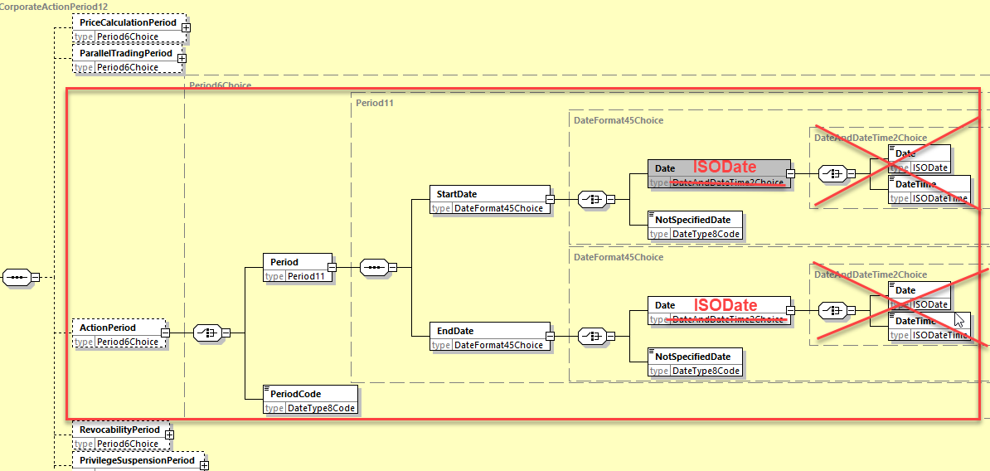

**Working Group Meeting**

|  |
| --- |
| **Discussion** |
| UK provided further clarification on the request for the change since if periods (69a Period) are used with date and time, then it should also accommodate the UTC time for all of them; else, time should be removed from most of or all the period qualifiers.  DE and LU are in favour of removing Time instead of adding a UTC time to the existing format options.  The US uses the time component in a few selected cases like PWAL (Period of Action), REVO (Revocability Period) and AREV (Account Servicer Revocability Period). But otherwise agree that it is rather strange to use time in periods.  The CA SWG finally agreed to reject the change for SR2025 and to postpone it to SR2026, to have more time to analyse and discuss further the details of the changes required with the SMPG CA WG and to revise the wording of the change for next year. |
| **Decision** |
| **Rejected.** |

## CR 002079: Add New Proration Indicator in CA Notification for Instructions below MIEX

|  |  |
| --- | --- |
| **Origin of request** | |
| Requesting Country: |  |
| Requesting Group: | SMPG |
| **Sponsors** | |
| SMPG | |
| **Message type(s) impacted** | |
| MT 564, seev.031 | |
| **Complies with regulation** | |
| None | |
| **Business impact of this request** | |
| LOW | |
| **Commitment to implement the change** | |
| Number of messages sent and received: 20000000  Percentage of messages impacted: 1  Commits to implement and when: SMPG in SR 2025 | |
| **Business context** | |
| When an elective event is subject to proration, the following scenario can occur:  The account owner instructs a quantity higher than the minimum quantity to instruct (MIEX) but after proration, the instruction is reduced to a quantity below the MIEX. In this case, the following scenario can apply:  (1) the instruction is rejected  (2) the instruction is not prorated and accepted in full with its original quantity.  (3) the instruction is prorated to the minimum quantity to instruct.  It is currently not possible to specify in the CA notification which process will be applied. | |
| **Nature of change** | |
| A new indicator should be added in the CA announcement (MT564/seev.031), at option level, to indicate how instructions prorated below the minimum quantity to instruct (MIEX) will be processed.  Indicator: PRMN - Proration below minimum quantity - Indicates how instructions prorated below the minimum quantity to instruct (MIEX) will be processed.  Values:  - REJT: Reject - Instructions will be rejected  - FULL: Accept in full - Instructions will be accepted in full (with their original quantity of securities instructed)  - MIEX: Minimum quantity - Instructions will be accepted but reduced to the minimum quantity to instruct (MIEX)  - UKNW - Unknown - The processing of instructions prorated below the minimum quantity to instruct is unknown | |
| **Examples** | |
|  | |

**Workaround**

|  |
| --- |
| This information is either not provided in the announcement or it can be part of the ADTX. |

**SWIFT Comment**

|  |
| --- |
|  |

**Standards Illustration**

**1. ISO 15022 Illustration**

**In the MT 564, in sequence E (at option level), add a new optional 22F indicator qualifier called “Proration Below Minimum Quantity Indicator” (“PRMN”) for, with values “REJT”, “FULL”, “MILT”, “MIEX”, “UKWN”, as defined and illustrated below:**

**MT 564 Field Specifications**

61. Field 22F: Indicator

FORMAT

|  |  |  |
| --- | --- | --- |
| Option F | :4!c/[8c]/4!c | (Qualifier)(Data Source Scheme)(Indicator) |

PRESENCE

Mandatory in optional sequence E

QUALIFIER

(Error code(s): T89)

(Error code(s): T89)

| **Order** | **M/O** | **Qualifier** | **R/N** | **CR** | **Options** | **Qualifier Description** |
| --- | --- | --- | --- | --- | --- | --- |
| 1 | M | CAOP | N | C5, C23 | F | Corporate Action Option Code Indicator |
| 2 | O | DISF | N |  | F | Disposition of Fractions Indicator |
| 3 | O | OFFE | R | C27, C28 | F | Offer Type Indicator |
| 4 | O | OPTF | R | C20 | F | Option Features Indicator |
| 5 | O | OSTA | N |  | F | Option Status |
| 6 | O | CETI | R |  | F | Certification/Breakdown Type Indicator |
| 7 | O | BIRI | N |  | F | Bid Range Type Indicator |
| **8** | **O** | **PRMN** | **N** |  | **F** | **Proration Below Minimum Quantity Indicator** |

DEFINITION

This qualified generic field specifies:

|  |  |  |
| --- | --- | --- |
| BIRI | Bid Range Type Indicator | Specifies the type of acceptable bid range values. |
| CAOP | Corporate Action Option Code Indicator | Specifies the corporate action options available to the account owner. |
| CETI | Certification/Breakdown Type Indicator | Specifies the type of certification/breakdown. |
| DISF | Disposition of Fractions Indicator | Specifies how fractions resulting from derived securities will be processed or how prorated decisions will be rounding, if provided with a pro ration rate. |
| OFFE | Offer Type Indicator | Specifies the conditions that apply to the offer. |
| OPTF | Option Features Indicator | Specifies the features that may apply to a corporate action option. |
| OSTA | Option Status | Specifies the status of the option. |
| **PRMN** | **Proration Below Minimum Quantity Indicator** | **Specifies how instructions prorated below the minimum quantity to instruct will be processed.** |

**CODES**

**If Qualifier is PRMN and Data Source Scheme is not present, Indicator must contain one of the following codes (Error code(s): K22):**

|  |  |  |
| --- | --- | --- |
| **FULL** | **Accepted in Full** | **Instructions will be accepted in full (with their original quantity of securities instructed).** |
| **MILT** | **Multiple Quantity** | **Instructions will be accepted but rounded up or down to the specified minimum multiple quantity to instruct according to the value of the disposition of fraction indicator.** |
| **MIEX** | **Minimum Quantity** | **Instructions will be accepted but prorated to the minimum quantity to instruct.** |
| **REJT** | **Rejected** | **Instructions will be rejected.** |
| **UKWN** | **Unknown** | **Processing of instructions prorated below the minimum quantity to instruct is unknown.** |

**2. ISO 20022 Illustration**

**1. In the seev.031 (CANO – CorporateActionNotification)** message, in the building block CorporateActionOptionDetails, add the new optional and non-repeatable element **“ProrationBelowMinimumQuantity”**, with code values **“REJT”, “FULL”, “MIEX”, “MILT”, “UKWN”,** as defined for ISO 15022 above and as illustrated below:

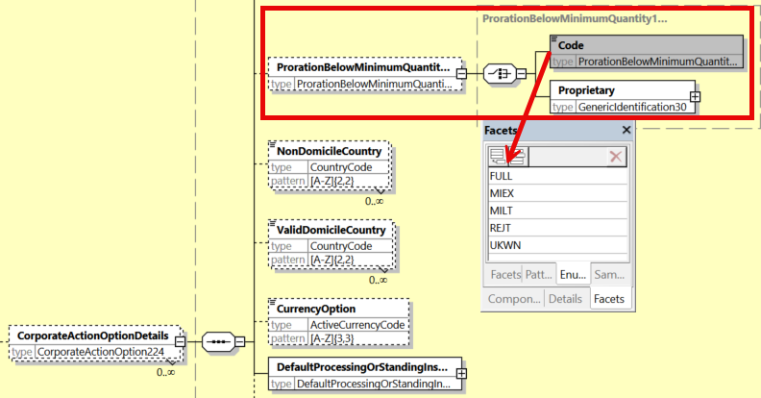

**Working Group Meeting**

|  |
| --- |
| **Discussion** |
| The CA SWG agreed with the business case.  As regards to the solution proposed, the SWG agreed that an additional code for the new PRMN qualifier is required. The code MILT (Multiple Quantity) should be added and the definition of the codes should be improved (as illustrated above) to better describe what happens to the instructions falling below MIEX or MILT.  CH suggests also that whenever an option is prorated, unless FULL or REJT, rounding information should be provided for MIEX and MILT via the DISF indicator present in the message.  Finally, the SWG resolved to vote on the reviewed solution for the CR. The CR was approved unanimously minus 1 vote.  The SWG requests the SMPG CA WG to provide a robust market practice for the usage of this new PRMN indicator. |
| **Decision** |
| **Approved with comments.** |

## CR 002102: Add Fiscal Year Date in CA Event Details

|  |  |
| --- | --- |
| **Origin of request** | |
| Requesting Country: |  |
| Requesting Group: | SMPG |
| **Sponsors** | |
| SMPG members | |
| **Message type(s) impacted** | |
| MT 564, seev.031 | |
| **Complies with regulation** | |
| None | |
| **Business impact of this request** | |
| LOW | |
| **Commitment to implement the change** | |
| Number of messages sent and received: 20000000  Percentage of messages impacted: 1  Commits to implement and when: SMPG in SR 2025 | |
| **Business context** | |
| For dividend events there is a need to understand which fiscal year the dividend pertains to in order to be able to deduct correct taxes for residents. In the old days companies would pay dividend once a year, this would be approved by the general assembly and paid as soon as possible after the approval at the general meeting. The D-block 98::MEET date would be sufficient, to point to the decisions data and therefore also the fiscal year to determine the tax rate.  The taxes for residents vary from year to year in Norway, and the tax deducted is determined based on the decision date for the payment.  Today companies often pay dividends up to 4 times a year. Where the board of directors would receive an authorization to decide the future payments from the general meeting, if the company reached its income goals. It is the date that the board has their board meeting and decided that dividends will be paid (based on the authorization given at the general meeting) which becomes the decision date. The tax rate of the fiscal tax year the decision is taken, will set the in applicable resident tax rate for the dividend.  Example:  The general meeting decides to have 4 dividends a year and will also be approved at the general meeting or by granting board of director’s authorization to decide the future payments.  Typically, q1 earnings gives q2 dividend which is approved at the general meeting (dividend no 1),  q2 earnings gives q3 payment (dividend no2) and, q3 earnings gives q4 payment (dividend no3)  Dividend number 1,2 and 3 is in the same fiscal year as the general meeting was held.  For the q4 earnings which gives the q1 payment, this decision is taken in a new fiscal tax year. The 4th dividend based on the q4 earnings will be taxable next tax year for residents. | |
| **Nature of change** | |
| New date period “FITY” to define fiscal tax year (when different from current)  Add 1 new Optional period code FITY (Fiscal Tax year) in the MT 564 in sequence D and in seev.031 (CANO – CorporateActionNotification) message (element to be added)  FITY Fiscal Year / Tax Year  MT564: (44) Field 69a: Period  With a period, qualifier you can better reflect a whole year (or some other period if other use cases arise) but in theory it could be also used to reflect a specific date if needed::  :69A::FITY//20230101/20231231  or  :69A::FITY//20230506/20230506 | |
| **Examples** | |
|  | |

**Workaround**

|  |
| --- |
|  |

**SWIFT Comment**

|  |
| --- |
|  |

**Standards Illustration**

**1. ISO 15022 Illustration**

**In the MT 564, in sequence D, add a new optional period qualifier “FITY” (Fiscal Year Period), as defined and illustrated below:**

**MT 564 Field Specifications**

48. Field 69a: Period

FORMAT

|  |  |  |
| --- | --- | --- |
| Option A | :4!c//8!n/8!n | (Qualifier)(Date)(Date) |
| Option B | :4!c//8!n6!n/8!n6!n | (Qualifier)(Date)(Time)(Date)(Time) |
| Option C | :4!c//8!n/4!c | (Qualifier)(Date)(Date Code) |
| Option D | :4!c//8!n6!n/4!c | (Qualifier)(Date)(Time)(Date Code) |
| Option E | :4!c//4!c/8!n | (Qualifier)(Date Code)(Date) |
| Option F | :4!c//4!c/8!n6!n | (Qualifier)(Date Code)(Date)(Time) |
| Option J | :4!c//4!c | (Qualifier)(Date Code) |

PRESENCE

Optional in optional sequence D

QUALIFIER

(Error code(s): T89)

| **Order** | **M/O** | **Qualifier** | **R/N** | **CR** | **Options** | **Qualifier Description** |
| --- | --- | --- | --- | --- | --- | --- |
| 1 | O | PRIC | N |  | A, B, C, D, E, F, or J | Price Calculation Period |
| 2 | O | INPE | N |  | A, B, C, D, E, F, or J | Interest Period |
| … |  |  |  |  |  |  |
| **16** | **O** | **FITY** | **N** |  | **A, C, E, or J** | **Fiscal Year Period** |

DEFINITION

This qualified generic field specifies:

|  |  |  |
| --- | --- | --- |
| BOCL | Book Closure Period | Period defining the last date on which shareholder registration will be accepted by the issuer and the date on which shareholder registration will resume. |
| CLCP | Claim Period | Period assigned by the court in a class action. It determines the client's eligible transactions that will be included in the class action and used to determine the resulting entitlement. |
| … | … | … |
| **FITY** | **Fiscal Year Period** | **Period defining the fiscal or tax year the dividend pertains to in order to correctly deduct taxes for residents.** |
| INPE | Interest Period | Period during which the interest rate has been applied. |
| PRIC | Price Calculation Period | Period during which the price of a security is determined. |
| SPLP | Split Period | Period during which a physical certificate can be split. |

**2. ISO 20022 Illustration**

**1. In the seev.031 (CANO – CorporateActionNotification)** message, in the building block CorporateActionDetails, add new optional and non-repeatable element **“FiscalYearPeriod”** to the optional field **Period Details.** The new “Fiscal Year” element may bedefined as choice element allowing for a period defined by start and end date or for a period code, as defined for ISO 15022 above and as illustrated below:

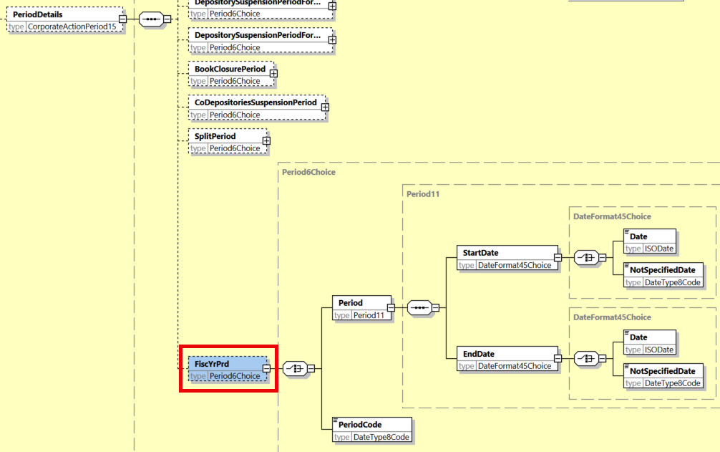

**Working Group Meeting**

|  |
| --- |
| **Discussion** |
| The CA SWG agreed with the business case and with the initial solution proposed slightly amended by removing the format options B, D and F to allow for a date only (without time).  DE raised the point that additional tax requirements will be needed in future when the EU Directive FASTER comes into play, but this cannot be planned yet, while this CR details a specific requirement. |
| **Decision** |
| **Approved.** |

## CR 002099: Add Dutch Auction Indicator in CA Notification

|  |  |
| --- | --- |
| **Origin of request** | |
| Requesting Country: | GB United Kingdom |
| Requesting Group: |  |
| **Sponsors** | |
| UK based Major Custodians | |
| **Message type(s) impacted** | |
| MT 564, seev.031 | |
| **Complies with regulation** | |
| None | |
| **Business impact of this request** | |
| MEDIUM | |
| **Commitment to implement the change** | |
| Number of messages sent and received: 1  Percentage of messages impacted:1  Commits to implement and when: UK based Major Custodians in SR 2025 | |
| **Business context** | |
| Dutch Auction events can be split into two categories, modified and unmodified. Each of these are processed differently, yet currently there is no indicator/qualifier that denotes whether a DTCH is modified or unmodified with this information being carried in narratives.  We would like to request a qualifier to record this information in a structured manner so to facilitate straight through processing | |
| **Nature of change** | |
| We would like to have a new qualifier in sequence D of the MT564 (to be used only for DTCH events) to record whether the Dutch Auction is modified or not. We would propose the following codes:  MDFD - Modified Dutch Auction  UNMD - Unmodified Dutch Auction. | |
| **Examples** | |
|  | |

**Workaround**

|  |
| --- |
| Narrative. |

**SWIFT Comment**

|  |
| --- |
|  |

**Standards Illustration**

**1. ISO 15022 Illustration**

**In the MT 564, in sequence D, add new optional and non-repeatable qualifier “Dutch Auction Type Indicator” (to be used for DTCH events only) to indicator field 22F, with codes “MDFD” (i.e. Modified Dutch Auction) and “UNMD” (i.e. Unmodified Dutch Auction), as defined and illustrated as follows:**

**MT 564 Field Specifications**

55. Field 22F: Indicator

FORMAT

|  |  |  |
| --- | --- | --- |
| Option F | :4!c/[8c]/4!c | (Qualifier)(Data Source Scheme)(Indicator) |

PRESENCE

Optional in optional sequence D

QUALIFIER

(Error code(s): T89)

| **Order** | **M/O** | **Qualifier** | **R/N** | **CR** | **Options** | **Qualifier Description** |
| --- | --- | --- | --- | --- | --- | --- |
| 1 | O | DIVI | N |  | F | Dividend Type Indicator |
| 2 | O | CONV | N |  | F | Event Sequence Type Indicator |
| … |  |  |  |  |  |  |
| 16 | O | CONS | N |  | F | Consent Type Indicator |
| 17 | O | INFO | N |  | F | Information Type Indicator |
| **18** | **O** | **DTCH** | **N** |  | **F** | **Dutch Auction Type Indicator** |

DEFINITION

This qualified generic field specifies:

|  |  |  |
| --- | --- | --- |
| ADDB | Additional Business Process Indicator | Specifies the additional business process linked to a corporate action event such as a claim compensation or tax refund. |
| CEFI | Certification Format Indicator | Specifies the certification format required, that is, physical or electronic format. |
| CHAN | Change Type Indicator | Specifies the type of change announced. |
| CONS | Consent Type Indicator | Specifies the type of consent announced. |
| CONV | Event Sequence Type Indicator | Specifies whether the event is an interim or a final event in a series of predefined or planned events of the same type and for the same underlying instrument. |
| DITY | Occurrence Type Indicator | Specifies the conditions in which the instructions and/or payment of the proceeds occurs. |
| DIVI | Dividend Type Indicator | Specifies the conditions in which a dividend is paid. |
| **DTCH** | **Dutch Auction Type Indicator** | **Specifies whether a Dutch auction is modified or unmodified.** |
| …. | … | … |
| TNDP | Tax On Non-Distributed Proceeds Indicator | Specifies the tax regulation being attributed to the non-distributed proceeds event or to any other event. |

CODES

**If Qualifier is DTCH and Data Source Scheme is not present, Indicator must contain one of the following codes (Error code(s): K22):**

|  |  |  |
| --- | --- | --- |
| **MDFD** | **Modified** | **All instructions are accepted at the same price (issuer bid).** |
| **UNMD** | **Unmodified** | **All instructions are accepted at the instructed price (offering bid).** |

**2. ISO 20022 Illustration**

**1. In the seev.031 (CANO – CorporateActionNotification)** message, in the building block CorporateActionDetails, add new optional and non-repeatable indicator element **“DutchAuction Type”,** typed by *DutchAuctionTypeFormat2Choice*, with embedded codes values **“MDFD”** and **“UNMD”** or proprietary code, as defined for ISO 15022 above and as illustrated below:

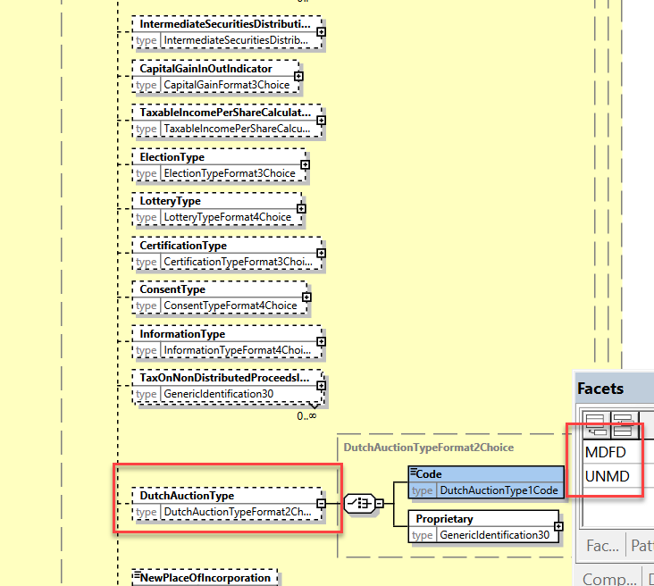

**Working Group Meeting**

|  |
| --- |
| **Discussion** |
| The CA SWG agreed with the business case and the proposed solution provided that the definitions of “Modified” vs. “Unmodified” are more explicit as agreed below:  *Modified = all instructions are accepted at same price (issuer bid).*  *Unmodified = all instructions are accepted at the instructed price (offering bid).*  UK indicates that the majority of Dutch Auctions are “unmodified” (60%) and only 40% are “modified”. |
| **Decision** |
| **Approved with comments.** |

## CR 002140: Add New Forfeiture of Interest Flag in Notification

|  |  |
| --- | --- |
| **Origin of request** | |
| Requesting Country: | US United States of America |
| Requesting Group: |  |
| **Sponsors** | |
| ISITC, SIFMA | |
| **Message type(s) impacted** | |
| MT 564, seev.031 | |
| **Complies with regulation** | |
| None | |
| **Business impact of this request** | |
| MEDIUM | |
| **Commitment to implement the change** | |
| Number of messages sent and received: 500  Percentage of messages impacted: 50  Commits to implement and when: DTCC, SIFMA in SR 2025 | |
| **Business context** | |
| In certain events, a bondholder can forfeit their interest payment if they elect during a certain time period typically between record and payable date. Forfeiture of interest can influence or delay an investment decision for the bondholder. It is something they need to consider when evaluating the economics of the event or decide when to elect in order to receive their interest payment. By delaying a few days, the bond holder can receive the entitlements of the offer coupled with their interest payment which could be material depending on the size of their position. In addition, it may not be intuitive to some holders that holding the contra CUSIP (i.e. place holder security) doesn’t entitle you to the interest payment. | |
| **Nature of change** | |
| New Yes / No indicator (:17B: Flag Forfeiture of Interest) at Event level to indicate that Bondholders who covert between Record Date and Payable Date will forfeit their interest. This can either be in the form of accrued interest or the on-cycle payment. This terminology is directly within the offering material of the event and is being requested to replace such terms in the narrative of the announcement. | |
| **Examples** | |
|  | |

**Workaround**

|  |
| --- |
| There is no such field that exists today. One flag Accrued Interest only states whether the bondholder is entitled to accrued interest. It does not state that while they may be entitled to it, they may be forfeiting it by converting. |

**SWIFT Comment**

|  |
| --- |
|  |

**Standards Illustration**

**1. ISO 15022 Illustration**

**In the MT 564, in sequence D, add new qualifier “Forfeiture of Interest” to the 17B Flag field, as defined and illustrated below:**

**MT 564 Field Specifications**

54. Field 17B: Flag

FORMAT

|  |  |  |
| --- | --- | --- |
| Option B | :4!c//1!a | (Qualifier)(Flag) |

PRESENCE

Optional in optional sequence D

QUALIFIER

(Error code(s): T89)

| **Order** | **M/O** | **Qualifier** | **R/N** | **CR** | **Options** | **Qualifier Description** |
| --- | --- | --- | --- | --- | --- | --- |
| 1 | O | CERT | N |  | B | Certification/Breakdown Flag |
| 2 | O | RCHG | N |  | B | Charges Flag |
| 3 | O | COMP | N |  | B | Information to be Complied With |
| 4 | O | ACIN | N |  | B | Accrued Interest Indicator |
| 5 | O | LEOG | N |  | B | Letter of Guaranteed Delivery Flag |
| 6 | O | SRDC | N |  | B | Shareholder Rights Directive Indicator |
| **7** | **O** | **FORI** | **N** |  | **B** | **Forfeiture of Interest Flag** |

DEFINITION

This qualified generic field specifies:

|  |  |  |
| --- | --- | --- |
| ACIN | Accrued Interest Indicator | Indicates whether the holder is entitled to accrued interest. |
| CERT | Certification/Breakdown Flag | Indicates whether certification/breakdown is required. |
| COMP | Information to be Complied With | Indicates whether restrictions apply to the event. |
| **FORI** | **Forfeiture of Interest Flag** | **Indicates that bondholders who convert between record date and payable date will forfeit their interest.** |
| LEOG | Letter of Guaranteed Delivery Flag | Indicates whether a letter of guaranteed delivery can be submitted in order to participate in the offer on full eligible position. It is not intended for use in situations arising from failed or late trades. |

**2. ISO 20022 Illustration**

**1. In the seev.031 (CANO – CorporateActionNotification)** message, in the building block CorporateActionDetails, add new optional and non-repeatable indicator element **“Forfeiture OfInterestIndicator”,** typed by a YesNoIndicator, as defined for ISO 15022 above and as illustrated below:

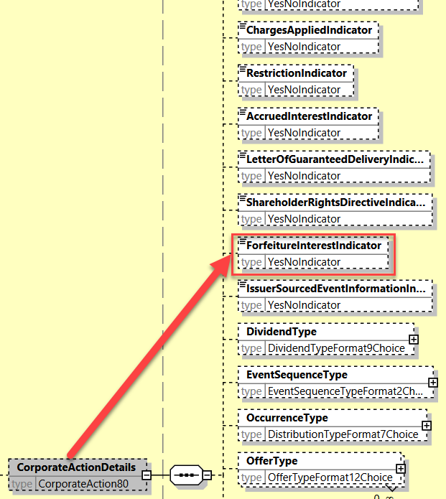

**Working Group Meeting**

|  |
| --- |
| **Discussion** |
| For IT, the market feedback is that the implementation solution is too complicated for the volume that would benefit from the change request. IT does not see a valid business case.  The rest of the CA SWG agreed with the business case and agreed with the proposed implementation solution.  Additionally, the SWG requests the SMPG CA WG to create a market practice for the usage of the new element. |
| **Decision** |
| **Approved as is.** |

## CR 002098: Add Price Calculation Method in CA Notification

|  |  |
| --- | --- |
| **Origin of request** | |
| Requesting Country: |  |
| Requesting Group: | SMPG |
| **Sponsors** | |
| SMPG, ISITC, SIFMA | |
| **Message type(s) impacted** | |
| MT 564, seev.031 | |
| **Complies with regulation** | |
| None | |
| **Business impact of this request** | |
| MEDIUM | |
| **Commitment to implement the change** | |
| Number of messages sent and received: 20000000  Percentage of messages impacted: 1  Commits to implement and when: SMPG, DTCC, SIFMA, major global custodians in SR 2025 | |
| **Business context** | |
| Following a request from SIFMA and DTCC, SMPG has identified the need to report the price calculation method, to allow holders to know which price methodology has been followed to define the price.  In particular, the following type of prices have been identified:  1) VWAP - Volume Weighted Average Price - Definition: Indicates whether the rate is based on a Volume-weighted average price which is a ratio of the cumulative share price to the cumulative volume traded over a given time period.  2) NAV - Net Asset Value - net value of an investment funds assets less its liabilities, divided by the number of shares outstanding  3) Average Closing Price - Closing price of the asset on a given d ay  4) Final asset value at the liquidation of the fund  5) Mid-market price a certain amount of time prior the date its announced | |
| **Nature of change** | |
| In the MT564 / CANO seev.031 - Cash Movement E2, we would like to add :22A Indicator Price Calculation Indicator  The following codes should be available:  VWAP: Volume-weighted average price - Indicates whether the rate is based on a Volume-weighted average price which is a ratio of the cumulative share price to the cumulative volume traded over a given time period.  NAVL: Net value of an investment funds assets less its liabilities, divided by the number of shares outstanding.  AVCL: Closing price of the asset on a given day  Final asset value at the liquidation of the fund  Mid-market price a certain amount of time prior the date its announced. | |
| **Examples** | |
|  | |

**Workaround**

|  |
| --- |
| Currently this is provided within narrative. |

**SWIFT Comment**

|  |
| --- |
|  |

**Standards Illustration**

**1. ISO 15022 Illustration**

**In the MT 564, in sequence E2 (Cash movement), add new optional and non-repeatable qualifier “Price Calculation Method Indicator” (“PRCM)”, with code values “VWAP”, “NAVA”, “AVCL”, “NAVF” and “MIMP”, to the mandatory 22F Indicator field, as defined and illustrated below:**

**MT 564 Field Specifications**

95. Field 22a: Indicator

FORMAT

|  |  |  |
| --- | --- | --- |
| Option F | :4!c/[8c]/4!c | (Qualifier)(Data Source Scheme)(Indicator) |
| Option H | :4!c//4!c | (Qualifier)(Indicator) |

PRESENCE

Mandatory in optional subsequence E2

QUALIFIER

(Error code(s): T89)

| **Order** | **M/O** | **Qualifier** | **R/N** | **CR** | **Options** | **Qualifier Description** |
| --- | --- | --- | --- | --- | --- | --- |
| 1 | M | CRDB | N |  | H | Credit/Debit Indicator |
| 2 | O | CONT | N |  | H | Contractual Payment Indicator |
| 3 | O | NELP | N |  | F | Non Eligible Proceeds Indicator |
| 4 | O | ITYP | N | C29 | F | Type of Income |
| 5 | O | TXAP | N |  | F | Issuer/Offeror Taxability Indicator |
| 6 | O | ETYP | R |  | F | Type of Exemption |
| 7 | O | OTYP | R | C29 | F | Other Type of Income |
| **8** | **O** | **PRCM** | **N** |  | **F** | **Price Calculation Method Indicator** |

DEFINITION

This qualified generic field specifies:

|  |  |  |
| --- | --- | --- |
| CONT | Contractual Payment Indicator | Specifies exceptions to contractual payment service. |
| CRDB | Credit/Debit Indicator | Specifies whether the value is a debit or credit. |
| ETYP | Type of Exemption | Specifies the basis for the reduced rate of withholding. |
| ITYP | Type of Income | Specifies the type of income. |
| NELP | Non-Eligible Proceeds Indicator | Specifies information regarding outturn resources that cannot be processed by the CSD. Special delivery instruction is required from the account owner for the CA outcome to be credited. |
| OTYP | Other Type of Income | Type of income to be used under another tax regime. |
| **PRCM** | **Price Calculation Method Indicator** | **Specifies the method applied for the calculation of the price.** |
| TXAP | Issuer/Offeror Taxability Indicator | Proceeds are taxable according to the information provided by the issuer/offeror. |

**CODES**

**In option F, if Qualifier is PRCM, and Data Source Scheme is not present, Indicator must contain one of the following codes (Error code(s): K22):**

|  |  |  |
| --- | --- | --- |
| **AVCL** | **Average Closing Price** | **Price of the asset at close of a given day.** |
| **MIMP** | **Mid-Market Price** | **Price at a certain amount of time prior to the date it is announced.** |
| **NAVA** | **Net Asset Value** | **Net value of an investment fund's assets less its liabilities, divided by the number of shares outstanding.** |
| **NAVF** | **Final Asset Value** | **Final asset value at the liquidation of the fund.** |
| **VWAP** | **Volume Weighted Average Price** | **The price is based on a volume-weighted average price which is a ratio of the cumulative share price to the cumulative volume traded over a given time period.** |

**2. ISO 20022 Illustration**

**1. In the seev.031 (CANO – CorporateActionNotification)** message, in the building block CorporateActionOptionDetails, add new optional and non-repeatable indicator element **“PriceCalculationMethod”,** typed by a *PriceCalculationMethodIndicator2Choice*, with **code values “AVCL”, “MIMP”, “NAVA”, “NAVF” and “VWAP”,** as defined for ISO 15022 above and as illustrated below:

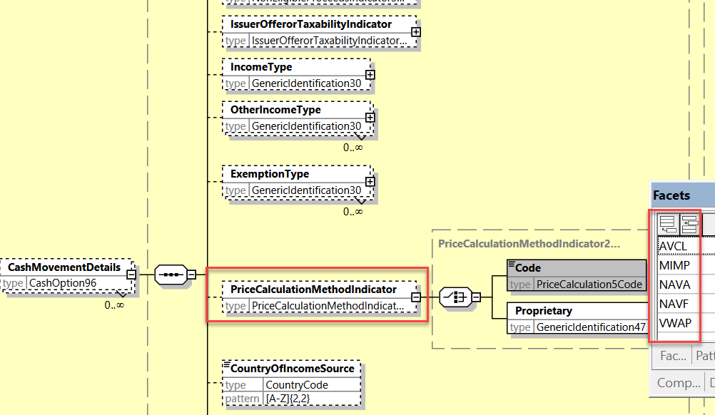

**Working Group Meeting**

|  |
| --- |
| **Discussion** |
| For DE and IT, the calculation method code proposed definitions are too generic and do not provide sufficient information on the actual calculation methods, e.g. for VWAP on how the volume weighted average price is calculated and for AVCL (e.g. which volumes on which markets/OTC, closing price on which market?).  Nevertheless, DE agrees with the US on the requirement for the proposed change but is not in favour of the change request until further analysis is conducted.  For the UK and IE, the prospectus can always be consulted to get further information on the calculation methods. Today this information is given in a narrative.  CH comments that the proposed solution is a good starting point to improve current free text/narrative and if further improvement would be required in the future, a respective CR can be raised to build on the current solution proposed.  For the US, what is being proposed is useful to a broad community.  Finally, the SWG resolved to vote on the CR.  The CR was approved by 11 votes in favour and 3 votes against (DE, IT, FR). |
| **Decision** |
| **Approved as is.** |

## CR 002159: Add New Acceptance Priority Type and Acceptance Priority Level Code

|  |  |
| --- | --- |
| **Origin of request** | |
| Requesting Country: | US United States of America |
| Requesting Group: |  |
| **Sponsors** | |
| ISITC, SIFMA | |
| **Message type(s) impacted** | |
| MT 564, seev.031, seev.035, seev.009 | |
| **Complies with regulation** | |
| None | |
| **Business impact of this request** | |
| MEDIUM | |
| **Commitment to implement the change** | |
| Number of messages sent and received: 3500  Percentage of messages impacted: 5  Commits to implement and when: DTCC, SIFMA in SR 2025 | |
| **Business context** | |
| New Offer Type Acceptance Priority is being requested to cover scenarios in the US market for certain events (e.g. Tender Offers (events subject to proration), Exchange Offers) in which higher tier investors receive payment ahead of lower tier investors. Within Corporate Action Announcements, there would be multiple events with each security that would have a designated priority in which today such information is displayed in narrative to state the acceptance priority level of the given security for the given offer.  SIFMA and DTCC are proposing to eliminate such narrative and create two new fields to strengthen the standard and provide better automation. A new Offer Type, Acceptance Priority and a new field Acceptance Priority Level. These two fields must be used in conjunction with each other in that the Offer Type must be present and it should state at which priority level within the event. | |
| **Nature of change** | |
| New Sequence D Offer Type - Acceptance Priority  Definition – Indicates that this event will be paid in a particular priority stated in the offering documentation. Higher Tiers of securities will be paid ahead of lower tiers of securities in this offer type.  Sequence D – New Field Acceptance Priority Level (3 byte alpha numeric) -  Definition - Priority Level of the given offer to which will be accepted within the tiered structured of acceptance for the event. These events in many cases are subject to proration.  Rule Validation: These fields must be used in conjunction with each other as they are in the prospectus in the initial announcement of the event details. | |
| **Examples** | |
|  | |

**Workaround**

|  |
| --- |
| The only current narrative that exists is narrative. |

**SWIFT Comment**

|  |
| --- |
| If applicable as well for bankruptcy events; new code should be added to a different qualifier than OFFE? |

**Standards Illustration**

**1. ISO 15022 Illustration**

**A. In the MT 564, in sequence D, add new code value “Acceptance Priority (ACPR)” to qualifier OFFE under the indicator field 22F, as defined and illustrated below:**

**MT 564 Field Specifications**

55. Field 22F: Indicator

FORMAT

|  |  |  |
| --- | --- | --- |
| Option F | :4!c/[8c]/4!c | (Qualifier)(Data Source Scheme)(Indicator) |

PRESENCE

Optional in optional sequence D

QUALIFIER

(Error code(s): T89)

| **Order** | **M/O** | **Qualifier** | **R/N** | **CR** | **Options** | **Qualifier Description** |
| --- | --- | --- | --- | --- | --- | --- |
| 1 | O | DIVI | N |  | F | Dividend Type Indicator |
| 2 | O | CONV | N |  | F | Event Sequence Type Indicator |
| 3 | O | DITY | N |  | F | Occurrence Type Indicator |
| 4 | O | OFFE | R | C27, C28, **C33** | F | Offer Type Indicator |
| 5 | O | SELL | N |  | F | Renounceable Status of Entitlement Indicator |
| 6 | O | ESTA | R |  | F | Corporate Action Event Stage |
| … |  |  |  |  |  |  |
| 17 | O | TNDP | R |  | F | Tax On Non-Distributed Proceeds Indicator |

DEFINITION

This qualified generic field specifies:

|  |  |  |
| --- | --- | --- |
| ADDB | Additional Business Process Indicator | Specifies the additional business process linked to a corporate action event such as a claim compensation or tax refund. |
| CEFI | Certification Format Indicator | Specifies the certification format required, that is, physical or electronic format. |
| … | … | … |
| LOTO | Lottery Type | Specifies the type of lottery announced. |
| OFFE | Offer Type Indicator | Specifies the conditions that apply to the offer. |
| RHDI | Intermediate Securities Distribution Type Indicator | Intermediates securities distribution type. |
| SELL | Renounceable Status of Entitlement Indicator | Specifies whether terms of the event allow resale of the rights. |
| TDTA | TID/TIS Calculated Indicator | Specifies whether the fund calculates the taxable income per dividend/taxable income per share. |
| TNDP | Tax On Non-Distributed Proceeds Indicator | Specifies the tax regulation being attributed to the non-distributed proceeds event or to any other event. |

CODES

If Qualifier is OFFE and Data Source Scheme is not present, Indicator must contain one of the following codes (Error code(s): K22):

|  |  |  |
| --- | --- | --- |
| **ACPR** | **Acceptance Priority** | **Event will be paid in a particular priority stated in the offering documentation. Higher tiers of securities will be paid ahead of lower tiers of securities.** |
| DISS | Dissenter's Rights | Securities' holder has the right to disagree with a mandatory event. This right is not inherent in all offers and therefore must be noted in announcements only when applicable. |
| ERUN | Restriction Exchange | Exchange of Restricted to Unrestricted (or vice versa). |
| FCFS | First Come First Served | Securities will be accepted in the order they have been submitted until the target number of quantity sought is reached. |
| FINL | Final Offer | Final or last offer to holders subject to offer conditions being reached, for example, 50% accepted on a tender. |
| NDIS | Dissenter's Rights Not Applicable | Dissenter's rights are not applicable for this offer. |
| PART | Partial Offer | Partial offer. |
| SQUE | Squeeze Out Bid | Offer launched by a company, in possession of a large number of the shares (90% - 95%) of a company (generally as a result of a tender offer), in order to acquire the remaining shares of that company. |

**B. In the MT 564, in sequence D, add new optional and non-repeatable qualifier “Acceptance Priority Level (ACPL)” to field 13a: Number Identification, as defined and illustrated below:**

**MT 564 Field Specifications**

53. Field 13a: Number Identification**~~: Coupon Number~~**

FORMAT

|  |  |  |
| --- | --- | --- |
| Option A | :4!c//3!c | (Qualifier)(Number Id) |
| Option B | :4!c/[8c]/30x | (Qualifier)(Data Source Scheme)(Number) |

PRESENCE

Optional in optional sequence D

QUALIFIER

(Error code(s): T89)

| **Order** | **M/O** | **Qualifier** | **R/N** | **CR** | **Options** | **Qualifier Description** |
| --- | --- | --- | --- | --- | --- | --- |
| 1 | O | COUP | R |  | A or B | Coupon Number |
| **2** | **O** | **ACPL** | **N** | **C33** | **A** | **Acceptance Priority Level** |

DEFINITION

This qualified generic field specifies:

|  |  |  |
| --- | --- | --- |
| COUP | Coupon Number | Number of the coupon attached/associated with a security. |
| **ACPL** | **Acceptance Priority Level** | **Level of priority of the given offer which will be accepted by the issuer/agent within the tiered structure of the event. Offer events in many cases are subject to proration.** |

**C. In the MT 564, add new NVR,** **to link the presence of the new PRAC qualifier to the presence of the ACPR offer type code:**

**C33**

**In sequence D, if field :13A::ACPL is present, then in sequence D, field :22F::OFFE//ACPR must be present (Error code(s): EXX).**

| **In sequence D, if field :13a::ACPL is ...** | **Then in sequence D, field :22F::OFFE//ACPR is ...** |
| --- | --- |
| **Present** | **Mandatory** |
| **Not present** | **Not allowed** |

**2. ISO 20022 Illustration**

**In the seev.031 (CANO – CorporateActionNotification)** message, in the building block CorporateActionDetails and CorporateActionOptionDetails

**And in the seev.035 (CAFÉ – CorporateActionMovementPreliminaryAdvice)** message, in the building block CorporateActionMovementDetails

**And in the seev.009 (AgentCorporateActionNotificationAdvice)** message, in the building block CorporateActionDetails and CorporateActionOptionDetails

* add new code **“ACPR” (Acceptance Priority)** to the data type code list *OfferType4Code*, data typing the “OfferType”/Code element, as defined for ISO 15022 above and as illustrated below;
* add new optional and non-repeatable element **“Acceptance Priority Level” (ACPL),** typed by *Exact3UpperCaseAlphaNumericText*, as defined for ISO 15022 above and as illustrated below;
* Add new Cross Element Complex rule named ***AcceptancePriorityLevel1Rule***to link the presence of the new “Acceptance Priority Level” element to the presence of the ACPR offer type code as follows: *If CorporateActionDetails/OfferType/Code value is ACPR (Acceptance Priority), then CorporateActionDetails/AcceptancePriorityLevel must be present.*

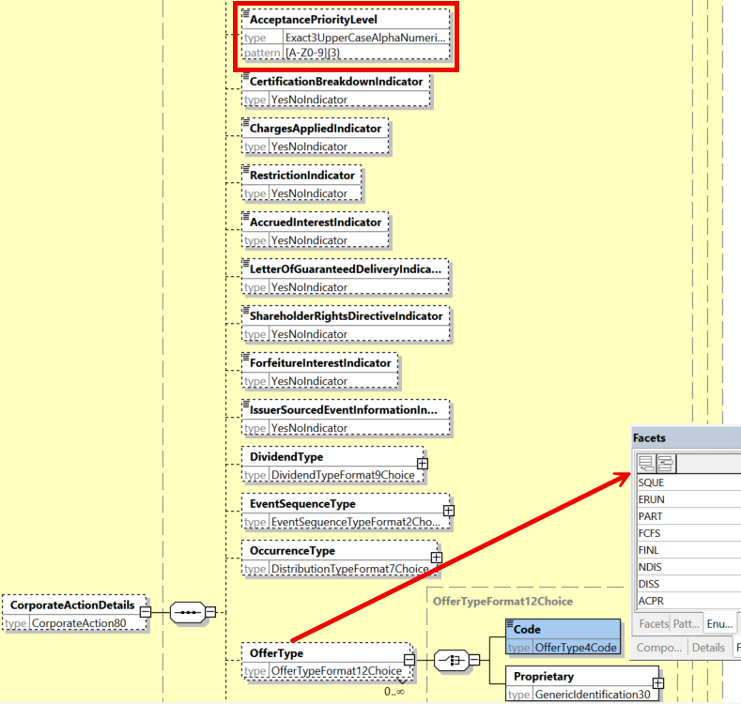

**Working Group Meeting**

|  |
| --- |
| **Discussion** |
| The CA SWG agreed on the business case and on the proposed solution slightly amended with the Acceptance Priority code changed from PRIO to ACPR and the definitions slightly amended.  It is confirmed that the format of the Acceptance Priority Level element accommodates alpha numeric characters. |
| **Decision** |
| **Approved with comments.** |

## CR 002100: Amend Definitions of Some Tax Related Amounts and Rates

|  |  |
| --- | --- |
| **Origin of request** | |
| Requesting Country: |  |
| Requesting Group: | SMPG |
| **Sponsors** | |
|  | |
| **Message type(s) impacted** | |
| MT 564, MT 566, seev.031, seev.035, seev.036, seev.009 | |
| **Complies with regulation** | |
| None | |
| **Business impact of this request** | |
| MEDIUM | |
| **Commitment to implement the change** | |
| Number of messages sent and received: 20000000  Percentage of messages impacted: 1  Commits to implement and when: SMPG in SR 2025 | |
| **Business context** | |
| We would like to change some definitions to remove misunderstandings on the definition of GRSS and NETT as they are inconsistent with each other and not respecting the current market practice, where NET is equal to GRSS less any tax.  Moreover, as TXAP applies both to the securities and cash movement, the definition of TXBL should be updated. | |
| **Nature of change** | |
| We would like to:  1) change the definition of NETT amount - (19B) to:  short definition to: Net Amount long definition to - Amount of money after tax deductions have been made.  2) change the definition of NETT rate - (92B) to:  long definition to - Cash dividend amount after tax deductions have been made.  3) change the definition of GRSS rate - (92B) to:  long definition to - Cash dividend amount before tax deductions have been made.  4) change the definition of GRSS amount - (19B) to:  long definition to - Amount of money before any tax deductions have been made.  5) change the definition of TXBL as code for 22F::TXAP to:  long definition to - The proceeds are taxable. | |
| **Examples** | |
|  | |

**Workaround**

|  |
| --- |
| None. |

**SWIFT Comment**

|  |
| --- |
|  |

**Standards Illustration**

**1. ISO 15022 Illustration**

**For MT 564 and MT 566, amend the following definitions (short and/or long) as described and illustrated below:**

* **In sequence E2 of MT 564 and sequence D2 of the MT 566, in the field 19B: Amount, for qualifier NETT amend the short definition and long definition.**
* **In sequence E2 of MT 564 and sequence D2 of MT 566, in the field 19B: Amount, for qualifier GRSS amend the long definition.**
* **In sequence E and E2 of MT 564, in the field 92a: Rate, for qualifier NETT amend the short and long definition.**
* **In sequence E and E2 of MT 564, in the field 92a: Rate and in sequence D and D2 of MT 566, in the field 92a: Rate, for qualifier GRSS amend the short and long definition.**
* **In sequence D and D2 of MT 566, in the field 92a: Rate, for qualifier NETT amend the short and long definition.**
* **In sequence E and E2 of MT 564, in the field 92: Rate, for qualifier INTP amend the short and long definition.**
* **In sequence D and D2 of MT 566, in the field 92: Rate, for qualifier INTP amend the short and long definition.**
* **In sequence E1 and E2 of MT 564, for qualifier TXAP in the field 22a: Indicator, change long definition for 22F: Indicator TXBL (Taxable).**
* **In sequence D1 and D2 of MT 566, for qualifier TXAP in the field 22a: Indicator, change long definition for 22F: Indicator TXBL (Taxable).**

**MT 564 Field Specifications**

98. Field 19B: Amount

FORMAT

|  |  |  |
| --- | --- | --- |
| Option B | :4!c//3!a15d | (Qualifier)(Currency Code)(Amount) |

PRESENCE

Conditional (see rule C2) in optional subsequence E2

QUALIFIER

(Error code(s): T89)

| **Order** | **M/O** | **Qualifier** | **R/N** | **CR** | **Options** | **Qualifier Description** |
| --- | --- | --- | --- | --- | --- | --- |
| 1 | O | ENTL | N |  | B | Entitled Amount |
| 2 | O | RESU | N | C1 | B | Resulting Amount |
| 3 | O | OCMT | N |  | B | Original Currency and Ordered Amount |
| 4 | O | CAPG | N |  | B | Capital Gains Amount |
| 5 | O | INDM | N |  | B | Indemnity Amount |
| 6 | O | CINL | N |  | B | Cash in Lieu of Shares |
| 7 | O | CHAR | N |  | B | Charges/Fees Amount |
| 8 | O | FLFR | N |  | B | Fully Franked Amount |
| 9 | O | UNFR | N |  | B | Unfranked Amount |
| 10 | O | TXFR | N |  | B | Tax Free Amount |
| 11 | O | TXDF | N |  | B | Tax Deferred Amount |
| 12 | O | SOIC | N |  | B | Sundry/Other Income Amount |
| 13 | O | GRSS | N |  | B | Gross Amount |
| 14 | O | INTR | N |  | B | Interest Amount |
| 15 | O | MKTC | N |  | B | Market Claim |
| 16 | O | NETT | N |  | B | Net **~~Cash~~** Amount |
| 48 | O | DEFP | N |  | B | Deemed Fund Amount |
| 49 | O | DEIT | N |  | B | Deemed Interest Amount |
| 50 | O | DERY | N |  | B | Deemed Royalties Amount |
| 51 | O | BUYU | N |  | B | Buy Up Amount |

DEFINITION

This qualified generic field specifies:

|  |  |  |
| --- | --- | --- |
| ACRU | Accrued Interest Amount | Amount of interest that has been accrued in between coupon payment periods. |
| ATAX | Additional Tax Amount | Amount of additional taxes that cannot be categorised. |
| … |  |  |
| GRSS | Gross Amount | Amount of money before any **tax** deductions **~~and allowances~~** have been made. |
| INCO | Income Portion | Amount relating to the underlying security for which income is distributed. |
| INDM | Indemnity Amount | (Unique to France) Amount due to a buyer of securities dealt prior to ex date which may be subject to different rate of taxation. |
| INTR | Interest Amount | Amount of money representing a coupon payment. |
| LOCO | Local Broker's Commission | Local broker's commission. |
| MFDV | Manufactured Dividend/Payment | Amount of money that the borrower pays to the lender as a compensation. It does not entitle the lender to reclaim any tax credit and is sometimes treated differently by the local tax authorities of the lender. Also covers compensation/indemnity of missed dividend concerning early/late settlements if applicable to a market. |
| MKTC | Market Claim | Amount of money resulting from a market claim. |
| NETT | Net **~~Cash~~** Amount | Amount of money after **tax** deductions **~~and allowances~~** have been made**.~~, if any, that is, the total amount +/- charges/fees.~~** |
| NRAT | NRA Tax Amount | Amount of tax related income subject to NRA (Non-Resident Alien). |
| OCMT | Original Currency and Ordered Amount | Posting/settlement amount in its original currency when conversion from/into another currency has occurred. |
| PAMM | Paying/Sub-paying Agent Commission | Amount of paying/sub-paying agent commission. |

**MT 564 Field Specifications**

68. Field 92a: Rate

PRESENCE

Optional in optional sequence E

QUALIFIER

(Error code(s): T89)

| **Order** | **M/O** | **Qualifier** | **R/N** | **CR** | **Options** | **Qualifier Description** |
| --- | --- | --- | --- | --- | --- | --- |
| 1 | O | GRSS | R | C7, C8 | F, H, J, or K | Gross ~~Dividend~~ **Distribution** Rate |
| 2 | O | TAXR | R | C7, C8, C19 | A, F, K, or R | Withholding Tax Rate |
| 3 | O | ATAX | N |  | A, F, or K | Additional Tax |
| 4 | O | OVEP | N |  | A or K | Maximum Allowed Oversubscription Rate |
| 5 | O | PROR | N |  | A or K | Pro-Ration Rate |
| 6 | O | INTP | R |  | A, F, J, or K | **Gross** Interest Rate Used for Payment |
| 7 | O | TDMT | R |  | J | Taxable Income Per Dividend/Share |
| 8 | O | NETT | R | C7, C8 | F, H, J, or K | Net ~~Dividend~~ **Distribution** Rate |
| 9 | O | IDFX | N | C18 | B | Issuer Declared Exchange Rate |
| 10 | O | TXIN | N |  | A, F, or K | Tax on Income |
| 11 | O | WITL | R | C7, C8, C19 | A, F, K, or R | Second Level Tax |
| 12 | O | BIDI | N | C25 | A, F, K, or P | Bid Interval Rate |

DEFINITION

This qualified generic field specifies:

|  |  |  |
| --- | --- | --- |
| ATAX | Additional Tax | Rate used for additional tax that cannot be categorised. |
| BIDI | Bid Interval Rate | Acceptable price increment used for submitting a bid. |
| GRSS | Gross **~~Dividend~~** **Distribution** Rate | **~~Cash dividend~~Distribution** **~~amount~~** **rate** **~~per equity~~** before **tax** **~~deductions~~** **~~or allowances~~** ha**s~~ve~~** been **~~made~~ deducted**. |
| IDFX | Issuer Declared Exchange Rate | Exchange rate (provided by the issuer) between the dividend or interest rate in the paid currency and the declared dividend or interest rate. |
| INTP | **Gross** Interest Rate Used for Payment | The actual interest rate **before tax** used for the payment of the interest for the specified interest period. |
| NETT | Net **Distribution** **~~Dividend~~** Rate | **Distribution** **~~Cash dividend amount~~** **rate** **~~per equity~~** after **tax** **~~deductions~~** **~~or allowances~~** ha**s~~ve~~** been **~~made~~ deducted**. |
| OVEP | Maximum Allowed Oversubscription Rate | A maximum percentage of shares available through the over subscription privilege, usually a percentage of the basic subscription shares, for example, an account owner subscribing to 100 shares may over subscribe to a maximum of 50 additional shares when the over subscription maximum is 50%. |
| PROR | Pro-Ration Rate | Percentage of securities accepted by the offeror/issuer. |
| TAXR | Withholding Tax Rate | Percentage of a cash distribution that will be withheld by the tax authorities of the jurisdiction of the issuer, for which a relief at source and/or reclaim may be possible. |
| TDMT | Taxable Income Per Dividend/Share | Amount included in the dividend/NAV that is identified as gains directly or indirectly derived from interest payments, for example, in the context of the EU Savings directive. |
| TXIN | Tax on Income | Overall tax withheld at source by fund managers prior to considering the tax obligation of each unit holder. |
| WITL | Second Level Tax | Rate at which the income will be withheld by a jurisdiction other than the jurisdiction of the issuer's country of tax incorporation, for which a relief at source and/or reclaim may be possible. It is levied in complement or offset of the withholding tax rate (TAXR) levied by the jurisdiction of the issuer's tax domicile. |

**MT 564 Field Specifications**

100. Field 92a: Rate

FORMAT

|  |  |  |
| --- | --- | --- |
| Option A | :4!c//[N]15d | (Qualifier)(Sign)(Rate) |
| Option B | :4!c//3!a/3!a/15d | (Qualifier)(First Currency Code)(Second Currency Code)(Rate) |
| Option F | :4!c//3!a15d | (Qualifier)(Currency Code)(Amount) |
| Option H | :4!c//3!a15d/4!c | (Qualifier)(Currency Code)(Amount)(Rate Status) |
| Option J | :4!c/[8c]/4!c/3!a15d[/4!c] | (Qualifier)(Data Source Scheme)(Rate Type Code)(Currency Code)(Amount)(Rate Status) |
| Option K | :4!c//4!c | (Qualifier)(Rate Type Code) |
| Option M | :4!c//3!a15d/15d | (Qualifier)(Currency Code)(Amount)(Quantity) |
| Option R | :4!c/[8c]/4!c/15d | (Qualifier)(Data Source Scheme)(Rate Type Code)(Rate) |

PRESENCE

Optional in optional subsequence E2

QUALIFIER

(Error code(s): T89)

| **Order** | **M/O** | **Qualifier** | **R/N** | **CR** | **Options** | **Qualifier Description** |
| --- | --- | --- | --- | --- | --- | --- |
| 1 | O | ATAX | N |  | A, F, or K | Additional Tax |
| 2 | O | CHAR | N |  | A, F, or K | Charges/Fees |
| 3 | O | EQUL | N |  | F or K | Equalisation Rate |
| 4 | O | ESOF | N |  | A, F, K, or M | Early Solicitation Fee Rate |
| 5 | O | FISC | N |  | A or K | Fiscal Stamp |
| 6 | O | GRSS | R | C7, C8 | F, H, J, or K | Gross ~~Dividend~~ **Distribution** Rate |
| 7 | O | EXCH | N | C1 | B | Exchange Rate |
| 8 | O | INCE | N |  | A, F, or K | Third Party Incentive Rate |
| 9 | O | INTP | R |  | A, F, J, or K | **Gross** Interest Rate Used for Payment |
| 10 | O | NETT | R | C7, C8 | F, H, J, or K | Net ~~Dividend~~ **Distribution** Rate |
| … |  |  |  |  |  |  |
| 19 | O | DEEM | R | C7, C8 | A, F, J, K, or R | Deemed Rate |

DEFINITION

This qualified generic field specifies:

|  |  |  |
| --- | --- | --- |
| ATAX | Additional Tax | Rate used for additional tax that cannot be categorised. |
| CHAR | Charges/Fees | Rate used to calculate the amount of the charges/fees that cannot be categorised. |
| DEEM | Deemed Rate | Rate applied for the calculation of deemed proceeds which are not paid to security holders but on which withholding tax is applicable. |
| EQUL | Equalisation Rate | The portion of the fund distribution which represents the average accrued income included in the purchase price for units bought during the account period. |
| ESOF | Early Solicitation Fee Rate | Cash rate made available, as an incentive, in addition to the solicitation fee, in order to encourage early participation in an offer. |
| EXCH | Exchange Rate | Exchange rate between the amount and the resulting amount. |
| FISC | Fiscal Stamp | Percentage of fiscal tax to apply. |
| GRSS | Gross **~~Dividend~~** **Distribution** Rate | **~~Cash dividend~~Distribution** **~~amount~~** **rate** **~~per equity~~** before **tax** **~~deductions~~** **~~or allowances~~** ha**s~~ve~~** been **~~made~~ deducted**. |
| INCE | Third Party Incentive Rate | Cash rate made available in an event in order to encourage participation in the offer. As information, payment is made to a third party who has solicited an entity to take part in the offer. |
| INTP | **Gross** Interest Rate Used for Payment | The actual interest rate **before tax** used for the payment of the interest for the specified interest period. |
| NETT | Net **Distribution** **~~Dividend~~** Rate | **Distribution** **~~Cash dividend amount~~** **rate** **~~per equity~~** after **tax** **~~deductions~~** **~~or allowances~~** ha**s~~ve~~** been **~~made~~ deducted**. |

**MT 564 Field Specifications**

72. Field 22a: Indicator

FORMAT

|  |  |  |
| --- | --- | --- |
| Option F | :4!c/[8c]/4!c | (Qualifier)(Data Source Scheme)(Indicator) |
| Option H | :4!c//4!c | (Qualifier)(Indicator) |

PRESENCE

Mandatory in optional subsequence E1

QUALIFIER

(Error code(s): T89)

| **Order** | **M/O** | **Qualifier** | **R/N** | **CR** | **Options** | **Qualifier Description** |
| --- | --- | --- | --- | --- | --- | --- |
| 1 | M | CRDB | N |  | H | Credit/Debit Indicator |
| 2 | O | TEMP | N |  | F | Temporary Indicator |
| 3 | O | NELP | N |  | F | Non Eligible Proceeds Indicator |
| 4 | O | TXAP | N |  | F | Issuer/Offeror Taxability Indicator |
| 5 | O | NSIS | N |  | H | New Securities Issuance Indicator |
| 6 | O | ITYP | N | C29 | F | Type of Income |
| 7 | O | ETYP | R |  | F | Type of Exemption |
| 8 | O | OTYP | R | C29 | F | Other Type of Income |

DEFINITION

This qualified generic field specifies:

|  |  |  |
| --- | --- | --- |
| CRDB | Credit/Debit Indicator | Specifies whether the value is a debit or credit. |
| ETYP | Type of Exemption | Specifies the basis for the reduced rate of withholding. |
| ITYP | Type of Income | Specifies the type of income. |
| NELP | Non Eligible Proceeds Indicator | Specifies information regarding outturn resources that cannot be processed by the CSD. Special delivery instruction is required from the account owner for the CA outcome to be credited. |
| NSIS | New Securities Issuance Indicator | Indicates whether the securities are newly issued or not. |
| OTYP | Other Type of Income | Type of income to be used under another tax regime. |
| TEMP | Temporary Indicator | Specifies that the security identified is a temporary security identification used for processing reasons, for example, contra security used in the US. |
| TXAP | Issuer/Offeror Taxability Indicator | Proceeds are taxable according to the information provided by the issuer/offeror. |

CODES

In option F, if Qualifier is TXAP and Data Source Scheme is not present, Indicator must contain the following code (Error code(s): K22):

|  |  |  |
| --- | --- | --- |
| TXBL | Taxable | The **relevant ~~securities~~** proceeds are taxable. |

CODES

If Qualifier is TXAP and Data Source Scheme is present, for example, IRSX in the United States, then the lists of Issuer/Offeror Taxability codes that may be used in Indicator are provided in the document titled "TXAP Taxability Codes" that is available on the SMPG website at **www.smpg.info**.

CODES

The Issuer/Offeror Taxability Indicator (TXAP) may only be used when no tax rate is provided in the message. It must not be used in events such as dividend or interest.

**2. ISO 20022 Illustration**

**1. In the seev.031 (CANO – CorporateActionNotification)** message, in sequence CorporateActionOptionDetails/CashMovementDetails/AmountDetails,

**And in the seev.035 (CAPA – CorporateActionMovementPreliminaryAdvice)** message, in sequence CorporateActionMovementDetails/CashMovementDetails/AmountDetails,

**And in the seev.036 (CACO – CorporateActionMovementConfirmation)** message, in sequence CorporateActionConfirmationDetails/CashMovementDetails/AmountDetails,

**And in the seev.009 (AgentCANotificationAdvice)** message, in sequence CorporateActionOptionDetails/CashMovementDetails/AmountDetails

* Amend the name and definition of the message element*“****NetCashAmount****”*as proposed and illustrated for ISO 15022 above.

**2. In the seev.031 (CANO – CorporateActionNotification)** message, in sequence CorporateActionOptionDetails/CashMovementDetails/AmountDetails,

**And in the seev.035 (CAPA – CorporateActionMovementPreliminaryAdvice)** message, in sequence CorporateActionMovementDetails/CashMovementDetails/AmountDetails,

**And in the seev.036 (CACO – CorporateActionMovementConfirmation)** message, in sequence CorporateActionConfirmationDetails/CashMovementDetails/AmountDetails,

**And in the seev.009 (AgentCANotificationAdvice)** message, in sequence CorporateActionOptionDetails/CashMovementDetails/AmountDetails

* Amend the definition of the message element ***“GrossCashAmount”*** as proposed and illustrated for ISO 15022 above.
* Moreover, the ISO 20022 element name must be changed from “GrossCashAmount” to “**GrossAmount**”, to be aligned with the ISO 15022 short definition.

**3. In the seev.031 (CANO – CorporateActionNotification)** message, in sequence CorporateActionOptionDetails/CashMovementDetails/RateAndAmountDetails,

**And in the seev.031 (CANO – CorporateActionNotification)** message, in sequence CorporateActionOptionDetails/RateAndAmountDetails,

**And in the seev.035 (CAPA – CorporateActionMovementPreliminaryAdvice)** message, in sequence CorporateActionMovementDetails/CashMovementDetails/RateAndAmountDetails,

**And in the seev.035 (CAPA – CorporateActionMovementPreliminaryAdvice)** message, in sequence CorporateActionMovementDetails/RateAndAmountDetails,

**And in the seev.036 (CACO – CorporateActionMovementConfirmation)** message, in sequence CorporateActionConfirmationDetails/CashMovementDetails/RateAndAmountDetails,

**And in the seev.036 (CACO – CorporateActionMovementConfirmation)** message, in sequence CorporateActionConfirmationDetails/RateAndAmountDetails,

**And in the seev.009 (AgentCANotificationAdvice)** message, in sequence CorporateActionOptionDetails/RateAndAmountDetails

* Amend the name and definition of the message element ***“GrossDividendRate”*** as proposed and illustrated for ISO 15022 above.
* Amend the name and definition of the message element ***“NetDividendRate”*** as proposed and illustrated for ISO 15022 above.
* Amend the name and definition of the message element ***“InterestRateUsedForPayment”*** as proposed and illustrated for ISO 15022 above.

**Working Group Meeting**

|  |
| --- |
| **Discussion** |
| The SWG agreed with the business case.  UK clarified that the net amount is the gross amount deducted by tax, which should be made clearer in the definitions of the respective qualifiers.  The CA SWG reviewed the definition changes proposed and made some additional changes to the initial solution proposal as follows:   * replacing “Dividend rate” by “Distribution rate” for GRSS and NETT and amend further the definition. * Slightly change short and long definition of INTP adding “gross”.   In ISO 20022, in the seev.031, 035 and 036, change the name of the GrossCashAmount element into GrossAmount to align it with the name used in ISO 150222 MT 564 and 566.  The SWG agreed with the proposed solution and reviewed definitions. |
| **Decision** |
| **Approved with comments** |

## CR 002178: Add New Documentation Required Flag and Documentation Deadline Date

|  |  |
| --- | --- |
| **Origin of request** | |
| Requesting Country: | US United States of America |
| Requesting Group: |  |
| **Sponsors** | |
| ISITC, SIFMA | |
| **Message type(s) impacted** | |
| MT 564, seev.031, seev.035, seev.009 | |
| **Complies with regulation** | |
| None | |
| **Business impact of this request** | |
| MEDIUM | |
| **Commitment to implement the change** | |
| Number of messages sent and received: 12000  Percentage of messages impacted: 15  Commits to implement and when: DTCC, SIFMA in SR 2025 | |
| **Business context** | |
| Two fields are being requested as part of this change request relating to paperwork. Both of these fields will help to clarify ambiguities in the paperwork process in the US market by strengthening the standard. These fields were requested by SIFMA Corporate Actions as part of their request to DTCC to receive more fielded data within the message instead of narrative.  1. New Documentation Required Flag at Option Level to detail that paperwork is required by the Offeror on or prior to the response deadline date. If the documentation/ paperwork is not submitted prior to the deadline, then your election may be null and void. This flag is needed as there is some paperwork which is required that is not related to beneficial certification. This means that the current field PAPW within the Certification Breakdown section is not accurately stating what is needed to be done. The examples provided details certain documentation scenarios that were not related to beneficiary information.  2. Documentation Deadline Date - New Documentation Deadline Date at Option level to be used when documentation has a date that is differing than Response Deadline. This can be before or after the response deadline. This field would not need to be stated if the documentation is required by the Response Deadline Date. Examples are attached to the business case. | |
| **Nature of change** | |
| 1. Within Corporate Action Option (E): 17B Flag Indicator Add  Documentation Required Flag - Documentation / Paperwork Required by the Offeror on or prior to the response deadline date. If the documentation/ paperwork is not submitted prior to the deadline, then your election may be null and void. This may or may not be related to beneficial owner level information.  2. Within Corporate Action Option (E) / 98A Date / Time Add  Documentation Deadline Date / Time - Deadline of the documentation / paperwork when such deadline is either earlier or later than the response deadline. | |
| **Examples** | |
|  | |

**Workaround**

|  |
| --- |
| For point 1, Certification Breakdown Type / Beneficial Owner Paperwork (PAPW) is the only field that exists relating to paperwork. This does not relate to the case when the event requires paperwork not relating to certification.  For point 2, there is no workaround. |

**SWIFT Comment**

|  |
| --- |
|  |

**Standards Illustration**

**1. ISO 15022 Illustration**

**In the MT 564, in sequence E, add:**

* **A new code value “Intermediary Documentation Required (DIOR)” to qualifier CETI under the 22F indicator field,**
* **new optional qualifier Documentation Deadline Date/Time to field 98A.**

**as defined and illustrated below:**

**MT 564 Field Specifications**

61. Field 22F: Indicator

FORMAT

|  |  |  |
| --- | --- | --- |
| Option F | :4!c/[8c]/4!c | (Qualifier)(Data Source Scheme)(Indicator) |

PRESENCE

Mandatory in optional sequence E

QUALIFIER

(Error code(s): T89)

| **Order** | **M/O** | **Qualifier** | **R/N** | **CR** | **Options** | **Qualifier Description** |
| --- | --- | --- | --- | --- | --- | --- |
| 1 | M | CAOP | N | C5, C23 | F | Corporate Action Option Code Indicator |
| 2 | O | DISF | N |  | F | Disposition of Fractions Indicator |
| 3 | O | OFFE | R | C27, C28 | F | Offer Type Indicator |
| 4 | O | OPTF | R | C20 | F | Option Features Indicator |
| 5 | O | OSTA | N |  | F | Option Status |
| 6 | O | CETI | R |  | F | Certification/Breakdown Type Indicator |
| 7 | O | BIRI | N |  | F | Bid Range Type Indicator |

DEFINITION

This qualified generic field specifies:

|  |  |  |
| --- | --- | --- |
| BIRI | Bid Range Type Indicator | Specifies the type of acceptable bid range values. |
| CAOP | Corporate Action Option Code Indicator | Specifies the corporate action options available to the account owner. |
| CETI | Certification/Breakdown Type Indicator | Specifies the type of certification/breakdown. |
| DISF | Disposition of Fractions Indicator | Specifies how fractions resulting from derived securities will be processed or how prorated decisions will be rounding, if provided with a pro ration rate. |
| OFFE | Offer Type Indicator | Specifies the conditions that apply to the offer. |
| OPTF | Option Features Indicator | Specifies the features that may apply to a corporate action option. |
| OSTA | Option Status | Specifies the status of the option. |

CODES

If Qualifier is CETI and Data Source Scheme is not present, Indicator must contain one of the following codes (Error code(s): K22):

|  |  |  |
| --- | --- | --- |
| ACCI | Accredited Investor | The holder of the security has to irrevocably certify that it is an Accredited Investor as defined in US Securities and Exchange Commission Regulation D. |
| **DIOR** | **Intermediary Documentation Required** | **Documentation required on or prior to the documentation deadline date.** |
| DOMI | Country of Domicile | The holder of the security has to certify his domicile. |
| FRAC | Fraction Breakdown | Indicates that the rounding rule in the Fraction Disposition component at the option level can be offered at the beneficial owner level. |
| FULL | Full Beneficial Owner Break Down | The holder of the security has to provide his beneficial owner details for disclosure/instruction purpose. |
| NCOM | Non-Company Related Person | The holder of the security has to certify he is a Non-Company related person. |
| NDOM | Country of Non-Domicile | The holder of the security has to certify, in line with the terms of the corporate action, that it is not domiciled in the country indicated. |
| PABD | (I)CSD participant breakdown | The (I)CSD has to provide its participants' details for disclosure purpose to the issuer/issuer's agent. |
| PAPW | Beneficial Owner's Paperwork | Indicates if the Beneficial Owner is responsible to fill in the paperwork. |
| QIBB | QIB Certification | The holder of the security has to irrevocably certify that it is a Qualified Institutional Buyer as defined in US Securities and Exchange Commission Rule 144A. |
| TRBD | Tax Rate Break Down | The holder of the security has to provide basic details on nominals and associated tax rate to be used by the account servicer. |

**MT 564 Field Specifications**

66. Field 98a: Date/Time

FORMAT

|  |  |  |
| --- | --- | --- |
| Option A | :4!c//8!n | (Qualifier)(Date) |
| Option B | :4!c/[8c]/4!c | (Qualifier)(Data Source Scheme)(Date Code) |
| Option C | :4!c//8!n6!n | (Qualifier)(Date)(Time) |
| Option E | :4!c//8!n6!n[,3n][/[N]2!n[2!n]] | (Qualifier)(Date)(Time)(Decimals)(UTC Indicator) |
| Option F | :4!c/[8c]/4!c6!n | (Qualifier)(Data Source Scheme)(Date Code)(Time) |
| Option J | :4!c//8!n6!n/4!a2!a2!c[3!c] | (Qualifier)(Date)(Time)(Identifier Code) |
| Option K | :4!c/8c/8!n6!n/34x | (Qualifier)(Data Source Scheme)(Date)(Time)(Proprietary Code) |

PRESENCE

Optional in optional sequence E

QUALIFIER

(Error code(s): T89)

| **Order** | **M/O** | **Qualifier** | **R/N** | **CR** | **Options** | **Qualifier Description** |
| --- | --- | --- | --- | --- | --- | --- |
| 1 | O | DVCP | N |  | A, B, C, or E | Depository Cover Expiration Date/Time |
| 2 | O | EARD | N |  | A, B, C, or E | Early Response Deadline Date/Time |
| 3 | O | EXPI | N |  | A, B, C, or E | Expiry Date/Time |
| 4 | O | MKDT | N |  | A, B, C, or E | Market Deadline Date/Time |
| 5 | O | PODT | N |  | A, B, C, or E | Protect Deadline Date/Time |
| 6 | O | SUBS | N |  | A, B, C, or E | Subscription Cost Debit Date/Time |
| 7 | O | RDDT | N |  | A, B, C, E, or F | Response Deadline Date/Time |
| 8 | O | CVPR | N |  | A, B, C, or E | Cover Expiration Deadline Date/Time |
| 9 | O | BORD | R | C21, C22 | A, B, C, E, J, or K | Stock Lending Deadline Date/Time |
| 10 | O | BLOK | N |  | A, B, C, or E | End of Securities Blocking Period |
| **11** | **O** | **DOCD** | **N** |  | **A, B, C, or E** | **Documentation Deadline Date/Time** |

DEFINITION

This qualified generic field specifies:

|  |  |  |
| --- | --- | --- |
| BLOK | End of Securities Blocking Period | Date until when the blocking of securities can occur upon instructing this option. |
| BORD | Stock Lending Deadline Date/Time | Date/time set as the deadline to respond, with instructions, to an outstanding event, for which the underlying security is out on loan. |
| CVPR | Cover Expiration Deadline Date/Time | Last day a holder can deliver the securities that it had elected on and/or previously protected. |
| **DOCD** | **Documentation Deadline Date/Time** | **Date/Time by when the documentation must be provided.** |
| DVCP | Depository Cover Expiration Date/Time | The last day that a participant of the depository can deliver securities that it had elected on and/or previously protected. |
| EARD | Early Response Deadline Date/Time | Date/time that the account servicer has set as the deadline to respond, with instructions, to an outstanding event, giving the holder eligibility to incentives. |
| EXPI | Expiry Date/Time | Date/time at which an order expires or on which a privilege or offer terminates. |
| MKDT | Market Deadline Date/Time | Issuer or issuer's agent deadline to respond, with an election instruction, to an outstanding offer or privilege. |
| PODT | Protect Deadline Date/Time | Last date/time a holder can request to defer delivery of securities pursuant to a notice of guaranteed delivery or other required documentation. |
| RDDT | Response Deadline Date/Time | Date/time at which the account servicer has set as the deadline to respond, with instructions, to an outstanding event. |
| SUBS | Subscription Cost Debit Date/Time | Date/time by which cash must be in place in order to take part in the event. |

**CODES**

**In option B, if Qualifier is DOCD, and Data Source Scheme is not present, Date Code must contain the following code (Error code(s): K98):**

|  |  |  |
| --- | --- | --- |
| **UKWN** | **Unknown Date** | **Date is unknown by the sender or has not been established.** |

**2. ISO 20022 Illustration**

**1. In the seev.031 (CANO – CorporateActionNotification)** message, in building block CorporateActionOptionDetails/CertificationBreakdownType, add new code **“Intermediary Documentation Required (DIOR)”** to the data type code list *BeneficiaryCertificationType4Code*, data typing the “Certification Breakdown Type”/Code element, as defined for ISO 15022 above and illustrated below:

2. **In the seev.031 (CANO – CorporateActionNotification)** message, in sequence CorporateActionOptionDetails/DateDetails, add new optional and non-repeatable element **“DocumentationDeadline”,** typed by a date format choice element, as defined for ISO 15022 above and illustrated below:

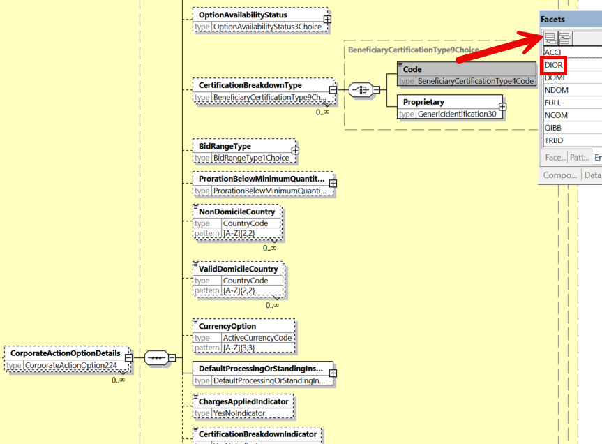

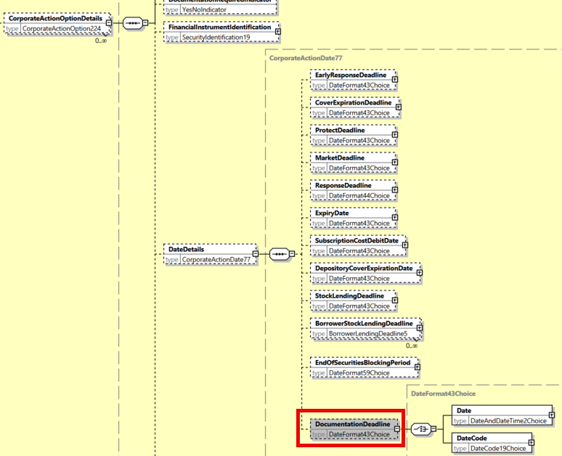

**Working Group Meeting**

|  |
| --- |
| **Discussion** |
| CH pointed out that a narrative would need to be provided anyway, to further specify the type of paperwork required and that a similar flag already exists for the Beneficial Owner (:22F::CETI//PAPW) that could be used for the purpose of indicating that additional paperwork is required.  The US agreed that the definition of the flag proposed needs to be amended to be clearer on what is required and by whom. The intention of the change request is to indicate through the proposed flag at option level that paperwork is required but it does not necessarily apply to the beneficial owner and thus PAPW cannot be used for that and a dedicated deadline needs to be associated to this type of additional documentation.  Therefore, the SWG agreed with the business case and reached consensus on the following slight changes in the proposed solution:   * Instead of creating a new flag, create a new code DIOR (Intermediary Documentation Required) into the CETI indicator in sequence E and broaden the definition. * The new deadline DOCD should be expressed as a Date/Time and the definition was broaden as well.   If any narrative is necessary to describe the documentation needed, PTNI or COMP narratives can be used. |
| **Decision** |
| **Approved with comments** |

## CR 002094: Remove Reversal Reason Code POCS

|  |  |
| --- | --- |
| **Origin of request** | |
| Requesting Country: |  |
| Requesting Group: | SMPG |
| **Sponsors** | |
| SMPG | |
| **Message type(s) impacted** | |
| MT 564, MT 566, seev.035, seev.037 | |
| **Complies with regulation** | |
| None | |
| **Business impact of this request** | |
| LOW  Removal of one code value in a list. | |
| **Commitment to implement the change** | |
| Number of messages sent and received: 20000000  Percentage of messages impacted: 1  Commits to implement and when: SMPG in SR 2025 | |
| **Business context** | |
| The code value Payment Outside Clearing System (POCS) is not deemed a consistent reversal reason code and its usage is to be avoided to avoid confusion. | |
| **Nature of change** | |
| In the MT 564 and MT566, remove the POCS (Payment Outside Clearing System) Reversal Reason code in field 24B in subsequence A2 of the MT 564 and MT 566. | |
| **Examples** | |
|  | |

**Workaround**

|  |
| --- |
| Do not use the code. |

**SWIFT Comment**

|  |
| --- |
|  |

**Standards Illustration**

**1. ISO 15022 Illustration**

**In MT 564 and MT 566, in sequence A2, remove reason code “POCS” from field 24B reversal reason, as defined and illustrated below:**

**MT 564 Field Specifications**

MT 564 Field Specifications

14. Field 24B: Reason Code: Reversal Reason

FORMAT

|  |  |  |
| --- | --- | --- |
| Option B | :4!c/[8c]/4!c | (Qualifier)(Data Source Scheme)(Reason Code) |

PRESENCE

Mandatory in optional subsequence A2

QUALIFIER

(Error code(s): T89)

| **Order** | **M/O** | **Qualifier** | **R/N** | **CR** | **Options** | **Qualifier Description** |
| --- | --- | --- | --- | --- | --- | --- |
| 1 | M | REVR | N | C32 | B | Reversal Reason |

DEFINITION

This qualified generic field specifies:

|  |  |  |
| --- | --- | --- |
| REVR | Reversal Reason | Specifies the reason for the payment reversal. |

CODES

If Data Source Scheme is not present, Reason Code must contain one of the following codes (Error code(s): K24):

|  |  |  |
| --- | --- | --- |
| DCBD | Day Count Basis Difference | Difference in day count basis. |
| FNRC | Funds Not Received | Funds have not been received. |
| IETR | Incorrect Event Level Tax Rate | Event level tax rate is incorrect. |
| IPCU | Incorrect Payment Currency | Payment currency is incorrect. |
| IPRI | Incorrect Price | Price is incorrect. |
| IRED | Incorrect Entitlement Date | Entitlement date is incorrect. |
| IVAD | Incorrect Value Date | Value date is incorrect. |
| NARR | Narrative Reason | See narrative field for reason. |
| **~~POCS~~** | **~~Payment Outside Clearing System~~** | **~~Payment will occur outside of clearing system.~~** |
| UPAY | Undue Payment | Payment is not due. |

**2. ISO 20022 Illustration**

**1. In the seev.035 (CAFE – CorporateActionMovementPreliminaryAdvice)** message, in element “Reversal Reason”, remove reason code **“POCS”**, as illustrated below;

**2. In the seev.037 (CARE – CorporateActionReversalAdvice),** in element “Reversal Reason”, remove reason code **“POCS”**, as below:

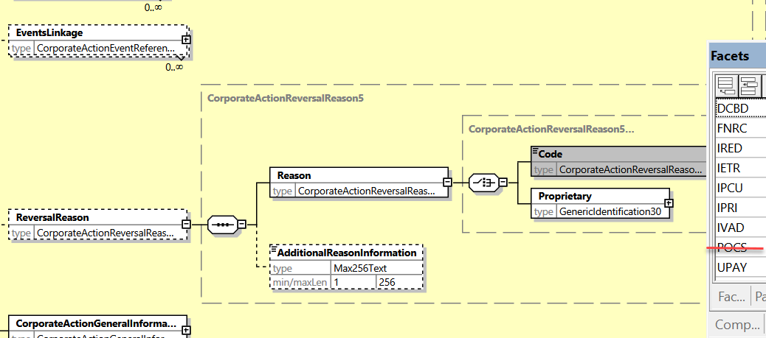

**Working Group Meeting**

|  |
| --- |
| **Discussion** |
| The SWG agreed with the business case and with the proposed solution. |
| **Decision** |
| **Approved as is.** |

## CR 002071: Amend NVRs Textual Description on Reversal Reason Presence

|  |  |
| --- | --- |
| **Origin of request** | |
| Requesting Country: |  |
| Requesting Group: | Swift |
| **Sponsors** | |
|  | |
| **Message type(s) impacted** | |
| MT 564, MT 566 | |
| **Complies with regulation** | |
| None | |
| **Business impact of this request** | |
| LOW (Textual change into the NVRs with very small impact) | |
| **Commitment to implement the change** | |
| Number of messages sent and received: 45000000  Percentage of messages impacted: 1  Commits to implement and when: in 2025 | |
| **Business context** | |
| Clarify the NVRs to avoid any misinterpretation of the rules. | |
| **Nature of change** | |
| In MT564, in NVR C32, and in MT 566, in NVR C11, change the conditional statement as follows “If subsequence A2 is present, then sequence D....” instead of “In subsequence A2 if field :24B::REVR is present, then sequence D...”.  This is justified by the fact that the field :24B::REVR is mandatory in the subsequence A2 in both messages. | |
| **Examples** | |
|  | |

**SWIFT Comment**

|  |
| --- |
|  |

**Standards Illustration**

**1. ISO 15022 Illustration**

**1. In the MT 564 in NVR C32, amend the textual description of the rule as illustrated below:**

**C32**

~~In~~ **If** subsequence A2~~, if field :24B::REVR~~ is present, then sequence D is mandatory, and in sequence D, field :22F::ADDB//REVR must be present (Error code(s): E32).

| **~~In~~ If subsequence A2 ~~if field :24B::REVR~~ is ...****(1)** | **Then sequence D is ...** | **And in sequence D, field :22F::ADDB//REVR is ...** |
| --- | --- | --- |
| Present | Mandatory | Mandatory |
| Not present | Optional | Not applicable |

*(1)**if the Data Source Scheme is present in field :24B::REVR, then the conditional rule does not apply.*

**2. In the MT 566 in NVR C11, amend the textual description of the rule as illustrated below:**

**C11**

~~In~~ **If** subsequence A2~~, if field :24B::REVR~~ is present, then in sequence A, field :23G:REVR must be present (Error code(s): E32).

| **~~In~~ If subsequence A2 ~~if field :24B::REVR~~ is ...****(1)** | **Then in sequence A, field :23G:REVR is ...** |
| --- | --- |
| Present | Mandatory |
| Not present | Optional |

*(1)**if the Data Source Scheme is present in field :24B::REVR, then the conditional rule does not apply.*

**Working Group Meeting**

|  |
| --- |
| **Discussion** |
| The SWG agreed with the business case and with the proposed solution. |
| **Decision** |
| **Approved as is.** |

## CR 002072: Aligning Status Codes in CA Instruction Status Message

|  |  |
| --- | --- |
| **Origin of request** | |
| Requesting Country: |  |
| Requesting Group: | SMPG |
| **Sponsors** | |
| SMPG | |
| **Message type(s) impacted** | |
| MT 567, seev.034 | |
| **Complies with regulation** | |
| None | |
| **Business impact of this request** | |
| MEDIUM | |
| **Commitment to implement the change** | |
| Number of messages sent and received: 20000000  Percentage of messages impacted: 1  Commits to implement and when: SMPG in SR 2025 | |
| **Business context** | |
| We would like to align some of the statuses available for the CA instruction confirmation message (MT567) to those available for to general meetings, so to provide information on the status of instructions once sent to CSDs and issuer agents.  This would allow to forward along the chain some of the statuses received from issuer/issuer CSD. As a way of an example, the acceptance of USE in the CREST system. | |
| **Nature of change** | |
| We would like to replicate the following statuses for MT567 and seev.034:  FRWD – Forwarded – Accepted and sent along the chain – to confirm that the instructions have been forwarded to the next intermediary in the chain;  RCIS – ReceivedByIssuerOrRegistrar – Instruction has been received and accepted/processed by issuer/issuer agent. | |
| **Examples** | |
|  | |

**Workaround**

|  |
| --- |
| Manual exchanges. |

**SWIFT Comment**

|  |
| --- |
|  |

**Standards Illustration**

**1. ISO 15022 Illustration**

**In the MT 567, in subsequence A2, add two new Status Code “FRWD” (i.e. Forwarded) and “RCIS” (i.e. Received by Issuer or Offeror) to qualifier “IPRC” in field 25D, as defined and illustrated below:**

**MT 567 Field Specifications**

11. Field 25D: Status Code

FORMAT

|  |  |  |
| --- | --- | --- |
| Option D | :4!c/[8c]/4!c | (Qualifier)(Data Source Scheme)(Status Code) |

PRESENCE

Mandatory in mandatory subsequence A2

QUALIFIER

(Error code(s): T89)

| **Order** | **M/O** | **Qualifier** | **R/N** | **CR** | **Options** | **Qualifier Description** |
| --- | --- | --- | --- | --- | --- | --- |
| 1 | M | CPRC | N | C4 | D | Cancellation Processing Status |
|  | or | EPRC | N | C4 | D | Corporate Action Event Processing Status |
|  | or | IPRC | N | C4 | D | Instruction Processing Status |

DEFINITION

This qualified generic field specifies:

|  |  |  |
| --- | --- | --- |
| CPRC | Cancellation Processing Status | Provides the status of a cancellation request. |
| EPRC | Corporate Action Event Processing Status | Provides the status of a corporate action or the status of a payment. |
| IPRC | Instruction Processing Status | Provides the status of an instruction. |

CODES

If Qualifier is IPRC and Data Source Scheme is not present, Status Code must contain one of the following codes (Error code(s): K25):

|  |  |  |
| --- | --- | --- |
| CAND | Instruction Cancelled | Instruction has been cancelled. |
| DFLA | Default Action | Default action is taken. |
| **FRWD** | **Forwarded** | **Instruction has been accepted and forwarded to the next intermediary in the chain.** |
| PACK | Accepted for Further Processing | Instruction has been accepted. This means that the instruction has been received, is processable and has been validated for further processing. |
| PEND | Pending | Instruction's processing is pending. |
| REJT | Rejected | Instruction has been rejected for further processing due to system reasons. |
| STIN | Standing Instruction | Standing instruction is applied. |
| **RCIS** | **Received by Issuer or Offeror** | **Instruction has been received and accepted by the issuer or offeror.** |

**2. ISO 20022 Illustration**

**1. In the seev.034 (CAIS – CorporateActionInstructionStatusAdvice)** message, in the message building block ***InstructionProcessingStatus***, add two new message elements **“Forwarded”** and **“ReceivedByIssuerOrOfferor”**, typed by *NoSpecifiedReason1*, as defined for ISO 15022 above and as illustrated for ISO 20022 below:

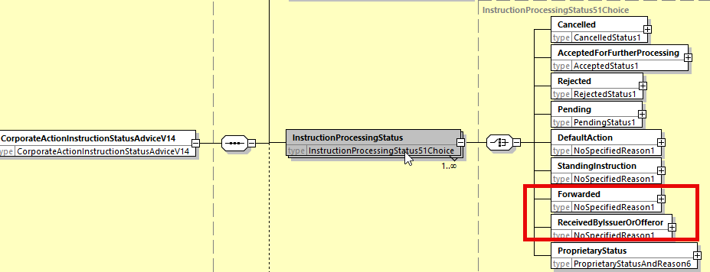

**Working Group Meeting**

|  |
| --- |
| **Discussion** |
| LU accepts the business case for Forwarding under the condition that a MP clarifies that a strong SLA would be needed for the Forwarding.  The group raised the point on the dependence on the information received from the previous intermediary in the chain, e.g. if the information as suggested above is provided or needs to be derived.  DE also supports the need for a strict market practice as well specifying for which status messages it can be used (CPRC ?) or if FRWD should be sent each time the instruction is passed on to another intermediary in the chain and in which conditions (no requirement for intermediaries to forward a status received via e-Mail or Fax or other means, as long as the communication is not STP, etc…).  The CA SWG agreed to remove the “processed” from the RCIS definition and to replace the “Registrar” by the “Offeror” in the short definition and the “Issuer agent” by the “Offeror” in the long definition for RCIS.  The SWG finally reached consensus on the business case and solution and request the SMPG to create a new market practice around the usage of these new statuses. |
| **Decision** |
| **Approved with comments** |

## CR 002074: Add Status Quantities in CA Instruction Status

|  |  |
| --- | --- |
| **Origin of request** | |
| Requesting Country: | GB United Kingdom |
| Requesting Group: |  |
| **Sponsors** | |
|  | |
| **Message type(s) impacted** | |
| MT 567, seev.034 | |
| **Complies with regulation** | |
| None | |
| **Business impact of this request** | |
| MEDIUM | |
| **Commitment to implement the change** | |
| Number of messages sent and received: 20000  Percentage of messages impacted: 10  Commits to implement and when: SMPG in 2025 | |
| **Business context** | |
| There is a need to change the CA instruction confirmation message (CAIS and MT567) to allow to report multiple statuses in the same message to address the following scenarios:  • instructions partially accepted due to pending settlement transactions,  • instruction accepted only for the part that is within the distribution ratio,  • instruction accepted only for the part that is within the multiple acceptable quantity.  We would like to amend the CA instruction confirmation message so to carry multiple statuses (if and where applicable) – the status, reason code and confirmed quantity need to become repeatable – related to the same instruction. Each MT567 will replace the previously issued one. | |
| **Nature of change** | |
| The change consists mainly in moving the quantity field from sequence B to A2. Since the sequence A2 is already repeatable in current version, providing several statuses with a new associated quantity is then possible.  1. In subsequence A2, add a new optional and repeatable (as per NVR C3) 36a quantity field with following qualifiers:  • QPAC: quantity of instructed securities accepted for further processing  • QPEN: quantity of instructed securities for which processing is pending  • QREJ: quantity of instructed securities for which processing is rejected  • QCAN: quantity of instructed securities for which instruction is cancelled  2. Add a new NVR mandating the presence of the new 36a quantity field or 19B::STAC Amount field when the field 25D Status Code is :25D::IPRC such that for the instruction processing status we have always a mandatory quantity or the STAC amount present.  3. Amend slightly the NVR C5  4. In sequence B, remove 36a quantity field (which is now moved in sequence A2). | |
| **Examples** | |
| Example of an account owner:   * has a settled position of 10 securities * has an outstanding receipt to acquire 5 securities * sends an instruction (non-default option) for 15 securities * the pending receipt settles partially for 2 securities * at the end of the election period, the pending receipt is still outstanding for 3 securities  1. The account owner will send a MT565 instruction with a QINS = 15 2. Upon receipt of the instruction, the account servicer will issue an MT567 carrying the following status    * :25D::IPRC//PACK for 10 securities (STAQ = 10);    * :25D::IPRC//PEND and :24B::PEND//PENR or LACK for 5 securities (STAQ = 5);   New A2 Status Subsequence sample  *:16R:STAT*  *:25D::IPRC//PACK*  *:36B::QPAC//UNIT/10,*  *:16S:STAT*  *:16R:STAT*  *:25D::IPRC//PEND*  *:36B::QPEN//UNIT/5,*  *:16R:REAS*  *:24B::PEND//PENR*  *:16S:REAS*  *:16S:STAT*   1. As soon as the pending receipt settlement instruction is partially settled for 2 securities, the account servicer will issue another MT567 to replace the previous one with the following status:    * :25D::IPRC//PACK for 12 securities (STAQ = 12);    * :25D::IPRC//PEND and :24B::PEND//PENR or LACK for 3 securities (STAQ = 3);   New A2 Status Subsequence sample  *:16R:STAT*  *:25D::IPRC//PACK*  *:36B::QPAC//UNIT/12,*  *:16S:STAT*  *:16R:STAT*  *:25D::IPRC//PEND*  *:36B::QPEN//UNIT/3,*  *:16R:REAS*  *:24B::PEND//PENR*  *:16S:REAS*  *:16S:STAT*   1. At the end of the election period, as the remaining transaction hasn’t settled, the account servicer will issue a MT567 with :    * :25D::IPRC//PACK for 12 securities (STAQ = 12);    * :25D::IPRC//REJT and :24B::REJT//LACK for 3 securities (STAQ = 3)   New A2 Status Subsequence  *:16R:STAT*  *:25D::IPRC//PACK*  *:36B::QPAC//UNIT/12,*  *:16S:STAT*  *:16R:STAT*  *:25D::IPRC//REJT*  *:36B::QREJ//UNIT/3,*  *:16R:REAS*  *:24B::REJT//LACK*  *:16S:REAS*  *:16S:STAT* | |

**Current Workaround**

|  |
| --- |
| Multiple MT567s could be sent but this may cause issues with reconciliation of the instructed quantity. |

**SWIFT Comment**

|  |
| --- |
| The change consists mainly in adding a new optional quantity field with 4 quantity qualifiers in sequence A2 to replace the existing one in sequence B  Since the sequence A2 is already repeatable in current version of the MT 567, providing several statuses with a new associated quantity is then feasible.  Should we link the usage of the new Quantities with the usage of the Status Code :25D:IPRC// via the update of the NVR C5 (see illustration below) ?  Should we also move the :19B::STAC (Status Cash Amount) in the subsequence A2 of the MT 567 together with the new quantities ? (not illustrated) and apply the same in the seev.034 ?  Should we also update the seev.042 similarly to the seev.034 in the sequence *AccountAndStatementDetails/CorporateActionEventAndBalance/Balance/ TotalInstructedBalanceDetails/OptionDetails/OptionInstructionDetails/InstructionStatus* ? |

**Standards Illustration**

**1. ISO 15022 Illustration**

**A. In the MT 567, in subsequence A2, add a new optional 36a Quantity of Financial Instrument field with 4 new quantity qualifiers QPAC, QPEN, QREJ and QCAN as defined and illustrated in ISO 15022 below:**

**MT 567 Format Specifications**

| **MT 567 Corporate Action Status and Processing Advice** | | | | | | |
| --- | --- | --- | --- | --- | --- | --- |
| **Status** | **Tag** | **Qualifier** | **Generic Field Name** | **Detailed Field Name** | **Content/Options** | ***No.*** |
| **Mandatory Sequence A General Information** | | | | | | |
| M | 16R |  |  | Start of Block | GENL | *1* |
| **----->** | | | | | | |
| M | 20C | 4!c | Reference | (see qualifier description) | :4!c//16x | *2* |
| **-----|** | | | | | | |
| M | 23G |  |  | Function of the Message | 4!c[/4!c] | *3* |
| M | 22F | CAEV | Indicator | Corporate Action Event Indicator | :4!c/[8c]/4!c | *4* |
| O | 98a | PREP | Date/Time | Preparation Date/Time | A, C, or E | *5* |
| **-----> Mandatory Repetitive Subsequence A1 Linkages** | | | | | | |
| M | 16R |  |  | Start of Block | LINK | *6* |
| O | 13a | LINK | Number Identification | Linked Message | A or B | *7* |
| M | 20C | 4!c | Reference | (see qualifier description) | :4!c//16x | *8* |
| M | 16S |  |  | End of Block | LINK | *9* |
| **-----| End of Subsequence A1 Linkages** | | | | | | |
| **-----> Mandatory Repetitive Subsequence A2 Status** | | | | | | |
| M | 16R |  |  | Start of Block | STAT | *10* |
| M | 25D | 4!c | Status Code | (see qualifier description) | :4!c/[8c]/4!c | *11* |
| **----->** | | | | | | |
| **O** | **36a** | **4!c** | **Quantity Of Financial Instrument** | **(see qualifier description)** | **B or D** | **12** |
| **-----|** | | | | | | |
| **-----> Optional Repetitive Subsequence A2a Reason** | | | | | | |
| M | 16R |  |  | Start of Block | REAS | *12* |
| M | 24B | 4!c | Reason Code | (see qualifier description) | :4!c/[8c]/4!c | *13* |
| O | 70D | REAS | Narrative | Reason Narrative | :4!c//6*35x | *14* |
| M | 16S |  |  | End of Block | REAS | *15* |
| **-----| End of Subsequence A2a Reason** | | | | | | |
| M | 16S |  |  | End of Block | STAT | *16* |
| **-----| End of Subsequence A2 Status** | | | | | | |
| M | 16S |  |  | End of Block | GENL | *17* |
| **End of Sequence A General Information** | | | | | | |

**MT 567 Field Specifications**

**12. Field 36a: Quantity of Financial Instrument**

**FORMAT**

|  |  |  |
| --- | --- | --- |
| **Option B** | **:4!c//4!c/15d** | **(Qualifier)(Quantity Type Code)(Quantity)** |
| **Option D** | **:4!c//4!c/30d** | **(Qualifier)(Quantity Type Code)(Quantity of Digital Tokens)** |

**PRESENCE**

**Conditional (see rule C7) in mandatory sequence A2**

**QUALIFIER**

**(Error code(s): T89)**

| **Order** | **M/O** | **Qualifier** | **R/N** | **CR** | **Options** | **Qualifier Description** |
| --- | --- | --- | --- | --- | --- | --- |
| **1** | **M** | **QPAC** | **R** | **C8** | **B or D** | **Accepted Quantity** |
|  | **or** | **QCAN** | **R** | **C9** | **B or D** | **Cancelled Quantity** |
|  | **or** | **QPEN** | **R** | **C10** | **B or D** | **Pending Quantity** |
|  | **or** | **QREJ** | **R** | **C11** | **B or D** | **Rejected Quantity** |

**DEFINITION**

**This qualified generic field specifies:**

|  |  |  |
| --- | --- | --- |
| **QPAC** | **Accepted Quantity** | **Quantity of instructed securities that has been accepted for further processing.** |
| **QPEN** | **Pending Quantity** | **Quantity of instructed securities for which processing is pending.** |
| **QREJ** | **Rejected Quantity** | **Quantity of instructed securities for which processing is rejected.** |
| **QCAN** | **Cancelled Quantity** | **Quantity of instructed securities for which instruction is cancelled.** |

**CODES**

**In option B, Quantity Type Code must contain one of the following codes (Error code(s): K36):**

|  |  |  |
| --- | --- | --- |
| **AMOR** | **Amortised Value** | **Quantity expressed as an amount representing the current amortised face amount of a bond, for example, a periodic reduction/increase of a bond's principal amount.** |
| **FAMT** | **Face Amount** | **Quantity expressed as an amount representing the face amount, that is, the principal, of a debt instrument.** |
| **UNIT** | **Unit Number** | **Quantity expressed as a number, for example, a number of shares.** |

**CODES**

**In option D, Quantity Type Code must contain the following code (Error code(s): K36):**

|  |  |  |
| --- | --- | --- |
| **DITU** | **Digital Token Unit Number** | **Quantity of digital token expressed as a number, for example, a number of blockchain tokens.** |

**NETWORK VALIDATED RULES**

**The integer part of Quantity must contain at least one digit. A decimal comma is mandatory and is included in the maximum length (Error code(s): T40,T43).**

**USAGE RULES**

**Format option D may only be used for digital assets.**

**C. Create new NVR C7 so as to forbid the presence of the new quantity qualifiers with the simultaneous presence of the existing STAQ qualifier or the presence of the 19B STAC amount as illustrated below:**

**C7**

**In sequence B, if field :19B::STAC is present or if field :36a::STAQ is present, then in subsequence A2, field :36a: is not allowed (Error code(s): E62).**

| **In sequence B, if field :19B::STAC is …** | **And if field :36a::STAQ is …** | **Then in subsequence A2, field :36a:: is ...** |
| --- | --- | --- |
| **Present** | **Not present** | **Not allowed** |
| **Not present** | **Present** | **Not allowed** |
| **Not present** | **Not present** | **Optional** |

**In subsequence A2, if field :36a: Quantity of Financial Instrument is present and sequence B is present, then field :36a:: STAQ is not allowed and field :19B::STAC is not allowed (Error code(s): E62)..**

| **In subsequence A2, if field :36a: Quantity of Financial Instrument is …** | **And if Sequence B is …** | **Then in sequence B, field :36a::STAQ is ...** | **And field :19B:STAC is …** |
| --- | --- | --- | --- |
| **Present** | **Present** | **Not allowed** | **Not allowed** |
| **Present** | **Not present** | **Not applicable** | **Not applicable** |
| **Not present** | **Present** | **Optional** | **Optional** |
| **Not present** | **Not present** | **Not applicable** | **Not applicable** |

**C8**

**In sequence A2, field :36a::QPAC cannot appear more than twice (maximum two occurrences). When repeated, one occurrence must have Quantity Type Code FAMT and the other occurrence must have Quantity Type Code AMOR (Error code(s): C71).**

| **In sequence A2, if field :36a::QPAC is ...** | **Then one occurrence of :36a::QPAC must be ...** | **And the other occurrence of :36a::QPAC must be ...** |
| --- | --- | --- |
| **Repeated** | **:36B::QPAC//FAMT** | **:36B::QPAC//AMOR** |
| **Not repeated** | **Not applicable** | **Not applicable** |

**C9**

**In sequence A2, field :36a::QCAN cannot appear more than twice (maximum two occurrences). When repeated, one occurrence must have Quantity Type Code FAMT and the other occurrence must have Quantity Type Code AMOR (Error code(s): C71).**

| **In sequence A2, if field :36a::QCAN is ...** | **Then one occurrence of :36a::QCAN must be ...** | **And the other occurrence of :36a::QCAN must be ...** |
| --- | --- | --- |
| **Repeated** | **:36B::QCAN//FAMT** | **:36B::QCAN//AMOR** |
| **Not repeated** | **Not applicable** | **Not applicable** |

**C10**

**In sequence A2, field :36a::QPEN cannot appear more than twice (maximum two occurrences). When repeated, one occurrence must have Quantity Type Code FAMT and the other occurrence must have Quantity Type Code AMOR (Error code(s): C71).**

| **In sequence A2, if field :36a::QPEN is ...** | **Then one occurrence of :36a::QPEN must be ...** | **And the other occurrence of :36a::QPEN must be ...** |
| --- | --- | --- |
| **Repeated** | **:36B::QPEN//FAMT** | **:36B::QPEN//AMOR** |
| **Not repeated** | **Not applicable** | **Not applicable** |

**C11**

**In sequence A2, field :36a::QREJ cannot appear more than twice (maximum two occurrences). When repeated, one occurrence must have Quantity Type Code FAMT and the other occurrence must have Quantity Type Code AMOR (Error code(s): C71).**

| **In sequence A2,, if field :36a::QREJ is ...** | **Then one occurrence of :36a::QREJ must be ...** | **And the other occurrence of :36a::QREJ must be ...** |
| --- | --- | --- |
| **Repeated** | **:36B::QREJ//FAMT** | **:36B::QREJ//AMOR** |
| **Not repeated** | **Not applicable** | **Not applicable** |

**D. In the MT 567, in sequence B, in fields 36a and 19B, add the NVR references C7 as illustrated below:**

**MT 567 Field Specifications**

26. Field 36a: Quantity of Financial Instrument: Status Quantity

FORMAT

|  |  |  |
| --- | --- | --- |
| Option B | :4!c//4!c/15d | (Qualifier)(Quantity Type Code)(Quantity) |
| Option D | :4!c//4!c/30d | (Qualifier)(Quantity Type Code)(Quantity of Digital Tokens) |

PRESENCE

Optional in optional sequence B

QUALIFIER

(Error code(s): T89)

| Order | M/O | Qualifier | R/N | CR | Options | Qualifier Description |
| --- | --- | --- | --- | --- | --- | --- |
| 1 | O | STAQ | R | C3, **C7** | B or D | Status Quantity |

DEFINITION

This qualified generic field specifies:

|  |  |  |
| --- | --- | --- |
| STAQ | Status Quantity | Quantity of securities that has been assigned the status indicated. |

**MT 567 Field Specifications**

27. Field 19B: Amount

FORMAT

|  |  |  |
| --- | --- | --- |
| Option B | :4!c//3!a15d | (Qualifier)(Currency Code)(Amount) |

PRESENCE

Optional in optional sequence B

QUALIFIER

(Error code(s): T89)

| Order | M/O | Qualifier | R/N | CR | Options | Qualifier Description |
| --- | --- | --- | --- | --- | --- | --- |
| 1 | O | CAPG | N |  | B | Capital Gains Amount |
| 2 | O | INDM | N |  | B | Indemnity Amount |
|  |  |  |  |  |  |  |
|  |  |  |  |  |  |  |
| 40 | O | STAC | N | C5, **C7** | B | Status Cash Amount |

**2. ISO 20022 Illustration**

A. I**n the seev.034 (CAIS – CorporateActionInstructionStatusAdvice)** message, in the InstructionProcessingStatus building block, add new optional and non-repeatable quantity element typed by *Quantity51Choice* in the following 4 sequences as follows:

* *CancelledQuantity* in the *Cancelled* sequence;
* *AcceptedQuantity* in the *AcceptedForFurtherProcessing* sequence;
* *RejectedQuantity* in the *Rejected* sequence*;*
* *PendingQuantity* in the *Pending sequence;*

As defined in 15022 above and as illustrated here below:

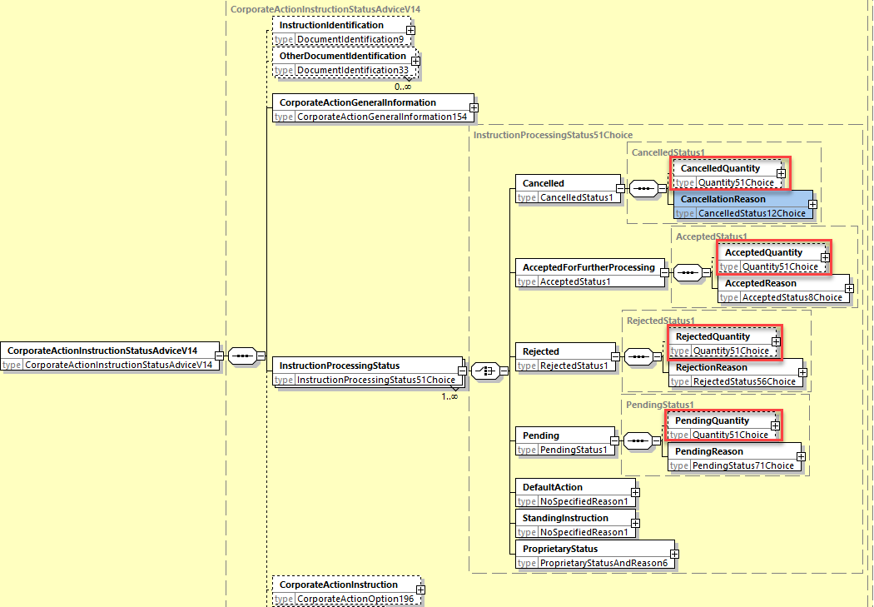

**B**. I**n the seev.034 (CAIS – CorporateActionInstructionStatusAdvice)** message, in the root of the message, add 3 new cross element complex rules defined as follows and replacing the 2 rules StatusQuantityOrStatusCashAmount1Rule and StatusQuantityOrStatusCashAmount1Rule:

* *StatusQuantity1Rule*(): If CorporateActionInstruction/StatusCashAmount is present, then InstructionProcessingStatus/Cancelled/CancelledQuantity and InstructionProcessingStatus/AcceptedForFurtherProcessing/AcceptedQuantity and InstructionProcessingStatus/Rejected/RejectedQuantity and InstructionProcessingStatus/Pending/PendingQuantity and CorporateActionInstruction/StatusQuantity are not allowed. (MT 567 C5 and C7).
* *StatusQuantity2Rule()*: If CorporateActionInstruction/StatusQuantity is present, then InstructionProcessingStatus/Cancelled/CancelledQuantity or InstructionProcessingStatus/AcceptedForFurtherProcessing/AcceptedQuantity or InstructionProcessingStatus/Rejected/RejectedQuantity or InstructionProcessingStatus/Pending/PendingQuantity and CorporateActionInstruction/StatusCashAmount are not allowed. (MT 567 C5 and C7).
* *StatusQuantity3Rule()*: If InstructionProcessingStatus/Cancelled/CancelledQuantity or InstructionProcessingStatus/AcceptedForFurtherProcessing/AcceptedQuantity or InstructionProcessingStatus/Rejected/RejectedQuantity or InstructionProcessingStatus/Pending/PendingQuantity are present, then CorporateActionInstruction/StatusQuantity and CorporateActionInstruction/StatusCAshAmount are not allowed. (MT 567 C5 and C7).

**Working Group Meeting**

|  |
| --- |
| **Discussion** |
| CH, DE, LU, XS and ZA are not enthusiastic about changing the way the MT 567 is structured regarding the quantities and how it would impact the flow and its usage?  Nevertheless, the business case and the proposed solution were finally agreed at the condition that the existing STAQ quantity remains in the sequence B so that the IPRC message can still be used as it is today and at the condition that a new NVR C7 be created so that the usage of :36a::STAQ, :19B:STAC and the new quantity of Financial Instrument field in the sequence A2 be all mutually exclusive.  The SWG agrees to not link the new quantities with the :25D status code as it is not the case with STAQ today and that the change must not be implemented in the seev.042 message.  The SWG requests the SMPG to create a new market practice on the usage and flow of the instruction status message when used with the new quantity field in sequence A2. |
| **Decision** |
| **Approved with comments** |

## CR 002092: Amendment of Reason Codes in CA Event Processing Status Message

|  |  |
| --- | --- |
| **Origin of request** | |
| Requesting Country: |  |
| Requesting Group: | SMPG |
| **Sponsors** | |
|  | |
| **Message type(s) impacted** | |
| MT 567, seev.032 | |
| **Complies with regulation** | |
| None | |
| **Business impact of this request** | |
| MEDIUM  null | |
| **Commitment to implement the change** | |
| Number of messages sent and received: 20000000  Percentage of messages impacted: 1  Commits to implement and when: SMPG - SR 2025 | |
| **Business context** | |
| We would like to update the statuses applicable to a CAPS to ensure they are relevant and correct. VLDA / MCER reason codes are not really used. | |
| **Nature of change** | |
| We would like to:  • remove VLDA from reason codes in PEND for CAPS and MT567  • remove MCER from CAPS  • change definition of AUTH in reason codes for CAPS and MT567 to "Pending because the reclaim is sent to the tax authorities". | |
| **Examples** | |
|  | |

**SWIFT Comment**

|  |
| --- |
| MCER has been used more than 7000 times in the MT567 during a year (2020/2021). No trace of the usage of VLDA though. |

**Standards Illustration**

**1. ISO 15022 Illustration**

**In the MT 567, in subsequence A2a, in field 24B, delete the code value” Valid for Tax Authorities” (VLDA) for PEND qualifier and amend the definition of the code value “Sent to Tax Authorities” (AUTH) and amend the usage rule as illustrated below:**

**MT 567 Field Specifications**

13. Field 24B: Reason Code

FORMAT

|  |  |  |
| --- | --- | --- |
| Option B | :4!c/[8c]/4!c | (Qualifier)(Data Source Scheme)(Reason Code) |

PRESENCE

Mandatory in optional subsequence A2a

QUALIFIER

(Error code(s): T89)

| Order | M/O | Qualifier | R/N | CR | Options | Qualifier Description |
| --- | --- | --- | --- | --- | --- | --- |
| 1 | M | PEND | N | C1 | B | Pending Reason |
|  | or | REJT | N | C1 | B | Rejection Reason |
|  | or | CAND | N | C1 | B | Cancellation Reason |
|  | or | CANP | N | C1 | B | Cancellation Pending Reason |
|  | or | PACK | N | C1 | B | Accepted Reason |

DEFINITION

This qualified generic field specifies:

|  |  |  |
| --- | --- | --- |
| CAND | Cancellation Reason | Specifies the reason why the instruction is cancelled. |
| CANP | Cancellation Pending Reason | Specifies the reason why a cancellation request sent for the related instruction is pending. |
| PACK | Accepted Reason | Specifies additional information about the processed instruction. |
| PEND | Pending Reason | Specifies the reason why the instruction/event has a pending status. |
| REJT | Rejection Reason | Specifies the reason why the instruction/cancellation request has a rejected status. |

CODES

If Qualifier is PEND and Data Source Scheme is not present, Reason Code must contain one of the following codes (Error code(s): K24):

|  |  |  |  |  |
| --- | --- | --- | --- | --- |
| ADEA | Account Servicer Deadline Missed | | Received after the account servicer's deadline. Processed on best effort basis. | |
| AUTH | Sent to Tax Authorities | | ~~For tax reclaim, the~~ ~~e~~Event is pending because the reclaim is sent to the tax authorities. | |
| BSTR | Before Instruction Period | | Instruction is submitted before instruction start date. | |
| … | ….. | | …. | |
| LATE | | Market Deadline Missed | | Instruction was received after market deadline. | |
| MCER | | Missing or Invalid Certification | | Awaiting receipt of adequate certification. | |
| MONY | | Insufficient Cash | | Insufficient cash in your account. | |
| MTAX | | Missing Tax Rate | | Tax rate is missing. | |
| NARR | Narrative Reason | | See narrative field for reason. | |
| NPAY | Payment Not Made | | Payment has not been made by issuer. | |
| NSEC | Securities Not Delivered | | Financial instruments have not been delivered by the issuer. | |
| NTAX | Inconsistent Tax Rate | | Tax rate is not consistent with the documentation in place. | |
| PENR | Pending Receipt | | The instruction is pending receipt of securities, for example, from a purchase, loan etc. | |
| SNAV | System Not Available | | System is not available. Instruction is sent outside of business hours. | |
| **~~VLDA~~** | **~~Valid for Tax Authorities~~** | | **~~For tax reclaim, the event is pending, the tax reclaim is valid for the tax authorities.~~** | |

USAGE RULES

The qualifier of the reason code must be in line with the code used for the status in field 25D, for example , :25D::~~EPRC~~**IPRC**//PEND  
:24B::PEND//MCER

**2. ISO 20022 Illustration**

**In the seev.032 (CAPS – CorporateActionEventProcessingStatusAdvice)** message, in the EventProcessingStatus building block, for the element ***Code*** in sequence Pending/Reason/ReasonCode, amend the contents of the ***PendingReason19Code*** typing the Code element as follows:

* Remove the VLDA and MCER code values
* Amend the definition of the AUTH code as proposed in ISO 15022 illustration above.

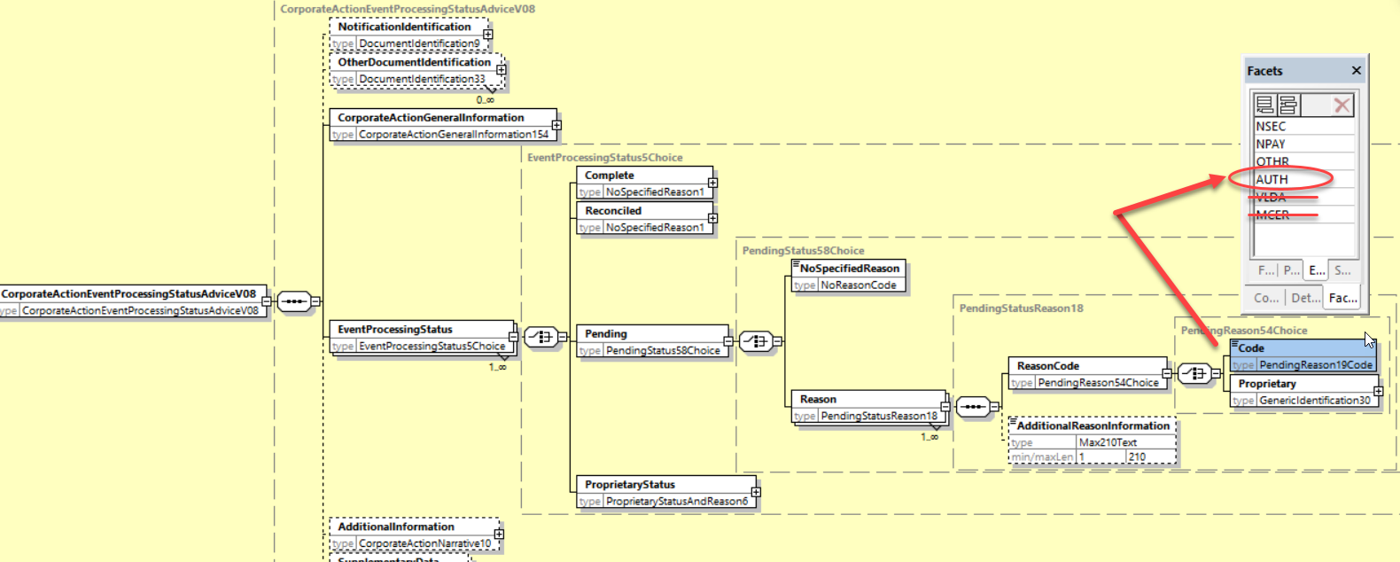

**Working Group Meeting**

|  |
| --- |
| **Discussion** |
| The SWG agrees with the business case and proposed solution. For the MT 567, the SMPG market practice (GMP Part 3) will need to be amended for MCER. |
| **Decision** |
| **Approved as is** |

## CR 002157: Add New Return Status Code on CA Instruction Status Messages

|  |  |
| --- | --- |
| **Origin of request** | |
| Requesting Country: | US United States of America |
| Requesting Group: |  |
| **Sponsors** | |
|  | |
| **Message type(s) impacted** | |
| MT 567, seev.034, seev.042 | |
| **Complies with regulation** | |
| None | |
| **Business impact of this request** | |
| MEDIUM  null | |
| **Commitment to implement the change** | |
| Number of messages sent and received: 375  Percentage of messages impacted: 50  Commits to implement and when: DTCC – SR 2025 | |
| **Business context** | |
| This change request seeks to add a new status and reason codes within the MT567, CAIS and CAST messages to the instruction workflow of Returned. The current status of Accepted for Further Processing does not always correspond to an instruction being fulfilled by the Agent. In the case of certain tender events, an instruction may be initially accepted by DTCC and then will not be selected by the agent based on the terms of the offer. In this case the instructed units are moved from their contra position back their underlying security. By having a Returned status with a reason code, this would complete the lifecycle of the instruction and correspond to the securities movement that occurs corresponding to the instruction.  The UNAC scenario happens on Tender events whereby if the instructed quantity after proration does not meet the minimum denomination, the instruction will not be accepted by the Agent. The instructed units would therefore be returned to the instructing party. For instance, an offer has a minimum denomination of 2000 with increments of 1000. There is an instruction for 3000. The offer gets prorated at 50%. The agent will not in this case accept the 1500 because if falls below the minimum denomination and therefore return the entire instruction. This scenario would be UNAC.  The PROR scenario is similar but in this case some of the instructed units would be accepted, and a portion would be returned. For instance, an offer has a minimum denomination of 2000 with increments of 1000. The instruction party sends an instruction for 3000. There is a 50% proration on the offer. 1,500 would be accepted from proration but it is not a valid increment so they would only accept 1000 of the instruction and return 2000. This scenario would be PROR. | |
| **Nature of change** | |
| New Instruction Processing Status (IPRC) 25D Reason - RETR Returned  and new Reason Codes :24B  PROR - Shares returned due to prorated acceptance  UNAC - Shares returned due to instruction not accepted by agent | |
| **Examples** | |
| UNAC -  CUSIP 81180WBD2 GCB Seagate HDD Cayman Corp ID - 135253851  CUSIP 817477AB8 Govt 144A Serbia Rep Corp ID - 123883241 | |

**Workaround**

|  |
| --- |
| Currently today the only workaround is that the instruction is to use PACK to accept the initial instruction. This is normally the end of the instruction lifecycle. An REJT could be use but the instruction is not really being rejected it is being returned as it was not accepted by the Agent in the case of a Tender Offer or in a Voting case in the US, the shares are moved back from the Contra Position back to the Parent CUSIP. |

**SWIFT Comment**

|  |
| --- |
|  |

**Standards Illustration**

**1. ISO 15022 Illustration**

**A. In the MT 567, in subsequence A2, in field 25D Status Code, add a new RETR (Returned) code value for the IPRC (Instruction Processing Status) qualifier as defined and illustrated here below:**

**MT 567 Field Specifications**

11. Field 25D: Status Code

FORMAT

|  |  |  |
| --- | --- | --- |
| Option D | :4!c/[8c]/4!c | (Qualifier)(Data Source Scheme)(Status Code) |

PRESENCE

Mandatory in mandatory subsequence A2

QUALIFIER

(Error code(s): T89)

| **Order** | **M/O** | **Qualifier** | **R/N** | **CR** | **Options** | **Qualifier Description** |
| --- | --- | --- | --- | --- | --- | --- |
| 1 | M | CPRC | N | C4 | D | Cancellation Processing Status |
|  | or | EPRC | N | C4 | D | Corporate Action Event Processing Status |
|  | or | IPRC | N | C4 | D | Instruction Processing Status |

DEFINITION

This qualified generic field specifies:

|  |  |  |
| --- | --- | --- |
| CPRC | Cancellation Processing Status | Provides the status of a cancellation request. |
| EPRC | Corporate Action Event Processing Status | Provides the status of a corporate action or the status of a payment. |
| IPRC | Instruction Processing Status | Provides the status of an instruction. |
|  |  |  |

CODES

If Qualifier is IPRC and Data Source Scheme is not present, Status Code must contain one of the following codes (Error code(s): K25):

|  |  |  |
| --- | --- | --- |
| CAND | Instruction Cancelled | Instruction has been cancelled. |
| DFLA | Default Action | Default action is taken. |
| PACK | Accepted for Further Processing | Instruction has been accepted. This means that the instruction has been received, is processable and has been validated for further processing. |
| PEND | Pending | Instruction's processing is pending. |
| REJT | Rejected | Instruction has been rejected for further processing due to system reasons. |
| **RETR** | **Returned** | **Instructed units are returned or partially returned to the instructing party.** |
| STIN | Standing Instruction | Standing instruction is applied. |

**B. In the MT 567, in subsequence A2A, in field 24B Reason Code, add a new qualifier Returned Reason (RETR) and add 2 new Returned Reason codes PROR and UNAC as defined and illustrated here below:**

**MT 567 Field Specifications**

13. Field 24B: Reason Code

FORMAT

|  |  |  |
| --- | --- | --- |
| Option B | :4!c/[8c]/4!c | (Qualifier)(Data Source Scheme)(Reason Code) |

PRESENCE

Mandatory in optional subsequence A2a

QUALIFIER

(Error code(s): T89)

| **Order** | **M/O** | **Qualifier** | **R/N** | **CR** | **Options** | **Qualifier Description** |
| --- | --- | --- | --- | --- | --- | --- |
| 1 | M | PEND | N | C1 | B | Pending Reason |
|  | or | REJT | N | C1 | B | Rejection Reason |
|  | or | CAND | N | C1 | B | Cancellation Reason |
|  | or | CANP | N | C1 | B | Cancellation Pending Reason |
|  | or | PACK | N | C1 | B | Accepted Reason |
|  | **or** | **RETR** | **N** | **C1** | **B** | **Returned Reason** |

DEFINITION

This qualified generic field specifies:

|  |  |  |
| --- | --- | --- |
| CAND | Cancellation Reason | Specifies the reason why the instruction is cancelled. |
| CANP | Cancellation Pending Reason | Specifies the reason why a cancellation request sent for the related instruction is pending. |
| PACK | Accepted Reason | Specifies additional information about the processed instruction. |
| PEND | Pending Reason | Specifies the reason why the instruction/event has a pending status. |
| REJT | Rejection Reason | Specifies the reason why the instruction/cancellation request has a rejected status. |
| **RETR** | **Returned Reason** | **Specifies the reason why the instructed units are returned or partially returned.** |

CODES

If Qualifier is PEND and Data Source Scheme is not present, Reason Code must contain one of the following codes (Error code(s): K24):

|  |  |  |
| --- | --- | --- |
| ADEA | Account Servicer Deadline Missed | Received after the account servicer's deadline. Processed on best effort basis. |
| …. | … | … |
| SNAV | System Not Available | System is not available. Instruction is sent outside of business hours. |
| VLDA | Valid for Tax Authorities | For tax reclaim, the event is pending, the tax reclaim is valid for the tax authorities. |

CODES

If Qualifier is PACK and Data Source Scheme is not present, Reason Code must contain one of the following codes (Error code(s): K24):

|  |  |  |
| --- | --- | --- |
| NARR | Narrative Reason | See narrative field for reason. |
| NSTP | Not STP | Instruction was not STP and had to be processed manually. |
| ……. |  |  |

CODES

**If Qualifier is RETR and Data Source Scheme is not present, Reason Code must contain one of the following codes (Error code(s): K24):**

|  |  |  |
| --- | --- | --- |
| **NARR** | **Narrative Reason** | **See narrative field for reason.** |
| **PROR** | **Prorated** | **Shares returned due to prorated acceptance.** |

**C. In the MT 567, amend NVR C1 as illustrated here below:**

**C1**

Within each occurrence of subsequence A2a, the qualifier in field 24B must be the same as the code (Status Code) used with the appropriate qualifier in field 25D of its surrounding subsequence A2 (Error code(s): E37).

| **In each occurrence of sequence A2 Status** | |
| --- | --- |
| **In each occurrence of subsequence A2a Reason (if present) if field :24B:: is ...** | **Then in sequence A2 Status, field :25D:: must be ...****(1)** |
| :24B::CAND | :25D::IPRC//CAND or :25D::CPRC//CAND |
| :24B::CANP | :25D::CPRC//CANP |
| :24B::PACK | :25D::IPRC//PACK or :25D::CPRC//PACK |
| :24B::PEND | :25D::IPRC//PEND or :25D::EPRC//PEND |
| :24B::REJT | :25D::IPRC//REJT or :25D::CPRC//REJT |
| **:24B::RETR** | **:25D::IPRC//RETR** |

*(1)**if the Data Source Scheme is present in field :25D:: then the conditional rule does not apply.*

**2. ISO 20022 Illustration**

A. I**n the seev.034 (CAIS – CorporateActionInstructionStatusAdvice)** message, in the ***InstructionProcessingStatus*** building block, add a new ***Returned*** status sequence structured the same way as for the other Cancelled, Rejected, Pending and AcceptedForFurtherProcessing sequences with a reason code list containing the code values PROR and OTHR (when the narrative is used).

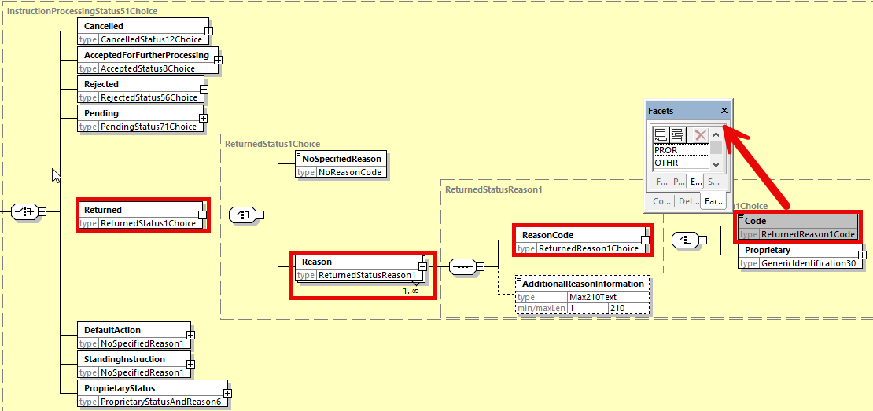

**B. In the seev.042 (CorporateActionInstructionStatementReport) message, in the *AccountAndStatementDetails* building block, in the sequence *CorporateActionEventAndBalance/Balance/TotalInstructedBalanceDetails/OptionDetails*, add a new optional and non-repeatable *OptionReturnedBalance* element typed by SignedQuantityFormat10 data type as illustrated below.**

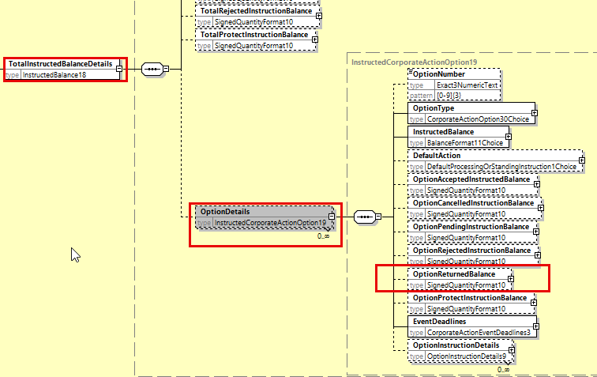

**C. In the seev.042 (CorporateActionInstructionStatementReport) message, in the *AccountAndStatementDetails* building block, in the sequence *CorporateActionEventAndBalance/Balance/TotalInstructedBalanceDetails/OptionDetails/OptionInstructionDetails/InstructionStatus*, add a new “*Returned”* sequence typed by a new data type which is a choice between NoSpecifiedReason and a “Reason” sequence with the reason codes PROR and OTHR and an “AdditionalInformation” element similarly to the other statuses as illustrated below:**

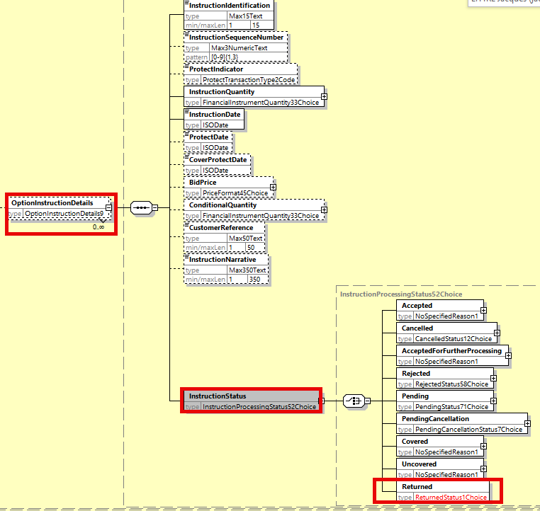

**Working Group Meeting**

|  |
| --- |
| **Discussion** |
| UK, IT and IE do not see the business case for the new “Returned” statuses. The SWG resolves to vote and the change request is approved by 11 votes in favor and 3 votes against (IT, UK , IE).  The SWG agrees also that the “Returned” status reason code value UNAC is not necessary.  The SWG request the SMPG to create a new market practice to clearly make the difference between the usage of the Rejected status and the new Returned status. |
| **Decision** |
| **Approved with comment.** |

## CR 002180: Add New Issuer Sourced Indicator in Notification (CA and GM)

|  |  |
| --- | --- |
| **Origin of request** | |
| Requesting Country: |  |
| Requesting Group: | Swift |
| **Sponsors** | |
|  | |
| **Message type(s) impacted** | |
| MT 564, seev.001, seev.031 | |
| **Complies with regulation** | |
| None | |
| **Business impact of this request** | |
| LOW | |
| **Commitment to implement the change** | |
| Number of messages sent and received: 2000000  Percentage of messages impacted: 5  Commits to implement and when: To be confirmed – SR2025 | |
| **Business context** | |
| There is a growing push in the corporate action area lately to adopt what is usually called an Issuer model by which the CA event key data are directly provided by the Issuer (Issuer Agent) to the first intermediary in the CA chain which improves the quality of and trust in the corporate action data by the following intermediaries in the chain, similarly to the existing SRD II indicator present in the current CA and GM messages. The presence of this indicator in the notification message would confirm that the key event information is directly sourced from the issuer. | |
| **Nature of change** | |
| Add a new Issuer Sourced indicator/flag or extend the scope of the existing SRD II indicator in the notification message of the CA and GM messages. | |
| **Examples** | |
|  | |

**SWIFT Comment**

|  |
| --- |
|  |

**Standards Illustration**

**1. ISO 15022 Illustration**

**A. In the MT 567, in sequence D, in field 17B Flag, add a new optional qualifier “Issuer Sourced Event** Information **Indicator (ISEV) as defined and illustrated here below:**

**MT 564 Field Specifications**

54. Field 17B: Flag

FORMAT

|  |  |  |
| --- | --- | --- |
| Option B | :4!c//1!a | (Qualifier)(Flag) |

PRESENCE

Optional in optional sequence D

QUALIFIER

(Error code(s): T89)

| **Order** | **M/O** | **Qualifier** | **R/N** | **CR** | **Options** | **Qualifier Description** |
| --- | --- | --- | --- | --- | --- | --- |
| 1 | O | CERT | N |  | B | Certification/Breakdown Flag |
| 2 | O | RCHG | N |  | B | Charges Flag |
| 3 | O | COMP | N |  | B | Information to be Complied With |
| 4 | O | ACIN | N |  | B | Accrued Interest Indicator |
| 5 | O | LEOG | N |  | B | Letter of Guaranteed Delivery Flag |
| 6 | O | SRDC | N |  | B | Shareholder Rights Directive Indicator |
| **7** | **O** | **ISEV** | **N** | **C33** | **B** | **Issuer Sourced Event Information Indicator** |

DEFINITION

This qualified generic field specifies:

|  |  |  |
| --- | --- | --- |
| ACIN | Accrued Interest Indicator | Indicates whether the holder is entitled to accrued interest. |
| CERT | Certification/Breakdown Flag | Indicates whether certification/breakdown is required. |
| COMP | Information to be Complied With | Indicates whether restrictions apply to the event. |
| LEOG | Letter of Guaranteed Delivery Flag | Indicates whether a letter of guaranteed delivery can be submitted in order to participate in the offer on full eligible position. It is not intended for use in situations arising from failed or late trades. |
| RCHG | Charges Flag | Indicates whether charges apply to the holder, for instance redemption charges. |
| SRDC | Shareholder Rights Directive Indicator | Indicates whether the announcement was initiated by the first intermediary in the custody chain in accordance with SRD II. |
| **ISEV** | **Issuer Sourced Event Information Indicator** | **Indicates whether the key corporate action event information in the notification is directly sourced from the issuer.** |

CODES

Flag must contain one of the following codes (Error code(s): K17):

|  |  |  |
| --- | --- | --- |
| N | No | No. |
| Y | Yes | Yes. |

**B. In the MT 564, add a new NVR C33 in order to avoid the simultaneous presence of both SRDC and ISEV as defined here below:**

**C33**

If the Shareholder Rights Directive Indicator (field :17B::SRDC) is present in sequence D, then the Issuer Sourced Event Information Indicator (field :17B::ISEV) is not allowed. If the Shareholder Rights Directive Indicator is not present, the Issuer Sourced Event Information Indicator is optional (Error code(s): EXX).

| **In sequence D, if field :17B::SRDCis ...** | **then field :17B::ISEV is ...** |
| --- | --- |
| **Present** | **Not allowed** |
| **Not present** | **Optional** |

**2. ISO 20022 Illustration**

**In the seev.031 (CANO – CorporateActionNotification) message,** in the ***CorporateActionDetails*** building block, add a new optional element “***IssuerSourcedEventInformationIndicator***” typed by YesNoIndicator data type.

In the CorporateActionDetails building block, add 2 new cross element rules defined as follows:

* ***IssuerSourcedEventInformation1Rule()***: “*If ShareholderRightsDIrectiveIndicator is present, then IssuerSourcedEventInformationIndicator must be absent.”*
* ***IssuerSourcedEventInformation2Rule()***: *“If IssuerSourcedEventInformationIndicator is present, then ShareholderRightsDIrectiveIndicator must be absent.”*

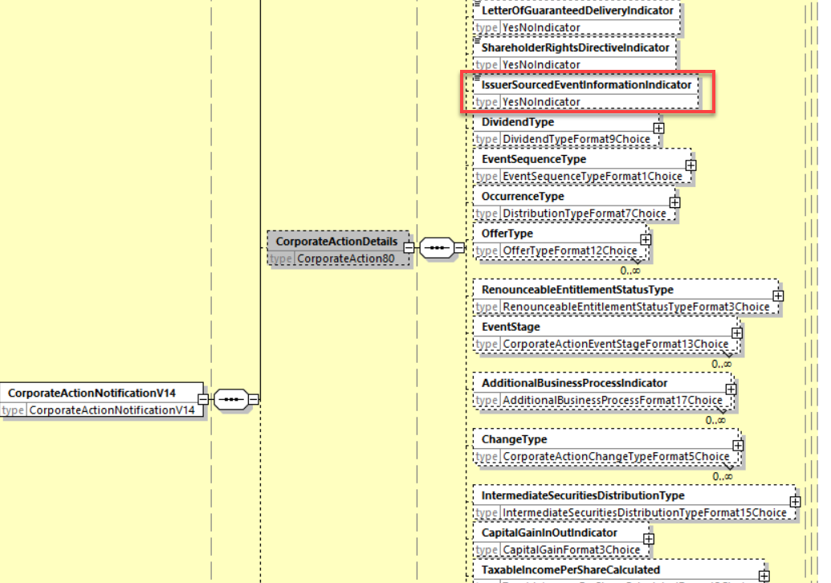

**In the seev.001 (MENO – MeetingNotification) message,** in the ***NotificationGeneralInformation*** building block, add a new optional element “***IssuerSourcedEventInformationIndicator***” typed by YesNoIndicator data type.

In the ***NotificationGeneralInformation*** building block, add 2 new cross element rules defined as follows:

* ***IssuerSourcedEventInformation1Rule()***: “If ShareholderRightsDIrectiveIndicator is present, then IssuerSourcedEventInformationIndicator must be absent.
* ***IssuerSourcedEventInformation2Rule()***: “If IssuerSourcedEventInformationIndicator is present, then ShareholderRightsDIrectiveIndicator must be absent.

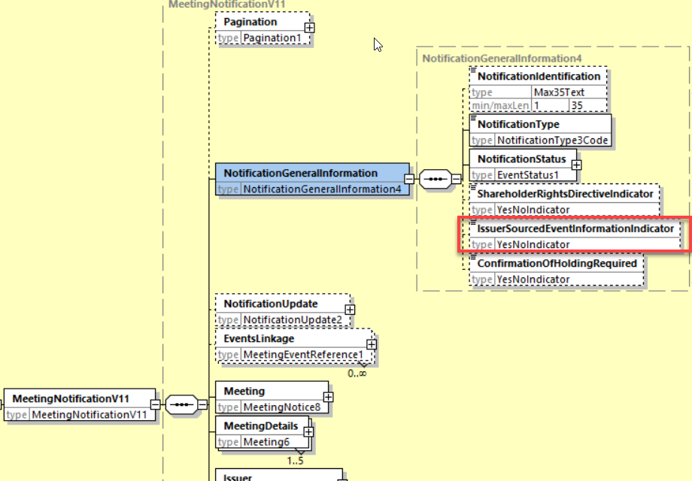

**Working Group Meeting**

|  |
| --- |
| **Discussion** |
| The SWG does not reject the business case per se but thinks it has not enough understanding of its usage in conjunction with the SRDC indicator (SRD II). The SWG would need to have the business case clarified first.  The SWG resolved to vote and the change is rejected by a huge majority of the countries.  The SWG requests the SMPG to further discuss the business case for this indicator and to potentially come back next year with an updated CR. |
| **Decision** |
| **Rejected** |

# Overview of ISO 20022 Submitted Change Requests

## CR 002196: Align Rate and Price Data Types with ISO 15022 Data Types for Securities Messages Coexistence (ISO 20022 CR 1390)

|  |  |
| --- | --- |
| **Origin of request** | |
| Requesting Country: |  |
| Requesting Group: | SMPG |
| **Sponsors** | |
|  | |
| **Message type(s) impacted** | |
| seev.031, seev.033, seev.035, seev.036, seev.042, 001, 008 (GM), 050, 052, 053 (MC), 009(IA) | |
| **Complies with regulation** | |
| None | |
| **Business impact of this request** | |
|  | |
| **Commitment to implement the change** | |
|  | |
| **Business context** | |
| The coexistence of asset servicing messages requires a field length disposition to be adapted in order to allow platforms operating both ISO standards to provide the same information in equivalent message types. | |
| **Nature of change** | |
| Change the BaseOneRate, PercentageRate and PercentagePrice data types in ISO 20022 to align them with the equivalent 15022 field length (fields 92A, B, R and 90A):  From: totalDigits: 11; fractionDigits: 10; baseValue: 100  To: totalDigits: 14; fractionDigits: 13; baseValue: 100 (remains unchanged). | |
| **Examples** | |
|  | |

**SWIFT Comment**

|  |
| --- |
| If we consider changing the data type restrictions for the basic types like **BaseOneRate** and **PercentageRate** in the corporate action messages only, it has an impact limited to the following CA MX messages: seev.031, seev.033, seev.035, seev.36, seev.042.  In each message, the impact on the message elements are as follows:  In seev.031, about **63** message elements impacted  In seev.033, about **13** message elements impacted  In seev.035, about **45** message elements impacted  In seev.036, about **37** message elements impacted  In seev.042, about **1** message elements impacted  If we extend the impact on all securities messages, the impact is huge, hundreds of messages could be impacted, however apart from the CA messages, no other securities messages should coexist with ISO 15022 medium term. Therefore, there is no real valid business case to extend the change to more than the CA messages to my opinion.  Nevertheless, the impact on the CA MX messages is not negligeable either as about 160 messages elements are impacted. |

**Standards Illustration**

**ISO 20022 Illustration**

In the following CA MX messages:

seev.009 (AgentCANotificationAdvice) message,seev.031 (CANO - CorporateActionNotification) message,

seev.033 (CAIS - CorporateActionInstruction) message,

seev.035 (CAFE - CorporateActionMovementPreliminaryAdvice) message,

seev.036 (CACO - CorporateActionConfirmation) message,

seev.042 (CAST - CorporateActionInstructionStatementReport) message,

* Replace the **BaseOneRate** data type by the **BaseOne14Rate** data type in the CA messages listed above which exists already in the repository as illustrated below and

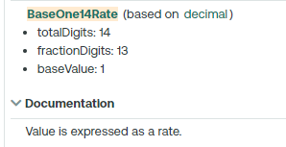

In the following CA MX messages:

seev.001 (MeetingNotification),

seev.008 (MeetingResultDissemination)

seev.009 (AgentCANotificationAdvice) message,

seev.050 (MarketClaimCreation) message,

seev.052 (MarketClaimStatusAdvice) message,

seev.053 (MarketClaimCancellationRequestStatusAdvice) message,seev.031 (CANO - CorporateActionNotification) message,

seev.033 (CAIS - CorporateActionInstruction) message,

seev.035 (CAFE - CorporateActionMovementPreliminaryAdvice) message,

seev.036 (CACO - CorporateActionConfirmation) message,

seev.042 (CAST - CorporateActionInstructionStatementReport) message,

* Replace the PercentageRate data Type by a new **Percentage14Rate** data type accommodating the same extended restrictions.

The PercentagePrice/PriceValue data type is actually reusing the PercentageRate basic type. Therefore PercentagePrice does not need to be modified specifically.

**Working Group Meeting**

|  |
| --- |
| **Discussion** |
| In addition to the above agreed solution, it was proposed by the ISO SEG CA ET to extend this implementation rate change to both the ***IncentivePremium*** and ***EarlyIncentivePremium*** elements in the GM message (**seev.001)** and to the ***WithholdingTaxRate*** element in the Market Claim messages (**seev.050, 052, 053**). |
| **Decision** |
| **Approved by the ISO SEG CA ET with comments. The extension to the seev.001 has also been approved by the ISO SEG GM & SID ET.** |

## CR 002198: Add New Transfer of Proceeds Type Indicator and Quantities Related to Market Claims (ISO 20022 CR 1396)

|  |  |
| --- | --- |
| **Origin of request** | |
| Requesting Country: | FI Finland |
| Requesting Group: |  |
| **Sponsors** | |
|  | |
| **Message type(s) impacted** | |
| MT 566, seev.036, seev.050 | |
| **Complies with regulation** | |
| None | |
| **Business impact of this request** | |
| Low | |
| **Commitment to implement the change** | |
|  | |
| **Business context** | |
| By utilizing this optional indicator, it would be possible to advice participants of a market claim transaction whether the seller has held the securities and has therefore actually received the entitlement that the claim is for.  In some of the markets like Finland, tax implications of a market claim can be treated differently depending on whether the delivering Account Holder has held the underlying securities and has received the entitlement, for example a dividend payment, for which the claim is for. This is perhaps even more relevant for the Corporate Action Movement Confirmation message, which is sometimes used as basis for tax vouchers and the like.  It is not possible to provide such information in the existing Market Claim Creation notification and therefore it is hard to achieve automation in the market claim handling by implementing the ISO20022 market claim messaging in such markets.  For markets where there is no fiscal impact on the market claim due to lack of securities, the new indicator could still provide valuable information for the receiving Account Holder since it would indicate that the underlying claim might not settle without complications. These claims could be treated with high priority. | |
| **Nature of change** | |
| The Finnish Tax Authority treats taxation of proceeds resulting from a market claim differently depending on whether the CSD securities account that is to deliver the proceeds as a market claim held all or some of the underlying securities at close of business on record date for the event.  Addition of a new element in the Market Claim Creation message to state whether the delivering securities account had the requisite holdings at cob record date, possibly in the Related Settlement Instruction Details block, would help to facilitate the automated processing of the market claims in the markets where it makes a difference whether the claim is detected as a result of lack of securities.  The element could be called ***“Transfer of Proceeds Type”*** and defined as an indicator with three values – ‘transfer of received proceeds’, ‘partial transfer of received proceeds’ and ‘no transfer of received proceeds, cash compensation only’ with following definitions:  ***‘transfer of received proceeds’*** *– Market Claim is to transfer proceeds received from the issuer to the entitled party.*  ***‘partial transfer of received proceeds’*** *– Market Claim is to transfer proceeds partially received from the issuer to the entitled party. Part is compensated in cash by the party that failed to fulfil its obligation.*  ***‘no transfer of received proceeds, cash compensation only’*** *– Market Claim is to compensate the entitled party in cash by the party that failed to fulfil its obligation. No proceeds have been received from the issuer.*  The similar information should also be added to the Corporate Action Movement Confirmation message, to clearly state the reason for the different tax treatment.  In the MT566/seev.036, the 3 code values could be added to the :22F::ADDB indicator.  It may also be possible to provide a breakdown of the quantities, meaning that if the delivering securities account had 2000 shares at cob record date but was supposed to deliver 10000 shares, assuming no partial settlement, this could also be included in the see.050 message in the Related Settlement Instruction Details sequence.  The new element could be called “Proceeds Breakdown” with 2 new quantity elements like: “Transfer of Received Proceeds” and “Cash Compensation”.  For the MT 566/seev.036, breakdown is only needed in case of ‘partial transfer of proceeds’ so it nor necessary to have a separate balance type for that in a widely used message. It could be considered instead that for ‘Partial Transfer of received proceeds’, confirmed balance CONB would always reflect the transfer of received proceeds quantity and difference between Total Eligible Balance ELIG and CONB would reflect the Cash Compensation Quantity.  When it’s just either ‘transfer of received proceeds’ or ‘cash compensation’ then CONB would equal to ELIG and reflect the respective quantity. | |
| **Examples** | |
| Account Holder AB has sold 1000 Securities XY to Account Holder BC that were eligible for a dividend of 1 EUR per share.  Settlement instructions to deliver and receive the shares with reference ABC123 are matched and subject to market claim identification.  Example 1)  Account Holder AB has not received any dividend since 1000 shares were both bought and sold, and the receipt did not settle, leaving AB without shares to deliver to BC.  Market Claim of 1000 EUR from Account Holder AB to Account Holder BC will hold the information that the market claim is performed on the basis of ‘no transfer of received proceeds, cash compensation only’.  Example 2)  Account Holder AB only held 200 shares on the Record Date of the dividend payment and therefore received a dividend of 200 EUR.  800 shares were both bought and sold, and the receipt did not settle, leaving AB without sufficient shares to deliver to BC, and BC did not allow partial settlement.  Market Claim of 1000 EUR from Account Holder AB to Account Holder BC may be split in to two separate market claim transactions in the proportion of the held position or be processed in one market claim transaction composed of two parts. If the former, one market claim would have the information ‘transfer or received proceeds’ and the other ‘no transfer of received proceeds, cash compensation only’. If the latter, the market claim would have the information ‘partial transfer of received proceeds’. | |

**SWIFT Comment**

|  |
| --- |
| We noticed that the SR2024 CR2002 (Remove Useless Market Claim Indicator Codes in Confirmations) was not implemented in the seev.036 messages. Since this CR impact the market claim codes in the confirmation message, it is suggested that the 4 claim codes removed last year in the MT566 be removed now in the seev.036 as well. |

**Standards Illustration**

**1. ISO 15022 Illustration**

**In the MT 566, in sequence C in indicator field :22F::ADDB, add 3 new code values “Transfer Of Received Proceeds”, “Partial Transfer Of Received Proceeds” and “No Transfer Of Received Proceeds” as defined and illustrated below:**

**MT 566 Field Specifications**

41. Field 22F: Indicator

FORMAT

|  |  |  |
| --- | --- | --- |
| Option F | :4!c/[8c]/4!c | (Qualifier)(Data Source Scheme)(Indicator) |

PRESENCE

Optional in optional sequence C

QUALIFIER

(Error code(s): T89)

| **Order** | **M/O** | **Qualifier** | **R/N** | **CR** | **Options** | **Qualifier Description** |
| --- | --- | --- | --- | --- | --- | --- |
| 1 | O | DIVI | N |  | F | Dividend Type Indicator |
| 2 | O | CONV | N |  | F | Event Sequence Type Indicator |
| 3 | O | DITY | N |  | F | Occurrence Type Indicator |
| 4 | O | OFFE | R |  | F | Offer Type Indicator |
| 5 | O | ADDB | R | C9 | F | Additional Business Process Indicator |
| 6 | O | CHAN | R |  | F | Change Type Indicator |
| 7 | O | RHDI | N | C5 | F | Intermediate Securities Distribution Type Indicator |
| 8 | O | ECIO | N |  | F | Capital Gain In/Out Indicator |
| 9 | O | TDTA | N |  | F | TID/TIS Calculated Indicator |
| 10 | O | LOTO | N |  | F | Lottery Type |
| 11 | O | TNDP | R |  | F | Tax On Non-Distributed Proceeds Indicator |

DEFINITION

This qualified generic field specifies:

|  |  |  |
| --- | --- | --- |
| ADDB | Additional Business Process Indicator | Specifies the additional business process linked to a corporate action event such as a claim compensation or tax refund. |
| CHAN | Change Type Indicator | Specifies the type of change announced. |
| CONV | Event Sequence Type Indicator | Specifies whether the event is an interim or a final event in a series of predefined or planned events of the same type and for the same underlying instrument. |
| DITY | Occurrence Type Indicator | Specifies the conditions in which the instructions and/or payment of the proceeds occurs. |
| DIVI | Dividend Type Indicator | Specifies the conditions in which a dividend is paid. |
| ECIO | Capital Gain In/Out Indicator | Specifies whether the capital gain is in the scope of the EU Savings directive for the income realised upon the sale, refund or redemption of shares and units ( ...) (Article 6(1d)). |
| LOTO | Lottery Type | Specifies the type of lottery announced. |
| OFFE | Offer Type Indicator | Specifies the conditions that apply to the offer. |
| RHDI | Intermediate Securities Distribution Type Indicator | Intermediates securities distribution type. |
| TDTA | TID/TIS Calculated Indicator | Specifies whether the fund calculates the taxable income per dividend/taxable income per share. |
| TNDP | Tax On Non-Distributed Proceeds Indicator | Specifies the tax regulation being attributed to the non-distributed proceeds event or to any other event. |

CODES

If Qualifier is ADDB and Data Source Scheme is not present, Indicator must contain one of the following codes (Error code(s): K22):

|  |  |  |
| --- | --- | --- |
| CLAI | Claim or Compensation | Relates to a claim on the associated corporate action event. |
| **CLFT** | **Full Transfer of Received Proceeds** | **Market Claim is to transfer proceeds received from the issuer to the entitled party.** |
| **CLNT** | **Partial Transfer of Received Proceeds** | **Market Claim is to transfer proceeds partially received from the issuer to the entitled party. Part is compensated in cash by the party that failed to fulfil its obligation.** |
| **CLPT** | **No Transfer of Received Proceeds** | **Market Claim is to compensate the entitled party in cash by the party that failed to fulfil its obligation. No proceeds have been received from the issuer.** |
| CONS | Consent | Relates to a consent within a corporate action event other than a Consent event (:22F::CAEV//CONS). |
| FPRE | Full Pre-Funding | Full pre-funding of a debt instrument by the issuer prior to original maturity when the issuer deposits assets in trust. Applicable only in the frame of a partial defeasance corporate action event. |
| INCP | Incentive Premium Payment | The event is a payment of an incentive premium related to the voting conditions prescribed at a general meeting. |
| NPLE | No Split Election | The issuer only allows a single option to be selected per designated holding. |
| PPRE | Partial Pre-Funding | Partial pre-funding of a debt instrument prior to maturity drawn through a lottery process. One new security is issued with an earlier maturity date for the refunded (called portion) and the other new security is issued with the original maturity date for the non refunded (remaining) portion. Applicable only in the frame of a partial defeasance corporate action event . |
| PPUT | Partial Mandatory Put Redemption | Partial mandatory exchange of a portion of bonds where the exchanged securities are usually remarketed. The issuer may offer holders the right to retain instead of exchanging their securities. A lottery will be used to determine eligibility for the event. |
| SCHM | Scheme/Plan of Arrangement | Component event of a scheme/plan of arrangement: a reorganisation of a company or a group of companies, and their capital. |
| TAXR | Tax Refund | Relates to a tax refund from the authorities on the associated corporate action event. |

**2. ISO 20022 Illustration**

**In the seev.036 (CACO - CorporateActionConfirmation)** message, in sequence *CorporateActionDetails/AdditionalProcessIndicator*, add in the data type code ***AdditionalBusinessProcess11Code*** of the ***Code*** element, the 3 new market claim related code as defined in ISO 15022 above and illustrated below:

It is also suggested to remove in the same code list the 4 codes ACLA, ATXF, CNTR and NAMC that were removed from the MT 566 last year for SR2024 in the scope of the MT CR2002 (*Remove Useless Market Claim Indicator Codes in Confirmations*) and that should have been removed in the seev.036 message and were not.

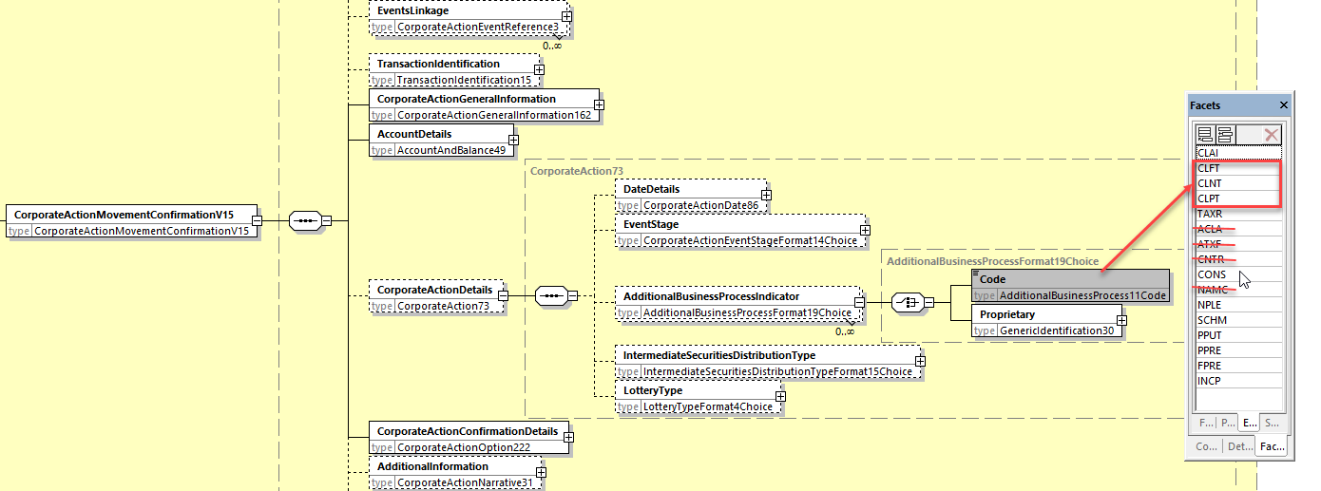

**In the seev.050 (MCCR – Market ClaimCreation) message,** in the building block RelatedSettlementInstructionDetails,

1. add a new optional and no-repeatable ***TransferOfProceedsTypeIndicator*** element with the 3 new code values CLFT, CLPT and CLNT as defined in ISO 15022 above.

The new **TransferOfProceedsTypeIndicator** is defined as follows: “*Indicates the type of transfer for the market claim proceeds****.”***

1. Add a new optional and non-repeatable sequence named “ProceedsQuantityBreakdown” with the 2 following quantity elements typed by *FinancialInstrumentQuantity18Choice*:
   * TransferOfReceivedProceedsQuantity: Quantity of securities proceeds transferred as the result of the market claim.
   * CashCompensationQuantity: Quantity of securities proceeds compensated in cash as the result of the market claim.

As illustrated below.

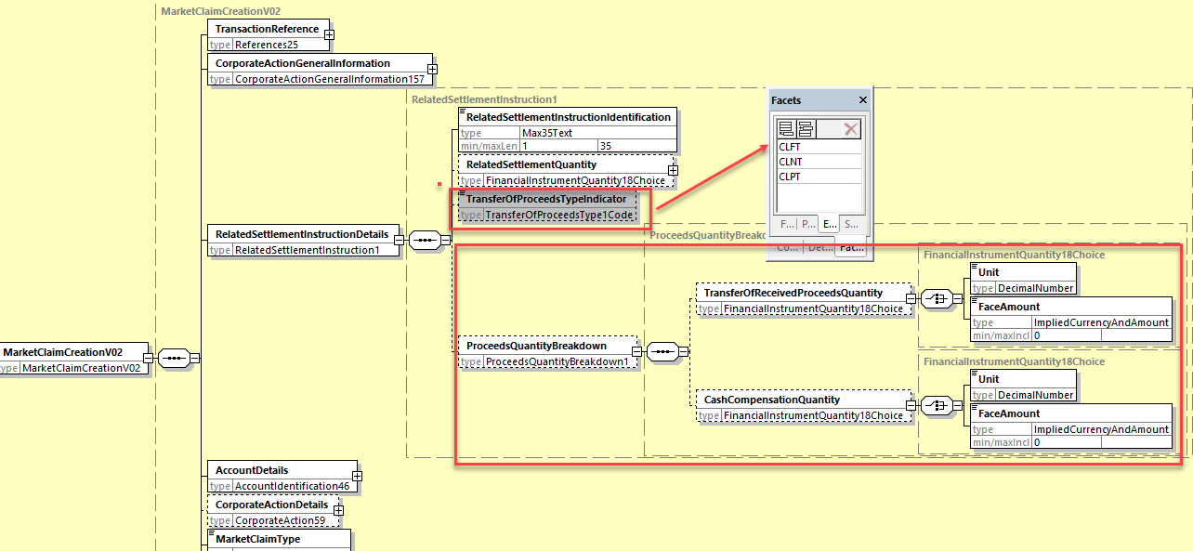

**Working Group Meeting**

|  |
| --- |
| **Discussion** |
| DE would prefer to validate further the implementation proposal with other markets to be sure that the solution is global, if need be. However, there is a majority of attending members in favor of the change for SR2025.  There were no additional feedback provided by email by the members not attending the meeting to support a postponement to SR2026. Therefore, the CR is approved. |
| **Decision** |
| **Approved by the ISO SEG CA ET.** |

## CR 002194: Add Reversal Reason Rule in CA Movement Preadvice Message (ISO 20022 CR 1370)

|  |  |
| --- | --- |
| **Origin of request** | |
| Requesting Country: |  |
| Requesting Group: | Swift |
| **Sponsors** | |
|  | |
| **Message type(s) impacted** | |
| seev.035, 037 | |
| **Complies with regulation** | |
| None | |
| **Business impact of this request** | |
|  | |
| **Commitment to implement the change** | |
|  | |
| **Business context** | |
| For the sake of coexistence between ISO 15022 and ISO 20022, the NVR rule C32 in the MT 564 should be replicated in the seev.035 when used with the CAPA function. | |
| **Nature of change** | |
| Add a new textual rule in the seev.035 mandating the presence of the NotificationOfReversal [REVR] code in the message element Code in the sequence CorporateActionDetails/AdditionalBusinessProcessIndicator when the ReversalReason building block is present. | |
| **Examples** | |
| MT564 | |

**SWIFT Comment**

|  |
| --- |
|  |

**Standards Illustration**

**2. ISO 20022 Illustration**

**A. In the seev.035 (CorporateActionMovementPreliminaryAdvice) message, in the root of the message, add a new cross element textual rule named ReversalReasonRule with one of the 2 following rule descriptions (to be decided at implementation time):**

Option 1:

If ReversalReason is present, then in MovementPreliminaryAdviceGeneralInformation, Function must be “PreadviceOfMovement” [CAPA] and CorporateActionDetails must be present and in at least one occurrence of CorporateActionDetails/AdditionalBusinessProcessIndicator, Code value must be REVR (NotificationOfReversal.

(MT564 NVR C32)

Or

Option 2:

If CorporateActionDetails is present and in at least one occurrence of AdditionalBusinessProcessIndicator, Code value is REVR (NotificationOfReversal), then ReversalReason must be present and MovementPreliminaryAdviceGeneralInformation/Function must be CAPA (PreadviceOfMovement).

(MT564 NVR C32)

B. **In the seev.035 (CorporateActionMovementPreliminaryAdvice) and in the seev.037 (CorporateActionMovementReversalAdvice) messages, in the *ReversalReason* building block, add the code value OTHR in the data type CorporateActionReversalReason2Code typing the Code element in the Reason sequence as illustrated below for the seev.037:**

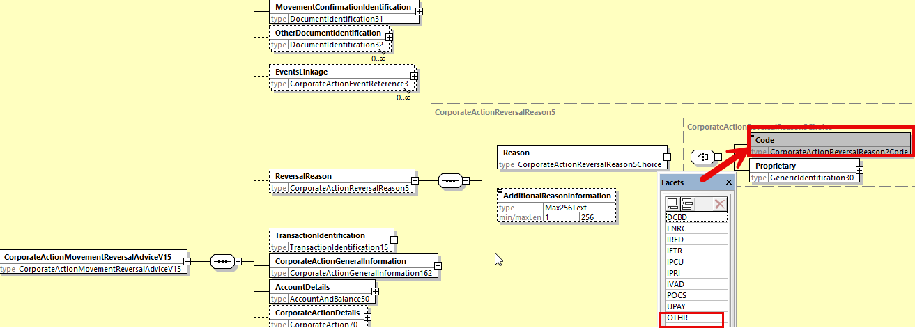

**Working Group Meeting**

|  |
| --- |
| **Discussion** |
| The ET agreed with the proposed rule solution and also agreed to add in the seev.035 and seev.037 messages, in the Reversal Reason code list, the missing OTHR code value to align with the presence of the NARR reason code in the reversal reason codes in ISO 15022. |
| **Decision** |
| **Approved as is by the ISO SEG CA ET.** |

## CR 002193: Amend Bid Interval Data Type in CA Notification Subset and Fix Pagination Rule (ISO 20022 CR 1368)

|  |  |
| --- | --- |
| **Origin of request** | |
| Requesting Country: |  |
| Requesting Group: | Swift |
| **Sponsors** | |
|  | |
| **Message type(s) impacted** | |
| seev.031, seev.035, seev.036, seev.042, seev.001, seev.004, seev.007, seev.008 | |
| **Complies with regulation** | |
| None | |
| **Business impact of this request** | |
|  | |
| **Commitment to implement the change** | |
|  | |
| **Business context** | |
| Assign the correct data type dedicated to the seev.031 CA subset message element in line with ISO 15022 restrictions.  In seev.031 and seev.001, correct the cross element complex rule *NotificationIdentificationRule* so that it can follow the new SMPG market practice on pagination which does no longer recommend (in the chain of the REPL messages) the usage of the PreviousNotificationIdentification element for the pages following page 1 of the paginated notification. The PreviousNotificationIdentification element should only be used in the first page of the REPL message. | |
| **Nature of change** | |
| In seev.031.**002**.14 (in variant 2 of the notification message), the element BidInterval in the sequence CorporateActionOptionDetails/RateAndAmountDetails has a data type which is used in variant 1 which is not restricted and therefore incorrect. This element should have the data type RateAndAmountFormat50Choice similarly to the data type of the same BidInterval element in the CorporateActionDetails/RateAndAmountDetails sequence in the variant 2 message.  In the seev.031, amend the cross element complex rule *NotificationIdentificationRule* and in the seev.001, amend the Previous*NotificationIdentificationRule* as follows:  *“If NotificationGeneralInformation/NotificationType is REPL (Replacement), and Pagination/PageNumber has value “1”, then NotificationUpdate/PreviousNotificationIdentification must be present.* | |
| **Examples** | |
|  | |

**SWIFT Comment**

|  |
| --- |
|  |

**Standards Illustration**

**ISO 20022 Illustration**

1. **In the subset message seev.031.002.14 (CANO – CorporateActionNotification),** the data type *RateAndAmountFormat38Choice* must be replaced by the data type ***RateAndAmountFormat50Choice*** so that the data type of the ***Amount*** element is ***RestrictedFINActiveCurrencyAnd13DecimalAmount***and the data type of the **IndexPoints** element is ***RestrictedFINDecimalNumber*** .

Current ISO 20022 design of BidInterval in the sev.031.002.14 that needs to be amended:

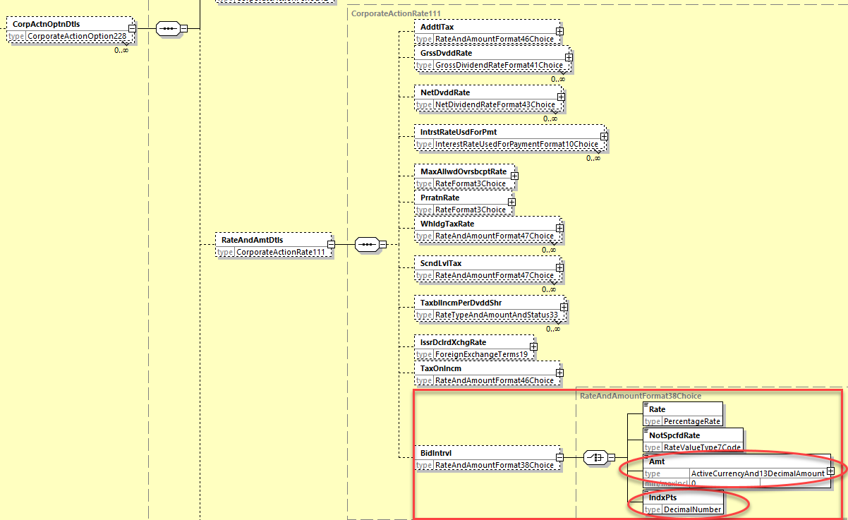

1. **In the seev.031 (CANO – CorporateActionNotification) message**, amend the *NotificationIdentificationRule* and **in the seev.001 (MENO – MeetingNotification) message**, amend the Previous*NotificationIdentificationRule* as follows:

*“If NotificationGeneralInformation/NotificationType is REPL (Replacement), and Pagination/PageNumber has value “1”, then NotificationUpdate/PreviousNotificationIdentification must be present.*

1. **In the seev.035 (CAFE – CorporateActionMovementPreliminaryAdvice) message**, add a similar rule than the rule *NotificationIdentificationRule* in the seev.031.
2. **In the seev.031 (CANO – CorporateActionNotification) message**, and **in the seev.001 (MENO – MeetingNotification) message**, add a new cross elements rules named PaginationRule described as follows:

*“If Pagination is present, then NotificationGeneralInformation/NotificationIdentification must be present.”*

1. **In the seev.035, seev.036 and seev.042, add a pagination rule similar to the one specified above for seev.031 and also in seev.001, seev.004, seev.007, seev.008.**

**Working Group Meeting**

|  |
| --- |
| **Discussion** |
| Implementation proposal agreed by the ET. In addition to the proposed solution, it was also agreed by the ISO SEG CA ET to add a new rule in listed messages to enforce the presence of the "NotificationIdentification" element (for the seev.031 and 001) when the "Pagination" component is present. |
| **Decision** |
| **Approved with comments by the ISO SEG CA ET.** |

## CR 002192: Amend Spelling of NotSpecifiedReason Element (ISO 20022 CR 1341)

|  |  |
| --- | --- |
| **Origin of request** | |
| Requesting Country: |  |
| Requesting Group: | Swift |
| **Sponsors** | |
|  | |
| **Message type(s) impacted** | |
| seev.006, seev.041, seev.042, seev.053 | |
| **Complies with regulation** | |
| None | |
| **Business impact of this request** | |
| Low | |
| **Commitment to implement the change** | |
|  | |
| **Business context** | |
| Have all components providing a status with “NoSpecifiedReason” in securities messages consistent vis a vis the xml tag used. | |
| **Nature of change** | |
| In the following components used in the above listed messages:  - In PendingCancellationStatus11Choice (in seev.053)  - In PendingCancellationStatus10Choice (in seev.006)  - In PendingCancellationStatus7Choice (in seev.041, 042)  The element “NotSpecifiedReason” should be spelled “NoSpecifiedReason” to be consistent with the spelling of NoSpecifiedReason in all other similar status components in asset servicing status messages since the element name has an impact on the corresponding xml tag used. | |
| **Examples** | |
|  | |

**SWIFT Comment**

|  |
| --- |
|  |

**Standards Illustration**

**ISO 20022 Illustration**

In the data type ***PendingCancellationStatus7Choice*** used in the seev.041.001.13 in the path *InstructionCancellationRequestStatus/PendingCancellation* and in the seev.042.001.12, in the path *AccountAndStatementDetails/CorporateActionEventAndBalance/Balance/TotalInstructedBalanceDetails/OptionDetails/OptionInstructionDetails/InstructionStatus/PendingCancellation*, the “***NotSpecifiedReason***” element name must be spelled as “***NoSpecifiedReason***”.

The same applies to:

* the data type ***PendingCancellationStatus10Choice*** used in the seev.006.001.10 in the paths *InstructionTypeStatus/CancellationStatus/GlobalCancellationStatus/PendingCancellation* and in *InstructionTypeStatus/CancellationStatus/DetailedCancellationStatus/InstructionCancellationStatus/PendingCancellation.*
* the data type ***PendingCancellationStatus11Choice*** used in the seev.053.001.02 in the paths *MarketClaimCancellationRequestStatus/PendingCancellation.*

Illustration in seev.041

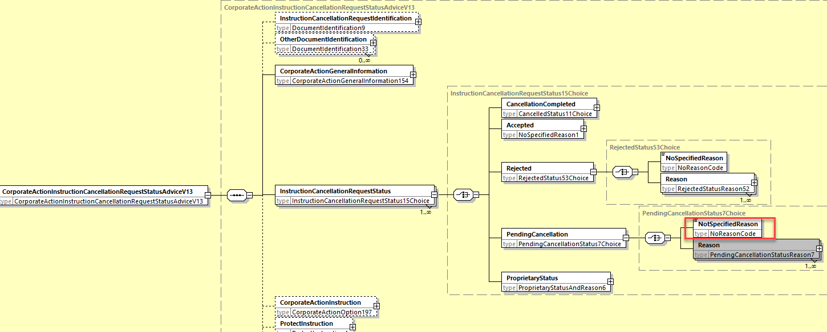

Illustration in seev.053.001.02

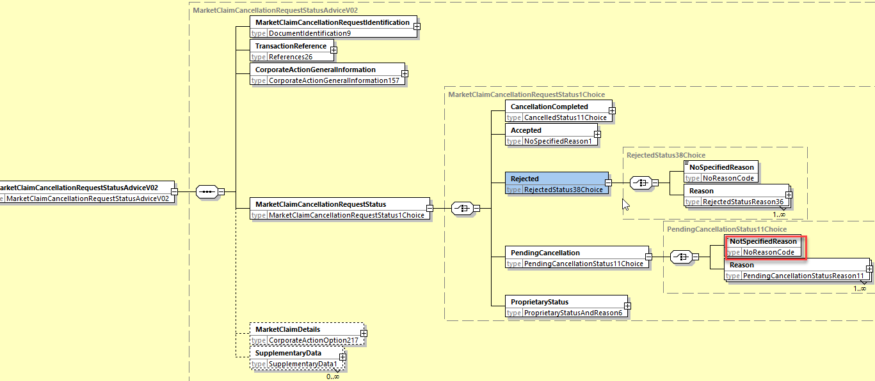

Illustration in the seev.006.001.10

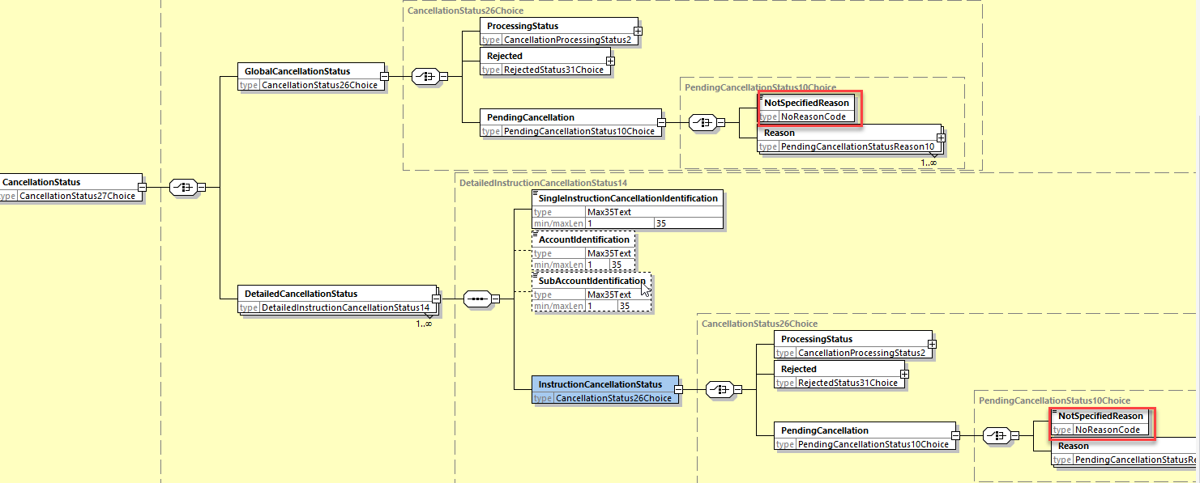

**Working Group Meeting**

|  |
| --- |
| **Discussion** |
| The ET agreed with the proposed solution. |
| **Decision** |
| **Approved as is by the ISO SEG CA ET.** |

## CR 002195: Remove Useless Rule in Market Claim Creation Message (ISO 20022 CR 1371)

|  |  |
| --- | --- |
| **Origin of request** | |
| Requesting Country: |  |
| Requesting Group: | Swift |
| **Sponsors** | |
|  | |
| **Message type(s) impacted** | |
| seev.050 | |
| **Complies with regulation** | |
| None | |
| **Business impact of this request** | |
|  | |
| **Commitment to implement the change** | |
|  | |
| **Business context** | |
| Remove useless rule. | |
| **Nature of change** | |
| Remove the rule Party2PresenceRule in the seev.050 in the settlementParties122 components used to type the SettlementParties elements as the result of this rule is always true/positive due to the fact that the Party1 element is mandatory. | |
| **Examples** | |
|  | |

**SWIFT Comment**

|  |
| --- |
|  |

**Standards Illustration**

**ISO 20022 Illustration**

**In the seev.050 (Market Claim Creation) message, delete the rule Party2PresenceRule located in the DeliveringSettlementParties and ReceivingSettlementParties message building blocks.**

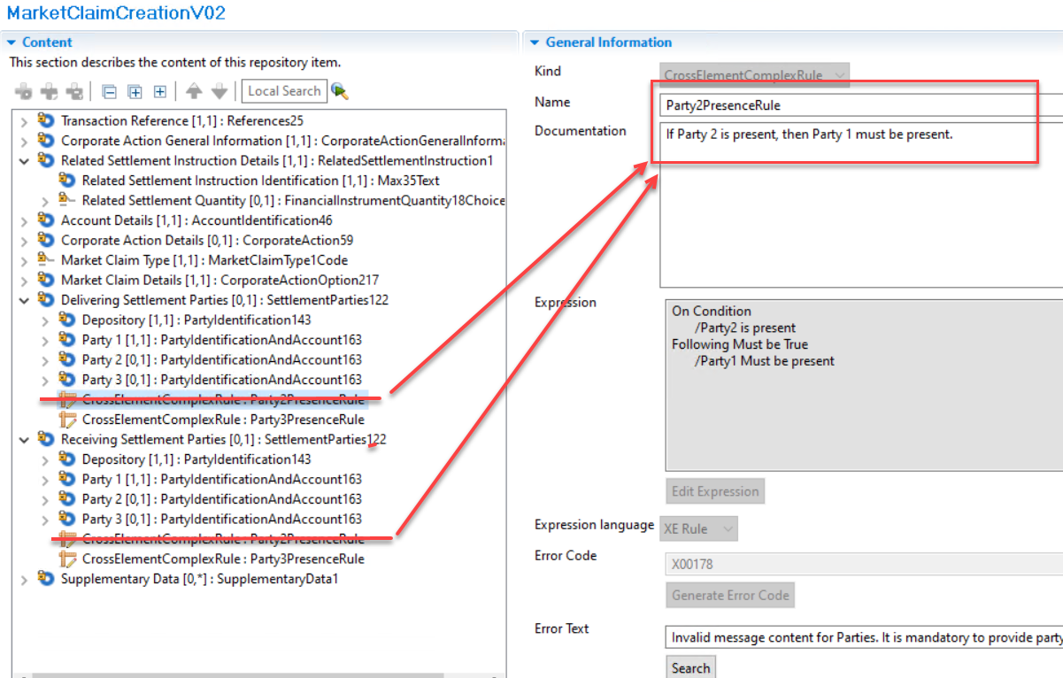

**Working Group Meeting**

|  |
| --- |
| **Discussion** |
| The ET agreed with the proposed solution. |
| **Decision** |
| **Approved as is by the ISO SEG CA ET.** |

## CR 002197: Issuer Agent - Agent Notification Advice Amendment and Alignment with CA Notification Message (ISO 20022 CR 1391)

|  |  |
| --- | --- |
| **Origin of request** | |
| Requesting Country: | US United States of America |
| Requesting Group: |  |
| **Sponsors** | |
| ISITC | |
| **Message type(s) impacted** | |
| seev.009, seev.011 | |
| **Complies with regulation** | |
| None | |
| **Business impact of this request** | |
|  | |
| **Commitment to implement the change** | |
|  | |
| **Business context** | |
| The purpose of this change request is to update the seev.009 so that it can be used in conjunction with the Issuer Agent Corporate Actions Announcement Initiative currently underway within the US market. Currently, there are many types of agent announcements which are manual. The adoption by agents of the seev.009 can address issues which deter automation. Ultimately, this will produce higher quality information.  By utilizing the seev.009 message as a vehicle for automation, structural changes can better align to how agents send data to DTCC and not confine the message structure to the CANO / MT564. The ability to structure the message based upon a group notification (e.g. Partial Call Notice) will simplify the process and make the initial business case more viable to the Agent community. It will also allow DTCC to replace legacy proprietary input medium with this new message through such capability. Also, there will be no downstream impact to the broader community since the seev.009 is not being used in production today. Also, this message in conjunction with the seev.011 confirmation will be a complete workflow for the agents to both send and receive confirmation of their announcement giving the agent full transparency if there are data quality issues with the announcement they create.  The ability to have the Agent sent the Agent Announcement Event ID and have DTCC link back the Official Corporate Action Event ID (COAF) through the seev.009 announcement and seev.011 confirmation status will define the full agent announcement lifecycle.  Many of the changes required for this message are to bring this message up to the content of the seev.031 where applicable. Also, there were some changes applicable to US Agents which were necessary for automation proprietary to DTCC. All of these are noted within the Agent CANO Inbound Requirements spreadsheet and the restricted seev.031 schema which are both attached below. | |
| **Nature of change** | |
| This change request seeks to modify the seev.009.001.01 Agent Notification Advice message in order to be used within the US Agent Announcement Initiative. Within SR2023, the seev.011.001.01 Agent Notification Status Advice was modified to align with current field structures and new status values which will better help solution the Agent Announcement workflow. As this initiative has progressed, we now have the need to make changes within the announcement structure to which the CANO seev.031 in certain cases cannot support. For instance, in the US Lottery events (DRAW, PDEF) in many cases are sent for a “family of CUSIPs” within one notice. For an agent, this is one event which would be considered one Agent Corporate Action Agent Reference Number sharing the same Publication Date and same Payment Date. However, there are some terms for each CUSIP which may be different like the Payment Rate. In the case of Partial Pre-refunding or Partial Defeasance events, they will have new Defeased / Non-Defeased CUSIPs or new refunded / non-refunded CUSIPS. Therefore, I am requesting capability process the notice as one message by creating a new indicator within the Underlying Security tag to state Group Underlying Security indicator as a choice. This would indicate that a separate section would be used having multiple Underlying CUSIPS each with their own details. Ultimately, each record within this Agent announcement would create a separate unique COAF published event downstream. But this would allow an agent to send one message to DTCC containing 100 CUSIPs instead of 100 messages for one Partial Call Notice. The other capability is to allow for the Underlying Security in Corporate Action General Information to be Repeatable when no other information in the event changes. In this case, one announcement could be sent for 100 CUSIPs all with the same event/ option/payout information.  Within the change request other key changes were made.  First, wherever possible the request is to use the current CANO seev.031 information to replace what is in the equivalent section in the seev.009. Only those elements pertinent to Agents were considered and a restricted CANO schema was created for this purpose to replace the relevant seev.009 content.  Second, key elements from the DTCC registered CANO extension supl.001 which Agents could supply were also considered. These are also in attached spreadsheet.  Third, the seev.009 Agent Announcement Notification structure was also reviewed. Several changes were proposed to make the message more intuitive. Agent information within the message was consolidated including Agent Role and Contact Information. Also as stated above, the strategy of using the CANO structure to override the equivalent section of the seev.009 will help bring the message to current practice and allow for future flexibility for all event types which may be considered as DTCC works with Agents going forward.  Detailed specifications of the changes: | |
| **Examples** | |
|  | |

**SWIFT Comment**

|  |
| --- |
|  |

**Standards Illustration**

**ISO 20022 Illustration**

The current design of (the first version of) the seev.009 (AgentCANotificationAdviceV01) is illustrated in the following snapshot.

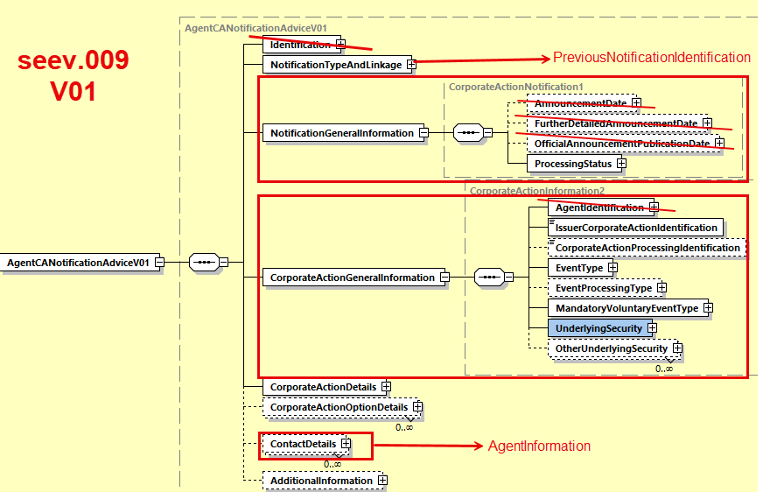

Since the first version of the seev.009 was practically a copy of the first version of the seev.031 (CANO – CorporateActionNotification) message (BAH excepted) with some issuer agent specificities, the basic principle behind the redesign of the seev.009 message was to start from the basic message structure of the latest version of the seev.031 (seev.31.001.14) and its variant 1 and to adapt it to the specific business data requirements for the issuer agents provided in the change request.

To this end, the “Identification” element has been removed since it is now present in the BAH.

The “Notification Type And Linkages” sequence is replaced by a single “Previous Notfication Identification” element.

The basic structure of the “Corporate Action General Information” element has been kept except that the Identification of the Agents has been extracted and placed at the root of the Message and merged with the “Contact Details” sequence.

The rest of the message i.e. the old “Corporate Action Details” and the “Corporate Action Option Details” sequences were fully replaced by the latest version of the same sequences in the seev.031 message and the specific business data requirements for the issuer agents have been inserted as per the requirements.

The basic structure of the seev.009 version 2 is therefore as illustrated below:

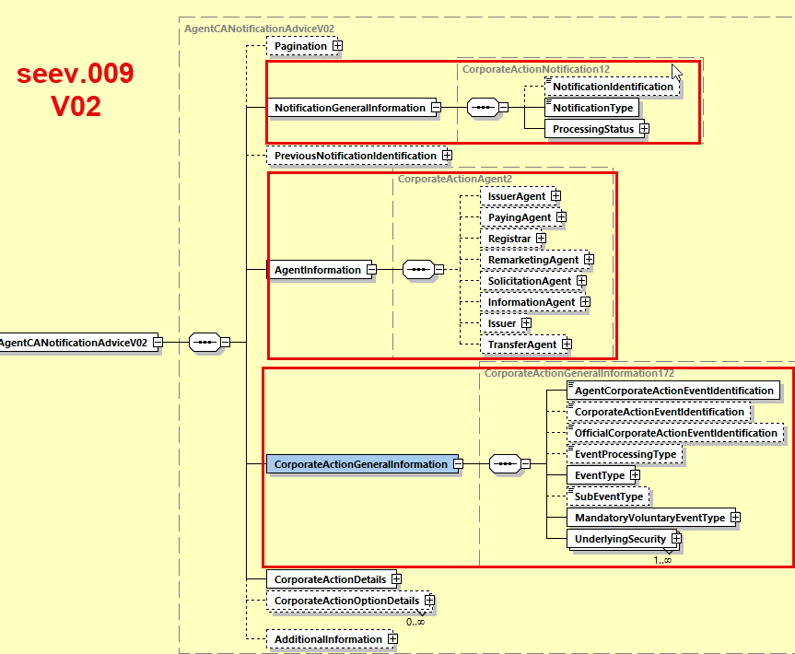

The draft schemas (with fully expanded xml tags) of the new seev.009 is provided below:



The draft message structure of the new seev.009 in Excel is provided here below:



When the changes requested in the CR impact the seev.011, the seev.011 will be updated as well (this is namely the case for the addition of the “Redemption” (REDM) code in the EventProcessingType).

**Working Group Meeting**

|  |
| --- |
| **Discussion** |
| The ET agreed with the proposed solution. |
| **Decision** |
| **Approved as is by the ISO SEG CA ET.** |

End of document

1. MWG maintenance meeting minutes are distributed around first week of September.