**Maintenance Change Request**

**for the update of ISO 20022 financial repository items**

*Note: the purpose of this document is to give guidelines to submitting organizations that will develop a new version of existing ISO 20022 messages based on change requests screened by the Standards Evaluation Group(s). Such development is subject to the approval of a Maintenance Change Request which must include a detailed description of the impact of each change on the related messages. The Maintenance Change Request must start with a general chapter covering topics related to the whole maintenance effort and a specific chapter for each change request, as described below. Please consult the iso20022.org website for additional details on the* [*maintenance process*](http://www.iso20022.org/maintenance.page)*. Valid Maintenance Change Requests for the following ISO 20022 yearly maintenance cycle must be sent to* [*iso20022ra@iso20022.org*](mailto:iso20022ra@iso20022.org) *by August 21st.*

1. **Name of the request:**

"ISO 20022 - Securities Clearing Maintenance 2024/2025"

1. **Submitting organization(s):**

Swift srl on behalf of Swift and FPL

1. **Related messages:**

Under this maintenance, below existing ISO 20022 message definitions will be maintained.

**Clearing messages**

| Message Identifier | MessageDefinition |
| --- | --- |
| secl.001.001.03 | Trade Leg Notification V3 |
| Secl.002.001.03 | Trade Leg Notification Cancellation V3 |
| secl.003.001.03 | Trade Leg Statement V3 |
| secl.004.001.03 | Net Position V3 |
| secl.010.001.03 | Settlement Obligation Report V3 |

1. **Commitments of the submitting organization:**

The submitting organization must confirm that it can and will:

* undertake the development of the new version of the candidate ISO 20022 message models that it will submit to the RA for compliance review and evaluation. For the ISO 20022 yearly maintenance cycle, new valid Message Definition models must be available to the RA by December 1.
* provide a new version of part 1 of the Message Definition Report (MDR) by December 1, and, optionally, new examples of valid and invalid message instances of each candidate message by May 1 at the latest.
* address any queries related to the description of the new models and messages as published by the RA on the ISO 20022 website.

If the submitting organization cannot develop all or part of the changes included in this Maintenance Change Request in the timeframe agreed by the SEG, it must propose an alternative solution for the change requests it cannot develop in time (eg postpone to a later date or to the next yearly maintenance cycle).

The submitting organization must confirm whether it intends or not to organize any testing or the actual implementation of the new version of the messages once the related documentation has been published by the RA. The purpose is to ensure that the documentation of the new version of the messages is accurate and consistent and to verify that these approved messages can be implemented with no adverse effects on communication infrastructures and/or applications.

The submitting organization must confirm its knowledge and acceptance of the ISO 20022 Intellectual Property Rights policy for contributing organizations, as follows.

*“Organizations that contribute information to be incorporated into the ISO 20022 Repository shall keep any Intellectual Property Rights (IPR) they have on this information. A contributing organization warrants that it has sufficient rights on the contributed information to have it published in the ISO 20022 Repository through the ISO 20022 Registration Authority in accordance with the rules set in ISO 20022. To ascertain a widespread, public and uniform use of the ISO 20022 Repository information, the contributing organization grants third parties a non-exclusive, royalty-free license to use the published information”.*

1. **Contact persons:**

* Karine Taquet, karine.taquet@swift.com, +32 2 655 37 84

1. **Change request with impact on clearing messages**:

1 ISO 20022 CR 1363: Apply the UTI on the Securities Clearing messages 3

# ISO 20022 CR 1363: Apply the UTI on the Securities Clearing messages

1. **Origin of the request:**

*A.1 Submitter*:

- ASX – CHESS (Clearing House Electronic Sub register System)

*A.2 Contact person:*

- Priscilla Ferri de Barros, priscilla.ferridebarros@asx.com.au, +61 481 816 515

*A.3 Sponsors*:

N/A

1. **Related messages:**

| Message Identifier | MessageDefinition |
| --- | --- |
| secl.001.001.03 | Trade Leg Notification V3 |
| secl.002.001.03 | Trade Leg Notification Cancellation V3 |
| secl.003.001.03 | Trade Leg Statement V3 |
| secl.004.001.03 | Net Position V3 |
| secl.010.001.03 | Settlement Obligation Report V3 |

1. **Description of the change request:**

In 2019, a Change Request (CR001448) was submitted by SMPG to support the Unique Transaction Identifier (UTI) code. The change involved was: adding a new format option to qualifier TRRF in field 20C of subsequence Linkages to allow 52 characters. Transport the Unique Transaction Identifier (UTI) in Trade Initiation and Confirmation (TIC) and Settlement and Reconciliation (S&R) messages. In each field where the deal reference is present, add a new qualifier, or increase the lengh to 52 char, to allow to specificallly put the UTI with a new format letter (U) with a lenght of 52 character for MT messages.

As part of this change, some ISO 20022 messages were updated, extending the Trade Identification <TradId> from 35 characters to 52 characters to accommodate the UTI.  
  
The Securities and Settlement (sese) and Securities Management (semt) messages were updated accordingly. However, the Securities and Clearing (secl) messages were not updated, and the Trade Identification <TradId> still has a data type of 35 characters. This discrepancy in data types is causing compatibility issues, as the UTI with 52 characters cannot be used across end-to-end processes.  
  
CHESS is requesting that the Change Request (CR001448) be applied to all ISO 20022 messages that include the Trade Identification <TradId> tag, so that the data type can be extended from 35 characters to 52 characters. It is particularly urgent to apply this update to the secl.001 – Trade Leg Notification message, as CHESS is currently unable to use the UTI with 52 characters and it is causing misalignment with other CHESS ISO 20022 messages (sese and semt) that were updated based on the CR.

This Change Request includes four specific actions:

**secl.001- Trade Leg Identification**

**secl.002- Trade Leg Notification Cancellation**

**secl.003- Trade Leg Statement**

**secl.004- Net Position**

**Change 1:** Update the definition of the Trade Identification <TradId> in the seclmessages and any other ISO messages that include this tag, aligning them with the changes made in the ISO 20022 sese and semt Business Areas as per CR001448.

**Current tag definition:**

“Reference allocated by the broker dealer.”

**New tag definition:** sese and semt

“Reference assigned to the trade by the investor or the trading party. This reference will be used throughout the trade life cycle to access/update the trade details.”

**Change 2:** Fix the data type of the Trade Identification <TradId> in the secl business area and any other ISO messages that include this tag, changing it from 35 characters to 52 characters.

**Current Data Type:**

Max35Text (based on string)

* minLength: 1
* maxLength: 35

**New Data Type:** sese and semt (CR001448)

Max52Text (based on string)

* minLength: 1
* maxLength: 52

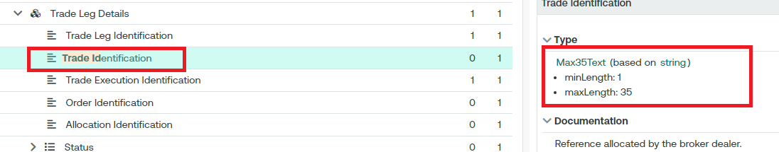

**Change 3:** Change the multiplicity of Trade Execution Identification <TradExctnId> from: mandatory to: optional in the secl messages, as CHESS intends to use the Trade Identification <TradId> UTI as the key Trade Identification in the end-to-end process. ISO could implement a cross-element rule stating that if the Trade Execution Identification is not provided, the Trade Id must be populated.

**Current Multiplicity:**

* Trade Identification <TradId> (0..1)
* Trade Execution Identification <TradExctnId> : (1..1)

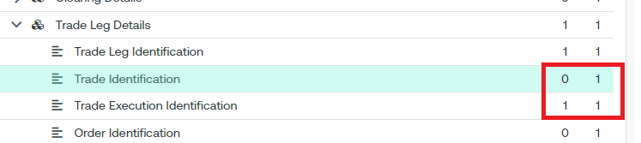

**New Multiplicity:**

* Trade Identification <TradId> (0..1)
* Trade Execution Identification <TradExctnId> : (0..1)

**secl**

**secl.010- Settlement Obligation Report**

**Change 1:** Add the Trade Id < TradId> “UTI’, inside the block Reference < Refs> as (0..*); data type Max52Text (based on string)

* minLength: 1
* maxLength: 52

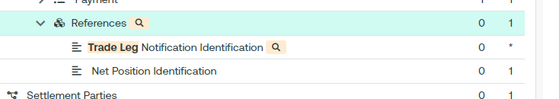

1. **Purpose of the change:**

The Australian Securities Exchange (ASX) has initiated a project to replace the current Australian equities clearing and settlement market infrastructure system (CHESS).

CHESS (Clearing House Electronic Subregister System) is the system operated by ASX to manage the clearing and settlement of equity market transactions, and to record current security holdings (and the holders) on a name on register basis. The implementation of the replacement system will provide the existing core functionality and services as well as service enhancements. The current proprietary CHESS messaging standards will be replaced with ISO 20022 standards.

The purpose of this Change Request is to apply the 2019 SMPG CR (001448) to all ISO messages in order to address the market’s/ASX’s need for supporting the Unique Transaction Identifier (UTI) code in ISO 20022 messages. By extending the data type of the Trade Identification <TradId> from 35 characters to 52 characters, the change request aims to enable the usage of the UTI with 52 characters across all business areas, including secl, sese, semt, and others.

1. **Urgency of the request:**

We request the SEG to consider this change request for the next maintenance cycle.

1. **Business examples:**

N/A

1. **SEG/TSG recommendation:**

|  |  |  |  |
| --- | --- | --- | --- |
| **Consider** | | **X** | **Timing** |
|  | | - **Next yearly cycle: 2024/2025**  (the change will be considered for implementation in the yearly maintenance cycle which starts in 2024 and completes with the publication of new message versions in the spring of 2025) | | **X** |
|  | | - **At the occasion of the next maintenance of the messages**  (the change will be considered for implementation, but does not justify maintenance of the messages in its own right – will be pending until more critical change requests are received for the messages) | |  |
|  | | - **Urgent unscheduled**  (the change justifies an urgent implementation outside of the normal yearly cycle) | |  |  |
|  | | - **Other timing:** | | |  |

Comments:

|  |  |
| --- | --- |
| **Reject** |  |

Reason for rejection:

1. **Impact analysis:**

This change request impacts the following Securities Clearing messages:

| Message Identifier | MessageDefinition |
| --- | --- |
| secl.001.001.03 | Trade Leg Notification V3 |
| secl.002.001.03 | Trade Leg Notification Cancellation V3 |
| secl.003.001.03 | Trade Leg Statement V3 |
| secl.004.001.03 | Net Position V3 |
| secl.010.001.03 | Settlement Obligation Report V3 |

**Proposed implementation:**

***Secl.001 example:***

After further discussions, a new UTI message element (with data type UTIIdentifier) will be added with a cross validation rule that enforces the presence of either the Trade Execution Identifier or the UTI.

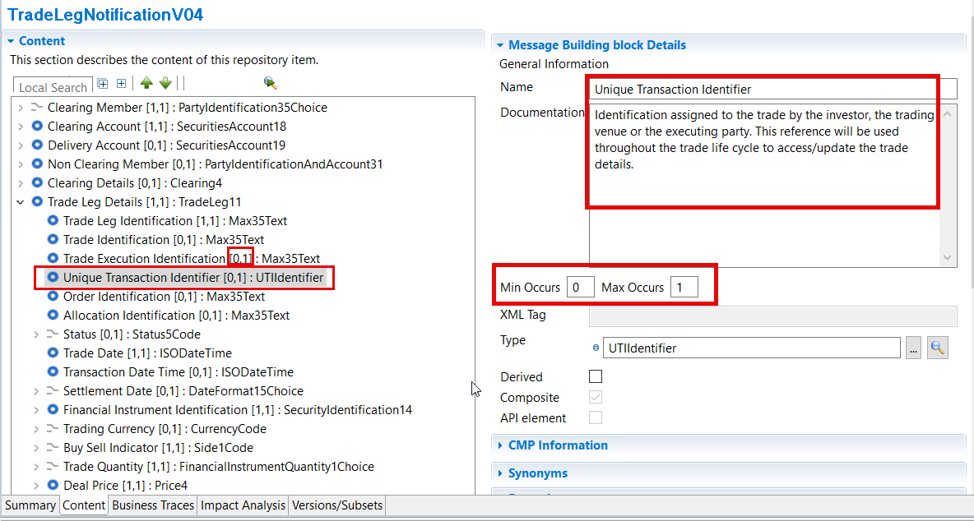

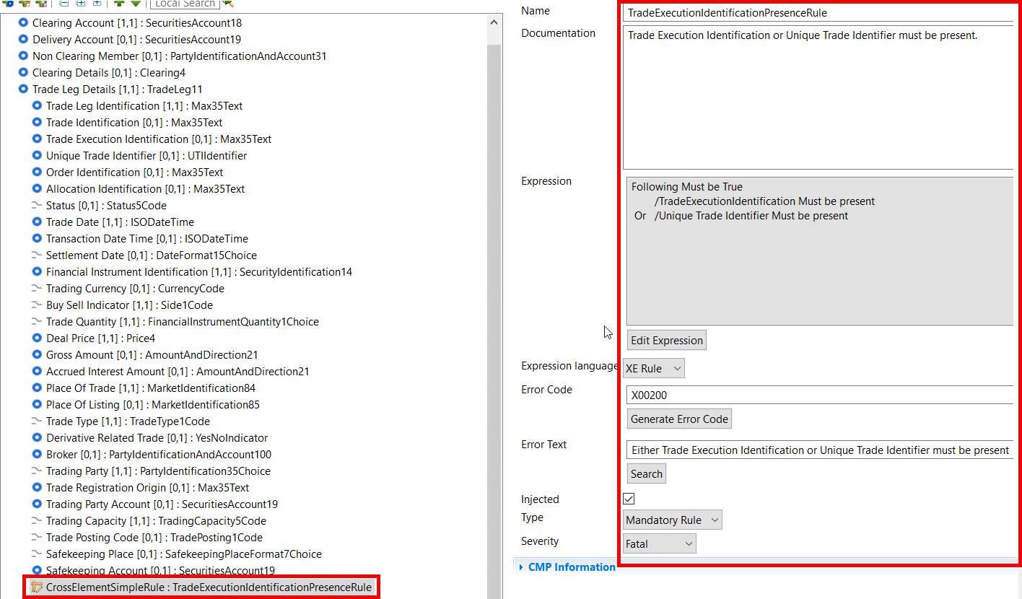

**IMPORTANT NOTE: for all the CCP Clearing messages that will be updated, the BIC data type must be changed from AnyBICIdentifier to AnyBICDec2014Identifier as per ISO CR0751 from maintenance 2018/2019. See embedded below.**



**Proposed timing:**

The submitting organization confirms that it can implement the requested changes in the requested timing.

|  |  |
| --- | --- |
| Timing | * As requested |

**Final decision of the SEG(s):**

|  |  |
| --- | --- |
| Approve | **X** |

Comments:

**secl.001, secl.002, secl.003, secl.004**

In the secl.001, secl.002, secl.003, secl.004, the Clearing SEG ET approved to add the UTI as a separate message element with data type UTIIdentifier.

If the UTI is generated by the trading venue than either Trade Identification or Trade Execution Identification will be populated and will be the same for the buy side and the sell side.

If the UTI is generated by the Clearing House, then the trade leg identification on the buy side and the sell side will be different.

Therefore, the simplest solution is to add a separate UTI message element typed as UTIIdentifier that would apply either to Trade Identification or Trade Execution Identification when it comes from FIX trade capture or, if it is generated by the clearing house then it would align to the trade leg identification. Trade leg identification will be different for each leg.

So, the SEG ET agreed to change Trade execution identification to optional, add the UTI as a separate message element typed as UTIIdentifier with an NVR stating that either the Trade Identification OR The Trade Execution Identification OR the UTI must be present. Trade Leg Identification will remain mandatory. If the UTI is generated depending on who is generating it will be implied to which identification is refers to.

Moreover, the definition of the UTI will be changed from the ISO generic definition.

*Unique trade Identifier (UTI) as agreed with the other counterparty.*

To

*Unique trade Identifier (UTI) that refers to either the trade identification, the trade execution identification or the trade leg identification.*

**secl.010**

Under block References an additional repetitive choice component will be created TradeLegNotificationIdentification as optional repetitive typed with a choice component with 2 elements the UTI and TradeLegNotifcationIdeintification.

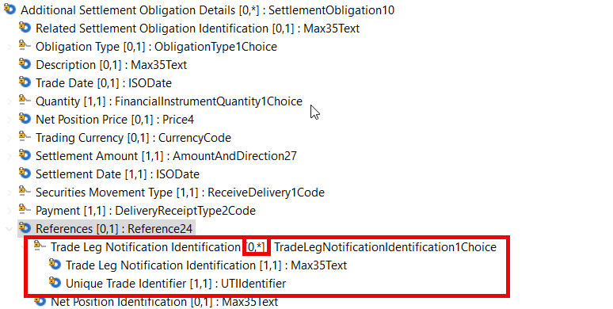

Question: when we look at the generic definition of the UTI we might want to change it there too

*Unique trade Identifier (UTI) as agreed with the other counterparty.*

|  |  |
| --- | --- |
| Reject |  |

Reason for rejection: