**Maintenance Change Request**

*Note: the purpose of this document is to give guidelines to submitting organisations that will develop a new version of existing ISO 20022 messages based on change requests screened by the Standards Evaluation Group(s). Such development is subject to the approval of a Maintenance Change Request which must include a detailed description of the impact of each change on the related messages. The Maintenance Change Request must start with a general chapter covering topics related to the whole maintenance effort and a specific chapter for each change request, as described below. Please consult the iso20022.org website for additional details on the* [*maintenance process*](http://www.iso20022.org/maintenance.page)*.*

1. Name of the request:

General Meeting Messages Maintenance for year 2024/2025

1. **Submitting organization(s):**

Swift, SMPG

1. **Related messages:**

Under this project, the following ISO 20022 General Meeting messages highlighted in blue below would be maintained in the context of the General Meeting messages maintenance for year 2024/2025 - depending upon the approval of the proposed modeling solutions:

|  |  |  |  |
| --- | --- | --- | --- |
|  | **Message Name** | **Abbreviated Name** | **Identifier** |
| 1 | MeetingNotificationV11 | MENO | seev.001.001.11 |
| 2 | MeetingCancellationV09 | MECN | seev.002.001.09 |
| 3 | MeetingEntitlementNotificationV09 | MENT | seev.003.001.09 |
| 4 | MeetingInstructionV09 | MEIN | seev.004.001.09 |
| 5 | MeetingInstructionCancellationRequestV09 | MEIC | seev.005.001.09 |
| 6 | MeetingInstructionStatusV10 | MEIS | seev.006.001.10 |
| 7 | MeetingVoteExecutionConfirmationV10 | MECO | seev.007.001.10 |
| 8 | MeetingResultDisseminationV09 | MERD | seev.008.001.09 |
| 9 | Securities Message Rejection |  | semt.001.001.04 |

1. **Commitments of the submitting organization:**

Swift and SMPG confirm that it can and will:

* undertake the development of the new version of the candidate ISO 20022 message models that it will submit to the RA for compliance review and evaluation by September 2024.
* provide a new version of part 1 of the Message Definition Report (MDR) and new examples of valid message instances of each message by October 2024 at the latest.
* address any queries related to the description of the new models and messages as published by the RA on the ISO 20022 website.

Swift confirms that it intends to organize the actual implementation of the new version of the messages on its SwiftNet network once the related documentation has been published by the RA.

The submitting organisations confirm their knowledge and acceptance of the ISO 20022 Intellectual Property Rights policy for contributing organisations, as follows.

*“Organisations that contribute information to be incorporated into the ISO 20022 Repository shall keep any Intellectual Property Rights (IPR) they have on this information. A contributing organisation warrants that it has sufficient rights on the contributed information to have it published in the ISO 20022 Repository through the ISO 20022 Registration Authority in accordance with the rules set in ISO 20022. To ascertain a widespread, public and uniform use of the ISO 20022 Repository information, the contributing organisation grants third parties a non-exclusive, royalty-free license to use the published information”.*

1. **Contact persons:**

Christine Strandberg – [christine.strandberg@seb.se](mailto:christine.strandberg@seb.se) – phone: +46 8 763 6074

Mari Fumagalli – [mariangela.fumagalli@bnpparibas.com](mailto:mariangela.fumagalli@bnpparibas.com) – phone: +44 207 595 4988

Jacques Littré – [jacques.littre@swift.com](mailto:jacques.littre@swift.com) – phone: +32 2 655 43 35

Miriam Ortseifen – [miriam.ortseifen@swift.com](mailto:miriam.ortseifen@swift.com) – Phone: +34 91 425 13 17

**ISO 20022 General Meeting Messages Maintenance 2024/2025**

**Table of Contents**

1 ISO CR1397: Add New Deregistration Processing Status to Meeting Instruction Status Message 4

2 ISO CR1398: Amend Definition of Meeting Attendee in Meeting Instruction Message 6

3 ISO CR1399: Remove the NotVoting Participation Method in the Meeting Messages 8

4 ISO CR1400: Add Beneficial Owner Details Requirements to the Meeting Notification Message 11

5 ISO CR1402: Add new Deadline Date Elements to the Meeting Notification Message 13

# ISO CR1397: Add New Deregistration Processing Status to Meeting Instruction Status Message

## Origin of the request:

### A.1 Submitter:

DESSUG CA – PSG (Deutsche SWIFT Securities Market User Group - Corporate Actions - Proxy Subgroup Germany). This group represents more than 20 different institutions including domestic and global proxy providers and registrars with a key role in the German General Meeting process.

### A.2 Contact person:

Hendrik Melchior, Hendrik.Melchior@Clearstream.com, Phone +49 69 211-13263

Daniel Schäfer, Daniel.Schaefer@hsbc.de, Phone +49 211 910-2362

Nils Stock, Nils.Stock@db.com, Phone +49 69 910-43199

Rainer Prior, Rainer.Prior@linkmarketservices.de, Phone +49 6196 8870 514

### A.3 Sponsors: German Market

## Related messages:

seev.006

## Description of the change request:

In markets where registration is required, deregistration is often processed automatically after the meeting. Deregistration is also required if a previously submitted registration instruction has been cancelled before the vote deadline.

A new processing status should be created: Deregistration completed (DREG)

Description: “Rights holder has been deregistered.”

1. **Purpose of the change:**

The change is required due to the market practice, automation of the business process and newly identified business requirement.

1. **Urgency of the request:**

SR2025.

1. **Business examples:**

N/A

1. **SEG/TSG recommendation:**

*This section is not to be taken care of by the submitter of the change request. It will be completed in due time by the SEG(s) in charge of the related ISO 20022 messages or the TSG for changes related to the BAH.*

|  |  |  |  |
| --- | --- | --- | --- |
| **Consider** | | **X** | **Timing** |
|  | | - **Next yearly cycle: 2024/2025**  (the change will be considered for implementation in the yearly maintenance cycle which starts in 2024 and completes with the publication of new message versions in the spring of 2025) | | X |
|  | | - **At the occasion of the next maintenance of the messages**  (the change will be considered for implementation, but does not justify maintenance of the messages in its own right – will be pending until more critical change requests are received for the messages) | |  |
|  | | - **Urgent unscheduled**  (the change justifies an urgent implementation outside of the normal yearly cycle) | |  |  |
|  | | - **Other timing:** | | |  |

Comments:

|  |  |
| --- | --- |
| **Reject** |  |

Reason for rejection:

1. **Impact analysis:**

This change request impacts the following General meeting messages:

* seev.006

1. **Proposed implementation:**

**In the seev.006.001.10 (MEIS - Meeting Instruction Status),** in sequence Instruction Status in the Instruction Type Status building block, add new Processing Status code value **“DREG” (Deregistration completed)** to the data type Status9Code of the ***ProcessingStatus/Status*** element as illustrated below and defined as “***Rights holder has been deregistered from the meeting participants list.***”:

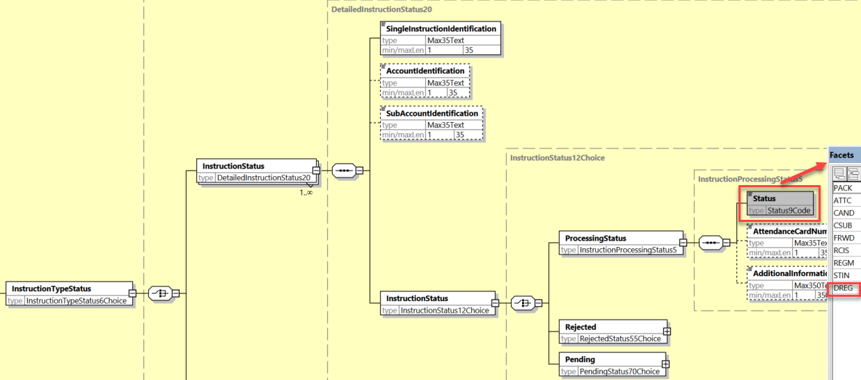

1. **Proposed timing:**

The submitting organization confirms that it can implement the requested changes in the requested timing.

|  |  |
| --- | --- |
| Timing | * As requested |

1. **Final decision of the SEG(s):**

|  |  |
| --- | --- |
| Approve | **X** |

Comments:

|  |  |
| --- | --- |
| Reject |  |

Reason for rejection:

# ISO CR1398: Amend Definition of Meeting Attendee in Meeting Instruction Message

## Origin of the request:

### A.1 Submitter:

DESSUG CA – PSG (Deutsche SWIFT Securities Market User Group - Corporate Actions - Proxy Subgroup Germany). This group represents more than 20 different institutions including domestic and global proxy providers and registrars with a key role in the German General Meeting process.

### A.2 Contact person:

Hendrik Melchior, Hendrik.Melchior@Clearstream.com, Phone +49 69 211-13263

Daniel Schäfer, Daniel.Schaefer@hsbc.de, Phone +49 211 910-2362

Nils Stock, Nils.Stock@db.com, Phone +49 69 910-43199

Rainer Prior, Rainer.Prior@linkmarketservices.de, Phone +49 6196 8870 514

### A.3 Sponsors: German Market

## Related messages:

seev.004

## Description of the change request:

Definition change of the meeting attendee, because in case of a Proxy the attendee could also have voting rights.

OLD: Identification of the security holder who will attend and vote at the meeting in person and/or the person assigned by the security holder to attend the meeting without having any voting rights or taking any action.

NEW: Identification of the security holder who will attend the meeting in person or the person assigned by the security holder to *attend the meeting, with or without having voting rights* or taking any action.

## Purpose of the change:

Definition change of the meeting attendee, because in case of a Proxy the attendee could also have voting rights.

## Urgency of the request:

By default.

## Business examples:

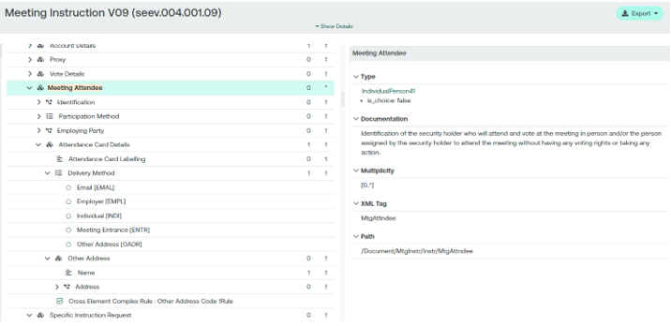

## SEG/TSG recommendation:

*This section is not to be taken care of by the submitter of the change request. It will be completed in due time by the SEG(s) in charge of the related ISO 20022 messages or the TSG for changes related to the BAH.*

|  |  |  |  |
| --- | --- | --- | --- |
| **Consider** | |  | **Timing** |
|  | | - **Next yearly cycle: 2024/2025**  (the change will be considered for implementation in the yearly maintenance cycle which starts in 2024 and completes with the publication of new message versions in the spring of 2025) | |  |
|  | | - **At the occasion of the next maintenance of the messages**  (the change will be considered for implementation, but does not justify maintenance of the messages in its own right – will be pending until more critical change requests are received for the messages) | |  |
|  | | - **Urgent unscheduled**  (the change justifies an urgent implementation outside of the normal yearly cycle) | |  |  |
|  | | - **Other timing:** | | |  |

Comments:

|  |  |
| --- | --- |
| **Reject** | **X** |

Reason for rejection:

**The ET rejects unanimously (to the exception of the submitter - Germany) the proposed change of definition as the reviewed definition mixes up the role of the Proxy and of the Meeting attendee, exactly what the current definition tries to avoid. This would introduce too much confusion in the message.**

# ISO CR1399: Remove the NotVoting Participation Method in the Meeting Messages

## Origin of the request:

*A.1 Submitter:*

DESSUG CA – PSG (Deutsche SWIFT Securities Market User Group - Corporate Actions - Proxy Subgroup Germany). This group represents more than 20 different institutions including domestic and global proxy providers and registrars with a key role in the German General Meeting process.

*A.2 Contact person:*

Hendrik Melchior, Hendrik.Melchior@Clearstream.com, Phone +49 69 211-13263

Daniel Schäfer, Daniel.Schaefer@hsbc.de, Phone +49 211 910-2362

Nils Stock, Nils.Stock@db.com, Phone +49 69 910-43199

Rainer Prior, Rainer.Prior@linkmarketservices.de, Phone +49 6196 8870 514

*A.3 Sponsors:* German Market

## Related messages:

seev.001, seev.004

## Description of the change request:

Not Voting (PHNV) option in the Participation Method / Code block should be removed as the scenario is already covered by PHYS with Meeting Attendee/ ParticipationMethod >not-voting< in the seev.004.

Simplify the message structure by removing unnecessary participation methods. Remove PHNV in /Document/MtgNtfctn/Mtg/Prtcptn/PrtcptnMtd/Cd from seev.001 and corresponding seev.004 field.

The investor can already use seev.004 /Document/MtgInstr/Instr/**MtgAttndee**/PrtcptnMtd with the only available code PHNV to indicate that the attendee should not have voting rights.

## Purpose of the change:

To simplify the ISO message structure as there is a lot of confusion with this field value.

## Urgency of the request:

By default.

## Business examples:



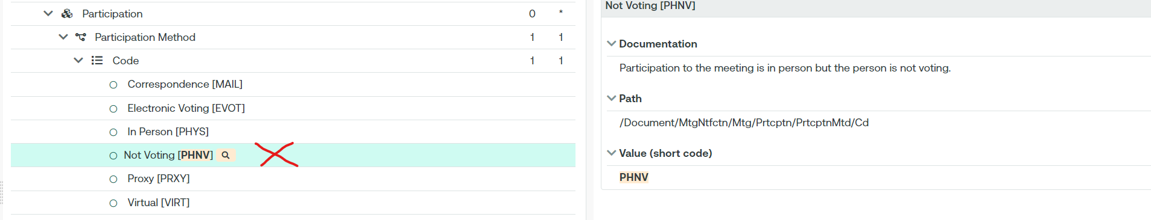

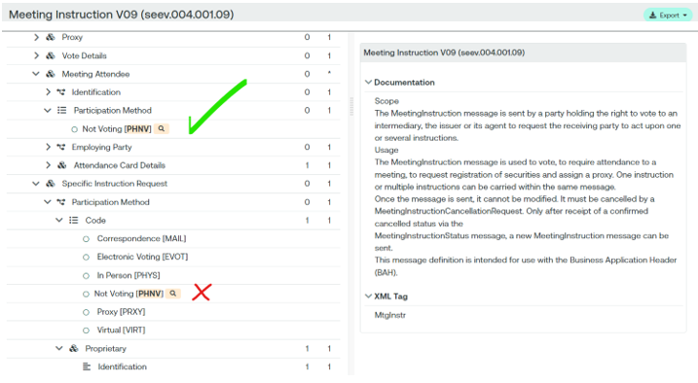

## SEG/TSG recommendation:

*This section is not to be taken care of by the submitter of the change request. It will be completed in due time by the SEG(s) in charge of the related ISO 20022 messages or the TSG for changes related to the BAH.*

|  |  |  |  |
| --- | --- | --- | --- |
| **Consider** | |  | **Timing** |
|  | | - **Next yearly cycle: 2024/2025**  (the change will be considered for implementation in the yearly maintenance cycle which starts in 2024 and completes with the publication of new message versions in the spring of 2025) | |  |
|  | | - **At the occasion of the next maintenance of the messages**  (the change will be considered for implementation, but does not justify maintenance of the messages in its own right – will be pending until more critical change requests are received for the messages) | |  |
|  | | - **Urgent unscheduled**  (the change justifies an urgent implementation outside of the normal yearly cycle) | |  |  |
|  | | - **Other timing:** | | |  |

Comments:

|  |  |
| --- | --- |
| **Reject** | **X** |

Reason for rejection:

**The ET rejects unanimously (to the exception of the submitter - Germany) the proposed change as this is a follow up of the CR 1398 that has been rejected. This would introduce too much confusion in the message.**

# ISO CR1400: Add Beneficial Owner Details Requirements to the Meeting Notification Message

## Origin of the request:

*A.1 Submitter*:

DESSUG CA – PSG (Deutsche SWIFT Securities Market User Group - Corporate Actions - Proxy Subgroup Germany). This group represents more than 20 different institutions including domestic and global proxy providers and registrars with a key role in the German General Meeting process.

*A.2 Contact person:*

Hendrik Melchior, Hendrik.Melchior@Clearstream.com, Phone +49 69 211-13263

Daniel Schäfer, Daniel.Schaefer@hsbc.de, Phone +49 211 910-2362

Nils Stock, Nils.Stock@db.com, Phone +49 69 910-43199

Rainer Prior, Rainer.Prior@linkmarketservices.de, Phone +49 6196 8870 514

*A.3 Sponsors*: German Market

## Related messages:

seev.001.001.xx

## Description of the change request:

/Document/MtgNtfctn/Vote/BnfclOwnrDsclsr – Beneficial Owner Disclosure.

This field indicates whether beneficiary details, for example, name and address, must be supplied in order to take part in a meeting. However, the originator is not allowed to define which BO details exactly are required.

As there are different requirements on Issuer/Market level, the exact definition of requirements would enhance STP processing.

The seev.001 should be enhanced with BO details. They should correspond the owner of the voting rights options provided in seev.004.

The solution should indicate what information is required, if applicable. For example, some countries require information such as mother's surname or email address, which is not always available at intermediary level.

## Purpose of the change:

The change is required due to the market practice, automation of the business process and newly identified business requirement.

## Urgency of the request:

SR2025

## Business examples:

None

## SEG/TSG recommendation:

*This section is not to be taken care of by the submitter of the change request. It will be completed in due time by the SEG(s) in charge of the related ISO 20022 messages or the TSG for changes related to the BAH.*

|  |  |  |  |
| --- | --- | --- | --- |
| **Consider** | | **X** | **Timing** |
|  | | - **Next yearly cycle: 2024/2025**  (the change will be considered for implementation in the yearly maintenance cycle which starts in 2024 and completes with the publication of new message versions in the spring of 2025) | | **X** |
|  | | - **At the occasion of the next maintenance of the messages**  (the change will be considered for implementation, but does not justify maintenance of the messages in its own right – will be pending until more critical change requests are received for the messages) | |  |
|  | | - **Urgent unscheduled**  (the change justifies an urgent implementation outside of the normal yearly cycle) | |  |  |
|  | | - **Other timing:** | | |  |

Comments:

|  |  |
| --- | --- |
| **Reject** |  |

Reason for rejection:

1. **Impact analysis:**

This change request impacts the following General meeting messages:

* seev.001

1. **Proposed implementation:**

**In the seev.001.001.11 (MENO - Meeting Notification),** in message sequence Vote, add new optional and non-repeatable sequence element called **“Requested Beneficial Owner Disclosure Details”**, with two subsequences “LegalPerson” and “NaturalPerson” and with

* the following optional indicator elements in Legal person: “Postal Address”, “Email Address”, “National Registration Number”, “LEIIdentification”, “AnyBIC”, “Client Identification”, “Company Registration Shareholder Identification”, “Country of Incorporation”.
* the following optional indicator elements in Natural Person: “Postal Address”, Email Address”, “Identification”, Nationality”, “Date and Place of Birth”, “Company Registration Shareholder Identification”.

all of them typed as *YesNoIndicator*, as illustrated below:

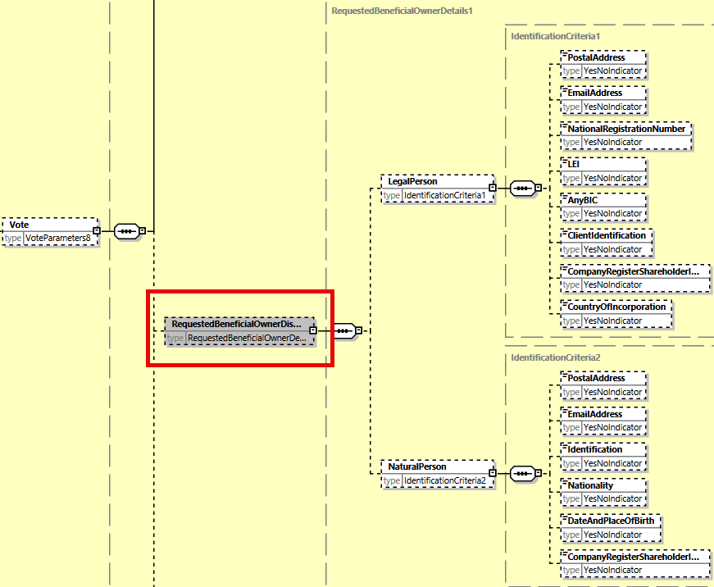

1. **Proposed timing:**

The submitting organization confirms that it can implement the requested changes in the requested timing.

|  |  |
| --- | --- |
| Timing | * As requested |

1. **Final decision of the SEG(s):**

|  |  |
| --- | --- |
| Approve |  |

Comments:

|  |  |
| --- | --- |
| Reject | **X** |

Reason for ET rejection: The Implementation proposal was well received but it appeared during the meeting that for some countries other or more BO contact details would be needed which are even not yet present in the instruction message itself today.

However, a short majority of the attendees would prefer to wait until a more complete set of BO details requirements are agreed before implementing the change.

Therefore, the ET agreed that the CR in its current form is rejected but it should be resubmitted next year and the ET recommends to the SMPG CA WG to refine and complement the CR together with the consolidated requirements of the markets before resubmitting it.

# ISO CR1402: Add new Deadline Date Elements to the Meeting Notification Message

## Origin of the request:

*A.1 Submitter*: DESSUG CA – PSG (Deutsche SWIFT Securities Market User Group - Corporate Actions - Proxy Subgroup Germany). This group represents more than 20 different institutions including domestic and global proxy providers and registrars with a key role in the German General Meeting process.

*A.2 Contact person:*

Hendrik Melchior, Hendrik.Melchior@Clearstream.com, Phone +49 69 211-13263

Daniel Schäfer, Daniel.Schaefer@hsbc.de, Phone +49 211 910-2362

Nils Stock, Nils.Stock@db.com, Phone +49 69 910-43199

Rainer Prior, Rainer.Prior@linkmarketservices.de, Phone +49 6196 8870 514

*A.3 Sponsors*: German Market

## Related messages:

seev.001

## Description of the change request:

Add an optional, not repetitive date field to fulfil local regulatory request [German Stock Corporation Act, Section 123 (2)].

Name: Last Application Target Deadline<LstApplTrGtDdl>

Presence: [0..1]

Datatype: ISODateTime

Definition:

Date by which application for participation in the general meeting or exercise of voting rights have to be enrolled. This deadline is set by the issuer. (Letzter Anmeldetag)

Location:

After “Registration Securities Market Deadline” (Path: /Document/MtgNtfctn/Mtg/RegnSctiesMktDdln)

## Purpose of the change:

Currently, none of the deadlines provided in seev.001 fulfil this legal requirement. Thus, an additional date field is required to fulfil local regulatory request.

## Urgency of the request:

SR2025

## Business examples:

n/a

## SEG/TSG recommendation:

*This section is not to be taken care of by the submitter of the change request. It will be completed in due time by the SEG(s) in charge of the related ISO 20022 messages or the TSG for changes related to the BAH.*

|  |  |  |  |
| --- | --- | --- | --- |
| **Consider** | | **X** | **Timing** |
|  | | - **Next yearly cycle: 2024/2025**  (the change will be considered for implementation in the yearly maintenance cycle which starts in 2022 and completes with the publication of new message versions in the spring of 2025) | | **X** |
|  | | - **At the occasion of the next maintenance of the messages**  (the change will be considered for implementation, but does not justify maintenance of the messages in its own right – will be pending until more critical change requests are received for the messages) | |  |
|  | | - **Urgent unscheduled**  (the change justifies an urgent implementation outside of the normal yearly cycle) | |  |  |
|  | | - **Other timing:** | | |  |

Comments:

|  |  |
| --- | --- |
| **Reject** |  |

Reason for rejection:

1. **Impact analysis:**

This change request impacts the following General meeting messages:

* seev.001

1. **Proposed implementation:**

**In the seev.001.001.11 (MENO - Meeting Notification)** in the Meeting building block, add 2 new optional elements *“EnrolmentMarketDeadline”* and *“EnrolmentDeadline”*, typed by DateFormat58Choice data type component, as illustrated below, and defined as:

* Enrolment Market Deadline: “*Date by which enrolment for participation in the general meeting or exercise of voting rights has to be instructed. This deadline is set by the issuer.*”
* Enrolment Deadline: “*Date by which enrolment for participation in the general meeting or exercise of voting rights has to be instructed. This deadline is set by the intermediary.*”

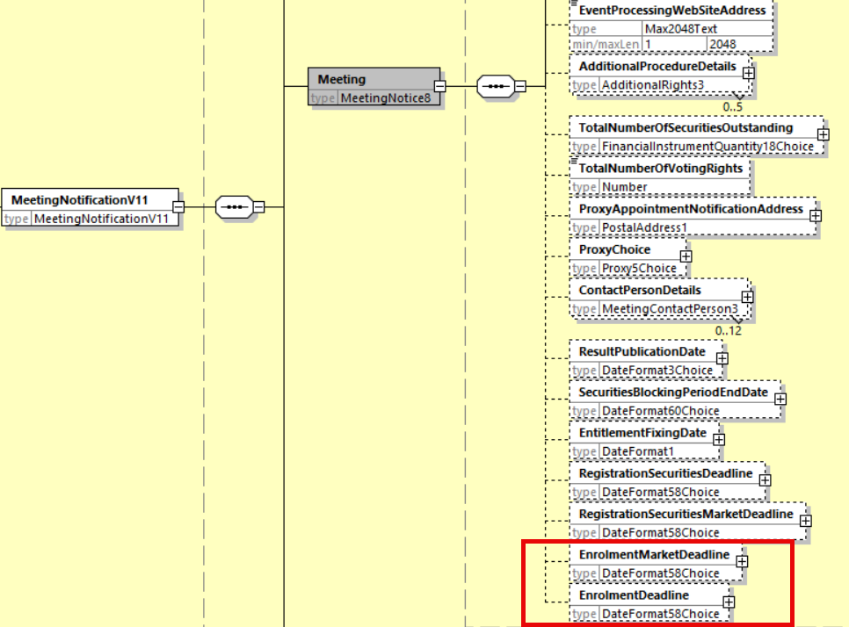

1. **Proposed timing:**

The submitting organization confirms that it can implement the requested changes in the requested timing.

|  |  |
| --- | --- |
| Timing | * As requested |

1. **Final decision of the SEG(s):**

|  |  |
| --- | --- |
| Approve | X |

Comments:

|  |  |
| --- | --- |
| Reject |  |

Reason for rejection: