**Maintenance Change Request**

**for the update of ISO 20022 financial repository items**

## Name of the request:

FX Post Trade Maintenance 2024 / 2025

## Submitting organization(s):

China Foreign Exchange Trade System（CFETS）

## Related messages:

Under this maintenance, below existing ISO 20022 message definitions will be maintained (resulting from the impact analysis performed on each CR).

**FX Post Trade Trade Capture message set:**

* fxtr.031.001.01 - ForeignExchangeTradeCaptureReportV01
* fxtr.033.001.01 - ForeignExchangeTradeCaptureReportAcknowledgementV01

**FX Post Trade Confirmation message set:**

* fxtr.037.001.01 - ForeignExchangeTradeConfirmationStatusAdviceV01

## Commitments of the submitting organization:

The submitting organization confirm that it can and will:

* undertake the development of the new version of the candidate ISO 20022 message models that it will submit to the RA for compliance review and evaluation. For the ISO 20022 yearly maintenance cycle, new valid Message Definition models must be available to the RA by December 1.
* provide a new version of part 1 of the Message Definition Report (MDR) by December 1, and, optionally, new examples of valid and invalid message instances of each candidate message by May 1 at the latest.
* address any queries related to the description of the new models and messages as published by the RA on the ISO 20022 website.

The submitting organization must confirm whether it intends or not to organize any testing or the actual implementation of the new version of the messages once the related documentation has been published by the RA.

CFETS will organize testing and the actual implementation of the new version of the messages once the related documentation has been published by the RA.

The submitting organization confirms its knowledge and acceptance of the ISO 20022 Intellectual Property Rights policy for contributing organizations, as follows.

CFETS acknowledges and accepts the ISO 20022 Intellectual Property Rights policy for contributing organizations, as follows.

*“Organizations that contribute information to be incorporated into the ISO 20022 Repository shall keep any Intellectual Property Rights (IPR) they have on this information. A contributing organization warrants that it has sufficient rights on the contributed information to have it published in the ISO 20022 Repository through the ISO 20022 Registration Authority in accordance with the rules set in ISO 20022. To ascertain a widespread, public and uniform use of the ISO 20022 Repository information, the contributing organization grants third parties a non-exclusive, royalty-free license to use the published information”.*

## Contact persons:

HuBingbing，[hubingbing_zh@chinamoney.com.cn](mailto:hubingbing_zh@chinamoney.com.cn)，021-38585653

# Change request number CR1077

1. **Origin of the request:**

*A.1 Submitter*:

China Foreign Exchange Trade System

*A.2 Contact person:*

HuBingbing，[hubingbing_zh@chinamoney.com.cn](mailto:hubingbing_zh@chinamoney.com.cn)，021-38585653

*A.3 Sponsors*:

China Foreign Exchange Trade System

1. **Related messages:**

fxtr.031 - ForeignExchangeTradeCaptureReportV01

1. **Description of the change request:**

Request to add the following new optional element to fxtr.031, the new elements are:

DateConfirmed, CombinationDealTicketIdentification, DealTicketIdentification, ContraCurrency,Base Currency Or Amount, Target Currency Or Amount.

* **DateConfirmed**

**Path:**

/Document/FXTradCaptrRpt/TradDtl/DtConfd

**Datatype:**

ISODate

**Multiplicity:**

[0..1]

**Proposed definition:**

The “DateConfirmed” is used to support cross-day transactions. It represents the date of the session, that is, the date when the transaction is placed, which is different from the date of the transaction. When trading continuously for 24 hours, the transaction date is the next day and the **session date** is the previous day, which constitutes a cross-day transaction. The date reserved for this field to support inter-day transactions, currently referring to the transaction date.

* **CombinationDealTicketIdentification**

**Path:**

/Document/FXTradCaptrRpt/TradDtl/CmbntnDealTcktId

**Datatype:**

Max35Text

**Multiplicity:**

[0..1]

**Proposed definition:**

Represents the option combination transaction ticket number. (There are two options for option exercise --full exercise and differential exercise. Only when the option is fully exercised on the exercise date will result in a spot trade -an alternative spot trade product - that is linked to the original option. Therefore, it is necessary to generate a ticket number to associate with the sub-option.)

* **DealTicketIdentification**

**Path:**

/Document/FXTradCaptrRpt/TradDtl/DealTcktId

**Datatype:**

Max35Text

**Multiplicity:**

[0..1]

**Proposed definition:**

Represents the transaction ticket number. When a Prime Broker transaction is performed, it needs to be split into two sub-transactions, and this ticker number is used to record the association of each sub-transaction with the original Prime Broker transaction.

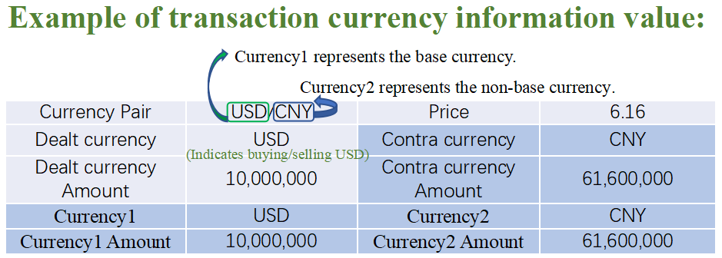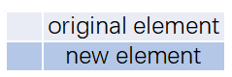

* **ContraCurrency**

**Path:**

/Document/FXTradCaptrRpt/TradDtl/ContraCcy

**Datatype:**

ActiveCurrencyCode

**Multiplicity:**

[0..1]

**Proposed definition:**

Represents the currency corresponding to the Dealt Currency in a currency pair.

**Base Currency Or AmountPath:**

/Document/FXTradCaptrRpt/TradDtl/BaseCcyOrAmt

**Datatype:**

AmountAndCurrency2**Multiplicity:**

[0..1]

**Proposed definition:**

Represents the base currency with optional amount, one of the essential elements of the transaction.

**Target Currency Or AmountPath:**

/Document/FXTradCaptrRpt/TradDtl/TrgtCcyOrAmt

**Datatype:**

AmountAndCurrency2**Multiplicity:**

[0..1]

**Proposed definition:**

Represents the non-base currency with optional amount, one of the essential elements of the transaction.

1. **Purpose of the change:**

Transaction capture report message, due to business changes, some new fields have been added to support more business scenarios:

1. Added "DateConfirmed" to indicate the transaction date to support cross-day transactions.
2. When the option is fully exercised on the exercise date will result in a spot trade (an alternative spot trade product) that is linked to the original option. Therefore, it is necessary to generate a ticket number "CombinationDealTicketIdentification"to associate a certain sub-option.
3. When a PB transaction is performed, it needs to be split into two sub-transactions, and "DealTicketIdentification" is the unique identifier of the transaction after the split,which is used to record the association of each sub-transaction with the original PB transaction.
4. "ContraCurrency, Base Currency Or Amount, Target Currency Or Amount" are essential elements for transactions.
5. **Urgency of the request:**

Subject to normal maintenance cycle.

1. **Business examples:**
2. Trade Capture Report as Notification:



1. Request Trade Capture Report:



1. **SEG/TSG recommendation:**

|  |  |  |  |
| --- | --- | --- | --- |
| **Consider** | |  | **Timing** |
|  | | - **Next yearly cycle: 2023/2024**  (the change will be considered for implementation in the yearly maintenance cycle which starts in 2021 and completes with the publication of new message versions in the spring of 2024) | | X |
|  | | - **At the occasion of the next maintenance of the messages**  (the change will be considered for implementation, but does not justify maintenance of the messages in its own right – will be pending until more critical change requests are received for the messages) | |  |
|  | | - **Urgent unscheduled**  (the change justifies an urgent implementation outside of the normal yearly cycle) | |  |  |
|  | | - **Other timing:** | | |  |

Comments: CR implementation postponed to 2024/2025 maintenance cycle.

|  |  |
| --- | --- |
| **Reject** |  |

Reason for rejection:

1. **Impact analysis and type of impact:**

Following the detailed analysis of the impact of the changes to the existing messages, we have not identified other impacted messages than the fxtr.031 already proposed in the submitter change request.

fxtr.031.001.01 - ForeignExchangeTradeCaptureReportV01

|  |  |  |
| --- | --- | --- |
| Type of impact | | |
|  | No impact | The change(s) will not impact the schema (the version number will not change) and will not impact the business applications of any users, e.g. the clarification of a definition |
| × | Conditional | The change(s) will impact the schema (at least the version number) and the business applications of certain users but not all, e.g. the addition of an optional component |
|  | Mandatory | The change(s) will impact the schema and the business applications of all users, e.g. addition of a mandatory component. |

1. **Proposed implementation:**

As per proposed implementation, the following changes update will result in the replacement of **Trade Detail[0,1]:Trade1** with a new version **Trade Detail[0,1]:Trade6**.

The updates will result in the following structure:

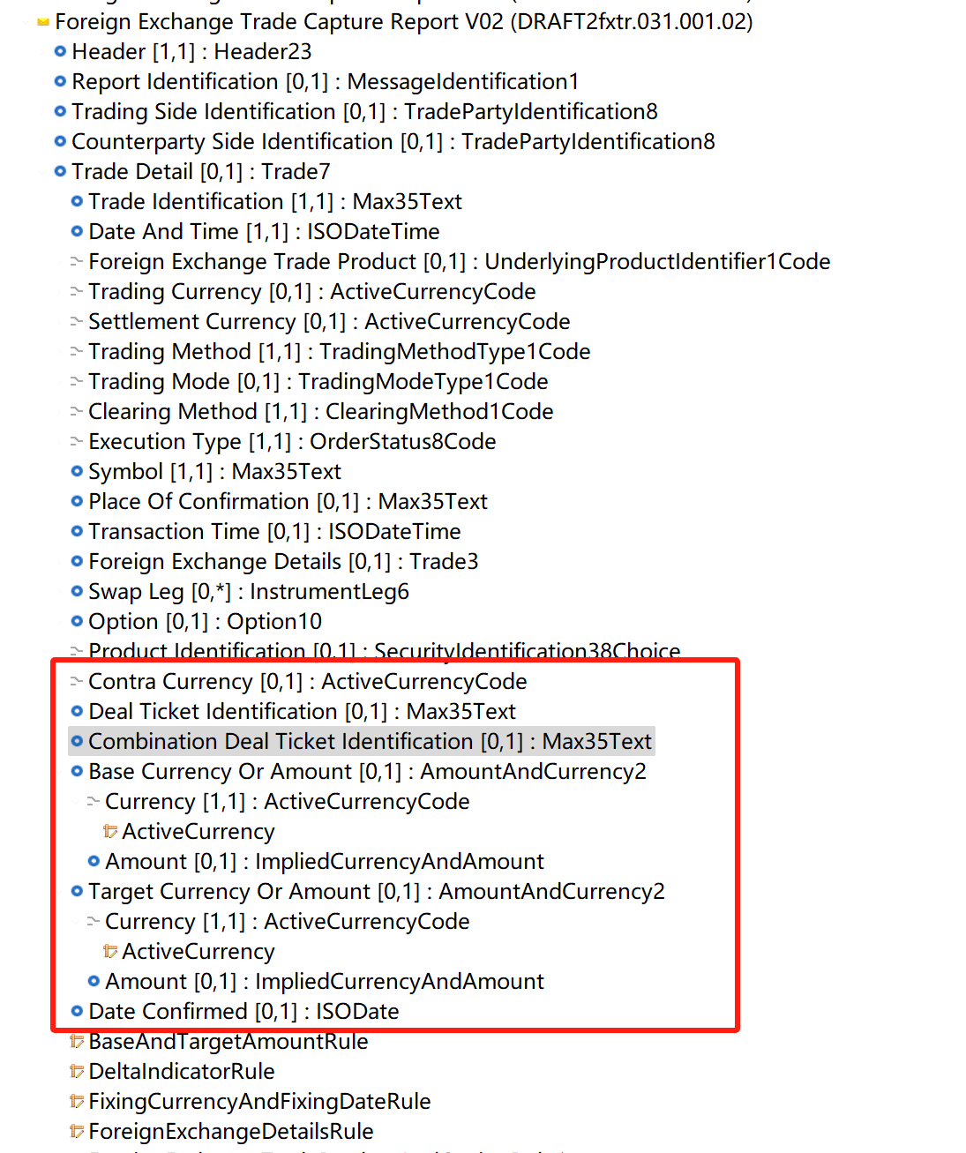

The following elements are already included in Trade Detail[0,1]:Trade1

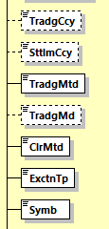

This CR then further proposes to add the following:

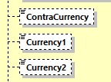

Question: If Symb is the USD/CNY, and TradgCcy is the dealt currency USD (using the example, and ContraCurrency is CNY - why are the proposed Currency1 and Currency2 needed? It seems redundant.

1. **Proposed timing:**

The submitting organization confirms that it can implement the requested changes in the requested timing, or, if not, proposes another timing.

|  |  |
| --- | --- |
| Timing | * As requested |
|  | * Other: |

1. **Final decision of the SEG(s):**

|  |  |
| --- | --- |
| Approve | X |

Comments: for implementation with the 2024/2025 maintenance.

|  |  |
| --- | --- |
| Reject |  |

Reason for rejection:

# Change request number CR1078

1. **Origin of the request:**

*A.1 Submitter*:

China Foreign Exchange Trade System

*A.2 Contact person:*

HuBingbing，[hubingbing_zh@chinamoney.com.cn，021-38585653](mailto:hubingbing_zh@chinamoney.com.cn，021-38585653)

*A.3 Sponsors*:

China Foreign Exchange Trade System

1. **Related messages:**

fxtr.033 - ForeignExchangeTradeCaptureReportAcknowledgementV01

1. **Description of the change request:**

Request to add the following new optional element to fxtr.033, the new element is: DealTicketIdentification.

* **DealTicketIdentification**

**Path:**

/Document/FXTradCaptrRptAck/ DealTcktId

**Datatype:**

Max35Text

**Multiplicity:**

[0..1]

**Proposed definition:**

Represents the transaction ticket number. When only the main broker is trading, it must be transmitted to PB (Prime Brokerage) institutions.

1. **Purpose of the change:**

In order to support the scenario of PB trading (PB means Prime Brokerage), in the prime broker trading mode, the transaction between the prime broker client and the prime broker counterparty is automatically split by the PB trading system to generate two transactions, one for the prime broker. A sub-transaction between the prime broker and the counterparty of the prime broker, and another sub-transaction between the prime broker and the client of the prime broker. Added **DealTicketIdentification** to the **fxtr.031(ForeignExchangeTradeCaptureReport)** message to represent each sub-transaction ticket number of the PB transaction.

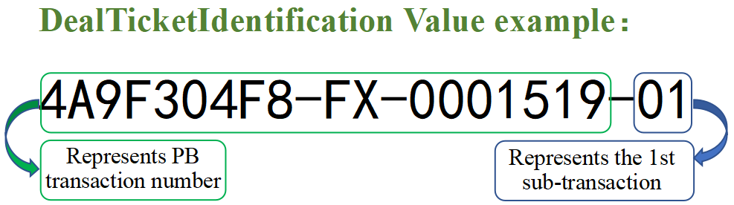

1. **Urgency of the request:**

Subject to normal maintenance cycle.

1. **Business examples:**
2. Trade Capture Report as Notification:



1. Request Trade Capture Report:



1. **SEG/TSG recommendation:**

|  |  |  |  |
| --- | --- | --- | --- |
| **Consider** | |  | **Timing** |
|  | | - **Next yearly cycle: 2023/2024**  (the change will be considered for implementation in the yearly maintenance cycle which starts in 2021 and completes with the publication of new message versions in the spring of 2024) | | X |
|  | | - **At the occasion of the next maintenance of the messages**  (the change will be considered for implementation, but does not justify maintenance of the messages in its own right – will be pending until more critical change requests are received for the messages) | |  |
|  | | - **Urgent unscheduled**  (the change justifies an urgent implementation outside of the normal yearly cycle) | |  |  |
|  | | - **Other timing:** | | |  |

Comments: Implementation postponed to 2024/2025 maintenance cycle.

|  |  |
| --- | --- |
| **Reject** |  |

Reason for rejection:

1. **Impact analysis and type of impact:**

The severity of the impact of the proposed change for the message users should be indicated in the table below (either “no impact”, “conditional’ or “mandatory”).

|  |  |  |
| --- | --- | --- |
| Type of impact | | |
|  | No impact | The change(s) will not impact the schema (the version number will not change) and will not impact the business applications of any users, e.g. the clarification of a definition |
| × | Conditional | The change(s) will impact the schema (at least the version number) and the business applications of certain users but not all, e.g. the addition of an optional component |
|  | Mandatory | The change(s) will impact the schema and the business applications of all users, e.g. addition of a mandatory component. |

1. **Proposed implementation:**

As per proposed implementation, the updates will result in the following structure:

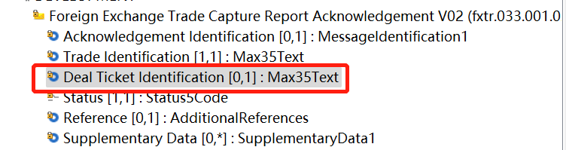

Proposed definition:

**DealTicketIdentification** Represents the transaction ticket number. When a PB transaction is performed, it needs to be split into two sub-transactions, and this number is used to record the association of each sub-transaction with the original PB transaction.

1. **Proposed timing:**

The submitting organization confirms that it can implement the requested changes in the requested timing, or, if not, proposes another timing.

|  |  |
| --- | --- |
| Timing | * As requested |
|  | * Other: |

1. **Final decision of the SEG(s):**

*This section is not to be taken care of by the submitting organization. It will be completed in due time by the SEG(s) in charge of the related ISO 20022 messages.*

|  |  |
| --- | --- |
| Approve | X |

Comments: for implementation with the 2024/2025 maintenance.

|  |  |
| --- | --- |
| Reject |  |

Reason for rejection:

# Change request number CR1080

1. **Origin of the request:**

*A.1 Submitter*:

China Foreign Exchange Trade System

*A.2 Contact person:*

HuBingbing，[hubingbing_zh@chinamoney.com.cn](mailto:hubingbing_zh@chinamoney.com.cn)，021-38585653

*A.3 Sponsors*:

China Foreign Exchange Trade System

1. **Related messages:**

fxtr.037 - ForeignExchangeTradeConfirmationStatusAdviceV01

1. **Description of the change request:**

Request to add “DeliveryType” to the fxtr.037 message to indicate the delivery method in the foreign exchange market.

Request to add a new Code in “DeliveryType4Code” Data type, and add “DeliveryType”

In fxtr.037.

* **PVSP**

**Added in:**

DeliveryType4Code

**Used in:**

DeliveryType

**Description:**

PVSP- means Payment Versus Payment

* **DeliveryType**

**Path:**

/Document/FXTradConfStsAdvc/TradDtl/DlvryTp

**Datatype:**

DeliveryType4Code

**Multiplicity:**

[0..1]

**Proposed definition:**

It is used to indicate the settlement type in the foreign exchange market

1. **Purpose of the change:**

There are multiple settlement methods for bilateral clearing transactions in the foreign exchange market, but at present, this message does not have any components that indicate delivery method, so apply to add “DeliveryType” to the message to indicate the settlement method.

“PVSP (Payment Versus Payment)” is an important settlement method, therefore, we hope to add this enumeration value to the DeliveryType4Code data type.

1. **Urgency of the request:**

Subject to normal maintenance cycle.

1. **Business examples:**

Not sure if a business example is required for this change request, because it is just a new enumeration value.

1. **SEG/TSG recommendation:**

|  |  |  |  |
| --- | --- | --- | --- |
| **Consider** | |  | **Timing** |
|  | | - **Next yearly cycle: 2023/2024**  (the change will be considered for implementation in the yearly maintenance cycle which starts in 2021 and completes with the publication of new message versions in the spring of 2024) | | X |
|  | | - **At the occasion of the next maintenance of the messages**  (the change will be considered for implementation, but does not justify maintenance of the messages in its own right – will be pending until more critical change requests are received for the messages) | |  |
|  | | - **Urgent unscheduled**  (the change justifies an urgent implementation outside of the normal yearly cycle) | |  |  |
|  | | - **Other timing:** | | |  |

Comments: Implementation postponed to 2024/2025 maintenance cycle.

|  |  |
| --- | --- |
| **Reject** |  |

Reason for rejection:

1. **Impact analysis and type of impact:**

Following the detailed analysis of the impact of the changes to the existing messages, we identified two additional impacted messages, compared to the list already proposed by the change request submitter.

The below list provides the full list of impacted messages per message set:

* **fxtr.037.001.01 - ForeignExchangeTradeConfirmationStatusAdviceV01**

The severity of the impact of the proposed change for the message users should be indicated in the table below (either “no impact”, “conditional’ or “mandatory”).

|  |  |  |
| --- | --- | --- |
| Type of impact | | |
|  | No impact | The change(s) will not impact the schema (the version number will not change) and will not impact the business applications of any users, e.g. the clarification of a definition |
| × | Conditional | The change(s) will impact the schema (at least the version number) and the business applications of certain users but not all, e.g. the addition of an optional component |
|  | Mandatory | The change(s) will impact the schema and the business applications of all users, e.g. addition of a mandatory component. |

1. **Proposed implementation:**

As per proposed implementation, the following changes update will result in the replacement of **Trade 2** with a new version. The updates will result in the following structure:

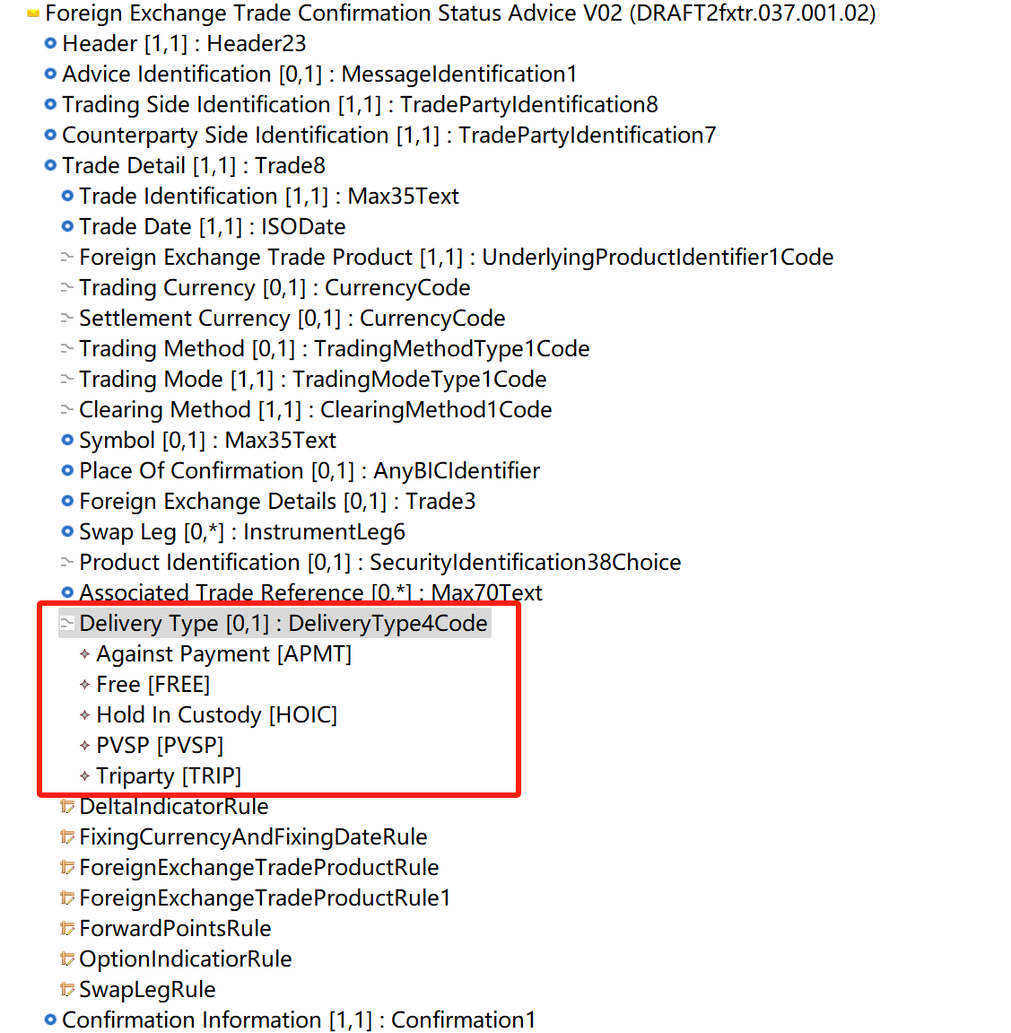

1. **Proposed timing:**

|  |  |
| --- | --- |
| Timing | * As requested |
|  | * Other: |

1. **Final decision of the SEG(s):**

|  |  |
| --- | --- |
| Approve | X |

Comments: for implementation with the 2024/2025 maintenance.

|  |  |
| --- | --- |
| Reject |  |

Reason for rejection:

**Appendix**

List of Change Requests for consideration after first screening

Change request number CR1077 3

Change request number CR1078 11

Change request number CR1080 16

The changes were approved at a meeting of the FX SEG on 10 Sept 2024.