Maintenance Change Request
for the update of ISO 20022 financial repository items

Table of contents
Table of contents 1
Overview 4
A. Name of the request: 4
B. Submitting organization(s): 4
C. Related messages: 4
D. Commitments of the submitting organization: 5
E. Contact persons: 5
ISO 20022 CR 1372: Add PREL and PATD codes in semt.022 message 6
A. MT Change Request 001778: SWIFT release 2025 - Add new information regarding a partially released quantity (changes required in semt.022 to include “PREL” code) 6
a. Origin of the request: 6
b. Related messages: 6
c. Description of the change request: 6
d. Purpose of the change: 7
e. Urgency of the request: 7
f. Business examples: 7
g. SEG/TSG recommendation: 8
B. Change request MT CR 001779: SWIFT release 2025 - Add new information to report a mismatch on the partial settlement indicator (changes required in semt.022 to include “PATD” code) 9
a. Origin of the request: 9
b. Related messages: 9
c. Description of the change request: 10
d. Purpose of the change: 11
e. Urgency of the request: 11
f. Business examples: 11
g. SEG/TSG recommendation: 12
C. Impact analysis and type of impact (for the whole scope of ISO CR 1372): 13
D. Proposed implementation: 13
E. Proposed timing: 13
F. Final decision of the SEG(s): 14
ISO 20022 CR 1373: Alignment of T2S messages with S&R maintenance CR001782 15
A. Origin of the request: 15
B. Related messages: 15
C. Description of the change request: 15
D. Purpose of the change: 17
E. Urgency of the request: 17
F. Business examples: 17
G. SEG/TSG recommendation: 17
H. Impact analysis and type of impact: 18
I. Proposed implementation: 19
J. Proposed timing: 19
K. Final decision of the SEG(s): 19
ISO 20022 CR 1374: Alignment of T2S messages with S&R maintenance CR001783 20
A. Origin of the request: 20
B. Related messages: 20
C. Description of the change request: 21
D. Purpose of the change: 22
E. Urgency of the request: 22
F. Business examples: 22
G. SEG/TSG recommendation: 22
H. Impact analysis and type of impact: 23
I. Proposed implementation: 24
J. Proposed timing: 24
K. Final decision of the SEG(s): 24
ISO 20022 CR 1404: Integration of supl.021 in camt and semt T2S Messages 25
A. Origin of the request: 25
B. Related messages: 25
C. Description of the change request: 25
D. Purpose of the change: 26
E. Urgency of the request: 27
F. Business examples: 28
G. SEG/TSG recommendation: 28
H. Impact analysis and type of impact: 28
I. Proposed implementation: 29
J. Proposed timing: 29
K. Final decision of the SEG(s): 29
ISO 20022 CR 1408: Change of UTI implementation and additions 30
A. Origin of the request: 30
B. Related messages: 30
C. Description of the change request: 30
D. Purpose of the change: 31
E. Urgency of the request: 31
F. Business examples: 31
G. SEG/TSG recommendation: 31
H. Impact analysis and type of impact: 32
I. Proposed implementation: 32
J. Proposed timing: 33
K. Final decision of the SEG(s): 33

Overview

Name of the request:
“Target2-Securities - Maintenance 2024-2025”

Submitting organization(s):
- Deutsche Bundesbank on behalf of 4CB
- TARGET2-Securities (T2S)nexo A.I.S.B.L. formerly (EPASOrg).

Related messages:
Under this maintenance, below existing ISO 20022 message definitions will be maintained (resulting from the impact analysis performed on each CR).
Target2-Securities - Intra-Balance Movements message set:
Message Identifier | MessageDefinition
camt.066.001.02 | Intra-balance Movement InstructionV02
camt.067.001.02 | Intra-balance Movement Status AdviceV02
camt.068.001.02 | Intra-balance Movement ConfirmationV02
camt.072.001.02 | Intra-balance Movement Modification RequestV02
camt.073.001.02 | Intra-balance Movement Modification Request Status AdviceV02
camt.074.001.02 | Intra-balance Movement Cancellation RequestV02
camt.075.001.02 | Intra-balance Movement Cancellation Request Status AdviceV02
camt.078.001.02 | Intra-balance Movement QueryV02
camt.079.001.02 | Intra-balance Movement Query ResponseV02
camt.080.001.02 | Intra-balance Movement Modification QueryV02
camt.081.001.02 | Intra-balance Movement Modification ReportV02
camt.082.001.02 | Intra-balance Movement Cancellation QueryV02
camt.083.001.02 | Intra-balance Movement Cancellation ReportV02
camt.084.001.02 | Intra-balance Movement Posting ReportV02
camt.085.001.02 | Intra-balance Movement Pending ReportV02
Target2-Securities - Collateral management message set
Message Identifier | MessageDefinition
colr.002.001.02 | Collateral Value ReportV02
Target2-Securities - Securities Reference Data message set
Message Identifier | MessageDefinition
reda.006.001.01 | Security Creation RequestV01
reda.007.001.01 | Security Maintenance RequestV01
reda.012.001.01 | Security ReportV01
Settlement and Reconciliation message set
Message Identifier | MessageDefinition
semt.022.001.05 | Securities Settlement Transaction Audit Trail Report

Commitments of the submitting organization:
As submitting organization, we confirm that we can and will:
- undertake, with SWIFT support, the development of the new version of the candidate ISO 20022 message models that we will submit to the RA for compliance review and evaluation by December 1.
- provide a new version of part 1 of the Message Definition Report (MDR) by December 1, and, optionally, new examples of valid and invalid message instances of each candidate message by May 1 at the latest.
- address any queries related to the description of the new models and messages as published by the RA on the ISO 20022 website.
for the following messages:
- camt.067.001.02 IntraBalanceMovement Status Advice
- camt.068.001.02 IntraBalanceMovement Confirmation
- semt.022.001.05 Securities Settlement Transaction Audit Trail Report
For all other messages listed in section C, we confirm that an alignment with the latest enhancements on digital assets is foreseen. However, the implementation timing for all 5 digital asset related CRs listed in this document should depend on whether more critical change requests are received for the impacted messages (i.e. the change will be considered for implementation but does not justify maintenance of the messages in its own right). Because we identified no further change request with critical impact on those messages for maintenance cycle 2024/2025, we will not provide a new version by December 1 and the implementation will be postponed until a later maintenance cycle when more critical change requests are received.
We do not intend to organize any testing of the actual implementation of the new version of the messages once the related documentation has been published by the RA.
We confirm our knowledge and acceptance of the ISO 20022 Intellectual Property Rights policy for contributing organizations, as follows:
“Organizations that contribute information to be incorporated into the ISO 20022 Repository shall keep any Intellectual Property Rights (IPR) they have on this information. A contributing organization warrants that it has sufficient rights on the contributed information to have it published in the ISO 20022 Repository through the ISO 20022 Registration Authority in accordance with the rules set in ISO 20022. To ascertain a widespread, public and uniform use of the ISO 20022 Repository information, the contributing organization grants third parties a non-exclusive, royalty-free license to use the published information”.

Contact persons:
To get additional information on this Maintenance Change Request you can contact.
- Stéphanie Radet (stephanie.radet@bundesbank.de), +49 69 9566-33528
- Ann-Kristin Gonska (ann-kristin.gonska@bundesbank.de), +49 69 9566-14278
- t2s-fam@bundesbank.de

ISO 20022 CR 1372: Add PREL and PATD codes in semt.022 message

MT Change Request 001778: SWIFT release 2025 - Add new information regarding a partially released quantity (changes required in semt.022 to include “PREL” code)

Origin of the request:
A.1 Submitter:
- Deutsche Bundesbank on behalf of the Eurosystem / 4CB
- TARGET2-Securities
A.2 Contact person:
- Stéphanie Radet, stephanie.radet@bundesbank.de, +49 69 9566-33528
- Ann-Kristin Gonska, ann-kristin.gonska@bundesbank.de, +49 69 9566-14278
- t2s-fam@bundesbank.de
A.3 Sponsors:
- AMI-SeCo SEG Task Force on the Optimisation of T2S message customisation (TFOS)

Related messages:
- semt.022.001.05 - SecuritiesSettlementTransactionAuditTrailReportV05

Description of the change request:
The MT CR-1778 changes stemming from SWIFT release 2022 changes were requested for ISO 15022 MT 548 and MT 537 and also in the equivalent ISO 20022 messages, sese.024 and semt.018.
The semt.022 (Securities Settlement Transaction Audit Trail Report) is a pillar 3 T2S message with no equivalence in ISO 15022. Therefore, the change was not implemented in the semt.022 message. Hence, this ISO CR focuses on changing the T2S semt.022 base message for Maintenance Release 2025 to add a new code ‘PREL’ (Partially Released) to qualifiers ‘PEND’ (pending status) and ‘PENF’ (failing status):
- code ‘PREL’ to be made available as pending reason code:
/Document/SctiesSttlmTxAudtTrlRpt/StsTrl/SttlmSts/Pdg/Rsn/Cd/Cd

- code ‘PREL’ to be made available as failing reason code:
/Document/SctiesSttlmTxAudtTrlRpt/StsTrl/SttlmSts/Flng/Rsn/Cd/Cd
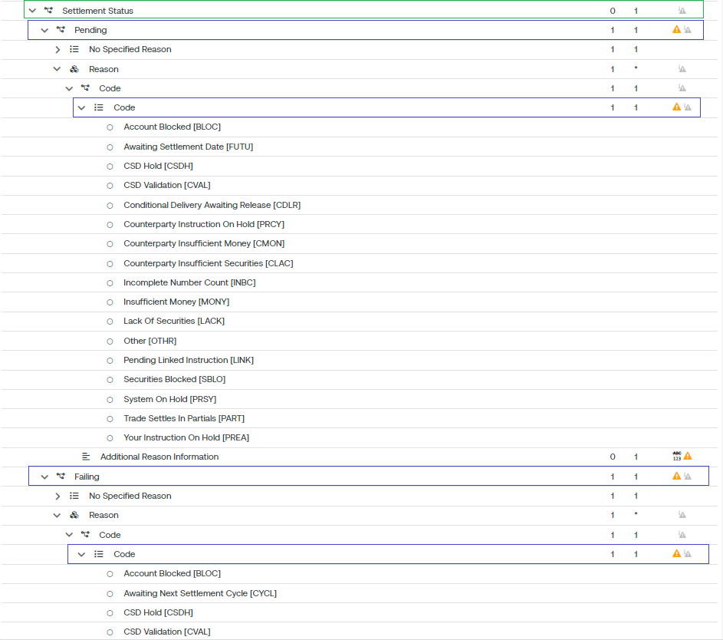

Purpose of the change:
The proposed change is to add a new reason code ‘PREL’ (Partially Released) to the qualifiers ‘PEND’ (pending) and ‘PENF’ (failing) status to advise the partially released status of a specific transaction during its whole life cycle.
Some institutions (CSD/ICSD or directly connected T2S party) may have to include the partially released status in the history of all the statuses of a specific transaction during its entire life cycle, as is the case for the semt.018 usage.

Urgency of the request:
We request the SEG to consider this change request for the next maintenance cycle.
It may allow the semt.018 and semt.022 usage alignment.

Business examples:
The Securities Settlement Transaction Audit Trail Report message (semt.022) is sent by T2S to a CSD or a directly connected T2S Party.
The report provides historical data on all changes and amendments, including statuses, to a single security Settlement Instruction as identified within the query criteria (either by the party’s instruction reference or by the T2S technical identifier) of the received Securities Transaction Status Query message (sese.021).
Communication flow:
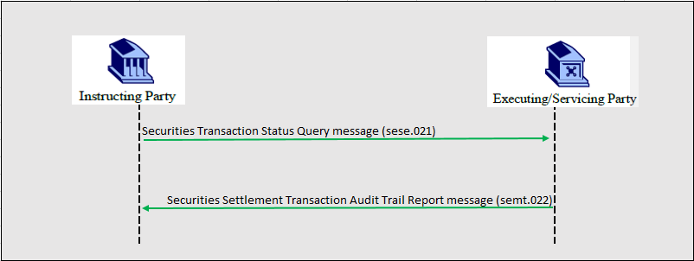

semt.022 message example:
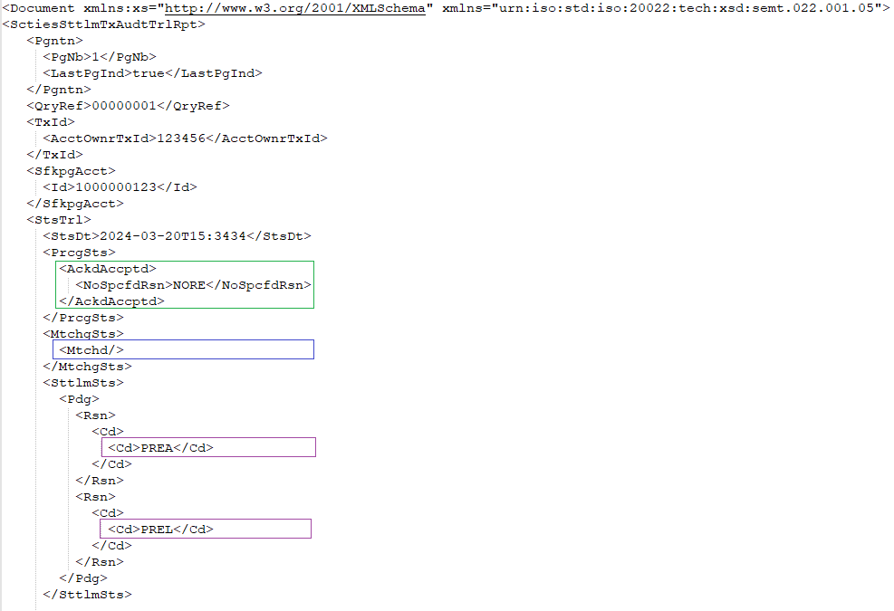
In this example, T2S sends a Securities Settlement Transaction Audit Trail Report as requested by the T2S Party using the message Securities Transaction Status Query regarding a Settlement Instruction with an account owner transaction id with a value of ‘123456’. The transaction as reported has been:
- accepted (AckAccptd)
- matched (Mtchd)
- on hold (PREA)
- partially released (PREL)

SEG/TSG recommendation:

Consider |  | X | Timing
 |  |  | - Next yearly cycle: 2024/2025  (the change will be considered for implementation in the yearly maintenance cycle which starts in 2024 and completes with the publication of new message versions in the spring of 2025) |  | X
- At the occasion of the next maintenance of the messages
(the change will be considered for implementation, but does not justify maintenance of the messages in its own right – will be pending until more critical change requests are received for the messages)
- Urgent unscheduled
(the change justifies an urgent implementation outside of the normal yearly cycle)
 |  |  | - Other timing:
Comments:

Reject
Reason for rejection:

Change request MT CR 001779: SWIFT release 2025 - Add new information to report a mismatch on the partial settlement indicator (changes required in semt.022 to include “PATD” code)

Origin of the request:
A.1 Submitter:
- Deutsche Bundesbank on behalf of the Eurosystem / 4CB
- TARGET2-Securities
A.2 Contact person:
- Stéphanie Radet, stephanie.radet@bundesbank.de, +49 69 9566-33528
- Ann-Kristin Gonska, ann-kristin.gonska@bundesbank.de, +49 69 9566-14278
- t2s-fam@bundesbank.de
A.3 Sponsors:
- AMI-SeCo SEG Task Force on the Optimisation of T2S message customisation (TFOS)

Related messages:
- semt.022.001.05 - Securities Settlement Transaction Audit Trail Report V05

Description of the change request:
The MT CR-1779 changes stemming from SWIFT release 2022 requested the implementation of a new ‘PATD’ (Partial Differ) code for ISO 15022 MT 548 and MT 537 and also in the equivalent ISO 20022 messages, sese.024 and semt.018.
The semt.022 (Securities Settlement Transaction Audit Trail Report) is a pillar 3 T2S message with no equivalence in ISO 15022. Therefore, the change was not implemented in the semt.022 message. Hence, this ISO CR focuses on changing the T2S semt.022 base message for Maintenance Release 2025 to add a new code ‘PATD’ to qualifiers ‘PEND’ (pending status) and ‘PENF’ (failing status):

- code ‘PATD’ to be made available as pending reason code:
/Document/SctiesSttlmTxAudtTrlRpt/StsTrl/SttlmSts/Pdg/Rsn/Cd/Cd

- code ‘PATD’ to be made available as failing reason code:
/Document/SctiesSttlmTxAudtTrlRpt/StsTrl/SttlmSts/Flng/Rsn/Cd/Cd

Purpose of the change:
The proposed change is to add a new reason code ‘PATD’ (Partial Differ) to the ‘PEND’ (pending) and ‘PENF’ (failing) qualifiers whenever a matched instruction is pending/failing and that there is a mismatch on the partial settlement indicator. So, a settlement status with a new reason code ‘PATD’ will be provided to advice about this discrepancy during its whole life cycle.
Some institutions (CSD/ICSD or directly connected T2S party) institutions may have needed to report the information regarding a mismatch on the partial settlement indicator, as is the case for the semt.018 usage.

Urgency of the request:
We request the SEG to consider this change request for the next maintenance cycle.
It may allow the semt.018 and semt.022 usage alignment.

Business examples:
The Securities Settlement Transaction Audit Trail Report message (semt.022) is sent by T2S to a CSD or a directly connected T2S Party.
The report provides historical data on all changes and amendments, including statuses, to a single security Settlement Instruction as identified within the query criteria (either by the party’s instruction reference or by the T2S technical identifier) of the received Securities Transaction Status Query message (sese.021).
Communication flow:
semt.022 message example:
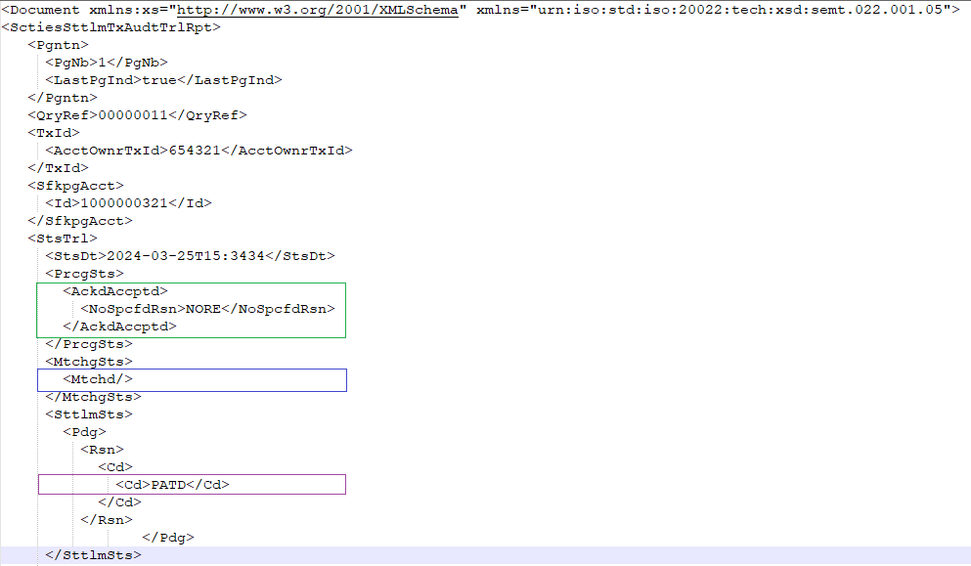
In this example, T2S sends a Securities Settlement Transaction Audit Trail Report as requested by the T2S Party using the message Securities Transaction Status Query regarding a Settlement Instruction with an account owner transaction id with a value of ‘654321’. The transaction as reported has been:
- accepted (AckAccptd)
- matched (Mtchd)
- unsettled-pending with a partial differ (PATD) pending reason code.

SEG/TSG recommendation:

Consider |  | X | Timing
 |  |  | - Next yearly cycle: 2024/2025  (the change will be considered for implementation in the yearly maintenance cycle which starts in 2024 and completes with the publication of new message versions in the spring of 2025) |  | X
- At the occasion of the next maintenance of the messages
(the change will be considered for implementation, but does not justify maintenance of the messages in its own right – will be pending until more critical change requests are received for the messages)
- Urgent unscheduled
(the change justifies an urgent implementation outside of the normal yearly cycle)
 |  |  | - Other timing:
Comments:

Reject
Reason for rejection:

Impact analysis and type of impact (for the whole scope of ISO CR 1372):
The following Message Identifiers registered by T2S as co-submitter will be impacted by both MT CRs 001778 and 001779:
semt.022.001.05 Securities Settlement Transaction Audit Trail Report

Type of impact
 | No impact | The change(s) will not impact the schema (the version number will not change) and will not impact the business applications of any users, e.g. the clarification of a definition
X | Conditional | The change(s) will impact the schema (at least the version number) and the business applications of certain users but not all, e.g. the addition of an optional component
 | Mandatory | The change(s) will impact the schema and the business applications of all users, e.g. addition of a mandatory component.

Proposed implementation:
Addition of codes “PREL” and “PATD” for the following paths in semt.022 base message:
- /Document/SctiesSttlmTxAudtTrlRpt/StsTrl/SttlmSts/Pdg/Rsn/Cd/Cd
- /Document/SctiesSttlmTxAudtTrlRpt/StsTrl/SttlmSts/Flng/Rsn/Cd/Cd

Proposed timing:
We confirm the implementation of this change request in the yearly maintenance cycle which starts in 2024 and completes with the publication of new message versions in the spring of 2025.

Timing | - As requested

Final decision of the SEG(s):
This section is not to be taken care of by the submitting organization. It will be completed in due time by the SEG(s) in charge of the related ISO 20022 messages.
Approve
Comments:

Reject
Reason for rejection:

ISO 20022 CR 1373: Alignment of T2S messages with S&R maintenance CR001782

Origin of the request:
A.1 Submitter:
- Deutsche Bundesbank on behalf of the Eurosystem / 4CB
- TARGET2-Securities
A.2 Contact person:
- Stéphanie Radet, stephanie.radet@bundesbank.de, +49 69 9566-33528
- Ann-Kristin Gonska, ann-kristin.gonska@bundesbank.de, +49 69 9566-14278
- t2s-fam@bundesbank.de
A.3 Sponsors:
- Swift (alignment with latest version)

Related messages:
Target2-Securities - Securities Reference Data message set
Message Identifier | MessageDefinition
reda.006.001.01 | Security Creation Request
reda.012.001.01 | Security Report
reda.019.001.01 | Securities Account Query
reda.020.001.01 | Securities Account Status Advice
reda.021.001.01 | Securities Account Report
reda.023.001.01 | Securities Account Modification Request
reda.032.001.01 | Securities Account Deletion Request
reda.035.001.01 | Securities Account Activity Advice
reda.036.001.01 | Securities Account Audit Trail Query
reda.037.001.01 | Securities Account Audit Trail Report
Target2-Securities - Collateral management message
Message Identifier | MessageDefinition
colr.002.001.02 | Collateral Value Report

Description of the change request:
Alignment of T2S registered messages with approved Change Requests from the Securities Maintenance Releases of 2022 and 2023.
The above messages are impacted by CR-001782 Add new Qualifier and Format Option for Blockchain Address/Wallet identification, , included in MCR #1261 published on ISO20022.org.
According to CR-001782, Digital Assets are not safekept in a traditional account but instead, are kept at a blockchain address or Wallet Identification. The CR now introduces a choice between a mandatory Securities Account or a Wallet Identification.
In all above messages, the Message Component SecuritiesAccount19 must be complemented by the addition of BlockChainAddressWallet3 and a validation rule: If SecuritiesAccount is present, BlockChainAddressOrWallet must be absent.

Example with a reda.012.001.01 Issuance Account (using SecuritiesAccount19)-

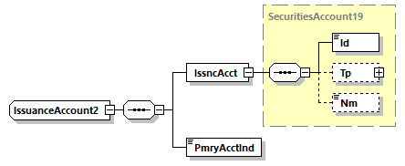
The new Issuance Account would look like this (Addition of BlockChain Address Wallet) in reda.012.001.02:
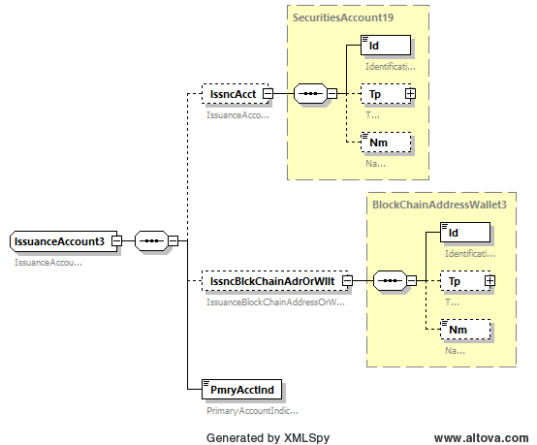

Purpose of the change:
Alignment of T2S registered messages with approved Change Requests from the Securities Maintenance Releases of 2022 and 2023.
In recent years, Digital Assets have emerged as a new security type, and members of Securities maintenance groups have expressed the request to enhance existing messages to include those new instruments, rather than creating new messages.
T2S will align its messages with these changes to follow the latest ISO 20022 standard.

Urgency of the request:
Approval of the change request for ISO 20022 Maintenance 2024/2025.
As to reduce the effort of maintenance, T2S might postpone the actual implementation of new draft message versions to a later maintenance cycle depending on whether the messages impacted by this change request will be otherwise affected by the scope of the MCR for maintenance cycle 2024/2025.

Business examples:
Examples illustrating the change request.

SEG/TSG recommendation:

Consider |  | X | Timing
 |  |  | - Next yearly cycle: 2024/2025  (the change will be considered for implementation in the yearly maintenance cycle which starts in 2024 and completes with the publication of new message versions in the spring of 2025) |  | X
- At the occasion of the next maintenance of the messages
(the change will be considered for implementation, but does not justify maintenance of the messages in its own right – will be pending until more critical change requests are received for the messages)
- Urgent unscheduled
(the change justifies an urgent implementation outside of the normal yearly cycle)
 |  |  | - Other timing:
Comments:

Reject
Reason for rejection:

Impact analysis and type of impact:
The following Message Identifiers registered by T2S will be impacted:
- reda.012.001.01 Security Report
- reda.018.001.01 Securities Account Creation Request
- reda.019.001.01 Securities Account Query
- reda.020.001.01 Securities Account Status Advice
- reda.021.001.01 Securities Account Report
- reda.023.001.01 Securities Account Modification Request
- reda.032.001.01 Securities Account Deletion Request
- reda.035.001.01 Securities Account Activity Advice
- reda.036.001.01 Securities Account Audit Trail Query
- reda.037.001.01 Securities Account Audit Trail Report
- colr.002.001.02 Collateral Value Report
Please note that contrary to message identifiers listed in section B, we identified:
- no impact from this change request on reda.006 Security Creation Request because there is no presence of Safekeeping Account in this message;
- an impact on the reda.018 Securities Account Creation Request: unless the Message Component SecuritiesAccount19 is not present in this message, a similar change should be performed to the Message Component SystemSecuritiesAccount7.

Type of impact
 | No impact | The change(s) will not impact the schema (the version number will not change) and will not impact the business applications of any users, e.g. the clarification of a definition
X | Conditional | The change(s) will impact the schema (at least the version number) and the business applications of certain users but not all, e.g. the addition of an optional component
 | Mandatory | The change(s) will impact the schema and the business applications of all users, e.g. addition of a mandatory component.

Proposed implementation:
The Message Component SecuritiesAccount19 must be complemented by the addition of BlockChainAddressWallet3 (or latest Message Component in the ISO 20022 dictionary) and a validation rule: If SecuritiesAccount is present, BlockChainAddressOrWallet must be absent. (see section C for detailed proposed implementation).

Proposed timing:
We will implement this change request at the occasion of the next maintenance of the messages (the change will be considered for implementation, but does not justify maintenance of the messages in its own right – will be pending until more critical change requests are received for the messages).

Timing | - Other: At the occasion of the next maintenance of the messages.

Final decision of the SEG(s):
This section is not to be taken care of by the submitting organization. It will be completed in due time by the SEG(s) in charge of the related ISO 20022 messages.
Approve
Comments:

Reject
Reason for rejection:

ISO 20022 CR 1374: Alignment of T2S messages with S&R maintenance CR001783

Origin of the request:
1 Submitter:
- Deutsche Bundesbank on behalf of the Eurosystem / 4CB
- TARGET2-Securities
A.2 Contact person:
- Stéphanie Radet, stephanie.radet@bundesbank.de, +49 69 9566-33528
- Ann-Kristin Gonska, ann-kristin.gonska@bundesbank.de, +49 69 9566-14278
- t2s-fam@bundesbank.de
A.3 Sponsors:
- Swift (alignment with latest version)

Related messages:
Target2-Securities - Intra-Balance Movements message set
Message Identifier | MessageDefinition
camt.066.001.02 | Intra-balance Movement Instruction
camt.067.001.02 | Intra-balance Movement Status Advice
camt.068.001.02 | Intra-balance Movement Confirmation
camt.072.001.02 | Intra-balance Movement Modification Request
camt.073.001.02 | Intra-balance Movement Modification Request Status Advice
camt.074.001.02 | Intra-balance Movement Cancellation Request
camt.075.001.02 | Intra-balance Movement Cancellation Request Status Advice
camt.078.001.02 | Intra-balance Movement Query
camt.079.001.02 | Intra-balance Movement Query Response
camt.081.001.02 | Intra-balance Movement Modification Report
camt.083.001.02 | Intra-balance Movement Cancellation Report
camt.084.001.02 | Intra-balance Movement Posting Report
camt.085.001.02 | Intra-balance Movement Pending Report
Target2-Securities - Securities Reference Data message set
Message Identifier | MessageDefinition
reda.006.001.01 | Security Creation Request
reda.007.001.01 | Security Maintenance Request
reda.012.001.01 | Security Report
Target2-Securities - Collateral management message set
Message Identifier | MessageDefinition
colr.002.001.02 | Collateral Value Report

Description of the change request:
Alignment of T2S registered messages with approved Change Requests from the Securities Maintenance Releases (2022 and 2023).
The above Intra-Balance, Securities Reference Data and Collateral Management messages are impacted by ISO 20022 CR01783 Add new Format Option for Quantity of Financial Instrument and Balances, included in MCR #1261 published on ISO20022.org.
All messages contain Message Component FinancialInstrumentQuantity1Choice. The component has been updated to FinancialInstrumentQuantity33Choice in SR2022.

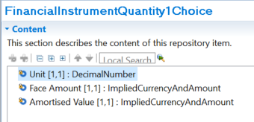

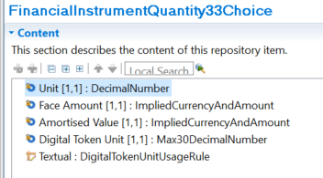

Purpose of the change:
Alignment of T2S registered messages with approved Change Requests from the Securities and Payments Maintenance Releases of 2022 and 2023.
In recent years, Digital Assets have emerged as a new security type, and members of Securities maintenance groups have expressed the request to enhance existing messages to include those new instruments, rather than creating new ones.
While Securities Reference Data and Collateral Management naturally fall in the Securities domain, it may be surprising to find the Intra-Balance messages in this CR, as they belong to the Cash Management business domain.
Those messages were modelled following the Securities Management Intra-Position (“semt”) messages and do contain Message Components impacted by the maintenance of Settlement and Reconciliation messages, therefore we do request their update as well.

Urgency of the request:
Approval of the change request for ISO 20022 Maintenance 2024/2025.
As to reduce the effort of maintenance, T2S might postpone the actual implementation of new draft message versions to a later maintenance cycle depending on whether the messages impacted by this change request will be otherwise affected by the scope of the MCR for maintenance cycle 2024/2025

Business examples:
Examples illustrating the change request

SEG/TSG recommendation:

Consider |  |  | Timing
 |  |  | - Next yearly cycle: 2024/2025  (the change will be considered for implementation in the yearly maintenance cycle which starts in 2024 and completes with the publication of new message versions in the spring of 2025) |  | X
- At the occasion of the next maintenance of the messages
(the change will be considered for implementation, but does not justify maintenance of the messages in its own right – will be pending until more critical change requests are received for the messages)
- Urgent unscheduled
(the change justifies an urgent implementation outside of the normal yearly cycle)
 |  |  | - Other timing:
Comments:

Reject
Reason for rejection:

Impact analysis and type of impact:
The following Message Identifiers registered by T2S will be impacted:
- camt.066.001.02 IntrabalanceMovementInstruction
- camt.067.001.02 IntrabalanceMovementStatusAdvice
- camt.068.001.02 IntrabalanceMovementConfirmation
- camt.072.001.02 IntrabalanceMovementModificationRequest
- camt.073.001.02 IntrabalanceMovementModificationRequestStatusAdvice
- camt.074.001.02 IntrabalanceMovementCancellationRequest
- camt.075.001.02 Intra-balanceMovementCancellationRequestStatusAdvice
- camt.078.001.02 Intra-balanceMovementQuery
- camt.079.001.02 Intra-balanceMovementQueryResponse
- camt.081.001.02 Intra-balanceMovementModificationReport
- camt.083.001.02 Intra-balanceMovementCancellationReport
- camt.084.001.02 Intra-balanceMovementPostingReport
- camt.085.001.02 Intra-balanceMovementPendingReport
- reda.006.001.01 SecurityCreationRequest
- reda.007.001.01 SecurityMaintenanceRequest
- reda.012.001.01 SecurityReport
- colr.002.001.02 CollateralValueReport

Type of impact
 | No impact | The change(s) will not impact the schema (the version number will not change) and will not impact the business applications of any users, e.g. the clarification of a definition
X | Conditional | The change(s) will impact the schema (at least the version number) and the business applications of certain users but not all, e.g. the addition of an optional component
 | Mandatory | The change(s) will impact the schema and the business applications of all users, e.g. addition of a mandatory component.

Proposed implementation:
Update datatype “FinancialInstrumentQuantity1Choice” to datatype “FinancialInstrumentQuantity33Choice” (or a later version of the message component if applicable). This update implies the addition of an element <Token Unit> with datatype “Max30DecimalNumber” and multiplicity [1..1] as well as a textual rule for DigitalTokenUnitUsage.

Proposed timing:
We propose to implement this change request at the occasion of the next maintenance of the messages (the change will be considered for implementation, but does not justify maintenance of the messages in its own right – will be pending until more critical change requests are received for the messages).

Timing | - Other: At the occasion of the next maintenance of the messages.
Note: for camt.067 and camt.068, the change request will be implemented within the current maintenance cycle 2024/2025 since more critical impact stemming from ISO 20022 CR 1404 has been identified.

Final decision of the SEG(s):
This section is not to be taken care of by the submitting organization. It will be completed in due time by the SEG(s) in charge of the related ISO 20022 messages.
Approve
Comments:

Reject
Reason for rejection:

ISO 20022 CR 1404: Integration of supl.021 in camt and semt T2S Messages

Origin of the request:
A.1 Submitter:
- Deutsche Bundesbank on behalf of the Eurosystem / 4CB
- TARGET2-Securities
A.2 Contact person:
- Stéphanie Radet, stephanie.radet@bundesbank.de, +49 69 9566-33528
- Ann-Kristin Gonska, ann-kristin.gonska@bundesbank.de, +49 69 9566-14278
- t2s-fam@bundesbank.de
A.3 Sponsors:
- Swift (Karine TAQUET)

Related messages:
Impacted messages:
- camt.067.001.02 IntraBalanceMovementStatusAdviceV02
- camt.068.001.02 IntraBalanceMovement ConfirmationV02
- semt.014.001.07 IntraPositionMovementStatusAdviceV07
- semt.015.001.09 IntraPositionMovementConfirmationV09

Description of the change request:
Currently, the supplementary data element is used for camt.067, camt.068, semt.014 and semt.015 messages to report the reference of the underlying business instruction involved in a Conditional Securities Delivery (CoSD) blocking scenario.
The objective of this change request is to include the reference of the business instruction that triggered a CoSD procedure directly in the impacted messages mentioned above instead of using the supplementary data element of supl.021.
This request proposes to create:
- A new Element “Related Transaction Identification” to report the reference of a transaction that is associated with the one of the message, in case of T2S, to report the reference of the business instruction related to a CoSD blocking scenario. This new element is to be added in camt.067, camt.068, semt.014 and semt.015 messages as follows:
  - Camt.067 and Semt.014: Within the Transaction Identification block:
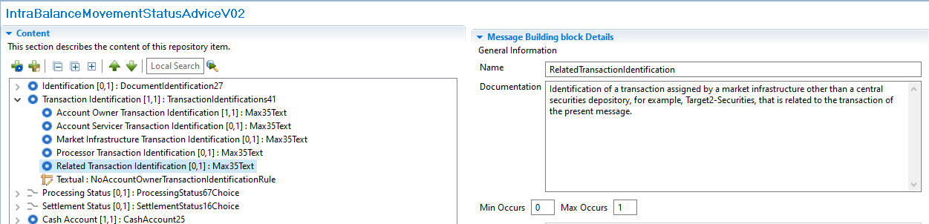
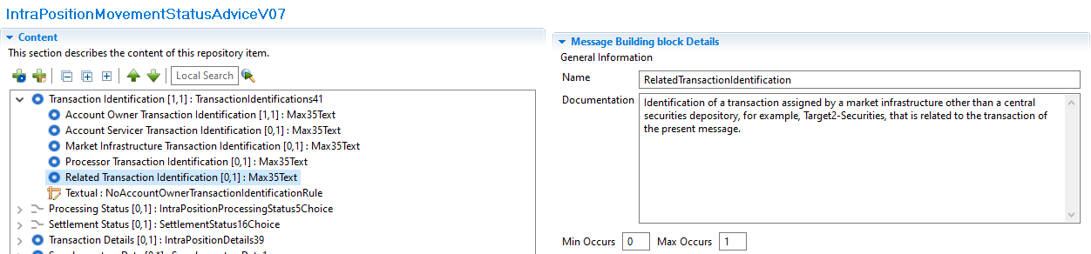
  - Camt.068 and Semt.015: Within the Additional Parameters block:
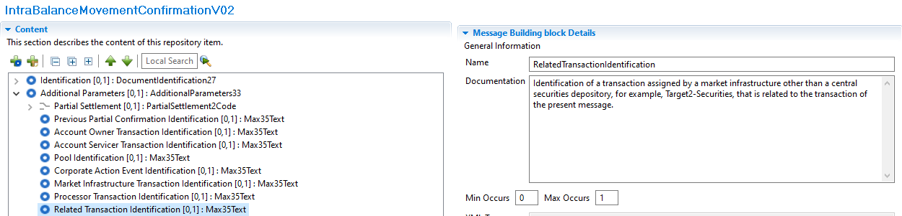
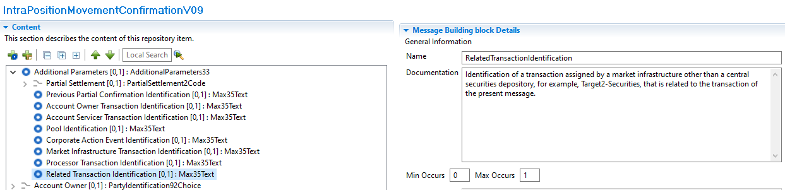

Purpose of the change:
Currently the reference of the business instruction related to a Conditional Securities Delivery (CoSD) blocking scenario is reported using the supl.021 message as an additional block (Supplementary Data element) inside the messages listed above as of today, the related ISO messages do not have any element available to provide this type of information
The purpose of this change is to adopt a more standardized way to report the reference of the business instruction related to a CoSD blocking scenario in case of intra balance (camt.067 and camt.068) and intra position (semt.014 and semt.015) movement messages, which is currently reported using a technical message component without a dedicated structured element inside the message.
This reference is the simplest way to identify the business Settlement Instructions responsible for the creation of the Settlement Restrictions created when a CoSD scenario is triggered, the detailed flow is explained hereafter:
- The conditional settlement process allows CSDs to settle instructions that require the fulfilment of a settlement condition outside T2S before allowing the securities settlement to take place in the system.
- To do so, T2S automatically detects and performs conditional settlement, based on CoSD rules defined and maintained by each CSD in static data. These rules identify the administering party; which will be the CSD in charge of managing the fulfilment of the external conditions.
- The system puts automatically the Settlement Instruction that meets a CoSD rule, on CoSD hold and blocks the relevant securities and/or cash depending on the CoSD rule.
- To block the securities/cash a settlement restriction on securities/cash is created internally by T2S to move the securities/cash from a Deliverable to a provisional Blocking position.
- Once the Settlement Restrictions are created the related messages are generated; as the restrictions were created in a CoSD scenario the reference of the business instruction that triggered this CoSD rule is reported in the supplementary data element:
  - In case of cash settlement restrictions, camt.067 and camt.068 IntraBalanceMovement messages, it will be the Reference of the related business instruction that debits the Dedicated Cash Account where the CoSD blocking occurs.
  - In case of securities settlement restrictions, semt.014 and semt.015 intra position movement messages, it will be the Reference of the related delivering business instruction where the CoSD blocking occurs.
- Once the external settlement conditions are fulfilled, the administering parties of the CoSD rule, trigger the release of the instruction. After the CoSD release is executed the securities/cash are delivered again to a Deliverable position and the business instruction finally settles. To move the securities/cash from the provisional blocking position, another Settlement Restriction is created, consequently, the reference of the business instruction will be reported again in the supplementary data block of the semt.015 or camt.068 messages generated for this end.
If this element is not integrated into the relevant messages, it will continue to be reported in the Supplementary Data block, which is not the most appropriate way to report such information.

Urgency of the request:
The Securities SEG is requested to consider this change request for the next maintenance cycle.

Business examples:
Examples illustrating the change request.

SEG/TSG recommendation:

Consider |  | X | Timing
 |  |  | - Next yearly cycle: 2024/2025  (the change will be considered for implementation in the yearly maintenance cycle which starts in 2024 and completes with the publication of new message versions in the spring of 2025) |  | X
- At the occasion of the next maintenance of the messages
(the change will be considered for implementation, but does not justify maintenance of the messages in its own right – will be pending until more critical change requests are received for the messages)
- Urgent unscheduled
(the change justifies an urgent implementation outside of the normal yearly cycle)
 |  |  | - Other timing:
Comments:

Reject
Reason for rejection:

Impact analysis and type of impact:
The following Message Identifiers registered by T2S will be impacted:
- camt.067.001.02 IntrabalanceMovementStatusAdviceV02
- camt.068.001.02 IntrabalanceMovementConfirmationV02
While impact has also been identified on semt.014 and semt.015 messages, the implementation in those messages is assumed to be in SWIFT’s responsibility as they are the owner.

Type of impact
 | No impact | The change(s) will not impact the schema (the version number will not change) and will not impact the business applications of any users, e.g. the clarification of a definition
X | Conditional | The change(s) will impact the schema (at least the version number) and the business applications of certain users but not all, e.g. the addition of an optional component
 | Mandatory | The change(s) will impact the schema and the business applications of all users, e.g. addition of a mandatory component.

Proposed implementation:
Addition of a new element named <Related Transaction Identification> with datatype “Max35Text” and multiplicity [0..1] under the following path:
- In camt.067: /Document/IntraBalMvmntStsAdvc/TxId
- In camt.068: /Document/IntraBalMvmntConf/AddtlParams

Proposed timing:
We confirm the implementation of this change request in the yearly maintenance cycle which starts in 2024 and completes with the publication of new message versions in the spring of 2025.

Timing | - As requested

Final decision of the SEG(s):
This section is not to be taken care of by the submitting organization. It will be c ompleted in due time by the SEG(s) in charge of the related ISO 20022 messages.
Approve
Comments:

Reject
Reason for rejection:

ISO 20022 CR 1408: Change of UTI implementation and additions

Origin of the request:
A.1 Submitter: SMPG Settlements & Reconciliation Working Group represented by Robin Leary (UK&IE Representative) and Karine Taquet (Swift Standards)
A.2 Contact person: Robin Leary (robin.leary@citi.com)
A.3 Sponsors: SMPG Settlements & Reconciliation Working Group

Related messages:
Securities Management Business Area:
semt.017, semt.018, semt.019, semt.022 (T2S UTI not included at all), sese.021, sese.023, sese.024, sese.025, sese.026, sese.028, sese.030, sese.031, sese.032, sese.033, sese.034, sese.035, sese.036, sese.038, sese.022, sese.041, sese.042
Securities Trade (UTI not included must be) Business Area:
setr.027, setr.030, setr.044, setr.029
Collateral Management Business Area:
colr.005, colr.019, colr.020, colr.021, colr.022, colr.23, colr.024
Reference Data Business Area:
reda.074
Cash Management Business Area:
camt.057, camt.111
Payments Clearing and Settlement Business Area:
pacs.009
Authorities Business Area:
auth.016, auth.029, auth.030, auth.052, auth.070, auth.078, auth.079, auth.080, auth.083, auth.084, auth.085, auth.090, auth.091, auth.092, auth.105, auth.106, auth.107, auth.108, auth.109, auth.113
Foreign Exchange Trade Business Area:
fxtr.008, fxtr.015, fxtr.016, fxtr.017, fxtr.014

Description of the change request:
As part of SR2019 (CR 001448), the UTI was added to numerous MT messages and, as part of co-existence, all equivalent ISO 20022 messages. In ISO 15022, this was done by adding a new 20U format option in qualifier TRRF (Deal Reference) and in ISO 20022, the Trade Identification element was made repetitive, and the length increased from 35 characters to 52 characters.
Whilst the ISO 15022 addition is easily distinguished between a traditional Deal Reference (:20C::TRRF) and UTI (:20U::TRRF), the ISO 20022 element does not easily distinguish between the two and can lead to confusion.
The proposal is to create a new element in ISO 20022 for the UTI in the Trade Details sequence and revert the Trade Identification element to its original form (non-repetitive and 35 characters). The ISO 15022 use will remain as is.
In the ISO 20022 messages where the UTI is not present, I must be added.
Given there's not a huge usage of the UTI in ISO 20022 messages at present, the change should be low impact.

Purpose of the change:
Create a new "Unique Transaction Identifier" element in the Trade Details sequence (or other relevant sequences) in all impacted ISO 20022 messages (where the change was made in SR2019). The new element should be optional, non-repetitive and up to 52 characters in length.
The "Trade Identification" element should be changed to revert to being non-repetitive and up to 35 characters in length.
From a translation perspective, :20C::TRRF would align to the Trade Identification element and :20U::TRRF would align to the new Unique Transaction Identifier element.
No changes are expected to the ISO 15022 MT messages.

In the ISO 20022 messages where the UTI is missing, it must be added.

Urgency of the request:
Cycle 2024-2025

Business examples:
Examples illustrating the change request.

SEG/TSG recommendation:

Consider |  | X | Timing
- Next yearly cycle: 2024/2025
(the change will be considered for implementation in the yearly maintenance cycle which starts in 2024 and completes with the publication of new message versions in the spring of 2025)
 |  |  | - At the occasion of the next maintenance of the messages  (the change will be considered for implementation, but does not justify maintenance of the messages in its own right – will be pending until more critical change requests are received for the messages) |  | X
- Urgent unscheduled
(the change justifies an urgent implementation outside of the normal yearly cycle)
 |  |  | - Other timing:
Comments:
There is no urgency for the FX changes. However, most of the messages will anyway be maintained as part of the maintenance cycle 2024/2025, as part of CR 1393, so this UTI change will be implemented alongside that.
It was noted that the UTI message component traces to type Max35Text in the business model, and that this will have to be changed.

Reject
Reason for rejection:

Impact analysis and type of impact:
The following Message Identifiers registered by T2S as co-submitter will be impacted:
- semt.022.001.05 SecuritiesSettlementTransactionAuditTrailReportV05

Type of impact
 | No impact | The change(s) will not impact the schema (the version number will not change) and will not impact the business applications of any users, e.g. the clarification of a definition
X | Conditional | The change(s) will impact the schema (at least the version number) and the business applications of certain users but not all, e.g. the addition of an optional component
 | Mandatory | The change(s) will impact the schema and the business applications of all users, e.g. addition of a mandatory component.

Proposed implementation:
Addition of new element <Unique Transaction Identifier> with multiplicity [0..1] and datatype Max52Text under the following path in semt.022:
- /Document/SctiesSttlmTxAudtTrlRpt/TxId

Proposed timing:
We confirm the implementation of this change request in the yearly maintenance cycle which starts in 2024 and completes with the publication of new message versions in the spring of 2025, since more critical impact on semt.022 has been identified due to ISO 20022 CR 1372 during this maintenance cycle.

Timing | - As requested (next maintenance of the impacted message is 2024/2025)

Final decision of the SEG(s):
This section is not to be taken care of by the submitting organization. It will be completed in due time by the SEG(s) in charge of the related ISO 20022 messages.
Approve
Comments:

Reject
Reason for rejection:

