**Maintenance Change Request**

**for the update of ISO 20022 financial repository items**

## Name of the request:

ISO 20022 Payments Maintenance 2024/2025

## Submitting organisation(s):

Swift

Standards Department,

Avenue Adele, 1

1310 La Hulpe - Belgium

## Related messages:

Under this maintenance, below existing ISO 20022 message definitions will be maintained (resulting from the impact analysis performed on each CR).

**Cash Management:**

|  |  |
| --- | --- |
| **camt.025.001.08** | ReceiptV08 |

**Cash Management – Charges Management:**

|  |  |
| --- | --- |
| **camt.105.001.02** | ChargesPaymentNotificationV02 |
| **camt.106.001.02** | ChargesPaymentRequestV02 |

**Exceptions and Investigation – Modernisation:**

|  |  |
| --- | --- |
| **camt.111.001.01** | InvestigationResponseV01 |

**Payments, Clearing and Settlement:**

|  |  |
| --- | --- |
| **pacs.002.001.14** | FIToFIPaymentStatusReportV14 |
| **pacs.004.001.13** | PaymentReturnV13 |
| **pacs.008.001.12** | FIToFICustomerCreditTransferV12 |
| **pacs.009.001.11** | FinancialInstitutionCreditTransferV11 |

**Bank-to-Customer Cash Management (previously under the responsibility of ISTH):**

|  |  |
| --- | --- |
| **camt.052.001.12** | BankToCustomerAccountReportV12 |
| **camt.053.001.12** | BankToCustomerStatementV12 |
| **camt.054.001.12** | BankToCustomerDebitCreditNotificationV12 |

**Message sets impacted not under responsibility of Swift:**

Please note that not all message sets are under the responsibility of Swift, and the RA contact the original submitting organisation of those messages set to confirm they intend to implement the changes in their respective message sets.

For those message sets, Swift cannot guarantee the submitting organisations will agree to implement the changes.

**Target2-Securities message set (under the responsibility of T2S):**

|  |  |
| --- | --- |
| **camt.066.001.02** | IntraBalanceMovementInstructionV02 |
| **camt.067.001.02** | IntraBalanceMovementStatusAdviceV02 |
| **camt.068.001.02** | IntraBalanceMovementConfirmationV02 |
| **camt.072.001.02** | IntraBalanceMovementModificationRequestV02 |
| **camt.073.001.02** | IntraBalanceMovementModificationRequestStatusAdviceV02 |
| **camt.074.001.02** | IntraBalanceMovementCancellationRequestV02 |
| **camt.075.001.02** | IntraBalanceMovementCancellationRequestStatusAdviceV02 |
| **camt.078.001.02** | IntraBalanceMovementQueryV02 |
| **camt.079.001.02** | IntraBalanceMovementQueryResponseV02 |
| **camt.081.001.02** | IntraBalanceMovementModificationReportV02 |
| **camt.083.001.02** | IntraBalanceMovementCancellationReportV02 |
| **camt.084.001.02** | IntraBalanceMovementPostingReportV02 |

**Swift note that the external submitter owning these messages (4CBs) will undertake the implementation, and this will be covered as part of a separate MCR document.**

## Commitments of the submitting organisation:

The submitting organisations confirm that they can and will:

* undertake the development of the new version of the candidate ISO 20022 message models that it will submit to the RA for compliance review and evaluation. New valid Message Definition models will be made available to the RA by December 1.
* provide a new version of part 1 of the related Message Definition Reports (MDR) by December 1, and new examples of valid message instances of each candidate message (only when valid samples were published for current version) by May 1 at the latest.
* address any queries related to the description of the new models and messages as published by the RA on the ISO 20022 website.

SWIFT intends to implement most of the above new versions on its SWIFTNet network once the related documentation has been published by the RA.

The submitting organisations confirm their knowledge and acceptance of the ISO 20022 Intellectual Property Rights policy for contributing organisations, as follows.

*“Organisations that contribute information to be incorporated into the ISO 20022 Repository shall keep any Intellectual Property Rights (IPR) they have on this information. A contributing organisation warrants that it has sufficient rights on the contributed information to have it published in the ISO 20022 Repository through the ISO 20022 Registration Authority in accordance with the rules set in ISO 20022. To ascertain a widespread, public and uniform use of the ISO 20022 Repository information, the contributing organisation grants third parties a non-exclusive, royalty-free license to use the published information”.*

## Contact persons:

Dean Chard – SWIFT Standards, [dean.chard@swift.com](mailto:dean.chard@swift.com)

Karin Deridder – SWIFT Standads, [karin.deridder@swift.com](mailto:karin.deridder@swift.com)

## Change Requests Withdrawn:

Swift notes that CR1380 was withdrawn by the submitter during the initial Payments SEG CR screening.

# Change request CR1366: BoE/SIX Interbank Clearing Ltd - Payments Clearing And Sett.

## Origin of the request:

*A.1 Submitter*: identity of the company, organization, group, initiative or community that submits the change request.

|  |  |
| --- | --- |
| Bank of England,  Threadneedle St, London, EC2R 8AH  United Kingdom | SIX Interbank Clearing Ltd (as a representative of the Swiss financial center in the standardization of payments)  CH-8021 Zürich |

*A.2 Contact person:* person(s) who can be contacted to get additional information on the request (name, e-mail, telephone)

|  |  |
| --- | --- |
| Helen Bygrave [helen.bygrave@bankofengland.co.uk](mailto:helen.bygrave@bankofengland.co.uk) | Roman Locher  Roman.Locher@six-group.com |

*A.3 Sponsors*: it is highly recommended that a submitter of a Change Request gain the agreement and support from as many additional organisations, groups, initiatives, or communities of users as possible, thus demonstrating as wide as possible a consultation of the relevant stakeholders. All organisations, groups, initiatives, or communities supporting the change request should be identified as sponsors along with a contact person, if possible. This community involvement is intended to help avoid delays and/or subsequent amendments to the change request.

## Related messages:

The list of ISO 20022 messages which would be impacted by the change, including the Message IDs as shown in the [Catalogue of ISO 20022 messages](http://www.iso20022.org/catalogue_of_messages.page). Only the latest version of a message definition can be maintained.

The submitter is invited to carefully examine whether the change may have an impact on other messages that come into play earlier or later in the transaction chain or on other messages that also use message components that this change request may impact.

Financial Institution Credit Transfer (pacs.009)

## Description of the change request:

A specific change request form must be completed for each particular change requested (for example, adding, deleting, modifying, renaming, changing the cardinality, moving an element/component, or changing the type of an element, changing a code set).

If the change request consists, for example, of adding new functionality which requires several changes which would not make sense if not performed all together, then all these related changes should be described on the same form.

Change requests may not lead to creation of new messages. In such cases, a 'business justification' for development of new candidate ISO 20022 messages must be introduced by a submitting organization that is ready to develop the new messages.

**Addition** of absent message components from the underlying credit transfer message to the Underlying Customer Credit Transfer section [/Document/FICdtTrf/CdtTrfTxInf/UndrlygCstmrCdtTrf] of the pacs.009.

All message components and elements therein should be made optional (even where they are mandatory in the underlying credit transfer) so that individual market practices may decide whether to implement them as mandatory in the pacs.009.

|  |  |  |
| --- | --- | --- |
| **Message component name** | **XMLTag** | **Change description** |
| Payment Identification | <PmtId> | <PmtId> contains all the identification message elements from the underlying credit transfer message that should be included in <UndrlygCstmrCdtTrf> section of the pacs.009   * Instruction Identification * End To End Identification * Transaction Identification * UETR * Clearing System Reference |
| Payment Type Information | <PmtTpInf> | <PmtTpInf> contains message components for specifying the type of payment from the underlying credit transfer message that should be included in <UndrlygCstmrCdtTrf> section of the pacs.009   * Instruction Priority * Clearing Channel * Service Level * Local Instrument * Category Purpose |
| Purpose | <Purp> | <Purp> contains the underlying reason for the payment transaction as provided in the underlying credit transfer message that should be included in <UndrlygCstmrCdtTrf> section of the pacs.009. |

## Purpose of the change:

Background, business context, community of users interested by the change and expected benefits/savings.

This section must explain why the existing ISO 20022 messages need to be changed. The reason for the update may be a business reason (e.g., evolution of market practice, or creation of new financial instruments), a technical reason (e.g., automation of the business process, or switch from a batch to a real time process), a regulatory reason (introduction, generally mandatory, of new rule/law) or the extension of the user community (newly identified business requirements).

We believe that the addition of the requested message components and elements to the pacs.009 will achieve a clear demarcation between the attributes of the pacs.009 and the attributes of the underlying credit transfer. In addition, the extra information from the underlying credit transfer can facilitate the automation of business processes.

For example, purpose code in a pacs.009 COVER payment reflects the purpose of the pacs.009 COVER rather than the purpose of the underlying credit transfer. The ability to transport the purpose code of the underlying credit transfer has the potential to realise multiple benefits such as fraud prevention, exceptions processing, efficient reconciliation and market intelligence.

## Urgency of the request:

By default, valid change requests introduced by June 1 and subsequently approved by the SEG/TSG will be included in the following yearly maintenance cycle which completes with the publication of new message versions by April/May of the following year, unless decided otherwise by the SEG/TSG.

If there is a need to have the new version of the related messages published earlier, the reason for the urgency of the maintenance and the expected consequences of a delay should be described here. Acceptance of such an unscheduled maintenance for the BAH is subject to approval by TSG. Acceptance of an unscheduled maintenance for messages other than the BAH is subject to the approval of the SEG and availability of a submitting organization to develop the new version of the messages.

*Note: the ISO 20022 maintenance results in the publication of a new version of an ISO 20022 message. The actual implementation of such new version on networks and in user installations is not within the purview of ISO.*

Next yearly cycle: 2024/2025

## Business examples:

Examples illustrating the change request.

## SEG/TSG recommendation:

*This section is not to be taken care of by the submitter of the change request. It will be completed in due time by the SEG(s) in charge of the related ISO 20022 messages or the TSG for changes related to the BAH.*

|  |  |  |  |
| --- | --- | --- | --- |
| **Consider** | | X | **Timing** |
|  | | - **Next yearly cycle: 2024/2025**  (the change will be considered for implementation in the yearly maintenance cycle which starts in 2024 and completes with the publication of new message versions in the spring of 2025) | | X |
|  | | - **At the occasion of the next maintenance of the messages**  (the change will be considered for implementation, but does not justify maintenance of the messages in its own right – will be pending until more critical change requests are received for the messages) | |  |
|  | | - **Urgent unscheduled**  (the change justifies an urgent implementation outside of the normal yearly cycle) | |  |  |
|  | | - **Other timing:** | | |  |

Comments:

|  |  |
| --- | --- |
| **Reject** |  |

Reason for rejection:

## Impact analysis and type of impact:

The following Message Identifiers will be impacted –

|  |  |
| --- | --- |
| **pacs.004.001.13** | PaymentReturnV13 |
| **pacs.009.001.11** | FinancialInstitutionCreditTransferV11 |

## Proposed implementation:

For discussion -

1. Swift notes this CR would introduce two UETR elements into one message. The UETR must be the same across a pacs.008 and pacs.009 Cov so should the UETR be removed from the pacs.009 underlying block to prevent misuse?

## Proposed timing:

The submitting organisation confirms that it can implement the requested changes in the requested timing.

|  |  |
| --- | --- |
| Timing | 2024/2025 |

## Final decision of the SEG(s):

|  |  |
| --- | --- |
| Approve |  |

|  |  |
| --- | --- |
| Reject |  |

Reason for rejection:

# Change request CR1335: CBPR+ - Underlying Financial Institution Credit Transfer

## Origin of the request:

*A.1 Submitter*: Swift

*A.2 Contact person :*  [evelyne.piron@swift.com](mailto:evelyne.piron@swift.com); [neil.buchan@swift.com](mailto:neil.buchan@swift.com)

*A.3 Sponsors*: CBPR plus working group

## Related messages:

Pacs.009.001.10 - Financial Institution Credit Transfer

## Description of the change request:

The Financial Institution Credit Transfer requires a block “Underlying Financial Institution Credit Transfer” like the existing “Underlying Customer Credit Transfer”. Such additional data component is required when the pacs.009 is used as a cover of a previously sent direct pacs.009 with settlement method COVE.

## Purpose of the change:

In CBPR plus today, there is a scenario where a Debtor Agent sends a direct pacs.009 to the Creditor Agent, to announce the receipt of funds. This process is used in some markets to provide adequate notification to the Creditor Agent that funds are being sent through the respective intermediary agents, enabling that bank to position the expected incoming funds with their treasury so that the funds can be applied with good value to the beneficiary institution.

In such scenario, the settlement should be done using a covering pacs.009 to provide all information present in the direct pacs.009, but it is not possible since the current “Underlying Customer Credit transfer” component relates to a pacs.008.

The current workaround proposed by CBPR plus is to send a pacs.009 without an underlying component, and the underlying creditor (present in the direct pacs.009) must be populated in the element “Instruction for Creditor Agent with code /UDLC/) in the pacs.009 settlement message.

The below message flows (extract from the CBPR plus UHB) provides clarify on the scenario described:

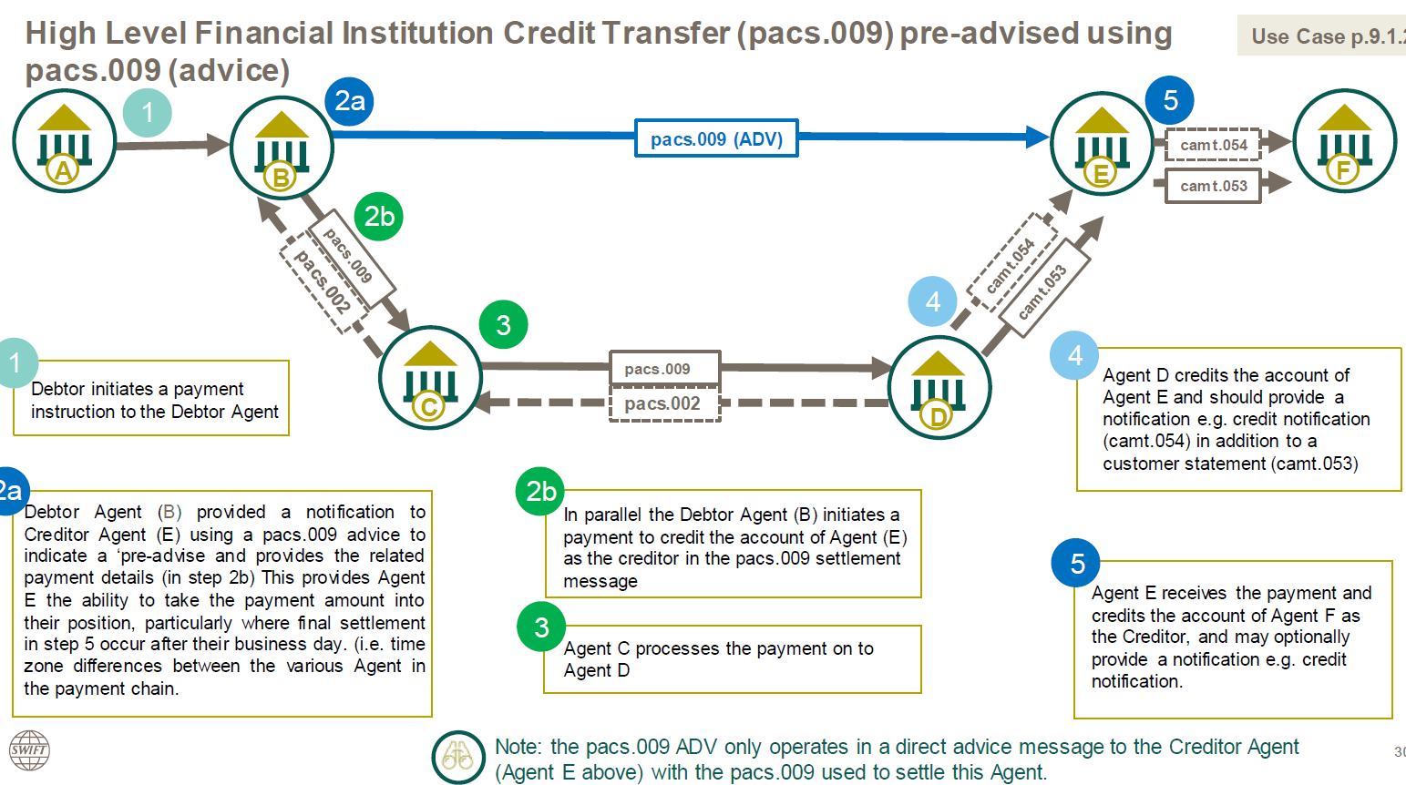

It is therefore requested to add the appropriate component in the pacs.009 to provide full party transparency in such scenario.

## Urgency of the request:

Next maintenance cycle

## Business examples:

N/A

## SEG/TSG recommendation:

*This section is not to be taken care of by the submitter of the change request. It will be completed in due time by the SEG(s) in charge of the related ISO 20022 messages or the TSG for changes related to the BAH.*

|  |  |  |  |
| --- | --- | --- | --- |
| **Consider** | | X | **Timing** |
|  | | - **Next yearly cycle: 2024/2025**  (the change will be considered for implementation in the yearly maintenance cycle which starts in 2024 and completes with the publication of new message versions in the spring of 2025) | | X |
|  | | - **At the occasion of the next maintenance of the messages**  (the change will be considered for implementation, but does not justify maintenance of the messages in its own right – will be pending until more critical change requests are received for the messages) | |  |
|  | | - **Urgent unscheduled**  (the change justifies an urgent implementation outside of the normal yearly cycle) | |  |  |
|  | | - **Other timing:** | | |  |

Comments:

|  |  |
| --- | --- |
| **Reject** |  |

Reason for rejection:

## Impact analysis and type of impact:

The following Message Identifiers will be impacted –

|  |  |
| --- | --- |
| **pacs.004.001.13** | PaymentReturnV13 |
| **pacs.009.001.11** | FinancialInstitutionCreditTransferV11 |

## Proposed implementation:

For discussion -

1. Swift notes that CR 1366 is a request to update underlying customer credit transfer with additional elements that were not included originally. To avoid future CRs for the underlying financial institution customer credit transfer it is proposed that the new block contains all elements available in the pacs.009. Does the PAYSEG support this?
2. As per CR 1366 are the PAYSEG comfortable having the UETR available in multiple places?

## Proposed timing:

The submitting organisation confirms that it can implement the requested changes in the requested timing.

|  |  |
| --- | --- |
| Timing | 2024/2025 |

## Final decision of the SEG(s):

|  |  |
| --- | --- |
| Approve |  |

|  |  |
| --- | --- |
| Reject |  |

Reason for rejection:

# Change request CR1355: Mojaloop (IIPS project) - Crypto Key

## Origin of the request:

*A.1 Submitter*:

The Mojaloop Foundation

*A.2 Contact person:*

Michael Richards. [Michael.Richards@infitx.com](mailto:Michael.Richards@infitx.com), +44 7785 360009

*A.3 Sponsors*:

1) Africanenda

2) Comesa Business Council

Contact: Dr. Jonathan Pinifolo, jpinifolo@comesabusinesscouncil.org

## Related messages:

Pacs.002.001 - FIToFIPaymentStatusReport

New message to be defined sealing the agreement of terms between the parties.

## Description of the change request:

We want to add an element to the data structure which describes a payment transaction. This element will contain a signature which other parties to the payment can use to verify that the beneficiary’s FI has warranted that the transaction has completed on their books, and will be used if the payment execution request has used the ILP v4 method of cryptographic locking See CR 1357 and CR 1358).

This element is optional and non-repetitive. It will be in the form of an encoded string, and is an instance of the existing ISO 20022 *Exact32HexBinaryText* type described in CR 1358. We propose the name *ExecutionConfirmation* for the element.

We propose that it should be added to the *TxInfAndSts* element of the *FIToFIPaymentStatusReport* data structure. This will result in new issues of the *FIToFIPaymentStatusReport* and *PaymentTransaction* elements.

Current structure of the *PaymentTransaction* element:

| **Or** | **MessageElement*<XML Tag>*** | **Mult.** | **Type** | **Constr. No.** | **Page** |
| --- | --- | --- | --- | --- | --- |
|  | **StatusIdentification***<StsId>* | [0..1] | Text |  | 32 |
|  | **OriginalGroupInformation***<OrgnlGrpInf>* | [0..1] | ± |  | 32 |
|  | **OriginalInstructionIdentification***<OrgnlInstrId>* | [0..1] | Text |  | 32 |
|  | **OriginalEndToEndIdentification***<OrgnlEndToEndId>* | [0..1] | Text |  | 32 |
|  | **OriginalTransactionIdentification***<OrgnlTxId>* | [0..1] | Text |  | 33 |
|  | **OriginalUETR***<OrgnlUETR>* | [0..1] | IdentifierSet |  | 33 |
|  | **TransactionStatus***<TxSts>* | [0..1] | CodeSet |  | 33 |
|  | **StatusReasonInformation***<StsRsnInf>* | [0..*] |  | C26 | 33 |
|  | **ChargesInformation***<ChrgsInf>* | [0..*] | ± |  | 35 |
|  | **AcceptanceDateTime***<AccptncDtTm>* | [0..1] | DateTime |  | 35 |
|  | **EffectiveInterbankSettlementDate***<FctvIntrBkSttlmDt>* | [0..1] | ± |  | 35 |
|  | **AccountServicerReference***<AcctSvcrRef>* | [0..1] | Text |  | 35 |
|  | **ClearingSystemReference***<ClrSysRef>* | [0..1] | Text |  | 35 |
|  | **InstructingAgent***<InstgAgt>* | [0..1] | ± |  | 36 |
|  | **InstructedAgent***<InstdAgt>* | [0..1] | ± |  | 36 |
|  | **OriginalTransactionReference***<OrgnlTxRef>* | [0..1] |  |  | 36 |

Proposed structure of the *PaymentTransaction* element:

| **Or** | **MessageElement*<XML Tag>*** | **Mult.** | **Type** | **Constr. No.** | **Page** |
| --- | --- | --- | --- | --- | --- |
|  | **StatusIdentification***<StsId>* | [0..1] | Text |  | 32 |
|  | **OriginalGroupInformation***<OrgnlGrpInf>* | [0..1] | ± |  | 32 |
|  | **OriginalInstructionIdentification***<OrgnlInstrId>* | [0..1] | Text |  | 32 |
|  | **OriginalEndToEndIdentification***<OrgnlEndToEndId>* | [0..1] | Text |  | 32 |
|  | **OriginalTransactionIdentification***<OrgnlTxId>* | [0..1] | Text |  | 33 |
|  | **OriginalUETR***<OrgnlUETR>* | [0..1] | IdentifierSet |  | 33 |
|  | **TransactionStatus***<TxSts>* | [0..1] | CodeSet |  | 33 |
|  | **StatusReasonInformation***<StsRsnInf>* | [0..*] |  | C26 | 33 |
|  | **ChargesInformation***<ChrgsInf>* | [0..*] | ± |  | 35 |
|  | **AcceptanceDateTime***<AccptncDtTm>* | [0..1] | DateTime |  | 35 |
|  | **EffectiveInterbankSettlementDate***<FctvIntrBkSttlmDt>* | [0..1] | ± |  | 35 |
|  | **AccountServicerReference***<AcctSvcrRef>* | [0..1] | Text |  | 35 |
|  | **ClearingSystemReference***<ClrSysRef>* | [0..1] | Text |  | 35 |
|  | **InstructingAgent***<InstgAgt>* | [0..1] | ± |  | 36 |
|  | **InstructedAgent***<InstdAgt>* | [0..1] | ± |  | 36 |
|  | **OriginalTransactionReference***<OrgnlTxRef>* | [0..1] |  |  | 36 |
|  | **ExecutionConfirmation** *<ExctnCnfrmtn>* | [0..1] | Exact32HexBinaryText |  |  |

We propose the following MDR description of the change:

*Presence:* [0..1]

*Definition:* when the FI which assumes credit risk as a result of completing the payment has satisfied itself that the payment which it is being asked to execute is a payment to whose terms it has agreed, and when it has committed to crediting the beneficiary with the payment, it responds to the other parties to the payment with a cryptographic key. The other parties to the payment can subsequently use this key to satisfy themselves that the credit party has warranted that they have executed the payment.

Usage: Where it is important to reduce the cost of failed payments, an institution or a payments scheme may elect to require that the terms of a payment are agreed in advance between the parties. Where this is the case, they may further wish to confirm this by issuing to the other parties a means which the other parties can use to assert, when they request execution of the payment, that the execution is based on a set of terms which have been agreed by the creditor institution and which have not been varied by any other party. When the creditor party subsequently commits the payment, it may return a cryptographic key to the other parties to the payment. Those parties can use the verifiable relationship between the key and the original lock, together with a non-repudiation signature, to implement a two-factor verification that the commitment matches the original lock which was applied to the terms of the payment, and that it was in fact issued by the party who originally sealed the terms of the payment.

“Payment” here refers to an individual credit transfer. The standard does not mandate the inclusion of this information for every payment in an overall FI to FI payment instruction; nor does it prescribe the form that this verification should take. These are matters for individual implementations.

*Datatype:* " Exact32HexBinaryText"

## Purpose of the change:

This change is designed to support a radical reduction in the costs associated with processing payments by removing the majority of the costs incurred by financial institutions in remediating failed payments.

A survey based on material collected in 2021 by LexisNexis[1] concluded that the average annual cost of failed payments (defined as payments that were rejected by a participant in the payment chain, and therefore excluding failures due to communications breakdowns) was $360k for banks, $220k for non-bank financial institutions, and $200k for corporates. The causes of these failures were broken down as shown below:

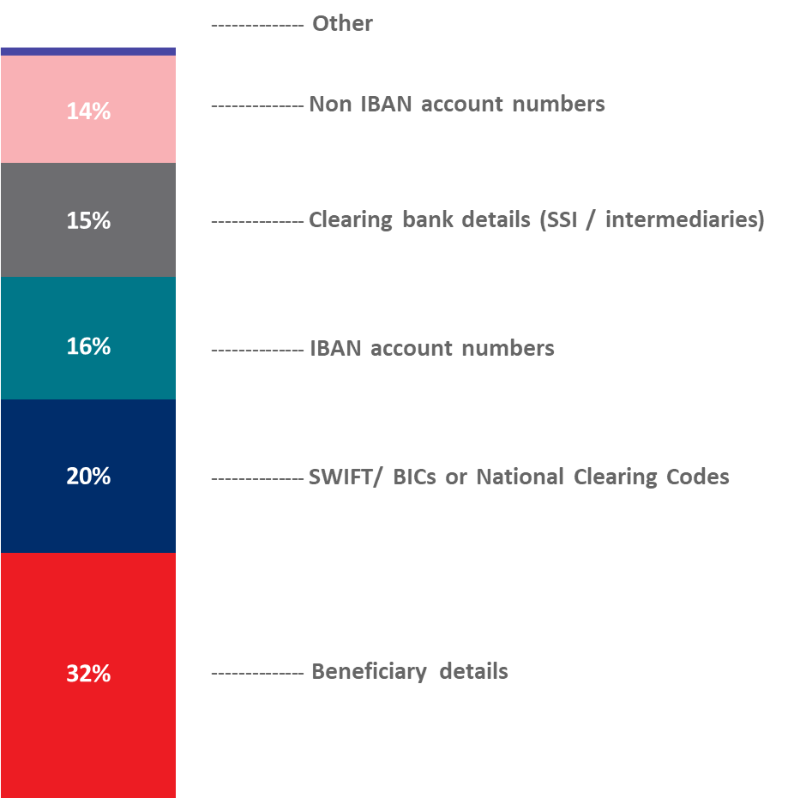

It appears clear from this analysis that most payment failures could be intercepted before a payment request is made.

A successful IIPS system must be capable of processing large numbers of low-value transfers (their target average value is 1USD) at a cost which makes the system viable. This requirement means that an IIPS system needs to avoid failures of the kind described above if at all possible, since failures require time to be spent across all parties in the dispute.

A key technique for achieving this aim is that IIPS systems require the parties to agree on the terms of the payment before any funds are committed. In order to meet this requirement, it is also necessary for the party who confirms the payment (that is, the creditor party) to be able to verify that it is in fact being asked to execute a payment whose terms it has agreed, and for other parties to the payment to be able to verify that the creditor party has warranted that it has in fact cleared the funds to its beneficiary, so that all parties will agree on the status of the payment.

In order to implement this technique, it must be possible to associate with the credit transfer request sufficient information to allow institutions which process the credit transfer request to verify, first, that the request has been reliably approved by the credit party and, second, that the terms of the credit transfer are in fact those which were approved and have not been varied in the interim. This information is associated with the credit transfer and not with the overall payment request. It would be perfectly legitimate for sets of terms to be agreed individually, or even out of band, and for them then to be bundled together in a single payment request.

When the creditor party to the payment approves the payment execution request, it will provide evidence which other parties to the payment can use to check that the cryptographic lock which they presented to the creditor institution was approved by the payer institution, and that it was the payer institution that approved it.

This proposal does not specify the type of information which a scheme will mandate in order to achieve these objectives, nor the procedures that IIPS systems will use to verify the legitimacy of the credit transfer request. We envisage that these will be matters for the Market Practice Document for individual implementations.

## Urgency of the request:

It is proposed to include this change request in the next regular maintenance cycle.

## Business examples:

The sequence diagram below shows an example of how the debtor party to a payment could attach to the payment execution request the cryptographic lock that it received from the creditor party when the creditor party approved the terms of the transfer. It then shows how the creditor party could use the cryptographic lock to verify that the proposed transfer matches the terms which it agreed to, and how the confirmation could be used by the other parties to the payment to confirm that the creditor party’s approval is an approval of the payment whose cryptographic lock was originally passed to the creditor party.

These features are shown in the following diagram:

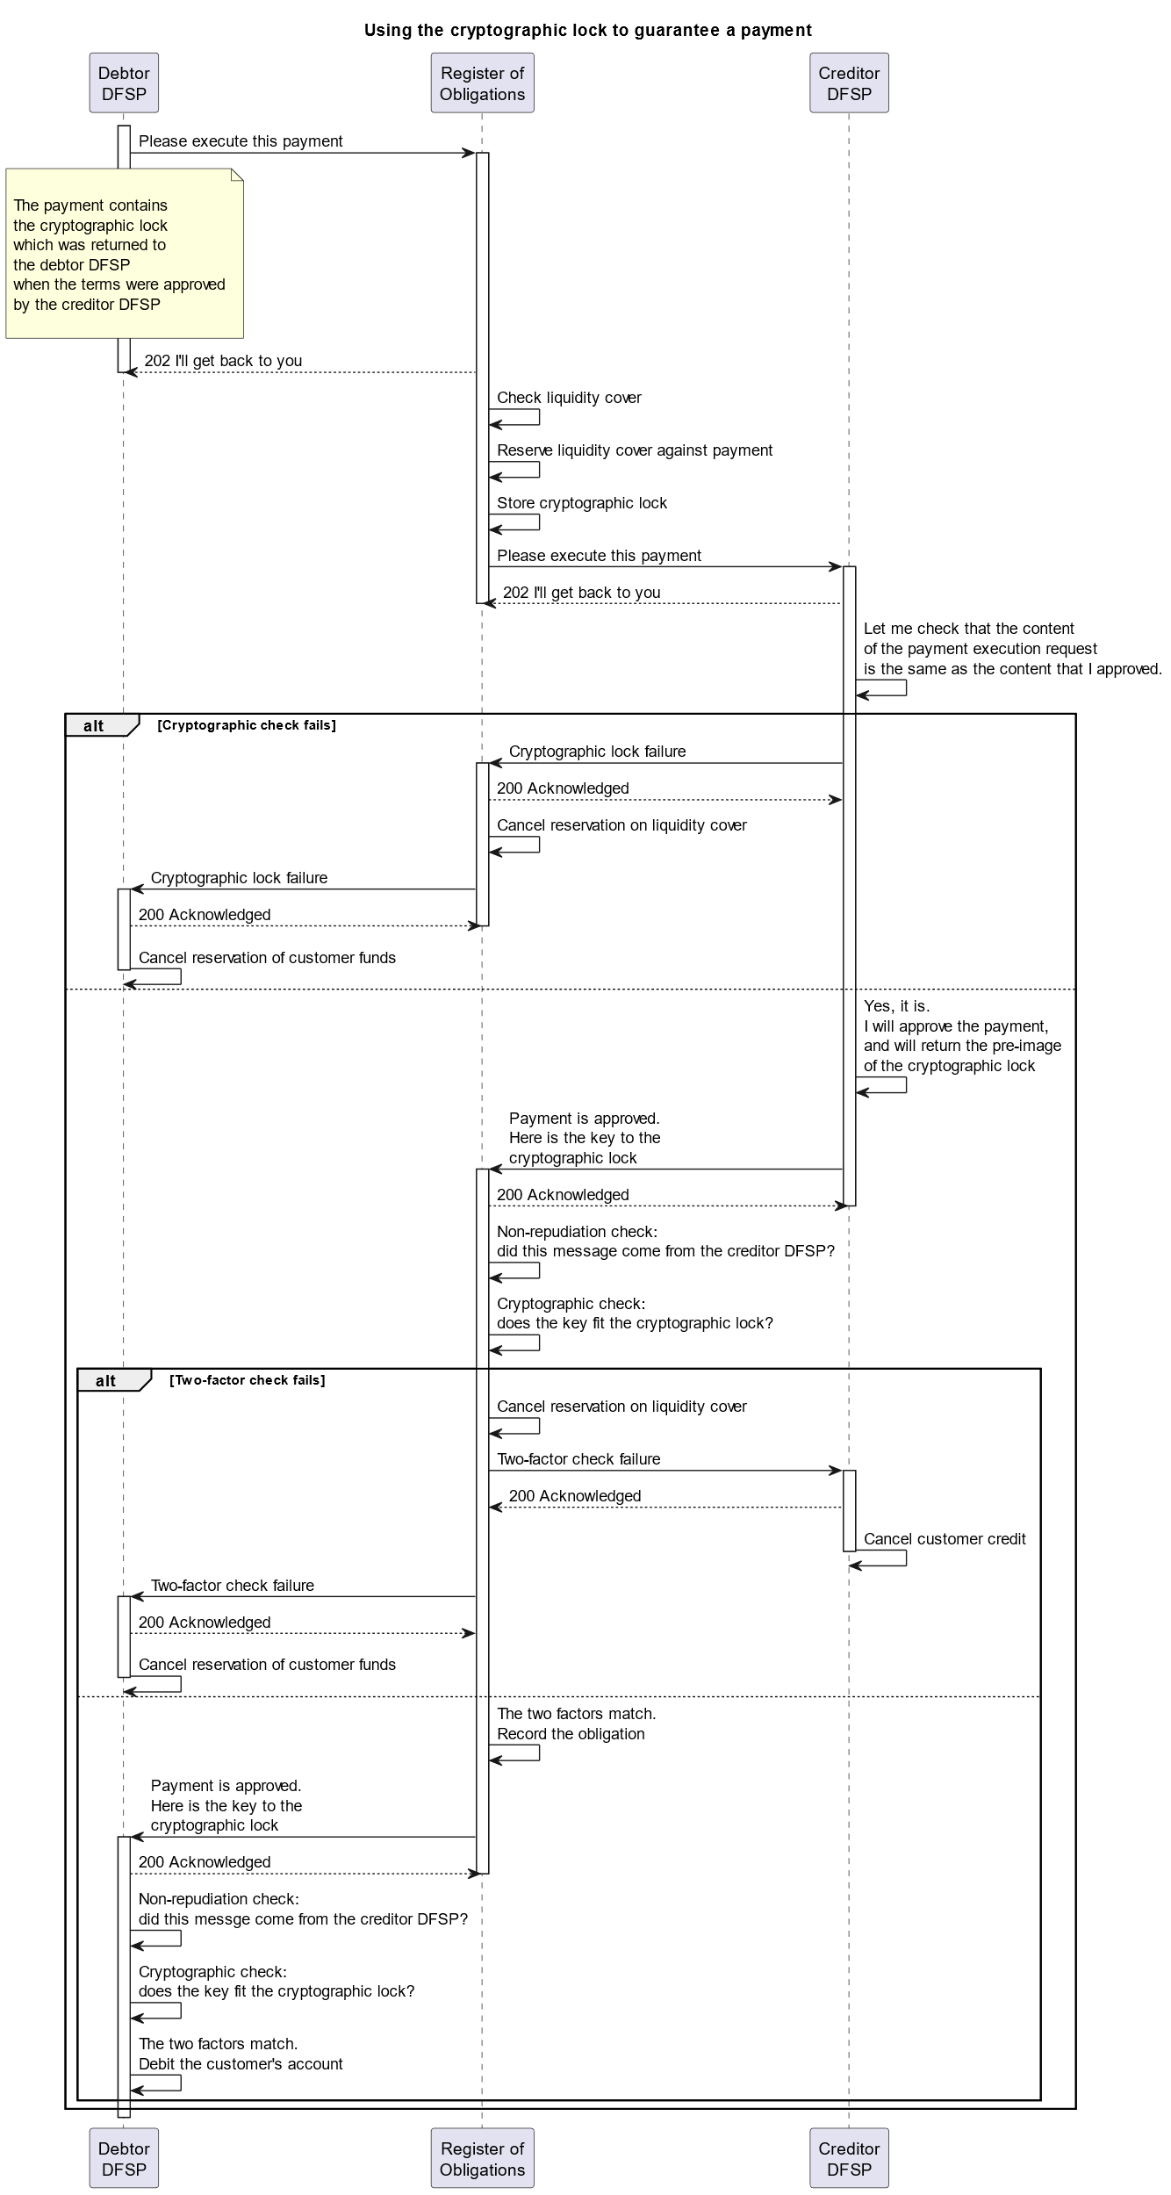

## SEG/TSG recommendation:

*This section is not to be taken care of by the submitter of the change request. It will be completed in due time by the SEG(s) in charge of the related ISO 20022 messages or the TSG for changes related to the BAH.*

|  |  |  |  |
| --- | --- | --- | --- |
| **Consider** | | X | **Timing** |
|  | | - **Next yearly cycle: 2024/2025**  (the change will be considered for implementation in the yearly maintenance cycle which starts in 2024 and completes with the publication of new message versions in the spring of 2025) | | X |
|  | | - **At the occasion of the next maintenance of the messages**  (the change will be considered for implementation, but does not justify maintenance of the messages in its own right – will be pending until more critical change requests are received for the messages) | |  |
|  | | - **Urgent unscheduled**  (the change justifies an urgent implementation outside of the normal yearly cycle) | |  |  |
|  | | - **Other timing:** | | |  |

Comments: CR will be reviewed as part of the 2024/2025 maintenance cycle.

|  |  |
| --- | --- |
| **Reject** |  |

Reason for rejection:

## Impact analysis and type of impact:

The following Message Identifiers will be impacted –

|  |  |
| --- | --- |
| **pacs.002.001.14** | FIToFIPaymentStatusReportV14 |

## Proposed implementation:

## Proposed timing:

The submitting organisation confirms that it can implement the requested changes in the requested timing.

|  |  |
| --- | --- |
| Timing | 2024/2025 |

## Final decision of the SEG(s):

|  |  |
| --- | --- |
| Approve |  |

|  |  |
| --- | --- |
| Reject |  |

Reason for rejection:

# Change request CR1356: Mojaloop (IIPS project) - Expiry Date/Time

## Origin of the request:

*A.1 Submitter*:

The Mojaloop Foundation

*A.2 Contact person:*

Michael Richards. [Michael.Richards@infitx.com](mailto:Michael.Richards@infitx.com), +44 7785 360009

*A.3 Sponsors*:

## Related messages:

Pacs.008.001 - FIToFICustomerCreditTransfer

Pacs.009.001 - FinancialInstitutionCreditTransfer

## Description of the change request:

An expiry time is required when a payment execution request is issued by one FI to another. This represents the time after which the payment execution request is invalidated and should not be executed by any of the parties.

This element is optional and non-repetitive. Its type should be *IsoDateTime*. We propose the name *ExpiryDateTime* for the element.

*Add structure for pacs.009*

We propose that it should be added to the *GroupHeader* element of the *FIToFICustomerCreditTransferV11* data structure. It is appropriate for this value to appear in the header rather than in the information relating to an individual payment because its intention is to provide a mechanism for finalising payments where there is a gross failure of a participant in the system: for instance, because internet access is not available or because the recipient’s service is unavailable. It is not intended to trap local failures to meet SLA response times; and therefore it is not expected that some transfers in a message would pass while others were timed out.

Current structure:

| **Or** | **MessageElement*<XML Tag>*** | **Mult.** | **Type** | **Constr. No.** | **Page** |
| --- | --- | --- | --- | --- | --- |
|  | **MessageIdentification** ***<MsgId>*** | **[1..1]** | **Text** |  | **654** |
|  | **CreationDateTime** ***<CreDtTm>*** | **[1..1]** | **DateTime** |  | **654** |
|  | **BatchBooking** ***<BtchBookg>*** | **[0..1]** | **Indicator** |  | **655** |
|  | **NumberOfTransactions** ***<NbOfTxs>*** | **[1..1]** | **Text** |  | **655** |
|  | **ControlSum** ***<CtrlSum>*** | **[0..1]** | **Quantity** |  | **655** |
|  | **TotalInterbankSettlementAmount** ***<TtlIntrBkSttlmAmt>*** | **[0..1]** | **Amount** | **C1****,** **C10** | **655** |
|  | **InterbankSettlementDate** ***<IntrBkSttlmDt>*** | **[0..1]** | **Date** |  | **655** |
|  | **SettlementInformation** ***<SttlmInf>*** | **[1..1]** |  | **C20****,** **C22****,** **C37****,** **C38****,** **C39****,** **C40****,** **C43****,** **C44** | **656** |
|  | **SettlementMethod** ***<SttlmMtd>*** | **[1..1]** | **CodeSet** |  | **659** |
|  | **SettlementAccount** ***<SttlmAcct>*** | **[0..1]** |  | **C15****,** **C14** | **659** |
|  | **Identification** ***<Id>*** | **[0..1]** | **±** |  | **660** |
|  | **Type** ***<Tp>*** | **[0..1]** | **±** |  | **660** |
|  | **Currency** ***<Ccy>*** | **[0..1]** | **CodeSet** | **C2** | **661** |
|  | **Name** ***<Nm>*** | **[0..1]** | **Text** |  | **661** |
|  | **Proxy** ***<Prxy>*** | **[0..1]** | **±** |  | **661** |
|  | **ClearingSystem** ***<ClrSys>*** | **[0..1]** |  |  | **661** |
| **{Or** | **Code** ***<Cd>*** | **[1..1]** | **CodeSet** |  | **662** |
| **Or}** | **Proprietary** ***<Prtry>*** | **[1..1]** | **Text** |  | **662** |
|  | **InstructingReimbursementAgent**  ***<InstgRmbrsmntAgt>*** | **[0..1]** | **±** |  | **662** |
|  | **InstructingReimbursementAgentAccount**  ***<InstgRmbrsmntAgtAcct>*** | **[0..1]** |  | **C15****,** **C14** | **662** |
|  | **Identification** ***<Id>*** | **[0..1]** | **±** |  | **663** |
|  | **Type** ***<Tp>*** | **[0..1]** | **±** |  | **663** |
|  | **Currency** ***<Ccy>*** | **[0..1]** | **CodeSet** | **C2** | **664** |
|  | **Name** ***<Nm>*** | **[0..1]** | **Text** |  | **664** |
|  | **Proxy** ***<Prxy>*** | **[0..1]** | **±** |  | **664** |
|  | **InstructedReimbursementAgent** ***<InstdRmbrsmntAgt>*** | **[0..1]** | **±** |  | **664** |

Proposed structure:

| **Or** | **MessageElement*<XML Tag>*** | **Mult.** | **Type** | **Constr. No.** | **Page** |
| --- | --- | --- | --- | --- | --- |
|  | **MessageIdentification** ***<MsgId>*** | **[1..1]** | **Text** |  | **654** |
|  | **CreationDateTime** ***<CreDtTm>*** | **[1..1]** | **DateTime** |  | **654** |
|  | **PaymentInstructionExpiryDateTime *<PmntInstrctnExpryDtTm>*** | **[0..1]** | **DateTime** |  |  |
|  | **BatchBooking** ***<BtchBookg>*** | **[0..1]** | **Indicator** |  | **655** |
|  | **NumberOfTransactions** ***<NbOfTxs>*** | **[1..1]** | **Text** |  | **655** |
|  | **ControlSum** ***<CtrlSum>*** | **[0..1]** | **Quantity** |  | **655** |
|  | **TotalInterbankSettlementAmount** ***<TtlIntrBkSttlmAmt>*** | **[0..1]** | **Amount** | **C1****,** **C10** | **655** |
|  | **InterbankSettlementDate** ***<IntrBkSttlmDt>*** | **[0..1]** | **Date** |  | **655** |
|  | **SettlementInformation** ***<SttlmInf>*** | **[1..1]** |  | **C20****,** **C22****,** **C37****,** **C38****,** **C39****,** **C40****,** **C43****,** **C44** | **656** |
|  | **SettlementMethod** ***<SttlmMtd>*** | **[1..1]** | **CodeSet** |  | **659** |
|  | **SettlementAccount** ***<SttlmAcct>*** | **[0..1]** |  | **C15****,** **C14** | **659** |
|  | **Identification** ***<Id>*** | **[0..1]** | **±** |  | **660** |
|  | **Type** ***<Tp>*** | **[0..1]** | **±** |  | **660** |
|  | **Currency** ***<Ccy>*** | **[0..1]** | **CodeSet** | **C2** | **661** |
|  | **Name** ***<Nm>*** | **[0..1]** | **Text** |  | **661** |
|  | **Proxy** ***<Prxy>*** | **[0..1]** | **±** |  | **661** |
|  | **ClearingSystem** ***<ClrSys>*** | **[0..1]** |  |  | **661** |
| **{Or** | **Code** ***<Cd>*** | **[1..1]** | **CodeSet** |  | **662** |
| **Or}** | **Proprietary** ***<Prtry>*** | **[1..1]** | **Text** |  | **662** |
|  | **InstructingReimbursementAgent**  ***<InstgRmbrsmntAgt>*** | **[0..1]** | **±** |  | **662** |
|  | **InstructingReimbursementAgentAccount**  ***<InstgRmbrsmntAgtAcct>*** | **[0..1]** |  | **C15****,** **C14** | **662** |
|  | **Identification** ***<Id>*** | **[0..1]** | **±** |  | **663** |
|  | **Type** ***<Tp>*** | **[0..1]** | **±** |  | **663** |
|  | **Currency** ***<Ccy>*** | **[0..1]** | **CodeSet** | **C2** | **664** |
|  | **Name** ***<Nm>*** | **[0..1]** | **Text** |  | **664** |
|  | **Proxy** ***<Prxy>*** | **[0..1]** | **±** |  | **664** |
|  | **InstructedReimbursementAgent** ***<InstdRmbrsmntAgt>*** | **[0..1]** | **±** |  | **664** |

We propose the following MDR description of the change:

*Presence:* [0..1]

*Definition:* The date and time after which the payment execution request should be cancelled if it has not completed.

Usage: Where it is important to reduce the cost of failed payments, and where infrastructure limitations may mean that participants may have connection problems and be unpredictably unreachable, it is important that payments should not be left in an indeterminate state. The definition of an expiry date for the payment allows participants to understand the point after which the payment should be regarded as failed. After that point, participants should regard the payment as failed due to a communications problem, cancel any funds they have reserved or moved as a consequence of the payment request, and mark the status of the payment as FAILED.

“Payment” here refers to a group of credit transfers contained in a payment execution request. The expiry time quoted is for all the individual credit transfer requests in the payment execution request. The standard does not mandate the action to be taken by participants when a payment execution request expires. This is a matter for individual implementations.

*Datatype:* "isoDateTime"

## Purpose of the change:

In the environments in which IIPS systems are deployed, the availability of systems when required cannot always be guaranteed. Core Banking Systems are sometimes offline for parts of the day, or entire participants may not be able to connect to the internet due to network outages.

In cases like this, the status of a credit transfer request may remain indeterminate for quite long periods. The sending FI will not know whether one of the other parties is taking some time to respond, or has not received the message, or has responded but the response has been interrupted. It is in circumstances like these that it is possible for parties to act on different inferences about whether or not the credit transfer request has been executed; and these differences in inference allow for the possibility of disputes between the parties. In the case of the high-volume, very low-value payments which IIPSs are designed to support, the resolution of disputes is an intolerably expensive matter and an IIPS system needs to be designed to minimise the number of disputes which arise.

One of these design decisions is that every payment execution request should be accompanied by an expiry time. Once the payment request has expired, all parties to the payment should treat it as a failed payment and should act accordingly. Before a payment is finalised by the eventual credit party, provided that the payment has not yet expired all parties should treat its status as indeterminate and should not take any irrevocable actions in relation to it.

## Urgency of the request:

It is proposed to include this change request in the next regular maintenance cycle.

## Business examples:

The sequence diagram below shows how the expiry time is used in an IIPS where a central message routing service manages the interaction between participants, and where participants communicate with the central routing service via APIs. The central routing service is responsible for monitoring transfer requests for expiry.

In the example, the debtor institution requests that a payment be executed. The creditor institution contacts its core banking system to execute the transfer of funds, but the CBS does not respond. Nothing happens in the system and, when the debtor institution enquires after the status of the payment, as status of INDETERMINATE is returned, as is normal while a payment is executing.

After the timeout period has elapsed, the central routing service cancels the payment execution request and informs the parties that the payment has been cancelled. Now when the debtor institution enquires after the status of the payment, a status of CANCELLED is returned.

These features are shown in the following diagram:

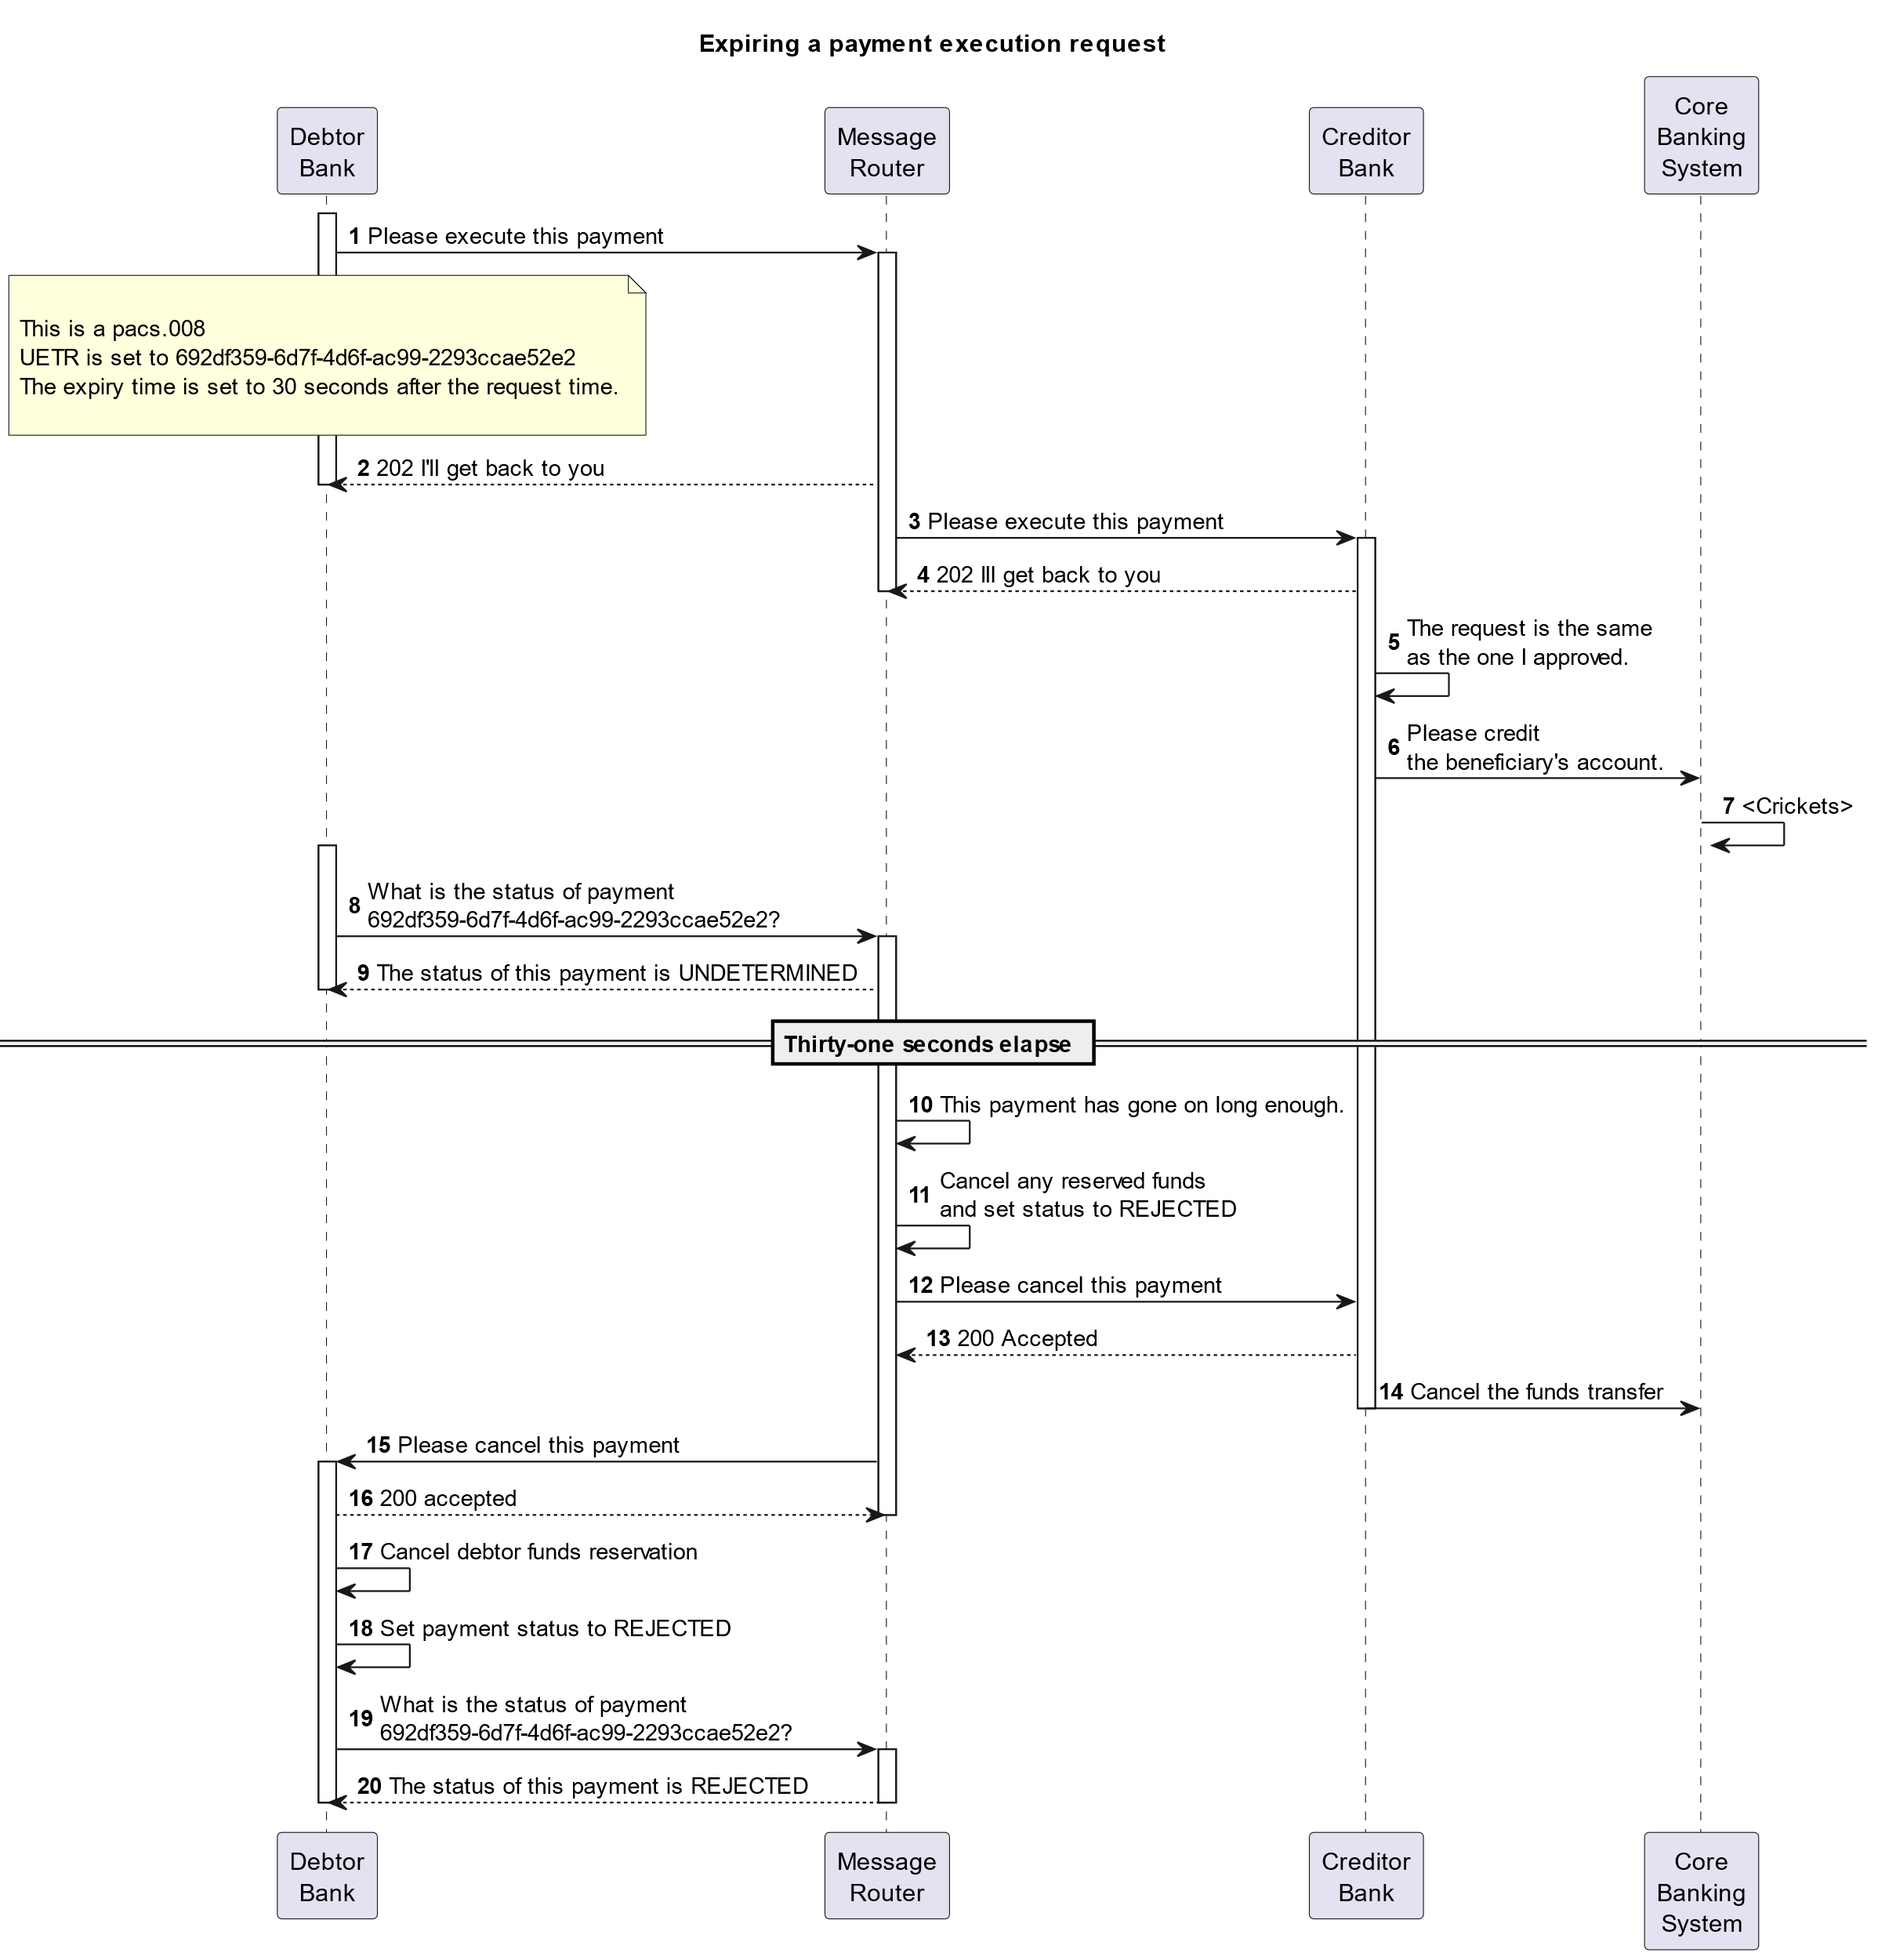

## SEG/TSG recommendation:

*This section is not to be taken care of by the submitter of the change request. It will be completed in due time by the SEG(s) in charge of the related ISO 20022 messages or the TSG for changes related to the BAH.*

|  |  |  |  |
| --- | --- | --- | --- |
| **Consider** | | X | **Timing** |
|  | | - **Next yearly cycle: 2024/2025**  (the change will be considered for implementation in the yearly maintenance cycle which starts in 2024 and completes with the publication of new message versions in the spring of 2025) | | X |
|  | | - **At the occasion of the next maintenance of the messages**  (the change will be considered for implementation, but does not justify maintenance of the messages in its own right – will be pending until more critical change requests are received for the messages) | |  |
|  | | - **Urgent unscheduled**  (the change justifies an urgent implementation outside of the normal yearly cycle) | |  |  |
|  | | - **Other timing:** | | |  |

Comments: CR will be reviewed as part of the 2024/2025 maintenance cycle.

|  |  |
| --- | --- |
| **Reject** |  |

Reason for rejection:

## Impact analysis and type of impact:

The following Message Identifiers will be impacted –

|  |  |
| --- | --- |
| **pacs.004.001.13** | PaymentReturnV13 |
| **pacs.008.001.12** | FIToFICustomerCreditTransferV12 |
| **pacs.009.001.11** | FinancialInstitutionCreditTransferV11 |

## Proposed implementation:

For discussion -

1. Swift notes that there are four CRs focusing on instant payment systems (IPS). To help users implementing the latest message versions we propose creating one dedicated block that carries a number of these new elements for IPS’s as opposed to having them spread throughout the messages as proposed by the submitter, this allows users to simply remove the block. Does the PAYSEG support this?

## Proposed timing:

The submitting organisation confirms that it can implement the requested changes in the requested timing.

|  |  |
| --- | --- |
| Timing | 2024/2025 |

## Final decision of the SEG(s):

|  |  |
| --- | --- |
| Approve |  |

|  |  |
| --- | --- |
| Reject |  |

Reason for rejection:

# Change request CR1357: Mojaloop (IIPS project) - CryptographicLock

## Origin of the request:

*A.1 Submitter*:

The Mojaloop Foundation

*A.2 Contact person:*

Michael Richards. [Michael.Richards@infitx.com](mailto:Michael.Richards@infitx.com), +44 7785 360009

*A.3 Sponsors*:

1) Africanenda

2) Comesa Business Council

Contact: Dr. Jonathan Pinifolo, jpinifolo@comesabusinesscouncil.org

## Related messages:

Pacs.008.001 - FIToFICustomerCreditTransfer

Pacs.009.001 - FinancialInstitutionCreditTransfer

New messages to be defined sealing the agreement of terms between the parties for payments and currency conversions.

## Description of the change request:

We want to define new elements in the data structure which describes a credit transfer transaction. This element will contain an encoded representation of the agreed terms of the credit transfer transaction, together with a signature which the approver of the terms can use to verify that they are in fact being asked to execute the payment on the terms agreed, and which other parties to the payment can use to verify that the beneficiary’s FI has warranted that the transaction has completed on their books.

This element is optional and non-repetitive. It will be in the form of a new data dictionary element, as described in an associated change request (CR1358). The new element’s type name is *CryptographicLockChoice*.

This new element is an instance of aelement of the *FIToFICustomerCreditTransfer* data structure. This structure is used both in the FIToFICustomerCreditTransfer element (pacs.008) and in the FinancialInstitutionCreditTransfer eement (pacs.009). This will result in new issues of the *FIToFICustomerCreditTransfer* and *CreditTransferTransactionInformation* elements.

Current structure of the *CreditTransferTransactionInformation* element:

| **Or** | **MessageElement*<XML Tag>*** | **Mult.** | **Type** | **Constr. No.** | **Page** |
| --- | --- | --- | --- | --- | --- |
|  | **PaymentIdentification***<PmtId>* | [1..1] | ± | C48 | 681 |
|  | **PaymentTypeInformation***<PmtTpInf>* | [0..1] | ± |  | 682 |
|  | **InterbankSettlementAmount***<IntrBkSttlmAmt>* | [1..1] | Amount | C1, C10 | 682 |
|  | **InterbankSettlementDate***<IntrBkSttlmDt>* | [0..1] | Date |  | 683 |
|  | **SettlementPriority***<SttlmPrty>* | [0..1] | CodeSet |  | 683 |
|  | **SettlementTimeIndication***<SttlmTmIndctn>* | [0..1] |  |  | 683 |
|  | **DebitDateTime***<DbtDtTm>* | [0..1] | DateTime |  | 683 |
|  | **CreditDateTime***<CdtDtTm>* | [0..1] | DateTime |  | 684 |
|  | **SettlementTimeRequest***<SttlmTmReq>* | [0..1] | ± |  | 684 |
|  | **AcceptanceDateTime***<AccptncDtTm>* | [0..1] | DateTime |  | 684 |
|  | **PoolingAdjustmentDate***<PoolgAdjstmntDt>* | [0..1] | Date |  | 684 |
|  | **InstructedAmount***<InstdAmt>* | [0..1] | Amount | C2, C11 | 684 |
|  | **ExchangeRate***<XchgRate>* | [0..1] | Rate |  | 685 |
|  | **ChargeBearer***<ChrgBr>* | [1..1] | CodeSet |  | 685 |
|  | **ChargesInformation***<ChrgsInf>* | [0..*] | ± |  | 685 |
|  | **MandateRelatedInformation***<MndtRltdInf>* | [0..1] | ± |  | 686 |
|  | **PreviousInstructingAgent1***<PrvsInstgAgt1>* | [0..1] | ± |  | 686 |
|  | **PreviousInstructingAgent1Account**  *<PrvsInstgAgt1Acct>* | [0..1] |  | C15, C14 | 687 |
|  | **Identification***<Id>* | [0..1] | ± |  | 687 |
|  | **Type***<Tp>* | [0..1] | ± |  | 687 |
|  | **Currency***<Ccy>* | [0..1] | CodeSet | C2 | 688 |
|  | **Name***<Nm>* | [0..1] | Text |  | 688 |
|  | **Proxy***<Prxy>* | [0..1] | ± |  | 688 |
|  | **PreviousInstructingAgent2***<PrvsInstgAgt2>* | [0..1] | ± |  | 689 |
|  | **PreviousInstructingAgent2Account**  *<PrvsInstgAgt2Acct>* | [0..1] |  | C15, C14 | 689 |
|  | **Identification***<Id>* | [0..1] | ± |  | 690 |
|  | **Type***<Tp>* | [0..1] | ± |  | 690 |
|  | **Currency***<Ccy>* | [0..1] | CodeSet | C2 | 690 |
|  | **Name***<Nm>* | [0..1] | Text |  | 691 |

Proposed structure of the *CreditTransferTransactionInformation* element:

| **Or** | **MessageElement*<XML Tag>*** | **Mult.** | **Type** | **Constr. No.** | **Page** |
| --- | --- | --- | --- | --- | --- |
|  | **PaymentIdentification***<PmtId>* | [1..1] | ± | C48 | 681 |
|  | **PaymentTypeInformation***<PmtTpInf>* | [0..1] | ± |  | 682 |
|  | **InterbankSettlementAmount***<IntrBkSttlmAmt>* | [1..1] | Amount | C1, C10 | 682 |
|  | **InterbankSettlementDate***<IntrBkSttlmDt>* | [0..1] | Date |  | 683 |
|  | **SettlementPriority***<SttlmPrty>* | [0..1] | CodeSet |  | 683 |
|  | **SettlementTimeIndication***<SttlmTmIndctn>* | [0..1] |  |  | 683 |
|  | **DebitDateTime***<DbtDtTm>* | [0..1] | DateTime |  | 683 |
|  | **CreditDateTime***<CdtDtTm>* | [0..1] | DateTime |  | 684 |
|  | **SettlementTimeRequest***<SttlmTmReq>* | [0..1] | ± |  | 684 |
|  | **AcceptanceDateTime***<AccptncDtTm>* | [0..1] | DateTime |  | 684 |
|  | **PoolingAdjustmentDate***<PoolgAdjstmntDt>* | [0..1] | Date |  | 684 |
|  | **InstructedAmount***<InstdAmt>* | [0..1] | Amount | C2, C11 | 684 |
|  | **ExchangeRate***<XchgRate>* | [0..1] | Rate |  | 685 |
|  | **ChargeBearer***<ChrgBr>* | [1..1] | CodeSet |  | 685 |
|  | **ChargesInformation***<ChrgsInf>* | [0..*] | ± |  | 685 |
|  | **MandateRelatedInformation***<MndtRltdInf>* | [0..1] | ± |  | 686 |
|  | **PreviousInstructingAgent1***<PrvsInstgAgt1>* | [0..1] | ± |  | 686 |
|  | **PreviousInstructingAgent1Account**  *<PrvsInstgAgt1Acct>* | [0..1] |  | C15, C14 | 687 |
|  | **Identification***<Id>* | [0..1] | ± |  | 687 |
|  | **Type***<Tp>* | [0..1] | ± |  | 687 |
|  | **Currency***<Ccy>* | [0..1] | CodeSet | C2 | 688 |
|  | **Name***<Nm>* | [0..1] | Text |  | 688 |
|  | **Proxy***<Prxy>* | [0..1] | ± |  | 688 |
|  | **PreviousInstructingAgent2***<PrvsInstgAgt2>* | [0..1] | ± |  | 689 |
|  | **PreviousInstructingAgent2Account**  *<PrvsInstgAgt2Acct>* | [0..1] |  | C15, C14 | 689 |
|  | **Identification***<Id>* | [0..1] | ± |  | 690 |
|  | **Type***<Tp>* | [0..1] | ± |  | 690 |
|  | **Currency***<Ccy>* | [0..1] | CodeSet | C2 | 690 |
|  | **Name***<Nm>* | [0..1] | Text |  | 691 |
|  | VerificationOfTerms *<VrfctnTrms>* | [0..1] | CryptographicLockChoice |  |  |

We propose the following MDR description of the change:

*Presence:* [0..1]

*Definition:* Information which the FI which assumes credit risk as a result of completing the payment can use to confirm that the payment which it is being asked to execute is a payment to whose terms it has agreed, and which other parties to the payment can subsequently use to satisfy themselves that the credit party has warranted that they have executed the payment.

Usage: Where it is important to reduce the cost of failed payments, an institution or a payments scheme may elect to require that the terms of a payment are agreed in advance between the parties. Where this is the case, they may further wish to confirm this by issuing to the other parties a means which the other parties can use to assert, when they request execution of the payment, that the execution is based on a set of terms which have been agreed by the creditor institution and which have not been varied by any other party. This field allows information about the verification of the terms for a payment to be attached to the definition of the payment.

“Payment” here refers to an individual credit transfer. The standard does not mandate the inclusion of this information for every payment in an overall FI to FI payment instruction; and it allows the implementer to choose the type of verification from among a range of types. Currently supported types are:

* A hexadecimal string representing a SHA-256 signature.
* A hexadecimal string representing an ILP version 4 prepare packet.

The form that this verification should take is left as a matter for individual implementations.

*Datatype:* " CryptographicLockChoice "

## Purpose of the change:

This change is designed to support a radical reduction in the costs associated with processing payments by removing the majority of the costs incurred by financial institutions in remediating failed payments.

A survey based on material collected in 2021 by LexisNexis[2] concluded that the average annual cost of failed payments (defined as payments that were rejected by a participant in the payment chain, and therefore excluding failures due to communications breakdowns) was $360k for banks, $220k for non-bank financial institutions, and $200k for corporates. The causes of these failures were broken down as shown below:



It appears clear from this analysis that most payment failures could be intercepted before a payment execution request is made.

A successful IIPS system must be capable of processing large numbers of low-value transfers (their target average value is 1 USD) at a cost which makes the system viable. This requirement means that an IIPS system needs to avoid failures of the kind described above if at all possible, since failures require time to be spent across all parties in the dispute.

A key technique for achieving this aim is that IIPS systems require the parties to agree on the terms of the payment before any funds are committed. In order to meet this requirement, it is also necessary for the party who confirms the payment (that is, the creditor party) to be able to verify that it is in fact being asked to execute a payment whose terms it has agreed, and for other parties to the payment to be able to verify that the creditor party has warranted that it has in fact cleared the funds to its beneficiary, so that all parties will agree on the status of the payment.

In order to implement this technique, it must be possible to associate with the credit transfer request sufficient information to allow institutions which process the credit transfer request to verify, first, that the request has been reliably approved by the credit party and, second, that the terms of the credit transfer are in fact those which were approved and have not been varied in the interim. This information is associated with the credit transfer and not with the overall payment request. It would be perfectly legitimate for sets of terms to be agreed individually, or even out of band, and for them then to be bundled together in a single payment request.

This proposal does not specify the type of information which a scheme will mandate in order to achieve these objectives, nor the procedures that IIPS systems will use to verify the legitimacy of the credit transfer request. We envisage that these will be matters for the Market Practice Document for individual implementations.

## Urgency of the request:

It is proposed to include this change request in the next regular maintenance cycle.

## Business examples:

The sequence diagram below shows an example of how the debtor party to a payment could attach to the payment execution request the cryptographic lock that it received from the creditor party when the creditor party approved the terms of the transfer. It then shows how the creditor party could use the cryptographic lock to verify that the proposed transfer matches the terms which it agreed to, and how the confirmation could be used by the other parties to the payment to confirm that the creditor party’s approval is an approval of the payment whose cryptographic lock was originally passed to the creditor party.

These features are shown in the following diagram:



## SEG/TSG recommendation:

*This section is not to be taken care of by the submitter of the change request. It will be completed in due time by the SEG(s) in charge of the related ISO 20022 messages or the TSG for changes related to the BAH.*

|  |  |  |  |
| --- | --- | --- | --- |
| **Consider** | | X | **Timing** |
|  | | - **Next yearly cycle: 2024/2025**  (the change will be considered for implementation in the yearly maintenance cycle which starts in 2024 and completes with the publication of new message versions in the spring of 2025) | | X |
|  | | - **At the occasion of the next maintenance of the messages**  (the change will be considered for implementation, but does not justify maintenance of the messages in its own right – will be pending until more critical change requests are received for the messages) | |  |
|  | | - **Urgent unscheduled**  (the change justifies an urgent implementation outside of the normal yearly cycle) | |  |  |
|  | | - **Other timing:** | | |  |

Comments: CR will be reviewed as part of the 2024/2025 maintenance cycle.

|  |  |
| --- | --- |
| **Reject** |  |

Reason for rejection:

## Impact analysis and type of impact:

The following Message Identifiers will be impacted –

|  |  |
| --- | --- |
| **pacs.004.001.13** | PaymentReturnV13 |
| **pacs.008.001.12** | FIToFICustomerCreditTransferV12 |
| **pacs.009.001.11** | FinancialInstitutionCreditTransferV11 |

## Proposed implementation:

For discussion -

1. Swift notes that there are four CRs focusing on instant payment systems (IPS). To help users implementing the latest message versions we propose creating one dedicated block that carries a number of these new elements for IPS’s as opposed to having them spread throughout the messages as proposed by the submitter, this allows users to simply remove the block. Does the PAYSEG support this?
2. The pain.013 carries a PaymentCondition element that could be considered similar to what is being created here. As the pain.013 is not available for maintenance Swift have chosen not to add this new element to that message at this stage. Does the PAYSEG support this?

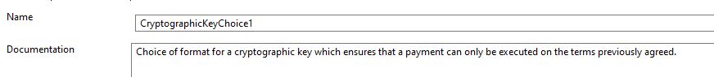

## Proposed timing:

The submitting organisation confirms that it can implement the requested changes in the requested timing.

|  |  |
| --- | --- |
| Timing | 2024/2025 |

## Final decision of the SEG(s):

|  |  |
| --- | --- |
| Approve |  |

|  |  |
| --- | --- |
| Reject |  |

Reason for rejection:

# Change request CR1358: Mojaloop (IIPS project) - Cryptographic Lock Data Element

## Origin of the request:

*A.1 Submitter*:

The Mojaloop Foundation

*A.2 Contact person:*

Michael Richards. [Michael.Richards@infitx.com](mailto:Michael.Richards@infitx.com), +44 7785 360009

*A.3 Sponsors*:

1) Africanenda

2) Comesa Business Council

Contact: Dr. Jonathan Pinifolo, [jpinifolo@comesabusinesscouncil.org](mailto:jpinifolo@comesabusinesscouncil.org)

## Related messages:

Pacs.008.001 - FIToFICustomerCreditTransfer

Pacs.009.001 - FinancialInstitutionCreditTransfer

New messages to be defined sealing the agreement of terms between the parties for Customer Credit credit transfers and Financial Institution credit transfers.

## Description of the change request:

We want to define new elements in the data dictionary to support the definition of a cryptographic lock which can be attached to the definition of a credit transfer. The reasons for wanting to attach a cryptographic lock are given in detail in CR 1357, which describes the use of the cryptographic lock. The cryptographic lock will be used in the following messages:

* The message which defines the agreed terms of a payment. This is a new message which is the subject of a Business Justification to be submitted to the ISO 20022 Payments SEG.
* The payment execution message (pacs.008).
* The message which defines the agreed terms of a cover request. This is a new message which is the subject of a Business Justification to be submitted to the ISO 20022 Payments SEG.
* The cover request message (pacs.009).

These elements will be defined by a definition analogous to that used in the existing data dictionary for elements such as *Frequency36Choice*, where the creator of the message can choose between different formats for a frequency of payment. In this case, we will allow the creator of the message to choose between different types of cryptographic lock.

The following types of cryptographic lock will be supported in the first instance:

1. An IlpV4Packet. This will be a representation of the data element of an ILP v4 packet, as described [here](https://interledger.org/developers/rfcs/interledger-protocol/). This element will be an encoded string of arbitrary length. The most accurate way of representing this element would be the candidate data element *hexBinary*.
2. A SHA-256 signature created using a private key belonging to the entity that sealed the terms of the payment. This signature will have a fixed length of 32 bytes, and will be represented as a hexadecimal string. The existing data elements which represent hexadecimal encodings of binary strings (e.g. Max32HexBinaryText) are not suitable for this purpose since they support strings of any length up to a maximum. We therefore propose a new data type, whose name will be Exact32HexBinaryText. It will be calqued on the existing Exact1HexBinaryText, and is described in more detail below.

The definition of the proposed new Exact32HexBinaryText data element in MDR format will be as follows:

***Exact32HexBinaryText***

*Definition: Specifies a character string with an exact length of 32 binary bytes (64 hexadecimal text characters).*

*Used for hex binary data only, supports only characters A-F and 0-9.*

*Type: Text*

*Format*

*pattern ([0-9A-F][0-9A-F]){32}*

The name of the proposed data type will be *CryptographicLockChoice*. The definition of the proposed new data type in MDR format will be:

**CryptographicLockChoice**

*Definition*: choice of format for a cryptographic lock which ensures that a payment execution request can only be executed on the terms previously agreed.

.

|  |  |  |  |  |  |
| --- | --- | --- | --- | --- | --- |
| **Or** | **MessageElement*<XML Tag>*** | **Mult.** | **Type** | **Constr. No.** | **Page** |
| {Or | IlpV4PreparePacket *<Ilpv4PrprPkt>* | [1..1] | HexBinary |  |  |
| Or} | Sha256Signature *<Sh256S>* | [1..1] | Exact32HexBinaryText |  |  |

## Purpose of the change:

Not provided

## Urgency of the request:

It is proposed to include this change request in the next regular maintenance cycle.

## Business examples:

Not provided

## SEG/TSG recommendation:

*This section is not to be taken care of by the submitter of the change request. It will be completed in due time by the SEG(s) in charge of the related ISO 20022 messages or the TSG for changes related to the BAH.*

|  |  |  |  |
| --- | --- | --- | --- |
| **Consider** | | X | **Timing** |
|  | | - **Next yearly cycle: 2024/2025**  (the change will be considered for implementation in the yearly maintenance cycle which starts in 2024 and completes with the publication of new message versions in the spring of 2025) | | X |
|  | | - **At the occasion of the next maintenance of the messages**  (the change will be considered for implementation, but does not justify maintenance of the messages in its own right – will be pending until more critical change requests are received for the messages) | |  |
|  | | - **Urgent unscheduled**  (the change justifies an urgent implementation outside of the normal yearly cycle) | |  |  |
|  | | - **Other timing:** | | |  |

Comments: CR will be reviewed as part of the 2024/2025 maintenance cycle.

|  |  |
| --- | --- |
| **Reject** |  |

Reason for rejection:

## Impact analysis and type of impact:

The following Message Identifiers will be impacted –

|  |  |
| --- | --- |
| **pacs.004.001.13** | PaymentReturnV13 |
| **pacs.008.001.12** | FIToFICustomerCreditTransferV12 |
| **pacs.009.001.11** | FinancialInstitutionCreditTransferV11 |

## Proposed implementation:

## Proposed timing:

The submitting organisation confirms that it can implement the requested changes in the requested timing.

|  |  |
| --- | --- |
| Timing | 2024/2025 |

## Final decision of the SEG(s):

|  |  |
| --- | --- |
| Approve |  |

|  |  |
| --- | --- |
| Reject |  |

Reason for rejection:

# Change request CR1379: BIS - FX Conversion Agent or Quote ID

## Origin of the request:

*A.1 Submitter*:

Bank for International Settlements Innovation Hub (Singapore Centre)

*A.2 Contact person:*

Name: Ben Dyson

E-mail: ben.dyson@bisih.org

Telephone: (+41 61) 280 8080 (BIS HQ)

*A.3 Sponsors*:

**Payment Network Malaysia Sdn Bhd (PayNet)**  
Payments Network Malaysia Sdn Bhd (PayNet) is the national payments network and shared central infrastructure for Malaysia’s financial markets.

**Banking Computer Services (BCS) Singapore**  
BCS manages and operates the national clearing and payment infrastructure in Singapore, including Fast And Secure Transfers (FAST), Interbank GIRO, eGiro, Cheque Clearing, PayNow and SGQR Central Repository.

## Related messages:

This change request is related to the **FIToFICustomerCreditTransferV12** (pacs.008.001.12). The change also impacts the **PaymentReturnV13** (pacs.004.001.13).

Although the business justification for this change request does not require this, the following messages could also benefit from this change:

* FIToFICustomerDirectDebitV11 (pacs.003.001.11)
* FIToFIPaymentReversalV13 (pacs.007.001.13)

## Description of the change request:

This change request proposes the addition of a section of elements to clearly identify the financial institution that provides currency conversion for a specific payment – the “FX Agent” in this proposal – and a Quote Id issued by that FX Agent.

This section of elements is closely related to the existing ExchangeRate (<XchgRate>) element in the pacs.008 and the pacs.004 messages.

**Change 1: New element**

This change therefore requests the addition of the following elements under CreditTransferTransactionInformation <CrdtTrfTxInf>. These elements are modelled on similar usage in ForeignExchangeTradeInstrucionV05 (fxtr.014.001.05).

**“AgreedRate” <AgrdRate>**

*Presence*: [0..2]

*Definition*: Contains information about the exchange rate agreed to by the FX Agent.

AgreedRate <AgrdRate> would contains the following AgreedRate3 elements:

**UnitCurrency <UnitCcy>**

*Presence*: [0..1]

*Definition*: Currency in which the rate of exchange is expressed in a currency exchange. In the example GBP1 = CUR XXX, the unit currency is GBP.

*Datatype:* ActiveCurrencyCode

**QuotedCurrency <QtdCcy>**

*Presence*: [0..1]

*Definition*: Currency into which the base (unit) currency is converted. In the example GBP 1 = CUR XXX, the unit currency is CUR.

*Datatype:* ActiveCurrencyCode

**ExchangeRate <XchngRate>**

*Presence:* [1..1]

*Definition:* The value of one currency expressed in relation to another currency. ExchangeRate expresses the ratio between UnitCurrency and QuotedCurrency (ExchangeRate = UnitCurrency/QuotedCurrency).

*Datatype:* "BaseOneRate"

Note that the UnitCurrency and QuotedCurrency overlap with the Originator and Destination Currency in the InterbankSettlement Amount and the InstructedAmount respectively and could thus be seen as duplication of information. However, to allow for the future scenario of an intermediary currency, where a transaction is not settled directly from the Originator to the Destination currency, but via an intermediary currency (f.e. USD or EUR), we propose to include these currencies in this section as well.

In addition, the following new element would be added to AgreedRate:

**Quote Identification <QtId>**

*Presence:* [1..1]

*Definition:* The identification of a quote issued by the FX Agent. The Quote Identification is generated by the FX Agent and can be used to associate the payment with a specific quote for this transaction, to unambiguously link the quote to the transaction. This identification is passed on unchanged, throughout the entire end-to-end chain.

To avoid conflict between quotes from different FX Agents, the Quote Id should be a UUIDv4Identifier.

*Datatype:* UUIDv4Identifier

In contrast to the usage of AgreedRate in the *fxtr* message, we propose that the multiplicity of the AgreedRate element should be [0..2] to allow for scenarios where an intermediary currency is involved in the payment. For example, a payment from Malaysia (MYR) to Mexico (MXN) may need to be routed through the eurozone (EUR). In this case there would be two AgreedRates, one from MYR to EUR, and one from EUR to MXN.

We are not aware of a scenario where more than one intermediary currency is required (since the cost of FX conversion would likely be higher than alternative routes), so suggest the multiplicity does not need to be higher than [0..2].

**Change 2: Identification of the FX Agent**

It is also important to identify the FX Agent – the agent that accepts the currency of the Debtor and pays out the currency of the Creditor.

The FX Agent can be described as follows:

**FXAgent <FXAgt>**

*Presence:* [0..2]

*Definition:* The Agent who provides FX conversion from the currency of the Debtor (or an intermediate currency) to the currency of the Creditor (or an intermediate currency).

*Datatype:* BranchAndFinancialInstitutionIdentifier6

Note that in the fxtr message set, the equivalent agent would probably be TradeParty. In the context of pacs.008 and pacs.004, this terminology is likely to be confusing, and so the new term “FX Agent” seems to be easier to understand.

**Location of FXAgent:**

We believe there are two possible locations for FXAgent and would appreciate the SEG’s judgement on the most effective place to record this information:

1. **Option 1: Include the FXAgent in the AgreedRate element**

This has the advantage of ensuring that the FXAgent is described within the AgreedRate block for the rate that they have quoted for. Where there are two FX conversions steps (ie where an intermediary currency is used), it would be clear which agent relates to each conversion and currency pair.

1. **Option 2: Add the FXAgent immediately under CreditTransferTransactionInformation <CrdtTrfTxInf>**

This approach has the advantage of ensuring that the pacs.008 message describes all Agents at the same level of hierarchy, in the same way that Intermediary Agents are described at the same level as DebtorAgent or CreditorAgent.

As some payments will flow through an intermediate currency and would have two AgreedRate elements (from the Debtor’s currency to an intermediate currency, then to the Creditor’s currency), this location would require the option to have FXAgent1 and FXAgent2 (similar to the numbering of IntermediaryAgent1, 2 and 3).

## Purpose of the change:

Although this change request was prompted by Nexus (see below), we have taken care to propose changes that are applicable to a wide range of cross-border payment scenarios and arrangements. We believe the changes address a general limitation of the current pacs.008 and pacs.004 data structure and would be beneficial across the payments industry.

**Nexus** is a BIS Innovation Hub (BISIH) project which aims to improve the speed, cost, transparency and accessibility of cross-border payments by linking instant payment systems (IPS). Connecting these IPS to each other has the potential to enable cross-border payments from sender to recipient within 60 seconds. This “interlinking” of IPS is a priority of the G20 Roadmap for Enhancing Cross-Border Payments, which highlights Project Nexus as a priority action (Action 2(c)) towards achieving the Roadmap’s targets for speed, cost, transparency, and accessibility.

Nexus payments require a financial institution to play the role of FX Provider – referred to as FX Agent in this proposal. The FX Agent is an entity that holds (at least) two currencies in (at least) two separate instant payment systems. The FX Agent may be a member of the IPS or may access the IPS indirectly by holding an account with an existing IPS member.

Different financial institutions can play the role of FX Agent, depending on the payment. In Nexus, an FX Agent may be the same entity as the Debtor Agent (where the Debtor Agent already holds the currency of the Creditor in the Creditor’s country), or the Intermediary Agent 1 (when the FX Agent is a separate entity from the Debtor Agent, but they are both participants in the same payment system). Alternatively, the FX Agent may be an entirely separate entity.

In a typical Nexus payment:

1. Nexus compiles going FX rates available from registered FX Agents
2. A Debtor Agent requests quotes for a specific currency pair from Nexus
3. Nexus generates a list of quotes from known FX Agents, each with a unique quote ID, and provides this to the Debtor Agent
4. The Debtor Agent selects the quote they wish to use and must reference this in the pacs.008 payment instruction
5. As the pacs.008 message flows from the Debtor Agent’s IPS through Nexus to the Creditor Agent’s IPS, Nexus will review the quote ID to validate that the ExchangeRate provided in the pacs.008 is the same as the ExchangeRate provided by the original quote.

**Limitations of the current pacs.008 data structure**

The current pacs.008 has an ExchangeRate <XchngRate> element but does not provide:

* An element to describe which financial institution in the pacs.008 is responsible for honouring that exchange rate by converting one currency to another (ie the FX Agent)
* An element to describe the Quote ID provided by that FX Agent, which can be validated by the clearing system or FX Agent itself to ensure that the ExchangeRate element is correct before it is applied to the InterbankSettlementAmount.

In the current blueprint for Nexus we have worked around the first limitation by adding the FX Quote Id to the Additional Remittance Information. This is not ideal, as it requires adding a prefix such as “NXSQT-” to the Quote ID (this prefix then needs to be stripped before the data can be used. This approach also runs the risk of a failed payment if the three Additional Remittance Information elements are already used for another purpose.

Inclusion of FX Agent and Quote Id elements as described above would address the ambiguity in pacs.008 about which agent is responsible for converting the currency in a cross-border payment and would allow cross-border payment services to reconcile the exchange rate provided against a quote issued by a specified FX Agent.

In order to make the change request future proof, as well as generic, this change request includes the option of referencing an intermediate currency (such as the major currencies) by requesting a multiplicity of 2 for the AgreedRate element.

## Urgency of the request:

This change request can follow the normal schedule.

## Business examples:

OPTION 1: FX AGENT DESCRIBED IN AGREED RATE:

<Document>

    <FIToFICstmrCdtTrf>

        …

        <CdtTrfTxInf>

            …

            <AgrdRate>

                <XchgRate>1.52</XchgRAte>

                <UnitCcy>SGD</UnitCcy>

                <QtdCcy>USD</QtdCcy>

                <QtId>703ed9f5-a626-4930-82de-7bf7b40b6715</QtId>

                <FXAgt>

                    <FinInstnId>

                        <BICFI>

                            AAAASGAA

                        </BICFI>

                    </FinInstnId>

                </FXAgt>

            </AgrdRate>

            …

        </CdtTrfTxInf>

    </FIToFICstmrCdtTrf>

</Document>

OPTION 2: FX AGENT DESCRIBED AT SAME LEVEL AS OTHER AGENTS:

<Document>

    <FIToFICstmrCdtTrf>

        …

        <CdtTrfTxInf>

            …

            <AgrdRate>

                <XchgRate>1.52</XchgRAte>

                <UnitCcy>SGD</UnitCcy>

                <QtdCcy>USD</QtdCcy>

                <QtId>703ed9f5-a626-4930-82de-7bf7b40b6715</QtId>

            </AgrdRate>

            <FXAgt1>

                <FinInstnId>

                    <BICFI>

                        AAAASGAA

                    </BICFI>

                </FinInstnId>

            </FXAgt1>

            …

        </CdtTrfTxInf>

    </FIToFICstmrCdtTrf>

</Document>

## SEG/TSG recommendation:

*This section is not to be taken care of by the submitter of the change request. It will be completed in due time by the SEG(s) in charge of the related ISO 20022 messages or the TSG for changes related to the BAH.*

|  |  |  |  |
| --- | --- | --- | --- |
| **Consider** | | X | **Timing** |
|  | | - **Next yearly cycle: 2024/2025**  (the change will be considered for implementation in the yearly maintenance cycle which starts in 2024 and completes with the publication of new message versions in the spring of 2025) | | X |
|  | | - **At the occasion of the next maintenance of the messages**  (the change will be considered for implementation, but does not justify maintenance of the messages in its own right – will be pending until more critical change requests are received for the messages) | |  |
|  | | - **Urgent unscheduled**  (the change justifies an urgent implementation outside of the normal yearly cycle) | |  |  |
|  | | - **Other timing:** | | |  |

Comments:

|  |  |
| --- | --- |
| **Reject** |  |

Reason for rejection:

## Impact analysis and type of impact:

The following Message Identifiers will be impacted –

|  |  |
| --- | --- |
| **pacs.004.001.13** | PaymentReturnV13 |
| **pacs.008.001.12** | FIToFICustomerCreditTransferV12 |
|  |  |

## Proposed implementation:

For discussion -

1. The pacs.003 and pacs.007 are not being maintained as part of this cycle. We invite the submitter to submit an additional CR when they have a business case for using these messages. Does the PAYSEG support this?
2. Swift notes the PAYSEG’s concerns that users may get confused as to which rate block to populate, Exchange Rate or Agreed Rate. Should Swift address this by adding a Usage rule that states Agreed Rate element … *“can only be used where bilaterally agreed or supported by a clearing or instant payment system”?*

## Proposed timing:

The submitting organisation confirms that it can implement the requested changes in the requested timing.

|  |  |
| --- | --- |
| Timing | 2024/2025 |

## Final decision of the SEG(s):

|  |  |
| --- | --- |
| Approve |  |

|  |  |
| --- | --- |
| Reject |  |

Reason for rejection:

# Change request CR1364: T2- 4CB - Instruction Copy - B2C Cash Mngmt (camt.052-054)

## Origin of the request:

*A.1 Submitter*:

Deutsche Bundesbank, on behalf of the Eurosystem

*A.2 Contact person:*

Steffen Fährmann, [steffen.faehrmann@bundesbank.de](mailto:steffen.faehrmann@bundesbank.de), +49 171 9244421

Stéphanie Radet, [stephanie.radet@bundesbank.de](mailto:stephanie.radet@bundesbank.de), +49 69 9566-33528

[evolution.emip@bundesbank.de](mailto:evolution.emip@bundesbank.de)

*A.3 Sponsors*:

The banking community of T2 (Eurosystems’ Market Infrastructures Platform)

## Related messages:

Bank To Customer Account Report V12 (camt.052.001.12)

Bank To Customer Statement V12 (camt.053.001.12)

Bank To Customer Debit Credit Notification V12 (camt.054.001.12)

## Description of the change request:

Similar to the camt.006 Return Transaction, we would like to see Instruction Copy added to the reporting messages.

* Element Name: <Instruction Copy>
* Multiplicity: [0..1]
* Datatype: Max20000Text (based on string), minLength: 1, maxLength: 20000.
* Proposed definition: “Copy of the original instruction, in free form text.

Illustration with an extract from the camt.006.001.11, in which Instruction Copy is nested in Transaction (see : /*Document/RtrTx/RptOrErr/BizRpt/TxRpt/TxOrErr/Tx/Pmt/InstrCpy*)

In all three messages, Instruction Copy could be included in “Entry Transaction” (see illustration below).

The camt.052/053/054 are not only used by Corporates and banks, but also by Global Custodians and investment managers, who could also benefit from the addition of the Instruction Copy element towards the end of the message, close to “Additional transaction Information”.

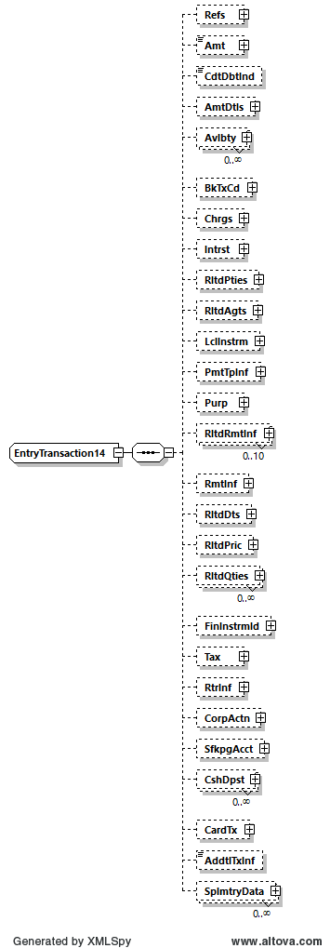

## Purpose of the change:

The camt.052, camt.053 and camt.054 aim to provide information for cash management and/or reconciliation. They can include details of underlying transactions that have been included in the entry.

Similarly, the camt.006 ReturnTransaction provides details of underlying transactions with the transaction administrator. But in addition to elements such as transaction references and agents/parties present in the camt.052/053 and 054, the camt.006 also enables the inclusion of the underlying transaction in element <InstructionCopy> and some of those transactions may not have been initiated by an ISO 20022 XML messages, as for instance today in T2:

* system generated transactions (e.g., standing order or automated liquidity transfers),
* User-to-Application entries (via GUI),
* proprietary XML messages where information cannot be fully mapped into camt.052, camt.053 and camt.054 structure,

Further benefits of the element <InstructionCopy> would be provision of

* full business message, i.e. including also the head.001 in addition to document into camt.052, camt.053, camt.054 reporting.
* transaction details of messages originally initiated in other data format, e.g., JSON

In the case of recovery scenario T2 will need <InstrCpy> in camt.054 to rebuild information on settled/executed instructions which cannot be retrieved from NSP. In particular a full copy of U2A and TARGET Services internal A2A messages is needed.

## Urgency of the request:

Next maintenance cycle*.*

## Business examples:

<InstrCpy>

<CDATA[ <AppHdr xmlns="urn:iso:std:iso:20022:tech:xsd:head.001.001.01" xmlns:n1="http://www.w3.org/2000/09/xmldsig#" xmlns:xsi="http://www.w3.org/2001/XMLSchema-instance" xsi:schemaLocation="urn:iso:std:iso:20022:tech:xsd:head.001.001.01 CLM_head_001_001_01_20200504.xsd"><Fr><FIId><FinInstnId><BICFI>PBABVED0XXX</BICFI><ClrSysMmbId><ClrSysId><Prtry>CLM</Prtry></ClrSysId><MmbId>SUR1-pbabved0xxx</MmbId></ClrSysMmbId></FinInstnId></FIId></Fr><To><FIId><FinInstnId><BICFI>TRGTXETTCLM</BICFI></FinInstnId></FIId></To><BizMsgIdr>B111712080576001</BizMsgIdr><MsgDefIdr>camt.050.001.05</MsgDefIdr><CreDt>2023-11-17T12:08:15Z</CreDt></AppHdr><Document xmlns="urn:iso:std:iso:20022:tech:xsd:camt.050.001.05" xmlns:xsi="http://www.w3.org/2001/XMLSchema-instance" xsi:schemaLocation="urn:iso:std:iso:20022:tech:xsd:camt.050.001.05 CLM_camt_050_001_05_20210624.xsd"><LqdtyCdtTrf><MsgHdr><MsgId>NONREF</MsgId></MsgHdr><LqdtyCdtTrf><LqdtyTrfId><InstrId>E111712080576001</InstrId><EndToEndId>E111712080576001</EndToEndId></LqdtyTrfId><CdtrAcct><Id><Othr><Id>AcctID</Id></Othr></Id></CdtrAcct><TrfdAmt><AmtWthCcy Ccy="EUR">01.00</AmtWthCcy></TrfdAmt><DbtrAcct><Id><Othr><Id>AcctID</Id></Othr></Id></DbtrAcct><SttlmDt>2023-11-17</SttlmDt></LqdtyCdtTrf></LqdtyCdtTrf></Document> ]]>

</InstrCpy>

## SEG/TSG recommendation:

*This section is not to be taken care of by the submitter of the change request. It will be completed in due time by the SEG(s) in charge of the related ISO 20022 messages or the TSG for changes related to the BAH.*

|  |  |  |  |
| --- | --- | --- | --- |
| **Consider** | | X | **Timing** |
|  | | - **Next yearly cycle: 2024/2025**  (the change will be considered for implementation in the yearly maintenance cycle which starts in 2024 and completes with the publication of new message versions in the spring of 2025) | | X |
|  | | - **At the occasion of the next maintenance of the messages**  (the change will be considered for implementation, but does not justify maintenance of the messages in its own right – will be pending until more critical change requests are received for the messages) | |  |
|  | | - **Urgent unscheduled**  (the change justifies an urgent implementation outside of the normal yearly cycle) | |  |  |
|  | | - **Other timing:** | | |  |

Comments:

|  |  |
| --- | --- |
| **Reject** |  |

Reason for rejection:

## Impact analysis and type of impact:

The following Message Identifiers will be impacted –

|  |  |
| --- | --- |
| **camt.052.001.12** | BankToCustomerAccountReportV12 |
| **camt.053.001.12** | BankToCustomerStatementV12 |
| **camt.054.001.12** | BankToCustomerDebitCreditNotificationV12 |

## Proposed implementation:

For discussion -

Swift has added a usage rule stating the element can only be used when the entry is not caused by an ISO message. However, the submitter includes an example where a copy of an ISO message is included. Is the usage rule agreeable with the PAYSEG?

## Proposed timing:

The submitting organisation confirms that it can implement the requested changes in the requested timing.

|  |  |
| --- | --- |
| Timing | 2024/2025 |

## Final decision of the SEG(s):

|  |  |
| --- | --- |
| Approve |  |

|  |  |
| --- | --- |
| Reject |  |

Reason for rejection:

# Change request CR1365: Swift - Obsolete - Exceptions & investigations

## Origin of the request:

*A.1 Submitter*: Swift

*A.2 Contact person:* Dean Chard [dean.chard@swift.com](mailto:dean.chard@swift.com)

*A.3 Sponsors*: /

## Related messages:

**Exceptions and Investigations:**

|  |  |
| --- | --- |
| **camt.029.001.13** | ResolutionOfInvestigationV13 |
| **camt.055.001.12** | CustomerPaymentCancellationRequestV12 |
| **camt.056.001.11** | FIToFIPaymentCancellationRequestV11 |

## Description of the change request:

The PAYSEG agreed that the existing exception and investigation messages would be maintained for a final time across the 2023/2024 cycle, in 2024/2025 they could become obsolete.

A few other registered message definitions and documents make mention to the exception and investigation messages that will become obsolete.

These references should be removed and/or updated.

The Registration Authority should carry out a full review to ascertain where these messages are mentioned, immediately apparent changes are as follows –

* Charges Management – MDR Part 1 Related Messages – remove mention of obsolete messages
* Exceptions and Investigations MDR Part 1 – camt.055, camt.056 and camt.029 should be the only remaining messages or they should be moved to the Exceptions and Investigations Modernization MDR Part 1
* The four highlighted camt.029 data blocks used to support the obsolete messages can be removed

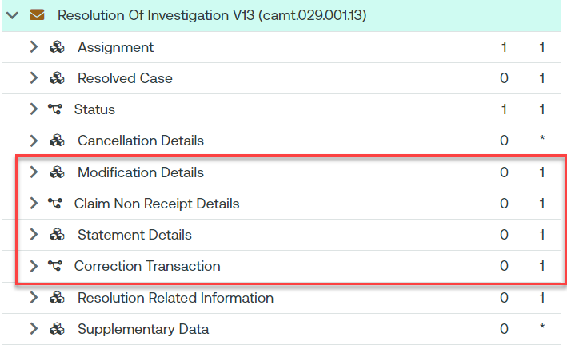

* The camt.029 Scope should be updated to remove mention of obsolete messages

Scope  
The ResolutionOfInvestigation message is sent by a case assignee to a case creator/case assigner.  
This message is used to inform of the resolution of a case, and optionally provides details about.  
- the corrective action undertaken by the case assignee;  
- information on the return where applicable.  
Usage  
The ResolutionOfInvestigation message is used by the case assignee to inform a case creator or case assigner about the resolution of a:  
- request to cancel payment case;  
~~- request to modify payment case;  
- unable to apply case;  
- claim non receipt case.~~  
The ResolutionOfInvestigation message covers one and only one case at a time. If the case assignee needs to communicate about several cases, then several Resolution Of Investigation messages must be sent.  
The ResolutionOfInvestigation message provides:  
- the final outcome of the case, whether positive or negative;  
- optionally, the details of the corrective action undertaken by the case assignee and the information of the return.  
~~Whenever a payment instruction has been generated to solve the case under investigation following a claim non receipt or an unable to apply, the optional CorrectionTransaction component present in the message must be completed.~~  
Whenever the action ~~of modifying or~~ cancelling a payment results in funds being returned or reversed, an investigating agent may provide the details in the resolution related investigation component, to identify the return or reversal transaction. These details will facilitate the account reconciliations at the initiating bank and the intermediaries. It must be stressed that the return or reversal of funds is outside the scope of this Exceptions and Investigation service. The features given here is only meant to transmit the information of return or reversal when it is available through the resolution of the case.  
The ResolutionOfInvestigation message must:  
- be forwarded by all subsequent case assignee(s) until it reaches the case creator;  
~~- not be used in place of a RejectCaseAssignment or CaseStatusReport or NotificationOfCaseAssignment message.~~  
~~Take note of an exceptional rule that allows the use of ResolutionOfInvestigation in lieu of a CaseStatusReport. CaseStatusReport is a response-message to a CaseStatusReportRequest. The latter which is sent when the assigner has reached its own time-out threshold to receive a response. However it may happen that when the request arrives, the investigating agent has just obtained a resolution. In such a situation, it would be redundant to send a CaseStatusReport when then followed immediately by a ResolutionOfInvestigation. It is therefore quite acceptable for the investigating agent, the assignee, to skip the Case Status Report and send the ResolutionOfInvestigation message directly.~~  
The ResolutionOfInvestigation message should be the sole message to respond to a cancellation request. Details of the underlying transactions and the related statuses for which the cancellation request has been issued may be provided in the CancellationDetails component.

* The camt.055 Scope should be updated to remove mention of obsolete messages

Scope  
The CustomerPaymentCancellationRequest message is sent by a case creator/case assigner to a case assignee.  
The CustomerPaymentCancellationRequest message is issued by the initiating party to request the cancellation of an initiation payment message previously sent (such as CustomerCreditTransferInitiation, CreditorPaymentActivationRequest or CustomerDirectDebitInitiation).  
Usage  
The CustomerPaymentCancellationRequest message must be answered with a:  
- ResolutionOfInvestigation message with a positive final outcome when the case assignee can perform the requested cancellation;  
- ResolutionOfInvestigation message with a negative final outcome when the case assignee may perform the requested cancellation but fails to do so (too late, irrevocable instruction);  
~~- RejectInvestigation message when the case assignee is unable or not authorised to perform the requested cancellation;  
- NotificationOfCaseAssignment message to indicate whether the case assignee will take on the case himself or reassign the case to a subsequent party in the payment processing chain.~~  
A CustomerPaymentCancellationRequest message concerns one and only one original payment instruction at a time.  
When a case assignee successfully performs a cancellation, it must return the corresponding funds to the case assigner. It may provide some details about the return in the ResolutionOfInvestigation message.  
The processing of a CustomerPaymentCancellationRequest message case may lead to a ***InvestigationRequest*** message sent to the creditor by its account servicing institution.  
~~The CustomerPaymentCancellationRequest message may be used to escalate a case after an unsuccessful request to modify the payment. In this scenario, the case identification remains the same as in the original CustomerPaymentCancellationRequest message and the element ReopenCaseIndication is set to 'Yes' or 'true'.~~The CustomerPaymentCancellationRequest message has the following main characteristics: the case creator assigns a unique case identification and the reason code for the cancellation request. This information will be passed unchanged to all subsequent case assignee(s).  
For the CustomerPaymentCancellationRequest message the case has been made optional, as the message might be used outside of a case management environment where the case identification is not relevant.  
Moreover, the case identification may be present at different levels:  
- One unique case is defined per cancellation request message: If multiple underlying groups, payment information blocks or transactions are present in the message and the case assignee has already forwarded the transaction for which the cancellation is requested, the case cannot be forwarded to the next party in the chain (see rule on uniqueness of the case) and the case creator will have to issue individual cancellation requests for each underlying individual transaction. In response to this cancellation request, the case must also be present at the message level in the Resolution of Investigation message;  
- One case per original group, payment information or transaction present in the cancellation request: For each group, payment information block or transaction within the payment information, a unique case has been assigned. This means, when a payment instruction has already been forwarded by the case assignee, the cancellation request may be forwarded to next party in the payment chain, with the unique case assigned to the transaction. When the group can only be cancelled partially, new cancellation requests need however to be issued for the individual transactions within the group for which the cancellation request has not been successful. In response to this cancellation request, the case must be present in the cancellation details identifying the original group or transaction in the Resolution of Investigation message;  
- No case used in cancellation request message: The cancellation of a payment instruction can be initiated by either the debtor/creditor or any subsequent agent in the payment instruction processing chain.

* The camt.056 Scope should be updated to remove mention of obsolete messages

Scope  
The FIToFIPaymentCancellationRequest message is sent by a case creator/case assigner to a case assignee.  
This message is used to request the cancellation of an original payment instruction. The FIToFIPaymentCancellationRequest message is exchanged between the instructing agent and the instructed agent to request the cancellation of a interbank payment message previously sent (such as FIToFICustomerCreditTransfer, FIToFICustomerDirectDebit or FinancialInstitutionCreditTransfer).  
  
The FIToFIPaymentCancellationRequest message supports both the request for cancellation (the instructed agent - or assignee - has not yet processed and forwarded the payment instruction) as well as the request for refund (payment has been fully processed already by the instructed agent - or assignee).  
  
Usage  
The FIToFIPaymentCancellationRequest message must be answered with a:  
- ResolutionOfInvestigation message with a positive final outcome when the case assignee can perform the requested cancellation;  
- ResolutionOfInvestigation message with a negative final outcome when the case assignee may perform the requested cancellation but fails to do so (too late, irrevocable instruction);  
~~- RejectInvestigation message when the case assignee is unable or not authorised to perform the requested cancellation;~~  
~~- NotificationOfCaseAssignment message to indicate whether the case assignee will take on the case himself or reassign the case to a subsequent party in the payment processing chain.~~  
A FIToFIPaymentCancellationRequest message concerns one and only one original payment instruction at a time.  
When a case assignee successfully performs a cancellation, it must return the corresponding funds to the case assigner. It may provide some details about the return in the ResolutionOfInvestigation message.  
The processing of a FIToFIPaymentCancellationRequest message case may lead to a ***InvestigationRequest*** message sent to the creditor by its account servicing institution.  
~~The FIToFIPaymentCancellationRequest message may be used to escalate a case after an unsuccessful request to modify the payment. In this scenario, the case identification remains the same as in the original FIToFIPaymentCancellationRequest message and the element ReopenCaseIndication is set to 'Yes' or 'true'.~~  
The FIToFIPaymentCancellationRequest message has the following main characteristics: the case creator assigns a unique case identification and the reason code for the cancellation request. This information will be passed unchanged to all subsequent case assignee(s).  
For the FIToFIPaymentCancellationRequest message the case has been made optional, as the message might be used outside of a case management environment where the case identification is not relevant.  
Moreover, the case identification may be present at different levels:  
- One unique case is defined per cancellation request message: If multiple underlying groups or transactions are present in the message and the case assignee has already forwarded the transaction for which the cancellation is requested, the case cannot be forwarded to the next party in the chain (see rule on uniqueness of the case) and the case creator will have to issue individual cancellation requests for each underlying individual transaction. In response to this cancellation request, the case must also be present at the message level in the Resolution of Investigation message;  
- One case per original group or transaction present in the cancellation request: For each group or transaction, a unique case has been assigned. This means, when a payment instruction has already been forwarded by the case assignee, the cancellation request may be forwarded to next party in the payment chain, with the unique case assigned to the transaction. When the group can only be cancelled partially, new cancellation requests need however to be issued for the individual transactions within the group for which the cancellation request has not been successful. In response to this cancellation request, the case must be present in the cancellation details identifying the original group or transaction in the Resolution of Investigation message;  
- No case used in cancellation request message.  
Cancellation of a cover payment:  
The cancellation of a payment instruction for which cover is provided by a separate instruction always results in the cancellation of the whole transaction, including the cover. The case assignee performing the cancellation must initiate the return of funds to the case creator. The case assigner must not request the cancellation of the cover separately.  
Cancellation request initiators:  
The cancellation of a payment instruction can be initiated by either the debtor/creditor or any subsequent agent in the payment instruction processing chain.

## Purpose of the change:

This will make the documentation and registered message definitions clearer, it will avoid the confusion of obsolete message definitions being mentioned.

## Urgency of the request:

2024/2025 maintenance cycle

## Business examples:

n/a

## SEG/TSG Recommendation:

*This section is not to be taken care of by the submitter of the change request. It will be completed in due time by the SEG(s) in charge of the related ISO 20022 messages or the TSG for changes related to the BAH.*

|  |  |  |  |
| --- | --- | --- | --- |
| **Consider** | | X | **Timing** |
|  | | - **Next yearly cycle: 2024/2025**  (the change will be considered for implementation in the yearly maintenance cycle which starts in 2024 and completes with the publication of new message versions in the spring of 2025) | |  |
|  | | - **At the occasion of the next maintenance of the messages**  (the change will be considered for implementation, but does not justify maintenance of the messages in its own right – will be pending until more critical change requests are received for the messages) | | X |
|  | | - **Urgent unscheduled**  (the change justifies an urgent implementation outside of the normal yearly cycle) | |  |  |
|  | | - **Other timing:** | | |  |

Comments:

As these messages will not be maintained as part of this cycle this change request will not be implemented at this stage.

|  |  |
| --- | --- |
| **Reject** |  |

Reason for rejection:

## Impact analysis and type of impact:

n/a

## Proposed implementation:

n/a

## Proposed timing:

The submitting organisation confirms that it can implement the requested changes in the requested timing.

|  |  |
| --- | --- |
| Timing | TBD with PaySEG |

## Final decision of the SEG(s):

|  |  |
| --- | --- |
| Approve |  |

|  |  |
| --- | --- |
| Reject |  |

Reason for rejection:

# Change request CR1377: Swiss CBPR+ Mirror Group - Settlement Block

## Origin of the request:

*A.1 Submitter*: Swiss CBPR+ Mirror Group

*A.2 Contact person:* Martin Winkelmann, martin.winkelmann@zkb.ch

*A.3 Sponsors*: Change request is supported by Swiss CBPR+ Community (represented by Swiss CBPR+ Mirror Group).

## Related messages:

camt.106.001.02

## Description of the change request:

CR is proposing a Settlement Block after the element "Charges Requestor" within the Group Header of the camt.106 message:

Settlement Block should include following information:

* Settlement Agent
* Settlement Account
* Settlement Date Request

**<SttlmInf>**

**<SttlmAgt>**

<FinInstnId>

<BICFI></BICFI>

<ClrSysMmbId>

<ClrSysId>

<Cd></Cd>

</ClrSysId>

<MmbId></MmbId>

</ClrSysMmbId>

<LEI></LEI>

<Nm></Nm>

<PstlAdr>

…

</PstlAdr>

</FinInstnId>

**</SttlmAgt>**

**<SttlmAcct>**

<Id>

<IBAN></IBAN>

<Othr>

<Id></Id>

<SchmeNm>

<Cd></Cd>

<Prtry></Prtry>

</SchmeNm>

<Issr></Issr>

</Othr>

<Tp>

<Cd></Cd>

<Prtry></Prtry>

</Tp>

<Ccy></Ccy>

<Nm></Nm>

<Prxy>

<Tp>

<Cd></Cd>

<Prtry></Prtry>

</Tp>

<Id></Id>

**</SttlmAcct>**

**<SttlmDtReq>**

<Dt></Dt>

**</SttlmDtReq>**

**</SttlmInf>**

## Purpose of the change:

The message definition as currently published (camt.106.001.02) is not suitable enough to process charge requests in an automated manner.

In the published version there is no possibility to mention the Bank and the Account to which the charges must be transferred. Without any instruction details (Bank, Account) an automated process is not possible.

As camt.106 is a request for charges message and could be seen like a bill which must be settled, a settlement date is also missing.

The community of beneficiaries of this CR are all agents requesting charges for payment transactions. It would allow the community to automate the charge process which is today a highly manual processing. Expected saving per agent are 1–3-man days/month.

## Urgency of the request:

1. Default CR process is suitable.

## Business examples:

A proper Settlement Block within the camt.106 message would allow agents to automate the charge payment process. After verifying the reported charge request against the referred underlying transaction, the payment of the charges via pacs.009 could be automated initiated if all the relevant settlement information's (Account Servicer, Account) are available in the camt.106 message.

A (Bank) Settlement Date in camt.106 would allow to fully automate the monitoring of the settlement of a camt.106 request. The "Charge Requestor" would book the charges during processing of the transaction with a value date (credit an income account, debit a suspense account). This value date is the (Bank) Settlement Date in the camt.106, the Account would be the Suspense Account and the FI is equally "Charge Requestor". As long, as the value date is not reached the suspense account will not generate a camt.053 (as camt.053 reports only entries with BOOK status). At value date, if the charges are settled, the suspense account is balanced an no camt.053 is produced. If the charges are not settled a camt.053 is generated and will generate a Recon-Break in the Recon-Tool.

This CR is a double win as it allows a full automated processing for the charge requestor and for the payer of the charges.

## SEG/TSG Recommendation:

*This section is not to be taken care of by the submitter of the change request. It will be completed in due time by the SEG(s) in charge of the related ISO 20022 messages or the TSG for changes related to the BAH.*

|  |  |  |  |
| --- | --- | --- | --- |
| **Consider** | | X | **Timing** |
|  | | - **Next yearly cycle: 2024/2025**  (the change will be considered for implementation in the yearly maintenance cycle which starts in 2024 and completes with the publication of new message versions in the spring of 2025) | | X |
|  | | - **At the occasion of the next maintenance of the messages**  (the change will be considered for implementation, but does not justify maintenance of the messages in its own right – will be pending until more critical change requests are received for the messages) | |  |
|  | | - **Urgent unscheduled**  (the change justifies an urgent implementation outside of the normal yearly cycle) | |  |  |
|  | | - **Other timing:** | | |  |

Comments:

|  |  |
| --- | --- |
| **Reject** |  |

Reason for rejection:

## Impact analysis and type of impact:

The following Message Identifiers will be impacted –

|  |  |
| --- | --- |
| **camt.106.001.02** | ChargesPaymentRequestV02 |

## Proposed implementation:

For discussion -

1. Swift note that ChargesRequestor appears several times throughout the message, within the GroupHeader and at Single, Per Transaction and Per Type levels. If the settlement information is only included at the Group Header level this implies the Charges Requestor at all levels must be the same value which may reduce the message’s flexibility. As such the new block has been added at all levels, does the PAYSEG support this?
2. Swift note, that as one of the first implementors of the camt.106 V2 the lack of a settlement block has generated some confusion in the industry. To address this in the simplest way we propose that the new Settlement block is a mirror of the subsequent pacs.009 payment of charges, allowing implementors to simply copy/paste the data, does the PAYSEG support this?

## Proposed timing:

The submitting organisation confirms that it can implement the requested changes in the requested timing.

|  |  |
| --- | --- |
| Timing | 2024/2025 |

## Final decision of the SEG(s):

|  |  |
| --- | --- |
| Approve |  |

|  |  |
| --- | --- |
| Reject |  |

Reason for rejection:

# Change request CR1378: Swiss CBPR+ Mirror Group - Renaming Record elements

## Origin of the request:

*A.1 Submitter*: Swiss CBPR+ Mirror Group

*A.2 Contact person:* Martin Winkelmann, martin.winkelmann@zkb.ch

*A.3 Sponsors*: Change request is supported by Swiss CBPR+ Community (represented by Swiss CBPR+ Mirror Group)

## Related messages:

camt.105.001.02 and camt.106.001.02

## Description of the change request:

CR is proposing a renaming of the following elements within the "Record" level:

* Debtor Agent --> Charge Bearer
* Debtor Agent Account --> Charge Bearer Account

## Purpose of the change:

As camt.105/106 are used in relation to pacs.008 and pacs.009 payment transactions the element currently named "Debtor Agent" (on Record level) is not fully compatible for a charge related to a pacs.009 as in this case the Debtor of the underlying transaction is in charge to pay the charges.

## Urgency of the request:

Default CR process is suitable.

## Business examples:

If a service charge for investigation is due to a pacs.009 the charge is requested from the Debtor of the underlying pacs.009 not from the Debtor Agent. To be fully transparent and self-explaining this name change would be an advantage.

The new naming would be in line with the already existing "Charge Requestor" (receiver of charges), whereas the "Charge Bearer" would be the payer of the charges.

## SEG/TSG recommendation:

*This section is not to be taken care of by the submitter of the change request. It will be completed in due time by the SEG(s) in charge of the related ISO 20022 messages or the TSG for changes related to the BAH.*

|  |  |  |  |
| --- | --- | --- | --- |
| **Consider** | | X | **Timing** |
|  | | - **Next yearly cycle: 2024/2025**  (the change will be considered for implementation in the yearly maintenance cycle which starts in 2024 and completes with the publication of new message versions in the spring of 2025) | | X |
|  | | - **At the occasion of the next maintenance of the messages**  (the change will be considered for implementation, but does not justify maintenance of the messages in its own right – will be pending until more critical change requests are received for the messages) | |  |
|  | | - **Urgent unscheduled**  (the change justifies an urgent implementation outside of the normal yearly cycle) | |  |  |
|  | | - **Other timing:** | | |  |

Comments:

|  |  |
| --- | --- |
| **Reject** |  |

Reason for rejection:

|  |  |
| --- | --- |
| **Reject** |  |

Reason for rejection:

## Impact analysis and type of impact:

The following Message Identifiers will be impacted –

|  |  |
| --- | --- |
| **camt.105.001.02** | ChargesPaymentNotificationV02 |
| **camt.106.001.02** | ChargesPaymentRequestV02 |

## Proposed implementation:

For discussion -

1. Swift notes that Charge Bearer is not in the pacs.009. Renaming this existing element to Charge Bearer may cause confusion, Charge Bearer is a four-digit code on a payment, it is not identification of an agent or party. To maintain interoperability with the previous version we would recommend adding new elements known as Debtor and Debtor Account, these can be copied from original payments and be used by implementors when a charge is being claimed on a pacs.008, pacs.009 or another message. It should address the submitter’s point that when a charge is claimed on a pacs.009 it can be the Debtor (who is an agent) who initiates payment of charges.

## Proposed timing:

The submitting organisation confirms that it can implement the requested changes in the requested timing.

|  |  |
| --- | --- |
| Timing | 2024/2025 |

## Final decision of the SEG(s):

|  |  |
| --- | --- |
| Approve |  |

|  |  |
| --- | --- |
| Reject |  |

Reason for rejection:

# Change request CR1392: Swift - Account elements optional in Confirmation Block

## Origin of the request:

*A.1 Submitter*: Swift

*A.2 Contact person:* Dominique Forceville/Pieter Herrebout

*A.3 Sponsors*: Case Management initiative and pilot group

## Related messages:

Camt.111 – investigation response V1

## Description of the change request:

The account is mandatory in the confirmation component under response data and investigation data.

The change requested is to make the account optional.

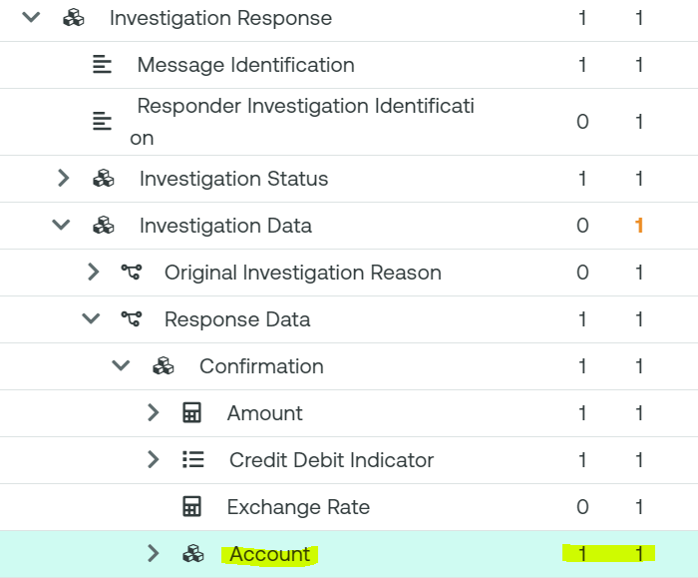

## Purpose of the change:

Today, the account element in the camt.111 investigation response message is mandatory in the investigation data>response data>confirmation block.

When a creditor agent (as account servicer) uses the camt.111 to close a creditor claim non receipt investigation by confirming the credit, it must populate the account that was used for the credit.

However, in creditor claim non receipt use cases that rely on central orchestration performed by Case Manager (Swift’s central utility for E&I), account information may not be available in the central tracking database that Case Manager uses to perform such operations.

This use case is described below and goes as follows:

1. Pacs.008 from debtor agent to intermediary agent 1
2. Pacs.008 from intermediary agent 1 to the creditor agent
3. The creditor agent confirms credit to the tracking system (ACCC status registered). This update to the tracker does not include account information.
4. The creditor contacts the debtor who contacts the debtor agent (not shown) as the funds are still missing and the debtor agent initiates a creditor claim non receipt operation by sending the camt.110 investigation request message to Case Manager.

4a. Since Case Manager relies on the tracking information where ACCC status was registered, Case Manager auto-closes the investigation by sending the camt.111 with CLSD status to the debtor agent.

Today, Case Manager populates the account element with the code word ‘NOTAVAILABLE’. The request is to make the account element optional so that it must not be used for auto-closure cases as described.

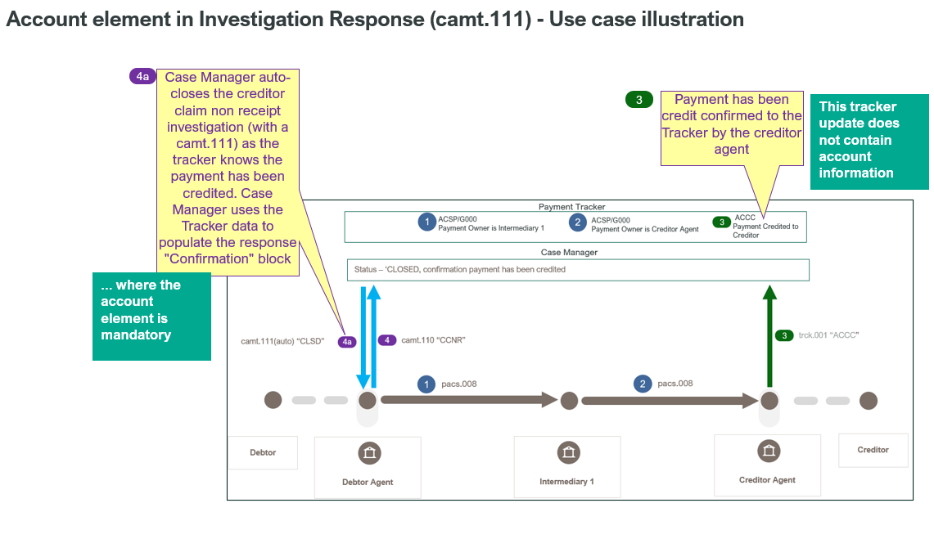

## Urgency of the request:

2024/2025 maintenance cycle

## Business examples:

See section ‘purpose of the change’

**Important note**: It needs to be ensured that the new version of the camt.111 (and camt.110) are not aligned with the new postal address/remittance information as we want to stay aligned with the current version of CBPR+/HVPS+ (the updated remittance is not backward compatible).

## SEG/TSG recommendation:

*This section is not to be taken care of by the submitter of the change request. It will be completed in due time by the SEG(s) in charge of the related ISO 20022 messages or the TSG for changes related to the BAH.*

|  |  |  |  |
| --- | --- | --- | --- |
| **Consider** | | X | **Timing** |
|  | | - **Next yearly cycle: 2024/2025**  (the change will be considered for implementation in the yearly maintenance cycle which starts in 2024 and completes with the publication of new message versions in the spring of 2025) | | X |
|  | | - **At the occasion of the next maintenance of the messages**  (the change will be considered for implementation, but does not justify maintenance of the messages in its own right – will be pending until more critical change requests are received for the messages) | |  |
|  | | - **Urgent unscheduled**  (the change justifies an urgent implementation outside of the normal yearly cycle) | |  |  |
|  | | - **Other timing:** | | |  |

Comments:

|  |  |
| --- | --- |
| **Reject** |  |

Reason for rejection:

## Impact analysis and type of impact:

The following Message Identifiers will be impacted –

|  |  |
| --- | --- |
| **camt.111.001.01** | InvestigationResponseV01 |

## Proposed implementation:

For discussion -

1. Swift notes that the modernised exception and investigation messages do not incorporate the ISO 2024 maintenance cycle changes such as the new PostalAddress and StructuredRemittanceInformation components. As owners of these messages Swift’s preference at this stage is for the messages to be aligned with Swift’s current CBPR+ implementation, as this uses previous message versions this does not contain the ISO 2024 maintenance cycle changes either. In addition to this the camt.111 is used as a response to a camt.110 therefore having one message contain the ISO 2024 maintenance cycle changes whilst the other does not would make little sense Does the PAYSEG support this?

## Proposed timing:

The submitting organisation confirms that it can implement the requested changes in the requested timing.

|  |  |
| --- | --- |
| Timing | 2024/2025 |

## Final decision of the SEG(s):

|  |  |
| --- | --- |
| Approve |  |

|  |  |
| --- | --- |
| Reject |  |

Reason for rejection:

# Change request CR1406: SMPG Payments Task Force - Change CA Event Type - camt.052-054

## Origin of the request:

*A.1 Submitter:* SMPG payment task force represented by Charles Boniver – Swift Standards, Karine Taquet – Swift Standards, Dean Shard – Swift Standards.

*A.2 Contact person:*

- Karine Taquet – Swift Standards - karine.taquet@swift.com (+32 2 655 3784)

- Dean Chard – Swift Standards - dean.chard@swift.com (+44 20 7762 2334)

*A.3 Sponsors:*

SMPG payment task force

## Related messages:

camt.052.001.12, camt.053.001.12 and camt.054.001.12

## Description of the change request:

Need to change the element used in the camt.052, camt.053 and camt.054 for the identification of the corporate action event type.

Currently, it is a Max35Text, and it should be the same element used in the seev messages: CorporateActionEventType84Choice.

In the camt.053:

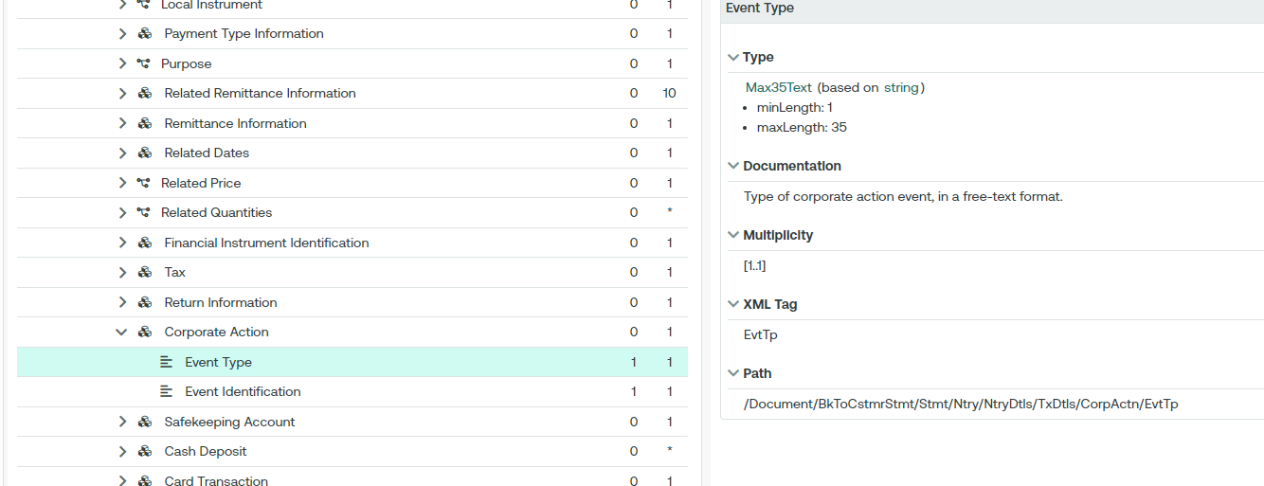

In the seev.031:

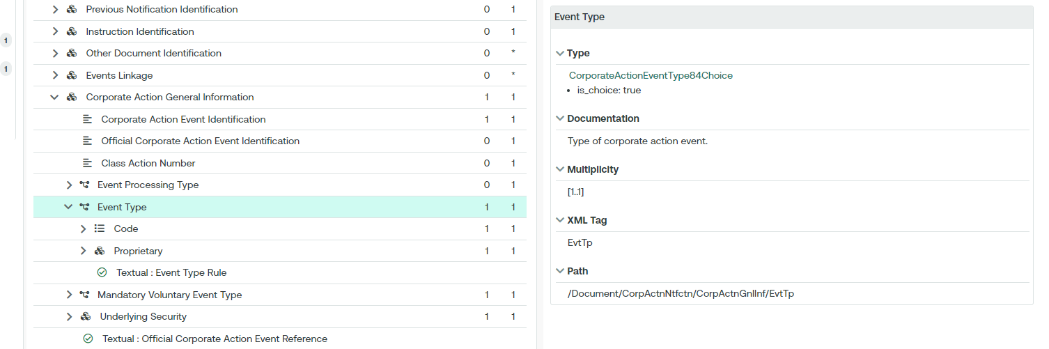

Also the event identification element (EvtId) in the camt.052, camt.053 & camt.054 should be replaced by two elements from the seev.031 message:

* Corporate Action Event Identification (CorpActnEvtId)
* Official Corporate Action Event Identification (OffclCorpActnEvtId)

In the camt.053:

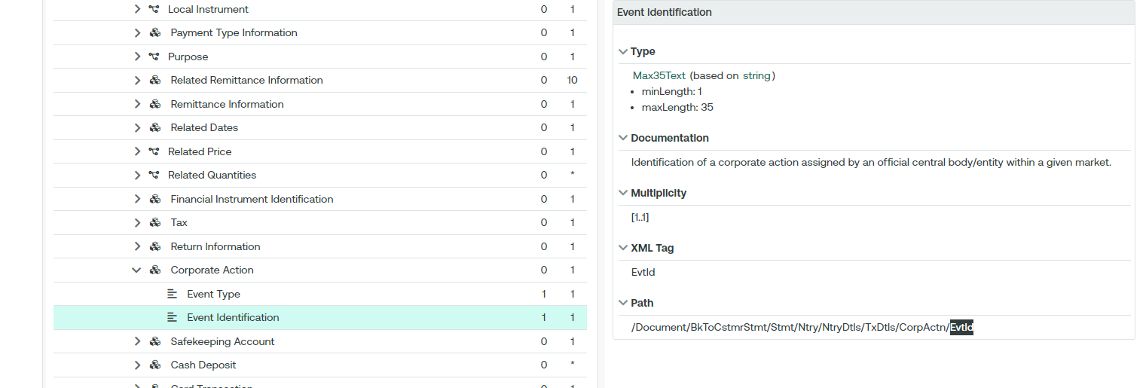

In the seev.031:

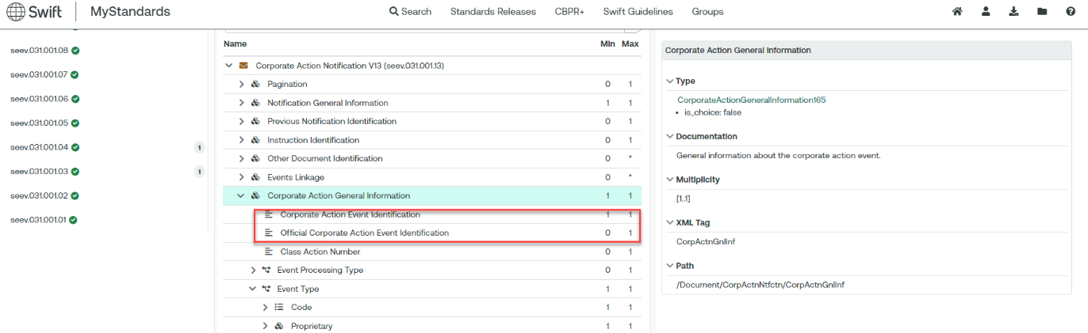

## Purpose of the change:

To align and use the latest message elements as in the corporate action messages.

## Urgency of the request:

Cycle 2024-2025

## Business examples:

N/A.

## SEG/TSG recommendation:

*This section is not to be taken care of by the submitter of the change request. It will be completed in due time by the SEG(s) in charge of the related ISO 20022 messages or the TSG for changes related to the BAH.*

|  |  |  |  |
| --- | --- | --- | --- |
| **Consider** | | X | **Timing** |
|  | | - **Next yearly cycle: 2024/2025**  (the change will be considered for implementation in the yearly maintenance cycle which starts in 2024 and completes with the publication of new message versions in the spring of 2025) | | X |
|  | | - **At the occasion of the next maintenance of the messages**  (the change will be considered for implementation, but does not justify maintenance of the messages in its own right – will be pending until more critical change requests are received for the messages) | |  |
|  | | - **Urgent unscheduled**  (the change justifies an urgent implementation outside of the normal yearly cycle) | |  |  |
|  | | - **Other timing:** | | |  |

Comments:

|  |  |
| --- | --- |
| **Reject** |  |

Reason for rejection:

## Impact analysis and type of impact:

The following Message Identifiers will be impacted –

|  |  |
| --- | --- |
| **camt.052.001.12** | BankToCustomerAccountReportV12 |
| **camt.053.001.12** | BankToCustomerStatementV12 |
| **camt.054.001.12** | BankToCustomerDebitCreditNotificationV12 |

## Proposed implementation:

For discussion -

Swift has externalised the previously embedded event type codes. All 67 embedded codes and their definitions have migrated to the new ExternalCorporateActionEventType1Code set. The proprietary option remains as modelled on the Securities messages to maintain interoperability.

## Proposed timing:

The submitting organisation confirms that it can implement the requested changes in the requested timing.

|  |  |
| --- | --- |
| Timing | 2024/2025 |

## Final decision of the SEG(s):

|  |  |
| --- | --- |
| Approve |  |

|  |  |
| --- | --- |
| Reject |  |

Reason for rejection:

# Change request CR1404: T2S- Eurosystem - Integration of supl.021 in camt and semt T2S messages

## Origin of the request:

*A.1 Submitter*: Deutsche Bundesbank on behalf of the Eurosystem / 4CB

*A.2 Contact person:*

- Stéphanie Radet, +49 69 9566-33528

- Ann-Kristin Gonska, +49 69 9566-14278

- [t2s-fam@bundesbank.de](mailto:t2s-fam@bundesbank.de)

*A.3 Sponsors*: SWIFT (Karine TAQUET)

## Related messages:

Impacted messages:

camt.067.001.02 Intra Balance Movement Status Advice V02

camt.068.001.02 Intra Balance Movement Confirmation V02

semt.014.001.07 Intra Position Movement Status Advice V07

semt.015.001.09 Intra Position Movement Confirmation V09

## Description of the change request:

Currently, the supplementary data element is used for camt.067, camt.068, semt.014 and semt.015 messages to report the reference of the underlying business instruction involved in a Conditional Securities Delivery (CoSD) blocking scenario.

The objective of this change request is to include the reference of the business instruction that triggered a CoSD procedure directly in the impacted messages mentioned above instead of using the supplementary data element of supl.021.

This request proposes to create:

* A new Element “Related Transaction Identification” to report the reference of a transaction that is associated with the one of the message, in case of T2S, to report the reference of the business instruction related to a CoSD blocking scenario. This new element is to be added in camt.067, camt.068, semt.014 and semt.015 messages as follows:
  + Camt.067 and Semt.014: Within the Transaction Identification block:

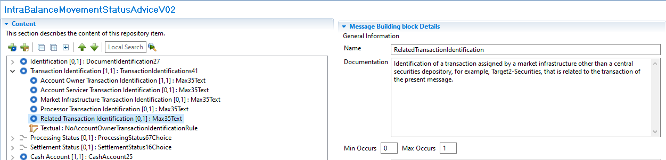

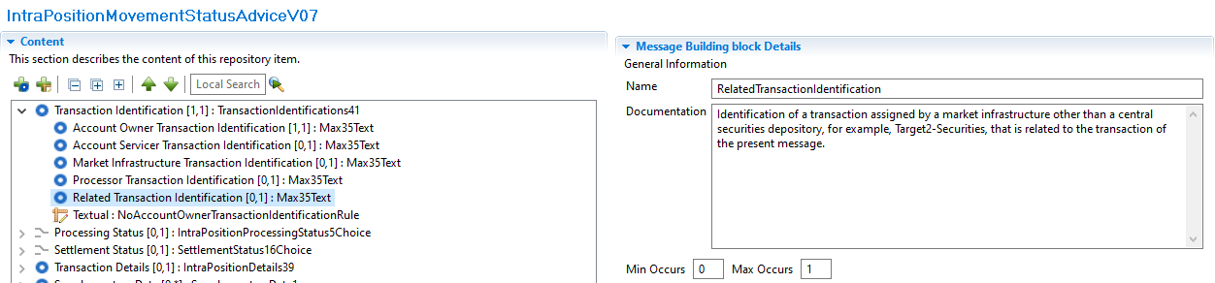

* + Camt.068 and Semt.015: Within the Additional Parameters block:

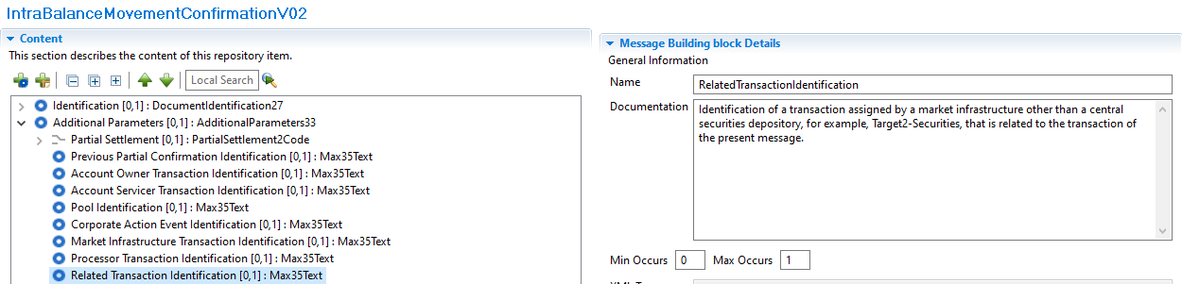

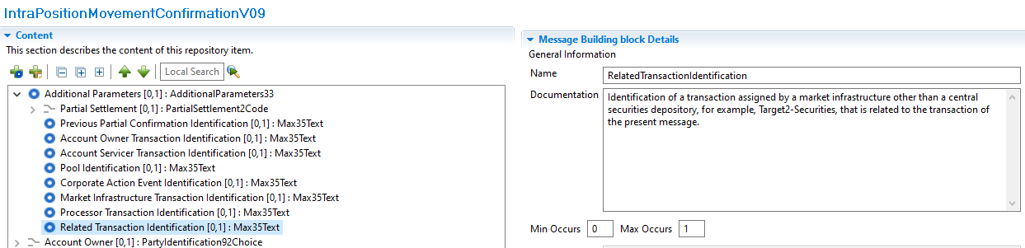

## Purpose of the change:

Currently the reference of the business instruction related to a Conditional Securities Delivery (CoSD) blocking scenario is reported using the supl.021 message as an additional block (Supplementary Data element) inside the messages listed above as of today, the related ISO messages do not have any element available to provide this type of information

The purpose of this change is to adopt a more standardized way to report the reference of the business instruction related to a CoSD blocking scenario in case of intra balance (camt.067 and camt.068) and intra position (semt.014 and semt.015) movement messages, which is currently reported using a technical message component without a dedicated structured element inside the message.

This reference is the simplest way to identify the business Settlement Instructions responsible for the creation of the Settlement Restrictions created when a CoSD scenario is triggered, the detailed flow is explained hereafter:

* The conditional settlement process allows CSDs to settle instructions that require the fulfilment of a settlement condition outside T2S before allowing the securities settlement to take place in the system.
* To do so, T2S automatically detects and performs conditional settlement, based on CoSD rules defined and maintained by each CSD in static data. These rules identify the administering party; which will be the CSD in charge of managing the fulfilment of the external conditions.
* The system puts automatically the Settlement Instruction that meets a CoSD rule, on CoSD hold and blocks the relevant securities and/or cash depending on the CoSD rule.
* To block the securities/cash a settlement restriction on securities/cash is created internally by T2S to move the securities/cash from a Deliverable to a provisional Blocking position.
* Once the Settlement Restrictions are created the related messages are generated; as the restrictions were created in a CoSD scenario the reference of the business instruction that triggered this CoSD rule is reported in the supplementary data element:
  + In case of cash settlement restrictions, camt.067 and camt.068 intra balance movement messages, it will be the Reference of the related business instruction that debits the Dedicated Cash Account where the CoSD blocking occurs.
  + In case of securities settlement restrictions, semt.014 and semt.015 intra position movement messages, it will be the Reference of the related delivering business instruction where the CoSD blocking occurs.
* Once the external settlement conditions are fulfilled, the administering parties of the CoSD rule, trigger the release of the instruction. After the CoSD release is executed the securities/cash are delivered again to a Deliverable position and the business instruction finally settles. To move the securities/cash from the provisional blocking position, another Settlement Restriction is created, consequently, the reference of the business instruction will be reported again in the supplementary data block of the semt.015 or camt.068 messages generated for this end.

If this element is not integrated into the relevant messages, it will continue to be reported in the Supplementary Data block, which is not the most appropriate way to report such information.

## Urgency of the request:

The Securities SEG is requested to consider this change request for the next maintenance cycle.

## Business examples:

Examples illustrating the change request.

## SEG/TSG recommendation:

*This section is not to be taken care of by the submitter of the change request. It will be completed in due time by the SEG(s) in charge of the related ISO 20022 messages or the TSG for changes related to the BAH.*

|  |  |  |  |
| --- | --- | --- | --- |
| **Consider** | | X | **Timing** |
|  | | - **Next yearly cycle: 2024/2025**  (the change will be considered for implementation in the yearly maintenance cycle which starts in 2022 and completes with the publication of new message versions in the spring of 2023) | | X |
|  | | - **At the occasion of the next maintenance of the messages**  (the change will be considered for implementation, but does not justify maintenance of the messages in its own right – will be pending until more critical change requests are received for the messages) | |  |
|  | | - **Urgent unscheduled**  (the change justifies an urgent implementation outside of the normal yearly cycle) | |  |  |
|  | | - **Other timing:** | | |  |

Comments:

|  |  |
| --- | --- |
| **Reject** |  |

Reason for rejection:

## Impact analysis and type of impact:

The following Message Identifiers will be impacted –

|  |  |
| --- | --- |
|  |  |
| **camt.067.001.02** | IntraBalanceMovementStatusAdviceV02 |
| **camt.068.001.02** | IntraBalanceMovementConfirmationV02 |

## Proposed implementation:

Swift notes that the external submitter owning these messages (4CBs) will undertake the implementation and this will be covered as part of a separate MCR document.

## Proposed timing:

The submitting organisation confirms that it can implement the requested changes in the requested timing.

|  |  |
| --- | --- |
| Timing | 2024/2025 |

## Final decision of the SEG(s):

|  |  |
| --- | --- |
| Approve |  |

|  |  |
| --- | --- |
| Reject |  |

Reason for rejection:

# Change request CR1408: SMPG - Change of the UTI implementation and additions

## Origin of the request:

*A.1 Submitter*: SMPG Settlements & Reconciliation Working Group represented by Robin Leary (UK&IE Representative) and Karine Taquet (Swift Standards)

*A.2 Contact person:* Robin Leary (robin.leary@citi.com)

*A.3 Sponsors*: SMPG Settlements & Reconciliation Working Group

## Related messages:

**Securities Management**

semt.017, semt.018, semt.019, semt.022 (T2S UTI not included at all), sese.021, sese.023, sese.024, sese.025, sese.026, sese.028, sese.030, sese.031, sese.032, sese.033, sese.034, sese.035, sese.036, sese.038, sese.022, sese.041, sese.042

**Securities Trade (UTI not included must be)**

setr.027, setr.030, setr.044, setr.029

**Collateral Management**

colr.005, colr.019, colr.020, colr.021, colr.022, colr.23, colr.024

**Reference Data**

reda.074

**Cash Management**

camt.057, camt.111

**Payments Clearing and Settlement**

pacs.009

**Authorities**

auth.016, auth.029, auth.030, auth.052, auth.070, auth.078, auth.079, auth.080, auth.083, auth.084, auth.085, auth.090, auth.091, auth.092, auth.105, auth.106, auth.107, auth.108, auth.109, auth.113

**Foreign Exchange Trade**

fxtr.008, fxtr.015, fxtr.016, fxtr.017, fxtr.014

## Description of the change request:

As part of SR2019 (CR 001448), the UTI was added to numerous MT messages and, as part of co-existence, all equivalent ISO 20022 messages. In ISO 15022, this was done by adding a new 20U format option in qualifier TRRF (Deal Reference) and in ISO 20022, the Trade Identification element was made repetitive, and the length increased from 35 characters to 52 characters.

Whilst the ISO 15022 addition is easily distinguished between a traditional Deal Reference (:20C::TRRF) and UTI (:20U::TRRF), the ISO 20022 element does not easily distinguish between the two and can lead to confusion.

The proposal is to create a new element in ISO 20022 for the UTI in the Trade Details sequence and revert the Trade Identification element to its original form (non-repetitive and 35 characters). The ISO 15022 use will remain as is.

In the ISO 20022 messages where the UTI is not present, I must be added.

Given there's not a huge usage of the UTI in ISO 20022 messages at present, the change should be low impact.

## Purpose of the change:

Create a new "Unique Transaction Identifier" element in the Trade Details sequence (or other relevant sequences) in all impacted ISO 20022 messages (where the change was made in SR2019). The new element should be optional, non-repetitive and up to 52 characters in length.

The "Trade Identification" element should be changed to revert to being non-repetitive and up to 35 characters in length.

From a translation perspective, :20C::TRRF would align to the Trade Identification element and :20U::TRRF would align to the new Unique Transaction Identifier element.

No changes are expected to the ISO 15022 MT messages.

In the ISO 20022 messages where the UTI is missing, it must be added.

## Urgency of the request:

Cycle 2024-2025

## Business examples:

Examples illustrating the change request.

## SEG/TSG recommendation:

*This section is not to be taken care of by the submitter of the change request. It will be completed in due time by the SEG(s) in charge of the related ISO 20022 messages or the TSG for changes related to the BAH.*

|  |  |  |  |
| --- | --- | --- | --- |
| **Consider** | | X | **Timing** |
|  | | - **Next yearly cycle: 2024/2025**  (the change will be considered for implementation in the yearly maintenance cycle which starts in 2024 and completes with the publication of new message versions in the spring of 2025) | | X |
|  | | - **At the occasion of the next maintenance of the messages**  (the change will be considered for implementation, but does not justify maintenance of the messages in its own right – will be pending until more critical change requests are received for the messages) | | X |
|  | | - **Urgent unscheduled**  (the change justifies an urgent implementation outside of the normal yearly cycle) | |  |  |
|  | | - **Other timing:** | | |  |

Comments: UTI will only be added to in-scope messages being maintained as part of other change requests.

|  |  |
| --- | --- |
| **Reject** |  |

Reason for rejection:

## Impact analysis and type of impact:

The following Message Identifiers will be impacted –

|  |  |
| --- | --- |
| **pacs.004.001.13** | PaymentReturnV13 |
| **pacs.008.001.12** | FIToFICustomerCreditTransferV12 |
| **pacs.009.001.11** | FinancialInstitutionCreditTransferV11 |
| **camt.052.001.12** | BankToCustomerAccountReportV12 |
| **camt.053.001.12** | BankToCustomerStatementV12 |
| **camt.054.001.12** | BankToCustomerDebitCreditNotificationV12 |

## Proposed implementation:

For discussion -

1. The PAYSEG has agreed to consider implementing the UTI in the relevant messages available for maintenance as part of this cycle. Swift note that historically, implementing new elements in some messages but not others has caused issues. The approach considered by the PAYSEG would the UTI added to a camt.053 but not a camt.057, added to a pacs.008 but not a pacs.003 etc. Does the PAYSEG support this approach or would deferring the CR to a maintenance cycle where the UTI can be implemented in all relevant messages be preferrable?

Assuming the PAYSEG are happy to implement in some messages this cycle…

1. Swift has made the UTIs repeatable and accompanied by an amount as our understanding is that numerous securities trades may be settled net via one payment. Does the PAYSEG support this?
2. Swift has placed the new block in the Credit Transfer Transaction Information block as we assume the UTI details can be relevant to both agents in the payment chain and end users such as the Debtor and Creditor. Does the PAYSEG support this?
3. At this stage only the only relevant messages in scope for maintenance and therefore eligible to include the UTI are the pacs.008, pacs.009, pacs.004, camt.052, camt.053 and camt.054.



## Proposed timing:

The submitting organisation confirms that it can implement the requested changes in the requested timing.

|  |  |
| --- | --- |
| Timing | 2024/2025 |

## Final decision of the SEG(s):

|  |  |
| --- | --- |
| Approve |  |

|  |  |
| --- | --- |
| Reject |  |

Reason for rejection:

# Change request CR1405: SMPG Payments Task Force - UTI to camt.052-054

## Origin of the request:

*A.1 Submitter*: SMPG payment task force represented by Charles Boniver – Swift Standards, Karine Taquet – Swift Standards, Dean Shard – Swift Standards.

*A.2 Contact person:*

- Karine Taquet – Swift Standards - [karine.taquet@swift.com](mailto:karine.taquet@swift.com) (+32 2 655 3784)

- Dean Chard – Swift Standards - [dean.chard@swift.com](mailto:dean.chard@swift.com) (+44 20 7762 2334)

*A.3 Sponsors:*

SMPG payment task force

## Related messages:

camt.052.001.12, camt.053.001.12 and camt.054.001.12

## Description of the change request:

Need to add the UTI reference in the camt.052, camt.053 and camt.054. It should be added in the entry details / Transaction details / References (/Document/BkToCstmrStmt/Stmt/Ntry/NtryDtls/TxDtls/Refs)

## Purpose of the change:

The UTI (Universal Transaction Identifier) is more and more used within the securities transactions. By having this reference in the camt messages, it will ease the resolution of potential reconciliation breaks.

## Urgency of the request:

Cycle 2024-2025

## Business examples:

N/A.

## SEG/TSG recommendation:

*This section is not to be taken care of by the submitter of the change request. It will be completed in due time by the SEG(s) in charge of the related ISO 20022 messages or the TSG for changes related to the BAH.*

|  |  |  |  |
| --- | --- | --- | --- |
| **Consider** | | X | **Timing** |
|  | | - **Next yearly cycle: 2024/2025**  (the change will be considered for implementation in the yearly maintenance cycle which starts in 2024 and completes with the publication of new message versions in the spring of 2025) | | X |
|  | | - **At the occasion of the next maintenance of the messages**  (the change will be considered for implementation, but does not justify maintenance of the messages in its own right – will be pending until more critical change requests are received for the messages) | | X |
|  | | - **Urgent unscheduled**  (the change justifies an urgent implementation outside of the normal yearly cycle) | |  |  |
|  | | - **Other timing:** | | |  |

Comments: UTI will only be added to in-scope messages being maintained as part of other change requests.

|  |  |
| --- | --- |
| **Reject** |  |

Reason for rejection:

## Impact analysis and type of impact:

The following Message Identifiers will be impacted –

|  |  |
| --- | --- |
| **camt.052.001.12** | BankToCustomerAccountReportV12 |
| **camt.053.001.12** | BankToCustomerStatementV12 |
| **camt.054.001.12** | BankToCustomerDebitCreditNotificationV12 |

## Proposed implementation:

## Proposed timing:

The submitting organisation confirms that it can implement the requested changes in the requested timing.

|  |  |
| --- | --- |
| Timing | 2024/2025 |

## Final decision of the SEG(s):

|  |  |
| --- | --- |
| Approve |  |

|  |  |
| --- | --- |
| Reject |  |

Reason for rejection:

# Change request CR1374: T2S / 4 CBs - Alignment with SR Maintenance CR001783

## Origin of the request:

*A.1 Submitter:*

- Deutsche Bundesbank on behalf of the 4CB[3]

- TARGET2-Securities

*A.2 Contact person:*

- Stephanie Radet, [stephanie.radet@bundesbank.de](mailto:stephanie.radet@bundesbank.de), +49 69 9566-33528

- Ann-Kristin Gonska, [ann-kristin.gonska@bundesbank.de](mailto:ann-kristin.gonska@bundesbank.de), +49 69 9566-14278

- [t2s-fam@bundesbank.de](mailto:t2s-fam@bundesbank.de)

*A.3 Sponsors*:

Swift (alignment with latest version)

## Related messages:

**Intra-Balance messages**

| Message Identifier | MessageDefinition |
| --- | --- |
| camt.066.001.02 | Intra-balance Movement Instruction |
| camt.067.001.02 | Intra-balance Movement Status Advice |
| camt.068.001.02 | Intra-balance Movement Confirmation |
| camt.072.001.02 | Intra-balance Movement Modification Request |
| camt.073.001.02 | Intra-balance Movement Modification Request Status Advice |
| camt.074.001.02 | Intra-balance Movement Cancellation Request |
| camt.075.001.02 | Intra-balance Movement Cancellation Request Status Advice |
| camt.078.001.02 | Intra-balance Movement Query |
| camt.079.001.02 | Intra-balance Movement Query Response |
| camt.081.001.02 | Intra-balance Movement Modification Report |
| camt.083.001.02 | Intra-balance Movement Cancellation Report |
| camt.084.001.02 | Intra-balance Movement Posting Report |
| camt.085.001.02 | Intra-balance Movement Pending Report |

**Securities Reference Data messages**

| Message Identifier | MessageDefinition |
| --- | --- |
| reda.006.001.01 | Security Creation Request |
| reda.007.001.01 | Security Maintenance Request |
| reda.012.001.01 | Security Report |

**Collateral management message**

| Message Identifier | MessageDefinition |
| --- | --- |
| colr.002.001.02 | Collateral Value Report |

## Description of the change request:

Alignment of T2S registered messages with approved Change Requests from the Securities Maintenance Releases (2022 and 2023).

The above Intra-Balance, Securities Reference Data and Collateral Management messages are impacted by **CR -001783** *Add new Format Option for Quantity of Financial Instrument and Balances*, included in [MCR #1261](https://www.iso20022.org/catalogue-message-definitions-change-requests?block_id=iso20022_change_request_catalogue_message_definitions_block&page=1) published on ISO20022.org.

All messages contain Message Component *FinancialInstrumentQuantity1Choice*. The component has been updated to *FinancialInstrumentQuantity33Choice* in SR2022.

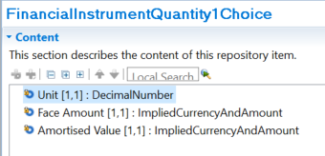

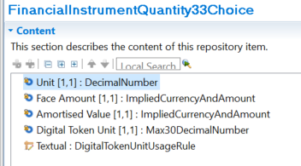

## Purpose of the change:

Alignment of T2S registered messages with approved Change Requests from the Securities and Payments Maintenance Releases of 2022 and 2023.

In recent years, Digital Assets have emerged as a new security type, and members of Securities maintenance groups have expressed the request to enhance existing messages to include those new instruments, rather than creating new ones.

While Securities Reference Data and Collateral Management naturally fall in the Securities domain, it may be surprising to find the Intra-Balance messages in this CR, as they belong to the Cash Management business domain.

Those messages were modelled following the Securities Management Intra-Position (“semt”) messages and do contain Message Components impacted by the maintenance of Settlement and Reconciliation messages, therefore we do request their update as well.

## Urgency of the request:

Approval of the change request for ISO 20022 Maintenance 2024/2025.

**As to reduce the effort of maintenance, T2S might postpone the actual implementation of new draft message versions to a later maintenance cycle depending on whether the messages impacted by this change request will be otherwise affected by the scope of the MCR for maintenance cycle 2024/2025**

## Business examples:

*Examples illustrating the change request*

## SEG/TSG recommendation:

*This section is not to be taken care of by the submitter of the change request. It will be completed in due time by the SEG(s) in charge of the related ISO 20022 messages or the TSG for changes related to the BAH.*

|  |  |  |  |
| --- | --- | --- | --- |
| **Consider** | | X | **Timing** |
|  | | - **Next yearly cycle: 2024/2025**  (the change will be considered for implementation in the yearly maintenance cycle which starts in 2024 and completes with the publication of new message versions in the spring of 2025) | | X |
|  | | - **At the occasion of the next maintenance of the messages**  (the change will be considered for implementation, but does not justify maintenance of the messages in its own right – will be pending until more critical change requests are received for the messages) | |  |
|  | | - **Urgent unscheduled**  (the change justifies an urgent implementation outside of the normal yearly cycle) | |  |  |
|  | | - **Other timing:** | | |  |

Comments:

|  |  |
| --- | --- |
| **Reject** |  |

Reason for rejection:

## Impact analysis and type of impact:

The following Message Identifiers will be impacted –

|  |  |
| --- | --- |
| **camt.066.001.02** | IntraBalanceMovementInstructionV02 |
| **camt.067.001.02** | IntraBalanceMovementStatusAdviceV02 |
| **camt.068.001.02** | IntraBalanceMovementConfirmationV02 |
| **camt.072.001.02** | IntraBalanceMovementModificationRequestV02 |
| **camt.073.001.02** | IntraBalanceMovementModificationRequestStatusAdviceV02 |
| **camt.074.001.02** | IntraBalanceMovementCancellationRequestV02 |
| **camt.075.001.02** | IntraBalanceMovementCancellationRequestStatusAdviceV02 |
| **camt.078.001.02** | IntraBalanceMovementQueryV02 |
| **camt.079.001.02** | IntraBalanceMovementQueryResponseV02 |
| **camt.081.001.02** | IntraBalanceMovementModificationReportV02 |
| **camt.083.001.02** | IntraBalanceMovementCancellationReportV02 |
| **camt.084.001.02** | IntraBalanceMovementPostingReportV02 |
| **camt.085.001.02** | IntraBalanceMovementPendingReportV02 |
| **camt.052.001.12** | BankToCustomerAccountReportV12 |
| **camt.053.001.12** | BankToCustomerStatementV12 |
| **camt.054.001.12** | BankToCustomerDebitCreditNotificationV12 |

## Proposed implementation:

Swift notes that the external submitter owning these messages (4CBs) will undertake the implementation and this will be covered as part of a separate MCR document.

As the CR also impacts statement messages Swift has implemented this in this message set.

## Proposed timing:

The submitting organisation confirms that it can implement the requested changes in the requested timing.

|  |  |
| --- | --- |
| Timing | 2024/2025 |

## Final decision of the SEG(s):

|  |  |
| --- | --- |
| Approve |  |

|  |  |
| --- | --- |
| Reject |  |

Reason for rejection:

# Change request CR1416: T2S - camt.025 Modification

## Origin of the request:

*A.1 Submitter*: Deutsche Bundesbank on behalf of the Eurosystem / 4CB

*A.2 Contact person:*

- Stéphanie Radet, +49 69 9566-33528

- Ann-Kristin Gonska, +49 69 9566-14278

- [t2s-fam@bundesbank.de](mailto:t2s-fam@bundesbank.de)

*A.3 Sponsors*: SWIFT Standards

## Related messages:

Impacted messages:

camt.025.001.08 Receipt V8

## Description of the change request:

T2S has been using the camt.025 since its onset. The Receipt message is sent by T2S to a CB or directly connected T2S Party or an RTGS system (e.g. TARGET2) to confirm/reject the execution of a liquidity transfers from a T2S Dedicated Cash Account to a cash account in an RTGS system and vice versa. It is also used to inform an RTGS system that all liquidity transfers in T2S are final (T2S UDFS R2024.JUN[4]).

If the liquidity transfer was not successful, an error Status or validation Status is sent back to the originator of the Liquidity Transfer, as well as the narrative of the error, contained in element <Desc>, which was up to version 07 a Max140Text string of characters. The above mentioned RequestHandling1 <Desc> is also used and aligned with the Error Handling <Desc> field within other cash management messages (camt.004, camt.006 etc.).

The new structure of the camt.025 version 08, introduced with fast track CR1346, does not cater anymore for a description of the Status. Instead, the new structure of the message, modeled after the pacs.002, forces the sender of the message to give a Reason for the Status in <AddtlInf>, which is however limited to max105Text string of characters, while being unbounded.

Comparison between the schema used by T2S and the base message:

1. camt.025.001.05 (version currently used by T2S in production)

Structure of RequestHandling1 (available until Receipt V07)

T2S Example:

*Business validation was not successful, and a Rejection Receipt is sent to the T2S Actor indicating the error that occurred.*

<Document xmlns="urn:iso:std:iso:20022:tech:xsd:**camt.025.001.05**">

<Rct>

<MsgHdr>

<MsgId>NONREF</MsgId>

<ReqTp>

<Prtry>

<Id>VSTS</Id>

</Prtry>

</ReqTp>

</MsgHdr>

<RctDtls>

<OrgnlMsgId>

<MsgId>LIQUIDITYREF</MsgId>

</OrgnlMsgId>

<ReqHdlg>

<StsCd>L007</StsCd>

**<Desc>LLCI003-Target (Credit) Account of internal or outbound LT is neither an existing nor an active T2S DCA or RTGS Account. </Desc>**

</ReqHdlg>

</RctDtls>

</Rct>

</Document>

1. Camt.025.001.08 (latest version)

Structure of RequestHandling3 (introduced with Receipt V08)

In order to migrate to Receipt V08, T2S would have to use StatusReason/AdditionalInformation for its narrative while not sending a Status Reason code at all.

## Purpose of the change:

To satisfy the camt.025 implementation of T2S, we request that the element <Description> be re-instated with Status Code, and leave StatusReasonInformation14 as done in CR-1346:

Note: the screenshot shows changes made from Receipt V07 to Receipt V08 with CR-1346. The element <Desc> was removed and the purpose of this change request is to re-instate it in a Receipt V09, so that T2S can continue to use it.

## Urgency of the request:

The Payment SEG is requested to consider this change request for the current maintenance cycle 2024/2025.

## Business examples:

Examples illustrating the change request.

## SEG/TSG recommendation:

*This section is not to be taken care of by the submitter of the change request. It will be completed in due time by the SEG(s) in charge of the related ISO 20022 messages or the TSG for changes related to the BAH.*

|  |  |  |  |
| --- | --- | --- | --- |
| **Consider** | | X | **Timing** |
|  | | - **Next yearly cycle: 2024/2025**  (the change will be considered for implementation in the yearly maintenance cycle which starts in 2024 and completes with the publication of new message versions in the spring of 2025) | | X |
|  | | - **At the occasion of the next maintenance of the messages**  (the change will be considered for implementation, but does not justify maintenance of the messages in its own right – will be pending until more critical change requests are received for the messages) | |  |
|  | | - **Urgent unscheduled**  (the change justifies an urgent implementation outside of the normal yearly cycle) | |  |  |
|  | | - **Other timing:** | | |  |

Comments:

|  |  |
| --- | --- |
| **Reject** |  |

Reason for rejection:

## Impact analysis and type of impact:

The following Message Identifiers will be impacted –

|  |  |
| --- | --- |
| **camt.025.001.08** | ReceiptV08 |

## Proposed implementation:

## Proposed timing:

The submitting organisation confirms that it can implement the requested changes in the requested timing.

|  |  |
| --- | --- |
| Timing | 2024/2025 |

## Final decision of the SEG(s):

|  |  |
| --- | --- |
| Approve |  |

|  |  |
| --- | --- |
| Reject |  |

Reason for rejection:

# Additional technical adjustments in the ISO 20022 rules identified during the maintenance (standing change request)

As part of the implementation, we have identified a number of technical errors in the description of the rules defined in the messages. Below is the exhaustive list of corrections as applied to the messages:

|  | **Issue in rule or data type** | **Description of the change required** |
| --- | --- | --- |
|  |  |  |

List of Change Requests for consideration after first screening

Change request CR1366: BoE/SIX Interbank Clearing Ltd - Payments Clearing And Sett. 4

Change request CR1335: CBPR+ - Underlying Financial Institution Credit Transfer 10

Change request CR1355: Mojaloop (IIPS project) - Crypto Key 17

Change request CR1356: Mojaloop (IIPS project) - Expiry Date/Time 26

Change request CR1357: Mojaloop (IIPS project) - CryptographicLock 35

Change request CR1358: Mojaloop (IIPS project) - Cryptographic Lock Data Element 46

Change request CR1379: BIS - FX Conversion Agent or Quote ID 51

Change request CR1364: T2- 4CB - Instruction Copy - B2C Cash Mngmt (camt.052-054) 63

Change request CR1365: Swift - Obsolete - Exceptions & investigations 70

Change request CR1377: Swiss CBPR+ Mirror Group - Settlement Block 78

Change request CR1378: Swiss CBPR+ Mirror Group - Renaming Record elements 84

Change request CR1392: Swift - Account elements optional in Confirmation Block 88

Change request CR1406: SMPG Payments Task Force - Change CA Event Type - camt.052-054 94

Change request CR1404: T2S- Eurosystem - Integration of supl.021 in camt and semt T2S messages 100

Change request CR1408: SMPG - Change of the UTI implementation and additions 105

Change request CR1405: SMPG Payments Task Force - UTI to camt.052-054 111

Change request CR1374: T2S / 4 CBs - Alignment with SR Maintenance CR001783 116

Change request CR1416: T2S - camt.025 Modification 122

Additional technical adjustments in the ISO 20022 rules identified during the maintenance (standing change request) 128

1. [True-Cost-of-Failed-Payments-Global-Report-2021-1_compressed.pdf (trustyoursupplier.com)](https://trustyoursupplier.com/wp-content/uploads/2022/06/True-Cost-of-Failed-Payments-Global-Report-2021-1_compressed.pdf)
2. [True-Cost-of-Failed-Payments-Global-Report-2021-1_compressed.pdf (trustyoursupplier.com)](https://trustyoursupplier.com/wp-content/uploads/2022/06/True-Cost-of-Failed-Payments-Global-Report-2021-1_compressed.pdf)
3. Group of national central banks mandated by the European Central Bank (ECB) Governing Council to build and operate the TARGET2-Securities platform; this Group is made of Banque de France, Banco de España, Banca d`Italia and Deutsche Bundesbank.
4. [ecb.europa.eu/paym/target/target-professional-use-documents-links/t2s/sdd/shared/pdf/T2S_UDFS_R2024.JUN_clean_20240222.en.pdf](https://www.ecb.europa.eu/paym/target/target-professional-use-documents-links/t2s/sdd/shared/pdf/T2S_UDFS_R2024.JUN_clean_20240222.en.pdf)