**Change Request**

**for the update of ISO 20022 financial repository items**

*Note: the purpose of this document is to give guidelines to parties who want to introduce a request to change an existing ISO 20022 message(s), or update other items of the ISO 20022 financial repository. Such change requests are subject to the approval of the ISO 20022 Standards Evaluation Group(s) in charge of the related message/item or to the approval of the Technical Support Group (TSG), if the requested change relates to the Business Application Header (BAH). Please consult the iso20022.org website for additional details on the* [*maintenance process*](http://www.iso20022.org/maintenance.page)*. All change requests conforming to this template received by June 1st will be considered for development in the following yearly ISO 20022 maintenance cycle which completes with publication of new message versions in April/May of the following year.*

Changes requests are to be submitted through the ISO 20022 website through [*this e-request*](https://www.iso20022.org/maintenance-iso-20022-message-definitions-request), in which this template must be attached.

1. **Origin of the request:**

*A.1 Submitter*: ASX – CHESS (Clearing House Electronic Subregister System)

Australian Securities Exchange (ASX)

20 Bridge Street

Sydney NSW 2000

1. **Related messages:**

secl.001- Trade Leg Identification

secl.002- Trade Leg Notification Cancellation

secl.003- Trade Leg Statement

secl.004- Net Position

secl.010- Settlement Obligation Report

 It is important to note that the data type of Trade Identification <TradId> tag should be aligned across all the ISO 20022 messages.

**Description of the change request:**

In 2019, a Change Request (CR001448) was submitted by SMPG to support the Unique Transaction Identifier (UTI) code. The change involved was: adding a new format option to qualifier TRRF in field 20C of subsequence Linkages to allow 52 characters. Transport the Unique Transaction Identifier (UTI) in Trade Initiation and Confirmation (TIC) and Settlement and Reconciliation (S&R) messages. In each field where the deal reference is present, add a new qualifier, or increase the lengh to 52 char, to allow to specificallly put the UTI with a new format letter (U) with a lenght of 52 character for MT messages.

As part of this change, some ISO 20022 messages were updated, extending the Trade Identification <TradId> from 35 characters to 52 characters to accommodate the UTI.  
  
The Securities and Settlement (sese) and Securities Management (semt) messages were updated accordingly. However, the Securities and Clearing (secl) messages were not updated, and the Trade Identification <TradId> still has a data type of 35 characters. This discrepancy in data types is causing compatibility issues, as the UTI with 52 characters cannot be used across end-to-end processes.  
  
CHESS is requesting that the Change Request (CR001448) be applied to all ISO 20022 messages that include the Trade Identification <TradId> tag, so that the data type can be extended from 35 characters to 52 characters. It is particularly urgent to apply this update to the secl.001 – Trade Leg Notification message, as CHESS is currently unable to use the UTI with 52 characters and it is causing misalignment with other CHESS ISO 20022 messages (sese and semt) that were updated based on the CR.  
  
This Change Request includes four specific actions:

secl.001- Trade Leg Identification

secl.002- Trade Leg Notification Cancellation

secl.003- Trade Leg Statement

secl.004- Net Position

**Change 1:** Update the definition of the Trade Identification <TradId> in the seclmessages and any other ISO messages that include this tag, aligning them with the changes made in the ISO 20022 sese and semt Business Areas as per CR001448.

**Current tag definition:**

“Reference allocated by the broker dealer.”

**New tag definition:** sese and semt

“Reference assigned to the trade by the investor or the trading party. This reference will be used throughout the trade life cycle to access/update the trade details.”

**Change 2:** Fix the data type of the Trade Identification <TradId> in the secl business area and any other ISO messages that include this tag, changing it from 35 characters to 52 characters.

**Current Data Type:**

Max35Text (based on string)

* minLength: 1
* maxLength: 35

**New Data Type:** sese and semt (CR001448)

Max52Text (based on string)

* minLength: 1
* maxLength: 52

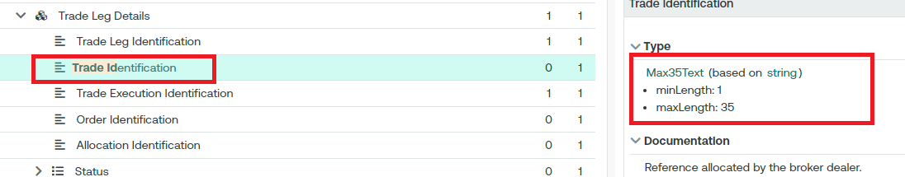

**Change 3:** Change the multiplicity of Trade Execution Identification <TradExctnId> from: mandatory to: optional in the secl messages, as CHESS intends to use the Trade Identification <TradId> UTI as the key Trade Identification in the end-to-end process. ISO could implement a cross-element rule stating that if the Trade Execution Identification is not provided, the Trade Id must be populated.

**Current Multiplicity:**

* Trade Identification <TradId> (0..1)
* Trade Execution Identification <TradExctnId> : (1..1)

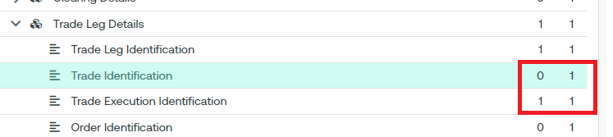

**New Multiplicity:**

* Trade Identification <TradId> (0..1)
* Trade Execution Identification <TradExctnId> : (0..1)

**Cross Element Simple Rule** : Trade Identification Or Trade Execution Identification Presence Rule

secl.010- Settlement Obligation Report

**Change 1:** Add the Trade Id < TradId> “UTI’, inside the block Reference < Refs> as (0..*); data type Max52Text (based on string)

* minLength: 1
* maxLength: 52

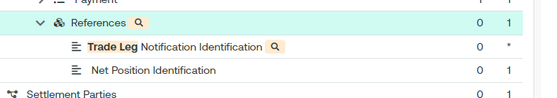

1. **Purpose of the change:**

The Australian Securities Exchange (ASX) has initiated a project to replace the current Australian equities clearing and settlement market infrastructure system (CHESS).

CHESS (Clearing House Electronic Subregister System) is the system operated by ASX to manage the clearing and settlement of equity market transactions, and to record current security holdings (and the holders) on a name on register basis. The implementation of the replacement system will provide the existing core functionality and services as well as service enhancements. The current proprietary CHESS messaging standards will be replaced with ISO 20022 standards.

The purpose of this Change Request is to apply the 2019 SMPG CR (001448) to all ISO messages in order to address the market’s/ASX’s need for supporting the Unique Transaction Identifier (UTI) code in ISO 20022 messages. By extending the data type of the Trade Identification <TradId> from 35 characters to 52 characters, the change request aims to enable the usage of the UTI with 52 characters across all business areas, including secl, sese, semt, and others.

1. **Urgency of the request:**

By default, valid change requests introduced by June 1 and subsequently approved by the SEG/TSG will be included in the following yearly maintenance cycle which completes with the publication of new message versions by April/May of the following year, unless decided otherwise by the SEG/TSG.

If there is a need to have the new version of the related messages published earlier, the reason for the urgency of the maintenance and the expected consequences of a delay should be described here. Acceptance of such an unscheduled maintenance for the BAH is subject to approval by TSG. Acceptance of an unscheduled maintenance for messages other than the BAH is subject to the approval of the SEG and availability of a submitting organization to develop the new version of the messages.

*Note: the ISO 20022 maintenance results in the publication of a new version of an ISO 20022 message. The actual implementation of such new version on networks and in user installations is not within the purview of ISO.*

1. **Business examples:**

The Trade Identification data type of the message secl.001 is not aligned with sese.023.

1. **SEG/TSG recommendation:**

*This section is not to be taken care of by the submitter of the change request. It will be completed in due time by the SEG(s) in charge of the related ISO 20022 messages or the TSG for changes related to the BAH.*

|  |  |  |  |
| --- | --- | --- | --- |
| **Consider** | |  | **Timing** |
|  | | - **Next yearly cycle: 2024/2025**  (the change will be considered for implementation in the yearly maintenance cycle which starts in 2024 and completes with the publication of new message versions in the spring of 2025) | |  |
|  | | - **At the occasion of the next maintenance of the messages**  (the change will be considered for implementation, but does not justify maintenance of the messages in its own right – will be pending until more critical change requests are received for the messages) | |  |
|  | | - **Urgent unscheduled**  (the change justifies an urgent implementation outside of the normal yearly cycle) | |  |  |
|  | | - **Other timing:** | | |  |

Comments:

|  |  |
| --- | --- |
| **Reject** |  |

Reason for rejection: