Change Request
for the update of ISO 20022 financial repository items
Note: the purpose of this document is to give guidelines to parties who want to introduce a request to change an existing ISO 20022 message(s), or update other items of the ISO 20022 financial repository. Such change requests are subject to the approval of the ISO 20022 Standards Evaluation Group(s) in charge of the related message/item or to the approval of the Technical Support Group (TSG), if the requested change relates to the Business Application Header (BAH). Please consult the iso20022.org website for additional details on the maintenance process. Change requests are to be sent to iso20022ra@iso20022.org. All change requests conforming to this template received by June 1st will be considered for development in the following yearly ISO 20022 maintenance cycle which completes with publication of new message versions in April/May of the following year.
- Origin of the request:
A.1 Submitter: Deutsche Bundesbank on behalf of the Eurosystem / 4CB
A.2 Contact person:
- Stéphanie Radet, +49 69 9566-33528
- Ann-Kristin Gonska, +49 69 9566-14278
- t2s-fam@bundesbank.de
A.3 Sponsors: SWIFT (Karine TAQUET)

- Related messages:
Impacted messages:
camt.067.001.02 Intra Balance Movement Status Advice V02
camt.068.001.02 Intra Balance Movement Confirmation V02
semt.014.001.07 Intra Position Movement Status Advice V07
semt.015.001.09 Intra Position Movement Confirmation V09

- Description of the change request:
Currently, the supplementary data element is used for camt.067, camt.068, semt.014 and semt.015 messages to report the reference of the underlying business instruction involved in a Conditional Securities Delivery (CoSD) blocking scenario.
The objective of this change request is to include the reference of the business instruction that triggered a CoSD procedure directly in the impacted messages mentioned above instead of using the supplementary data element of supl.021.

This request proposes to create:

- A new Element “Related Transaction Identification” to report the reference of a transaction that is associated with the one of the message, in case of T2S, to report the reference of the business instruction related to a CoSD blocking scenario. This new element is to be added in camt.067, camt.068, semt.014 and semt.015 messages as follows:

  - Camt.067 and Semt.014: Within the Transaction Identification block:
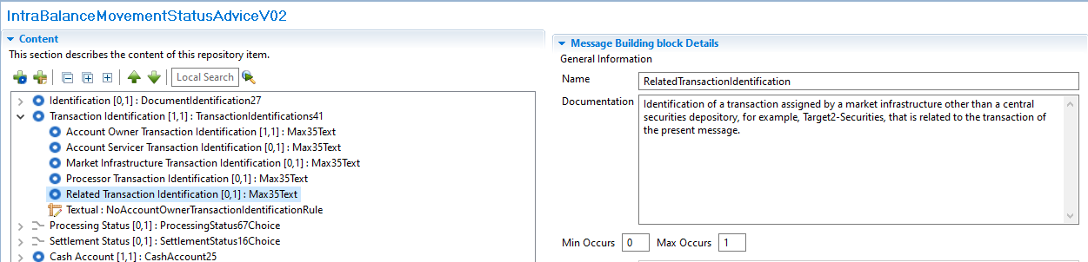
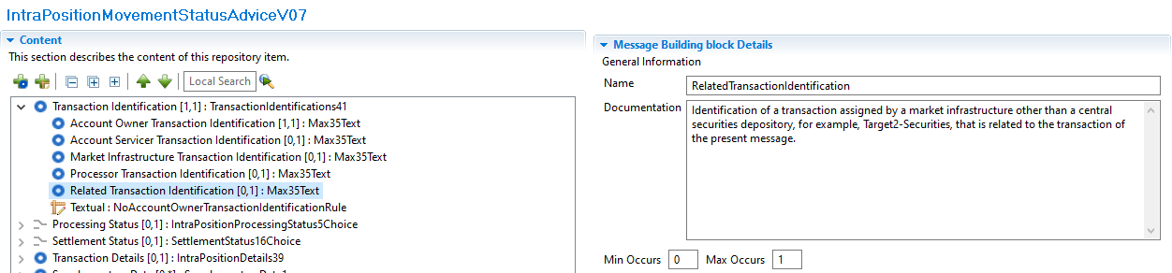

  - Camt.068 and Semt.015: Within the Additional Parameters block:
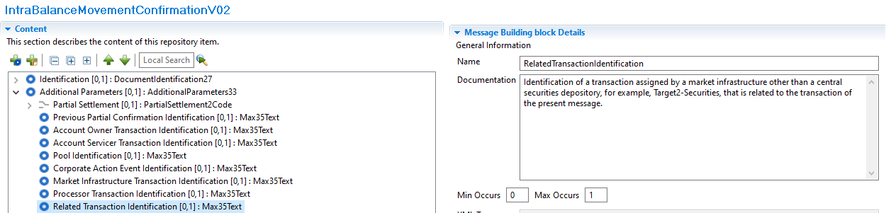
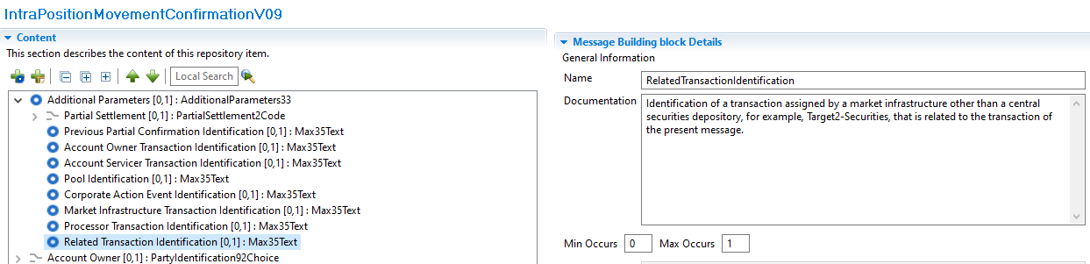

- Purpose of the change:
Currently the reference of the business instruction related to a Conditional Securities Delivery (CoSD) blocking scenario is reported using the supl.021 message as an additional block (Supplementary Data element) inside the messages listed above as of today, the related ISO messages do not have any element available to provide this type of information
The purpose of this change is to adopt a more standardized way to report the reference of the business instruction related to a CoSD blocking scenario in case of intra balance (camt.067 and camt.068) and intra position (semt.014 and semt.015) movement messages, which is currently reported using a technical message component without a dedicated structured element inside the message.
This reference is the simplest way to identify the business Settlement Instructions responsible for the creation of the Settlement Restrictions created when a CoSD scenario is triggered, the detailed flow is explained hereafter:
- The conditional settlement process allows CSDs to settle instructions that require the fulfilment of a settlement condition outside T2S before allowing the securities settlement to take place in the system.
- To do so, T2S automatically detects and performs conditional settlement, based on CoSD rules defined and maintained by each CSD in static data. These rules identify the administering party; which will be the CSD in charge of managing the fulfilment of the external conditions.
- The system puts automatically the Settlement Instruction that meets a CoSD rule, on CoSD hold and blocks the relevant securities and/or cash depending on the CoSD rule.
- To block the securities/cash a settlement restriction on securities/cash is created internally by T2S to move the securities/cash from a Deliverable to a provisional Blocking position.
- Once the Settlement Restrictions are created the related messages are generated; as the restrictions were created in a CoSD scenario the reference of the business instruction that triggered this CoSD rule is reported in the supplementary data element:
  - In case of cash settlement restrictions, camt.067 and camt.068 intra balance movement messages, it will be the Reference of the related business instruction that debits the Dedicated Cash Account where the CoSD blocking occurs.
  - In case of securities settlement restrictions, semt.014 and semt.015 intra position movement messages, it will be the Reference of the related delivering business instruction where the CoSD blocking occurs.
- Once the external settlement conditions are fulfilled, the administering parties of the CoSD rule, trigger the release of the instruction. After the CoSD release is executed the securities/cash are delivered again to a Deliverable position and the business instruction finally settles. To move the securities/cash from the provisional blocking position, another Settlement Restriction is created, consequently, the reference of the business instruction will be reported again in the supplementary data block of the semt.015 or camt.068 messages generated for this end.

If this element is not integrated into the relevant messages, it will continue to be reported in the Supplementary Data block, which is not the most appropriate way to report such information.

- Urgency of the request:
The Securities SEG is requested to consider this change request for the next maintenance cycle.

- Business examples:
Examples illustrating the change request.

- SEG/TSG recommendation:
This section is not to be taken care of by the submitter of the change request. It will be completed in due time by the SEG(s) in charge of the related ISO 20022 messages or the TSG for changes related to the BAH.

Consider |  |  | Timing
 |  |  | - Next yearly cycle: 2024/2025  (the change will be considered for implementation in the yearly maintenance cycle which starts in 2022 and completes with the publication of new message versions in the spring of 2023) |  | X
- At the occasion of the next maintenance of the messages
(the change will be considered for implementation, but does not justify maintenance of the messages in its own right – will be pending until more critical change requests are received for the messages)
- Urgent unscheduled
(the change justifies an urgent implementation outside of the normal yearly cycle)
 |  |  | - Other timing:
Comments:

Reject
Reason for rejection:

