Change Request
for the update of ISO 20022 financial repository items
Note: the purpose of this document is to give guidelines to parties who want to introduce a request to change an existing ISO 20022 message(s), or update other items of the ISO 20022 financial repository. Such change requests are subject to the approval of the ISO 20022 Standards Evaluation Group(s) in charge of the related message/item or to the approval of the Technical Support Group (TSG), if the requested change relates to the Business Application Header (BAH). Please consult the iso20022.org website for additional details on the maintenance process. Change requests are to be sent to iso20022ra@iso20022.org. All change requests conforming to this template received by June 1st will be considered for development in the following yearly ISO 20022 maintenance cycle which completes with publication of new message versions in April/May of the following year.
- Origin of the request:
A.1 Submitter: Deutsche Bundesbank on behalf of the Eurosystem / 4CB
A.2 Contact person:
- Stéphanie Radet, +49 69 9566-33528
- Ann-Kristin Gonska, +49 69 9566-14278
- t2s-fam@bundesbank.de
A.3 Sponsors: SWIFT (Karine TAQUET)

- Related messages:
Impacted messages:
sese.024.001.12 SecuritiesSettlementTransactionStatusAdviceV12
sese.025.001.11 SecuritiesSettlementTransactionConfirmationV11
sese.032.001.11 SecuritiesSettlementTransactionGenerationNotificationV11

- Description of the change request:
Currently, in T2S the matching reference needed for sese.024, sese.025 and sese.032 is not available within these messages and is provided as a supplementary data element in supl.021.
The objective of this change request is to include the matching reference directly in the impacted messages mentioned above instead of using the supplementary data element of supl.021.

This request proposes to create:
- a new Element “Matching Transaction Identification” to report the matching reference. This new element is to be added in sese.024, sese.025 and sese.032 messages as follows:

  - Sese.024: Within the Transaction Identification block.
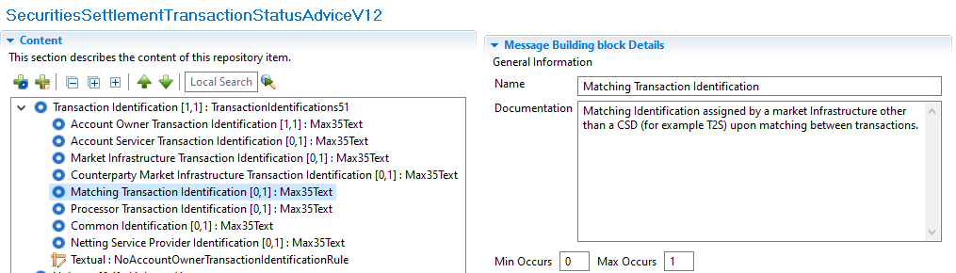

  - Sese.025 and Sese.032: Within the Transaction Identification Details block:
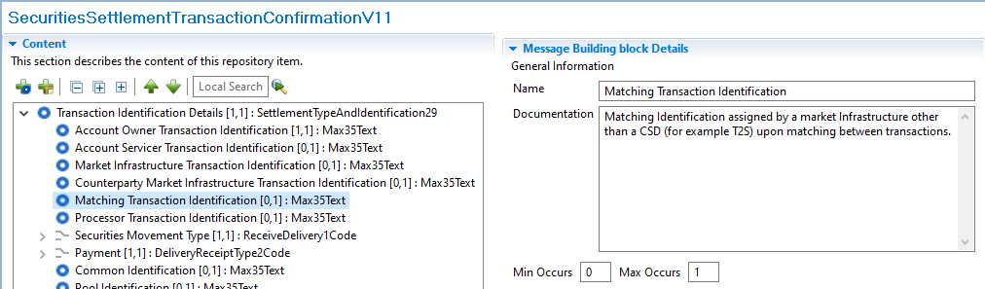

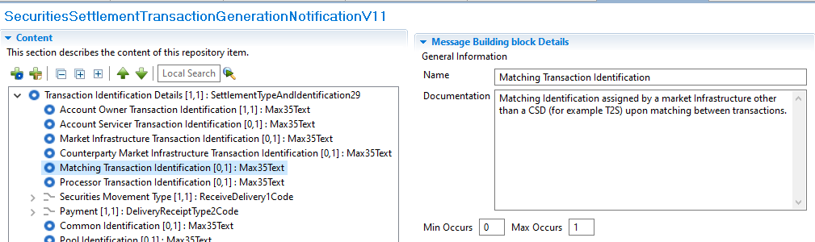

- Purpose of the change:
Currently the supl.021 message is used in T2S as an additional block (Supplementary Data) inside the securities settlement messages listed above with the sole purpose of reporting the Matching Reference; as of today, the related ISO messages do not have any element available to provide this information.
The purpose of this change is to adopt a more standardized way to report the matching reference of a Settlement Transaction in case of Settlement Instruction related messages (sese.024, sese.025 and sese.032) which is currently reported using a technical message component without a dedicated structured element inside the message.
The Matching Reference provided is the common identification assigned by a market infrastructure (for example T2S) upon matching between transactions, regardless if the transactions matched in the system or on the contrary entered already matched. With this reference, users could easily identify all the instructions involve in a particular transaction.
As an example, for cross border settlement transactions, the matching reference allow the users to locate all the instructions that compose a Cross-CSD transaction, including the realignment technical instructions (as the business and realignment instructions share the same matching reference).

If this element is not integrated into the relevant messages, it will continue to be reported in the Supplementary Data block, which is not the most appropriate way to report the matching reference.

- Urgency of the request:
The Securities SEG is requested to consider this change request for the next maintenance cycle.

- Business examples:
Examples illustrating the change request.

- SEG/TSG recommendation:
This section is not to be taken care of by the submitter of the change request. It will be completed in due time by the SEG(s) in charge of the related ISO 20022 messages or the TSG for changes related to the BAH.

Consider |  |  | Timing
 |  |  | - Next yearly cycle: 2024/2025  (the change will be considered for implementation in the yearly maintenance cycle which starts in 2022 and completes with the publication of new message versions in the spring of 2023) |  | X
- At the occasion of the next maintenance of the messages
(the change will be considered for implementation, but does not justify maintenance of the messages in its own right – will be pending until more critical change requests are received for the messages)
- Urgent unscheduled
(the change justifies an urgent implementation outside of the normal yearly cycle)
 |  |  | - Other timing:
Comments:

Reject
Reason for rejection:

