**Change Request**

**for the update of ISO 20022 financial repository items**

*Note: the purpose of this document is to give guidelines to parties who want to introduce a request to change an existing ISO 20022 message(s), or update other items of the ISO 20022 financial repository. Such change requests are subject to the approval of the ISO 20022 Standards Evaluation Group(s) in charge of the related message/item or to the approval of the Technical Support Group (TSG), if the requested change relates to the Business Application Header (BAH). Please consult the iso20022.org website for additional details on the* [*maintenance process*](http://www.iso20022.org/maintenance.page)*. Change requests are to be sent to* [*iso20022ra@iso20022.org*](mailto:iso20022ra@iso20022.org)*. All change requests conforming to this template received by June 1st will be considered for development in the following yearly ISO 20022 maintenance cycle which completes with publication of new message versions in April/May of the following year.*

# Change request MT CR 001778: SWIFT release 2025 - Add new information regarding a partially released quantity (changes required in semt.022 to include “PREL” code)

## Origin of the request:

*A.1 Submitter*:

- Deutsche Bundesbank on behalf of the Eurosystem / 4CB

- TARGET2-Securities

*A.2 Contact person:*

- Stéphanie Radet, [stephanie.radet@bundesbank.de](mailto:stephanie.radet@bundesbank.de), +49 69 9566-33528

- Ann-Kristin Gonska, [ann-kristin.gonska@bundesbank.de](mailto:ann-kristin.gonska@bundesbank.de), +49 69 9566-14278

- [t2s-fam@bundesbank.de](mailto:t2s-fam@bundesbank.de)

*A.3 Sponsors*:

- AMI-SeCo SEG Task Force on the Optimisation of T2S message customisation (TFOS)

## Related messages:

semt.022.001.05 - Securities Settlement Transaction Audit Trail Report V05

## Description of the change request:

The MT CR-1778 changes stemming from SWIFT release 2022 changes were requested for ISO 15022 MT 548 and MT 537 and also in the equivalent ISO 20022 messages, sese.024 and semt.018.

The semt.022 (Securities Settlement Transaction Audit Trail Report) is a pillar 3 T2S message with no equivalence in ISO 15022. Therefore, the change was not implemented in the semt.022 message. Hence, this ISO CR focuses on changing the T2S semt.022 base message for Maintenance Release 2025 to add a new code ‘PREL’ (Partially Released) to qualifiers ‘PEND’ (pending status) and ‘PENF’ (failing status):

* code ‘PREL’ to be made available as pending reason code:

/Document/SctiesSttlmTxAudtTrlRpt/StsTrl/SttlmSts/Pdg/Rsn/Cd/Cd

* code ‘PREL’ to be made available as failing reason code:

/Document/SctiesSttlmTxAudtTrlRpt/StsTrl/SttlmSts/Flng/Rsn/Cd/Cd

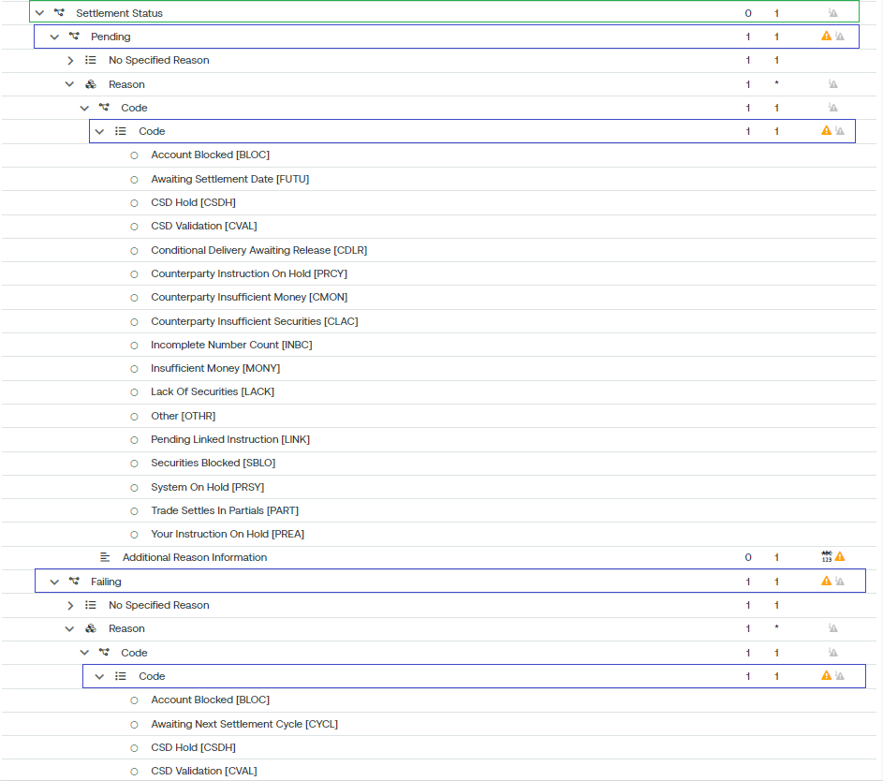

## Purpose of the change:

The proposed change is to add a new reason code ‘PREL’ (Partially Released) to the qualifiers ‘PEND’ (pending) and ‘PENF’ (failing) status to advise the partially released status of a specific transaction during its whole life cycle.

Some institutions (CSD/ICSD or directly connected T2S party) may have to include the partially released status in the history of all the statuses of a specific transaction during its entire life cycle, as is the case for the semt.018 usage.

## Urgency of the request:

We request the SEG to consider this change request for the next maintenance cycle.

It may allow the semt.018 and semt.022 usage alignment.

## Business examples:

The Securities Settlement Transaction Audit Trail Report message (semt.022) is sent by T2S to a CSD or a directly connected T2S Party.

The report provides historical data on all changes and amendments, including statuses, to a single security Settlement Instruction as identified within the query criteria (either by the party’s instruction reference or by the T2S technical identifier) of the received Securities Transaction Status Query message (sese.021).

***Communication flow:***

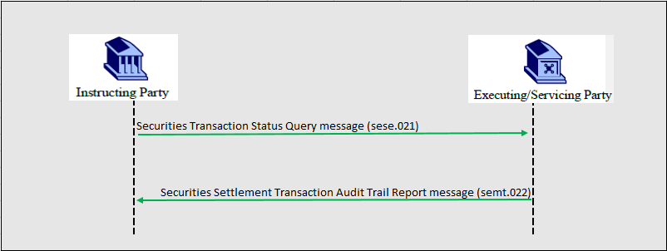

***semt.022 message example:***

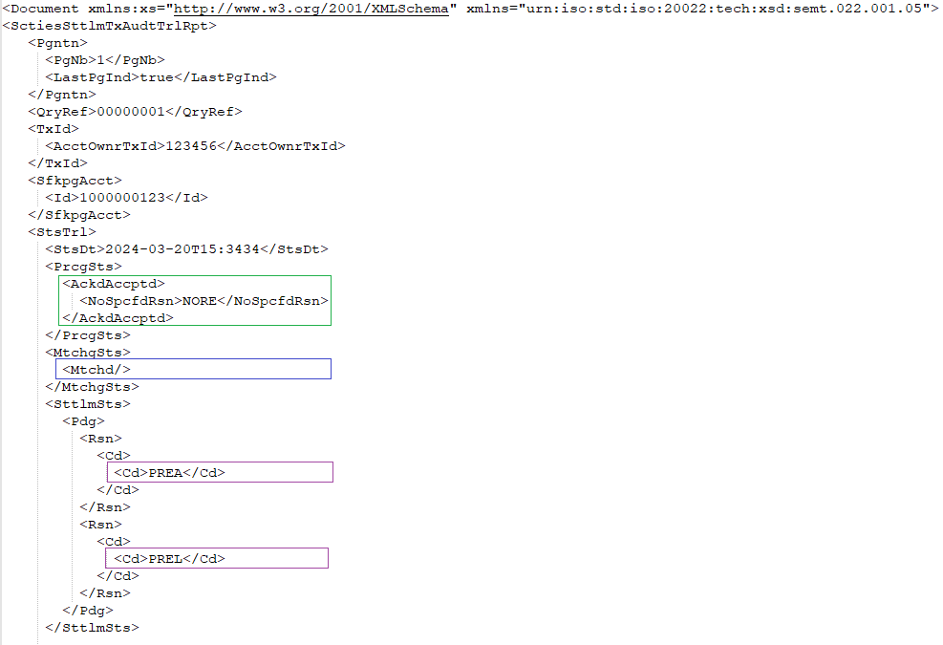

In this example, T2S sends a Securities Settlement Transaction Audit Trail Report as requested by the T2S Party using the message Securities Transaction Status Query regarding a Settlement Instruction with an account owner transaction id with a value of ‘123456’. The transaction as reported has been:

* accepted (AckAccptd)
* matched (Mtchd)
* on hold (PREA)
* partially released (PREL)

## SEG/TSG recommendation:

*This section is not to be taken care of by the submitter of the change request. It will be completed in due time by the SEG(s) in charge of the related ISO 20022 messages or the TSG for changes related to the BAH.*

|  |  |  |  |
| --- | --- | --- | --- |
| **Consider** | |  | **Timing** |
|  | | - **Next yearly cycle: 2024/2025**  (the change will be considered for implementation in the yearly maintenance cycle which starts in 2024 and completes with the publication of new message versions in the spring of 2025) | | X |
|  | | - **At the occasion of the next maintenance of the messages**  (the change will be considered for implementation, but does not justify maintenance of the messages in its own right – will be pending until more critical change requests are received for the messages) | |  |
|  | | - **Urgent unscheduled**  (the change justifies an urgent implementation outside of the normal yearly cycle) | |  |  |
|  | | - **Other timing:** | | |  |

Comments:

|  |  |
| --- | --- |
| **Reject** |  |

Reason for rejection:

# Change request MT CR 001779: SWIFT release 2025 - Add new information to report a mismatch on the partial settlement indicator (changes required in semt.022 to include “PATD” code)

## Origin of the request:

*A.1 Submitter*:

- Deutsche Bundesbank on behalf of the Eurosystem / 4CB

- TARGET2-Securities

*A.2 Contact person:*

- Stéphanie Radet, [stephanie.radet@bundesbank.de](mailto:stephanie.radet@bundesbank.de), +49 69 9566-33528

- Ann-Kristin Gonska, [ann-kristin.gonska@bundesbank.de](mailto:ann-kristin.gonska@bundesbank.de), +49 69 9566-14278

- [t2s-fam@bundesbank.de](mailto:t2s-fam@bundesbank.de)

*A.3 Sponsors*: SWIFT

- AMI-SeCo SEG Task Force on the Optimisation of T2S message customisation (TFOS)

1. **Related messages:**

semt.022.001.05 - Securities Settlement Transaction Audit Trail Report V05

## Description of the change request:

The MT CR-1779 changes stemming from SWIFT release 2022 requested the implementation of a new ‘PATD’ (Partial Differ) code for ISO 15022 MT 548 and MT 537 and also in the equivalent ISO 20022 messages, sese.024 and semt.018.

The semt.022 (Securities Settlement Transaction Audit Trail Report) is a pillar 3 T2S message with no equivalence in ISO 15022. Therefore, the change was not implemented in the semt.022 message. Hence, this ISO CR focuses on changing the T2S semt.022 base message for Maintenance Release 2025 to add a new code ‘PATD’ to qualifiers ‘PEND’ (pending status) and ‘PENF’ (failing status):

* code ‘PATD’ to be made available as pending reason code:

/Document/SctiesSttlmTxAudtTrlRpt/StsTrl/SttlmSts/Pdg/Rsn/Cd/Cd

* code ‘PATD’ to be made available as failing reason code:

/Document/SctiesSttlmTxAudtTrlRpt/StsTrl/SttlmSts/Flng/Rsn/Cd/Cd



## Purpose of the change:

The proposed change is to add a new reason code ‘PATD’ (Partial Differ) to the ‘PEND’ (pending) and ‘PENF’ (failing) qualifiers whenever a matched instruction is pending/failing and that there is a mismatch on the partial settlement indicator. So, a settlement status with a new reason code ‘PATD’ will be provided to advice about this discrepancy during its whole life cycle.

Some institutions (CSD/ICSD or directly connected T2S party) institutions may have needed to report the information regarding a mismatch on the partial settlement indicator, as is the case for the semt.018 usage.

## Urgency of the request:

We request the SEG to consider this change request for the next maintenance cycle.

It may allow the semt.018 and semt.022 usage alignment.

## Business examples:

The Securities Settlement Transaction Audit Trail Report message (semt.022) is sent by T2S to a CSD or a directly connected T2S Party.

The report provides historical data on all changes and amendments, including statuses, to a single security Settlement Instruction as identified within the query criteria (either by the party’s instruction reference or by the T2S technical identifier) of the received Securities Transaction Status Query message (sese.021).

***Communication flow:***



***semt.022 message example:***

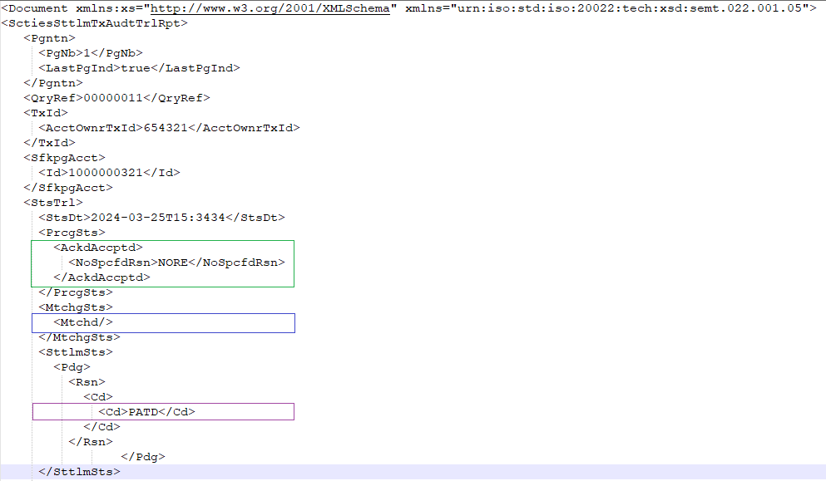

In this example, T2S sends a Securities Settlement Transaction Audit Trail Report as requested by the T2S Party using the message Securities Transaction Status Query regarding a Settlement Instruction with an account owner transaction id with a value of ‘654321’. The transaction as reported has been:

* accepted (AckAccptd)
* matched (Mtchd)
* unsettled-pending with a partial differ (PATD) pending reason code.

## SEG/TSG recommendation:

*This section is not to be taken care of by the submitter of the change request. It will be completed in due time by the SEG(s) in charge of the related ISO 20022 messages or the TSG for changes related to the BAH.*

|  |  |  |  |
| --- | --- | --- | --- |
| **Consider** | |  | **Timing** |
|  | | - **Next yearly cycle: 2024/2025**  (the change will be considered for implementation in the yearly maintenance cycle which starts in 2024 and completes with the publication of new message versions in the spring of 2025) | | X |
|  | | - **At the occasion of the next maintenance of the messages**  (the change will be considered for implementation, but does not justify maintenance of the messages in its own right – will be pending until more critical change requests are received for the messages) | |  |
|  | | - **Urgent unscheduled**  (the change justifies an urgent implementation outside of the normal yearly cycle) | |  |  |
|  | | - **Other timing:** | | |  |

Comments:

|  |  |
| --- | --- |
| **Reject** |  |

Reason for rejection: