Change Request
for the update of ISO 20022 financial repository items

- Origin of the request:
A.1 Submitter: nexo A.I.S.B.L.
A.2 Contact person:
- Philippe CECE (philippe.cece@nexo-standards.org)
- Laure BELTRI (laure.beltri@frenchsys.com)

A.3 Sponsors: nexo A.I.S.B.L.

- Related messages:

- AcceptorConfigurationUpdate V13 (catm 003.001.13)

- Description of the change request:

We want to update the message component HostCommunicationParameters6 in order to add 2 new message elements. These new elements will identify if a receiver is able to support XML messages or API, in XML or in JSON.

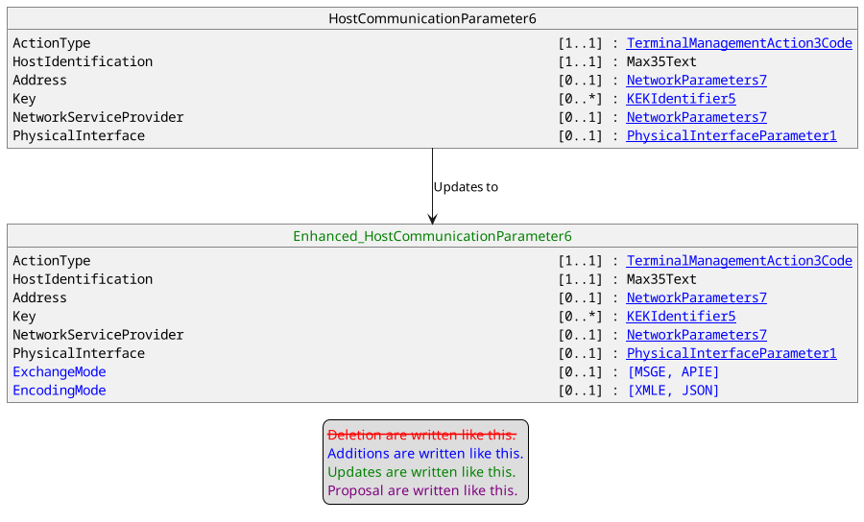

- Purpose of the change:

nexo standards plans to provide specifications with support of API and JSON encoding. Then a live solution on the field might be composed of POIs and servers communicating through classical ISO20022 XML messages or through JSON API. In order to ensure interoperability, it is important to identify how communication could be initiated between these actors. Since the POI is initiating this communication, it must know how to communicate and should be able to find this configuration in the HostCommunicationParameters received through an AcceptorConfigurationUpdate.

- Urgency of the request:
Urgent
- Business examples:
Examples illustrating the change request.
- SEG/TSG recommendation:
This section is not to be taken care of by the submitter of the change request. It will be completed in due time by the SEG(s) in charge of the related ISO 20022 messages or the TSG for changes related to the BAH.

Consider |  |  | Timing
 |  |  | - Next yearly cycle: 2024/2025  (the change will be considered for implementation in the yearly maintenance cycle which starts in 2018 and completes with the publication of new message versions in the spring of 2019) |  | X
- At the occasion of the next maintenance of the messages
(the change will be considered for implementation, but does not justify maintenance of the messages in its own right – will be pending until more critical change requests are received for the messages)
- Urgent unscheduled
(the change justifies an urgent implementation outside of the normal yearly cycle)
 |  |  | - Other timing:
Comments:

Reject
Reason for rejection:

