**Maintenance Change Request**

**for the update of ISO 20022 financial repository items**

1. **Origin of the request:**

*A.1 Submitter*: nexo A.I.S.B.L.

*A.2 Contact person:*

* Andrew Hamilton (andrewr.hamilton@ncratleos.com)
* Philippe Cece (philippe.cece@nexo-standards.org)

*A.3 Sponsors*: nexo A.I.S.B.L.

1. **Related messages:**

* ATMDeviceReport (caam.001.001.03),
* ATMDeviceControlV03 (caam.002.001.03),
* ATMKeyDownloadRequestV03 (caam.003.001.03),
* ATMKeyDownloadResponseV03 (caam.004.001.03),
* ATMReconciliationAdviceV02 (caam.009.001.02),
* ATMReconciliationAcknowledgementV02 (caam.010.001.02).

2 new messages introduced.

1. **Description of the change request:**

### Add a new Command code value

The Command Type ATMCommand6Code will be extended to include: ReconciliationRequest

Datatype: ATMCommand6Code

|  |  |  |
| --- | --- | --- |
| CodeName | Name | Definition |
| … |  |  |
| KCHG | KeyReplace | Replaces an existing cryptographic key. In a TR34 scheme this would be used to implement a Rebind operation. |
| RREQ | ReconciliationRequest | Send a ReconciliationRequest message |

### Add a new TypeOfOperation code value

The codeset ATMOperation1Code will be extended to include: RemoteCounterUpdate

Datatype: ATMOperation1Code

|  |  |  |
| --- | --- | --- |
| CodeName | Name | Definition |
| … |  |  |
| UNLD | Unloading | Unloading cassette. |
| RCUP | RemoteCounterUpdate | Remotely updating an ATM counter. |

### Create a new ATMReconciliationRequest Message

The ATMReconciliationRequest message is sent by a terminal to an acquiring server when it needs it to inform the terminal of updates to the reconciliation counts. The terminal will send the existing counts in the Cassette structure.

The ATMReconciliationRequest <ATMRcncltnReq> message is defined as:

|  |  |  |  |  |  |
| --- | --- | --- | --- | --- | --- |
| Or | Message Element | Mult. | Type |  |  |
|  | Header <Hdr> | [1..1] | Header31 |  |  |
|  | ProtectedATMRcncltnReqRequest <Prtctd ATMRcncltnReq> | [0..1] | ± |  |  |
|  | ATMReconciliationRequest < ATMRcncltnReq > | [0..1] |  |  |  |
|  | Environment <Env> | [1..1] | ATMEnvironment7 |  |  |
|  | Transaction <Tx> | [0..1] |  |  |  |
|  | TypeOfOperation <TpOfOpr> | [1..1] | Codeset. Note the new value RCUP (Remote Counter Update) |  |  |
|  | TransactionId <TxId> | [0..1] | Text |  |  |
|  | ReconciliationId <RcncltnId> | [0..1] | Text |  |  |
|  | Cassette <Csstt> | [0..*] | ± |  |  |
|  | SecurityTrailer <SctyTrlr> | [0..1] | ± |  |  |

### Create a new ATMReconciliationResponse Message

The ATMReconciliationResponse message is sent by an acquiring server to a terminal in response to an ATMReconciliationRequest message. The response will contain the counts which need to be updated.

The ATMReconciliationResponse <ATMRcncltnRspn> message is defined as:

|  |  |  |  |  |  |
| --- | --- | --- | --- | --- | --- |
| Or | Message Element | Mult. | Type |  |  |
|  | Header <Hdr> | [1..1] | Header31 |  |  |
|  | ProtectedATMRcncltnReqResponse <Prtctd ATMRcncltnRspn> | [0..1] | ± |  |  |
|  | ATMReconciliationResponse < ATMRcncltnRspn > | [0..1] |  |  |  |
|  | Environment <Env> | [1..1] | ATMEnvironment7 |  |  |
|  | Transaction <Tx> | [0..1] |  |  |  |
|  | TypeOfOperation <TpOfOpr> | [1..1] | Codeset. New value RCUP (Remote Counter Update) |  |  |
|  | TransactionId <TxId> | [0..1] | Text |  |  |
|  | ReconciliationId <RcncltnId> | [0..1] | Text |  |  |
|  | Cassette <Csstt> | [0..*] |  |  |  |
|  | PhysicalIdentifier <PhysId> | [1..1] | Text |  |  |
|  | LogicalIdentifier <LogicId> | [0..1] | Text |  |  |
|  | SerialNumber <SrlNb> | [0..1] | Text |  |  |
|  | Type <Tp> | [0..1] | Codeset |  |  |
|  | SubType <SubTp> | [0..1] | Codeset |  |  |
|  | MediaType <MdiaTp> | [0..1] | Codeset |  |  |
|  | MediaCounters <MdiaCntrs> | [0..*] |  |  |  |
|  | UnitValue <UnitVal> | [0..1] | Amount |  |  |
|  | Currency <Ccy> | [0..1] | Codeset |  |  |
|  | MediaCategory <MdiaCtgy> | [0..1] | Codeset |  |  |
|  | InitialCount <InitCnt> | [0..1] | Number |  |  |
|  | CurrentNumber <CurNb> | [0..1] | Number |  |  |
|  | CurrentAmount <CurAmt> | [0..1] | Amount |  |  |
|  | FlowTotals <FlowTtls> | [0..*] |  |  |  |
|  | Type <Tp> | [1..1] | Codeset |  |  |
|  | AddedNumber <AddedNb> | [0..1] | Quantity |  |  |
|  | RemovedNumber <RmvdNb> | [0..1] | Quantity |  |  |
|  | DispensedNumber <DspnsdNb> | [0..1] | Quantity |  |  |
|  | DepositedNumber <DpstdNb> | [0..1] | Quantity |  |  |
|  | RecycledNumber <RcycldNb> | [0..1] | Quantity |  |  |
|  | RetractedNumber <RtrctdNb> | [0..1] | Quantity |  |  |
|  | RejectedNumber <RjctdNb> | [0..1] | Quantity |  |  |
|  | PresentedNumber <PresntdNb> | [0..1] | Quantity |  |  |
|  | SecurityTrailer <SctyTrlr> | [0..1] | ± |  |  |

Where InitialCount <InitCnt> is a new element in MediaCounters <MdiaCntrs> and is defined:

Presence: [0..1]

Definition: Number of media items in cassette after last replenishment

Datatype: Positive Number

All elements, apart from InitialCount, in the above two messages are as presently defined in the nexo ISO20022 standard.

1. **Purpose of the change:**

Business justification:

During replenishment of valuables the Cash-in-Transit (CIT) personnel may cause an error in counts by entering an incorrect value for valuables in a cassette swap, media added or media removed. This proposal allows an operator at a remote location to correct mistakes entered at the ATM during replenishment; for example, the CIT person informs the acquiring server (through a supervisor application) that 1000 notes have been entered, when actually 2000 notes were entered. An acquiring server operator can remotely set the initial value to 2000 by adding 1000 notes, hence correcting the mistake.

The proposal adds a new command which will command the ATM to send a new Reconciliation Request to its acquiring server. When this message is sent, the acquiring server will respond with a new Reconciliation Response message which contains the corrected counts.

## Example Use Case

The following diagram shows an example sequence, where in a DeviceControl message from the server a ReconciliationRequest command is sent to the terminal. The terminal will send the ReconciliationRequest message to the Server, followed by the ReconciliationResponse message from the server with the corrected counts for the cassettes. On receipt of this message the terminal will update the XFS counts for the relevant cassettes and inform the server of the update by sending a ReconciliationAdvice message, which would be followed by the ReconciliationAcknowledgement message by the server to acknowledge receipt of the Advice.

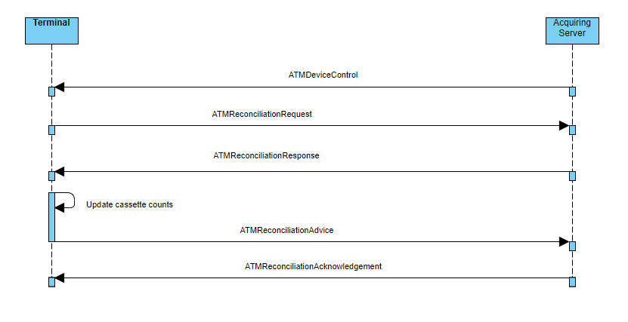

1. **Urgency of the request:**

*Urgent.*

1. **Business examples:**
2. **SEG recommendation:**

*This section is not to be taken care of by the submitter of the change request. It will be completed in due time by the SEG(s) in charge of the related ISO 20022 messages.*

|  |  |  |  |  |  |  |
| --- | --- | --- | --- | --- | --- | --- |
| **Consider** | |  | **Timing** |  |  |  |
|  |  | | - **Next yearly cycle: 2024/2025**  (the change will be considered for implementation in the yearly maintenance cycle which starts in 2024 and completes with the publication of new message versions in the spring of 2025) | | X |  |
|  |  | | - **At the occasion of the next maintenance of the messages**  (the change will be considered for implementation, but does not justify maintenance of the messages in its own right – will be pending until more critical change requests are received for the messages) | |  |  |
|  |  | | - **Urgent unscheduled**  (the change justifies an urgent implementation outside of the normal yearly cycle) | |  |  |
|  |  | | - **Other timing:** | | |  |

Comments:

|  |  |
| --- | --- |
| **Reject** |  |

Reason for rejection: