**Maintenance Change Request**

**for the update of ISO 20022 financial repository items**

1. **Origin of the request:**

*A.1 Submitter*: nexo A.I.S.B.L.

*A.2 Contact person:*

* Andrew Hamilton ([andrewr.hamilton@ncratleos.com](mailto:andrewr.hamilton@ncratleos.com))
* Philippe Cece (philippe.cece@nexo-standards.org)

*A.3 Sponsors*: nexo A.I.S.B.L.

1. **Related messages:**

New messages introduced.

1. **Description of the change request:**

Two new messages are proposed to support Configuration Downloads. The proposed message structure would be as shown below.

The ATMConfigurationReport is defined:

|  |  |  |  |  |  |
| --- | --- | --- | --- | --- | --- |
| Or | Message Element | Mult. | Type |  |  |
|  | Header <Hdr> | [1..1] | Header31 |  |  |
|  | ProtectedATMConfigurationReport <PrtctdAtmCfgRp> | [0..1] | ± |  |  |
|  | ATMConfigurationReport <AtmCfgRp> | [0..1] |  |  |  |
|  | Environment <Env> | [1..1] | ATMEnvironment7 |  |  |
|  | ActiveVersion <ActvVrsn> | [0..1] | Max35Text |  |  |
|  | NonActiveVersion <NActvVrsn> | [0..*] |  |  |  |
|  | ConfigurationVersion <ConfgrtnVrsn> | [1..1] | Max35Text |  |  |
|  | ConfigurationStatus <ConfigSts> | [1..1] | Codeset: values: Fail, AwaitingActivation |  |  |
|  | FailReason <FailRsn> | [0..1] | Max70Text |  |  |
|  | SecurityTrailer <ScrtyTrlr> | [0..1] | ContentInformationType15 |  |  |

Where:

**ActiveVersion <ActvVrsn>**

Presence: [0..1]

Definition: The configuration version which is active on the terminal.

Datatype: Max35Text

**ConfigurationVersion <**ConfgrtnVrsn**>**

Presence: [1..1]

Definition: The non-active configuration version which is being reported.

Datatype: Max35Text

**ConfigurationStatus <**ConfgrtnSts**>**

Presence: [1..1]

Definition: The status of the non-active configuration. This can be either: ‘Fail’ (i.e. the configuration update has failed), or ‘AwaitingActivation’ (i.e. the configuration download was successful and is now awaiting a future activation date).

Datatype: ActivationStatus

**FailReason <**FailRsn**>**

Presence: [0..1]

Definition: The reason a configuration update has failed on the terminal.

Datatype: Max70Text

The ATMConfigurationControl is defined:

|  |  |  |  |  |  |
| --- | --- | --- | --- | --- | --- |
| Or | Message Element | Mult. | Type |  |  |
|  | Header <Hdr> | [1..1] | Header31 |  |  |
|  | ProtectedATMConfigurationControl <PrtctdAtmCfgCtrl> | [0..1] | ± |  |  |
|  | ATMConfigurationControl <AtmCfgCtrl> | [0..1] |  |  |  |
|  | Environment <Env> | [1..1] | ATMEnvironment7 |  |  |
|  | ConfigurationVersion <ConfgrntVrsn> | [0..1] | Max35Text |  |  |
|  | ActionRequired <ActnReq> | [1..1] | Codeset. Values: APLY, NONE |  |  |
|  | Property <Prop> | [0..*] |  |  |  |
|  | PropertyName <PropName> | [1..1] | Max70Text |  |  |
|  | PropertyType <PropTp> | [0..1] | Codeset. Values: String, Number, Boolean, JSON, CSV |  |  |
|  | PropertyValue <PropVal> | [1..1] | Max2000Text |  |  |
|  | ActivationDate <ActvtnDt> | [0..1] | DateTime |  |  |
|  | SecurityTrailer <ScrtyTrlr> | [0..1] | ContentInformationType15 |  |  |

Where:

**ConfigurationVersion <**ConfgrtnVrsn**>**

Presence: [0..1]

Definition: The configuration version which is being sent to the terminal.

Datatype: Max35Text

**ActionRequired <**ActnReq**>**

Presence: [1..1]

Definition: The action which is required by the terminal on receipt of this configuration update. This will be one of: APLY (Apply) apply the configuration update, or NONE no configuration to be applied.

Datatype: Codeset

**PropertyName <PropName>**

Presence: [1..1]

Definition: The name of the property to be update on the terminal.

Datatype: text

**PropertyType <PropTp>**

Presence: [1..1]

Definition: The type of the property. It will be one of: String, Number, Boolean, JSON, CSV (i.e. a CSV[1] string representing a table of data).

Datatype: codeset

**PropertyValue <PropVal>**

Presence: [1..1]

Definition: The value to be assigned to the property.

Datatype: Max2000Text

**ActivationDate <ActvntDt>**

Presence: [0..1]

Definition: Date when the whole configuration is to be activated. If no activation date is provided, the activation must occur immediately.

Datatype: “ISODate”

1. **Purpose of the change:**

Business justification:

It is very common to have configuration options on ATM client applications. For example, updating a Financial Institution Table (FIT) to enable new cards to be supported, or enabling a transaction which previously had been disabled.

Ideally, we want such configuration changes to be made dynamically without requiring an application restart. They are different to application configuration changes which can be done using software download and then require the terminal to be restarted to take effect.

The proposal is to add a very lightweight set of messages which enable properties of the client to be updated. The property is defined by a name (text), a type (codeset) and a value (text). The value types would be: a number, a string, a boolean, a complex structure in a JSON formatted string, or a Table which is made up of a CSV string representing a table of data). A configuration will have a version. When requested by a server the terminal will be able to report the version of the configuration properties it has active, so the server can decide whether to update the client with a new version or not. A date and time optional element would denote when the configuration should be activated on the terminal.

## Example use cases

### Dynamic Configuration Update

The following shows a sequence diagram of the use case where the configuration update is requested by the server on the back of a Response message. The Terminal sends an ATMConfigurationReport message to the server with the version of the configuration which is active. The server determines a new version of the configuration properties needs to be sent to the terminal and responds with an ATMConfigurationControl message containing the updated properties. Once the client has made the updates on the terminal, it sends an ATMConfigurationReport message to inform the server the updates have been activated on the terminal and informs it of its new configuration version. The server responds with an ATMConfigurationControl (informing the client no further updates are required).

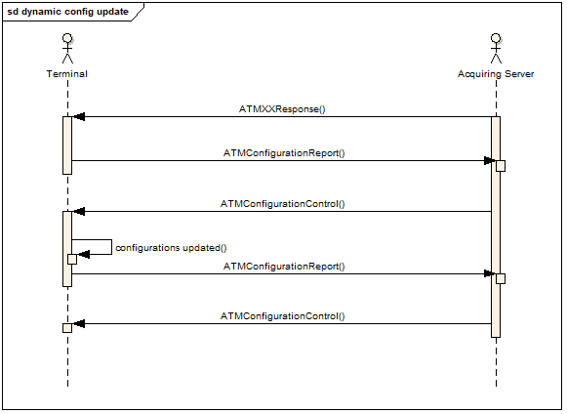

Diagram: Dynamic Configuration Update

### Timed Configuration Update

The following diagram shows a timed configuration update. The configuration change is sent back to the terminal in the ATMConfigurationControl. The terminal parses the updates to be made, and if these are changes it can make, it schedules a task to activate the updates at the time requested and sends back an ATMConfigurationReport message with a Status value for the configuration version of AwaitingActivation. When the time comes to make the update, the terminal activates the configuration updates. If the update was successfully made, it will update the version of the configuration on the terminal to the one associated with the new configuration. Optionally the terminal may send another ATMConfigurationReport message to the server informing it of the change in status of the configuration version.

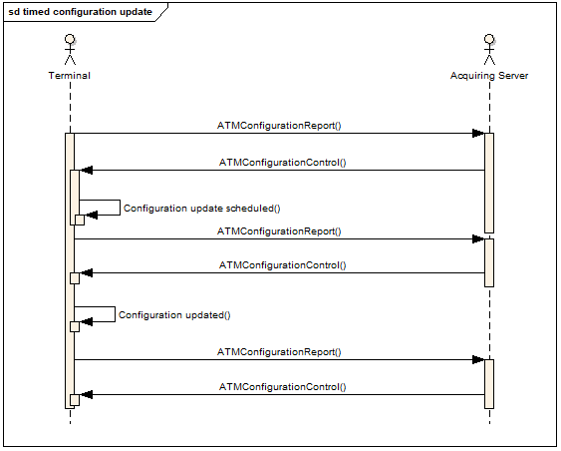

Diagram: Timed configuration update

### Configuration Update Failure

The sequence diagram for a failed configuration update will be the same as the previous diagram. When a configuration download or its activation fails, a ConfigurationReport should be sent to the server to inform it of the failure. An optional FailReason element describing in text the reason for the failure. The proposed semantics would be if any one parameter update fails, all updates are backed out, so the configuration version clearly identifies the values of all configuration parameters.

1. **Urgency of the request:**

*Urgent.*

1. **Business examples:**
2. **SEG recommendation:**

*This section is not to be taken care of by the submitter of the change request. It will be completed in due time by the SEG(s) in charge of the related ISO 20022 messages.*

|  |  |  |  |  |  |  |
| --- | --- | --- | --- | --- | --- | --- |
| **Consider** | |  | **Timing** |  |  |  |
|  |  | | - **Next yearly cycle: 2024/2025**  (the change will be considered for implementation in the yearly maintenance cycle which starts in 2024 and completes with the publication of new message versions in the spring of 2025) | | X |  |
|  |  | | - **At the occasion of the next maintenance of the messages**  (the change will be considered for implementation, but does not justify maintenance of the messages in its own right – will be pending until more critical change requests are received for the messages) | |  |  |
|  |  | | - **Urgent unscheduled**  (the change justifies an urgent implementation outside of the normal yearly cycle) | |  |  |
|  |  | | - **Other timing:** | | |  |

Comments:

|  |  |
| --- | --- |
| **Reject** |  |

Reason for rejection:

1. Conforms to <https://tools.ietf.org/html/rfc4180>, where commas are used as separators, double quotes are used where a cell value has a comma, and headers are provided.