Change Request
for the update of ISO 20022 financial repository items

- Origin of the request:
A.1 Submitter: nexo A.I.S.B.L.
A.2 Contact person:
- Philippe CECE (philippe.cece@nexo-standards.org)
- Evelyne de JONGHE (evelyne.de-jonghe@frenchsys.com)

A.3 Sponsors: nexo A.I.S.B.L.

- Related messages:

- AcceptorAuthorisationResponse V13 (caaa.002.001.13)
- AcceptorCancellationResponse V13 (caaa.006.001.13)
- AcceptorBatchTransfer V13 (caaa.011.001.13)
- AcceptorNonFinancialResponse V04 (caaa.023.001.04)
- AcceptorTransactionLogReportResponse V04 (caaa.025.001.04)
- AcceptorToAcquirerBatchFileExchange V01 (caaa.026.001.01)
- SaleToPOIServiceResponse V06 (casp.002.001.06)
- SaleToPOIReportResponse V06 (casp.010.001.06)
- SaleToPOIMessageStatusResponse V06 (casp.015.001.06)

- Description of the change request:

We want to update ActionType13Code to identify that the card must not be stored on a CardOnFile because it can’t be used for credential on file and recurring setup.
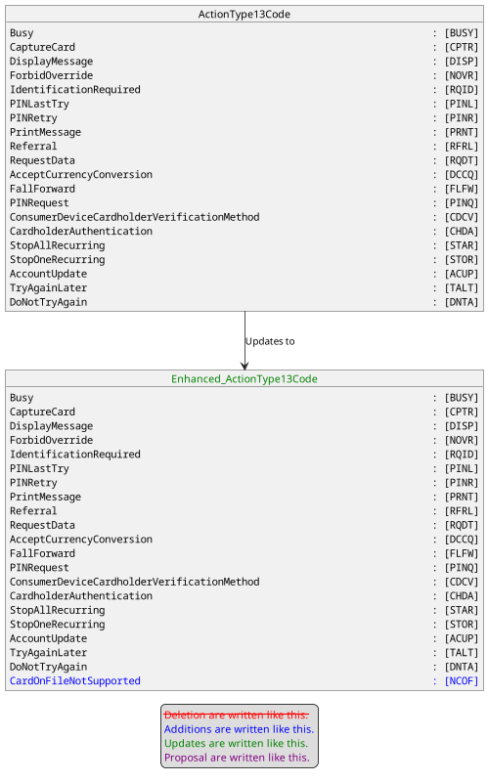

- Purpose of the change:

This change request aims to inform the accepting solution that it can’t process a subsequent transaction with credentials for this account. Then it could help the accepting solution to run specific tasks related to this action. This action code could be received with an Approved transaction.

- Urgency of the request:
Urgent
- Business examples:
Examples illustrating the change request.
- SEG/TSG recommendation:
This section is not to be taken care of by the submitter of the change request. It will be completed in due time by the SEG(s) in charge of the related ISO 20022 messages or the TSG for changes related to the BAH.

Consider |  |  | Timing
 |  |  | - Next yearly cycle: 2024/2025  (the change will be considered for implementation in the yearly maintenance cycle which starts in 2018 and completes with the publication of new message versions in the spring of 2019) |  | X
- At the occasion of the next maintenance of the messages
(the change will be considered for implementation, but does not justify maintenance of the messages in its own right – will be pending until more critical change requests are received for the messages)
- Urgent unscheduled
(the change justifies an urgent implementation outside of the normal yearly cycle)
 |  |  | - Other timing:
Comments:
There are comments from the representatives of Mastercard and VISA that the new Action Type CARD ON FILE NOT SUPPORTED is not existing in Issuer Responses. This is a Merchant Advice Code so far. Nevertheless the other participants recommend to tolerate this minor inconsistency since the terminal to Acquirer Host may interpret the response of the issuer in another way.

Reject
Reason for rejection:

