Change Request
for the update of ISO 20022 financial repository items

- Origin of the request:
A.1 Submitter: nexo A.I.S.B.L.
A.2 Contact person:
- Philippe CECE (philippe.cece@nexo-standards.org)
- Evelyne de JONGHE (evelyne.de-jonghe@frenchsys.com)

A.3 Sponsors: nexo A.I.S.B.L.

- Related messages:

- AcceptorAuthorisationRequest V13 (caaa.001.001.13)
- AcceptorCompletionAdvice V13 (caaa.003.001.13)
- AcceptorCancellationRequest V13 (caaa.005.001.13)
- AcceptorCancellationAdvice V13 (caaa.007.001.13)
- AcceptorBatchTransfer V13 (caaa.011.001.13)
- AcceptorCurrencyConversionRequest V11 (caaa.016.001.11)
- TransactionAdvice V05 (caaa.020.001.05)
- AcceptorNonFinancialRequest V04 (caaa.022.001.04)
- AcceptorTransactionLogReportResponse V04 (caaa.025.001.04)
- AcceptorToAcquirerBatchFileExchange V01 (caaa.026.001.01)
- SaleToPOIServiceRequest V06 (casp.001.001.06)
- SaleToPOIServiceResponse V06 (casp.002.001.06)
- SaleToPOIReportResponse V06 (casp.010.001.06)
- SaleToPOIMessageStatusResponse V06 (casp.015.001.06)

- Description of the change request:

We want to update CardPaymentServiceType9Code to identify transactions that are eligible to deferred clearing like transactions related to health system.
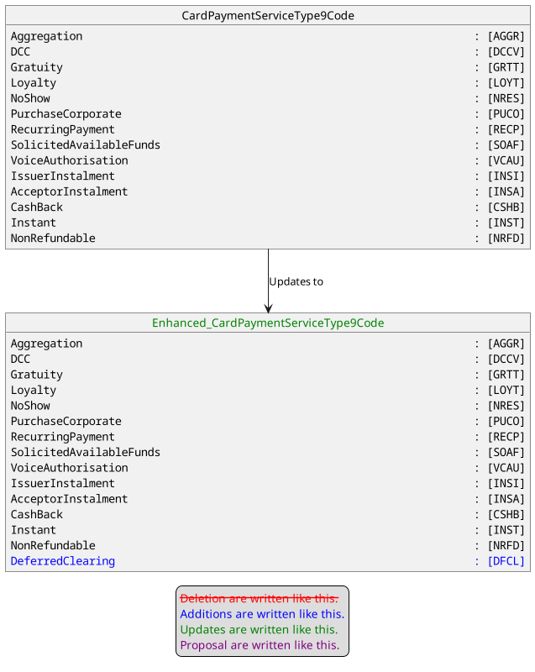

- Purpose of the change:

This change request aims to inform acquiring and clearing system that the transaction is eligible to deferred clearing. This feature is common for transaction related to healthcare.

- Urgency of the request:
Urgent
- Business examples:
Examples illustrating the change request.
- SEG/TSG recommendation:
This section is not to be taken care of by the submitter of the change request. It will be completed in due time by the SEG(s) in charge of the related ISO 20022 messages or the TSG for changes related to the BAH.

Consider |  |  | Timing
 |  |  | - Next yearly cycle: 2024/2025  (the change will be considered for implementation in the yearly maintenance cycle which starts in 2018 and completes with the publication of new message versions in the spring of 2019) |  | X
- At the occasion of the next maintenance of the messages
(the change will be considered for implementation, but does not justify maintenance of the messages in its own right – will be pending until more critical change requests are received for the messages)
- Urgent unscheduled
(the change justifies an urgent implementation outside of the normal yearly cycle)
 |  |  | - Other timing:
Comments:
There is a comment from the VISA representative that the position of the new code is not the right one in AdditionalService with the Type CardPaymentServiceType9Code.
Since it is more a service attribute the submitter is asked to consider whether the code list ServiceAttribute with multiplicity [0..1] can be used for this new code. If there is no objection from the nexo Acquirer Protocol WG members this solution will be implemented otherwise the code list AdditionalService will be enhanced. The participants present in the final meeting will tolerate this compromise.

Reject
Reason for rejection:

