Change Request
for the update of ISO 20022 financial repository items
Note: the purpose of this document is to give guidelines to parties who want to introduce a request to change an existing ISO 20022 message(s), or update other items of the ISO 20022 financial repository. Such change requests are subject to the approval of the ISO 20022 Standards Evaluation Group(s) in charge of the related message/item or to the approval of the Technical Support Group (TSG), if the requested change relates to the Business Application Header (BAH). Please consult the iso20022.org website for additional details on the maintenance process. Change requests are to be sent to iso20022ra@iso20022.org. All change requests conforming to this template received by June 1st will be considered for development in the following yearly ISO 20022 maintenance cycle which completes with publication of new message versions in April/May of the following year.
- Origin of the request:
A.1 Submitter: DESSUG CA – PSG (Deutsche SWIFT Securities Market User Group - Corporate Actions - Proxy Subgroup Germany). This group represents more than 20 different institutions including domestic and global proxy providers and registrars with a key role in the German General Meeting process.
A.2 Contact person: Hendrik Melchior, Hendrik.Melchior@Clearstream.com, Phone +49 69 211-13263 --- Daniel Schäfer, Daniel.Schaefer@hsbc.de, Phone +49 211 910-2362 --- Nils Stock, Nils.Stock@db.com, Phone +49 69 910-43199 --- Rainer Prior, Rainer.Prior@linkmarketservices.de, Phone +49 6196 8870 514
A.3 Sponsors: German Market
- Related messages:
seev.001, seev.004
- Description of the change request:
Not Voting (PHNV) option in the Participation Method / Code block should be removed as the scenario is already covered by PHYS with Meeting Attendee/ ParticipationMethod >not-voting< in the seev.004.
Simplify the message structure by removing unnecessary participation methods. Remove PHNV in /Document/MtgNtfctn/Mtg/Prtcptn/PrtcptnMtd/Cd from seev.001 and corresponding seev.004 field.
The investor can already use seev.004 /Document/MtgInstr/Instr/MtgAttndee/PrtcptnMtd with the only available code PHNV to indicate that the attendee should not have voting rights.

- Purpose of the change:
To simplify the ISO message structure as there is a lot of confusion with this field value.
- Urgency of the request:
By default.
- Business examples:

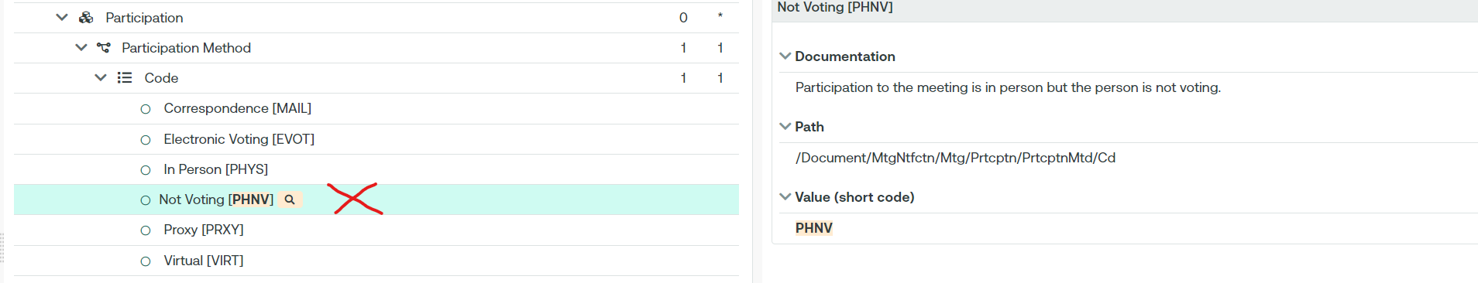
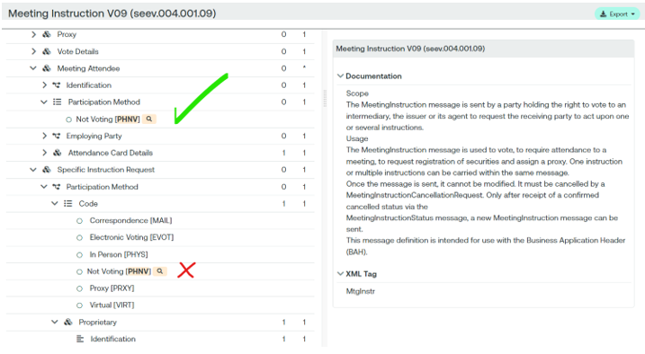

- SEG/TSG recommendation:
This section is not to be taken care of by the submitter of the change request. It will be completed in due time by the SEG(s) in charge of the related ISO 20022 messages or the TSG for changes related to the BAH.

Consider |  |  | Timing
- Next yearly cycle: 2024/2025
(the change will be considered for implementation in the yearly maintenance cycle which starts in 2024 and completes with the publication of new message versions in the spring of 2025)
- At the occasion of the next maintenance of the messages
(the change will be considered for implementation, but does not justify maintenance of the messages in its own right – will be pending until more critical change requests are received for the messages)
- Urgent unscheduled
(the change justifies an urgent implementation outside of the normal yearly cycle)
 |  |  | - Other timing:
Comments:

Reject | X
Reason for rejection:
The ET rejects unanimously (to the exception of the submitter - Germany) the proposed change as this is a follow up of the CR 1398 that has been rejected. This would introduce too much confusion in the message.

