Change Request
for the update of ISO 20022 financial repository items
Note: the purpose of this document is to give guidelines to parties who want to introduce a request to change an existing ISO 20022 message(s), or update other items of the ISO 20022 financial repository. Such change requests are subject to the approval of the ISO 20022 Standards Evaluation Group(s) in charge of the related message/item or to the approval of the Technical Support Group (TSG), if the requested change relates to the Business Application Header (BAH). Please consult the iso20022.org website for additional details on the maintenance process. All change requests conforming to this template received by June 1st will be considered for development in the following yearly ISO 20022 maintenance cycle which completes with publication of new message versions in April/May of the following year.
Changes requests are to be submitted through the ISO 20022 website through this e-request, in which this template must be attached.
- Origin of the request:
A.1 Submitter: CLS Bank International
A.2 Contact person: Stuart Buckley. sbuckley@cls-services.com

A.3 Sponsors: This change will be socialised with all CLS Member/Participant banks via an official Participant notice. We adopt a policy at CLS of aligning our messages to the latest standards where there is a valid business case to do so. No objections to this strategy have been received.
- Related messages:
The list of ISO 20022 messages which would be impacted by the change, including the Message IDs as shown in the Catalogue of ISO 20022 messages. Only the latest version of a message definition can be maintained.

Message | Message Name
camt.088.001.02.xsd | NetReportV02

- Description of the change request:
Updating the camt.088 with the capability of handling CNH/CNY to align with the fxtr messages that are also being updated to align with field 39M Payment Clearing Centre in the MT 300 and MT 304.

This addition to the camt.088 will ensure that we are fully aligned to the MT 300 and MT 304 and meet future market expectations regarding standards compatibility between the XML message suite and the MT 3XX messages.
- Purpose of the change:
CLS also has a policy of aligning messages to the latest versions and standards. Adding the above change to the camt.088 continues this practice. This Payment Clearing Centre option has been omitted from previous updates but may be required by the market in the future, so we feel the updates are essential to ensure the camt.088 is up to date when required by the business. This will meet our Participants expectations regarding standards alignment across our message suite.
- Urgency of the request:
- Default timeline of June 1st for submission and availability of the new versions in SR2025
- Business examples:
The new MX element/s required in the camt.088 message to align with the below MT 300 and MT 304 change requests from previous Standards releases.

Field 39M
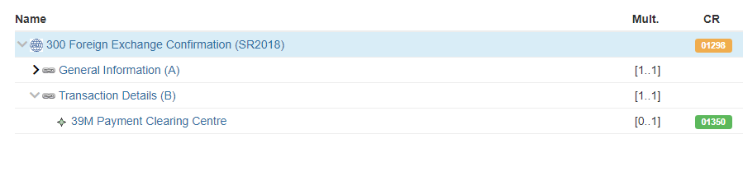

SEG/TSG recommendation:
This section is not to be taken care of by the submitter of the change request. It will be completed in due time by the SEG(s) in charge of the related ISO 20022 messages or the TSG for changes related to the BAH.

Consider |  | X | Timing
 |  |  | - Next yearly cycle: 2024/2025  (the change will be considered for implementation in the yearly maintenance cycle which starts in 2024 and completes with the publication of new message versions in the spring of 2025) |  | X
- At the occasion of the next maintenance of the messages
(the change will be considered for implementation, but does not justify maintenance of the messages in its own right – will be pending until more critical change requests are received for the messages)
- Urgent unscheduled
(the change justifies an urgent implementation outside of the normal yearly cycle)
 |  |  | - Other timing:
Comments:
CLS stated that they wish to use this feature as soon as possible and would therefore like it included to the maintenance cycle 2024/2025. This CR is directly linked to CR1394.

Reject
Reason for rejection:

