**Change Request**

**for the update of ISO 20022 financial repository items**

*Note: the purpose of this document is to give guidelines to parties who want to introduce a request to change an existing ISO 20022 message(s), or update other items of the ISO 20022 financial repository. Such change requests are subject to the approval of the ISO 20022 Standards Evaluation Group(s) in charge of the related message/item or to the approval of the Technical Support Group (TSG), if the requested change relates to the Business Application Header (BAH). Please consult the iso20022.org website for additional details on the* [*maintenance process*](http://www.iso20022.org/maintenance.page)*. All change requests conforming to this template received by June 1st will be considered for development in the following yearly ISO 20022 maintenance cycle which completes with publication of new message versions in April/May of the following year.*

Changes requests are to be submitted through the ISO 20022 website through [*this e-request*](https://www.iso20022.org/maintenance-iso-20022-message-definitions-request), in which this template must be attached.

1. **Origin of the request:**

*A.1 Submitter*: CLS Bank International

*A.2 Contact person:* Stuart Buckley. sbuckley@cls-services.com

*A.3 Sponsors*: This change will be socialised with all CLS Member/Participant banks via an official Participant notice. We adopt a policy at CLS of aligning our messages to the latest standards where there is a valid business case to do so. No objections to this strategy have been received.

1. **Related messages:**

The list of ISO 20022 messages which would be impacted by the change, including the Message IDs as shown in the [Catalogue of ISO 20022 messages](http://www.iso20022.org/catalogue_of_messages.page). Only the latest version of a message definition can be maintained.

|  |  |
| --- | --- |
| **Message** | **Message Name** |
| fxtr.014.001.05.xsd | ForeignExchangeTradeInstructionV05 |
| fxtr.015.001.05.xsd | ForeignExchangeTradeInstructionAmendmentV05 |
| fxtr.016.001.05.xsd | ForeignExchangeTradeInstructionCancellationV05 |
| fxtr.017.001.05.xsd | ForeignExchangeTradeStatusAndDetailsNotificationV05 |

1. **Description of the change request:**

Updating the message schemas listed above from the suite of CLS related FX messages with the following:

* Underlying Product Identifier (update from 6-12 chr to align to 22U in the MT 300/304)
* Calculation Agent field (to align to 26K)
* Payment Clearing Centre field (to align to 39M)
* Post Trade Events sequence (to align to Optional sequence F)
  + Event Type and Reference (to align to 21H)
  + Underlying liability Reference (to align to 21F)
  + Profit and Loss Settlement Date (to align to 30F)
  + Profit and Loss Settlement Amount (to align to 32H)
  + Outstanding Settlement Amount (to align to 33E)

These additions to the fxtr messages will ensure that they are fully aligned to the MT 300 and MT 304 and meet future market expectations regarding standards compatibility between the XML message suite and the MT 3XX messages.

1. **Purpose of the change:**

CLS also has a policy of aligning messages to the latest versions and standards. Adding the above fields to the fxtr messages continues this practice. These fields have been omitted from previous updates but may be required by the market in the future, so we feel the updates are essential to ensure the fxtr messages are up to date when required by the business. This will meet our Participants expectations regarding standards alignment across our message suite.

1. **Urgency of the request:**
2. Default timeline of June 1st for submission and availability of the new versions in SR2025
3. **Business examples:**

These are new MX elements required in the fxtr messages to align with the below MT 300 and MT 304 change requests from previous Standards releases.

Field 22U

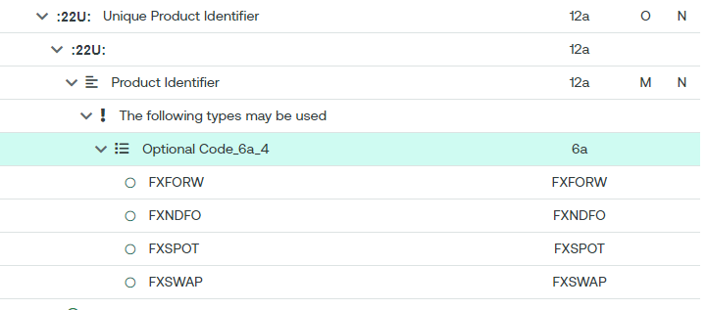

Field 39M

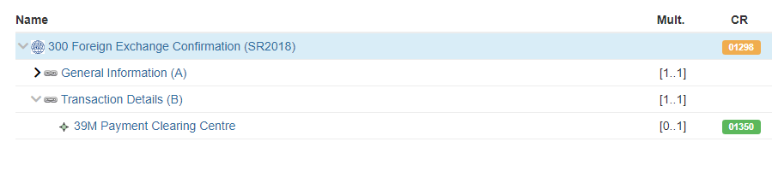

Field 26K

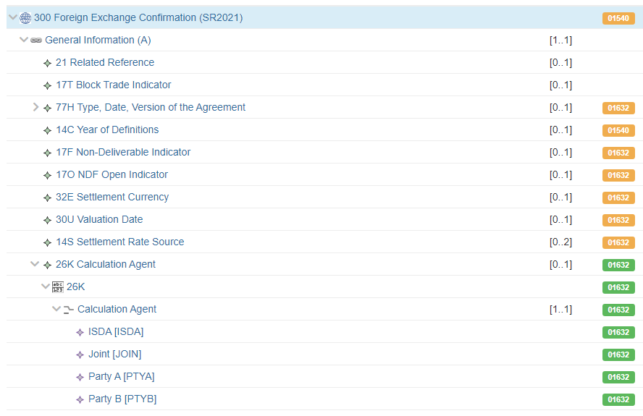

Post Trade events sequence (Fields 21H, 21F, 30F, 32H and 33E)

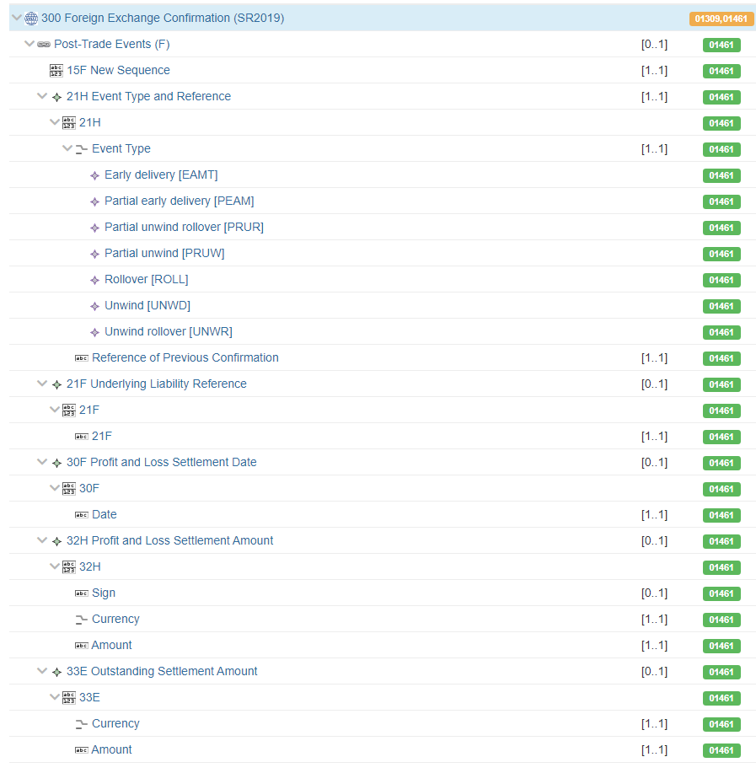

1. **SEG/TSG recommendation:**

*This section is not to be taken care of by the submitter of the change request. It will be completed in due time by the SEG(s) in charge of the related ISO 20022 messages or the TSG for changes related to the BAH.*

|  |  |  |  |
| --- | --- | --- | --- |
| **Consider** | | X | **Timing** |
|  | | - **Next yearly cycle: 2024/2025**  (the change will be considered for implementation in the yearly maintenance cycle which starts in 2024 and completes with the publication of new message versions in the spring of 2025) | | X |
|  | | - **At the occasion of the next maintenance of the messages**  (the change will be considered for implementation, but does not justify maintenance of the messages in its own right – will be pending until more critical change requests are received for the messages) | |  |
|  | | - **Urgent unscheduled**  (the change justifies an urgent implementation outside of the normal yearly cycle) | |  |  |
|  | | - **Other timing:** | | |  |

Comments:

CLS stated that they plan to use the Payment Clearing Centre as soon as it is available, as part of their netting service. They would therefore like the CR to be implemented as part of the maintenance cycle 2024/2025.

It was noted that Underlying Product Identifier should be correctly referred to as Unique Product Identifier.

|  |  |
| --- | --- |
| **Reject** |  |

Reason for rejection: