**Change Request**

**for the update of ISO 20022 financial repository items**

*Note: the purpose of this document is to give guidelines to parties who want to introduce a request to change an existing ISO 20022 message(s), or update other items of the ISO 20022 financial repository. Such change requests are subject to the approval of the ISO 20022 Standards Evaluation Group(s) in charge of the related message/item or to the approval of the Technical Support Group (TSG), if the requested change relates to the Business Application Header (BAH). Please consult the iso20022.org website for additional details on the* [*maintenance process*](http://www.iso20022.org/maintenance.page)*. All change requests conforming to this template received by June 1st will be considered for development in the following yearly ISO 20022 maintenance cycle which completes with publication of new message versions in April/May of the following year.*

Changes requests are to be submitted through the ISO 20022 website through [*this e-request*](https://www.iso20022.org/maintenance-iso-20022-message-definitions-request), in which this template must be attached.

1. **Origin of the request:**

*A.1 Submitter*: CLS Bank International

*A.2 Contact person:* Stuart Buckley. sbuckley@cls-services.com

*A.3 Sponsors*: This change will be socialised with all CLS Member/Participant banks via an official Participant notice. We adopt a policy at CLS of aligning our messages to the latest standards where there is a valid business case to do so. No objections to this strategy have been received.

1. **Related messages:**

The list of ISO 20022 messages which would be impacted by the change, including the Message IDs as shown in the [Catalogue of ISO 20022 messages](http://www.iso20022.org/catalogue_of_messages.page). Only the latest version of a message definition can be maintained.

|  |  |
| --- | --- |
| **Message** | **Message Name** |
| fxtr.030.001.05.xsd | ForeignExchangeTradeBulkStatusNotificationV05 |

1. **Description of the change request:**

Updating the message schema for the fxtr.030.001.05 message to optimize the bulk trade status notifications for bilateral netting in CLSNet and reducing the number of notifications generated.

Bulk trade status notifications generated for bilateral netting in CLSNet currently require individual notifications to link each net position (<LkdRptId>) with the corresponding trades. This message schema creates inefficiencies when handling a large number of bilateral net positions, requiring generation of numerous notifications. To optimize this process, we propose a schema update that allows the inclusion of multiple bilateral positions within a single bulk notification. This improvement will significantly reduce the number of notifications generated.

Currently in CLSNet the fxtr.030 is used to link the Obligation Id (Bilateral Reference) for each net position to the underlying trades.

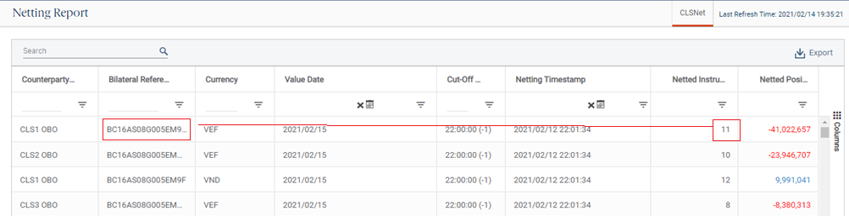

**Purpose of the change:**

To optimize the fxtr.030 message for bilateral netting to reduce the number of notifications generated for CLSNet without negatively impacting the schema for general use in the primary CLSSettlement service.

1. **Urgency of the request:**
2. Default timeline of June 1st for submission and availability of the new versions in SR2025
3. **Business examples:**

**Sample fxtr.030:**

Unlike the primary CLSSettlement service, we need to establish the link between the bilateral net position and the underlying trades; So the <LkdRptId> (Obligation Id in camt.088) is populated.

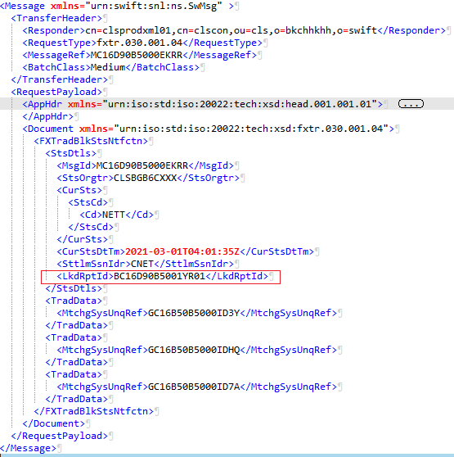

**Sample camt.088 showing a single obligation:**

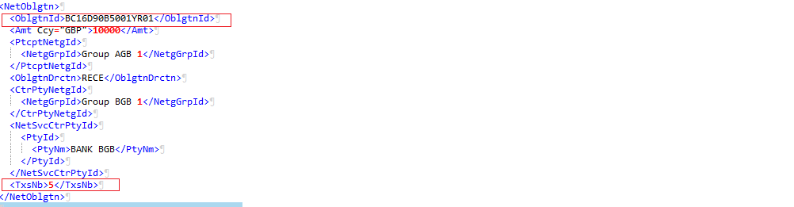

1. **SEG/TSG recommendation:**

*This section is not to be taken care of by the submitter of the change request. It will be completed in due time by the SEG(s) in charge of the related ISO 20022 messages or the TSG for changes related to the BAH.*

|  |  |  |  |
| --- | --- | --- | --- |
| **Consider** | | X | **Timing** |
|  | | - **Next yearly cycle: 2024/2025**  (the change will be considered for implementation in the yearly maintenance cycle which starts in 2024 and completes with the publication of new message versions in the spring of 2025) | | X |
|  | | - **At the occasion of the next maintenance of the messages**  (the change will be considered for implementation, but does not justify maintenance of the messages in its own right – will be pending until more critical change requests are received for the messages) | |  |
|  | | - **Urgent unscheduled**  (the change justifies an urgent implementation outside of the normal yearly cycle) | |  |  |
|  | | - **Other timing:** | | |  |

Comments:

CLS stated that they wish to use this feature as soon as possible and would therefore like it included to the maintenance cycle 2024/2025. This CR is directly linked to CR1395.

|  |  |
| --- | --- |
| **Reject** |  |

Reason for rejection: