**Change Request**

**for the update of ISO 20022 financial repository items**

*Note: the purpose of this document is to give guidelines to parties who want to introduce a request to change an existing ISO 20022 message(s), or update other items of the ISO 20022 financial repository. Such change requests are subject to the approval of the ISO 20022 Standards Evaluation Group(s) in charge of the related message/item or to the approval of the Technical Support Group (TSG), if the requested change relates to the Business Application Header (BAH). Please consult the iso20022.org website for additional details on the* [*maintenance process*](http://www.iso20022.org/maintenance.page)*. Change requests are to be sent to* [*iso20022ra@iso20022.org*](mailto:iso20022ra@iso20022.org)*. All change requests conforming to this template received by June 1st will be considered for development in the following yearly ISO 20022 maintenance cycle which completes with publication of new message versions in April/May of the following year.*

1. **Origin of the request:**

*A.1 Submitter:* SMPG payment task force represented by Charles Boniver – Swift Standards, Karine Taquet – Swift Standards, Dean Shard – Swift Standards.

*A.2 Contact person:*

- Karine Taquet – Swift Standards - karine.taquet@swift.com (+32 2 655 3784)

- Dean Chard – Swift Standards - dean.chard@swift.com (+44 20 7762 2334)

*A.3 Sponsors:*

SMPG payment task force

1. **Related messages:**

camt.052.001.12, camt.053.001.12 and camt.054.001.12

1. **Description of the change request:**

Need to change the element used in the camt.052, camt.053 and camt.054 for the identification of the corporate action event type.

Currently, it is a Max35Text, and it should be the same element used in the seev messages: CorporateActionEventType84Choice.

In the camt.053:

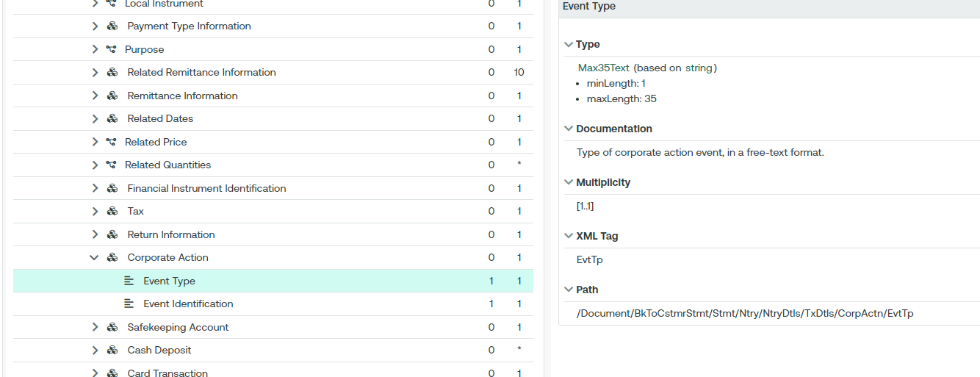

In the seev.031:

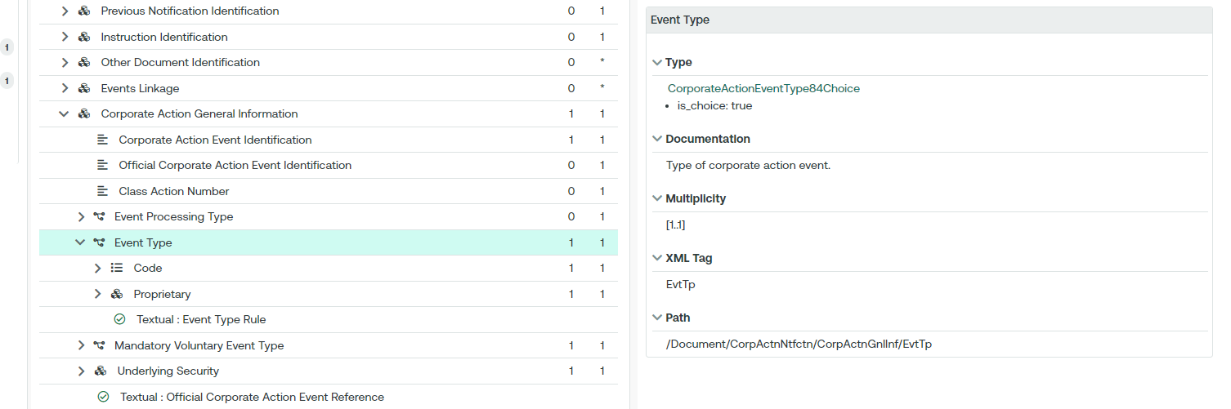

Also the event identification element (EvtId) in the camt.052, camt.053 & camt.054 should be replaced by two elements from the seev.031 message:

* Corporate Action Event Identification (CorpActnEvtId)
* Official Corporate Action Event Identification (OffclCorpActnEvtId)

In the camt.053:

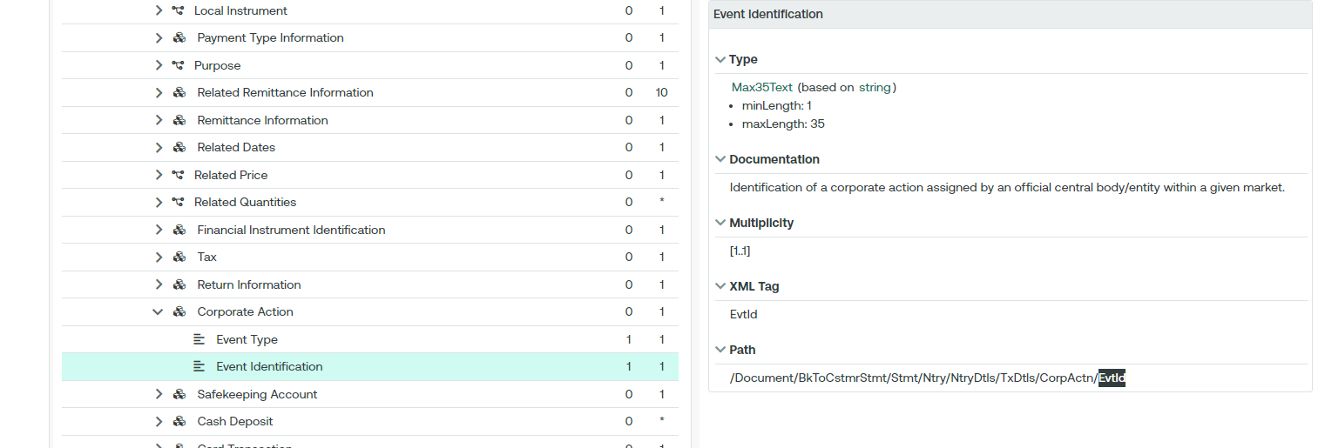

In the seev.031:

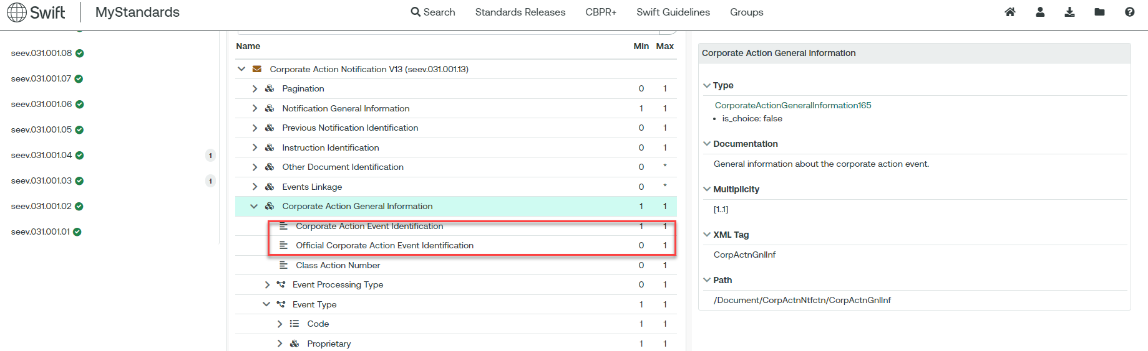

1. **Purpose of the change:**

To align and use the latest message elements as in the corporate action messages.

1. **Urgency of the request:**

Cycle 2024-2025

1. **Business examples:**

N/A.

1. **SEG/TSG recommendation:**

*This section is not to be taken care of by the submitter of the change request. It will be completed in due time by the SEG(s) in charge of the related ISO 20022 messages or the TSG for changes related to the BAH.*

|  |  |  |  |
| --- | --- | --- | --- |
| **Consider** | | X | **Timing** |
|  | | - **Next yearly cycle: 2024/2025**  (the change will be considered for implementation in the yearly maintenance cycle which starts in 2024 and completes with the publication of new message versions in the spring of 2025) | | X |
|  | | - **At the occasion of the next maintenance of the messages**  (the change will be considered for implementation, but does not justify maintenance of the messages in its own right – will be pending until more critical change requests are received for the messages) | |  |
|  | | - **Urgent unscheduled**  (the change justifies an urgent implementation outside of the normal yearly cycle) | |  |  |
|  | | - **Other timing:** | | |  |

Comments:

|  |  |
| --- | --- |
| **Reject** |  |

Reason for rejection: