**Change Request**

**for the update of ISO 20022 financial repository items**

*Note: the purpose of this document is to give guidelines to parties who want to introduce a request to change an existing ISO 20022 message(s), or update other items of the ISO 20022 financial repository. Such change requests are subject to the approval of the ISO 20022 Standards Evaluation Group(s) in charge of the related message/item or to the approval of the Technical Support Group (TSG), if the requested change relates to the Business Application Header (BAH). Please consult the iso20022.org website for additional details on the* [*maintenance process*](http://www.iso20022.org/maintenance.page)*. Change requests are to be sent to* [*iso20022ra@iso20022.org*](mailto:iso20022ra@iso20022.org)*. All change requests conforming to this template received by June 1st will be considered for development in the following yearly ISO 20022 maintenance cycle which completes with publication of new message versions in April/May of the following year.*

1. **Origin of the request:**

*A.1 Submitter*: Swift

*A.2 Contact person:* Dominique Forceville/Pieter Herrebout

*A.3 Sponsors*: Case Management initiative and pilot group

1. **Related messages:**

Camt.111 – investigation response V1

1. **Description of the change request:**

The account is mandatory in the confirmation component under response data and investigation data.

The change requested is to make the account optional.

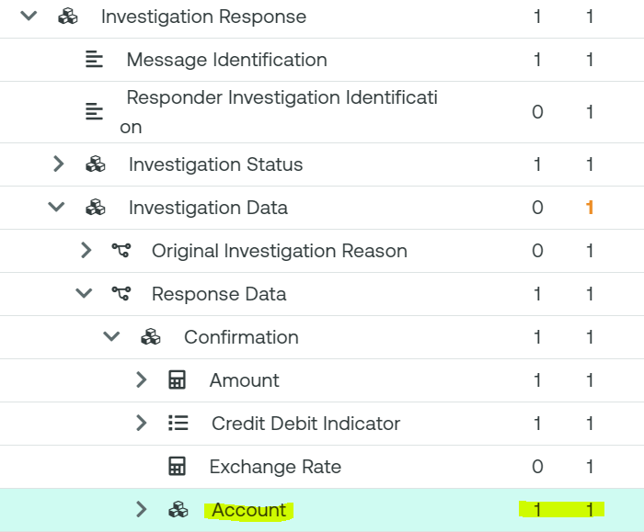

1. **Purpose of the change:**

Today, the account element in the camt.111 investigation response message is mandatory in the investigation data>response data>confirmation block.

When a creditor agent (as account servicer) uses the camt.111 to close a creditor claim non receipt investigation by confirming the credit, it must populate the account that was used for the credit.

However, in creditor claim non receipt use cases that rely on central orchestration performed by Case Manager (Swift’s central utility for E&I), account information may not be available in the central tracking database that Case Manager uses to perform such operations.

This use case is described below and goes as follows:

1. Pacs.008 from debtor agent to intermediary agent 1
2. Pacs.008 from intermediary agent 1 to the creditor agent
3. The creditor agent confirms credit to the tracking system (ACCC status registered). This update to the tracker does not include account information.
4. The creditor contacts the debtor who contacts the debtor agent (not shown) as the funds are still missing and the debtor agent initiates a creditor claim non receipt operation by sending the camt.110 investigation request message to Case Manager.

4a. Since Case Manager relies on the tracking information where ACCC status was registered, Case Manager auto-closes the investigation by sending the camt.111 with CLSD status to the debtor agent.

Today, Case Manager populates the account element with the code word ‘NOTAVAILABLE’. The request is to make the account element optional so that it must not be used for auto-closure cases as described.

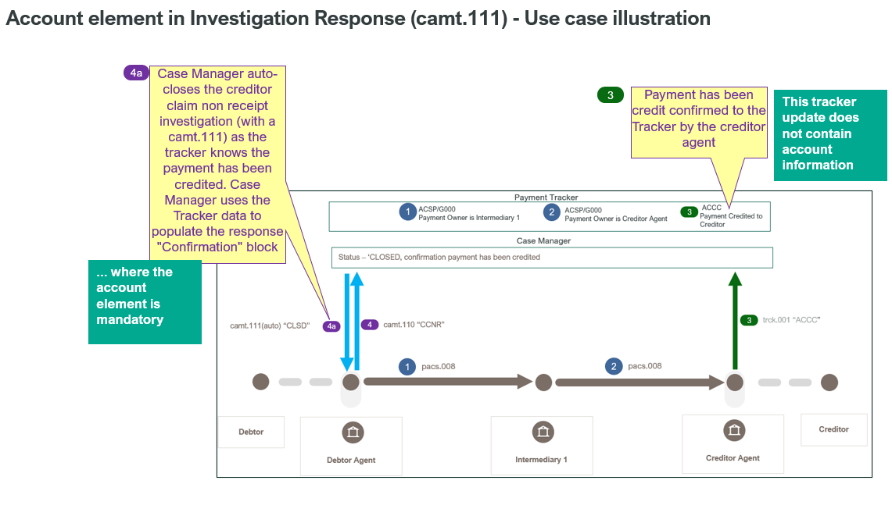

1. **Urgency of the request:**

2024/2025 maintenance cycle

1. **Business examples:**

See section ‘purpose of the change’

**Important note**: It needs to be ensured that the new version of the camt.111 (and camt.110) are not aligned with the new postal address/remittance information as we want to stay aligned with the current version of CBPR+/HVPS+ (the updated remittance is not backward compatible).

1. **SEG/TSG recommendation:**

*This section is not to be taken care of by the submitter of the change request. It will be completed in due time by the SEG(s) in charge of the related ISO 20022 messages or the TSG for changes related to the BAH.*

|  |  |  |  |
| --- | --- | --- | --- |
| **Consider** | | X | **Timing** |
|  | | - **Next yearly cycle: 2024/2025**  (the change will be considered for implementation in the yearly maintenance cycle which starts in 2024 and completes with the publication of new message versions in the spring of 2025) | | X |
|  | | - **At the occasion of the next maintenance of the messages**  (the change will be considered for implementation, but does not justify maintenance of the messages in its own right – will be pending until more critical change requests are received for the messages) | |  |
|  | | - **Urgent unscheduled**  (the change justifies an urgent implementation outside of the normal yearly cycle) | |  |  |
|  | | - **Other timing:** | | |  |

Comments:

|  |  |
| --- | --- |
| **Reject** |  |

Reason for rejection: