Change Request
for the update of ISO 20022 financial repository items
Note: the purpose of this document is to give guidelines to parties who want to introduce a request to change an existing ISO 20022 message(s), or update other items of the ISO 20022 financial repository. Such change requests are subject to the approval of the ISO 20022 Standards Evaluation Group(s) in charge of the related message/item or to the approval of the Technical Support Group (TSG), if the requested change relates to the Business Application Header (BAH). Please consult the iso20022.org website for additional details on the maintenance process. Change requests are to be sent to iso20022ra@iso20022.org. All change requests conforming to this template received by June 1st will be considered for development in the following yearly ISO 20022 maintenance cycle which completes with publication of new message versions in April/May of the following year.
- Origin of the request:
A.1 Submitter: Deutsche Bundesbank on behalf of the Eurosystem / 4CB
A.2 Contact person:
- Stéphanie Radet, +49 69 9566-33528
- Ann-Kristin Gonska, +49 69 9566-14278
- t2s-fam@bundesbank.de
A.3 Sponsors: SWIFT Standards

- Related messages:
Impacted messages:
camt.025.001.08 Receipt V8

- Description of the change request:
T2S has been using the camt.025 since its onset. The Receipt message is sent by T2S to a CB or directly connected T2S Party or an RTGS system (e.g. TARGET2) to confirm/reject the execution of a liquidity transfers from a T2S Dedicated Cash Account to a cash account in an RTGS system and vice versa. It is also used to inform an RTGS system that all liquidity transfers in T2S are final (T2S UDFS R2024.JUN).
If the liquidity transfer was not successful, an error Status or validation Status is sent back to the originator of the Liquidity Transfer, as well as the narrative of the error, contained in element <Desc>, which was up to version 07 a Max140Text string of characters. The above mentioned RequestHandling1 <Desc> is also used and aligned with the Error Handling <Desc> field within other cash management messages (camt.004, camt.006 etc.).
The new structure of the camt.025 version 08, introduced with fast track CR1346, does not cater anymore for a description of the Status. Instead, the new structure of the message, modeled after the pacs.002, forces the sender of the message to give a Reason for the Status in <AddtlInf>, which is however limited to max105Text string of characters, while being unbounded.

Comparison between the schema used by T2S and the base message:
- camt.025.001.05 (version currently used by T2S in production)
Structure of RequestHandling1 (available until Receipt V07)
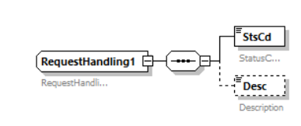
T2S Example:
Business validation was not successful, and a Rejection Receipt is sent to the T2S Actor indicating the error that occurred.
<Document xmlns="urn:iso:std:iso:20022:tech:xsd:camt.025.001.05">
<Rct>
<MsgHdr>
<MsgId>NONREF</MsgId>
<ReqTp>
<Prtry>
<Id>VSTS</Id>
</Prtry>
</ReqTp>
</MsgHdr>
<RctDtls>
<OrgnlMsgId>
<MsgId>LIQUIDITYREF</MsgId>
</OrgnlMsgId>
<ReqHdlg>
<StsCd>L007</StsCd>
<Desc>LLCI003-Target (Credit) Account of internal or outbound LT is neither an existing nor an active T2S DCA or RTGS Account. </Desc>
</ReqHdlg>
</RctDtls>
</Rct>
</Document>

- Camt.025.001.08 (latest version)
Structure of RequestHandling3 (introduced with Receipt V08)
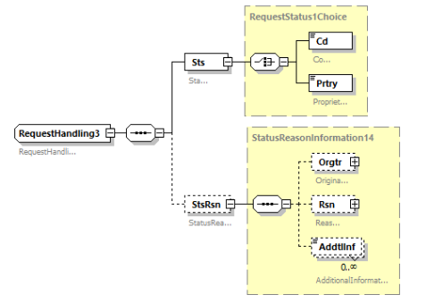
In order to migrate to Receipt V08, T2S would have to use StatusReason/AdditionalInformation for its narrative while not sending a Status Reason code at all.
- Purpose of the change:
To satisfy the camt.025 implementation of T2S, we request that the element <Description> be re-instated with Status Code, and leave StatusReasonInformation14 as done in CR-1346:

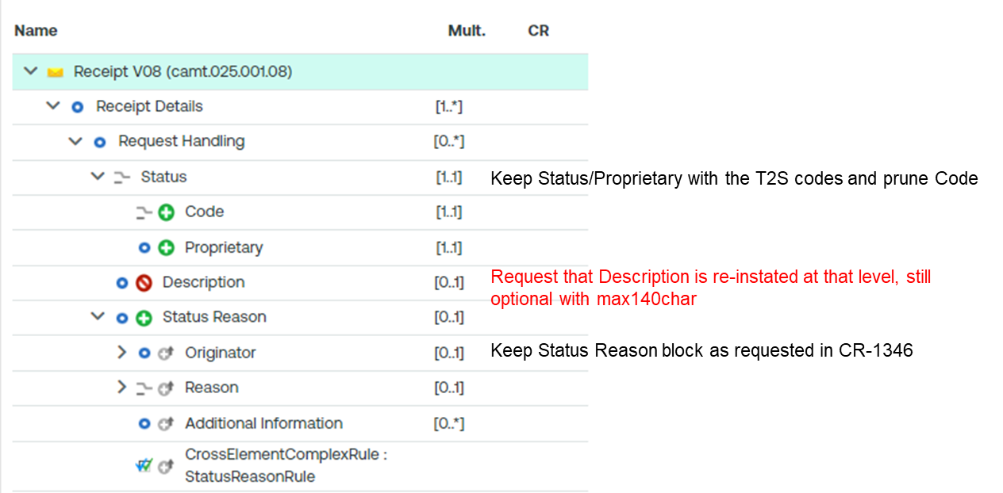
Note: the screenshot shows changes made from Receipt V07 to Receipt V08 with CR-1346. The element <Desc> was removed and the purpose of this change request is to re-instate it in a Receipt V09, so that T2S can continue to use it.

- Urgency of the request:
The Payment SEG is requested to consider this change request for the current maintenance cycle 2024/2025.

- Business examples:
Examples illustrating the change request.
SEG/TSG recommendation:
This section is not to be taken care of by the submitter of the change request. It will be completed in due time by the SEG(s) in charge of the related ISO 20022 messages or the TSG for changes related to the BAH.

Consider |  |  | Timing
- Next yearly cycle: 2024/2025
(the change will be considered for implementation in the yearly maintenance cycle which starts in 2024 and completes with the publication of new message versions in the spring of 2025)
- At the occasion of the next maintenance of the messages
(the change will be considered for implementation, but does not justify maintenance of the messages in its own right – will be pending until more critical change requests are received for the messages)
- Urgent unscheduled
(the change justifies an urgent implementation outside of the normal yearly cycle)
 |  |  | - Other timing:
Comments:

Reject
Reason for rejection:

ecb.europa.eu/paym/target/target-professional-use-documents-links/t2s/sdd/shared/pdf/T2S_UDFS_R2024.JUN_clean_20240222.en.pdf

