Change Request
for the update of ISO 20022 financial repository items
Note: the purpose of this document is to give guidelines to parties who want to introduce a request to change an existing ISO 20022 message(s), or update other items of the ISO 20022 financial repository. Such change requests are subject to the approval of the ISO 20022 Standards Evaluation Group(s) in charge of the related message/item or to the approval of the Technical Support Group (TSG), if the requested change relates to the Business Application Header (BAH). Please consult the iso20022.org website for additional details on the maintenance process. Change requests are to be sent to iso20022ra@iso20022.org. All change requests conforming to this template received by June 1st will be considered for development in the following yearly ISO 20022 maintenance cycle which completes with publication of new message versions in April/May of the following year.
- Origin of the request:
A.1 Submitter: Swift / ISO 20022 TSG.
A.2 Contact person: Jamie Osborne, Jamie.osborne@swift.com
A.3 Sponsors: Swift / ISO 20022 TSG.
- Related messages:
nvlp.001.001.01

- Description of the change request:
Retype the References MessageElement with an ExternalSchema type.
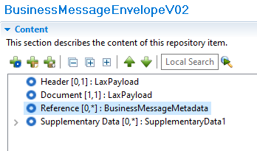
Figure 1: Standards Editor view of the change - the External Schema type is named “BusinessMessageMetadata”.
This remodelling supports backwards compatibility with nvlp.001.001.01 (by allowing users to enforce strict parsing against https://www.iso20022.org/standardsrepository/type/Reference22) while reducing the complexity of the resulting XML schema from 43 types to 6 as shown in the included schema. This schema is also five times smaller, and exponentially simpler to comprehend and use.
Note: This proposal removes the second Supplementary Data element in the Reference element (BizMsgEnvlp/Ref/SplmtryData), allowing deletion of the now redundant SupplementaryDataAndDocumentRule Textual Rule at the root element.
Note also that this proposal may be simplified even further by typing Reference with the same existing ISO 20022 LaxPayload generic external schema type as already used the Header and Document elements as shown here:
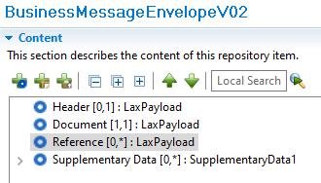
Figure 2: Alternative modelling using existing LaxPayload generic ExternalSchema type

Although that approach is certainly simpler, we propose to create a dedicated type based on LaxPayload because this allows us to add a further layer of definition and detail at the level of that type as shown.
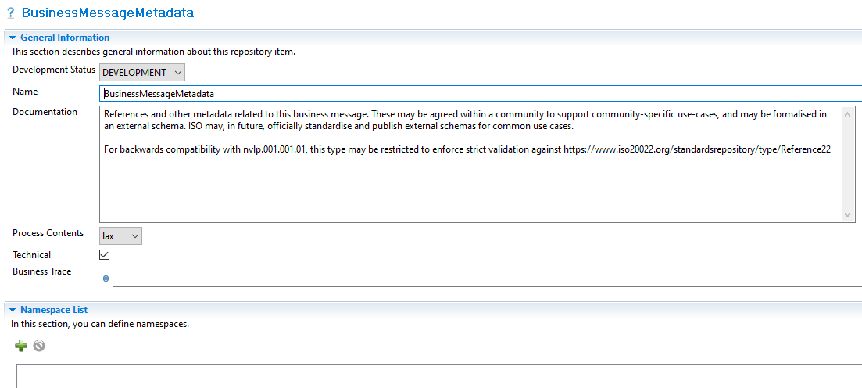
Figure 3: Creating a dedicated ExternalSchema type is often done for ISO 20022 because it allows additional information to be provided to implementers.
This approach mimics what ISO does for the Supplementary Data Envelope, for example, which specialises an analogous lax ExternalSchema type with further detail to help implementers understand how to use that type, as shown.
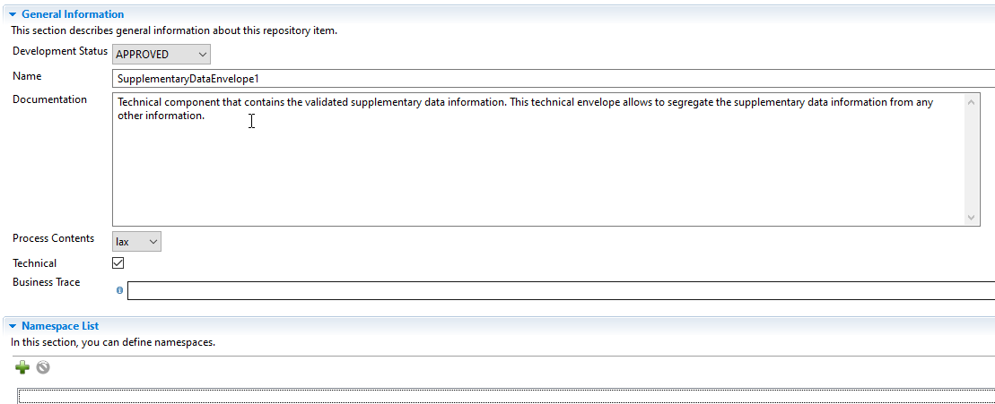
Figure 4: The proposed change mimics how other ISO 20022 types like Supplementary Data are modelled.
This approach also makes it easier for users to restrict the BME-specific type-only with a more restrictive namespace-based restriction, as is done in the BAH Signature Element, which also adds more specific descriptive detail in the Documentation for the type:
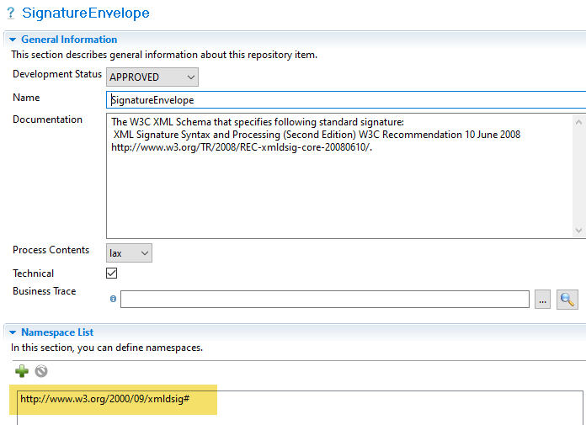
Figure 5: The proposed approach simplifies and clarifies for communities who would like to further restrict the type to their specific use case.

The separate, explicit type also clarifies and encourages implementers to refine that specific type as desired, using common practices and tooling. Here is an example showing how TARGET has done this to the signature element in their RTGS Business Application Header. Here TARGET uses MyStandards to change it from lax to strict processing.
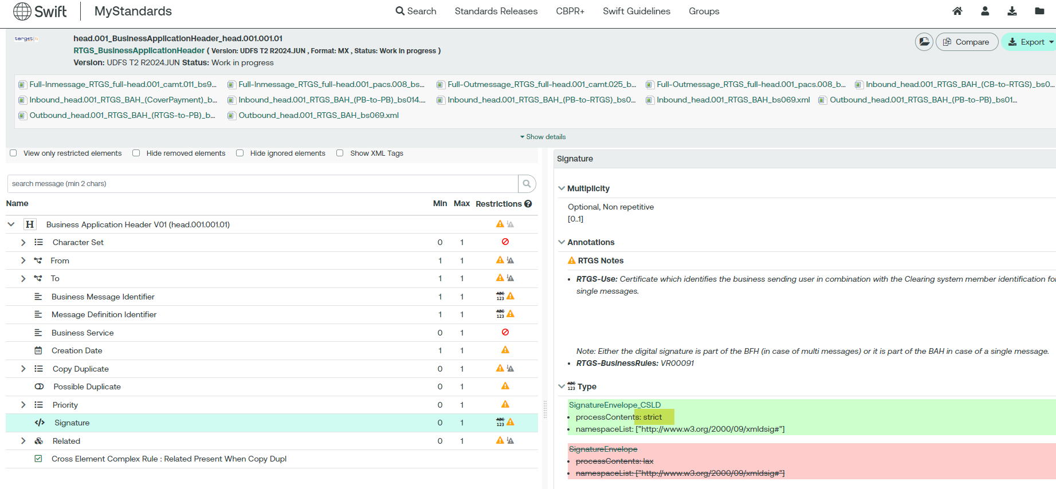
Figure 6: An example how a similar type is restricted by Target, using a tool like MyStandards.

- Purpose of the change:
The ISO 20022 Business Message Envelope (BME) closes an important gap in the ISO 20022 standard and opens many opportunities to improve end-to-end interoperability, transparency, and performance for users of the standard. It also offers an ISO 20022-compliant framework for communities to build valuable new adjacencies to their ISO 20022 messaging. It is therefore a welcome addition to ISO 20022.
However, because the BME is part of the business payload of an ISO 20022 Business Message, when present, it must be supported and transported end-to-end through the entire transaction. As the reader understands, an intermediary processing step may not drop information that is present in the Business Payload because it is unable to parse/process it.
Although it is part of the Business Payload, a technical processing envelope like the BME will be processed by far more technical, lower-level middleware than a typical ISO 20022 Business Message. While a typical ISO 20022-compliant Payments Application is expected to support a huge library of multiple versions of pacs, pain, camt, acmt, business standards, and to maintain these year on year, this is not the case for middleware and other systems that will interact with the BME.
For this reason, technical envelopes such as the BME must be flexible, while remaining as technically simple to process as possible. If data is present that an intermediary processing step does not understand or need to support its intermediary processing, then it must be as simple and efficient as possible to simply ignore and pass that data through.
Version 01 of the ISO 20022 Business Message Envelope (nvlp.001.001.01) is unnecessarily complex and difficult to support and maintain because it contains an explicitly modelled references element that is far too extensive and specific for a simple technical envelope. We know from more than 20 years of experience that ISO 20022 implementation and maintenance expense is directly related to the complexity of an ISO 20022 message – As the amount of formally modelled information in an ISO 20022 message grows, so does the effort and expense to support it.
This fact was highlighted when a CR was submitted against the BME before it was even one year old, and before Swift had even completed our review – the CR proposed an entirely new version of the BME simply because payments messages had begun to support a new version of the PostalAddress MessageComponent.
This CR highlighted the challenges with the current nvlp.001.001.01 Reference model – Not only does it impose a requirement to be able to process a complex structure on users of this element, it imposes a structure that contains data that is entirely irrelevant to a technical envelope (for example, postal addresses and the date and place of birth of individual persons) – This data can change for reasons that have nothing at all to do with any reasonable BME use-case.
Swift supports the original design intent of the references element, which is to provide a flexible mechanism for intermediaries to optionally introduce simple markup to the message to support various kinds of business tracking, auditing, etc, purposes. We do not feel, however, that ISO is ready to standardise these use cases, nor to restrict what users might want to put in this element. We can confidently say however, that we find no reasonable use case for the kind of data that is modelled in nvlp.001.001.01 Reference22 to be copied as-is into the BME from a business message such as a pacs.008. There can therefore be no reason to tightly couple these layers by sharing data elements.
After reviewing extensively with implementation experts across Swift and within our community, we felt that it was too risky to support the BME V01 because it imposes a requirement on Swift to be able to parse and honour the references end-to-end. The implementation cost throughout the Swift ecosystem is enormous and it cannot be justified, especially considering the potential for further changes like the aforementioned PostalAddress change.
Swift therefore requests that the formally modelled element is replaced with a simple, external schema that communities may formalise independently, where required, to support their use cases.
This design opens the possibility that communities may still submit models to formalise the contents of the references element to ISO as part of a less formal and restrictive submission process.

- Urgency of the request:
Swift recommends that this change is implemented as soon as possible – as mentioned above, the BME is a long overdue, welcome addition to the standard. Swift has identified BME use cases that we would like to explore, but nvlp.001.001.01 is not generally useful as-is for the reasons outline above.
Swift also believes that this change should be made before users begin to seriously consider implementing version 01. Although this proposal is backwards compatible with version 01, if we leave this update until after users have begun to implement, the early adopters will face unnecessary friction and maintenance burden when interoperating with other sub-systems that use version 02.

- Business examples:
Examples illustrating the change request provided separately to the TSG.

- SEG/TSG recommendation:
This section is not to be taken care of by the submitter of the change request. It will be completed in due time by the SEG(s) in charge of the related ISO 20022 messages or the TSG for changes related to the BAH.

Consider |  |  | Timing
- Next yearly cycle: 2024/2025
(the change will be considered for implementation in the yearly maintenance cycle which starts in 2024 and completes with the publication of new message versions in the spring of 2025)
- At the occasion of the next maintenance of the messages
(the change will be considered for implementation, but does not justify maintenance of the messages in its own right – will be pending until more critical change requests are received for the messages)
- Urgent unscheduled
(the change justifies an urgent implementation outside of the normal yearly cycle)
 |  |  | - Other timing:
Comments:

Reject
Reason for rejection:

