Maintenance Change Request

Note: the purpose of this document is to give guidelines to submitting organisations that will develop a new version of existing ISO 20022 messages based on change requests screened by the Standards Evaluation Group(s). Such development is subject to the approval of a Maintenance Change Request which must include a detailed description of the impact of each change on the related messages. The Maintenance Change Request must start with a general chapter covering topics related to the whole maintenance effort and a specific chapter for each change request, as described below. Please consult the iso20022.org website for additional details on the maintenance process.

- Name of the request:
General Meeting Messages Maintenance for year 2023/2024
- Submitting organization(s):
Swift, SMPG
- Related messages:
Under this project, the following ISO 20022 General Meeting messages highlighted in blue are maintained in the context of the General Meeting messages maintenance for year 2023/2024:

 | Message Name | Abbreviated Name | Identifier
1 | MeetingNotificationV10 | MENO | seev.001.001.10
2 | MeetingCancellationV09 | MECN | seev.002.001.09
3 | MeetingEntitlementNotificationV09 | MENT | seev.003.001.09
4 | MeetingInstructionV09 | MEIN | seev.004.001.09
5 | MeetingInstructionCancellationRequestV09 | MEIC | seev.005.001.09
6 | MeetingInstructionStatusV09 | MEIS | seev.006.001.09
7 | MeetingVoteExecutionConfirmationV09 | MECO | seev.007.001.09
8 | MeetingResultDisseminationV08 | MERD | seev.008.001.08
9 | Securities Message Rejection |  | semt.001.001.04

- Commitments of the submitting organization:
Swift and SMPG confirm that it can and will:
- undertake the development of the new version of the candidate ISO 20022 message models that it will submit to the RA for compliance review and evaluation by September 2023.
- provide a new version of part 1 of the Message Definition Report (MDR) and new examples of valid message instances of each message by October 2023 at the latest.
- address any queries related to the description of the new models and messages as published by the RA on the ISO 20022 website.
Swift confirms that it intends to organize the actual implementation of the new version of the messages on its SwiftNet network once the related documentation has been published by the RA.

The submitting organisations confirm their knowledge and acceptance of the ISO 20022 Intellectual Property Rights policy for contributing organisations, as follows.
“Organisations that contribute information to be incorporated into the ISO 20022 Repository shall keep any Intellectual Property Rights (IPR) they have on this information. A contributing organisation warrants that it has sufficient rights on the contributed information to have it published in the ISO 20022 Repository through the ISO 20022 Registration Authority in accordance with the rules set in ISO 20022. To ascertain a widespread, public and uniform use of the ISO 20022 Repository information, the contributing organisation grants third parties a non-exclusive, royalty-free license to use the published information”.

- Contact persons:
Christine Strandberg – christine.strandberg@seb.se – phone: +46 8 763 6074
Mari Fumagalli – mariangela.fumagalli@bnpparibas.com – phone: +44 207 595 4988
Jacques Littré – jacques.littre@swift.com – phone: +32 2 655 43 35
ISO 20022 General Meeting Messages Maintenance 2022/2023

Table of Contents

1 CR 1300 Resolution Title and Resolution Description Extension 4
2 CR 1307 Add New Lent and Borrowed Balance Types for Triparty Securities Lending Services 9
3 CR 1302 Make AccountIdentification Mandatory in Instruction Cancellation 13
4 CR 1299 Add new Pending and Rejection Status Reason Code for Instructions Received Prior to Entitlement Date 15
5 CR 1304 Missing Reason Code for Duplicate Business Message Identifier 19

CR 1300 Resolution Title and Resolution Description Extension
- Origin of the request:
A.1 Submitter: SMPG.
A.2 Contact person: Jean-Paul Lambotte jean-paul.lambotte@euroclear.com
A.3 Sponsors: SMPG, Euroclear

- Related messages:
seev.001, seev.007 & seev.008

- Description of the change request:
In the seev.001, seev.007 and seev.008 messages, the length of the resolution title is currently limited to 350 characters (Max350Text) and the length of the resolution description is currently limited to 1025 characters (Max1025Text). Some general meetings require longer titles and descriptions.
In order to avoid this limitation,
- the maximum length of the title element should be extended to 1025 characters (Max1025Text)
- the maximum length of the description element should be extended to 8000 characters (Max8000Text).
- the description element should be repetitive [0,*] (repetitiveness should be used in the exceptional case where the description would exceed 8000 characters)
This is applicable to :
- seev.001 - /Meeting Notification/Resolution/Description/Title & /Meeting Notification/Resolution/Description/Description

- seev.007 – /Meeting vote Execution Confirmation/Vote Instructions/Vote Per Resolution/Description/Title & /Meeting vote Execution Confirmation/Vote Instructions/Vote Per Resolution/Description/Description

- seev.008 – /Meeting Result Dissemination/Vote Result/Description/Title &/Meeting Result Dissemination/Vote Result/Description/Description

- Purpose of the change:
To support long resolution title description, the length of the fields must be extended and the description field must be made repetitive.
- On Euroclear bank side, we observed so far about 3 to 5 cases per month of too long resolution descriptions. This is based on the limited set of markets where we already use ISO20022. This will probably increase in the future. On top of this we have a lot of misuse of duplicate resolution id. We should probably add an item at SMPG level to clarify (sometimes stating the obvious) the usage of the resolution id.
For instance, having two resolutions with same id and same language should be forbidden (I don’t know if a validation could even be foreseen at message level?)
- Note that both the titles and descriptions are usually drafted by lawyers and approved by the board. So, reducing their size when the issuer (or its agent) realize it is too long would require review by lawyers and second validation by the board which would just not happen as this would delay the whole process. And then how would the issuer agent or intermediary decide what to put in the message (only the 2 first sentence of the description, for instance?) and what to put on the website only?
- Urgency of the request:
SR2024

- Business examples:
Some cases already occurred on the FR market. As a work around, the resolution title was populated with ‘Resolution 1’ and the real title was provided at the start of the description field which is a misuse of the message.
- Attachment below gives an example of a too long title (in French):
- Attachment below is an extract from a seev.001 we received. The total length of the resolution is 1477 and it is split on 3 resolutions in the message:
- SEG/TSG recommendation:
This section is not to be taken care of by the submitter of the change request. It will be completed in due time by the SEG(s) in charge of the related ISO 20022 messages or the TSG for changes related to the BAH.

Consider |  | X | Timing
 |  |  | - Next yearly cycle: 2023/2024  (the change will be considered for implementation in the yearly maintenance cycle which starts in 2018 and completes with the publication of new message versions in the spring of 2019) |  | X
- At the occasion of the next maintenance of the messages
(the change will be considered for implementation, but does not justify maintenance of the messages in its own right – will be pending until more critical change requests are received for the messages)
- Urgent unscheduled
(the change justifies an urgent implementation outside of the normal yearly cycle)
 |  |  | - Other timing:
Comments:

Reject
Reason for rejection:

- Impact analysis:
This change request impacts only the following General Meeting messages:
seev.001.001.10 MeetingNotificationV10
seev.007.001.09 MeetingVoteExecutionConfirmationV09
seev.008.001.08 MeetingResultDisseminationV08

- Proposed implementation:

In the seev.001.001.10 (MENO - MeetingNotification) in sequence Description in Resolution building block and,

In the seev.007.001.09 (MECO - MeetingVoteExecutionConfirmation) in sequence VotePerResolution/Description in VoteInstructions building block and,

In the seev.008.001.08 (MERD - MeetingResultDissemination) in Description sequence in VoteResult building block,

Change the data type of the Title element by Max1025Text and change the data type of the element Description by Max8000Text and make this Description element repetitive as illustrated below for the seeev.001.

Note that it is not possible with a rule (even with a complex one) to check in a repetitive sequence that all IssuerLabel values or that all Language values are different.
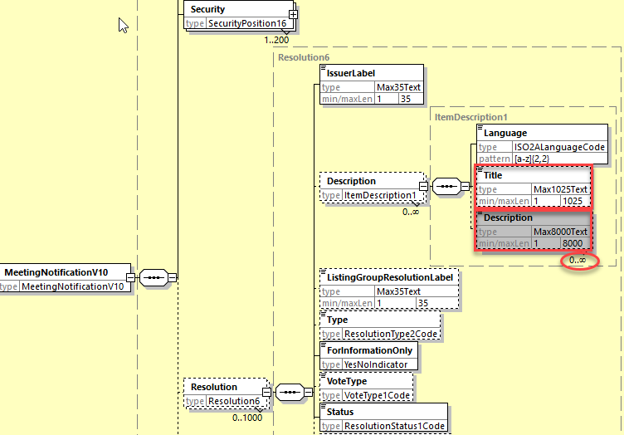
- Proposed timing:
The submitting organization confirms that it can implement the requested changes in the requested timing

Timing | - As requested

- Final decision of the SEG(s):

Approve | X
Comments:

Reject
Reason for rejection:

CR 1307 Add New Lent and Borrowed Balance Types for Triparty Securities Lending Services (CR Withdrawn)
- Origin of the request:
A.1 Submitter: XS NMPG.
A.2 Contact person: Jean-Paul Lambotte jean-paul.lambotte@euroclear.com
A.3 Sponsors: XS NMPG, Euroclear

- Related messages:
Seev.001 & seev.003

- Description of the change request:
Two types of securities lending services exist :
- Bilateral Autoborrow (Lending and Borrowing)
- Triparty Securities Lending (TSL)
The lent/borrowed balances generated by these two services should be reported in distinct balances of the seev.001 and seev.003. Indeed, a different level of service can be applied to balances generated by the bilateral autoborrow service compared to the balances generated by the Triparty Securities Lending service. By using different balances, the account owner will know that different actions might be required depending on the balances on which the securities are held.
Two new balances types should be created in the seev.001 and seev.003 to report the "Triparty Lent Balance” and “Triparty Borrowed Balance”
A similar change request has been submitted for the CA messages.

- Purpose of the change:
Allow distinction between Bilateral lent/borrowed positions and Triparty Securities Lending lent/borrowed positions.
- Urgency of the request:
SR2024

- Business examples:
/

- SEG/TSG recommendation:
This section is not to be taken care of by the submitter of the change request. It will be completed in due time by the SEG(s) in charge of the related ISO 20022 messages or the TSG for changes related to the BAH.

Consider |  | X | Timing
 |  |  | - Next yearly cycle: 2023/2024  (the change will be considered for implementation in the yearly maintenance cycle which starts in 2018 and completes with the publication of new message versions in the spring of 2019) |  | X
- At the occasion of the next maintenance of the messages
(the change will be considered for implementation, but does not justify maintenance of the messages in its own right – will be pending until more critical change requests are received for the messages)
- Urgent unscheduled
(the change justifies an urgent implementation outside of the normal yearly cycle)
 |  |  | - Other timing:
Comments:

Reject
Reason for rejection:

- Impact analysis:
The present change request is identical to the Swift CR 2018 for SR2024 for the corporate action messages.
The following general meeting messages would be impacted by this CR:
seev.001.001.10 MeetingNotificationV10

seev.003.001.09 MeetingEntitlementNotificationV09

- Proposed implementation:

In the seev.001.001.10 (MENO – MeetingNotification) and

in the seev.003.001.09 (MENT – MeetingEntitlementNotification) and
Position/HoldingBalance in the building block Security and

Add 2 new code values TPLN (Triparty Lent Balance) and TPBR (Triparty Borrowed Balance) to the data type SecuritiesEntryType2Code of the BalanceType element as defined and illustrated below:

TPLN | Triparty Lent Balance | Balance of financial instruments that have been loaned to another party via a triparty lending securities service.
TPBR | Triparty Borrowed Balance | Balance of financial instruments that have been borrowed from a third party via a triparty lending securities service.

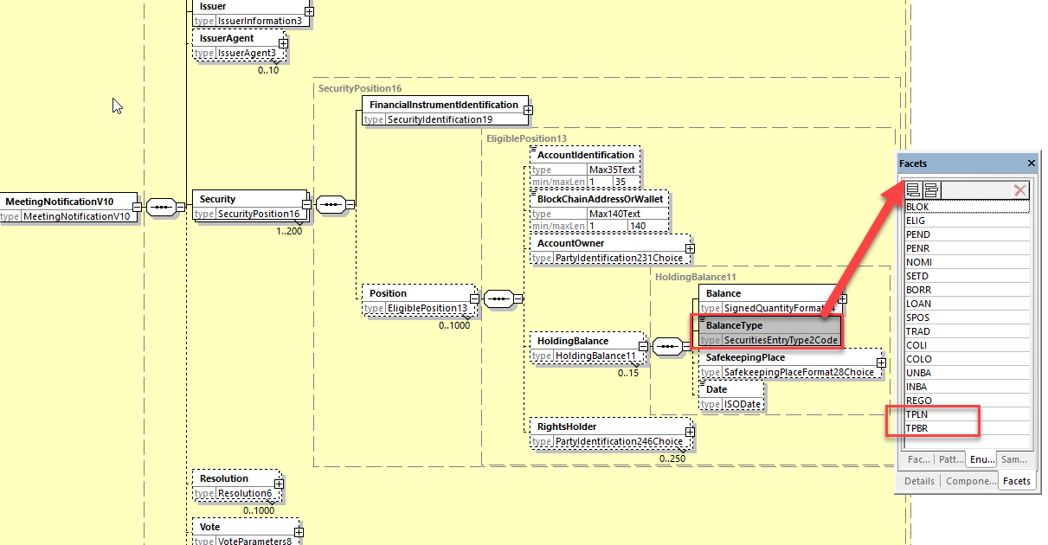

- Proposed timing:
The submitting organization confirms that it can implement the requested changes in the requested timing

Timing | - As requested

- Final decision of the SEG(s):

Approve
Comments:

Reject | X
Reason for rejection:
Outcome: The CR has been withdrawn by XS on Sept. 6 - To be further reviewed by SMPG and eventually resubmitted in SR2025 with a solution reviewed.

CR 1302 Make AccountIdentification Mandatory in Instruction Cancellation
- Origin of the request:
A.1 Submitter: SMPG CA WG
A.2 Contact person:
Christine Strandberg: Christine.Strandberg@seb.com
Mariangela Fumagalli: mariangela.fumagalli@bnpparibas.com -
Jacques Littré: Jacques.littre@swift.com -
A.3 Sponsors:
SMPG CA WG members

- Related messages:
seev.005.001.09 MeetingInstructionCancellationRequestV09

- Description of the change request:
We would like to make the “AccountIdentification” element in the path “ToBeCancelledInstruction/InstructedPosition” of the seev.005 a mandatory element.

- Purpose of the change:
To align the general meeting messages to the corporate action messages.

- Urgency of the request:
For next release.
Note: the ISO 20022 maintenance results in the publication of a new version of an ISO 20022 message. The actual implementation of such new version on networks and in user installations is not within the purview of ISO.

- Business examples:
Examples illustrating the change request.
NA

- SEG/TSG recommendation:
This section is not to be taken care of by the submitter of the change request. It will be completed in due time by the SEG(s) in charge of the related ISO 20022 messages or the TSG for changes related to the BAH.

Consider |  | X | Timing
 |  |  | - Next yearly cycle: 2023/2024  (the change will be considered for implementation in the yearly maintenance cycle which starts in 2022 and completes with the publication of new message versions in the spring of 2023) |  | X
- At the occasion of the next maintenance of the messages
(the change will be considered for implementation, but does not justify maintenance of the messages in its own right – will be pending until more critical change requests are received for the messages)
- Urgent unscheduled
(the change justifies an urgent implementation outside of the normal yearly cycle)
 |  |  | - Other timing:
Comments:

Reject | X
Reason for rejection:
The SMPG withdraws the CR as there is already a cross element rule defined in the seev.005 message which enforces the presence of the account or of the blockchain wallet.

CR 1299 Add new Pending and Rejection Status Reason Code for Instructions Received Prior to Entitlement Date
- Origin of the request:
A.1 Submitter: SMPG CA WG
A.2 Contact person:
Christine Strandberg: christine.strandberg@seb.se
Mariangela Fumagalli: mariangela.fumagalli@bnpparibas.com
Jacques Littré: Jacques.littre@swift.com
A.3 Sponsors:
SMPG CA WG members
- Related messages:
seev.006.001.09 - MeetingInstructionStatus

- Description of the change request:
We would like to add a new reason code to PEND and REJT statuses in seev.006 for “Instruction received prior to entitlement date” to inform account owners of the fact the instruction has been received prior to the entitlement date.

- Purpose of the change:
To inform clients via a dedicated reasons code instead of using narratives.

- Urgency of the request:
For next release.
Note: the ISO 20022 maintenance results in the publication of a new version of an ISO 20022 message. The actual implementation of such new version on networks and in user installations is not within the purview of ISO.
- Business examples:
Examples illustrating the change request.
NA
- SEG/TSG recommendation:
This section is not to be taken care of by the submitter of the change request. It will be completed in due time by the SEG(s) in charge of the related ISO 20022 messages or the TSG for changes related to the BAH.

Consider |  | X | Timing
 |  |  | - Next yearly cycle: 2023/2024  (the change will be considered for implementation in the yearly maintenance cycle which starts in 2022 and completes with the publication of new message versions in the spring of 2023) |  | X
- At the occasion of the next maintenance of the messages
(the change will be considered for implementation, but does not justify maintenance of the messages in its own right – will be pending until more critical change requests are received for the messages)
- Urgent unscheduled
(the change justifies an urgent implementation outside of the normal yearly cycle)
 |  |  | - Other timing:
Comments:

Reject
Reason for rejection:

- Impact analysis:
The present change request is identical to the CA MT CR 2026 for SR2024 for the corporate action messages (i.e. MT567, seev.034 and seev.042).
This change request impacts only the following general meeting message:
seev.006.001.09 MeetingInstructionStatusV09

- Proposed implementation:
The implementation solution will be the same as the one adopted for the CR 2026 for the corporate action messages.

In the seev.006.001.09 (MEIS – MeetingInstructionStatus), in the sequence InstructionTypeStatus/InstructionStatus/InstructionStatus/Rejected/Reason/ReasonCode,
add in the data type code RejectionReason65Code of the Code element the new status code IPED (Instruction Prior To Entitlement Date) as defined and as illustrated below:

IPED | Instruction Prior To Entitlement Date | Instruction was received prior to entitlement date.

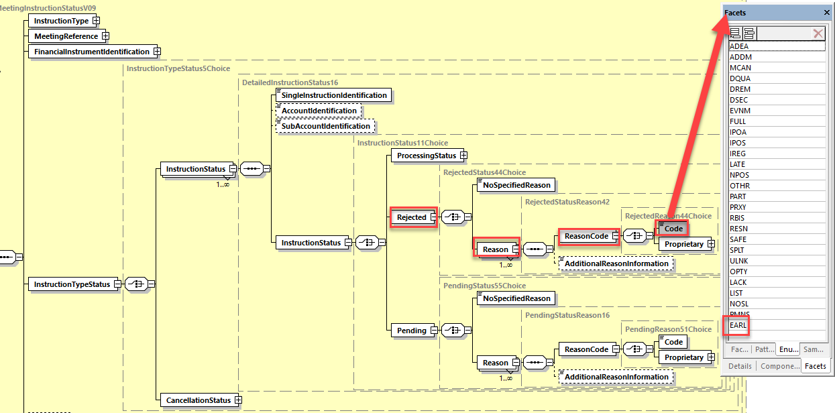

And in the sequence InstructionTypeStatus/InstructionStatus/InstructionStatus/Pending/Reason/ReasonCode,
add in the data type code PendingReason16Code of the Code element the new status code IPED (Instruction Prior To Entitlement Date) as illustrated below:

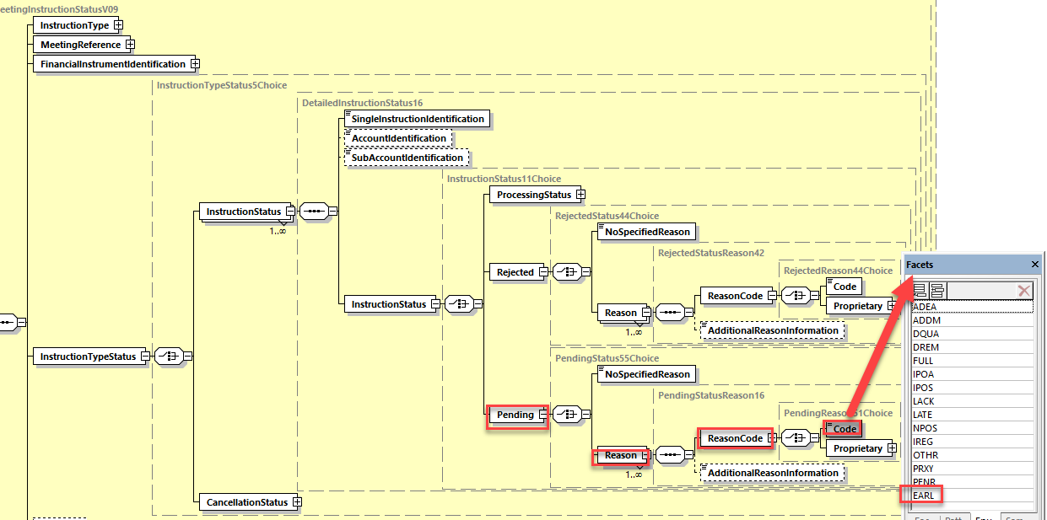

- Proposed timing:
The submitting organization confirms that it can implement the requested changes in the requested timing

Timing | - As requested

- Final decision of the SEG(s):

Approve | X
Comments:

Reject
Reason for rejection:

CR 1304 Missing Reason Code for Duplicate Business Message Identifier
- Origin of the request:
A.1 Submitter: Euroclear.
A.2 Contact person: Jean-Paul Lambotte jean-paul.lambotte@euroclear.com
A.3 Sponsors: Euroclear

- Related messages:
Seev.006

- Description of the change request:
In the seev.034 (and MT567), it is possible to report that an instruction is rejected due to duplicate business message identifier.
This rejection reason code does not exists in the seev.006 meeting instruction status.
The rejection reason code “Duplicate Instruction [DUPL]” (Definition “Instruction is rejected due to duplicate business message identifier”) should be added in the seev.006.

- Purpose of the change:
Allow rejection of duplicate instruction identifier and improve consistency between seev.006 and seev.035.
- Urgency of the request:
SR2024

- Business examples:
/

- SEG/TSG recommendation:
This section is not to be taken care of by the submitter of the change request. It will be completed in due time by the SEG(s) in charge of the related ISO 20022 messages or the TSG for changes related to the BAH.

Consider |  | X | Timing
 |  |  | - Next yearly cycle: 2021/2022  (the change will be considered for implementation in the yearly maintenance cycle which starts in 2018 and completes with the publication of new message versions in the spring of 2019) |  | X
- At the occasion of the next maintenance of the messages
(the change will be considered for implementation, but does not justify maintenance of the messages in its own right – will be pending until more critical change requests are received for the messages)
- Urgent unscheduled
(the change justifies an urgent implementation outside of the normal yearly cycle)
 |  |  | - Other timing:
Comments:

Reject
Reason for rejection:

- Impact analysis:
This change request impacts only the following message:
seev.006.001.09 MeetingInstructionStatusV09

- Proposed implementation:
In the seev.006.001.09 (MEIS – MeetingInstructionStatus), in the sequence InstructionTypeStatus/InstructionStatus/InstructionStatus/Rejected/Reason/ReasonCode, add in the data type code RejectionReason65Code of the Code element the new status code DUPL (Duplicate Instruction) as defined and as illustrated below:
DUPL | Duplicate Instruction | Instruction is rejected due to duplicate business message identifier.
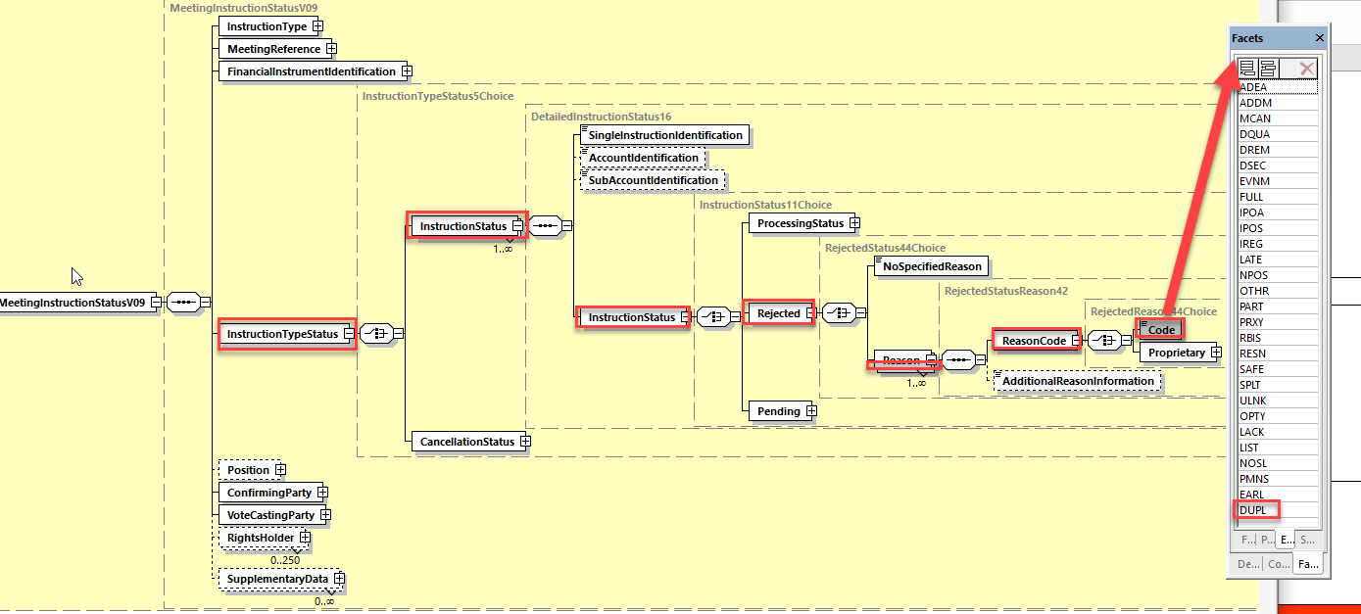

- Proposed timing:
The submitting organization confirms that it can implement the requested changes in the requested timing

Timing | - As requested

- Final decision of the SEG(s):

Approve | X
Comments:

Reject
Reason for rejection:

