Change Request
for the update of ISO 20022 financial repository items
- Origin of the request:
A.1 Submitter:
The Mojaloop Foundation
A.2 Contact person:
Michael Richards. Michael.Richards@infitx.com, +44 7785 360009
A.3 Sponsors:
- Related messages:
Pacs.008.001 - FIToFICustomerCreditTransfer
Pacs.009.001 - FinancialInstitutionCreditTransfer

- Description of the change request:
An expiry time is required when a payment execution request is issued by one FI to another. This represents the time after which the payment execution request is invalidated and should not be executed by any of the parties.
This element is optional and non-repetitive. Its type should be IsoDateTime. We propose the name ExpiryDateTime for the element.
Add structure for pacs.009
We propose that it should be added to the GroupHeader element of the FIToFICustomerCreditTransferV11 data structure. It is appropriate for this value to appear in the header rather than in the information relating to an individual payment because its intention is to provide a mechanism for finalising payments where there is a gross failure of a participant in the system: for instance, because internet access is not available or because the recipient’s service is unavailable. It is not intended to trap local failures to meet SLA response times; and therefore it is not expected that some transfers in a message would pass while others were timed out.

Current structure:

Or | MessageElement<XML Tag> | Mult. | Type | Constr. No. | Page
 | MessageIdentification <MsgId> | [1..1] | Text |  | 654
 | CreationDateTime <CreDtTm> | [1..1] | DateTime |  | 654
 | BatchBooking <BtchBookg> | [0..1] | Indicator |  | 655
 | NumberOfTransactions <NbOfTxs> | [1..1] | Text |  | 655
 | ControlSum <CtrlSum> | [0..1] | Quantity |  | 655
 | TotalInterbankSettlementAmount <TtlIntrBkSttlmAmt> | [0..1] | Amount | C1, C10 | 655
 | InterbankSettlementDate <IntrBkSttlmDt> | [0..1] | Date |  | 655
 | SettlementInformation <SttlmInf> | [1..1] |  | C20, C22, C37, C38, C39, C40, C43, C44 | 656
 | SettlementMethod <SttlmMtd> | [1..1] | CodeSet |  | 659
 | SettlementAccount <SttlmAcct> | [0..1] |  | C15, C14 | 659
 | Identification <Id> | [0..1] | ± |  | 660
 | Type <Tp> | [0..1] | ± |  | 660
 | Currency <Ccy> | [0..1] | CodeSet | C2 | 661
 | Name <Nm> | [0..1] | Text |  | 661
 | Proxy <Prxy> | [0..1] | ± |  | 661
 | ClearingSystem <ClrSys> | [0..1] |  |  | 661
{Or | Code <Cd> | [1..1] | CodeSet |  | 662
Or} | Proprietary <Prtry> | [1..1] | Text |  | 662
 | InstructingReimbursementAgent  <InstgRmbrsmntAgt> | [0..1] | ± |  | 662
 | InstructingReimbursementAgentAccount  <InstgRmbrsmntAgtAcct> | [0..1] |  | C15, C14 | 662
 | Identification <Id> | [0..1] | ± |  | 663
 | Type <Tp> | [0..1] | ± |  | 663
 | Currency <Ccy> | [0..1] | CodeSet | C2 | 664
 | Name <Nm> | [0..1] | Text |  | 664
 | Proxy <Prxy> | [0..1] | ± |  | 664
 | InstructedReimbursementAgent <InstdRmbrsmntAgt> | [0..1] | ± |  | 664

Proposed structure:

Or | MessageElement<XML Tag> | Mult. | Type | Constr. No. | Page
 | MessageIdentification <MsgId> | [1..1] | Text |  | 654
 | CreationDateTime <CreDtTm> | [1..1] | DateTime |  | 654
 | PaymentInstructionExpiryDateTime <PmntInstrctnExpryDtTm> | [0..1] | DateTime
 | BatchBooking <BtchBookg> | [0..1] | Indicator |  | 655
 | NumberOfTransactions <NbOfTxs> | [1..1] | Text |  | 655
 | ControlSum <CtrlSum> | [0..1] | Quantity |  | 655
 | TotalInterbankSettlementAmount <TtlIntrBkSttlmAmt> | [0..1] | Amount | C1, C10 | 655
 | InterbankSettlementDate <IntrBkSttlmDt> | [0..1] | Date |  | 655
 | SettlementInformation <SttlmInf> | [1..1] |  | C20, C22, C37, C38, C39, C40, C43, C44 | 656
 | SettlementMethod <SttlmMtd> | [1..1] | CodeSet |  | 659
 | SettlementAccount <SttlmAcct> | [0..1] |  | C15, C14 | 659
 | Identification <Id> | [0..1] | ± |  | 660
 | Type <Tp> | [0..1] | ± |  | 660
 | Currency <Ccy> | [0..1] | CodeSet | C2 | 661
 | Name <Nm> | [0..1] | Text |  | 661
 | Proxy <Prxy> | [0..1] | ± |  | 661
 | ClearingSystem <ClrSys> | [0..1] |  |  | 661
{Or | Code <Cd> | [1..1] | CodeSet |  | 662
Or} | Proprietary <Prtry> | [1..1] | Text |  | 662
 | InstructingReimbursementAgent  <InstgRmbrsmntAgt> | [0..1] | ± |  | 662
 | InstructingReimbursementAgentAccount  <InstgRmbrsmntAgtAcct> | [0..1] |  | C15, C14 | 662
 | Identification <Id> | [0..1] | ± |  | 663
 | Type <Tp> | [0..1] | ± |  | 663
 | Currency <Ccy> | [0..1] | CodeSet | C2 | 664
 | Name <Nm> | [0..1] | Text |  | 664
 | Proxy <Prxy> | [0..1] | ± |  | 664
 | InstructedReimbursementAgent <InstdRmbrsmntAgt> | [0..1] | ± |  | 664

We propose the following MDR description of the change:
Presence: [0..1]
Definition: The date and time after which the payment execution request should be cancelled if it has not completed.

Usage: Where it is important to reduce the cost of failed payments, and where infrastructure limitations may mean that participants may have connection problems and be unpredictably unreachable, it is important that payments should not be left in an indeterminate state. The definition of an expiry date for the payment allows participants to understand the point after which the payment should be regarded as failed. After that point, participants should regard the payment as failed due to a communications problem, cancel any funds they have reserved or moved as a consequence of the payment request, and mark the status of the payment as FAILED.

“Payment” here refers to a group of credit transfers contained in a payment execution request. The expiry time quoted is for all the individual credit transfer requests in the payment execution request. The standard does not mandate the action to be taken by participants when a payment execution request expires. This is a matter for individual implementations.
Datatype: "isoDateTime"

- Purpose of the change:
In the environments in which IIPS systems are deployed, the availability of systems when required cannot always be guaranteed. Core Banking Systems are sometimes offline for parts of the day, or entire participants may not be able to connect to the internet due to network outages.
In cases like this, the status of a credit transfer request may remain indeterminate for quite long periods. The sending FI will not know whether one of the other parties is taking some time to respond, or has not received the message, or has responded but the response has been interrupted. It is in circumstances like these that it is possible for parties to act on different inferences about whether or not the credit transfer request has been executed; and these differences in inference allow for the possibility of disputes between the parties. In the case of the high-volume, very low-value payments which IIPSs are designed to support, the resolution of disputes is an intolerably expensive matter and an IIPS system needs to be designed to minimise the number of disputes which arise.
One of these design decisions is that every payment execution request should be accompanied by an expiry time. Once the payment request has expired, all parties to the payment should treat it as a failed payment and should act accordingly. Before a payment is finalised by the eventual credit party, provided that the payment has not yet expired all parties should treat its status as indeterminate and should not take any irrevocable actions in relation to it.
- Urgency of the request:
It is proposed to include this change request in the next regular maintenance cycle.
- Business examples:
The sequence diagram below shows how the expiry time is used in an IIPS where a central message routing service manages the interaction between participants, and where participants communicate with the central routing service via APIs. The central routing service is responsible for monitoring transfer requests for expiry.
In the example, the debtor institution requests that a payment be executed. The creditor institution contacts its core banking system to execute the transfer of funds, but the CBS does not respond. Nothing happens in the system and, when the debtor institution enquires after the status of the payment, as status of INDETERMINATE is returned, as is normal while a payment is executing.
After the timeout period has elapsed, the central routing service cancels the payment execution request and informs the parties that the payment has been cancelled. Now when the debtor institution enquires after the status of the payment, a status of CANCELLED is returned.
These features are shown in the following diagram:
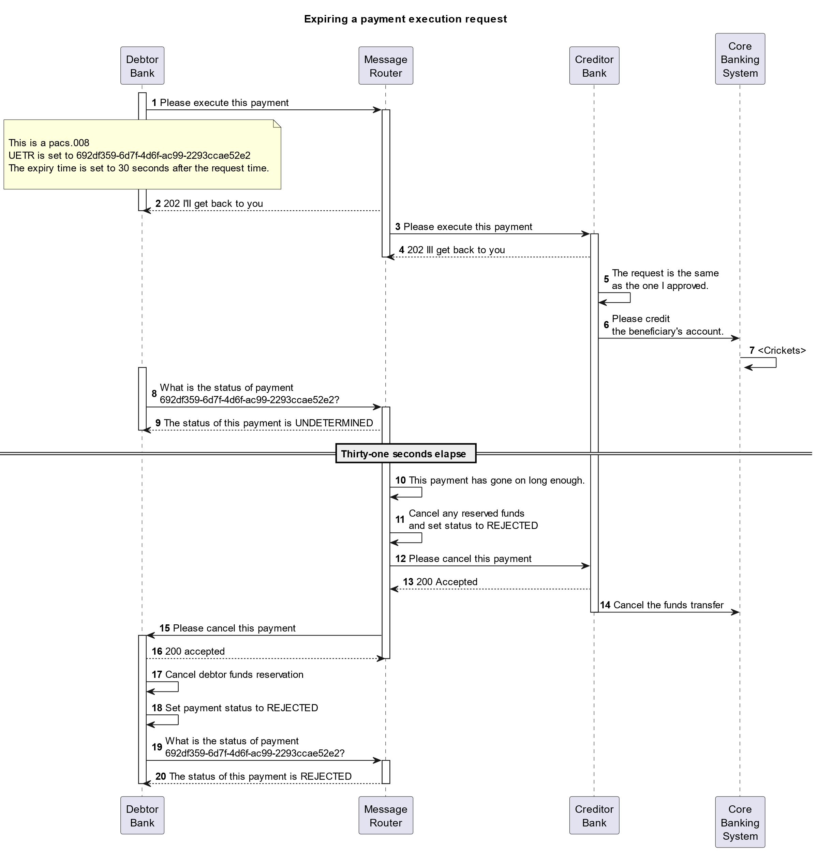
- SEG/TSG recommendation:
This section is not to be taken care of by the submitter of the change request. It will be completed in due time by the SEG(s) in charge of the related ISO 20022 messages or the TSG for changes related to the BAH.

Consider |  | X | Timing
 |  |  | - Next yearly cycle: 2024/2025  (the change will be considered for implementation in the yearly maintenance cycle which starts in 2024 and completes with the publication of new message versions in the spring of 2025) |  | X
- At the occasion of the next maintenance of the messages
(the change will be considered for implementation, but does not justify maintenance of the messages in its own right – will be pending until more critical change requests are received for the messages)
- Urgent unscheduled
(the change justifies an urgent implementation outside of the normal yearly cycle)
 |  |  | - Other timing:
Comments: CR will be reviewed as part of the 2024/2025 maintenance cycle.

Reject
Reason for rejection:

