Change Request
for the update of ISO 20022 financial repository items
- Origin of the request:

A.1 Submitter:
Banco Central do Brasil (Central Bank of Brazil)

A.2 Contact person:
Liliane Dutra: liliane.dutra@ipmfglobal.com.br + 55 11 98542-4421
Fernanda Pedroso: fernanda.pedroso@bcb.gov.br +55 51 3215-7309
Fernando Cavalcanti: fernando.cavalcanti@bcb.gov.br +55 61 3414-2589
Maurício Honda: mauricio.honda@bcb.gov.br +55 11 3491-6342
Rojane Perdigão: rojane.abranches@bcb.gov.br +55 31 3253-7149

A.3 Sponsors:
ABNT CEE-112 Brazilian Standards Committee

- Related messages:
Business Domain Exceptions and Investigations, Cash Management Message Set:
- camt.029.001.12 ResolutionOfInvestigationV12
- camt.055.001.11 CustomerPaymentCancellationRequestV11

- Description of the change request:
  - Inclusion of Supplementary Data with CancellationStatusDetails in the camt.029.001.12 and in the camt.055.001.11

Cancellation Processing Details:
The communication between participants in an instant payment system requires the identification of the date and time when the request is processed, accepted or rejected, since operations must be initiated and carried out under a tight deadline and in a synchronized manner. However, the current version of the Cash Management message set does not contain a message element for the date and time when the cancellation request is accepted by the Debtor Agent or rejected by the Creditor Agent, for example.
The inclusion of the CancellationProcessingDetails element in the messages listed under “Related messages” would provide information about date and time in different stages of the scheduled payment cancellation flow process. The list below provides some of the possible timestamps to be included in the messages:

- Request of cancellation accepted by the Creditor Agent;
- Request of cancellation rejected by the Creditor Agent;
- Request of cancellation rejected by the Debtor Agent;
- Request of cancellation accepted by the Debtor Agent.

Element | Mult. | Type
CancellationProcessingDetails | [1..*]
CancellationProcessingType | [1..1] | CodeSet
ProcessingDateTime | [1..1] | ISODateTime

- Purpose of the change:
The Central Bank of Brazil (BCB), in the context of the Pix evolving agenda, is developing a new solution to enable recurring automatic payments upon prior authorization of the payer, without the need of any further action at each new transaction. This solution, so far called "Automatic Pix", aims to address several gaps that currently exist in the local market, providing convenience for users.
The objectives of Automatic Pix are: to achieve greater efficiency in the market, through the implementation of direct debit system in Pix; to stimulate competition, with the provision of the service to all participants on equal terms; to expand access to direct debit for companies of all sizes and reduce their costs; to increase the possibilities of payment means to users, augmenting the breadth of use cases served by Pix; to strengthen the use of Pix by businesses and to increase the convenience of use on Pix.
The solution under development includes a robust and convenient authorization system for the payer, with facilitated cancellation dynamics. This facilitates the management of recurring payments for Creditors and eliminates the need to establish multiple agreements to provide recurring payment services. It also stimulates competition and enables the use of the service by a greater number of payers and receivers.
In addition, Automatic Pix will allow new use cases, benefiting payment service providers (PSP's) and users.
For the Brazilian model of recurring payments under Automatic Pix, it is necessary that the messages currently used to support the cancellation of scheduled payments linked to payment mandates includes additional timestamp elements. The possibility to request the cancellation of payment initiation messages linked to the mandates will allow the Pix participants to reduce errors when debtors and/or creditors request for a payment cancellation.
Thus, participants need to have the updated information about cancellation requests (synchronized) to control the periodic debits, avoiding losses for any of the involved agents.

- Urgency of the request:
The proposal is to include this element as Supplementary Data, justified by the immediate need of the instant payment system in Brazil (Pix), in order to develop the operational manuals and the technical specification of the product, that will be launched in April 2024.
In addition, it is widely known that changes in the elements of the message structure can have negative impacts on the other jurisdictions that already use these messages. If any other community, besides Brazil, recognizes a benefit of using the requested new element, we will request the inclusion of this information in the block of structural elements for the next message revision cycle.

- Business examples:
For this change request we focused on the stage of Automatic Pix where the payments related to a mandate have been activated through the exchange of payment initiation messages pain.013 and pain.014. If, for some reason, one of these scheduled payments must be cancelled, both the debtor and the creditor under a given mandate will be allowed to request its cancellation. To request for the cancellation of a scheduled payment, messages camt.055 and camt.029 will be exchanged between the Debtor and the Creditor agents. For example:
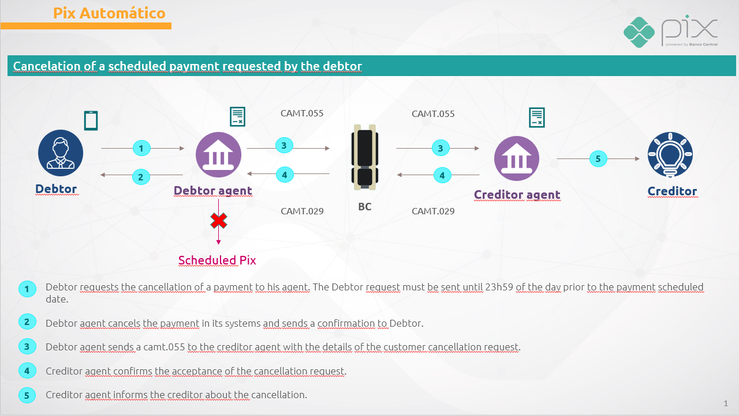
The Central Bank of Brazil – BCB is responsible for providing infrastructure for the transmission of the cancellation messages. The cancellation request message, camt.055, must contain information about the date and time in which the cancellation is processed by the Debtor Agent — when cancellation is requested by the Debtor (flowchart above) —, or date and time in which the cancellation is requested by the Creditor Agent — when cancellation is requested by the Creditor. Accordingly, the resolution of investigation, camt.029, must also contain information about the date and time in which the cancellation request was accepted or rejected.

SEG/TSG recommendation:
This section is not to be taken care of by the submitter of the change request. It will be completed in due time by the SEG(s) in charge of the related ISO 20022 messages or the TSG for changes related to the BAH.

Consider |  |  | Timing
- Next yearly cycle: 2024/2025
(the change will be considered for implementation in the yearly maintenance cycle which starts in 2024 and completes with the publication of new message versions in the spring of 2025)
- At the occasion of the next maintenance of the messages
(the change will be considered for implementation, but does not justify maintenance of the messages in its own right – will be pending until more critical change requests are received for the messages)
- Urgent unscheduled
(the change justifies an urgent implementation outside of the normal yearly cycle)
 |  |  | - Other timing:
Comments:

Reject
Reason for rejection:

