Maintenance Change Request
for fast track maintenance of existing message definitions
Note: the purpose of this document is to give guidelines to submitting organizations that intend to use the Fast Track maintenance process to develop a new version of existing ISO 20022 messages. Such development is subject to the approval, by the related Standards Evaluation Group (SEG), of a Maintenance Change Request which must include a detailed description of the impact of each change on the related messages. The Maintenance Change Request must start with a general chapter covering topics related to the whole maintenance effort and a specific chapter for each change request, as described below. Please consult the iso20022.org website for additional details on the Fast Track maintenance process.
Maintenance Changes requests are to be submitted through the ISO 20022 website through this e-request, in which this template must be attached.

- Submitting organization(s):
SWIFT (sponsored by CBPR plus working group)

- Related messages:
- camt.105.001.01 - Charges Payment Notification
- camt.106.001.01- Charges Payment Request

- Purpose of the change:
The change in the structure of both messages will allow more flexibility to the account servicing for the reporting of the Charges.

- Urgency of the request:
Swift intends to build usage guidelines in the scope of the CBPR+ implementation, that should be deployed in November 2024, based on the updated ISO 20022. Therefore, it is essential that the requested changes are implemented in the ISO 20022 messages as soon as possible
- Commitments of the submitting organization:
The submitting organization confirms that it can and will:
- undertake the development of the new version of the candidate ISO 20022 message model that it will submit to the RA for compliance review. The submitting organisation is invited to mention here the expected date of submission to the RA for compliance review.
- address any queries related to the description of the message versions as published by the RA on the ISO 20022 website.
The submitting organization confirms its knowledge and acceptance of the ISO 20022 Intellectual Property Rights policy for contributing organizations, as follows.
“Organizations that contribute information to be incorporated into the ISO 20022 Repository shall keep any Intellectual Property Rights (IPR) they have on this information. A contributing organization warrants that it has sufficient rights on the contributed information to have it published in the ISO 20022 Repository through the ISO 20022 Registration Authority in accordance with the rules set in ISO 20022. To ascertain a widespread, public and uniform use of the ISO 20022 Repository information, the contributing organization grants third parties a non-exclusive, royalty-free license to use the published information”.

- Contact persons:

Evelyne Piron (Swift): evelyne.piron@swift.com;

Neil Buchan (Swift): neil.buchan@swift.com

Change number 1: Update of the message structure

- Related messages:
- camt.105.001.01 - Charges Payment Notification
- camt.106.001.01- Charges Payment Request

- Description of the change and type of impact:
The request is to modify the structure of the current base messages to be able to cover three possible use cases:
- Payment Notification or Request of a single amount of charges
- Payment Notification or Request of charges aggregated per transaction. The new structure should also allow providing a breakdown per charge type and amount and a total amount
- Payment Notification or Request of charges aggregated per type of charges. The new structured should also allow providing a total per charge type.

The Group header of both messages should contain a Total charges block that will contain the total charges amount that is notified (camt.105) or for which payment is requested (camt.106).

- Proposed implementation:
The major changes that are requested are listed below:
- In Group Header:
  - Regroup the elements “Number of Charges records”, “Control Sum”, “Total Charges Amount” and “Credit Debit Indicator” in a new component “Total Charges”
  - Add one element “Charge Requestor” (same element is added in sub sequence “Single” , “Per Transaction” and “Per Type”)
  - Add two elements “Charges Account” and “Charges Account Owner”. Cross element rules should also be added to make sure the two elements are only present once in the message.
- Change the structure of the existing “Charges” component to support three scenarios (as explained above in B), then allowing to provide one single amount of charges, or charges aggregated per transaction, or breakdown per charge type and amount and a total amount. That component should be mandatory and non repetitive
  - Single: this option of the choice (Single) will allow to provide all details related to the charge amount that is notified or for which payment is requested.
  - Per Transaction: this option of the choice (Single) will allow to provide the amount of charge per transaction with repetitive “Record” component that should be mandatory and repetitive. Such component should contain a “Total Charge Per Record” and “Charges Breakdown” (in case multiple charge types relate to one transaction).
  - Per Type: this option of the choice (repetitive) will allow to provide the amount of charge per type with a repetitive “Record” component that should be mandatory and repetitive.

Below is the high-level overview of the current version of the ISO 20022 message and the expected structure after maintenance (illustration for the camt105 only since similar to camt.106):

Current implementation:

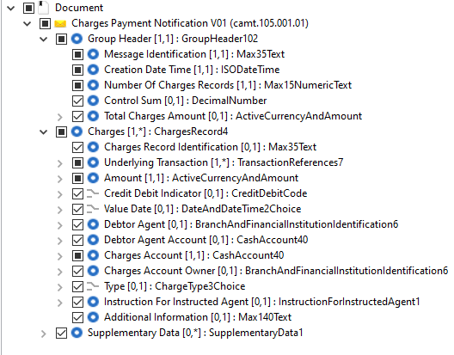

Proposed implementation to support the 3 use cases.
- Single:

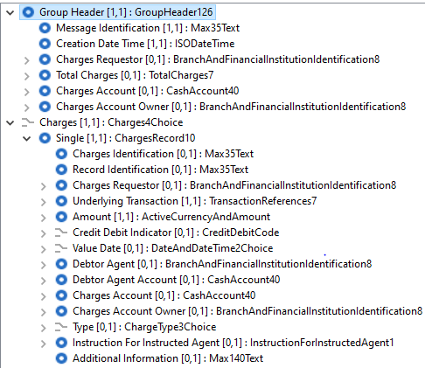

- Per Transaction

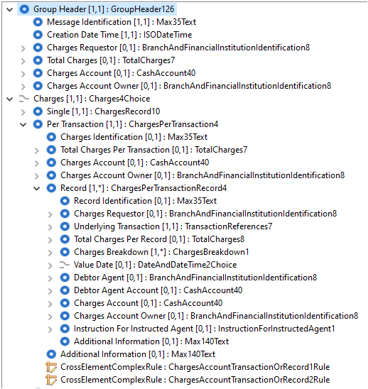

- Per Type

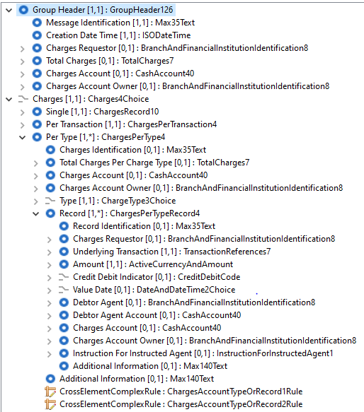
- Decision of the SEG(s):

This section is not to be taken care of by the submitting organization. It will be completed in due time by the SEG(s) in charge of the related ISO 20022 message definitions.

Change
 | approved | X
 | rejected
Comments:

Timing
 | - Fast track maintenance  (the change justifies an urgent implementation using the fast track maintenance process) |  | 2023/2024
- At the occasion of the next maintenance of the messages
(the change will be considered for implementation, but does not justify an urgent implementation – will be pending until the next [yearly] maintenance of the messages)

