Change Request
for the update of an External Code Set
Note: this document is to be completed by parties that request to either add new codes or clarify the definition of existing codes or replace existing codes by new one(s) or expire existing codes in one of the External Code Sets used in ISO 20022 messages. All change requests conforming to this template that are received prior to the end of a quarter (31 March, 30 June, 30 September, 31 December) will be evaluated by the SEG and, if approved, incorporated in the following quarterly publication cycle of the External Code Sets (respectively, by end of May, August, November and February), unless otherwise specified by the SEG.

Origin of the request:

A.1 Submitter:

Name of the company, organization, group, initiative or community that submits the change request. | Swift

A.2 Contact person:
Person that can be contacted for additional information on the request

A.2.1. First name, Last name | Dominique Forceville
A.2.2. Email address | dominique.forceville@swift.com
A.2.3. Telephone | 0032 2 655 4948

A.3 Sponsors:
If the submitter acts on behalf of or has gained support from other organisations, groups, initiatives or communities, these should be listed as sponsors.

Swift community

Description of the change request:
Specify the request type: creation of new code set, update of existing code set, deletion of existing code set.
For the creation of a new code set or for updating an existing code set, also complete the table in section H below. For the addition of new codes, all the details must be specified, including a proposed code, a proposed code name, a clear definition, and any other indications, such as an example or format to be published with the code set.
Request type: creation, update, deletion | Update

Related External Code Set:
For updating or deleting an existing code set, indicate the exact name of the code set as indicated in the External Code Sets documents on iso20022.org. For creating a new code set, indicate a proposed name for the new code set.
A specific change request form must be completed for each code set to be updated.

ExternalServiceLevel1Code

Purpose of the change:
Background, business context, community of users interested by the change and expected benefits/savings.
This section must explain why the existing code set needs to be changed. The reason for the update may be a business reason (e.g., evolution of market practice, or creation of new financial instruments), a technical reason (e.g., automation of the business process, or switch from a batch to a real time process), a regulatory reason (introduction, generally mandatory, of new rule/law) or the extension of the user community (newly identified business requirements).

Our request is to update the ExternalServiceLevel1Code list adding a new code SPLI.
The name of this code is ‘Split payment’ and the definition of the code is ‘A split payment is a payment that is split into several payments of lower value namely with the purpose to comply with maximum amount thresholds applicable to some domestic Payment Market Infrastructures or to reduce counterparty liquidity risk’.
We are creating a bilateral/multilateral agreement which expects certain agreed servicing conditions from the involved participants and PMI. The service level code represents the agreed rules and processes under which the transaction should be processed to avoid being considered as a duplicate.
- The servicing conditions include (non exhaustive):
  - using a new uetr for each split payment
  - using the same end to end identification in each split payment
  - carrying forward the SPLI service level (to allow following agents to process the payment according to the rules, and to assist the Creditor to reconcile them together by identifying them as split payments with the same end to end identification).

Using a new UETR together with the SPLI service level (and with the end-to-end-identification shared by all split payments), the Tracker will be able to identify the original payment to which the split payments are related, and to provide notifications about the status of those split payments to the sender of the original payment. The Creditor Agent and Creditor will also be able to benefit from advance visibility of each split payment in the Tracker and to check on the progress of their status.
See section F for more background information.

Urgency of the request:
By default, valid change requests, subsequently approved by the SEG will be included in the following quarterly publication of External Code Sets, unless decided otherwise by the SEG.
If there is a need to have the new version of the related code set published earlier, the reason for the urgency and the expected consequences of a delay should be described here. Acceptance of such an unscheduled publication is subject to approval by the SEG.

The code should be available by November 2024.

Business examples:
Provide examples illustrating usage of the code set and indicate messages where the code set may be used.

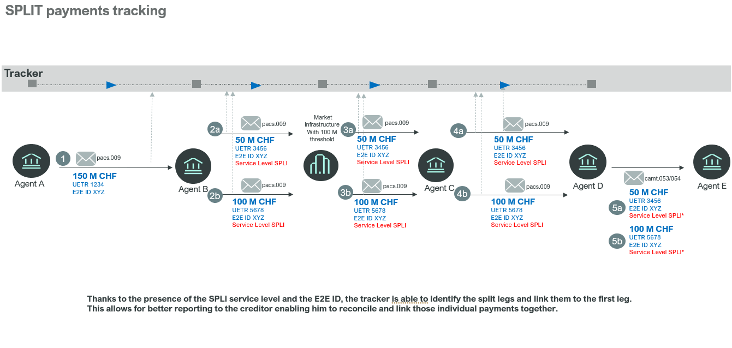
The SPLI service level code will be used in the:
- pacs.009
- camt.053/054 (in the version that allows for service level)
- trck.001/2/4 (note that business justification for the registration of these tracker messages is approved and submission will have in 2024).
- Please note that the service level SPLI will also be used in the tracker APIs for which Swift will submit the resources for registration in 2024.

SEG recommendation:
This section will be completed by the SEG in charge of the related External Code Set.

Accept |  | X | Timing
 |  |  | Next possible quarterly release |  | X
 |  |  | Urgent request

Comments:

Reject

Reason for rejection:

DESCRIPTION OF THE CHANGE REQUEST

Type | Code Value | Code Name | Code Definition | Replaced By | Additional Information
Addition | SPLI | Split Payment | A split payment is a payment that is split into several payments of lower value, namely with the purpose to comply with maximum amount thresholds applicable to some domestic Payment Market Infrastructures or to reduce counterparty liquidity risk | N/A | N/A

