Change Request
for the update of ISO 20022 financial repository items

- Origin of the request:
A.1 Submitter: nexo A.I.S.B.L.
A.2 Contact person:
- Philippe CECE (philippe.cece@nexo-standards.org)
- Evelyne de JONGHE (evelyne.de-jonghe@frenchsys.com)
A.3 Sponsors: nexo A.I.S.B.L.

- Related messages:

- AcceptorBatchTransfer V12 (caaa.011.001.12)
- AcceptorCompletionAdvice V12 (caaa.003.001.12)
- TransactionAdvice V04 (caaa.020.001.04)

- Description of the change request:

We discovered that the same message element TransactionVerificationResult is available in two different locations, which creates interoperability issue. These locations are in message elements Transaction and Cardholder.
The aim of this change request is to correct this interoperability issue by removing the Transaction location since the information managed by TransactionVerificationResult is mainly related to the cardholder authentication.

- Purpose of the change:

The following diagram identify the change of the CardPaymentTransaction105 which is the type of the Transaction message element.

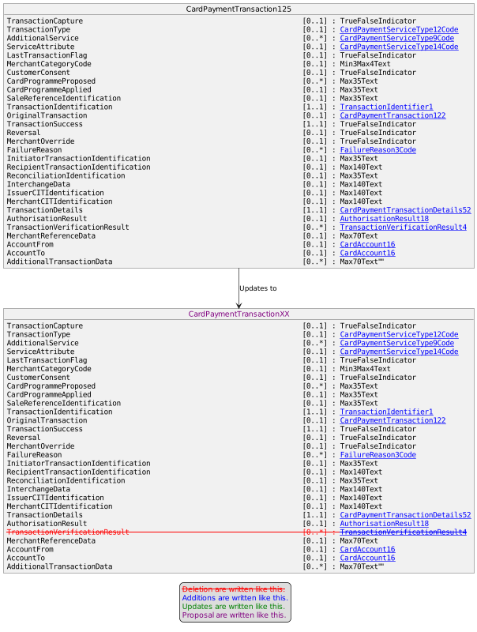

The definition of TransactionVerificationResult in Cardholder 20 will be also improved by stressing that result is linked to cardholder. The new definition will be “Result of performed cardholder verifications for the transaction”

- Urgency of the request:

Urgent

- Business examples:
Examples illustrating the change request.
- SEG/TSG recommendation:
This section is not to be taken care of by the submitter of the change request. It will be completed in due time by the SEG(s) in charge of the related ISO 20022 messages or the TSG for changes related to the BAH.

Consider |  |  | Timing
 |  |  | - Next yearly cycle: 2023/2024  (the change will be considered for implementation in the yearly maintenance cycle which starts in 2023 and completes with the publication of new message versions in the spring of 2024) |  | X
- At the occasion of the next maintenance of the messages
(the change will be considered for implementation, but does not justify maintenance of the messages in its own right – will be pending until more critical change requests are received for the messages)
- Urgent unscheduled
(the change justifies an urgent implementation outside of the normal yearly cycle)
 |  |  | - Other timing:
Comments:

Reject
Reason for rejection:

