Change Request
for the update of ISO 20022 financial repository items

- Origin of the request:
A.1 Submitter: nexo A.I.S.B.L.
A.2 Contact person:
- Philippe CECE (philippe.cece@nexo-standards.org)
- Laure BELTRI (laure.beltri@frenchsys.com)
A.3 Sponsors: nexo A.I.S.B.L.

- Related messages:

- MaintenanceDelegationRequest V09 (catm.005.001.09)
- MaintenanceDelegationResponse V07 (catm.006.001.07)

- Description of the change request:

In case of delegation, we should be also able to download terminal packages.

- Purpose of the change:

As explained before we will update the list of elements that could be delegated DataSetCategory16Code with TerminalPackage as identified in the following diagram.

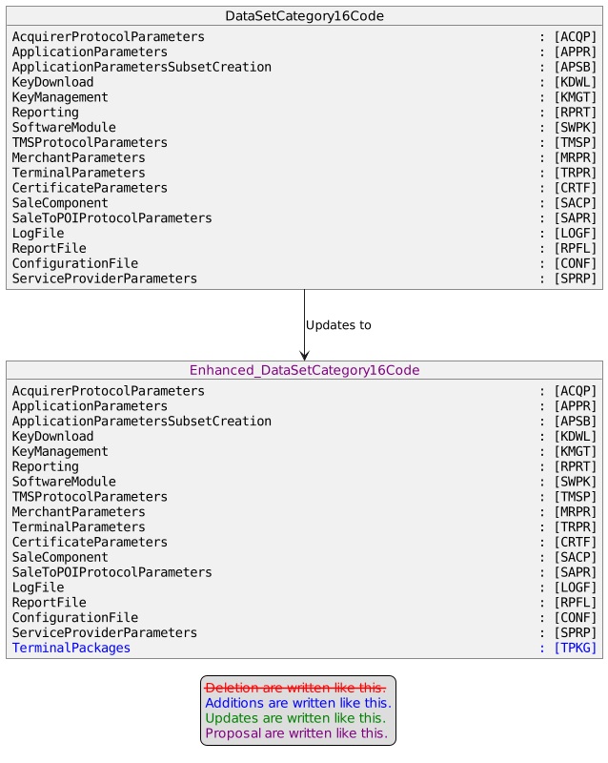

- Urgency of the request:

Not Urgent

- Business examples:
Examples illustrating the change request.

- SEG/TSG recommendation:
This section is not to be taken care of by the submitter of the change request. It will be completed in due time by the SEG(s) in charge of the related ISO 20022 messages or the TSG for changes related to the BAH.

Consider |  |  | Timing
 |  |  | - Next yearly cycle: 2023/2024  (the change will be considered for implementation in the yearly maintenance cycle which starts in 2023 and completes with the publication of new message versions in the spring of 2024) |  | X
- At the occasion of the next maintenance of the messages
(the change will be considered for implementation, but does not justify maintenance of the messages in its own right – will be pending until more critical change requests are received for the messages)
- Urgent unscheduled
(the change justifies an urgent implementation outside of the normal yearly cycle)
 |  |  | - Other timing:
Comments:

Reject
Reason for rejection:

