Change Request
for the update of ISO 20022 financial repository items

- Origin of the request:
A.1 Submitter: nexo A.I.S.B.L.
A.2 Contact person:
- Philippe CECE (philippe.cece@nexo-standards.org)
- Laure BELTRI (laure.beltri@frenchsys.com)
A.3 Sponsors: nexo A.I.S.B.L.

- Related messages:

- AcceptorAuthorisationRequest V12 (caaa.001.001.12)
- AcceptorAuthorisationResponse V12 (caaa.002.001.12)
- AcceptorCompletionAdvice V12 (caaa.003.001.12)
- AcceptorCompletionAdviceResponse V11 (caaa.004.001.11)
- AcceptorCancellationRequest V12 (caaa.005.001.12)
- AcceptorCancellationResponse V11 (caaa.006.001.11)
- AcceptorCancellationAdvice V12 (caaa.007.001.12)
- AcceptorCancellationAdviceResponse V11 (caaa.008.001.11)
- AcceptorReconciliationRequest V11 (caaa.009.001.11)
- AcceptorReconciliationResponse V10 (caaa.010.001.10)
- AcceptorBatchTransfer V12 (caaa.011.001.12)
- AcceptorBatchTransferResponse V11 (caaa.012.001.11)
- AcceptorDiagnosticRequest V11 (caaa.013.001.11)
- AcceptorDiagnosticResponse V10 (caaa.014.001.10)
- AcceptorCurrencyConversionRequest V10 (caaa.016.001.10)
- AcceptorCurrencyConversionResponse V10 (caaa.017.001.10)
- AcceptorCurrencyConversionAdvice V07 (caaa.018.001.07)
- AcceptorCurrencyConversionAdviceResponse V06 (caaa.019.001.06)
- TransactionAdvice V04 (caaa.020.001.04)
- TransactionAdviceResponse V04 (caaa.021.001.04)
- AcceptorNonFinancialRequest V03 (caaa.022.001.03)
- AcceptorNonFinancialResponse V03 (caaa.023.001.03)
- AcceptorTransactionLogReportRequest V03 (caaa.024.001.03)
- AcceptorTransactionLogReportResponse V03 (caaa.025.001.03)

- StatusReport V12 (catm.001.001.12)
- ManagementPlanReplacement V11 (catm.002.001.11)
- AcceptorConfigurationUpdate V12 (catm.003.001.12)
- MaintenanceDelegationRequest V09 (catm.005.001.09)
- MaintenanceDelegationResponse V07 (catm.006.001.07)
- CertificateManagementRequest V06 (catm.007.001.06)
- CertificateManagementResponse V06 (catm.008.001.06)

- SaleToPOIServiceRequest V05 (casp.001.001.05)
- SaleToPOIServiceResponse V05 (casp.002.001.05)
- SaleToPOIReconciliationRequest V05 (casp.003.001.05)
- SaleToPOIReconciliationResponse V05 (casp.004.001.05)
- SaleToPOISessionManagementRequest V05 (casp.005.001.05)
- SaleToPOISessionManagementResponse V05 (casp.006.001.05)
- SaleToPOIAdministrativeRequest V05 (casp.007.001.05)
- SaleToPOIAdministrativeResponse V05 (casp.008.001.05)
- SaleToPOIReportRequest V05 (casp.009.001.05)
- SaleToPOIReportResponse V05 (casp.010.001.05)
- SaleToPOIAbort V05 (casp.011.001.05)
- SaleToPOIEventNotification V05 (casp.012.001.05)
- SaleToPOIMessageStatusRequest V05 (casp.014.001.05)
- SaleToPOIMessageStatusResponse V05 (casp.015.001.05)
- SaleToPOIDeviceRequest V05 (casp.016.001.05)
- SaleToPOIDeviceResponse V05 (casp.017.001.05)

- Description of the change request:

Since few years we have introduced elliptic curve signature support, like the support of Elliptic Curve Digital Signature Algorithm or Elliptic Curve Schnorr Digital Signature Algorithm algorithms. We would like to extend the list of supported signature algorithms to include algorithms with some beneficial computing features. Consequently, we want to add the support of the Elliptic Curve Optimised Schnorr Digital Signature Algorithm, the Elliptic Curve Full Schnorr Digital Signature and the Edward Digital Signature Algorithms.

On the other hand, we would like to provide support of Chinese algorithms for digest, cipher and elliptic curve signature, which will also create the support of new authentication methods.

In consequence, we suggest modifying the list of supported of algorithms.

- Purpose of the change:

As explained before we will update the list of signature algorithms Algorithm25Code with new ones as identified in the following diagram.

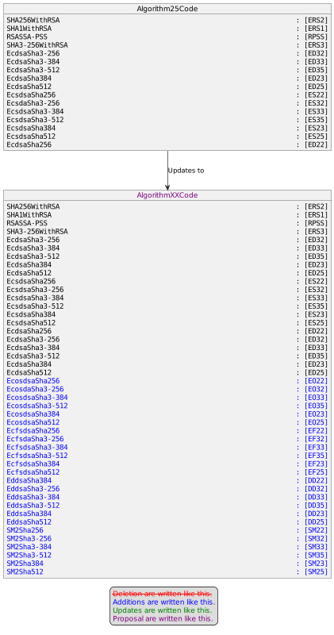

The list of cipher suite Algorithm24Code will be modified to support the SM4 algorithm with a CBC or CTR mode of operation as identified in the following diagram.

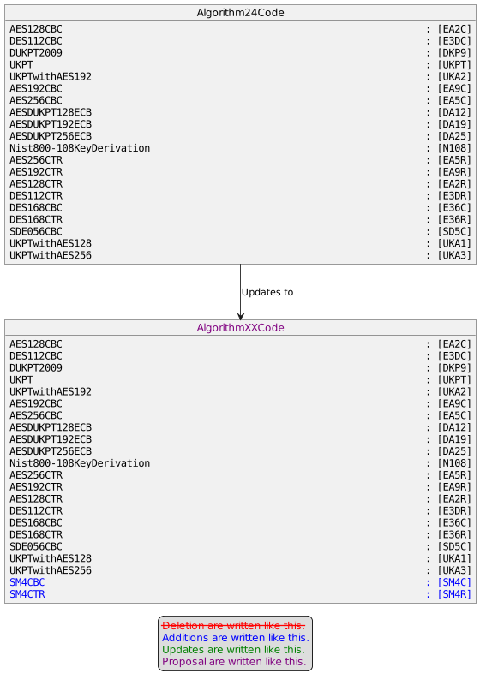

The list of digest suite Algorithm16Code will be enriched with the support of SM3 algorithm.

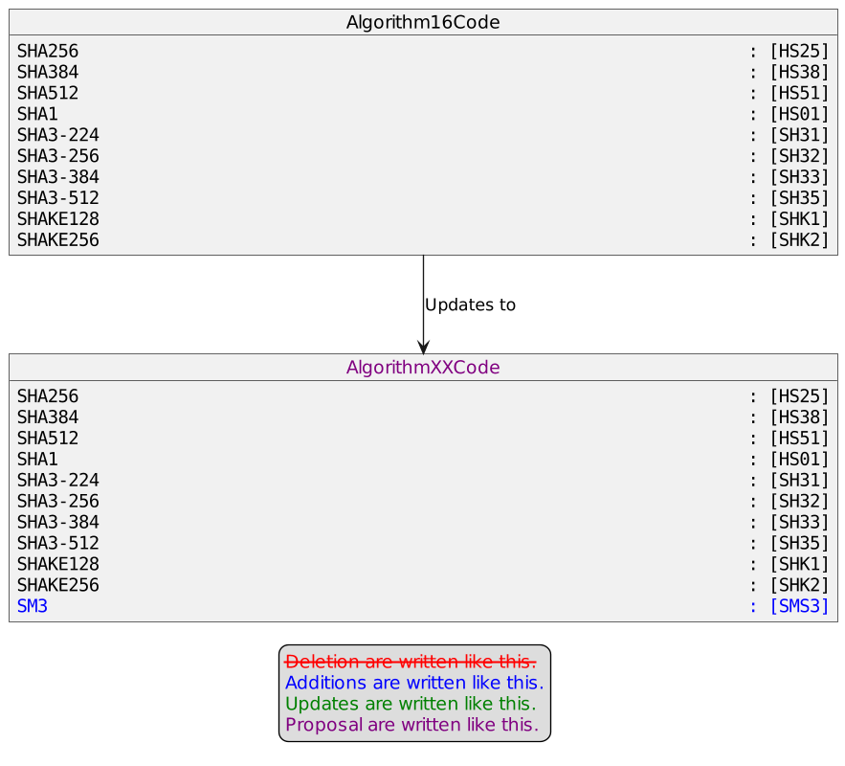

Consequently the list of authentication method Algorithm17Code will be updated to support couples of SM3 and of various SM4 enciphering.

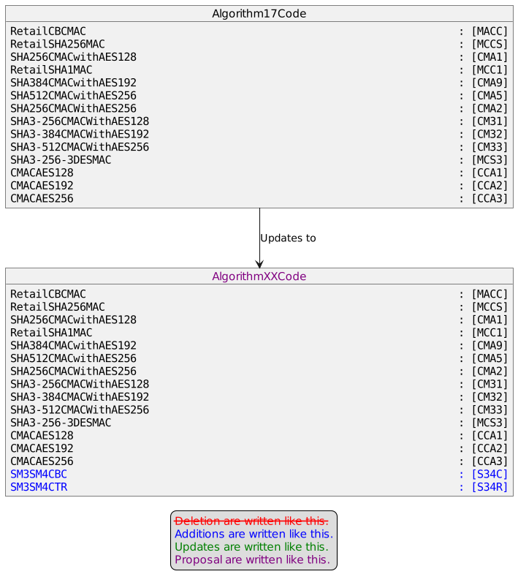

- Urgency of the request:

Urgent

- Business examples:
Examples illustrating the change request.
- SEG/TSG recommendation:
This section is not to be taken care of by the submitter of the change request. It will be completed in due time by the SEG(s) in charge of the related ISO 20022 messages or the TSG for changes related to the BAH.

Consider |  |  | Timing
 |  |  | - Next yearly cycle: 2023/2024  (the change will be considered for implementation in the yearly maintenance cycle which starts in 2023 and completes with the publication of new message versions in the spring of 2024) |  | X
- At the occasion of the next maintenance of the messages
(the change will be considered for implementation, but does not justify maintenance of the messages in its own right – will be pending until more critical change requests are received for the messages)
- Urgent unscheduled
(the change justifies an urgent implementation outside of the normal yearly cycle)
 |  |  | - Other timing:
Comments:

Reject
Reason for rejection:

