Change Request
for the update of ISO 20022 financial repository items

- Origin of the request:
A.1 Submitter: nexo A.I.S.B.L.
A.2 Contact person:
- Philippe CECE (philippe.cece@nexo-standards.org)
- Laure BELTRI (laure.beltri@frenchsys.com)
A.3 Sponsors: nexo A.I.S.B.L.

- Related messages:

- StatusReport V12 (catm.001.001.12)
- AcceptorConfigurationUpdate V12 (catm.003.001.12)

- Description of the change request:

The Terminal Management protocol supports key downloading, but we would like to restrict the access or usage of these keys to some specified applications residing on the POI and in some extent to some sub components or actors like a specific acquirer.
Consequently, we will add in CryptographicKey17 an element, that could be repeated, called restrictedAccess defined with a new component called GenericIdentificationXX to identify components that could use this key. The definition of this new element will be “Identifies components that could have access to this key.”
And to ensure, on some architectures, that the information has not been altered an additional ProtectedRestrictedAccess will be provided as a Cryptographic Message Syntax message component.
- Purpose of the change:

As explained before we will update the CryptographicKey17 with the new elements.

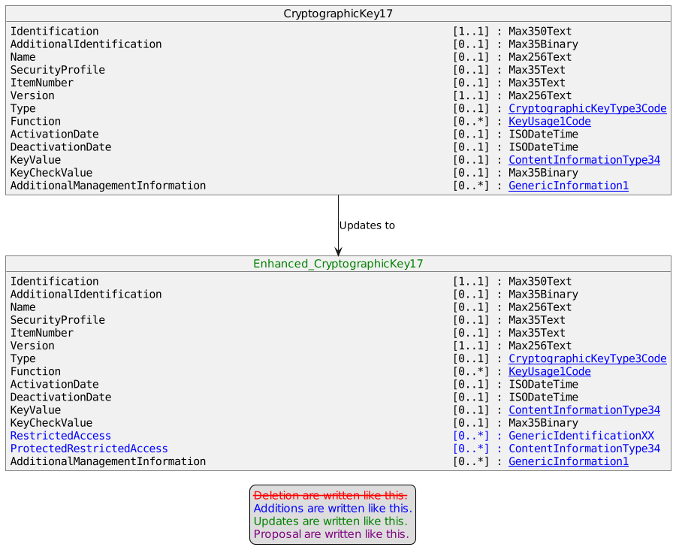

The message component GenericIdentificationXX is documented as points to an element in the system and is defined by the following diagram.
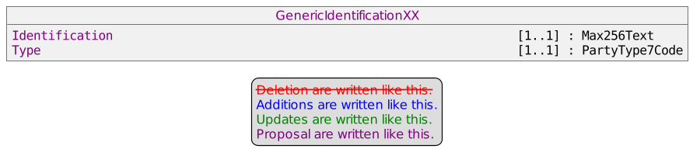

- Urgency of the request:

Urgent

- Business examples:
Examples illustrating the change request.
- SEG/TSG recommendation:
This section is not to be taken care of by the submitter of the change request. It will be completed in due time by the SEG(s) in charge of the related ISO 20022 messages or the TSG for changes related to the BAH.

Consider |  |  | Timing
 |  |  | - Next yearly cycle: 2023/2024  (the change will be considered for implementation in the yearly maintenance cycle which starts in 2023 and completes with the publication of new message versions in the spring of 2024) |  | X
- At the occasion of the next maintenance of the messages
(the change will be considered for implementation, but does not justify maintenance of the messages in its own right – will be pending until more critical change requests are received for the messages)
- Urgent unscheduled
(the change justifies an urgent implementation outside of the normal yearly cycle)
 |  |  | - Other timing:
Comments:

Reject
Reason for rejection:

