Change Request
for the update of ISO 20022 financial repository items

- Origin of the request:
A.1 Submitter: nexo A.I.S.B.L.
A.2 Contact person:
- Philippe CECE (philippe.cece@nexo-standards.org)
- Evelyne de JONGHE (evelyne.de-jonghe@frenchsys.com)
A.3 Sponsors: nexo A.I.S.B.L.

- Related messages:

- AcceptorAuthorisationRequest V12 (caaa.001.001.12)
- AcceptorAuthorisationResponse V12 (caaa.002.001.12)
- AcceptorBatchTransfer V12 (caaa.011.001.12)
- AcceptorCompletionAdvice V12 (caaa.003.001.12)
- AcceptorCurrencyConversionAdvice V07 (caaa.018.001.07)
- AcceptorCurrencyConversionResquest V10 (caaa.016.001.10)
- AcceptorCurrencyConversionResponse V10 (caaa.017.001.10)
- AcceptorNonFinancialRequest V03 (caaa.022.001.03)
- AcceptorTransactionLogReportResponse V03 (caaa.025.001.03)
- SaleToPOIMessageStatusResponse V05 (casp.015.001.05)
- SaleToPOIReportResponse V05 (casp.010.001.05)
- SaleToPOIServiceRequest V05 (casp.001.001.05)
- SaleToPOIServiceResponse V05 (casp.002.001.05)
- TransactionAdvice V04 (caaa.020.001.04)

- Description of the change request:

We received a lot of support requests from implementers to understand how to manage Instalment and Recurring transactions. With the current model recurring transaction and instalment payments shared the same message component RecurringTransaction, and the message element Instalment.

The aim of this change request is to harmonize the model by clearly identifying message element and component for each dedicated type of payment as identified by the following diagrams.

- Purpose of the change:

The following diagram identify the change of the RecurringTransaction5 which will be derived to MultiTransaction1 to convey instalment information.

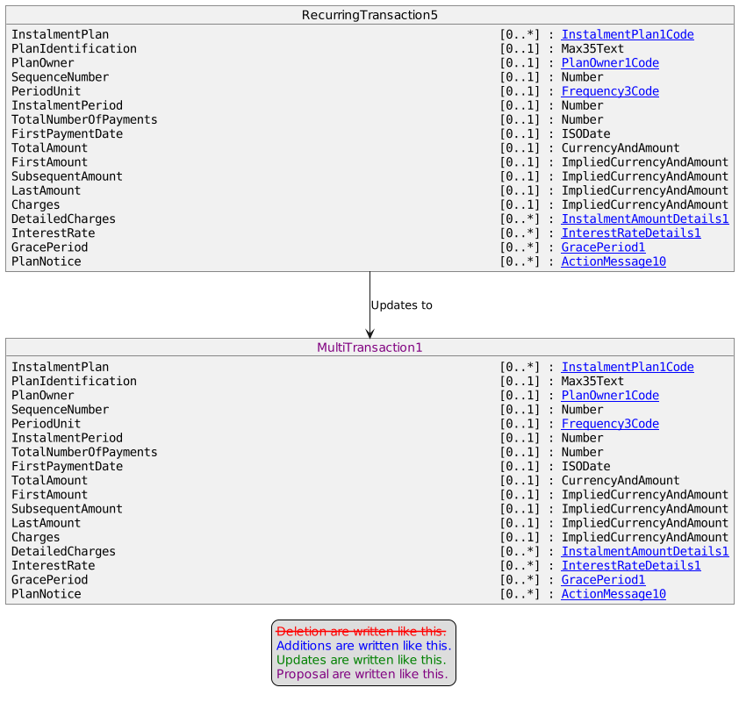

The definition of RecurringTransaction5 will be simplified to focus on recurring information only as depicted in the following diagram.

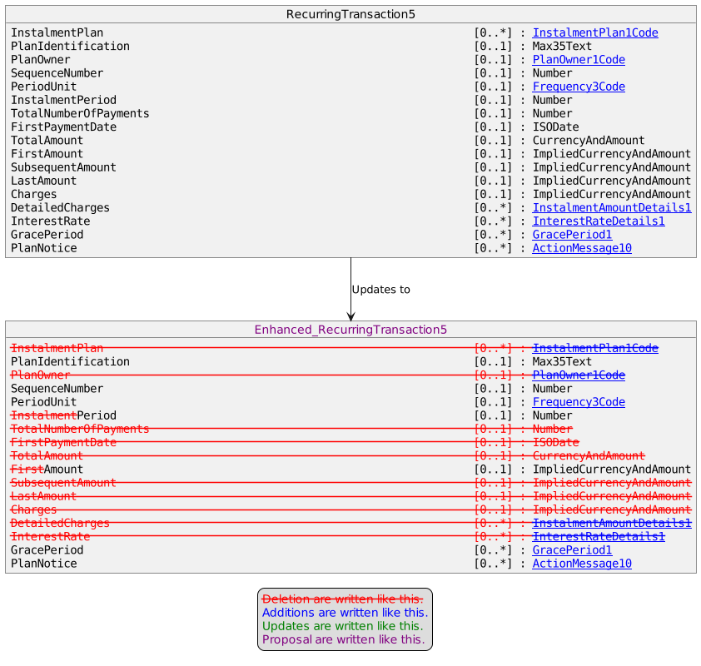

Consequently, the transaction details will be updated to include a new message element devoted to recurring.

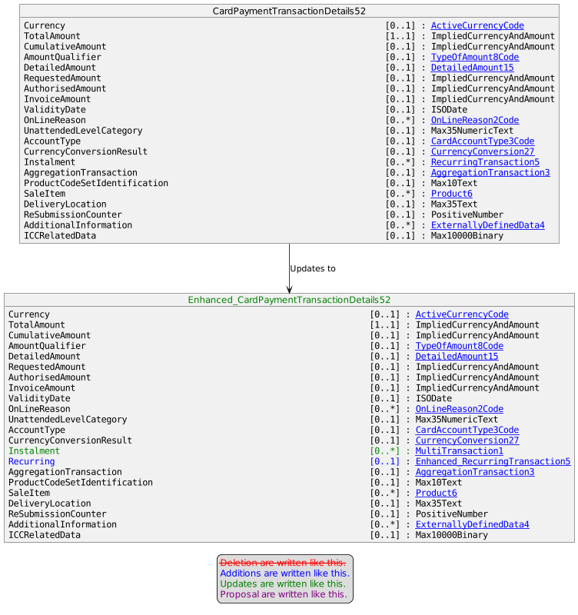

- Urgency of the request:

Urgent

- Business examples:
Examples illustrating the change request.
- SEG/TSG recommendation:
This section is not to be taken care of by the submitter of the change request. It will be completed in due time by the SEG(s) in charge of the related ISO 20022 messages or the TSG for changes related to the BAH.

Consider |  |  | Timing
 |  |  | - Next yearly cycle: 2023/2024  (the change will be considered for implementation in the yearly maintenance cycle which starts in 2023 and completes with the publication of new message versions in the spring of 2024) |  | X
- At the occasion of the next maintenance of the messages
(the change will be considered for implementation, but does not justify maintenance of the messages in its own right – will be pending until more critical change requests are received for the messages)
- Urgent unscheduled
(the change justifies an urgent implementation outside of the normal yearly cycle)
 |  |  | - Other timing:
Comments:

Reject
Reason for rejection:

