Change Request
for the update of ISO 20022 financial repository items

- Origin of the request:
A.1 Submitter: nexo A.I.S.B.L.
A.2 Contact person:
- Philippe CECE (philippe.cece@nexo-standards.org)
- Evelyne de JONGHE (evelyne.de-jonghe@frenchsys.com)
A.3 Sponsors: nexo A.I.S.B.L.

- Related messages:

- AcceptorAuthorisationRequest V12 (caaa.001.001.12)
- AcceptorAuthorisationResponse V12 (caaa.002.001.12)
- AcceptorCompletionAdvice V12 (caaa.003.001.12)
- AcceptorCompletionAdviceResponse V11 (caaa.004.001.11)
- AcceptorCancellationRequest V12 (caaa.005.001.12)
- AcceptorCancellationResponse V11 (caaa.006.001.11)
- AcceptorCancellationAdvice V12 (caaa.007.001.12)
- AcceptorCancellationAdviceResponse V11 (caaa.008.001.11)
- AcceptorReconciliationRequest V11 (caaa.009.001.11)
- AcceptorReconciliationResponse V10 (caaa.010.001.10)
- AcceptorBatchTransfer V12 (caaa.011.001.12)
- AcceptorBatchTransferResponse V11 (caaa.012.001.11)
- AcceptorDiagnosticRequest V11 (caaa.013.001.11)
- AcceptorDiagnosticResponse V10 (caaa.014.001.10)
- AcceptorCurrencyConversionRequest V10 (caaa.016.001.10)
- AcceptorCurrencyConversionResponse V10 (caaa.017.001.10)
- AcceptorCurrencyConversionAdvice V07 (caaa.018.001.07)
- AcceptorCurrencyConversionAdviceResponse V06 (caaa.019.001.06)
- TransactionAdvice V04 (caaa.020.001.04)
- TransactionAdviceResponse V04 (caaa.021.001.04)
- AcceptorNonFinancialRequest V03 (caaa.022.001.03)
- AcceptorNonFinancialResponse V03 (caaa.023.001.03)
- AcceptorTransactionLogReportRequest V03 (caaa.024.001.03)
- AcceptorTransactionLogReportResponse V03 (caaa.025.001.03)

- ManagementPlanReplacement V11 (catm.002.001.11)
- MaintenanceDelegationRequest V09 (catm.005.001.09)

- SaleToPOIServiceRequest V05 (casp.001.001.05)
- SaleToPOIServiceResponse V05 (casp.002.001.05)
- SaleToPOIReconciliationRequest V05 (casp.003.001.05)
- SaleToPOIReconciliationResponse V05 (casp.004.001.05)
- SaleToPOISessionManagementRequest V05 (casp.005.001.05)
- SaleToPOISessionManagementResponse V05 (casp.006.001.05)
- SaleToPOIAdministrativeRequest V05 (casp.007.001.05)
- SaleToPOIAdministrativeResponse V05 (casp.008.001.05)
- SaleToPOIReportRequest V05 (casp.009.001.05)
- SaleToPOIReportResponse V05 (casp.010.001.05)
- SaleToPOIAbort V05 (casp.011.001.05)
- SaleToPOIEventNotification V05 (casp.012.001.05)
- SaleToPOIMessageStatusRequest V05 (casp.014.001.05)
- SaleToPOIMessageStatusResponse V05 (casp.015.001.05)
- SaleToPOIDeviceRequest V05 (casp.016.001.05)
- SaleToPOIDeviceResponse V05 (casp.017.001.05)

- Description of the change request:

Sometimes we may have to process a card without an expiry date. Typically, it could be the case with a contactless device where the card has been tokenised.

So we need to define the message element ExpiryDate as optional.

- Purpose of the change:

As explained before we will define ExpiryDate in the message component PlanCardData15 as optional as highlighted in the following diagram.

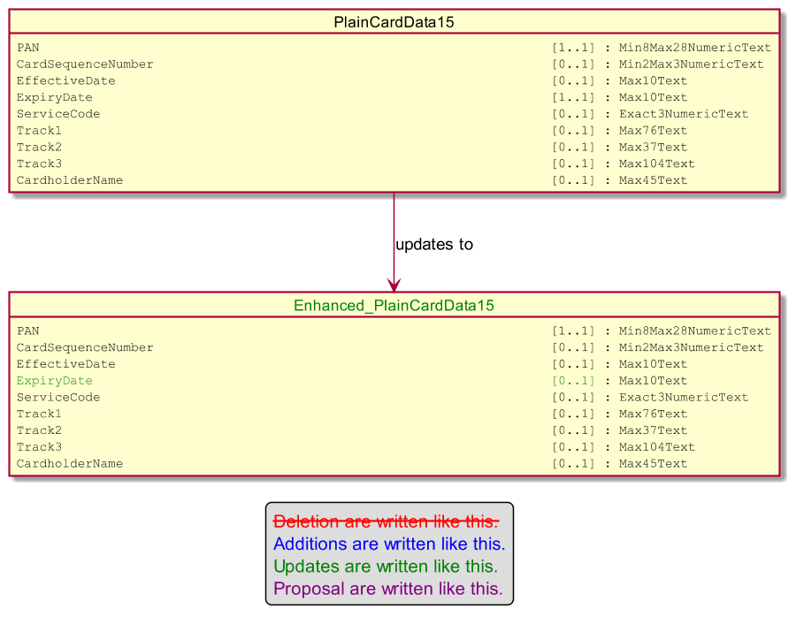

- Urgency of the request:

Urgent

- Business examples:
Examples illustrating the change request.
- SEG/TSG recommendation:
This section is not to be taken care of by the submitter of the change request. It will be completed in due time by the SEG(s) in charge of the related ISO 20022 messages or the TSG for changes related to the BAH.

Consider |  |  | Timing
 |  |  | - Next yearly cycle: 2023/2024  (the change will be considered for implementation in the yearly maintenance cycle which starts in 2023 and completes with the publication of new message versions in the spring of 2024) |  | X
- At the occasion of the next maintenance of the messages
(the change will be considered for implementation, but does not justify maintenance of the messages in its own right – will be pending until more critical change requests are received for the messages)
- Urgent unscheduled
(the change justifies an urgent implementation outside of the normal yearly cycle)
 |  |  | - Other timing:
Comments:

Reject
Reason for rejection:

