Change Request
for the update of ISO 20022 financial repository items
- Origin of the request:
A.1 Submitter: Euroclear.
A.2 Contact person: Jean-Paul Lambotte jean-paul.lambotte@euroclear.com
A.3 Sponsors: Euroclear

- Related messages:
Seev.031

- Description of the change request:
In the MT564 (Sequence E1), it is possible to report the indicator :22F::NELP//NELS to indicate that a proceed security is not eligible in the CSD.
This code does not exists in ISO20022. The value NELS “Security not eligible in the CSD” should be added in the message seev.031, in the element /Corporate Action Notification/ Corporate Action Options/Securities Movement/Non-Eligible Proceed Indicator [NELP].
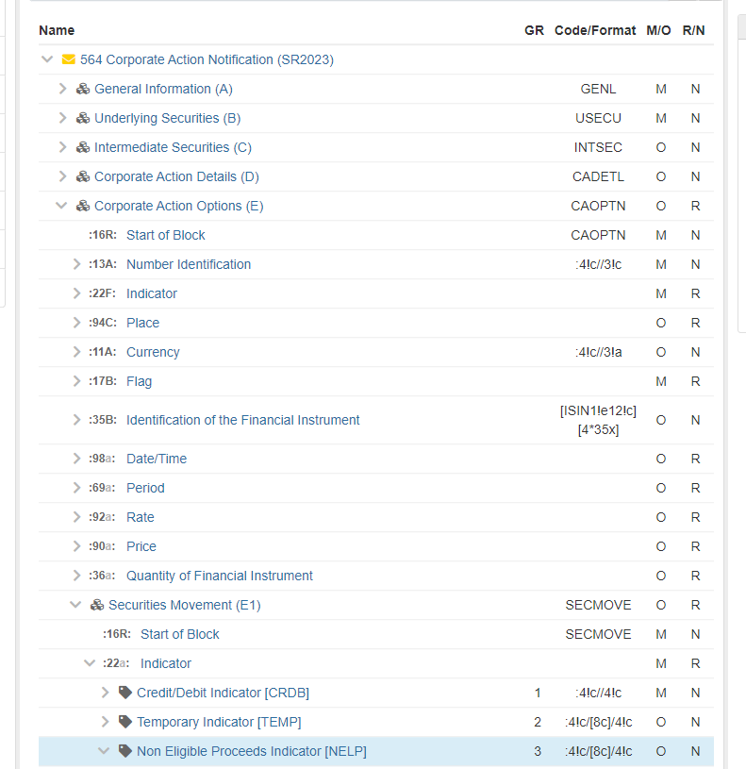

- Purpose of the change:
Allow reporting of non-eligible securities proceeds and improve consistency between seev.031 and MT564

- Urgency of the request:
SR2024

- Business examples:
/

- SEG/TSG recommendation:
This section is not to be taken care of by the submitter of the change request. It will be completed in due time by the SEG(s) in charge of the related ISO 20022 messages or the TSG for changes related to the BAH.

Consider |  | X | Timing
 |  |  | - Next yearly cycle: 2023/2024  (the change will be considered for implementation in the yearly maintenance cycle which starts in 2023 and completes with the publication of new message versions in the spring of 2024) |  | X
- At the occasion of the next maintenance of the messages
(the change will be considered for implementation, but does not justify maintenance of the messages in its own right – will be pending until more critical change requests are received for the messages)
- Urgent unscheduled
(the change justifies an urgent implementation outside of the normal yearly cycle)
 |  |  | - Other timing:
Comments:

Reject
Reason for rejection:

