Change Request
for the update of ISO 20022 financial repository items
- Origin of the request:
A.1 Submitter: SMPG.
A.2 Contact person: Jean-Paul Lambotte jean-paul.lambotte@euroclear.com
A.3 Sponsors: SMPG, Euroclear

- Related messages:
Seev.001, seev.007 & seev.008

- Description of the change request:
In the seev.001, seev.007 and seev.008 messages, the length of the resolution title is currently limited to 350 characters (Max350Text) and the length of the resolution description is currently limited to 1025 characters (Max1025Text). Some general meetings require longer titles and descriptions.
In order to avoid this limitation,
- the maximum length of the title element should be extended to 1025 characters (Max1025Text)
- the maximum length of the description element should be extended to 8000 characters (Max8000Text).
- the description element should be repetitive [0,*] (repetitiveness should be used in the exceptional case where the description would exceed 8000 characters)

This is applicable to :
- seev.001 - /Meeting Notification/Resolution/Description/Title & /Meeting Notification/Resolution/Description/Description
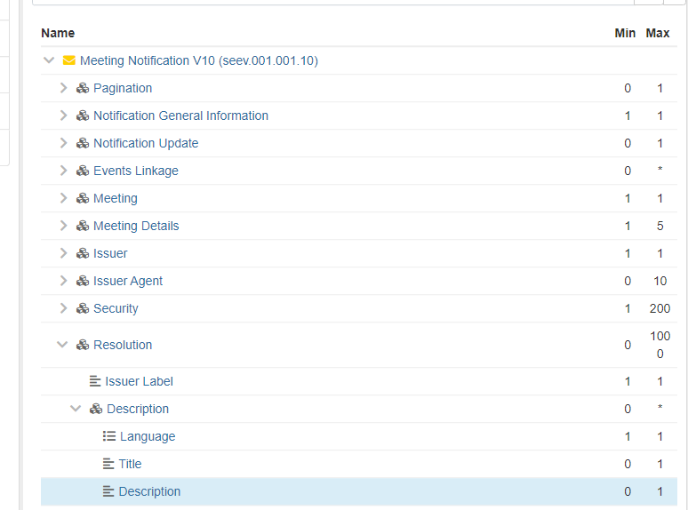

- seev.007 – /Meeting vote Execution Confirmation/Vote Instructions/Vote Per Resolution/Description/Title & /Meeting vote Execution Confirmation/Vote Instructions/Vote Per Resolution/Description/Description
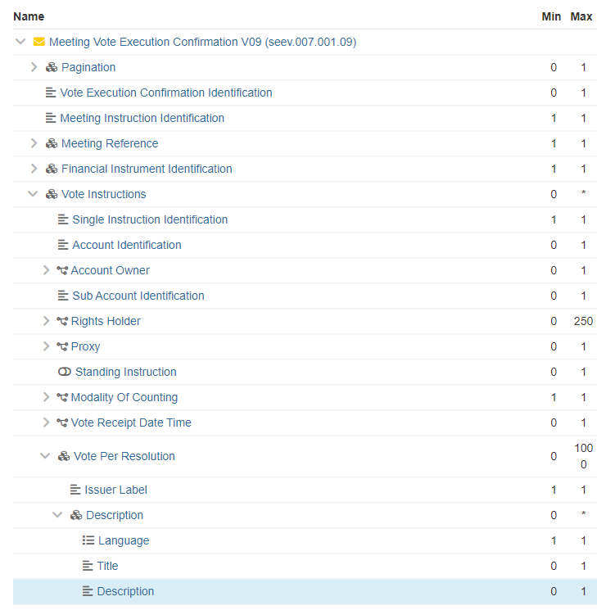

- seev.008 – /Meeting Result Dissemination/Vote Result/Description/Title &/Meeting Result Dissemination/Vote Result/Description/Description

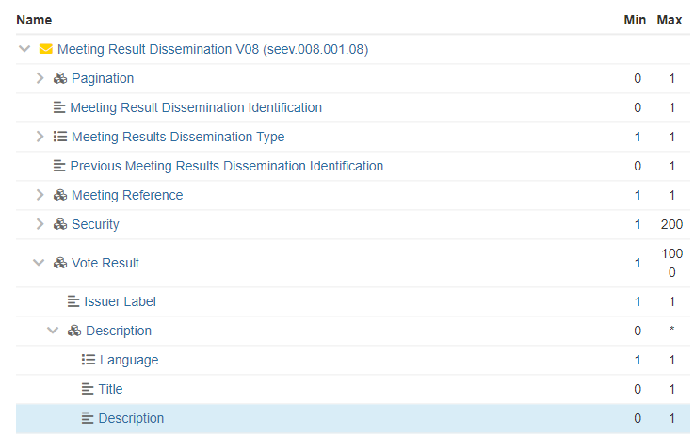

- Purpose of the change:
To support long resolution title description, the length of the fields must be extended and the description field must be made repetitive.
(The title of the resolution is usually defined by company lawyers and validated by the board and can result in title longer than 350 characters)

- Urgency of the request:
SR2024

- Business examples:
Some cases already occurred on the FR market. As a work around, the resolution title was populated with ‘Resolution 1’ and the real title was provided at the start of the description field which is a misuse of the message.

- SEG/TSG recommendation:
This section is not to be taken care of by the submitter of the change request. It will be completed in due time by the SEG(s) in charge of the related ISO 20022 messages or the TSG for changes related to the BAH.

Consider |  | X | Timing
 |  |  | - Next yearly cycle: 2023/2024  (the change will be considered for implementation in the yearly maintenance cycle which starts in 2023 and completes with the publication of new message versions in the spring of 2024) |  | X
- At the occasion of the next maintenance of the messages
(the change will be considered for implementation, but does not justify maintenance of the messages in its own right – will be pending until more critical change requests are received for the messages)
- Urgent unscheduled
(the change justifies an urgent implementation outside of the normal yearly cycle)
 |  |  | - Other timing:
Comments:

Reject
Reason for rejection:

