Change Request
for the update of ISO 20022 financial repository items
Note: the purpose of this document is to give guidelines to parties who want to introduce a request to change an existing ISO 20022 message(s), or update other items of the ISO 20022 financial repository. Such change requests are subject to the approval of the ISO 20022 Standards Evaluation Group(s) in charge of the related message/item or to the approval of the Technical Support Group (TSG), if the requested change relates to the Business Application Header (BAH). Please consult the iso20022.org website for additional details on the maintenance process. Change requests are to be sent to iso20022ra@iso20022.org. All change requests conforming to this template received by June 1st will be considered for development in the following yearly ISO 20022 maintenance cycle which completes with publication of new message versions in April/May of the following year.
- Origin of the request:
A.1 Submitter: SMPG CA WG
A.2 Contact person:
Christine Strandberg: christine.strandberg@seb.se - +46 (8) 763 60 74
Mariangela Fumagalli: mariangela.fumagalli@bnpparibas.com - +442075954988
Jacques Littré: Jacques.littre@swift.com - +3226554335
A.3 Sponsors:
SMPG CA WG members
- Related messages:
seev.042.001.11 - CorporateActionInstructionStatementReportV11

- Description of the change request:
In the seev.042 (CorporateActionInstructionStatementReport) message, change the data type “NoSpecifiedReason1” of the “Pending” status element in path “AccountAndStatementDetails / CorporateActionEventAndBalance / Balance / TotalInstructedBalanceDetails / OptionDetails / OptionInstructionDetails / InstructionStatus” by the data type “PendingStatus66Choice” used to type the “Pending” element in the seev.034 (CorporateActionInstructionStatusAdvice) message as illustrated below:
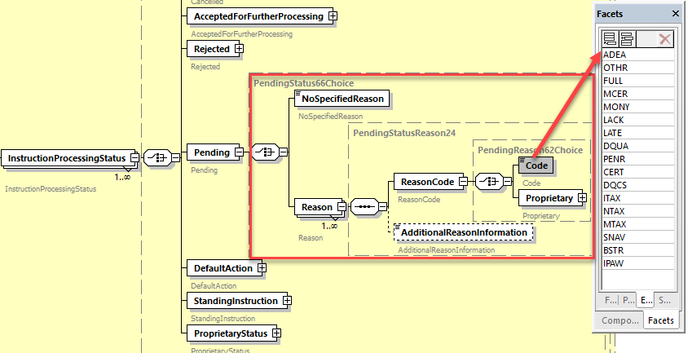

- Purpose of the change:
The pending reason codes defined in the InstructionStatementReport message must be fully aligned with the same pending status reason codes defined in the CorporateActionInstructionStatus message and in the MT567.

- Urgency of the request:
For next release.
Note: the ISO 20022 maintenance results in the publication of a new version of an ISO 20022 message. The actual implementation of such new version on networks and in user installations is not within the purview of ISO.
- Business examples:
Examples illustrating the change request.
NA
- SEG/TSG recommendation:
This section is not to be taken care of by the submitter of the change request. It will be completed in due time by the SEG(s) in charge of the related ISO 20022 messages or the TSG for changes related to the BAH.

Consider |  | X | Timing
 |  |  | - Next yearly cycle: 2023/2024  (the change will be considered for implementation in the yearly maintenance cycle which starts in 2023 and completes with the publication of new message versions in the spring of 2024) |  | X
- At the occasion of the next maintenance of the messages
(the change will be considered for implementation, but does not justify maintenance of the messages in its own right – will be pending until more critical change requests are received for the messages)
- Urgent unscheduled
(the change justifies an urgent implementation outside of the normal yearly cycle)
 |  |  | - Other timing:
Comments:

Reject
Reason for rejection:

